System Requirement:

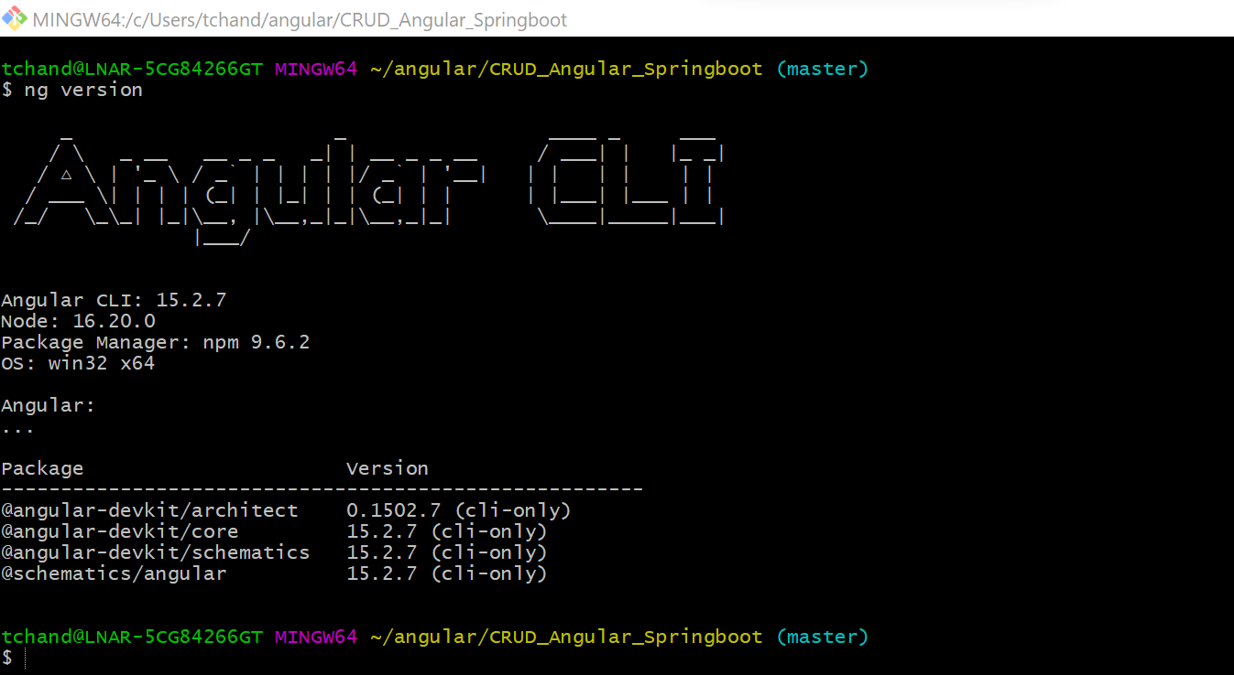

JAVA: 11

Maven 3.3.0

Rest API Port: 9999 (Please refer swager UI)

DB: In Memory (H2 DB)

IDE: Visual Studio and STS

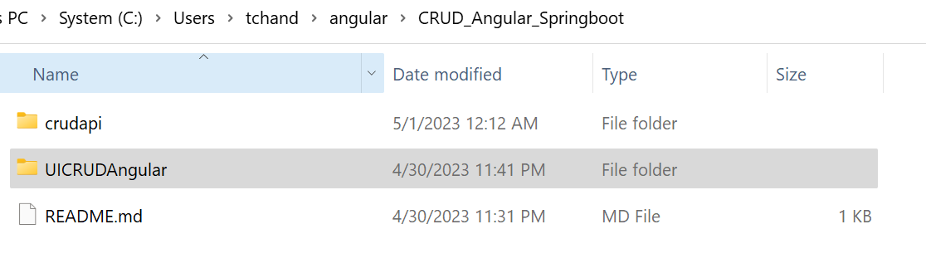

Angular UI code: CRUD_Angular_Springboot\UICRUDAngular

Command for Running Angular code:

ng install or npm install

ng serve or npm start

Spring Boot Rest API: CRUD_Angular_Springboot\crudapi

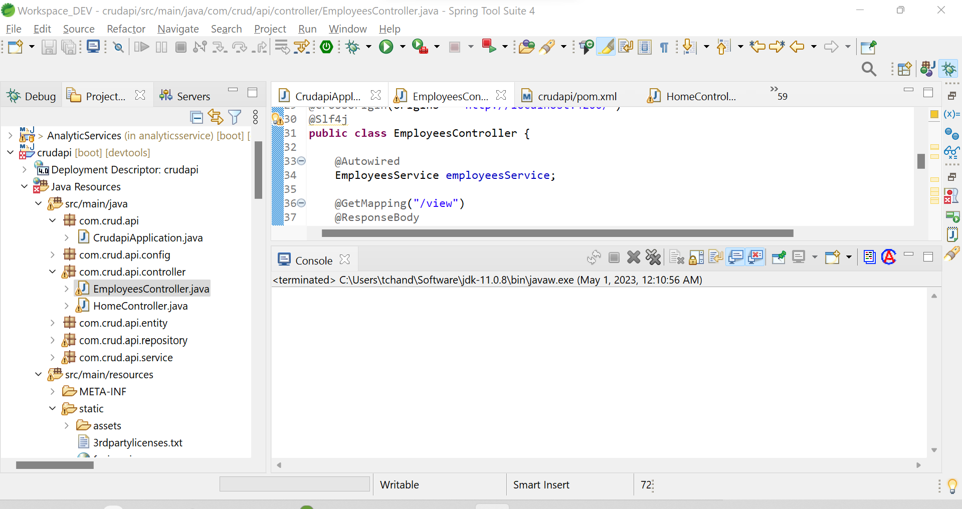

Rest APIs up command: mvn clean package

mvn spring-boot:run

DB Console: <http://localhost:9999/h2-console/>

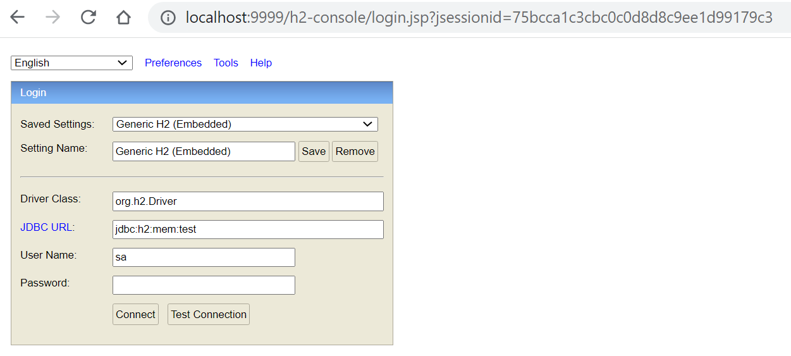

Click Connect:

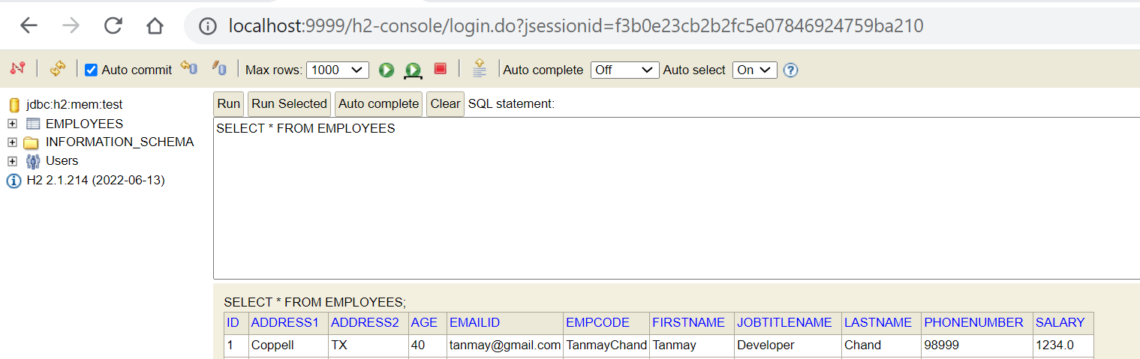

Swager for Rest API:

<http://localhost:9999/swagger-ui/index.html#/employees-controller>

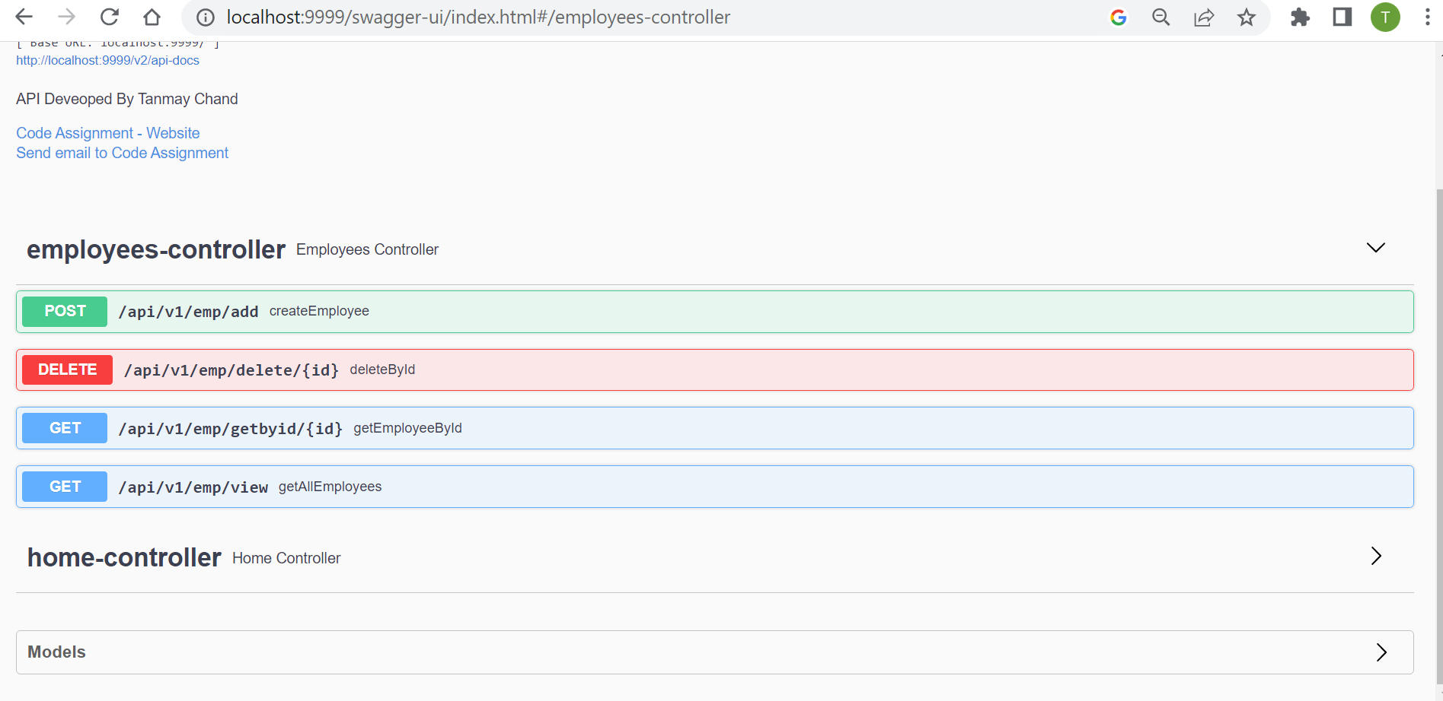

View Page:

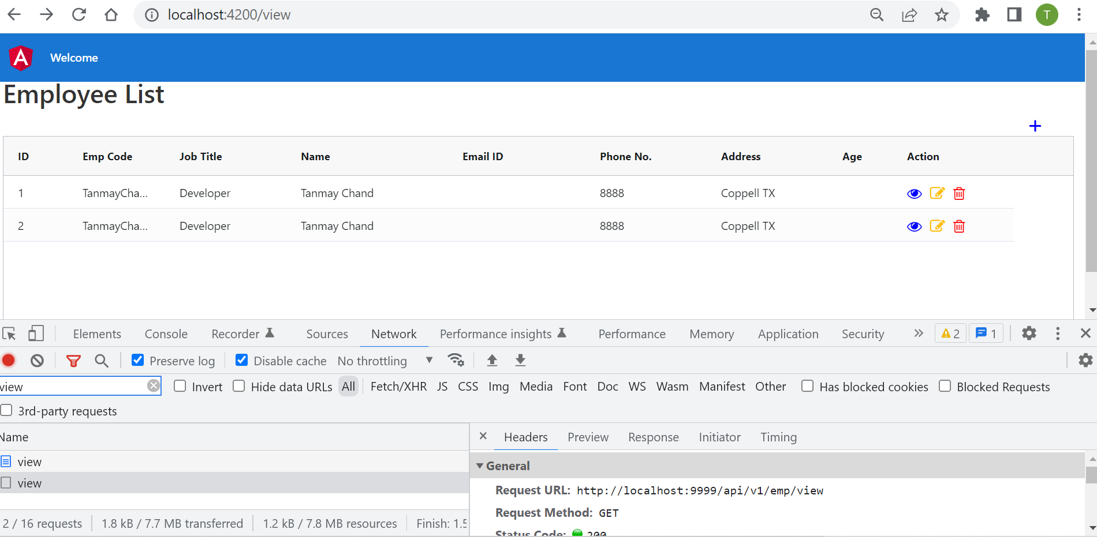

Edit By ID:

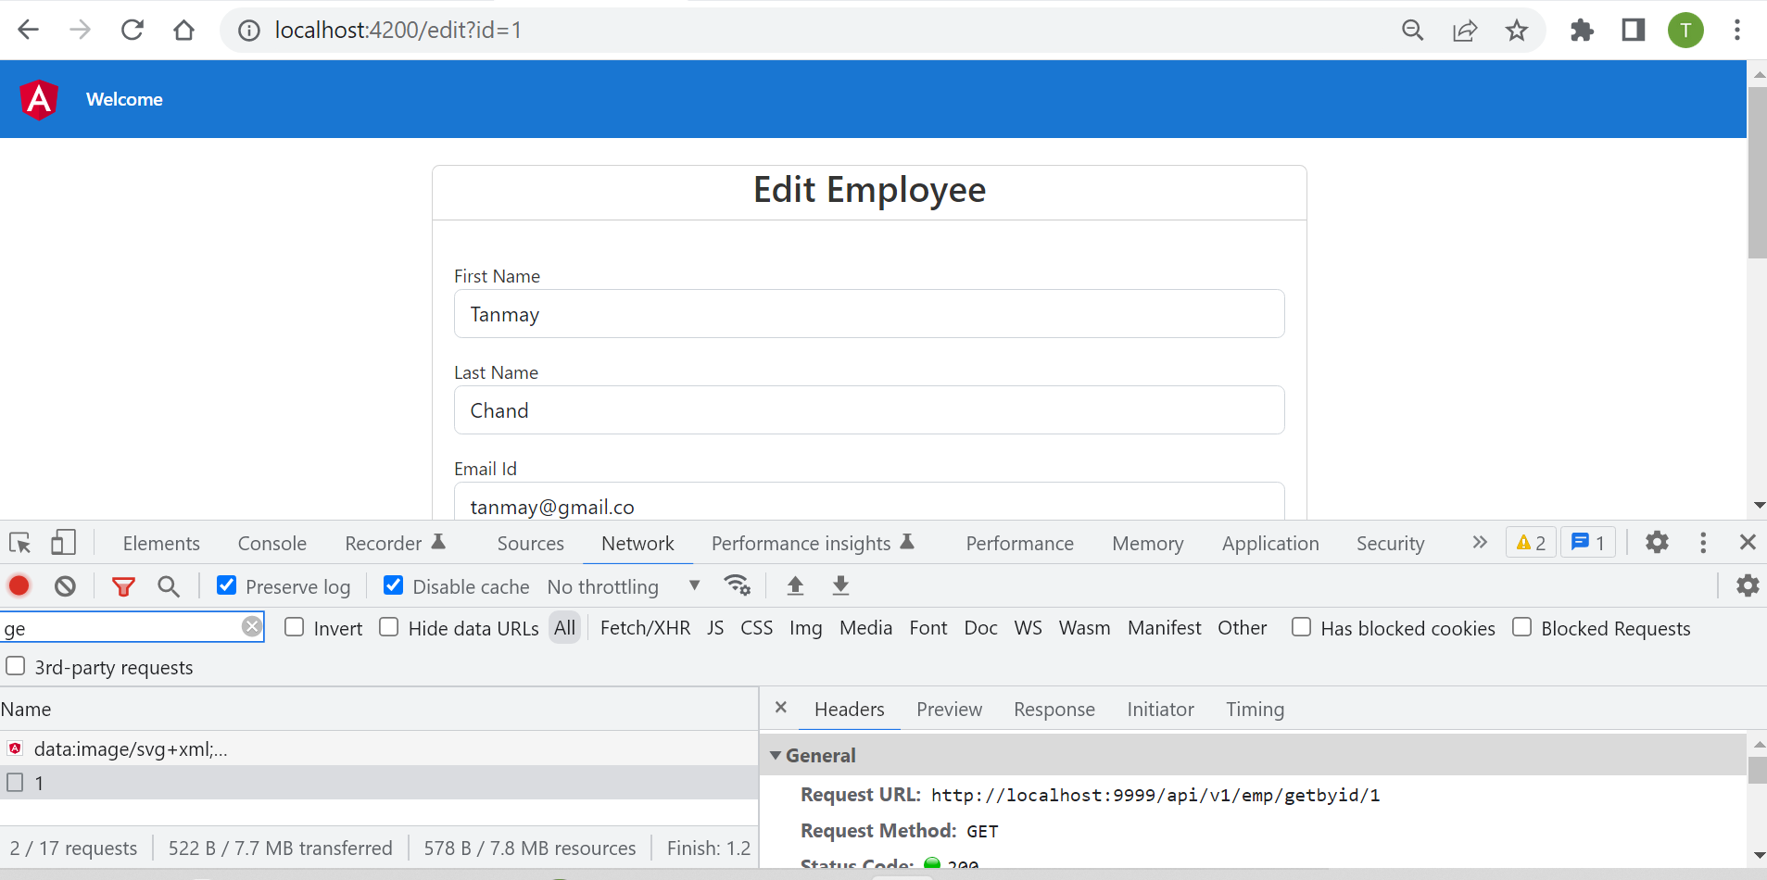

Add Employee: