

Software Engineering Methods CT871

Semester Two Assignment:
MedManage System
System Modeling using UML models: An object orientated approach

Name: Tara Keeeeena
Student ID: 06510426
Course: MSc Software Design & Development

Contents

Page:

3. Introduction
4. Use Case Diagram
5. Use Case Scenarios
9. Activity Diagram
10. Class Diagram
11. Sequence Diagrams
14. State Machine Diagram
15. MedManage Prototype


MedManage
System

Task: To develop a computer system (MedManage) for a busy doctor’s office both to manage appointments and manage patient medical records.

The following report includes function, structural and behavioural models in order to describe who will use the system, what the system will do, and where and when it will be used.

Models:

- Functional models (Activity Diagram & Use Case) – to describe the external behavioural view of the system
- Structural models (Class diagrams) - to depict the static view of an information system
- Behavioural models (Interaction Diagrams and State Diagrams) -to represent the internal behaviour or dynamic view of the system.

Use Case Model – (adding tester ling here)
Another edit

Assumptions:
- Doctor’s office with one doctor on site
- The customer/patient does not interact with the system directly. All appointments are managed by the receptionist and so is a main user of the system (not patients).

MedManage Use Case Diagram:

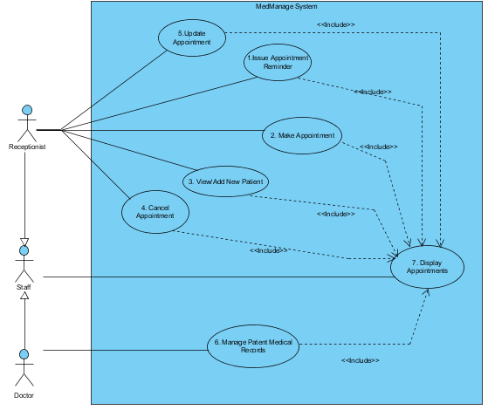

Use Case Scenarios

Use Case Name: | 1. Issue Appointment Reminder
Actors: | Receptionist
Description: | This use case scenario describes how the user (receptionist) can use MedManage system to generate an appointment reminder for patients
Trigger: | When the user clicks on the ‘View Appointments’ button
Preconditions: | User must have authentication rights
Post-condition: | User has successfully viewed appointment schedule for two weeks after
Normal Flow: | - Staff logs into the system
 | - Staff click on the view appointments page
 | - Staff enters appointment dates two weeks from present
 | - Staff views all patients with scheduled appointment in this time period
 | - The system confirm the appointment
Alternative Flow: | - If patient is new then the staff will enter patient details (name, address, ages,etc) and go to Use Case 4.
 | - If the date is reserved then a message will be shown and the system return to step 3.
 | - Staff can cancel at any time

Use Case Name: | 2. Make Appointment
Actors: | Receptionist
Description: | This use case scenario describes how the user (receptionist) can create a new appointment on MedManage System
Trigger: | When the user clicks on the ‘Create New Appointment’ button
Preconditions: | User must have authentication rights
Post-condition: | User has successfully created/added new a new appointment on patient database
Normal Flow: | - Staff logs into the system
 | - Staff click on the appointment page
 | - Staff enters patients name/DOB to retrieve patient file
 | - Staff enters the appointment date
 | - The system confirm the appointment
Alternative Flow: | - If patient is new then the staff will enter patient details (name, address, ages,etc) and go to Use Case 4.
 | - If the date is reserved then a message will be shown and the system return to step 3.
 | - Staff can cancel at any time

Use Case Name: | 3a. Add New Patient
Actors: | Receptionist
Description: | This use case scenario describes how the user (receptionist) can create a new patient record on MedManage System
Trigger: | When the user clicks on the ‘Add New Patient’ button
Preconditions: | User must have authentication rights
Post-condition: | User has successfully created/added new a new patient record on patient database
Normal Flow: | - Staff enters authentication details
 | - Staff clicks on ‘Add New Patient’ button
 | - Staff enters patients name, numbers and details
 | - Staff clicks ‘Submit’ to register new patient
 | - The system confirms new patient record
Alternative Flow: | If patient already exists in database – user alerted

Use Case Name: | 3b. View Patients Database
Actors: | Receptionist
Description: | This use case scenario describes how the user (receptionist) view the patient database to see if patient is new or existing patient
Trigger: | When the user clicks on the ‘View Patient Database’ button
Preconditions: | User must have authentication rights
Post-condition: | User has successfully views the patient database
Normal Flow: | 1.Staff enters authentication details
 | 2. Staff clicks on ‘View Patient Database’ button
 | 3. Staff enters patients name, numbers and details
 | - The system displays patient details
Alternative Flow: | - The patient does not exist in the records
 | - Staff goes to Use Case 4: Add New Patient

Use Case Name: | 4. Cancel Appointment
Actors: | Receptionist
Description: | This use case scenario describes how the user (receptionist) can cancel an appointment on MedManage System
Trigger: | When the user clicks on the ‘View Appointments Calendar’ button
Preconditions: | User must have authentication rights
Post-condition: | User has successfully cancelled a patient’s appointment
Normal Flow: | - Staff enters authentication details
 | - Staff clicks on ‘View Appointments Calendar’ button
 | - Staff enters patients name, numbers and details
 | - The system displays appointment details
 | - Staff clicks ‘Cancel Appointment’ and confirms request
 | - The system confirms appointment cancelled

Use Case Name: | 4. Update Appointment
Actors: | Receptionist
Description: | This use case scenario describes how the user (receptionist) can update an appointment on MedManage System
Trigger: | When the user clicks on the ‘View Appointments Calendar’ button
Preconditions: | User must have authentication rights
Post-condition: | User has successfully updated a patient’s appointment
Normal Flow: | - Staff enters authentication details
 | - Staff clicks on ‘View Appointments Calendar’ button
 | - Staff enters patients name, numbers and details
 | - The system displays appointment details
 | - Staff clicks ‘Update Appointment’ and confirms request
 | - The system confirms appointment updated

Use Case Name: | 6. Manage Patient Medical Records
Actors: | Doctor
Description: | This use case scenario describes how the user (doctor) can view and update scheduled appointments in the system
Trigger: | When the user clicks on the ‘View/Update Patient Records’ button
Preconditions: | User must have authentication rights
Post-condition: | User has successfully viewed/updated a patient’s medical records
Normal Flow: | - Doctor enters authentication details
 | - Doctor clicks on View/Update Patient Records’ button
 | - Doctor enters patient details
 | - The system displays patient records
 | - Doctor updates medical records after appointment
 | - The system displays updated patient records
Alternative Flow: | - Patient not on file. Patient must be added to database

MedManage : Activity Diagram

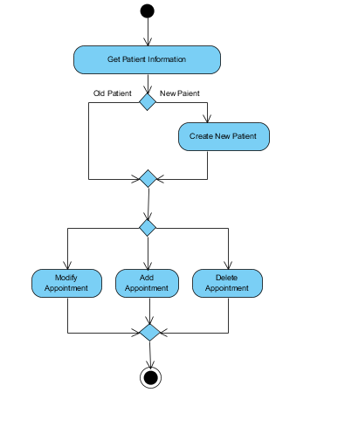

MedManage Domain Model: Class Diagram

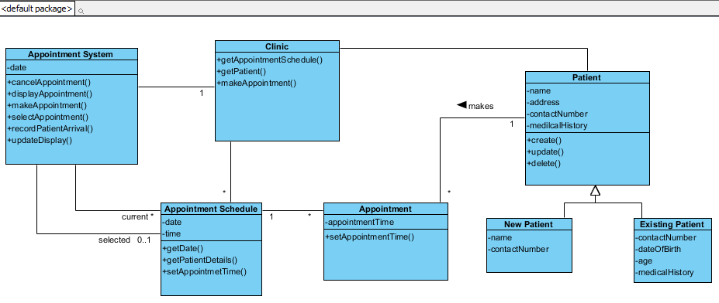

Interaction Diagram : Sequence Diagrams

Cancelling an Appointment:

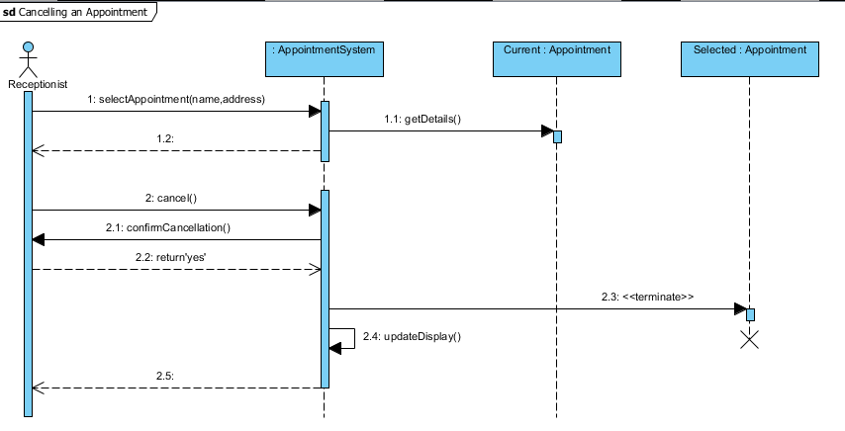

Making an Appointment for Existing Patient

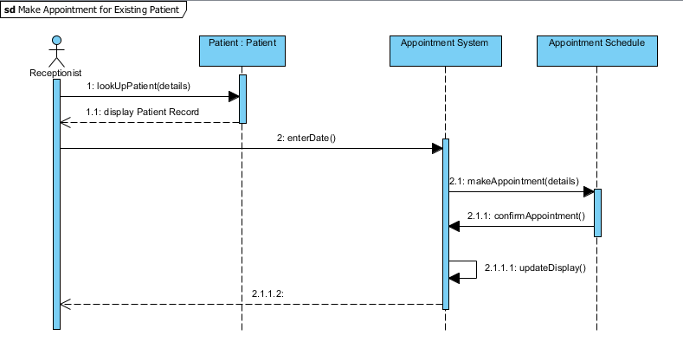

Making an Appointment for a NEW Patient

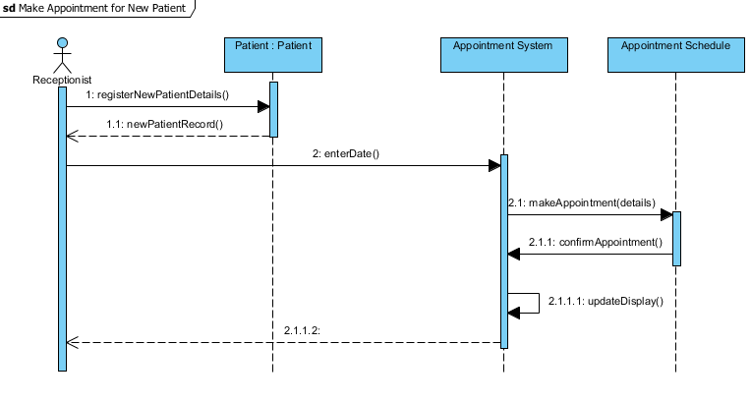
Issue Patient Appointment Reminder

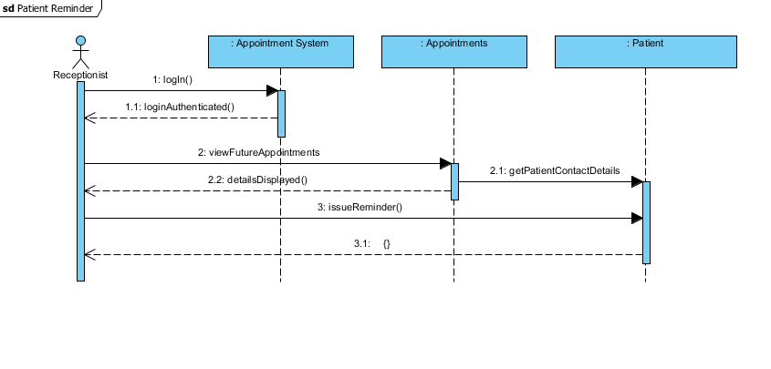

Changing an Appointment

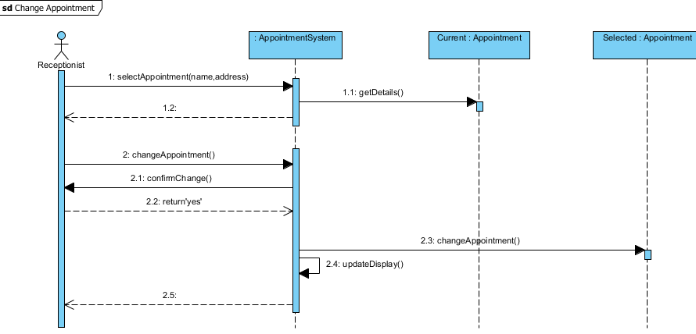

Managing Patient Medical Records

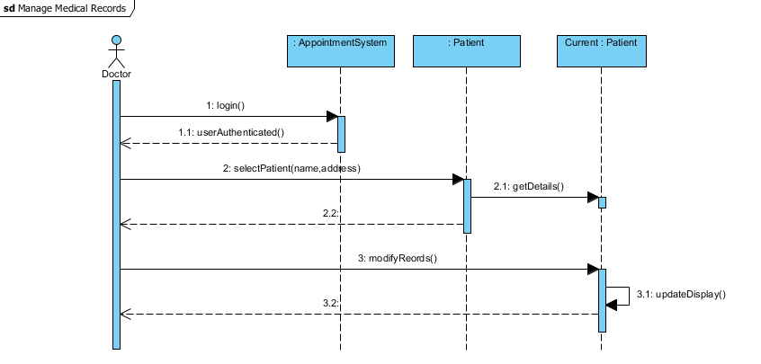

MedManage: State Machine Diagram

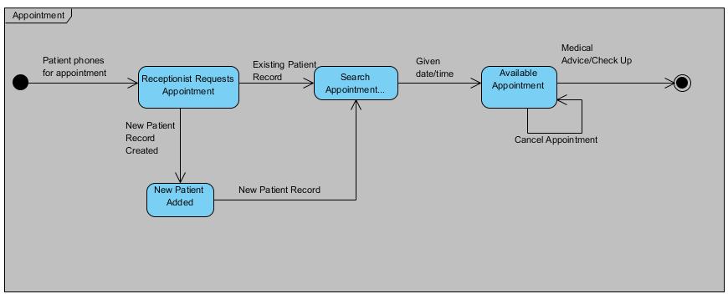

MedManage System – Prototype

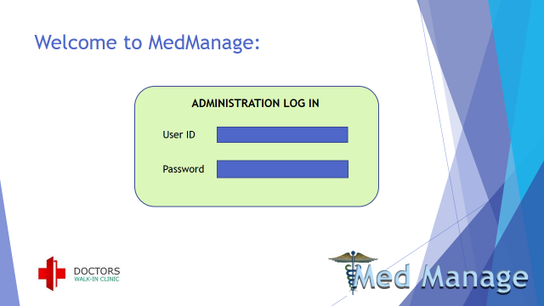

Receptionist’s view of system
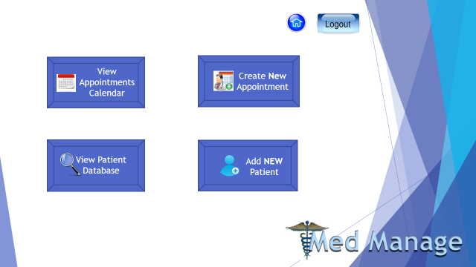
Adding a new patient to patient database
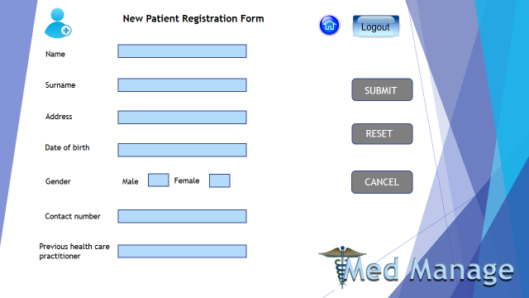

Appointments/Schedule Page
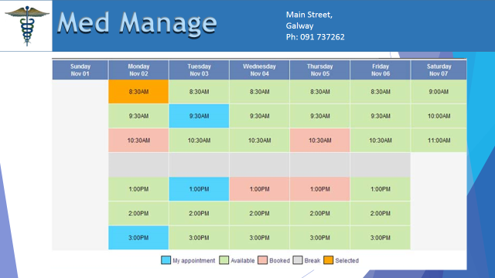

Patient Records (receptionist view – no medical records accessed)

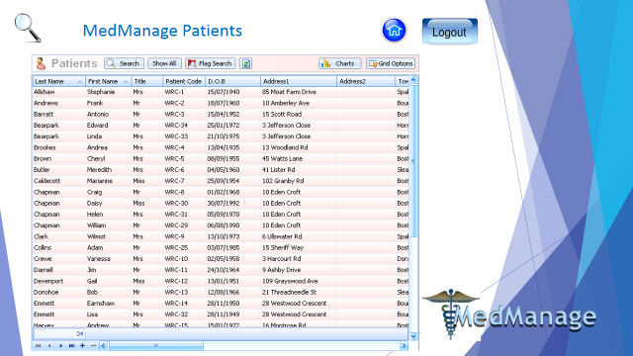

Doctor’s System Interface
-More extensive view of patient database - details and medical records

