Squaring a binomial & completing a square trinomial
By Don Cohen

We’ll show that (a+b)² = a² + 2ab + b² with the following pictures:

64 = 8² = (5+3)² (or some other combination of 8)

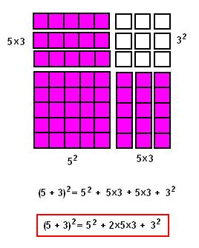

Can you make up another one like this with the squares?

How about (x + 4) ² , below

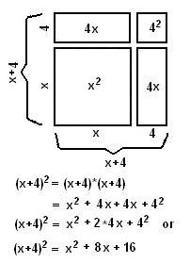

Fill in the 2 blanks to make this true: (x + _ ) ² = x² + 10x + _

What about (x + y ) ² =

