STELLAR CINEMAS
Website Planning & Documentation Report

  - Website objective and business goals
Stellar Cinemas is a multiplex cinema brand based in Gaborone, Botswana. The primary objective of this website is to serve as the official digital presence for the cinema, enabling customers to discover current and upcoming films, purchase tickets online, and engage with the brand's promotions and loyalty programmes without having to physically visit the box office.
According to studies, a well-defined website objective aligns directly with measurable business goals. For Stellar Cinemas, the website aims to achieve the following business goals:
- Increase Revenue: Drive online ticket sales by offering a seamless, end-to-end booking experience without requiring physical box-office visits.
- Improve Customer Information Access: Publish accurate, up-to-date screening schedules and movie listings to keep audiences informed and reduce missed showings.
- Strengthen Brand Identity: Position Stellar Cinemas as Botswana's premier cinema experience through consistent, premium branding that reflects the quality of the in-theatre experience.
- Enhance Customer Engagement: Allow customers to provide feedback and enquiries directly through the website, reducing call-centre load and improving responsiveness.
- Grow the Customer Database: Capture leads for loyalty programme sign-ups and promotional newsletters through the feedback and contact form.
  - Target Audience
The target audience for the Stellar Cinemas website is defined through demographic analysis and an understanding of digital behaviour among Botswana's urban population, particularly in Gaborone
Primary Audience
- Age Range & Location: Urban residents of Gaborone and surrounding areas, aged 16–35.
- Occupation: Predominantly students (secondary school, tertiary education) and young working professionals.
- Gender: Mix of male and female audiences; family groups are a secondary sub-segment for weekend screenings.
- Income Level: Lower-to-middle income earners; price-sensitive and responsive to promotional offers such as student discounts.
- Technical Aptitude: Moderate-to-high. Most users access the internet primarily via smartphones (Android is dominantly used in Botswana). Desktop use is secondary, common among office workers.
Secondary Audience
- Families: Families with children aged 5–12 seeking weekend entertainment
- Tourists: Tourism visitors to Gaborone seeking leisure activities.
1.3 Type of website content
The content categories are defined as follows:
- Movie Listings: Current and upcoming film listings with trailers, cast, genre tags, and age ratings.
- Online Booking & Feedback Form: An interactive booking/feedback form including seat availability.
- Promotions & Offers: Pricing, loyalty programme details, and special promotional offers.
- Location, Contact & About us: Branch location, opening hours, contact details, and a Google Maps embed.

2.1 Information design & taxonomy
Information architecture: The structure of the website adheres to the 3 clicks rules meaning that no page requires more than three clicks to reach from the homepage.
Site map
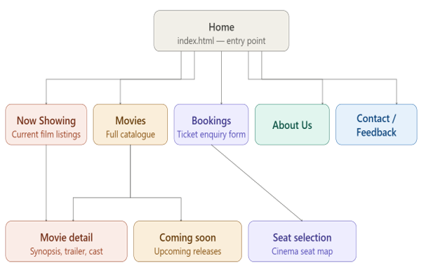
All five main pages are accessible from the global navigation bar present on every page. Sub-pages (Movie Details, Coming Soon, and Seat Selection) are accessed via contextual links within the relevant parent page content. The footer provides secondary navigation links to all primary pages.
3. Page template and design
To ensure uniformity, all pages will share the following structure:
- Shared Stylesheet: All pages use the same external CSS file for visual consistency.
- Footer: Three-column footer with site links, hours, and contact.
- Header: Fixed top navigation bar and logo.
4. Technical brief
The technologies and resources to be used in the development of the website include
Category | Tool / Technology | Purpose
Markup | HTML5 | Semantic structure of all web pages including forms, media elements, and accessibility attributes.
Styling | CSS3 | Custom external stylesheet for all visual design, animations, and responsive layout.
Scripting | JavaScript | Interactive behaviours: booking form validation, carousel controls, seat selection.
Code Editor | Visual Studio Code | Primary IDE with extensions: Live Server, Prettier, HTML CSS Support, GitHub integration.
Image Editing | Canva | Creating and editing logos, banners, poster artwork, icons, and promotional graphics.
Browser Testing | Chrome, Firefox, Edge, Opera | Cross-browser compatibility testing to ensure consistent rendering across all major browsers.
Validation | W3C Validator | Validating HTML5 and CSS3 code to ensure W3C standards compliance.

5. Quality assurance
6. Publishing & Promotion
7. Future developments or recommendations

