**Name, Last name: Tevfik Kesici**

**Student No: 20200808004**

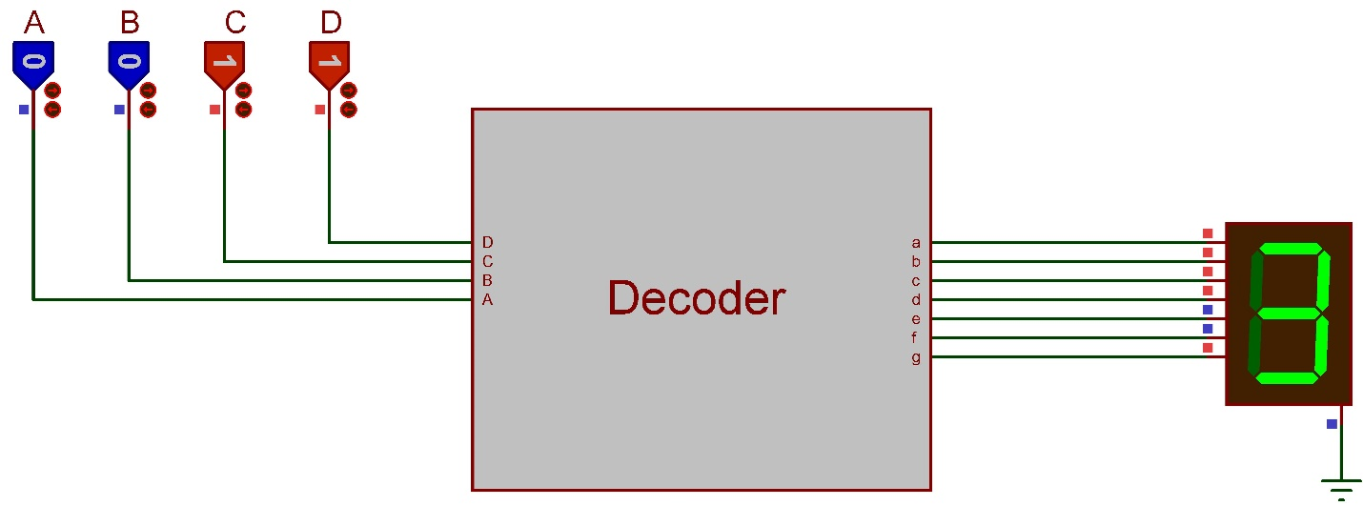

**LAB 08 Assignment**

Your task is to design a decoder circuit that runs a 7-segment display. The circuit must show the numbers from 0 to 9 that is controlled with 4-bit input (ABCD). The steps you should do as follows.

1. Fill the truth table in page 2.

2. Obtain the simplest Boolean function for each LED (a to g) of the 7-segment display using Karnough Map. (We did first 3 LED (a,b,c) in the Lab class). Fill the karnough maps in page 3 and write the functions you obtained to the last raw of each K-Map table. For each rectangle use different colors on the borders to make the table easy to understand (Example table is given in the first K-Map which is for Fa).

**PS: Upload first and second questions as single .pdf file.**

3. Finally, design the Boolean functions on Proteus Design Suite. (Use bridges/buses/jumpers!). Upload the project file.

**PS: Don’t forget to fill your name and student number on each page.**

**Name, Last name: Tevfik Kesici**

**Student No: 20200808004**

**Truth Table**

|  |  |  |  |  |  |  |  |  |  |  |  |
| --- | --- | --- | --- | --- | --- | --- | --- | --- | --- | --- | --- |
| **Digit** | **Inputs** | | | | **Outputs (Seven Segment Led Pins)** | | | | | | |
| **A** | **B** | **C** | **D** | **a** | **b** | **c** | **d** | **e** | **f** | **g** |
| **0** | 0 | 0 | 0 | 0 | 1 | 1 | 1 | 1 | 1 | 1 | 0 |
| **1** | 0 | 0 | 0 | 1 | 0 | 1 | 1 | 0 | 0 | 0 | 0 |
| **2** | 0 | 0 | 1 | 0 | 1 | 1 | 0 | 1 | 1 | 0 | 1 |
| **3** | 0 | 0 | 1 | 1 | 1 | 1 | 1 | 1 | 0 | 0 | 1 |
| **4** | 0 | 1 | 0 | 0 | 0 | 1 | 1 | 0 | 0 | 1 | 1 |
| **5** | 0 | 1 | 0 | 1 | 1 | 0 | 1 | 1 | 0 | 1 | 1 |
| **6** | 0 | 1 | 1 | 0 | 1 | 0 | 1 | 1 | 1 | 1 | 1 |
| **7** | 0 | 1 | 1 | 1 | 1 | 1 | 1 | 0 | 0 | 0 | 0 |
| **8** | 1 | 0 | 0 | 0 | 1 | 1 | 1 | 1 | 1 | 1 | 1 |
| **9** | 1 | 0 | 0 | 1 | 1 | 1 | 1 | 1 | 0 | 1 | 1 |

**Name, Last name: Tevfik Kesici**

**Student No: 20200808004**

|  |  |  |  |  |  |  |  |  |  |  |  |  |  |  |  |  |  |  |  |  |  |  |  |  |  |  |  |  |  |  |  |  |  |  |  |  |  |  |  |  |  |  |  |  |  |  |  |  |  |  |  |  |  |  |  |  |  |  |  |  |  |
| --- | --- | --- | --- | --- | --- | --- | --- | --- | --- | --- | --- | --- | --- | --- | --- | --- | --- | --- | --- | --- | --- | --- | --- | --- | --- | --- | --- | --- | --- | --- | --- | --- | --- | --- | --- | --- | --- | --- | --- | --- | --- | --- | --- | --- | --- | --- | --- | --- | --- | --- | --- | --- | --- | --- | --- | --- | --- | --- | --- | --- | --- |
| |  |  |  |  |  | | --- | --- | --- | --- | --- | | **CD**  **AB** | **00** | **01** | **11** | **10** | | **00** | **1** | **0** | **1** | **1** | | **01** | **0** | **1** | **1** | **1** | | **11** | **X** | **X** | **X** | **X** | | **10** | **1** | **1** | **X** | **X** | | **A + C + BD + B’D’** | | | | | | |  |  |  |  |  | | --- | --- | --- | --- | --- | | **CD**  **AB** | **00** | **01** | **11** | **10** | | **00** | **1** | **1** | **1** | **1** | | **01** | **1** | **0** | **1** | **0** | | **11** | **X** | **X** | **X** | **X** | | **10** | **1** | **1** | **X** | **X** | |  | | | | | |
| |  |  |  |  |  | | --- | --- | --- | --- | --- | | **CD**  **AB** | **00** | **01** | **11** | **10** | | **00** | **1** | **1** | **1** | **0** | | **01** | **1** | **1** | **1** | **1** | | **11** | **X** | **X** | **X** | **X** | | **10** | **1** | **1** | **X** | **X** | |  | | | | | | |  |  |  |  |  | | --- | --- | --- | --- | --- | | **CD**  **AB** | **00** | **01** | **11** | **10** | | **00** | **1** | **0** | **1** | **1** | | **01** | **0** | **1** | **0** | **1** | | **11** | **X** | **X** | **X** | **X** | | **10** | **1** | **1** | **X** | **X** | |  | | | | | |
| |  |  |  |  |  | | --- | --- | --- | --- | --- | | **CD**  **AB** | **00** | **01** | **11** | **10** | | **00** | **1** | **0** | **0** | **1** | | **01** | **0** | **0** | **0** | **1** | | **11** | **X** | **X** | **X** | **X** | | **10** | **1** | **0** | **X** | **X** | |  | | | | | | |  |  |  |  |  | | --- | --- | --- | --- | --- | | **CD**  **AB** | **00** | **01** | **11** | **10** | | **00** | **1** | **0** | **0** | **0** | | **01** | **1** | **1** | **0** | **1** | | **11** | **X** | **X** | **X** | **X** | | **10** | **1** | **1** | **X** | **X** | |  | | | | | |
| |  |  |  |  |  | | --- | --- | --- | --- | --- | | **CD**  **AB** | **00** | **01** | **11** | **10** | | **00** | **0** | **0** | **1** | **1** | | **01** | **1** | **1** | **0** | **1** | | **11** | **X** | **X** | **X** | **X** | | **10** | **1** | **1** | **X** | **X** | |  | | | | | |  |