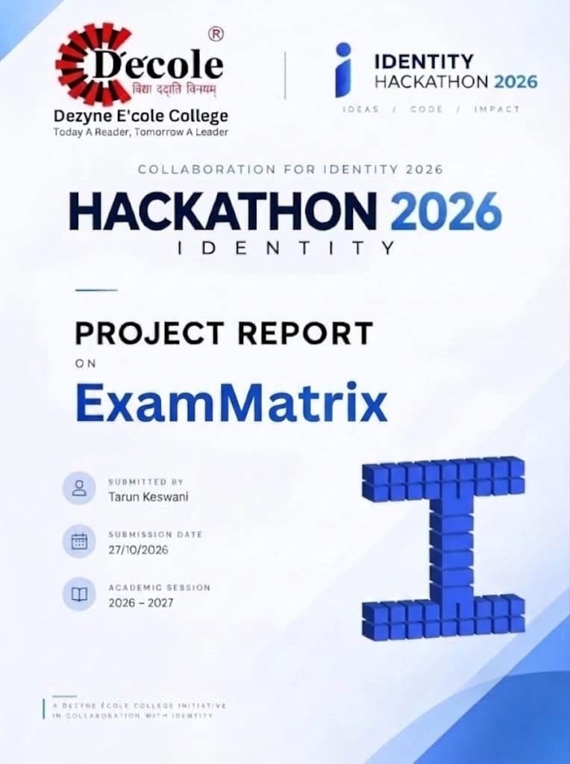

ExamMatrix – Project Execution Report
Project Overview
I built ExamMatrix, a full-stack web application designed to automate college exam scheduling and hall seat allocations. The system replaces manual paper notice boards with a searchable web portal where students can instantly look up their seat numbers and invigilators can manage hall timetables.

Technical Stack & Live Deployments
- Backend: Java 17, Spring Boot 3.2.5, Spring Data JPA, Hibernate, JUnit 5.

- Database: MySQL 8.0 hosted on Clever Cloud (secured via environment variables).

- Frontend: HTML5, CSS3, Vanilla JavaScript (ES6+ async/fetch API).

- Containerization & Cloud Hosting: Docker (Multi-stage build), Render (Backend API), Netlify (Frontend UI).

- Live Frontend: https://exammatrix.netlify.app

- Live Backend: https://exam-matrix.onrender.com

Core Work Executed
- Backend Architecture: Authored core domain entities (Exam, Student, HallAllocation) using OOP encapsulation principles. Created REST Controllers for CRUD operations and built Spring Data JPA repositories.

- Custom Exception Handling: Created custom handlers (ResourceNotFoundException, DatabaseConnectionException) to return structured HTTP status codes and clean error payloads.

- Frontend Integration: Developed a light-mode UI and wrote async fetch API functions to connect the interface with live Render endpoints.

- Deployment & Security: Configured Docker multi-stage builds on Render, enabled CORS for Netlify, and secured database credentials using environment variables.

- Unit Testing: Wrote automated tests using JUnit 5 and Mockito, verifying service logic via mvn test.

Future Enhancements
- Automated PDF Email Distribution: Integrate iText / Apache PDFBox with JavaMailSender to generate personalized PDF hall tickets and automatically email them to students upon seating finalization.

- Role-Based Access Control (RBAC): Implement Spring Security with JWT for Admin, Faculty, and Student access.

AI Use Declaration
AI Tool | What I asked it to do | What I wrote, changed, or checked myself
Gemini | Explain Spring Boot architecture, Maven setup, and REST API controller patterns. | Created project structure via Spring Initializr, selected dependencies, and authored Java entity classes.
Gemini | Troubleshoot HikariCP MySQL database connection errors and suggest JDBC URL parameter fixes. | Configured Clever Cloud MySQL database instance, verified remote permissions, and updated environment variables.
Gemini | Write and debug a multi-stage Dockerfile to fix cloud container compilation errors. | Fixed repository path structure, verified root directory configuration, and triggered continuous integration builds.
Gemini | Demonstrate JavaScript fetch() patterns using async/await for handling REST endpoints. | Built the user interface in HTML/CSS, wrote DOM manipulation logic, and implemented loading/error states.
Declaration: I confirm that this entry is my own work, that every AI tool used is listed above, and that I can explain every part of the submitted code.

Name: Tarun Keswani
Date: October 27, 2026

