The Impact of Variable Leakage Rates on OE Ratios a Logistic Simulation

**Generates** Two variables: **y** the response variable and **x** a single risk factor. Four hospital sets of 1,000 cases each are generated with varying leakage rates of 0%, 10%,20% and 40%.  
**Parameters** (set by user)  
- q: Prevalence of outcome **y**  
- p: Prevalence of single risk factor **x**  
- rho: Spearman rank correlation. rho is used to set the strength of association of y with x. The higher the abs(rho), the higher the ROC for glm(y ~ x,family = binomial(link=‘logit’))  
- Four hospital sets of 1,000 cases generated with varying leakage rates% (0,10,20,40)

plot(cars)

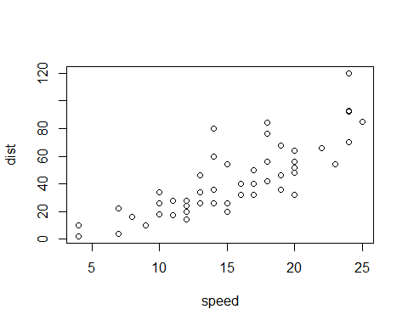

Add a new chunk by clicking the *Insert Chunk* button on the toolbar or by pressing *Ctrl+Alt+I*.

When you save the notebook, an HTML file containing the code and output will be saved alongside it (click the *Preview* button or press *Ctrl+Shift+K* to preview the HTML file).

The preview shows you a rendered HTML copy of the contents of the editor. Consequently, unlike *Knit*, *Preview* does not run any R code chunks. Instead, the output of the chunk when it was last run in the editor is displayed.