Student.java
package com.TestJPA.TestJPA;

//imports

@Entity
@Table(name="student")
public class Student {

@Id
@GeneratedValue(strategy = GenerationType.SEQUENCE)
int id;

int totalmarks;

String usn,name, address;

/// setter and getter methods
@Override
public String toString() {
return "Student [id=" + id + ", totalmarks=" + totalmarks + ", usn=" + usn + ", name=" + name + ", address="
+ address + "]";
}
}

StudentMain.java

package com.TestJPA.TestJPA;

//imports

@SpringBootApplication
public class StudentMain {
public static void main(String[] args) {
SpringApplication.run(StudentMain.class, args);
}
}

StudentRepo.java //Internship

package com.TestJPA.TestJPA;

import org.springframework.data.jpa.repository.JpaRepository;

public interface StudentRepo extends JpaRepository<Student, Integer> {

}

StudentService.java
package com.TestJPA.TestJPA;

import java.util.List;
import java.util.Optional;

import org.springframework.beans.factory.annotation.Autowired;
import org.springframework.stereotype.Service;

@Service
public class StudentService {

@Autowired
StudentRepo sr;

public void insertStudent(String name,String address,String usn,int totalmarks) {
Student s = new Student();
s.setAddress(address);
s.setTotalmarks(totalmarks);
s.setName(name);
s.setUsn(usn);
sr.save(s);
}

public List<Student> display(){
return sr.findAll();
}

public void remove(int id) {
// TODO Auto-generated method stub
Optional<Student> s =sr.findById(id);
if(s.isPresent()){
sr.deleteById(id);
}else {
System.out.println("not found by id"+id);
}
}
}

StudentWeb.java

package com.TestJPA.TestJPA;

import java.util.List;

//imports

@RestController
@RequestMapping("/student")
public class StudentWeb {
@Autowired
StudentService ss;

@GetMapping("/get")
public List<Student> display(){
return ss.display();
}

@PostMapping("/post")
public void insertStudent(@RequestBody Student s) {
ss.insertStudent(s.getName(),s.getAddress(),s.getUsn(),s.getTotalmarks());
System.out.println(" inserted successfully");
}

@DeleteMapping("/{id}")
public void deleteStudent(@PathVariable int id ) {
ss.remove(id);
}
}

application.properties:

spring.datasource.url=jdbc:mysql://localhost:3306/student
spring.datasource.driverClassName=com.mysql.cj.jdbc.Driver
spring.datasource.username=root
spring.datasource.password=rvce
spring.jpa.show-sql: true
spring.jpa.hibernate.ddl-auto=update

Install the maven packages in the system:
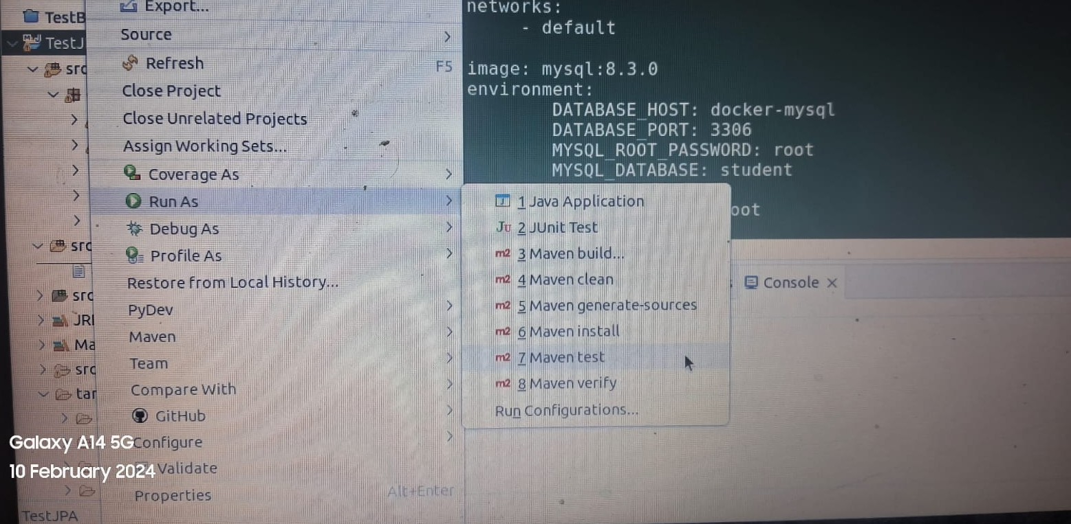

Dockerfile

FROM openjdk:17-alpine
WORKDIR /opt
ENV PORT 8080
EXPOSE 8080
COPY /target/*.jar /opt/app.jar
ENTRYPOINT exec java $JAVA_OPTS -jar app.jar

#Build a docker image
$docker build --build-arg JAR_FILE=target/*.jar -t myorg/myapp .

Docker-compose.yml

version: "3.8"

services:
app:
image: 36ae1c6419be393b408fec0ee86e5b2539e7ba018b1d9c581bdfa7f63c381c3f
ports:
- 8080:8080
environment:
spring.datasource.url: jdbc:mysql://db:3306/student
spring.datasource.driverClassName: com.mysql.cj.jdbc.Driver
spring.datasource.username: admin
spring.datasource.password: root
depends_on:
- db
networks:
- default
db:
image: mysql
environment:
DATABASE_HOST: docker-mysql
DATABASE_PORT: 3306
MYSQL_ROOT_PASSWORD: root
MYSQL_DATABASE: student
MYSQL_USER: admin
MYSQL_PASSWORD: root
networks:
- default

>>docker-compose up
