**FOURTH INCREMENT**

**Submitted by**

**Konireddy, Tirumala Reddy**

**Nalluri,Chaitanya**

**Vintha, DIvya Sree**

**Arimanda, Syamala Reddy**

**Project Goal and Objectives**

**Motivation**

As the population ages the disability is increasing day by day.Currently about 10 percent of the families are living with disability which is roughly around 650 million and about 20 percent of the worlds population is having the same kind of disability and statistics show a steady increase in these numbers.



This motivated us to help those people with disability and to make their daily life easy.To achieve that we have developed an Android app in the mobile device using a TI sensor tag**.**

**Significance**

Our project is mainly designed using a Texas Instrument sensor tag and an Android app which is very helpful for the physically challenged people to convey their emotions using the gestures easily to the concerned persons and provides some fun through the games.Our main motto is to develop an application which provides relaxation to the disabled and parallely to have a gesture alert system.

It is hard for a vision challenged person to convey the message to a person whoever concerned i.e., his care taker or an incharge of his nutrition that he is hungry or feeling thirsty and if he is in any kind of emergency.This can be made easy by our application using an accelerometer and a sensor tag.

**Objectives**

* Email or text alert service for the caretakers of disabled people when he is feeling thirsty or hungry.
* An emergency alert system which directly sends message to the concerned person if the person needs help.
* Physical Trainer service helping the disabled people to be fit.
* Sickness Alerts to Care Taker’s and Doctor’s.
* Fun activities for Mental relief and Entertainment.

**System Features**

* We are providing a Alert service to Care taker’s of visually challenged people by motion gestures related to feeling hunger, need some water, power short circuit etc., through mails or text messages.

 

* We also provide a physical trainer application which recommends and instructs some fitness programs based on their Body Mass Index. At the end of the workouts session we will provide him a feedback about his exercise.

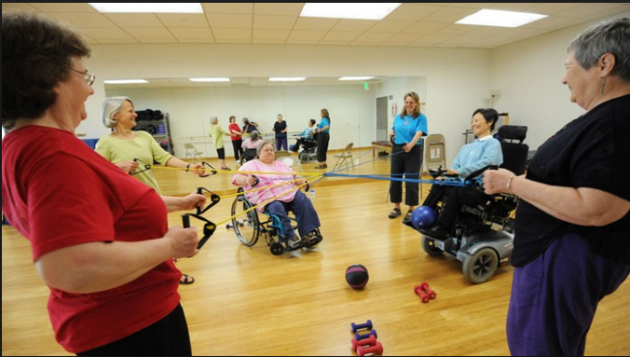

* We are providing a sickness alert service to physician and doctor in charge regarding the person using temperature sensor.



* We are also providing some entertainment with fun activities for a visually challenged person using TI sensor.

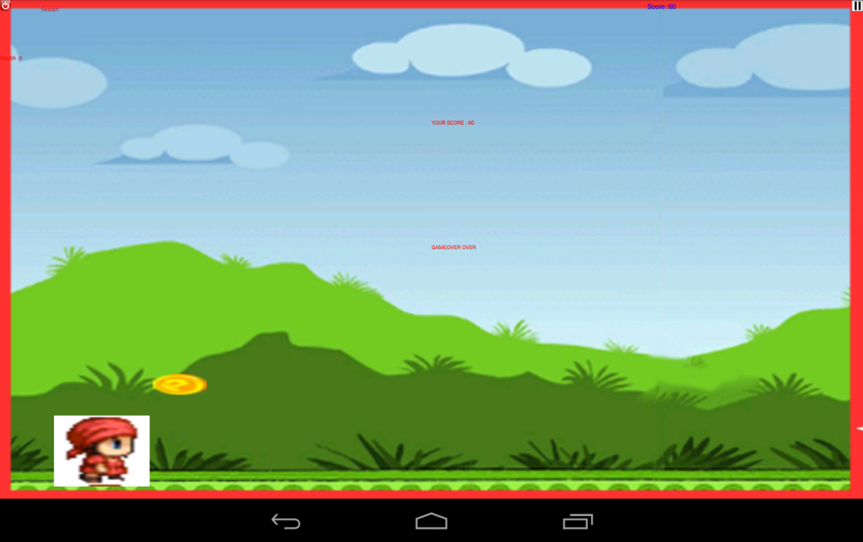

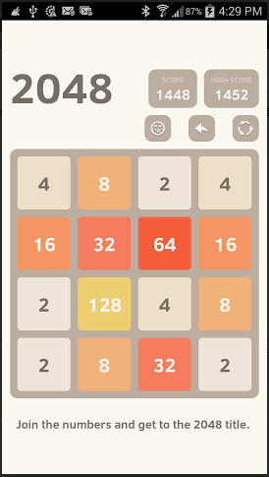

**System Architecture:**

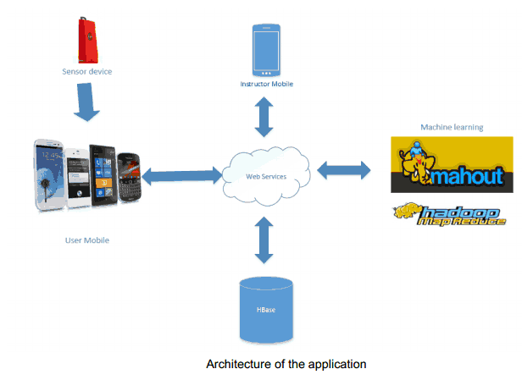

Online Application: Game by Motion

**Devices/Sensors**

**BLE sensor tag,mobile-gps service tag**

The CC2541 Sensor tag developed by Texas Instruments is used to detect and listen the gestures given by the persons which are required for the Application.This device is capable of detecting and sending the data related to the senses and they are described below

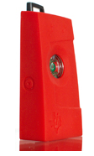

* The IR temperature Sensor embedded in it is used to measure the temperature values.
* The humidity factor in the environment is detected by the Humidity Sensor**.**
* The pressure control points are detected by the pressure sensor.
* This device also supports accelerometer data depending on the weight factor experienced by the sensor.
* The Gyroscope feature of this device measures the orientation based on principles of angular momentum.
* The Magnetometer in this device is used to sense the magnetic field and its strength in the surroundings.

Thus, [CC2541](http://www.ti.com/product/cc2541) Sensor Tag is the first Bluetooth Smart development kit focused on wireless sensor applications and it is the only development kit targeted for smartphone app developers making Bluetooth low energy app development easier and faster,including temperature sensor, humidity sensor, pressure sensor, accelerometer, gyroscope and magnetometer.

**Motion Models**

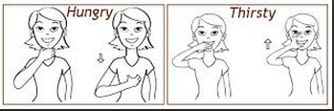

In our project we have taken three different motions to represent the required gestures. .Description of each gesture is given below.

Hungry: For this gesture,we’ve given an expression using single hand motion according to the x and z axes.

Thirsty: For this gesture, we’ve given a flatened L alphabet motion captured in 3D plane.

Game: For the game gesture, we have taken a regular top down motion gesture with pressure which seems to be like a stomp with the hand.

**Game Logic/Features**

**2048 game and got to run:**

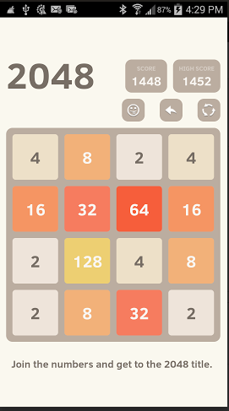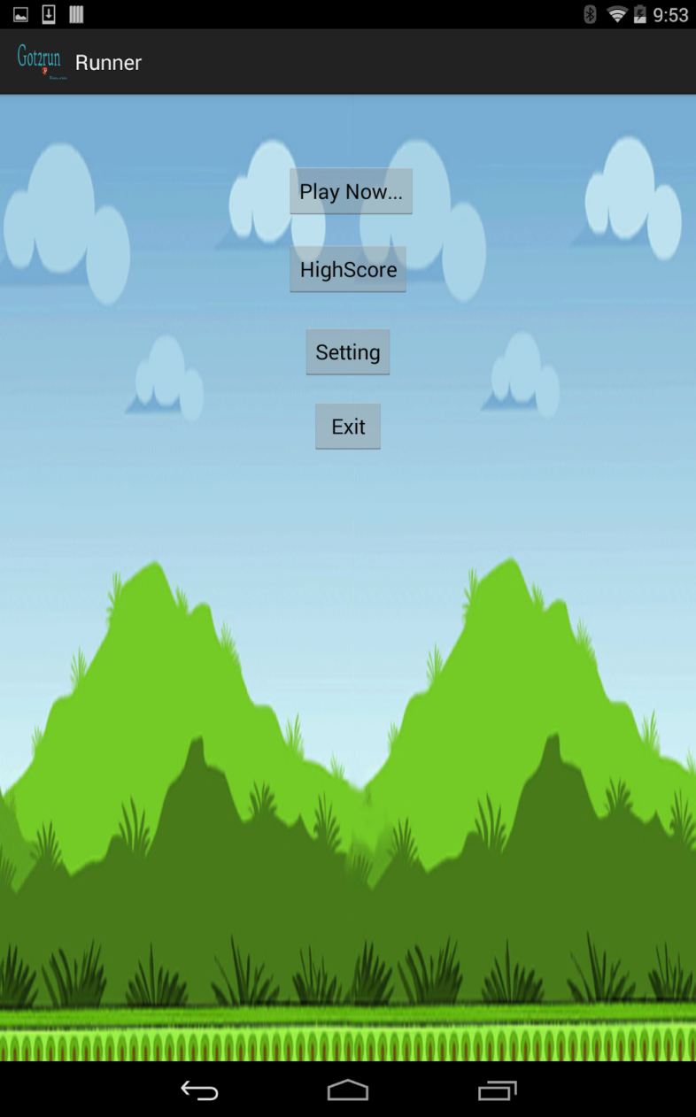

We have imported 2048 and got to run game from the internet resources and tried e the ontouch event with the accelerometer data from the BLE Sensor Tag.These android games runs in the eclipse platform which is compatible with all the screen resolutions.We have given motion control to open the game and also motion control for playing the game.

**Recognition/Analysis Approaches (Workflow, Algorithms, Input/Outputs)**

* The Accelerometer and Gyroscope data is collected from BLE Sensor as a text file with tab seperation.
* We are generating a sequential file to eliminate the noise and the idle state data collected from sensor tag.
* Then, we are training the classifier with the sequential files for each action. For our project we had trained three gestures till now.

1. Pat on stomach - To notify the Care taker that the user is Hungry.

2. Flattened L alphabet - To notify the Care taker that the user is Thirsty.

3. Top down motion of hand - To activate and play games.

* Here, we are using open source games Got2run and 2048 games for our Application
* This sensor text files are uploaded into the HBase using a web Service.
* We are also looking towards training the classifier using Wiigee library now.
* Machine learning algorithms of R / Mahout uses the data in Hbase for providing Alert services and Physical trainer services fro Accelerometer and Temperature data.
* We use HMMM Motion recognition algorithm to detect the required motions given by user upon a training set of three gestures

**System Features and Android App GUI (screen captures)**

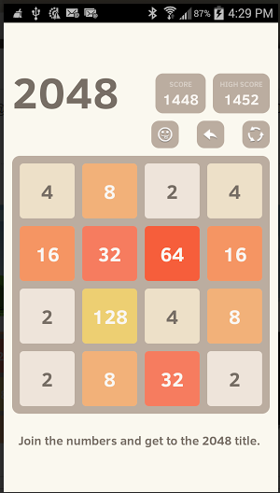

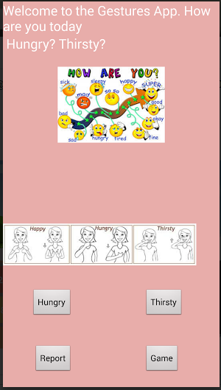

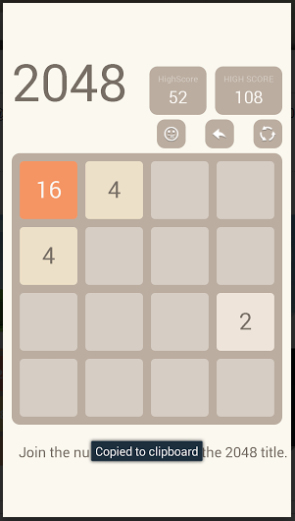



**Offline Application: Activity Report**

**Devices/Sensors**

We have started developing our project in an android application and the dynamic data is being generated making changes with the library AchartEngine and a [CC2541](http://www.ti.com/product/cc2541) Sensor Tag is the first Bluetooth Smart development kit focused on wireless sensor applications and it is the only development kit targeted for smartphone app developers making Bluetooth low energy app development easier and faster,including temperature sensor, humidity sensor, pressure sensor, accelerometer, gyroscope and magnetometer.

**Activity Models**

**An open source code is imported under the name of AchartEngine**

**.Version 0.2.0 was launched which is the first open-source charting library for Android. At that time, Android SDK was at version 1.1.It is a charting library which supports line chart,area chart,scatter chart,time chart,pie chart etc and can be displayed with the X axis horizontally or vertically and support many other custom features.They can be added to any group inorder to view and can be used to start an activity.**

**Features**

* **This model and the graphing code is well optimized such as it can handle and display huge number of values.**
* **There are three main types of charts supported by AChartEngine:**
* **XY charts display the data on the 2 axes**
* **Round chart display the data using pie diagrams**
* **Combined chart is used ti display the combination of both the XY charts.**

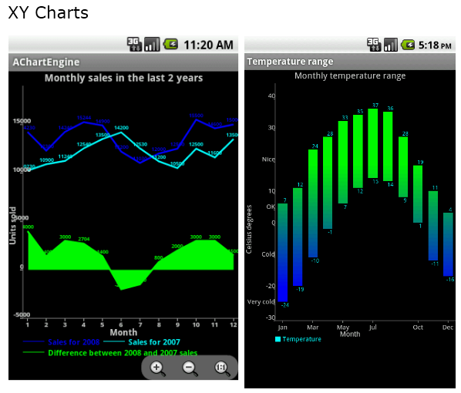

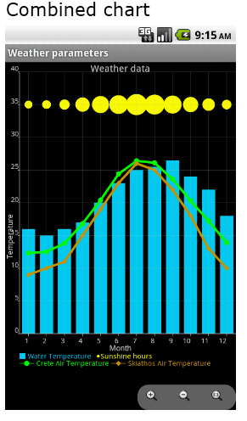

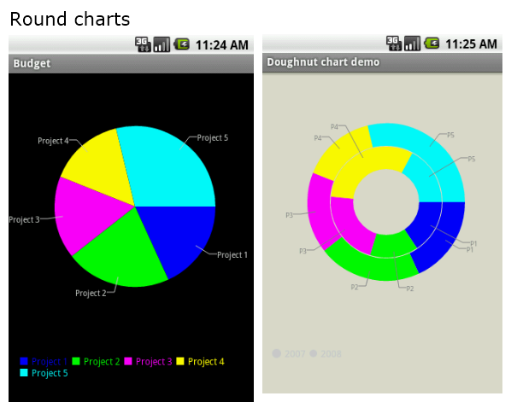

**Recognition/Analysis Approaches (Workflow, Algorithms, Input/Outputs)**

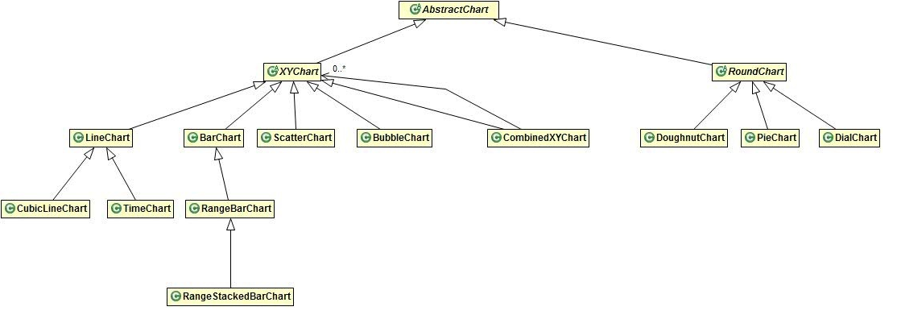

* **The AbstractChart class describes behavior that is shared by all charts, including drawing background, legend, titles,...**
* **The XYChart class describes state and behavior that is common to the XY chart types like the rendering of axes, labels,...**
* **The RoundChart is similar to XYChart, but for the chart types that have a circular shape.**

**System Features – Software Architecture, HBase Design and Android App GUI (screen**

**captures)**

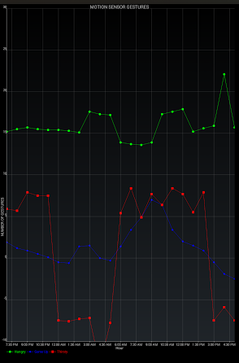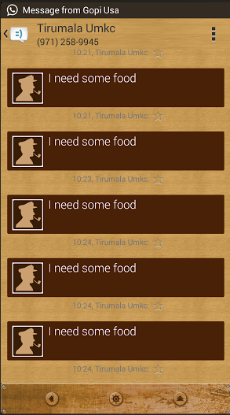

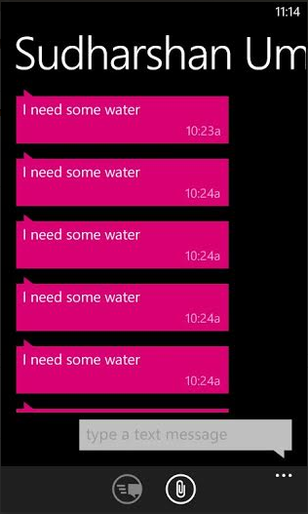

**Evaluation: Motion/Activity Recognition**

**Number of Users**

**Types of Motions/Activitieso Size of data, Number of Gestures**

**Each gesture is tested for about 25 times.**

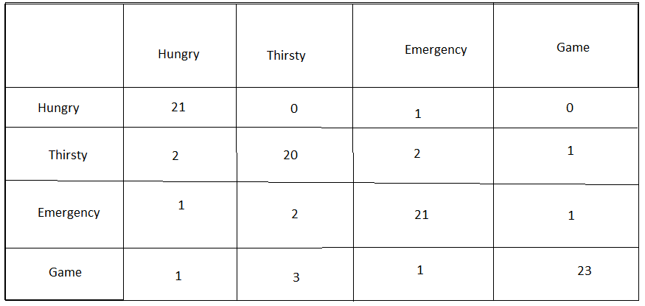

**Data Preparation (e.g., Cross Validation)**

**Accuracy – Precision/Recall/F-Measure**

**Hungry gesture**

**Accuracy=(TP+TN)/ALL**

**=21+74/100**

**=95/100**

**=0.95**

**Error rate=1-Accuracy**

**=1-0.95**

**=0.05**

**Sensitivity=TP/P**

**= 21/25**

**=0.84**

**Specificity=TN/N**

**=74/75**

**=0.986667**

**Precision=TP/TP+FP**

**=21/21+1**

**=0.9545**

**Recall=TP/TP+FN**

**=21/21+4**

**=21/25**

**=0.84**

**F-measure=2*precision*recall/precision+recall**

**=0.89359**

**Thirsty gesture**

**Accuracy=(TP+TN)/ALL**

**=20+70/100**

**=90/100**

**=0.9**

**Error rate=1-Accuracy**

**=1-0.9**

**=0.1**

**Sensitivity=TP/P**

**= 20/25**

**=0.8**

**Specificity=TN/N**

**=70/75**

**=0.9333**

**Precision=TP/TP+FP**

**=20/20+5**

**=0.8**

**Recall=TP/TP+FN**

**=20/20+5**

**=20/25**

**=0.8**

**F-measure=2*precision*recall/precision+recall**

**=0.8**

**Emergency gesture**

**Accuracy=(TP+TN)/ALL**

**=21+71/100**

**=92/100**

**=0.92**

**Error rate=1-Accuracy**

**=1-0.92**

**=0.08**

**Sensitivity=TP/P**

**= 21/25**

**=0.84**

**Specificity=TN/N**

**=71/75**

**=0.94667**

**Precision=TP/TP+FP**

**=21/21+4**

**=0.84**

**Recall=TP/TP+FN**

**=21/21+4**

**=21/25**

**=0.84**

**F-measure=2*precision*recall/precision+recall**

**=0.84**

**Game Gesture:**

**Accuracy=(TP+TN)/ALL**

**=23+70/100**

**=93/100**

**=0.93**

**Error rate=1-Accuracy**

**=1-0.93**

**=0.07**

**Sensitivity=TP/P**

**= 23/25**

**=0.92**

**Specificity=TN/N**

**=70/75**

**=0.9333**

**Precision=TP/TP+FP**

**=23/23+2**

**=0.92**

**Recall=TP/TP+FN**

**=23/23+2**

**=23/25**

**=0.8214**

**F-measure=2*precision*recall/precision+recall**

**=0.86790**

**Limitations**

**Related Work:**

Many speech to text applications are available to store the notes or messages. Our application takes the input using gestures and alerts the trainer with their requirement.

https://play.google.com/store/apps/details?id=com.khymaera.android.listnotefree

The temperature sensor application gives the readings of temperature in specified scales. Our application alerts the user for any unusual temperatures of the user.

https://play.google.com/store/apps/details?id=com.dexterltd.temprature_sensor_lite

**References:**

<http://www.ti.com/tool/cc2541dk-sensor?keyMatch=cc2541%20sensor%20tag&tisearch=Search-EN#descriptionArea>

<http://en.wikipedia.org/wiki/Gyroscope>

<http://en.wikipedia.org/wiki/Magnetometer>

<http://en.wikipedia.org/wiki/Accelerometer>

<https://play.google.com/store/apps/details?id=com.dexterltd.temprature_sensor_lite>

<https://play.google.com/store/apps/details?id=com.khymaera.android.listnotefree>

<http://www.gosphero.com/games/>

<http://www.zwodnik.com/list/android/free-and-open-source-games-for-android/>

<https://play.google.com/store/apps/details?id=com.beatsportable.beats>

<https://github.com/search?q=android+game+dance&type=Repositories&ref=searchresults>

<https://github.com/xtbl/android_kids_world_animals>

<https://github.com/search?q=android+touch+game&ref=cmdform>