

Hackathon report

Watch while Eat application



April 7, 2014

Student name : Tirumala Reddy Konireddy

STUDENT ID : 16174347

# Application Goal and Objectives

## Motivation

We will apply data mining and machine learning tools and techniques to build an intelligent app for recommending videos/movies while you eat.

## Objectives

The primary objective of this app is to integrate the public’s interest in Movies/videos with the food they had. With the type of food the people had, we aim to offer recommendation services to users. A user should be able to sort, and read Movie recommendations based on the food he wish to have. Registered users should be able to subscribe and receive recommendations based on their stored preferences.

## Significance

Thanks to technology, everyone is able to watch a movie while having food. It’s good, if we will be provide some nice recommendation of movies at that time with minimum search.

**Design and Model:**

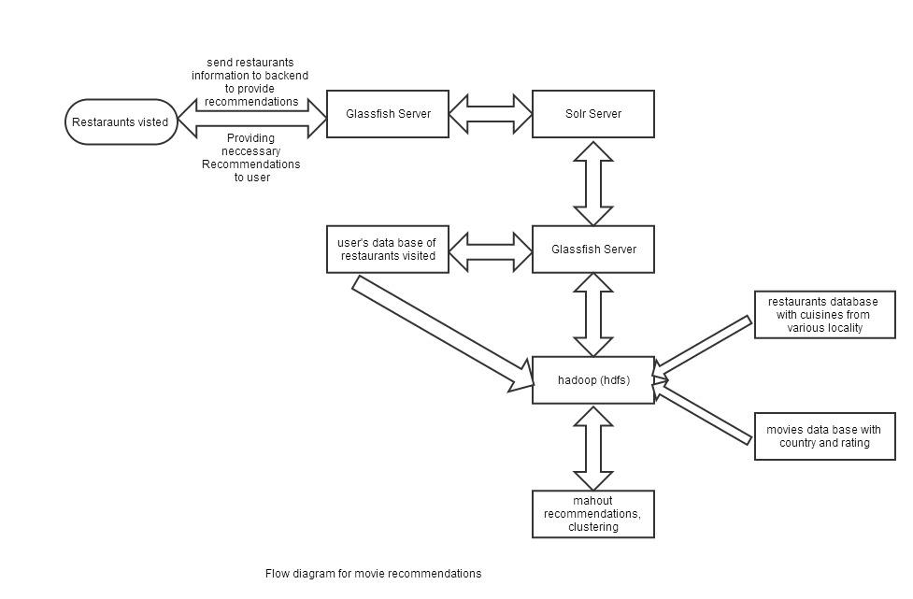

**Work Flow diagram for Watch while eat application**

## System Architecture Diagram

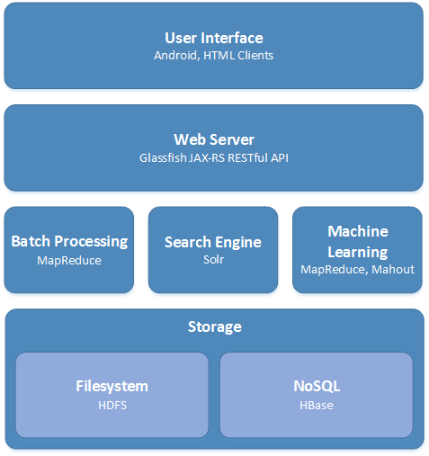

**System Architecture Diagram**

**Data Model:**

I am using restaurants data containing restaurant id, restaurant name and location (or) country specific cuisines offered by the restaurant. Here, I am assuming that if a user went to a restaurant offering some nice Indian food, He may be an Indian and he is interested in Indian films. Based on this, we can judge the user’s nationality and interest. Providing nice recommendation of movies based on the country will ease the user to search for a movie or a video.

**Features:**

Here, we are providing recommendations for both movies and restaurants based on the restaurants the user frequently visits.

**Data:**

**Restaurant data base:**

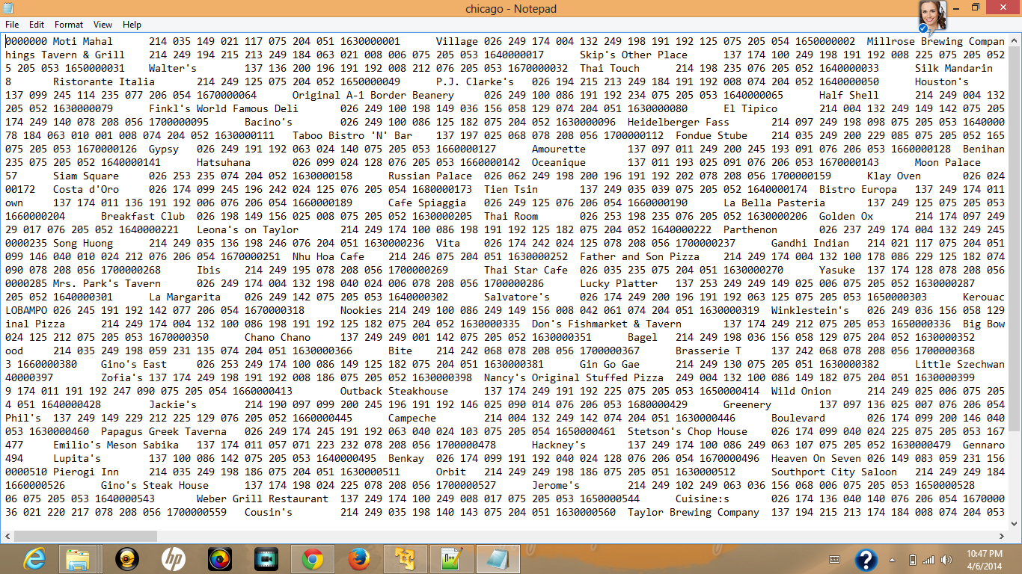

**Restaurants data base containing restaurant id, restaurant name and the special cuisines offered by them**

From the above txt data with tab separation between every two columns, I am clustering the restaurants into some groups based based on the cuisines offered by every restaurant which are provided in 3rd column of above data.

**Movie data base:**

The movie data base contains the nationality of movie, movie name and the genre of the movie. Here, I do grouping of movies based on the nationality and the genre of the movie. Here, I have more than one genre for each movie. Inorder to do clustering i had done split the entire genre combination into individual genres. Then , i had developed a algorithm to do group of movies based on the genres and country. I recommend the movies here based on the restaurant the user wished and the movie genres that the user had watched previously.

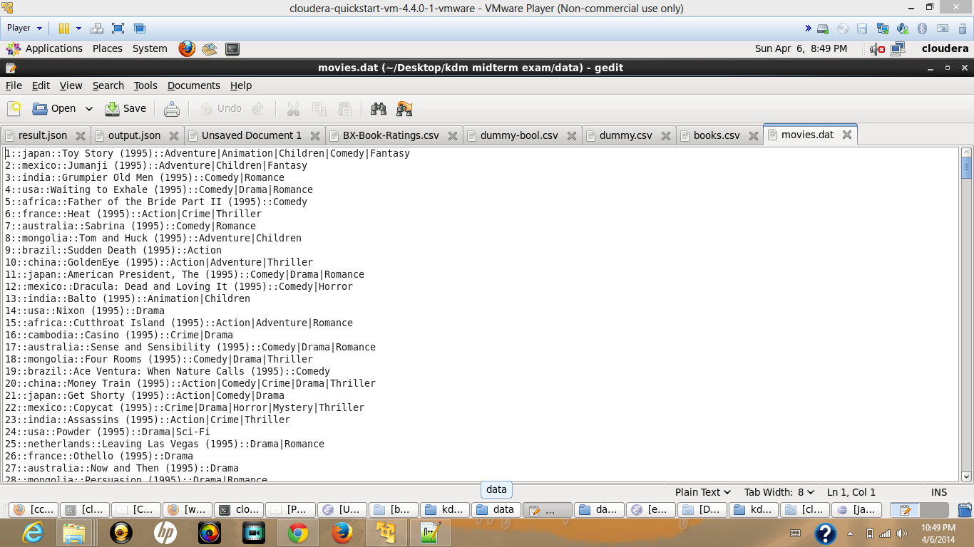

**Movies data base containing movie id, movie nation, movie name and the genre of movie.**

For more details, Please, find my dataset files in github url : [**https://github.com/tkhgf/kdm_midtermexam**](https://github.com/tkhgf/kdm_midtermexam)

**Implementation:**

**Predictive and Selection Algorithm:**

**1. Clustering :**

I am assuming if a user went to a restaurant offering some nice Indian food, He may be an Indian and he is interested in Indian films. Based on this, we can judge the user’s nationality and interest. Providing nice recommendation of movies based on the country will ease the user to search for a movie or a video.

**Algorithm for Restaurant data :**

1. First, I had done considered the cuisine id’s offered by each restaurant.

2. Then, I used K means clustering algorithm for grouping the restaurants which are offering same type of cuisines.

3. From, I get groups of similar restaurants here and I had written the results to a file which i had used for providing recommendations.

**Algorithm for Movies data :**

1. First, I had done considered the a combination of genres of the movie.

2. I do split the whole genre into individual splits like Action, Adventure, Comedy etc.,

3. Then , I do K means clustering algorithm using nationality and genres of the movie .

3. From, I get groups of similar movies here and I had written the results to a file which i had used for providing movie recommendations based on the restaurant user visited.

**Recommendation Algorithm:**

1. Here, I am considering both the movie clusters and Restaurant clusters.

2. First, I look for the restaurant clusters to which group the user wished.

3. Based on the restaurant cluster, I detect the user’s preference of nationality.

4. I also looked for the movies that the user had previously watched if any.

5. Using the movie clusters , i will get the user preference of genre.

6. Based on the user’s preference of both nation and genre i recommend movies that user may wish to watch and which are not previously viewed by User.

7. I will also provide restaurant recommendations by the preference of cuisines using restaurant clusters.

**Mobile App Design:**

Here, I had used a drop down menu for choosing the nationality of user’s wish. Based on this I am retreive the movie and restaurant recommendations from the solr server.

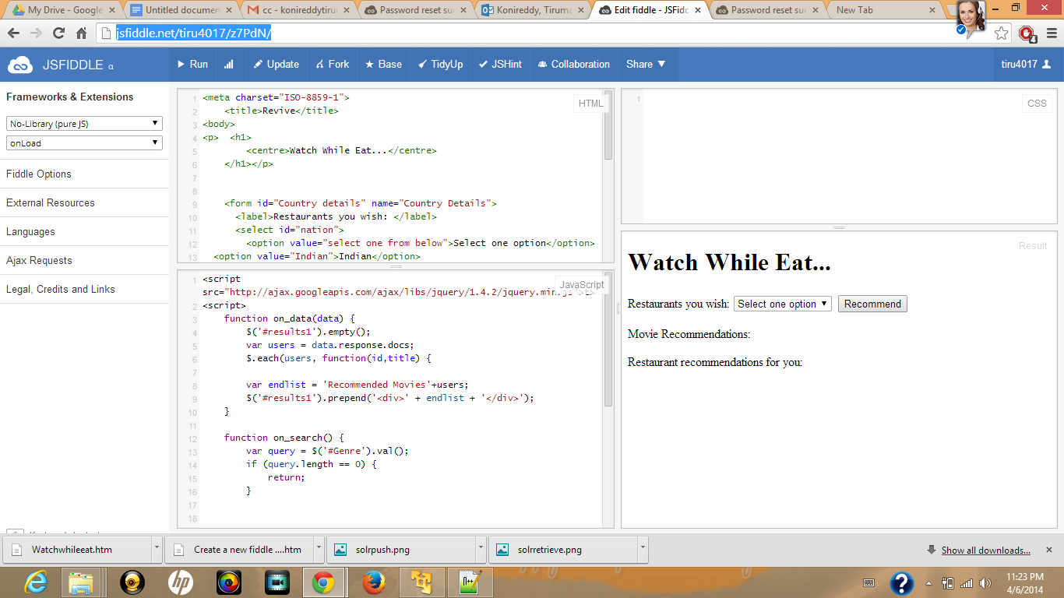

**Web App Design**

**Output :**

**Clustering Output results:**

I had done implemented the Clustering algorithm using java project.

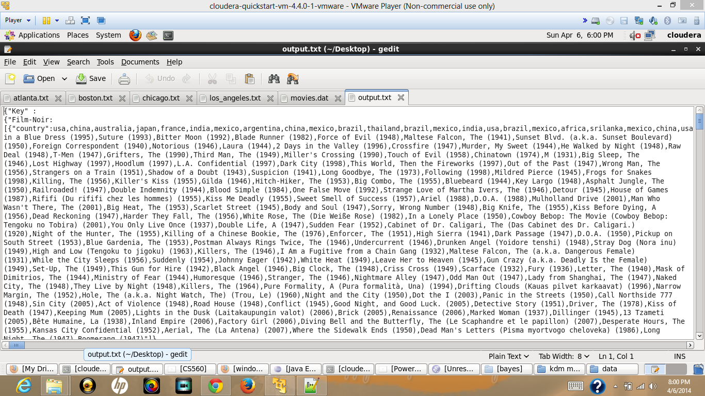

**Cluster of movie data based on genre and country**

**Recommendation Output:**

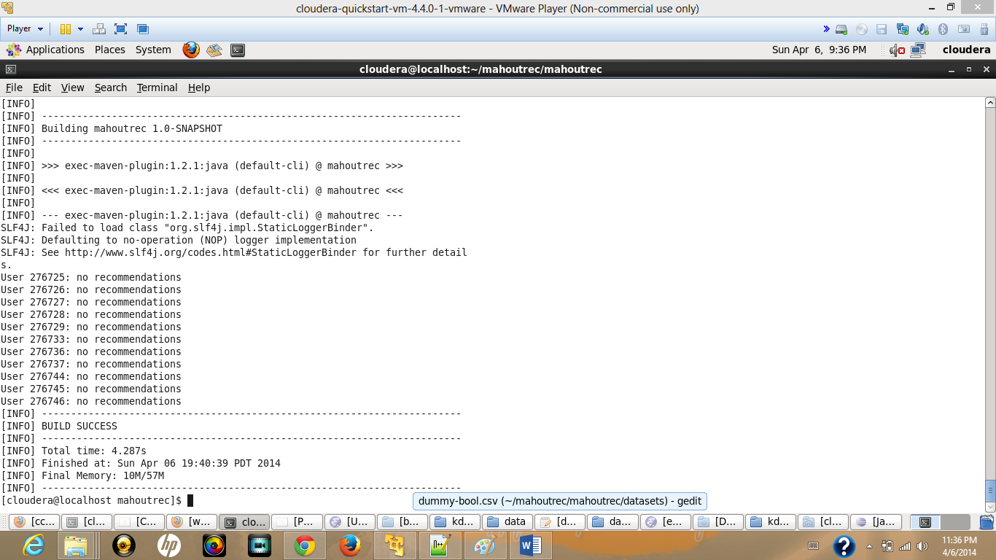

**Pushing Output Results to Solr:**

I had written the clustering results in json format using java program. Then, i had uploaded a part of my results to solr server in group6 as it is not able to upload all my data.

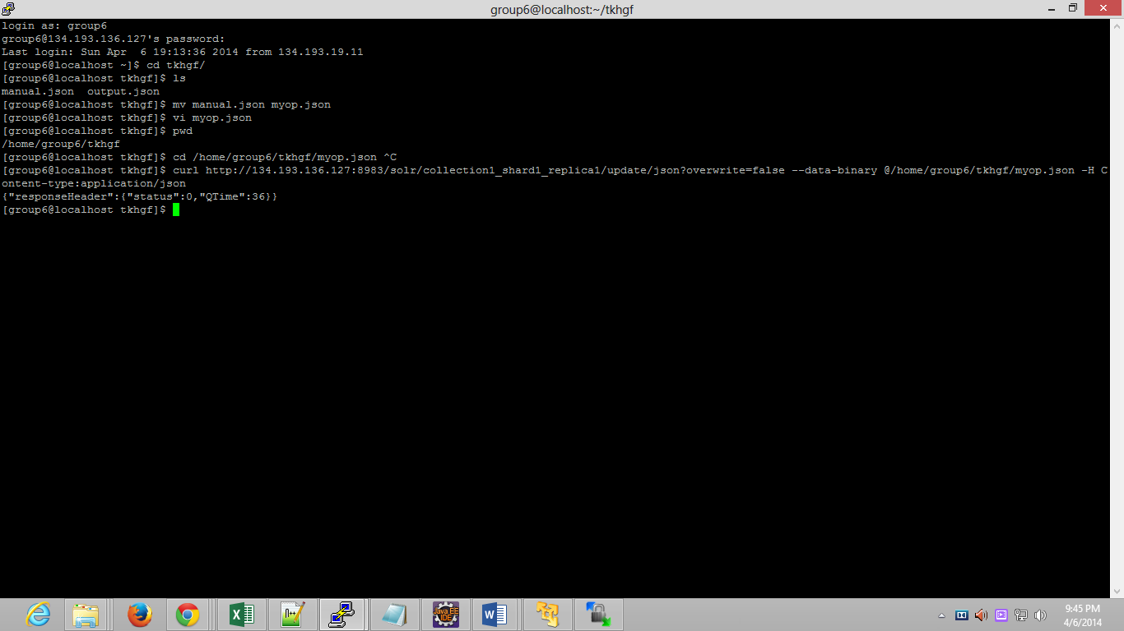

**Solr uploading**

**Solr retrieving:**

I had verified the data that pushed to solr server in the browser.

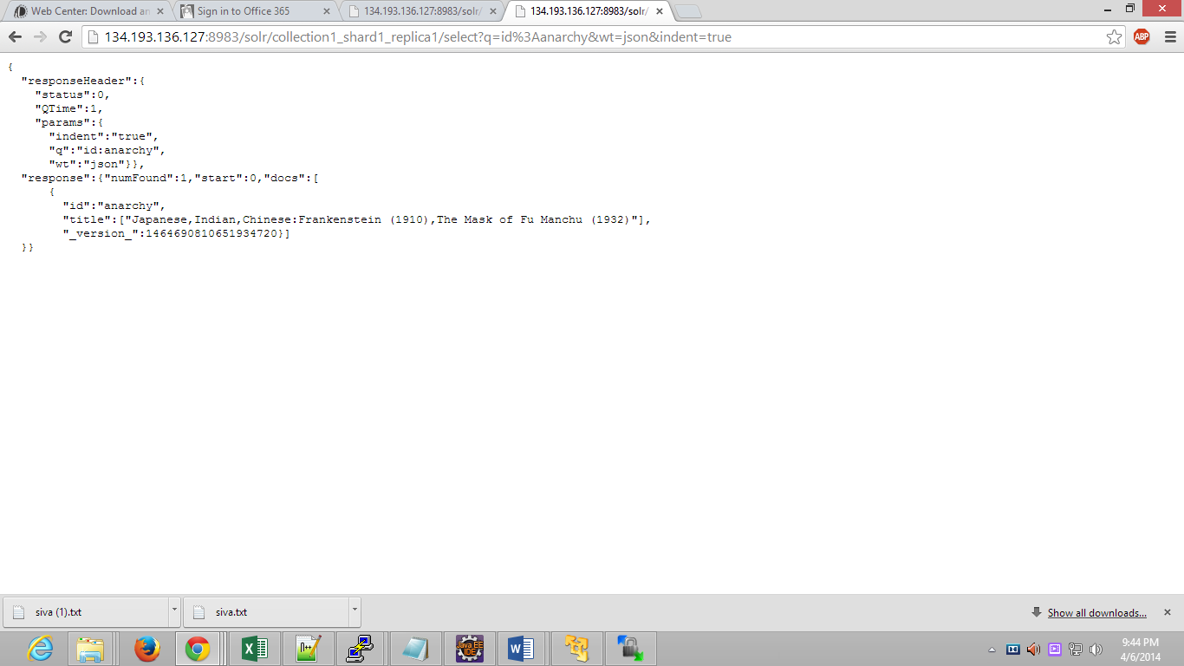

**Github Url:**

[**https://github.com/tkhgf/kdm_midtermexam**](https://github.com/tkhgf/kdm_midtermexam)

**Webapp Url:**

[**http://jsfiddle.net/tiru4017/z7PdN/2/**](http://jsfiddle.net/tiru4017/z7PdN/2/)

**The End**