Lab 01 Report

Group Tasks

Group 1

Tirumala Reddy Konireddy

Krishna Chaitanya Nalluri

Syamala Reddy Arimanda

Divya Sree

**Task 01**

**Connection service:**

(TI Sensor Tag with Android sensor app)

We had gone through the source code and understood about the services like broadcasting of motion data provided by the TI motion sensor device connected to Mobile device through Bluetooth. We understood the fact that, low energy data transfer service is introduced in bluetooth from bluetooth 4.0 and above versions. Hence, The Android Mobile devices with bluetooth 4.0 or above only support the communication between TI sensor tag and Android Mobile. Similarly, We had studied about the libraries that contain useful methods to work easily with external sensor devices from Android 4.3 or above.

While, I run my android sample application meant for connection service, We noticed the change in values of dimensions of X, Y and Z axis using the accelerometer embedded in the sensor tag on its movement as below. Now, we are comfortable to debug the code using logs and establish communication between TI Sensor Tag and the Android Mobile Device.

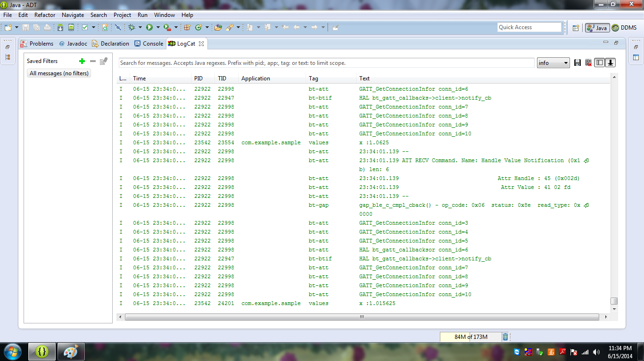

**CONNECTION SERVICE APPLICATION LOG CAT**

**Task 02**

**Moblie Sensor**

(Mobile Sensor with Android Sensor App)

This application is about changing the background color of the main activity with the tilting or shaking of mobile device using accelerometer sensor in the mobile device**.** We had understood about the Activity class, Onlistener, Onpaused and Onresume methods clearly. We are comfortable to use views like Textview, EditText, and Layouts, Toasts, logs and working with accelerometer sensor of Mobile device after studying and running this application.

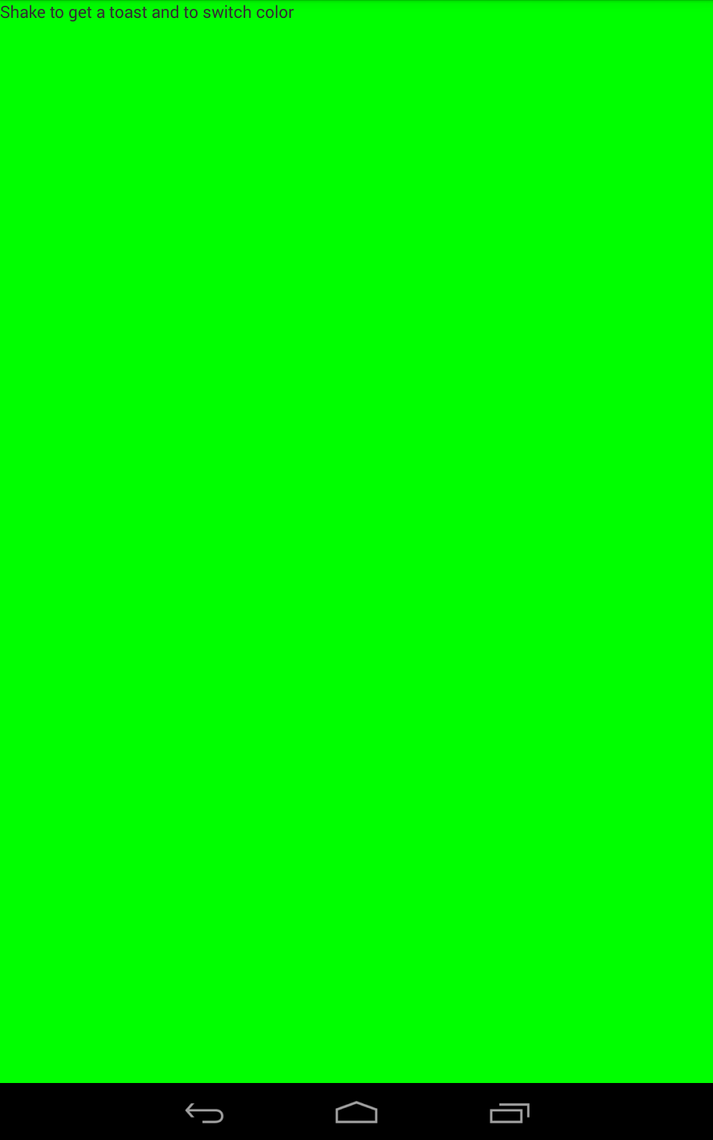

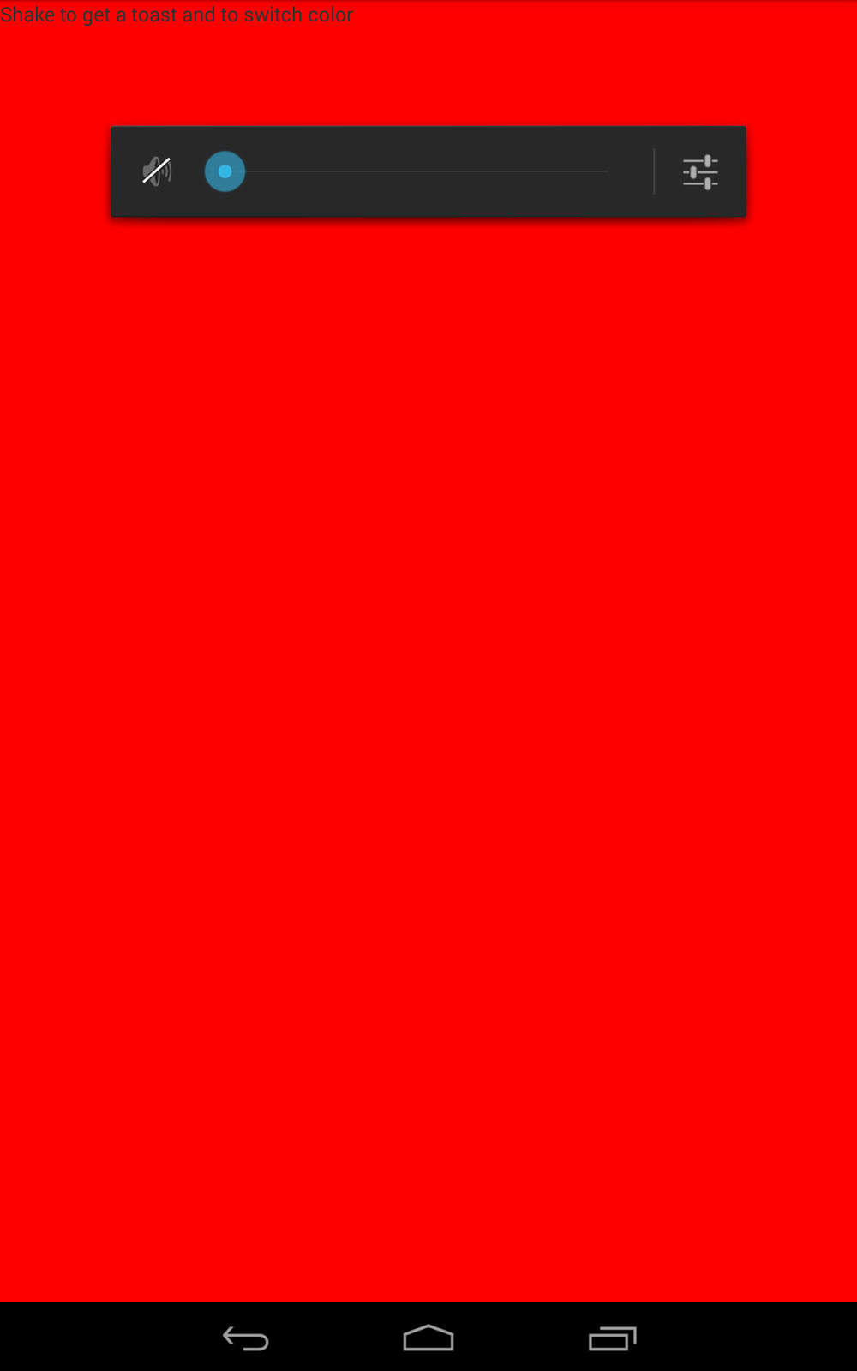

**Task 03**

**Global Postioning System**

(GPS feature with Android Smart Phone)

This application is about notifying the user with his current location in two formats( Address and Latitude and Longitude location) as below. From this, we understood about the working with GPS sensor in the Mobile Device).

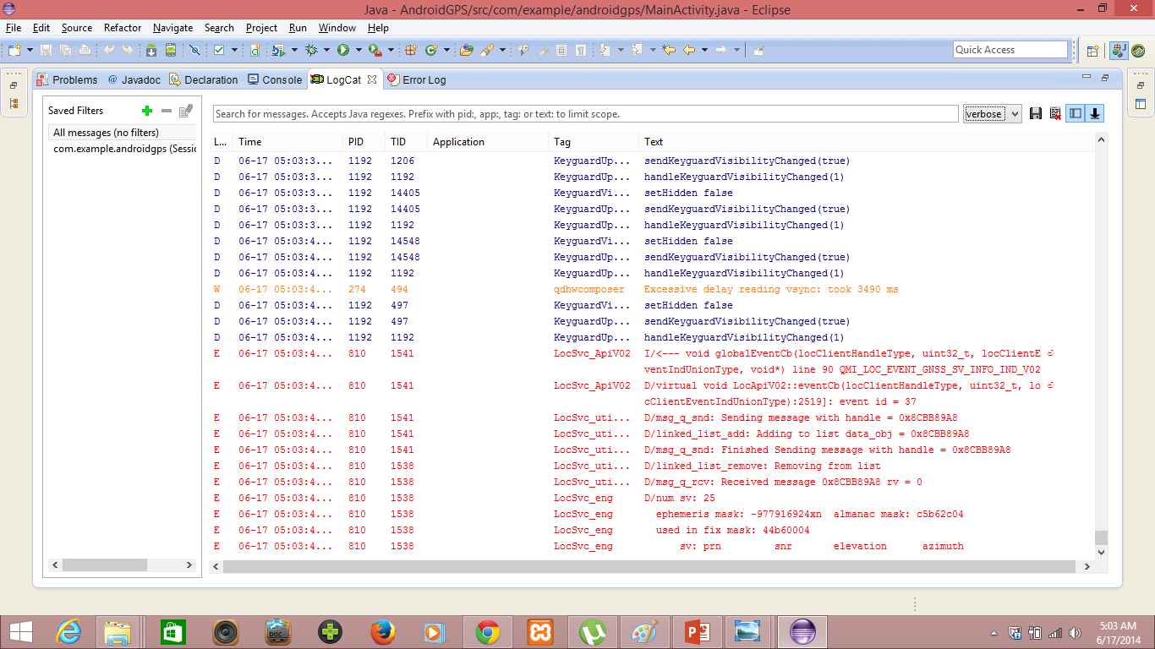

**Android GPS Application Launching**

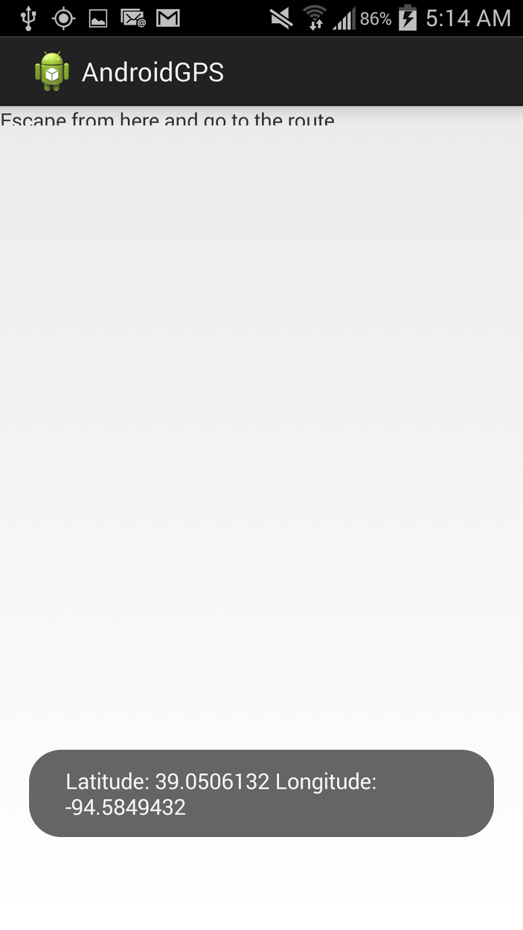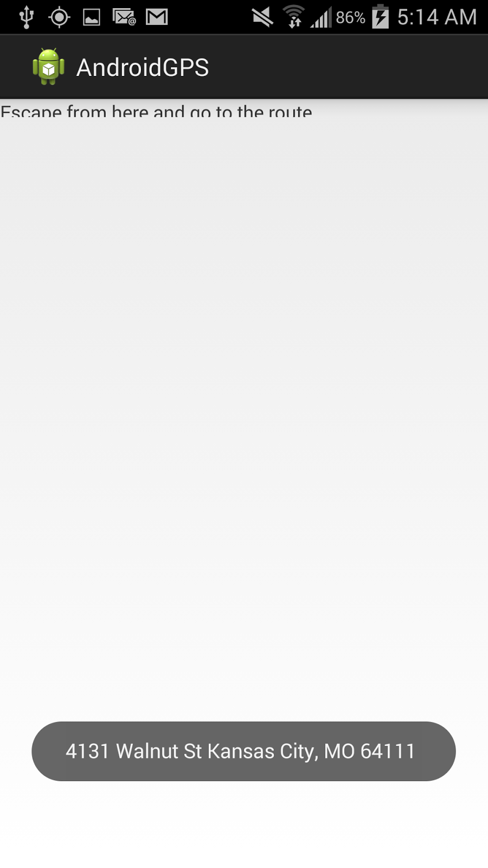

**Toast Message notifying the Current location in Latitude and Longitude position and Current Address**

**Task 04**

**Gesture Trainer and Detector**

(WIGEE APP with Android Smart Phone)

This application is about training a gesture by given the same input motion for upto 1000 times ideally. After some debugging and running the Android Application, We had trained our application with 4 motions each one trained for about 10 times after running this application in our Android Mobile device.

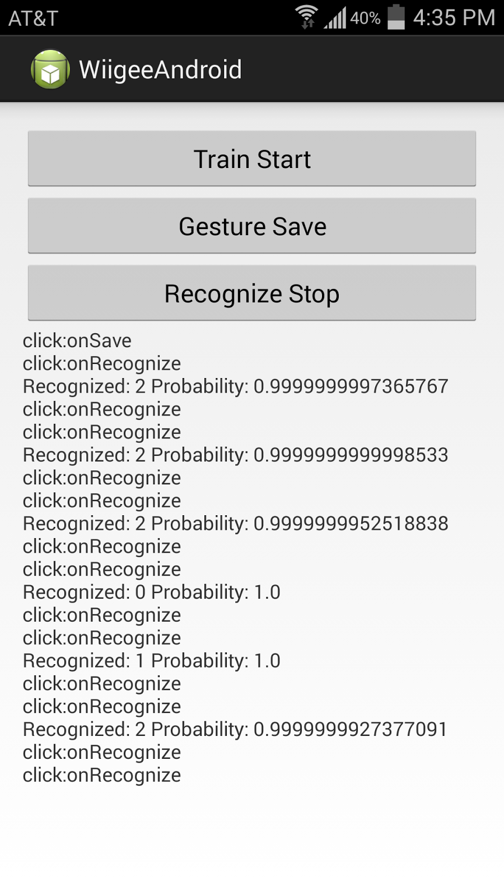

**Task 05**

**(TI Chronos watch with Java App)**

This application is developed in C# using Motion capture to capture hand motion as a kick. First, we had downloaded and installed the TI chronos watch Control Center installer for Windows Operating System. Then, We connect the RF device that communicates the data about motions captured by TI chronos watch. Then we observed the change in amplitude of X, Y and Z dimensions with the movement of Chronos Watch as below.

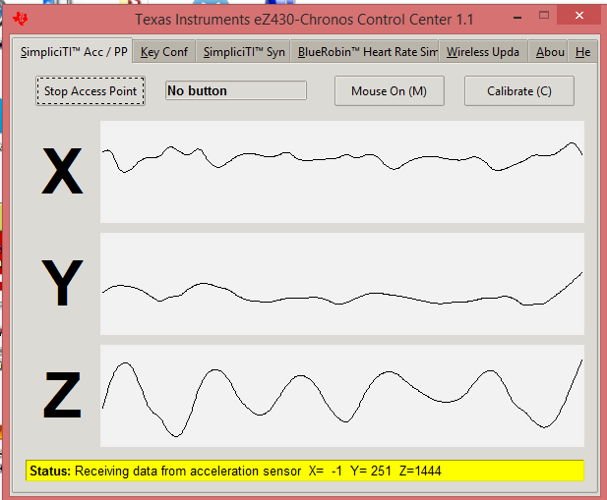

**TI CHRONOS WATCH CONTROL CENTER**

Then, We run the Punch game that is capable of detecting the kick motion by hand. We observed that this application is capable of detecting the force applied on kicking through motion capturing. We had some fun playing with this application. We are looking forward towards developing a multiplayer one like this using two chronos watches at a time.

