Operations Report – Sample
This sample docx embeds a flow diagram image for the image-describer PoC.
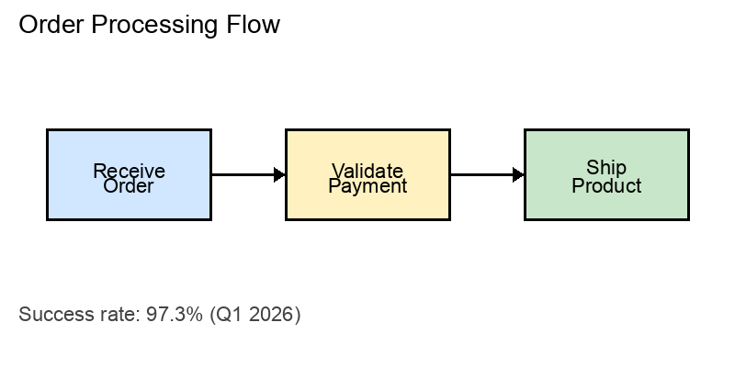
The figure above shows a three-step pipeline: receive order, validate payment, and ship product.

