Twitter Sentiment Analysis for 2016 Election

Toney Kim
Department of Information Systems, California State University
Los Angeles
Tel. 213-000-0000, Fax. 213-000-0000
e-mail : tkim69@calstatela.edu

Abstract: Social media applications such as Twitter are increasingly becoming more useful to communicate ideas and attitudes. During the 2016 presidential election, experts used polls and surveys to inaccurately predict that Hillary Clinton would win the election. However, using newer forms sentiment analysis on Twitter messages, we may be able to obtain a more accurate prediction of voter’s attitudes than methods used by experts for the 2016 presidential election.

1. Introduction
The 2016 Presidential elections was a surprising upset with many people believing Hillary Clinton would win. Many polls and experts predicted that Donald Trump would lose. When we compare the popular vote with that of the electoral college, we can see that Hillary did win the popular vote; however, Trump won the election. Yet, the predicted margin was expected to be much larger.
Social media was highly used and important to the 2016 election. When we analyze the sentiment of the American people on social media, such as Twitter, we can see that the polls and experts did not accurately capture the attitudes of the voters.

2. Literature Review
Sentiment analysis is a very popular and highly utilized method of analyzing written messages. Many different methods of sentiment analysis exist, Yaqub and his team members utilized SentiStrength senitment analysis to analyze Twitter messages from Oct. 29, 2016 to Nov. 18, 2016 [3]. He noticed that Trump had overall better sentiments than Hillary over the course of their study and recognized the overall negative sentiment nature of both candidates. Our analysis is similar to Yaqub, but will utilize a lexicon sentiment analysis and focus on American voters in the 4 major time zones of the continental United States.
Another study done by Chin and colleagues, focused on the same 2016 presidential election on Twitter; however, they focused on the emojis that were used in the messages and the location of the tweet by state [1]. By analyzing emoji sentiments, they were able to determine states that were more suppotive of Hillary and Trump. Our analysis will not include emojis, but will analyze the words using sentiment analysis and by time zone for Oct. 30, 2016.
Sentiment analysis on Twitter messages is a very active field of research. Not only is it used to analyze candidates, but also topics that are popular and important to the people. Another study done analyzed important topics during the 2016 election year [2]. They were able to find out what key topics were being highly discussed and at what time during that year as well as the sentiment. Our study will be focused only on Hillary and Trump and only for the tweets during the one day of Oct. 30, 2016.

3. Methodology
3.1 Dataset
The dataset was received from Professor Woo, and downloaded from url:
https://s3.amazonaws.com/vm-election10282016-2/tweets10302016.tgz
This dataset contained 12.5GB of Twitter tweets from Oct 30, 2016 or approximatley 1.8 million tweets from around the world with each tweet being around 7.2KB.

3.2 Infrastructure
The datset was uploaded and analyzed using Amazon Elastic MapReduce (EMR) cloud services using Hadoop 2.8.5 and Hive 2.3.3. The m3.xlarge cluster was selected with 3 nodes, 15GB of ram and 300GB of hard drive space with Intel Xeon E5-2670 CPUs of 2.8GHZ.

3.3 Sentiment Analysis
The type of sentiment analysis used was lexicon based with the dictionary located at:
https://s3.amazonaws.com/hipicdatasets/dictionary.tsv
The Twitter messages were filtered at each step of the analysis. First by Pacific, Mountain, Central and Eastern time zones, then for keywords of only Trump or Hillary. Finally the remaining tweets were analyzed with sentiment analysis for postiive and negative results.

4. Analysis and Results

4.1 Overall Results

Table 1. Overall Sentiment Analysis Results
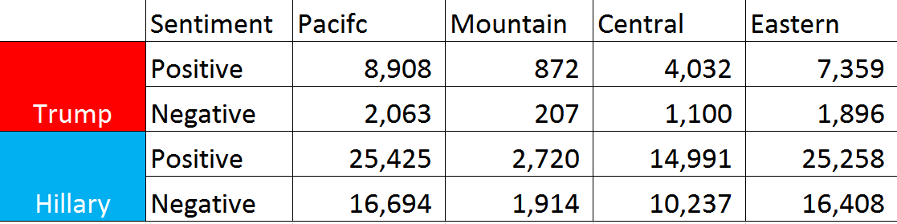

The overall sentiment analysis contained more tweets for Hillary than Trump and one might assume that Hillary is more favored than Trump. If the positive to negative numbers were converted to ratios; however, Trump would have a higher postive ratio than Hillary in all four timezones. Unfortunately, the actual election results do not show a correlation of Trump being more favored than Hillary as seen in Figure 1.
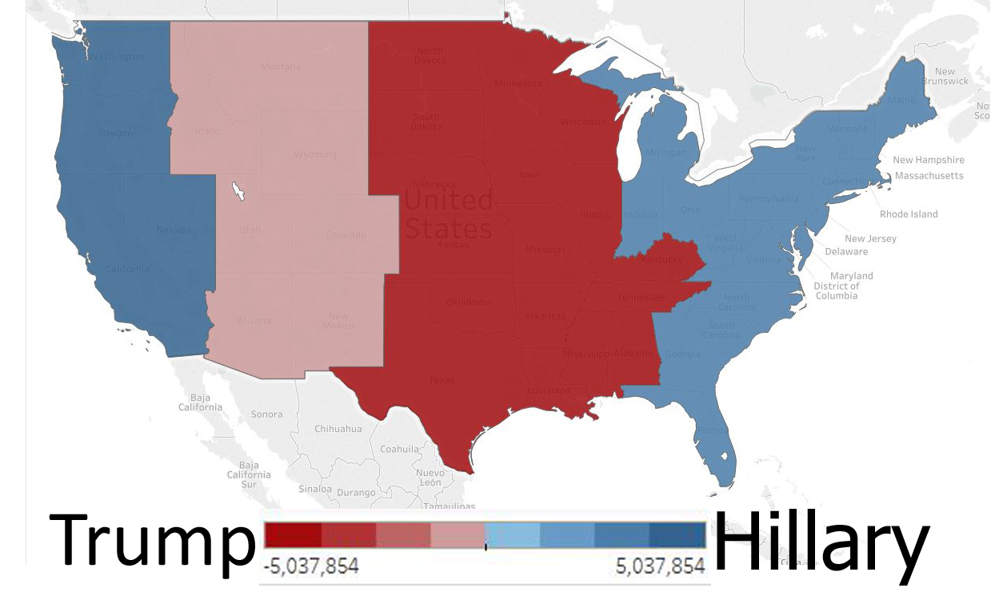
Figure 1. Popular Vote of 2016 Election Results by Time Zone

The overall sentiment analysis is difficult to understand as well as to find a correlation that matches what was seen during the election.

4.2 Positive Sentiment Transfer
If the sentiments numbers are redistributed to only show the postive sentiments of Hillary and Trump, we can see a slight correlation for Hillary.The negative sentiment amounts of one candidate were added to the postiive sentiment amount of the other. In essence, if one is not for a candidate, it is assumed they are in favor of the opposing candidate. The results of positive setiment transfer shows the country in favor of Hillary and not for Trump.

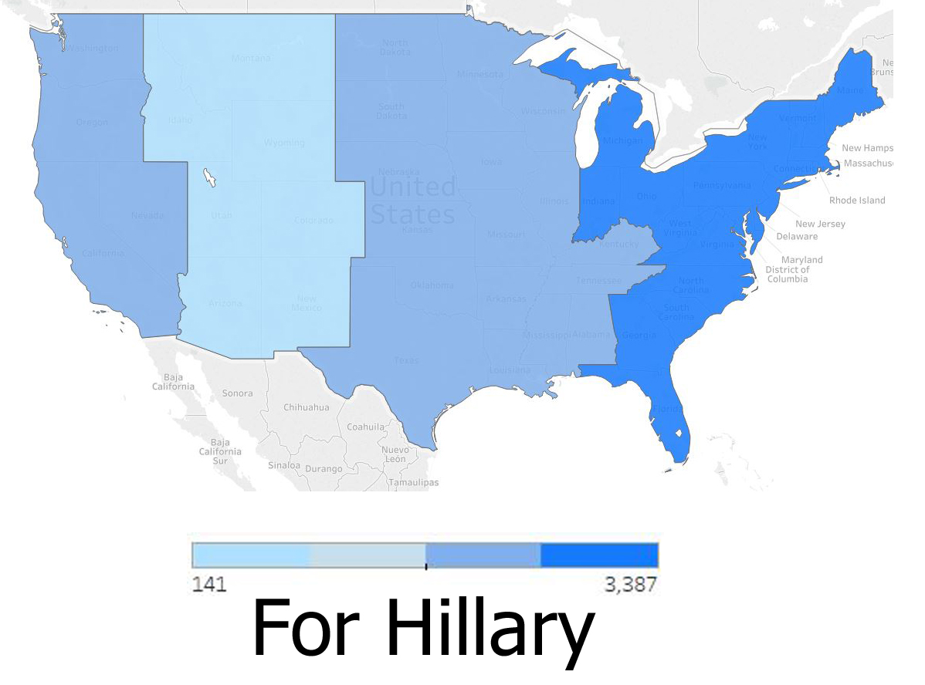
Figure 2. Positive Sentiment Transfer Map by Time Zone

When comparing the positive sentiment transfer map of Figure 2 with the popular vote map of Figure 1, we can see that Hillary has strong support in Eastern and Western timezones as in the actual; however, Trump’s popularity in the Central and Mountain timezones is not seen.

4.3 Negative Sentiment Transfer

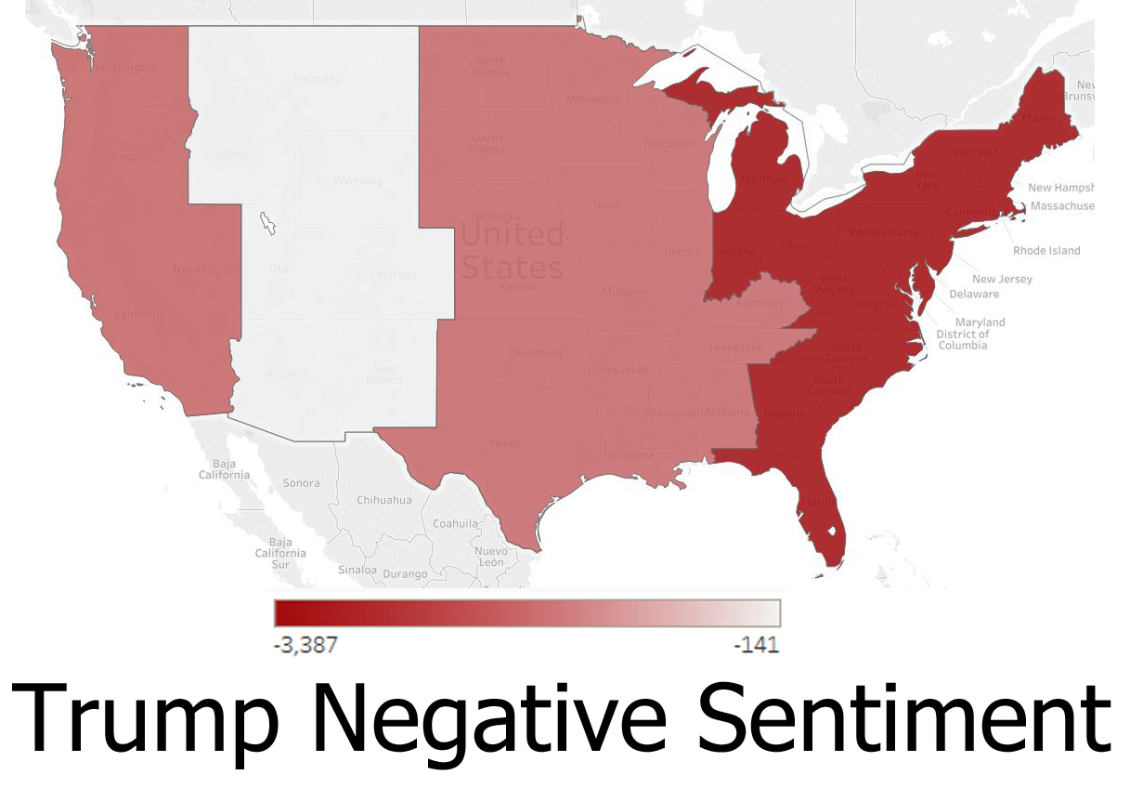
Figure 3. Trump Negative Transfer Sentiment Map

When the sentiment numbers are redistributed to only show the negative sentiments of Trump and Hillary, we can see that Trump has with more negative sentiments.

5. Discussion and Conclusion

Although a slight correlation was found with positive sentiment transfer results and the actual popular results, the small resulting sample size makes it difficult to have absolute confidence in the results. The data was from Oct. 30, 2016, which was a week before the actual election and it possible more relevant tweets would have increased as the election day approached.
However, from the originally amount of 1.8 million tweets, only a few thousand tweets remained after the filtering. Better methods of sentiment analysis could increase the final sample size; nevertheless, to get a true assesment of attitudes, more social network platforms will have to be included and other methods to obtain the non technical older population’s attitudes. Older voters are important, since a large percentage of them actually vote compared to younger voters who use social media platforms.

References
[1] Chin, D., Zappone, A., & Zhao, J. (2016). Analyzing Twitter sentiment of the 2016 presidential candidates. News & Publications: Stanford University.
[2] Johnson, K., & Goldwasser, D. (2016). " All I know about politics is what I read in Twitter": Weakly Supervised Models for Extracting Politicians’ Stances From Twitter. In Proceedings of COLING 2016, the 26th International Conference on Computational Linguistics: Technical Papers(pp. 2966-2977).
[3] Yaqub, U., Chun, S., Atluri, V., & Vaidya, J. (2017, June). Sentiment based analysis of tweets during the US Presidential Elections. In Proceedings of the 18th Annual International Conference on Digital Government Research (pp. 1-10). ACM.

