SOCIAL SCIENCE RESEARCH **26,** 309–330 (1997)

ARTICLE NO. SO970600

Shifting Margins of Housing Status in Los Angeles

Jennifer Wolch and Wei Li

*Department of Geography, University of Southern California*

Changes in housing circumstances over the 1980s were more dramatic in Los Angeles than nationwide. Reductions in housing autonomy were larger, as were diversity gaps in crowding, affordability gaps between owners and renters, and generation gaps in home ownership. Margins of the housing status distribution also changed more sharply. The precariously housed expanded at double the national rate and their housing problems worsened; the generously housed fell overall but the most affluent further improved their housing situation. Young people, female-headed households, and African-Americans were at higher risk of becoming precariously housed than their counterparts nationwide; the prospect of enjoying generous housing circumstances fell faster for Asians and established immigrants; and precarious housing rates were four times higher than the nation character- ized inner city communities by 1990. Findings underscore regional variability in housing circumstances, and suggest growing needs for household assistance. Welfare reform, however, is likely to intensify housing problems and precipitate rising rates of homeless- ness in Los Angeles and other American cities. r 1997 Academic Press

During the 1980s, the number of homeless people in American cities climbed rapidly. Whereas during most of the postwar period it would have been unusual to see visibly homeless people wandering the street, by the end of the 1980s such individuals had become a common, if not daily, sight for many urban residents. And such visibly homeless persons were only the tip of an iceberg, composed of people clinging to the most precarious rungs of the housing ladder. Over the course of the 1985–1990 period, it has been estimated that 3.1% of the U.S. population, or 5.7 million people, had been literally homeless, and that 4.6% or

We thank Dowell Myers for invaluable assistance with this research, and Dallas Dishman for cartographic production. Catherine Walsh provided superior research assistance in earlier phases of the analysis, which were supported by the Russell Sage Census Monograph Project. Support from the National Science Foundation and the Center for Advanced Study in the Behavioral Sciences, and from USC’s Southern California Studies Center, is also gratefully acknowledged.

Current address for Dr. Li: Department of Geography and Asian American Studies Institute, University of Connecticut.

Address correspondence and reprint requests to Dr. Jennifer Wolch, Department of Geography, University of Southern California, Los Angeles, CA 90089-0255.

309

0049-089X/97 $25.00

Copyright r 1997 by Academic Press All rights of reproduction in any form reserved.

8.5 million had been either literally homeless or doubled up with family or friends (Link *et al.,* 1994).

The homelessness crisis of the 1980s is a complex phenomenon, tied to the growth of the poor population during a period when affordable housing resources were shrinking. But not everyone was getting poorer during the decade; quite the contrary, as Levy (1995) and others have demonstrated, the rich got richer during the 1980s. They also appear to have built more and more extravagant homes for themselves. This trend, which real estate experts term ‘‘mansionization,’’ is widely noted in the media and refers to the construction of extraordinarily large homes—many thousands of square feet, in fact—with a host of ancillary special- purpose rooms and facilities.

As part of the Russell Sage Census Monograph Project, Myers and Wolch (1995) analyzed Public Use Microdata Sample (PUMS) data for 1980 and 1990 to better understand how such extremes were linked to the more general housing situations of American households. Specifically, they sought to grasp how shifts in the distribution of income resulting from the globalization of the economy, economic restructuring, key demographic shifts, and reductions in many welfare state programs translated into housing market outcomes for people across the country. Briefly, they found that during the decade, while many Americans continued to realize the American Dream of owning one’s home and living in prosperity, this Dream faded and seemed to slip away for others. The distribution of housing status became increasingly polarized along a number of key dimen- sions including housing autonomy (or the ability of people to set up their own households), crowding, affordability, and home ownership. Young people lost ability to own their own homes, while older people gained, creating a ‘‘generation gap’’ in housing. Along several dimensions, including residential crowding and affordability, White households gained at the same time that people of color lost ground, and thus there was a ‘‘diversity gap’’ in housing. Renters were also far more apt to suffer from crowding and excessive rent burdens than home owners. And, using a multidimensional index to measure the extreme margins of the housing status distribution, Myers and Wolch found that the proportion of *precariously housed* households grew overall, while the number of those who were the most *generously housed* grew as well, reflecting a *polarization* in housing status over the course of the decade.

The national portrait that was painted suggested the need for more detailed analysis. In particular, given the aggregate geographic scale of the analysis, the question of how broader economic and demographic dynamics had played out to shape the distribution of housing status in particular places remained unanswered. The local level is especially important in housing analysis, since housing market dynamics operate in functionally integrated geographic areas, such as metropoli- tan regions, in which submarkets of households and housing resources are linked through filtering and vacancy chains. In this article, we present preliminary results from an analysis of housing circumstances and the margins of the housing status distribution in Los Angeles during the decade of the 1980s. We chose Los Angeles

not only because it is convenient and we know a good deal about the region, but because in many ways Los Angeles—with its large homeless population as well as high-tech and movie industry-driven affluence—offers an extreme case of metropolitan social and economic polarization. This analysis parallels the national study in terms of methodology and reliance on PUMS as the principal data source, enabling comparisons to be made between the United States and Los Angeles cases.

In the next section, we set the scene of Los Angeles in the 1980s, by sketching out the region’s economic, welfare state, and demographic context during this period. Then, the following two sections present findings of the PUMS analysis. In the last section, we discuss the implications of the analysis for further research and public policy.

THE REGIONAL CONTEXT

Los Angeles, and more generally the Southern California region, was power- fully affected by the progressive *globalization* of markets and the rise of post-Fordist flexible production systems during the 1980s, *deindustrialization* and the flight of capital to international locations, and the *reindustrialization* of craft industries and *service sector growth* during this period. Although service sector growth and revitalized craft industries partially offset job losses in mass produc- tion manufacturing, the types of jobs created were vastly different—low-wage and contingent. Los Angeles, once the largest manufacturing district in the nation, experienced a 46% decline in mass production industry jobs like autos and steel during the 1980s alone—leading to the loss of large numbers of medium-skill jobs (Scott, 1993, p. 185). And although defense-dependent sectors such as aircraft, guided missiles, and computers grew in the early part of the decade as a result of the Reagan-era defense build-up, by the end of the period many of these industries were in serious decline. High-tech shrinkage resulted in layoffs of high-wage/high- skill workers, and large numbers of low-wage service workers employed in defense-dependent communities. Service sector growth associated with Los Angeles’ role in globalization, involving international finance and trade, and global business services, brought high-wage/high-skill jobs to the region, but also low-wage/low-skill jobs, as did the reindustrialization of internationalizing craft sectors such as furniture, food processing, and especially garment manufacture.

The result of these job shifts was polarization of the wage distribution and an expansion in surplus labor. In 1969, only 7% of male workers earned under

$10,000; by 1987 the proportion had doubled to 14%. The high-wage segment of the workforce had grown to more than 11%, while those earning between $20,000 and $30,000 fell from 32 to 25% (Research Group on the Los Angeles Economy, 1989). During the 1980s, a recent analysis of PUMS data suggests that the share of labor force with earnings below 70% of the median grew from around 35 to 37%, while the share earning more than 130% of the median grew from about 38 to 40% (Scott, 1996). Workers in immigrant-reliant manufacturing and distribu- tive services industry occupations were especially hard hit, experiencing major reductions in real wages as well as declining employment opportunities (Scott, 1996, Table 3). With respect to surplus labor, recent estimates suggest that by the

early 1990s, 14% of the workforce was out of work and large numbers of people were underemployed (Southern California Interuniversity Consortium on Home- lessness and Poverty, 1995).

Many people who lost jobs or saw their wages fall during the 1980s were forced to seek *welfare state services* to keep them from winding up on the streets. But by the early 1980s, the social safety net had begun to thin (Wolch and Dear, 1993). Welfare and disability provisions changed, and large numbers of recipients lost cash benefits, along with health care and food stamps. Other social programs were also deeply cut throughout the Reagan era, including job training, human services, commu- nity development and other forms of income support (Wolch and Akita, 1988). And federal assistance to states and localities was radically scaled back, hand-in-hand with devolution of program responsibilities to the states—the ‘‘New Federalism.’’California, in midst of the tax limitation movement, made deeper cuts, privatized services, and further devolved responsibilities onto the counties. Even so, welfare caseloads exploded at a rate of 13% per year as the economy shrunk. Counties faced rising costs of welfare administration and public health, as well as indigent relief. Los Angeles County elected to keep these expenditures in check by retrenching even further (Lee, 1991).

Lastly, several *demographic changes* increased the number of households looking for affordable shelter and affected their composition, for example, the aging of the baby boomers, which deepened job competition, and the rise in nonfamily households and single-parent families, which exacerbated the competi- tion for small, affordable units. In Los Angeles, these trends were overlaid by huge international immigration flows from Latin America and Asia, driven by geopolitical conflict, internal political turmoil, and economic globalization. By 1990, 25% of all Southern California residents were foreign-born, up from less than 10% in 1970 (Myers *et al.,* 1995). Some share, especially Asian immigrants, were people working in international trade and globalizing corporations, but most others were young and arrived seeking low-skill jobs and affordable dwelling units.

The economic, welfare state, and demographic context underlay the emergence of a regional population characterized by deepening social and economic polariza- tion. The implications of this situation for housing status, however, was dependent upon the *housing supply* side of the equation. Here, *federal commitments* to produce affordable housing stagnated; increases in rent vouchers did not match growth in eligibility and did nothing to increase production (Wolch and Dear, 1993). In Los Angeles, there was virtually no new public housing built during the 1980s, and vouchers were mostly a moot issue. The federal voucher program phone application system was closed down in 1986 because the waiting list was several years long; reopened in 1989, it shut after 4 days and 180,000 calls (Wolch and Dear, 1993). In addition, affordable units were eliminated from the housing stock through *gentrification* and *urban renewal* in region’s central cities, while *exclusionary local land use policies* and *community opposition* in the suburbs slowed the pace of affordable construction. In general, patterns of *demolitions and new construction* meant that small, older, affordable units were lost and more up-scale units were built (Heilman, 1989). In the areas with the largest increases

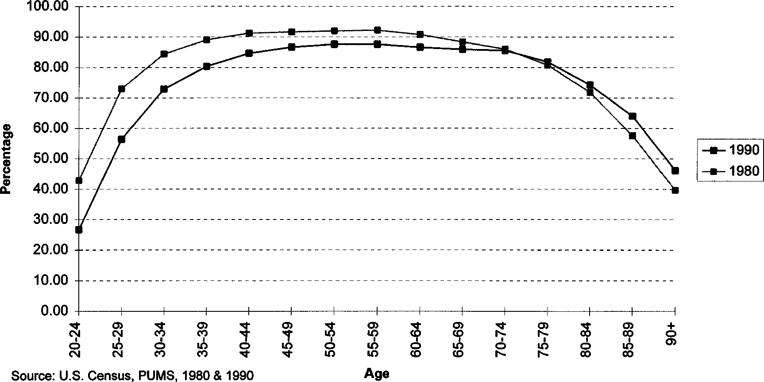

FIG. 1. Percentage who were householders or spouses of householders in Los Angeles County by age: 1980 and 1990.

in poor population, numbers of housing units stagnated or actually fell. In the City of Los Angeles, for example, population grew by 135,000 between 1990 and 1994, during which time only 18,500 additional housing units were added to the stock (City of Los Angeles, 1995). The result was rapid *price/rent escalation.* Overall, in real terms, Los Angeles County rents rose over 50% during the 1980s, and regional house prices, equal to the national average in 1974, were 55% above that norm by the mid-1980s (Baer, 1986). Such price escalation effectively eliminated low-cost units. Between 1974 and 1985, the number of affordable units fell by 42%; such units were 35% of the stock in 1974, but only 16% by 1985 (Research Group on the Los Angeles Economy, 1989, p. 183).

CHANGES IN HOUSING CIRCUMSTANCES

Given this backdrop, we turn to the PUMS analysis to describe how these broad economic, demographic and housing supply trends influenced the housing circum- stances of people in Los Angeles County between 1980 and 1990.

*Changes in housing autonomy.* Household formation rates determine the proportion of ‘‘autonomous’’ individuals, namely those who are either indepen- dent householders living on their own, or the spouses of such householders. During the 1960s and 1970s in the United States, housing autonomy grew rapidly as young people gained economic independence and were able to move into their own quarters. This pattern changed radically during the 1980s for the nation, but even more so in Los Angeles, and starting from a slightly lower base (Fig. 1). In 1980, 73% of people in the 25- to 29-year-old age group lived autonomously, compared to 79% for the nation. This rate of autonomy fell to 56% by 1990, a drop of almost 17 percentage points. In contrast, older people were more apt to remain in their own households in 1990 compared to 1980. Among the 85- to

89-year-old group, housing autonomy grew more than 6%, mirroring the national trend.

Young women in Los Angeles had higher rates of autonomy than their counterparts nationally, and higher rates than men, also going against the national pattern. Otherwise, the reduction in housing autonomy over the 1980s was of roughly similar proportions for men and women for most of the age distribution. Males in their mid to late twenties, however, were much less apt to be independent in 1990 than 1980 (70% in 1980 compared to 50% in 1990). Differences by race/ethnicity were even more dramatic. In the 25- to 29-year-old age group, for instance, 75% of non-Hispanic Whites had been living autonomously; this had dropped 10 percentage points by 1990 (thus dropping more slowly than the total population). Among Hispanic and especially African American people in this group, however, the gap grew to 20 percentage points—double the White decline. At the elderly end of the age distribution, African Americans retained or increased their ability to remain independently housed over the decade from age 55 on, especially the above 80-year-old cohorts, while among Hispanic people au- tonomy was lower for every age group until age 75. The Asian population had a much different pattern: although like other groups, young Asians were decreas- ingly able to form their own households, in both 1980 and 1990 rates of Asian housing autonomy began to fall from age 40 or 45. This may reflect differences in intergenerational housing patterns, especially among Asian immigrants to the region.

*Residential crowding.* Increases in crowding can indicate that individuals are having trouble establishing or maintaining autonomous households. Given the falling ability of young people to establish their own households over the 1980s, we thus might expect to see increases in crowding. And indeed, in the nation as a whole, although crowding rates fell throughout the postwar period, the 1980s witnessed an upturn in crowding. The picture in Los Angeles, where rates of household formation fell even faster than for the country overall, there was an immense growth in crowding. This increase was experienced almost entirely by renters; the share of crowded renter households, where crowding is defined as more than 1 person per room, rose almost 19 percentage points, to 27% of all renters. Rates of ‘‘extreme’’ crowding, or more than 1.5 persons per room, rose the fastest.

The *diversity gap in crowding* was the most striking aspect of the overcrowded housing picture: whereas non-Hispanic White households had experienced little crowding, crowding among African American households was twice the White rate. But both of these rates, while increasing somewhat over the decade, were low compared to Asian and Hispanic households. Among Asians, moderate crowding was 4 times the White rate while extreme crowding was 9 times higher; Hispanic households had 5 times the moderate crowding rate of Whites and 13 times the extreme rate. More than 40% of Asian and almost 60% of Hispanic households were crowded by these definitions (Fig. 2).

It is important to view these results with some caution. What housing analysts

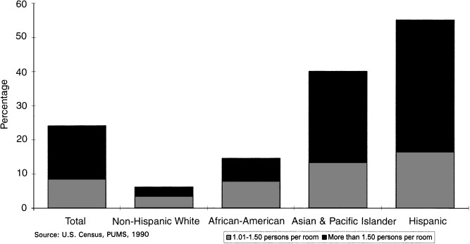

FIG. 2. Overcrowding prevalence for renters: Sum of moderate and extreme overcrowding by race/ethnicity in Los Angeles County, 1990.

have conventionally termed ‘‘overcrowded housing’’ is actually a complex set of behaviors about which we know relatively little. Definitions of crowding have changed over time, falling as overall housing circumstances of Americans improved over the course of this century; definitions are social constructs and relative. Moreover, while crowding was once thought to be a direct expression of financial constraint, recent studies show that race and ethnicity also play a central role (Myers, Baer, and Choi, 1996). Although crowding rates are higher among poor renter households, for example, if one controls for household size, and for income or rent burdens, Asian and Hispanic households still display much higher crowding prevalence rates at each income or burden level.

This suggests that among some sections of the population, there is (1) a greater cultural tolerance for crowding, (2) greater emphasis on other types of consump- tion than housing, or (3) a *positive* preference for intergenerational household structures, despite the resulting reduction in space per person. These possibilities suggest that consideration be given to redesigning longstanding policies aimed at reducing crowding, which were implemented during the postwar period of increasing household incomes, in those areas characterized by falling incomes and cultural diversity.

*Affordability.* Affordability problems were worse in Los Angeles than in the nation overall, and the *affordability gaps* between owners and renters, and race/ethnic groups were larger. By 1990 almost a quarter of all renter households were paying more than half of their incomes for rent, and almost 40% were paying more than 35%. Only 10% of owners paid more than half of their income for housing, and less than 15% paid more than 35%.

African American households as a group were the most severely burdened, with 29% of renters paying more than 50% of income on housing. The highest rates of burden increase, however, were among Asian and Hispanic households.

TABLE 1

Home Ownership Attainment by Race and Hispanic Origin, at Selected Ages in Angeles, 1980–1990*a*

|  |  |  |  |
| --- | --- | --- | --- |
|  | 1980 (%) | 1990 (%) | Change |
| Ages 25–34 Total | 32 | 27 | 25 |
| Whites, non-Hispanic | 37 | 33 | 24 |
| Blacks | 23 | 14 | 29 |
| Asians | 37 | 38 | 2 |
| Hispanics | 27 | 21 | 26 |
| Ages 65–74 Total | 59 | 68 | 9 |
| Whites, nonHispanic | 61 | 73 | 12 |
| Blacks | 53 | 57 | 4 |
| Asians | 55 | 56 | 1 |
| Hispanics | 49 | 62 | 12 |

*a Source.* U.S. Census, PUMS, 1980, 1990.

But perhaps the most striking finding relates to the gender gap in affordability. More than 30% percent of female-headed renter households had payment burdens of 50% or more, compared to 18% of male-headed households.

Part of the affordability problem was clearly due to rising rents and home values. However, falling incomes also played a major role. A recent survey of households living in rent-stabilized units within the City of Los Angeles found that their median incomes dropped by a third between 1990 and 1993, and the share paying more than 40% of income on rent grew by 60%, although rents had declined marginally since 1987 (Hamilton, Rabinovitz and Alschuler, Inc., 1994). The role of falling incomes in producing affordability problems is also supported by recent findings of growing income polarization in California, caused primarily by declining incomes among the least well-off (Reed, Haber, and Mameesh, 1996).

*Home ownership.* In Los Angeles, the rate of home ownership is considerably lower than for the nation as a whole, but like the nation, the ownership rate fell slightly over the 1980s. The *generation gap* in home ownership—the difference between ownership rates for younger versus older cohorts—was far more striking in Los Angeles than in the country as a whole, however, especially for African Americans and Hispanic households (Table 1).

Ownership rates among the 25- to 34-year-old group were only 32% in Los Angeles compared to 51% nationally, and fell to 27% by 1990; among the 65- to 75-year-old group, ownership rates climbed from 59 to 68% in 1990. Thus the generation gap grew from 26 percentage points, to a startling 41 percentage points in Los Angeles—a gap that both grew faster and ended up larger than for the country as a whole. For African Americans, the generation gap was actually smaller than the overall gap, a reversal of the national pattern—and thus good news; the generation gap actually shrank for Asian households. However, reflect-

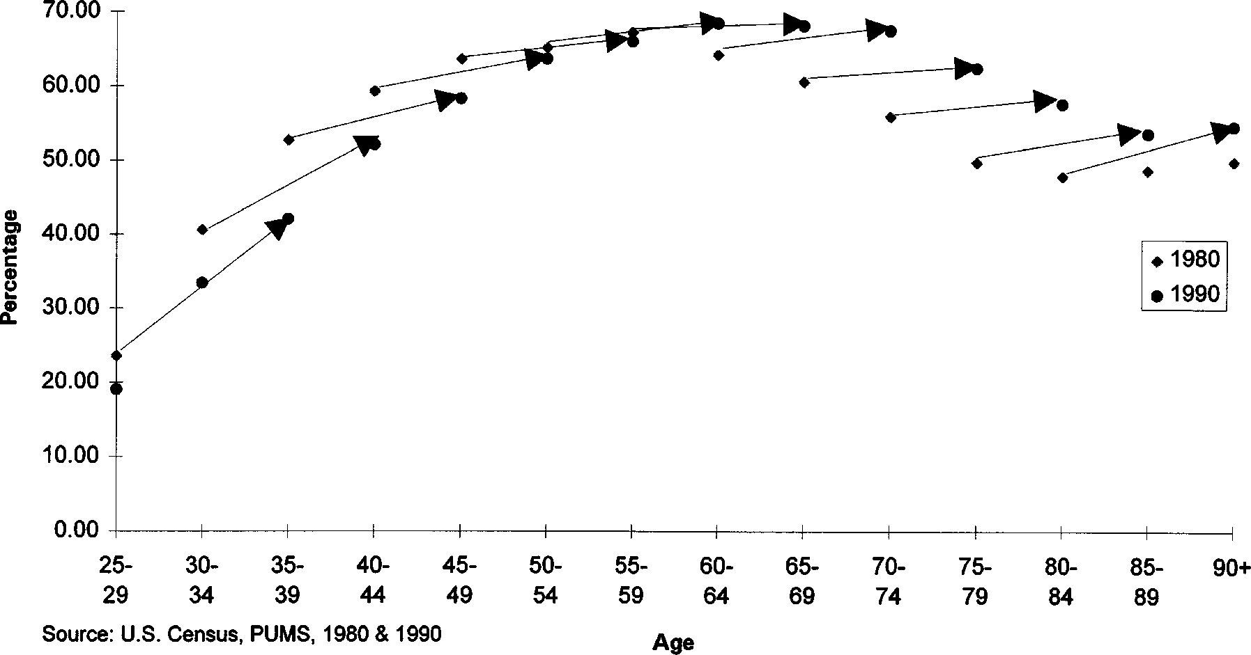

FIG. 3. Trajectories of home ownership in Los Angeles County by age: 1980–1990.

ing the increase in low-income Latino immigrants to the region during the 1980s, as well as the increasing economic security of older Latinos (whose rates of ownership rose as fast as did Whites during the decade), the gap grew fastest for Hispanic households: from 22% in 1980 to over 40% in 1990—for an 18 percentage point gap.

Assessing the progress of cohorts into and out of home ownership, we can see that the cohort aged 25–29 in 1980 went from less than a 25% ownership rate to just over 40% by the time they had become the 35- to 39-year-old cohort in 1990 (Fig. 3). This is 20 percentage points lower than the rate for 35- to 39-year-olds had been 10 years earlier. This is worrisome, since it is unlikely that these younger cohorts will ever catch up to close the gap between themselves and older cohorts, thus leading to falling ownership rates over time.

On the other side of the age distribution, the drop-off in ownership rates that is typical of older cohorts as they age and become less able to maintain an independent living unit was apparent in both 1980 and 1990, but the drop off in 1990 occurred later in the age distribution. Moreover, individual cohorts in Los Angeles had very different experiences than their national counterparts. For example, the ownership rate of 75- to 79-year-olds actually *rose* by the time this cohort had turned 85–89 in 1990. And many of the older cohorts had ownership rates 15 percentage points higher than their 1980 counterparts, indicating that the elderly in Los Angeles fared better in this respect than did their cohorts nation-wide.

SHIFTING MARGINS OF HOUSING STATUS

In an effort to assess the overall impact of changing economic, demographic and housing market conditions on the housing circumstances of Los Angeles’ population during the 1980s, we utilized the composite measures of housing

TABLE 2

Margins of Housing Status in Los Angeles County, 1980 and 1990*a*

|  |  |  |  |  |  |  |
| --- | --- | --- | --- | --- | --- | --- |
|  | 1980 | 1990 | Change | 1980 (%) | 1990 (%) | Change |
| Precariously housed |  |  |  |  |  |  |
| Los Angeles | 224,320 | 288,123 | 163,803 | 8.2 | 9.7 | 11.5 |
| U.S. | 4.1 m | 5.2 m | 11.1 m | 5.1 | 5.6 | 10.5 |
| Generously housed |  |  |  |  |  |  |
| Los Angeles | 559,520 | 449,149 | 2110,371 | 20.5 | 15.1 | 25.4 |
| U.S. | 16.5 m | 17.2 m | 10.7 m | 20.6 | 18.7 | 21.9 |

*a Source.* U.S. Census, PUMS, 1980, 1990.

status developed for the national analysis. Since these measures are described in detail in Myers and Wolch (1995), the full range of definitional issues will not be rehearsed again here. Briefly, the *margins* of the housing status distribution were defined as the *precariously housed* and the *generously housed.* The precariously housed group included extremely poor, rent-burdened households, specifically renter households whose incomes were 50% or less than the Los Angeles County median household income (adjusted for household size) and whose payment burdens exceeded 50%. In contrast, the generously housed group included owners and renters who were more affluent, with household incomes of 120% or more of median county income, with light payment burdens of 15% or less.

*Changes in margins of housing status.* Nationally, the rate and number of precariously housed households grew during the course of the 1980s. The number of generously housed grew as well, although their proportion dipped slightly. How did Los Angeles, with its more polarized income distribution, legions of homeless, and spectacular affluence, compare? As shown in Table 2, the Los Angeles situation was quite different from the national norm, but not necessarily in the ways that might been have expected.

Both the number of precariously housed households and their proportion of total households grew faster in Los Angeles, from a base much larger in percentage terms than in the nation, so that by 1990 almost 10% of all Los Angeles households were precariously housed. Reflecting the dramatic increases in income inequality in California due to falling incomes of the least affluent (Reed, Haber, and Mameesh, 1996), the region’s precariously housed group had also become poorer, with slightly larger shares in the 20–35% of median income category, and more rent-burdened, with slightly more paying over 70% of their income for housing. For example, in 1980 26% of the precariously housed who had incomes between 20 and 35% of median also had rent burdens of 70% or more; by 1990 this group had expanded to over 31% of the precariously housed, as incomes slid downward and rents inched up. The group also became more crowded by the conventional definition. Crowding is also reflected in the fact that the share of households with two or more persons per bedroom rose, with recent

immigrants constituting the fastest growing component of the household popula- tion with two or more persons per bedroom. Recent immigrants also grew from less than a third to almost half of all households with four or more persons per bedroom. In sum, then, the size of the precariously housed group grew, as did its share of the total household population, and the housing circumstances of this group became even more desperate than they had been in 1980.

In contrast, the size and proportion of the generously housed group fell—and fell far faster than in the nation as a whole, from about the same level (roughly a fifth of the household population in 1980). We know that for several reasons, the generously housed group is undercounted (for example, condominiums are excluded from the PUMS sample because their value was not recorded in 1980, and payment burdens for owners are overestimated since they do not reflect the tax benefits of home ownership; see Myers and Wolch, 1995, for a detailed discussion). But despite underestimation, the drop for Los Angeles is striking. Does this mean that Los Angeles was *not* really the home of the rich and famous during the 1980s? Did the situation of the most affluent and well-housed actually deteriorate, contrary to all popular expectation?

Closer investigation of the generously housed group over the 1980s reveals some fascinating dynamics. In some respects Los Angeles’ generously housed population was shaped by the same forces that operated across the nation, which shrunk the lower end of the generously housed group. For example, the income position of the generously housed worsened for the least affluent of this group. Recall that to be considered generously housed, a household had to have had 120% or more of median income, adjusted for household size. At the lower reaches of the generously housed income distribution, households are only moderately well off financially and even at 300% of median, their income was just over $100,000/year ($104,895). In all but the very top income category (400% of median), the share of generously housed households declined, especially in the 121–200% of median category, mirroring the pattern for all households in the region. This drop in affluence among the middle-income categories was driven by economic restructuring but in addition the demographics of the homeowner population played a role: as the large numbers of postwar homebuyers who purchased cheap housing in the 1950s and 1960s retired, their cash incomes dropped despite their continued ownership (of housing units that were hugely inflated in value), and their very light payment burdens. Second, as a rapid house price run-up hit the region in the mid to late 1980s, moderate income people stretched to buy into the housing market or upgrade their circumstances, pushing them beyond the 15% payment burden cutoff. For example, the share of homeowners paying less than a quarter of their income for housing fell, while those paying between 25 and 49% rose. And lastly, migration probably played a role; the elderly migrated away from Los Angeles during the 1980s in numbers disproportionate to their population share (Frey, 1995, p. 746). It is reasonable to assume that middle class but generously housed retirees facing declining cash

incomes sold their homes to younger households and moved away from the high-cost Los Angeles region.

In contrast, the ‘‘super-rich’’ element got richer and even more generously housed, and the share with the lightest payment burdens rose. The segment of the generously housed with incomes 400% of median or more grew from less than 10% to more than 16%. Generously housed owners with a less than 10% payment burden grew 6 percentage points (from 61 to 67%); the share with abundant space resources also expanded. Households with more than three bedrooms per person more than doubled, and the share with one or fewer persons per bedroom grew from less than 57% in 1980 to over 64% in 1990; and the share of generously housed residing in large housing units (with five or more bedrooms) also grew, with the share of large units claimed by the generously housed reaching almost twice their representation in the total household population by 1990. Whites, and to a lesser extent Asians, were overrepresented among the generously housed with large homes. In the case of Asians, this was apt to be linked to the prevalence of multigenerational living arrangements among more affluent immigrants, since Asian immigrant households living in large housing units in general were far more apt to have multiple families in the household than any other group (especially the more established immigrants).

Thus despite the drop in number and proportion of generously housed house- holds during the 1980s, which would lead to a conclusion that the housing status distribution became less rather than more polarized over the decade, the reality was more complex. The number and proportion of precariously housed house- holds did indeed become larger, and the economic status of the precariously housed population deteriorated; the position of the least advantaged among the generously housed also deteriorated, but the most affluent group expanded and enjoyed even more generous housing circumstances. These dynamics reveal how economic and demographic shifts worked to differentiate the rich and those who had merely been generously housed in 1980: in the postwar period, many Americans were able to become generously housed, even though their cash incomes were relatively modest. During the 1980s, however, what Harrison and Bluestone (1988) termed the ‘‘great U-turn’’ had caught up with these households and only a share—the superwealthy—were able to continue climbing the housing ladder.

*Composition of precariously and generously housed.* As one might predict, the 1990 precariously housed population in Los Angeles was disproportionately composed of younger people, women, nonfamily households and female-headed households, African American and Hispanic households, and immigrants, espe- cially recent settlers. The proportion receiving public assistance was far greater than average, and they were much more likely to be out of the labor force. Similarly, the generously housed were disproportionately older, males, married couple families, Whites, and native-born, with higher rates of employment than average and negligible rates of public assistance income (Table 3).

Over the decade, the share of precariously housed householders who were

TABLE 3

Composition of Precariously and Generously Housed*a*

Precariously housed

Total households

Generously housed

Sex

|  |  |  |  |
| --- | --- | --- | --- |
| Age |  | | |
| Under 25 | 12.5 | 5.2 | 1.7 |
| 25–34 | 27.8 | 24.1 | 13.2 |
| 35–44 | 20.7 | 23.3 | 16.8 |
| 45–54 | 10.4 | 16.3 | 21.7 |
| 55–64 | 8.8 | 12.9 | 23.5 |
| 65–74 | 9.6 | 10.7 | 15.8 |
| 751 | 10.1 | 7.5 | 7.2 |
| Female | 54.2 | 33.8 | 22.7 |
| Household type |  |  |  |
| Married couple | 25.8 | 49.4 | 64.4 |
| Male-headed | 23 | 20.7 | 18 |
| Female-headed | 51.2 | 29.8 | 17.7 |
| Race/ethnicity |  |  |  |
| White | 36.1 | 53.4 | 66.1 |
| Black | 18.7 | 11.4 | 8.4 |
| Asian | 8.4 | 9 | 8.3 |
| Hispanic | 15.9 | 12.2 | 9.2 |
| Nativity |  |  |  |
| Not foreign born | 54.7 | 66.7 | 77.8 |
| Arrived 1980 or after | 23.1 | 11.9 | 4.8 |
| Arrived before 1980 | 22.2 | 21.3 | 17.4 |
| Income |  |  |  |
| Public assistance income | 26.2 | 6.6 | 1.7 |
| Labor force status |  |  |  |
| Not in labor force | 46.6 | 25.6 | 23.6 |
| Employed | 45.4 | 70.8 | 74.5 |
| Unemployed | 8 | 3.5 | 1.9 |

*a Source.* U.S. Census, PUMS, 1990.

women declined disproportionately, as did the share of older people, nonfamily households, Whites, and native-born householders. The share of married couple families, which declined overall, became greater for the precariously housed, as did the share of precariously housed who were in the labor force, which grew to over 53%. Women grew as a share of the generously housed, as did older people and non-labor force participants, single parent households, Asians, and more established immigrants.

*Shifting risks of becoming precariously or generously housed.* The composi- tional data tell us about the shifting characteristics of the margins of the housing status distribution, but a rates analysis indicates the differential risks of being precariously housed faced by various subgroups within the population, and how those risks shifted as the decade progressed. Similarly, such analysis can indicate

TABLE 4

Changing Rates of Precarious and Generous Housing Status*a*

Precariously housed rate Generously housed rate 1980 1990 Difference 1980 1990 Difference

|  |  |  |  |  |  |  |
| --- | --- | --- | --- | --- | --- | --- |
| Age |  | | | | | |
| Under 25 | 18.4 | 23.3 | 4.9 | 7.6 | 5 | 22.6 |
| 25–34 | 9 | 11.2 | 2.2 | 12.1 | 8.3 | 23.8 |
| 35–44 | 6.1 | 8.6 | 2.5 | 20.2 | 10.9 | 29.3 |
| 45–54 | 4.8 | 6.2 | 1.4 | 32.5 | 20.1 | 212.4 |
| 55–64 | 5 | 6.6 | 1.6 | 34 | 27.6 | 26.4 |
| 65–74 | 8.9 | 8.7 | 20.2 | 18.5 | 22.2 | 3.7 |
| 751 | 13.7 | 13 | 20.7 | 10.6 | 14.5 | 3.9 |
| Household type |  |  |  |  |  |  |
| Married couple | 3.2 | 5 | 1.8 | 27.9 | 19.6 | 8.3 |
| Male-headed | 6.4 | 11 | 4.6 | 23.7 | 14.3 | 29.4 |
| Female-headed | 15.9 | 19.3 | 3.4 | 11.7 | 10.6 | 21.1 |
| Nonfamily | 13.4 | 12.7 | 20.7 | 11.8 | 10 | 21.8 |
| Race/ethnicity |  |  |  |  |  |  |
| White | 6.7 | 6.5 | 20.2 | 23.3 | 18.6 | 24.7 |
| Black | 13.3 | 15.9 | 2.6 | 14.6 | 11 | 23.6 |
| Asian | 7.6 | 9.1 | 1.5 | 21.2 | 13.8 | 27.4 |
| Hispanic | 9.8 | 12.5 | 2.7 | 15.3 | 11.4 | 23.9 |
| Nativity |  |  |  |  |  |  |
| Not foreign born | 7.7 | 7.9 | 0.2 | 22.2 | 17.6 | 24.6 |
| Arrived in past 10 years | 12.6 | 18.7 | 6.1 | 9.9 | 6.1 | 23.8 |
| Arrived 101 years ago | 8.1 | 10.1 | 2 | 18.1 | 12.3 | 25.8 |

*Source.* U.S. Census, PUMS, 1980, 1990.

who was most likely to enjoy generous housing circumstances, and how such possibilities changed over the decade.

Young people, under age 25, had the highest rates of precarious housing status in 1980, and this age group’s risk increased by 5 percentage points over the 1980s ending at a level higher than the national rate. The rates faced by householders in their twenties, grew much faster in Los Angeles than nationally, and rates rose for each group until the age 65 group. The only age groups whose chances of generous housing circumstances improved were the over 65 categories, and rates for younger and especially middle-aged groups fell far faster than was the case nationally (Table 4).

Married couples had the lowest precarious housing and the highest generous housing rates in 1980, and their prospects for becoming generously housed grew over the decade. In contrast, female-headed households had the highest rate of precarious housing status, and their risks grew: almost 20% of all female-headed households were at the lowest margins of the housing status distribution by 1990 (compared to 15% nationally). Male-headed households had lower rates of precariousness in 1980, but faster growth in risk; male-headed households also

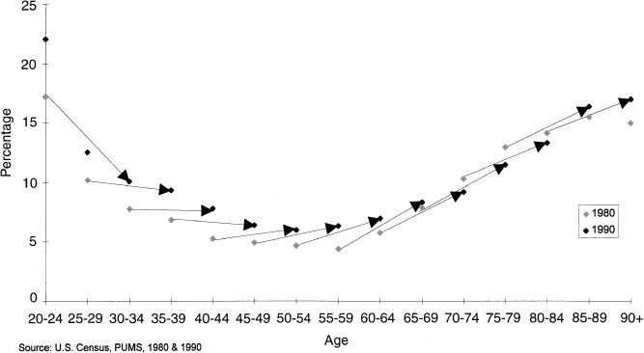

FIG. 4. Trajectories of precariously housed in Los Angeles County by age: 1980–1990.

faced dropping prospects for becoming generously housed, their rate falling from 24% to less than 15%, faster than any other group.

With respect to race/ethnicity, African American households had the highest rates of precariously housing status in 1980 and their risks increased the fastest of any other racial/ethnic group. Rates of generous housing fell for all race/ethnicity groups, but the steepest drop was among Asians who started out above the national rate but fell more than twice the national rate to end up lower in 1990 in Los Angeles than the country as a whole. Lastly, recent immigrants had the highest rates of precarious housing status in 1980, and saw their risks rise from 13 to 19% over the decade, a level and growth rate above the national average. More established immigrant groups, in contrast, suffered the most rapid decline in chances of becoming generously housed—much more rapid than such immigrants in the nation overall.

An analysis of age-specific risks of becoming precariously or generously housed reveals how individual cohorts fared over the decade and highlights the radical generation gap operating in the housing status distribution. Like the nation as a whole, householders passing from the under age 25 to the 25- to 34-year-old group over the course of the decade ended up at greater risk of being precariously housed than those aged 25–34 had been in 1980. Given the even greater gap between the precariously housed rate among those under 25 in 1980 and 1990, this cohort will face dramatically higher risks of precarious housing status in 10 years time than the 25–34 cohort did in 1990 (Fig. 4).

Rates of generous housing status plummeted particularly as middle-aged cohorts moved through the decade. For example, those aged 35–39 made little gain in their chances of being generous housed; their rate had barely changed by 1990, when they were aged 45–49, and was almost 15 percentage points lower than those who had been age 45–49 in 1980. Large lags characterized each

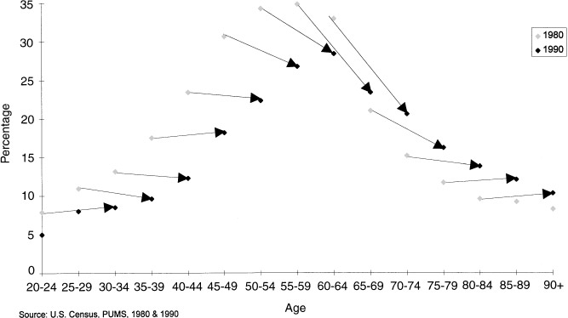

FIG. 5. Trajectories of generously housed in Los Angeles County by age: 1980–1990.

successive age cohort, diminishing slightly through the middle aged cohorts. Only those groups over 75 in 1980 faced marginally higher chances of being gener- ously housed in 1990 than they had in 1980 (Fig. 5).

*Landscape of Los Angeles’ housing status margins.* The proportion of precari- ously housed households in the region’s central cities of Los Angeles and Long Beach rose by more than 2 percentage points over the 1980s, twice the rate of noncentral city growth. The proportion of generously housed fell in both central city and noncentral city areas, but the rate of decline was sharpest in the noncentral city zones of the county. This is not surprising, given the decentralized geographic pattern of defense-dependent industries, which were downsized during the period: high-technology districts in the San Fernando Valley and Antelope Valley were hard hit, as were the South Bay beach communities where many of the region’s most affluent high-tech workers were concentrated. Thus despite the go-go image of Los Angeles in the 1980s, by the end of the decade areas which had long been growing increasingly affluent and were considered invulnerable to economic hardship had slipped badly (Fig. 6).

Unfortunately we cannot compare the housing status distribution at a disaggre- gated level; the 1980 PUMS does not permit any further disaggregation than central city/noncentral city. We can, however, consider the 1990 distribution of housing status by Public Use Microdata Area (PUMA; Figs. 7 and 8). Not surprisingly, the central core of the county, in particular South Central Los Angeles, had the highest rates of precariously housed households, with rates up to more than two times the county average (21, 10% respectively). Given that the precariously housed became even poorer and more rent burdened over the course of the decade, this geographical concentration underscores the deepening eco- nomic desolation of communities such as South Central and a host of other areas of central Los Angeles that in prior decades contained solid, working-class neighborhoods.

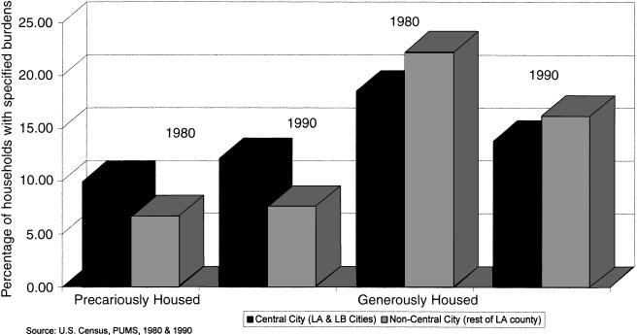

FIG. 6. Precariously and generously housed in Los Angeles County by geographical area: 1980–1990.

Pockets of the generously housed were also located in the expected areas, such as the Westside, the West San Fernando Valley, the San Gabriel Mountains communities, the Palos Verdes Peninsula, and the beach communities of the South Bay, where in some PUMAs they reached more than 23%. But the generously housed were also moderately concentrated in the rapidly growing Chinese ethnoburb in the San Gabriel Valley. Lastly, it is interesting to note that the inner-ring suburban communities were most apt to be polarized, with average or

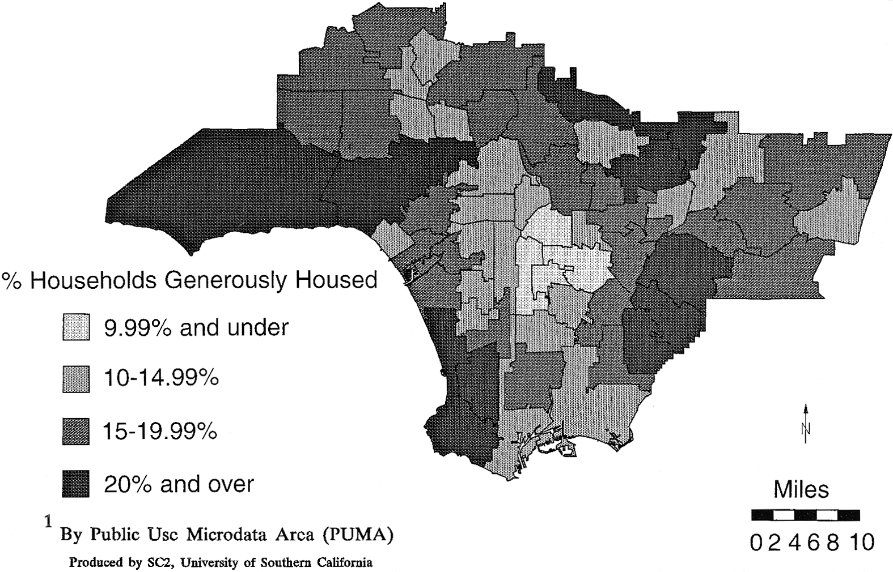

FIG. 7. Generously housed households, metropolitan Los Angeles County, 1990.

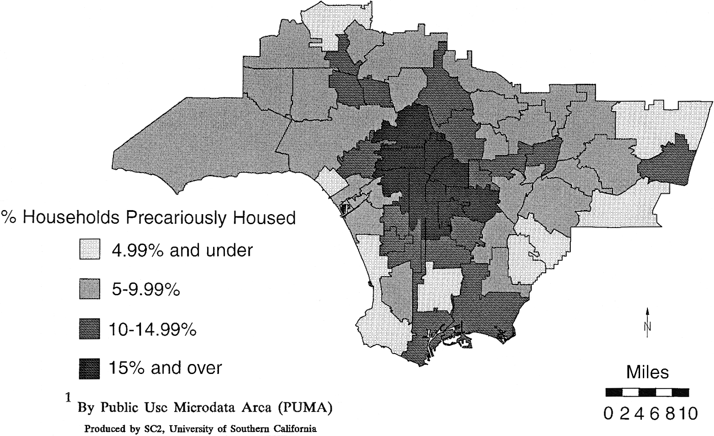

FIG. 8. Precariously housed households, metropolitan Los Angeles County, 1990.

above average proportions of both precariously and generously housed house- holds.

DISCUSSION

Our preliminary analysis of housing status in Los Angeles during the 1980s reveals that this metropolitan region mirrored the nation in important respects. Like the nation as a whole, the Los Angeles area displayed reductions in housing autonomy, a growing diversity gap in crowding between Whites and other racial/ethnic groups, affordability gaps between owners and renters, and genera- tion gaps in rates of home ownership. In addition, the margins of the housing status distribution shifted in the same directions as in the nation: the number of precarious households grew, as did their share of the regional household popula- tion, and the share of generously housed households fell.

Yet Los Angeles harbored a range of shelter-related problems that were either far more severe than those experienced by average American households or were locale-specific:

x Rates of housing autonomy fell faster for young people, from a lower base, in Los Angeles especially among African Americans and Hispanics, while autonomy among middle-aged Asians declined.

x Residential crowding rates (especially extreme crowding) grew much faster in the region, almost entirely among renters, and at particularly high rates among Asian and Hispanic households.

x The affordability problem worsened more rapidly in Los Angeles than in the nation as a whole, especially for renters, African Americans, and households

headed by women, with rates of affordability declining the fastest for Asian and Hispanic households.

x The generation gap in home ownership was far higher in Los Angeles, reaching 41 percentage points by 1990 compared to 30 points for the nation; in a reversal of national patterns, this gap was smaller than average among African American households, but it widened for Hispanics as the number of poor, young immigrant households grew along with the number of increasingly secure older Hispanic households in the region.

These changes in the region’s housing picture translated into dramatic shifts in the margins of the housing status distribution:

x The number of precariously housed households grew faster over the decade than the national norm, to reach 10% by 1990—almost double the national rate; at the same time, the precariously housed margin of the housing status distribution became poorer, more rent-burdened, and crowded, especially precariously housed immigrants.

x The region’s share of generously housed households began the 1980s at about the same level as the nation, but fell far faster and declined in absolute terms (unlike the nation). While the bottom portion of the generously housed margin became worse-off with regard to income and housing payment burdens, those at the very top succeeded in growing even richer, reducing their light housing cost burdens still further, and expanding their consumption of residential space.

x Young people, women, African Americans and Hispanics, nonfamily and female-headed households were disproportionately represented amongst the pre- cariously housed, as they were in the nation; similarly, older householders, men, Whites, and married couple households were disproportionately represented among the generously housed. However, young people were at higher risk of becoming precariously housed in Los Angeles as they were nationwide, and female-headed households and African American households were also at greater risk. The prospect of enjoying generous housing circumstances fell twice as fast for the region’s Asian households as for their counterparts nationwide, and while recent immigrants faced an increased risk of becoming precariously housed, longer established immigrants saw their chances of attaining generous housing circumstances fall faster over the decade than did established immigrants else- where in the country.

x The share of precariously housed households grew faster in the central cities of Los Angeles and Long Beach than in noncentral city areas, with rates double the regional average (and thus 4 times the national average) common in the central and south-central communities of the county; the number and proportion of generously housed households fell throughout the county, but dropped more rapidly in noncentral city areas as traditional residential landscapes of suburban affluence and housing affordability were reshaped by profound economic and demographic shifts.

Our analysis of the housing status distribution in Los Angeles is primarily descriptive in nature. Future investigations will extend this study through the use

of multivariate modeling. For example, logistical regression analysis of the determinants of membership in either precariously or generously housed group, in both 1980 and 1990, would enable us to tease out how particular groups in the region were differentially impacted by the changing economic and demographic contexts that characterized the decade. Other multivariate approaches could reveal the changing fortunes of workers in particular occupations or industries, by race/ethnicity and gender, and age cohort. We are also interested in understanding more about generously housed immigrants. Such households form a crucial part of ethnoburbs, such as the Chinese-dominated west San Gabriel Valley, an increasingly class-stratified and geographically integrated outpost in the global economy. Lastly, the mansionization phenomenon deserves closer analysis, so that we can better grasp how the demand for large homes may be segmented on the basis of single generational versus multigenerational family household status and location, and what such market segmentation may mean for urban land use planning.

Already at this juncture, however, there are some clear policy implications of

our findings. Some mirror those identified in the Myers and Wolch study of housing polarization in the nation, for example, the need for additional housing assistance resources to help close the gap between the growing number of people eligible for such assistance and its availability, and the inherent inequity in maintaining hugely disproportionate subsidies to homeowners, especially the most affluent, in the form of income tax code provisions that permit the deduction of mortgage interest payments from homeowner taxable income. Unfortunately, current housing assistance budgets are not growing, nor is the regressive nature and enormous subsidy to more affluent homeowners inherent in the mortgage interest deduction provision apt to become a topic of policy debate. Thus the policy context in these areas does not bode well for those at the precarious margins of the housing status distribution.

Other implications, not taken up in the earlier study, revolve around the falling rates of housing autonomy among young people, and the increase in persons per room and per bedroom among households, interlinked trends that were much more pronounced in Los Angeles than in the nation overall. Whether driven by economic necessity and/or cultural preference, rising levels of residential unit occupancy have instigated a major effort on the part of landlord organizations to institute occupancy standards. Although past legal cases have shown than restric- tive occupancy standards, such as a limit of two persons per bedroom, impose a disparate impact on families with children and are therefore discriminatory, a major revision of the U.S. Housing Bill under consideration by Congress during 1995–1996 would have in effect allowed landlords to enforce a two-person per bedroom occupancy ceiling (Section 508, U.S. Housing Reform Bill of 1996). Such a policy would be disastrous to poor households, especially those with children, and would also discriminate against multigenerational households. In Los Angeles, such a sweeping change could be used to displace a large share of

households, especially immigrant households with children residing in the central portion of the county.

Lastly, although the precipitating causes of homelessness often lie beyond the housing realm, the increase in households living in ever more precarious housing conditions means that unless social safety net provisions are strengthened, more and more people will become homeless, especially in Los Angeles. In fact, the need for additional income assistance is even more profound than our estimates suggest, given the severe post-1989 recession in California that resulted in falling incomes among less affluent households (Reed, Haber, and Mameesh, 1996) and the fact that virtually all manufacturing jobs lost in the state were located in Southern California. Such a strengthening of the safety net is not, of course, what is happening at either the national level or the local level in the Los Angeles region. Instead, homeless policy continues to emphasize emergency assistance, while the welfare, human service, and employment assistance supports so critical to *preventing* homelessness are being cut. Recently enacted changes in the federal Aid to Families with Dependent Children Program, the Food Stamp Program, and in the Supplemental Security Income Program will inevitably push many individu- als, especially children and disabled people, from their precarious housing arrangements onto the streets.

Precariously housed individuals reliant on locally provided public assistance will also be at greatly heightened risk of homelessness. For example, General Relief payments to indigent single adults in Los Angeles County have already fallen from $343 per month in 1993 to $212 in 1996. This is less than the cost of a Single Room Occupancy hotel room in Skid Row; paradoxically, as a result of this radical reduction in benefits, vacancy rates are climbing in nonprofit SROs subsidized by public dollars. Shortly, the County plans to further restrict access to General Relief, allowing employable recipients to claim benefits only 5 months per year. As in the case of Michigan, which eliminated local relief entirely in the early 1990s, the results are bound to be devastating. The tenuous hold on shelter among the growing ranks of precariously housed households in the region can only be sustained by a major reversal of welfare, employment, and housing subsidy policies at all levels.

REFERENCES

Baer, W. C. (1986). ‘‘Housing in an internationalizing region: Housing stock dynamics in Southern California and the dilemmas of fairshare,’’ Environment and Planning D: Society and Space **4,** 337–350.

City of Los Angeles (1995). Consolidated Plan for 1995, City of Los Angeles Community Develop- ment Department, Los Angeles.

Frey, W. H. (1995). ‘‘Immigration and internal migration ‘‘Flight’’ from U.S. metropolitan areas: Toward a new demographic Balkanisation,’’ Urban Studies **32,** 733–757.

Hamilton, Robinovitz, and Alschuler, Inc. (1994). Rental Housing Study 1994, City of Los Angeles Department of Housing, Rent Stabilization Division, Los Angeles.

Harrison, B., and Blueston, B. (1988). The Great U-Turn, Basic Books, New York.

Heilman, J. (1989). Dynamics of Rental Housing in Los Angeles from 1960–1986: Changes in Affordability and Location of Supply, Working Paper No. 21, Los Angeles Homelessness Project, University of Southern California, Los Angeles.

Lee, W. (1991). Local Outcomes of Welfare State Restructuring: Los Angeles in the 1980s, Working Paper No. 36, Los Angeles Homelessness Project, University of Southern California, Los Angeles.

Levy, F. (1995). ‘‘Incomes and income inequality,’’ *in* State of the Union, Vol. 1: Economic Trends (R. Farley, Ed.), pp. 1–58. Russell Sage, New York.

Link, B., *et al.* (1994). ‘‘Lifetime and five-year prevalence of homelessness in the United States,’’ American Journal of Public Health **84,** 1970–1912.

Myers, D., Baer, W. C., and Choi, S.-Y. (1996). ‘‘The changing problem of overcrowded housing,’’ Journal of the American Planning Association **62,** 66–84.

Myers, D., *et al.* (1995). The Changing Immigrants of Southern California, Research Report No. LCRI-95-04R, Lusk Center Research Institute, University of Southern California, Los Angeles.

Myers, D., and Wolch, J. (1995). ‘‘The polarization of housing status,’’ *in* State of the Union, Vol. 1: Economic Trends (R. Farley, Ed.), pp. 269–334, Russell Sage, New York.

Reed, D., Haber, M. G., and Mameesh, L. (1996). The Distribution of Income in California, Public Policy Institute of California, San Francisco.

Research Group on the Los Angeles Economy (1989). The Widening Divide: Income Inequality and Poverty in Los Angeles, University of California, Los Angeles.

Scott, A. J. (1993). ‘‘The new Southern Californian economy: Pathways to industrial resurgence,’’ *in* Policy Options for Southern California (A. J. Scott, Ed.), pp. 179–195. Working Paper No. 4, Lewis Center for Regional Research, University of California, Los Angeles.

Scott, L. (1996). ‘‘Peripheralization at the core: Income polarization in Los Angeles,’’ unpublished manuscript, Department of Geography, University of Southern California, Los Angeles.

Southern California Interuniversity Consortium on Homelessness and Poverty (1995). Jobs, Welfare and Homelessness, SCICHP, Los Angeles.

Wolch, J., and Dear, M. (1993). Malign Neglect: Homelessness in an American City, Jossey-Bass, San Francisco.

Wolch, J., and Akita, A. (1988). ‘‘The federal response to homelessness and its implications for American cities,’’ Urban Geography **9,** 62–85.