Q1- Essay –

1. My Favorite Festival

Q2- Fill ups(is, am, are)

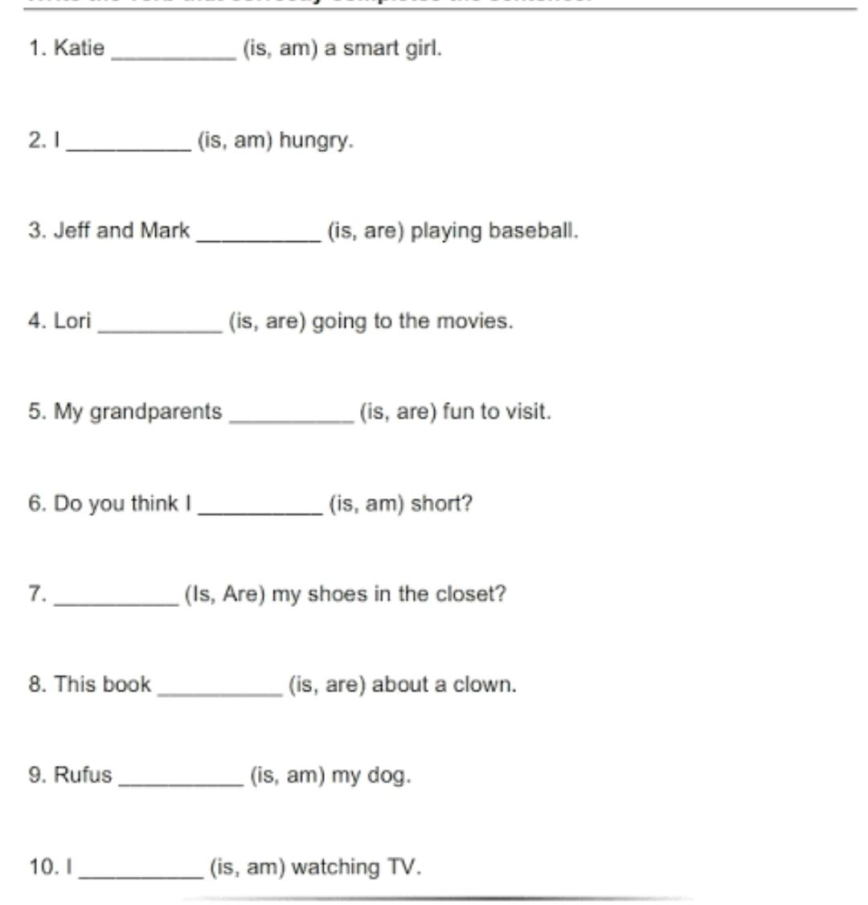

Q3 Make the Sentence- (with the help of have, has)

Q4 Comprehension

