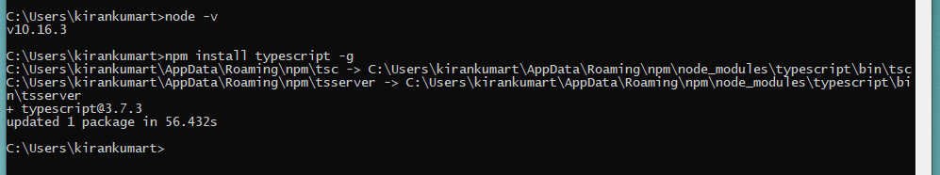

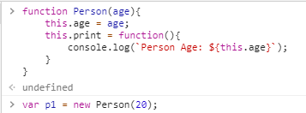

Below is reference, but the context changes.

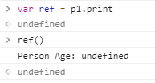

Bind p1 to the reference. Doesn’t change the context. This is explicit bind.

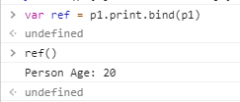

NPM Init creates package.json

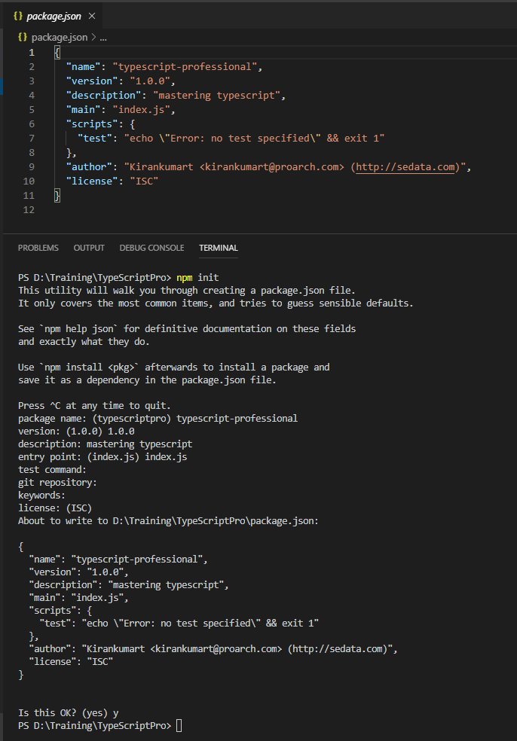

To create tsconfig.json

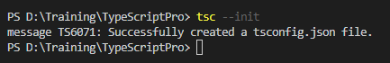

# Writing Declaration Files

First install lodash

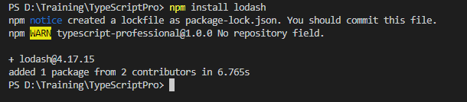

The folder name can be @types / typings

# Augmenting Modules with Declarations

We need to add @types folder

npm add @types/lodash

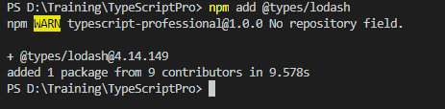

# tsconfig and Compiler Options

ES6 & ES2015 both are almost same.

ES5:

export class Person {

constructor(private name: string) {}

getName() {

return this.name;

}

}

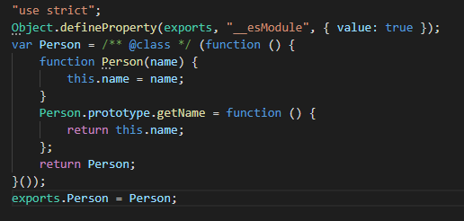

ES2015:

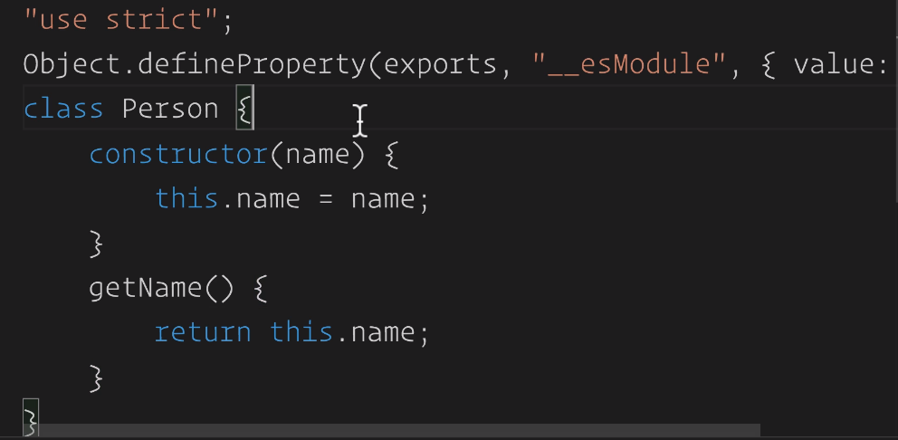

exports.Person = Person;

Default:

