Investigaing ultra reliable connections (URC).

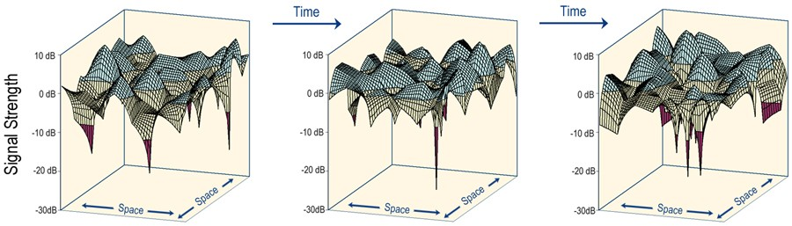

The 5G systems must include support for less common equipment. Epically the industrial settings and massive data collection. This could be a wireless controlled robot, witch would need low latency and ultra high reliability . Smart meters witch would require the ability to support a lot of users and support low signal strength because it would need to conserve it’s battery, (low receiver gain)

equipment

Diversity is a method to protect against deep fades -> we want to see if this is the case for very high fades. Channel receiver

*  

**Equipment and setup**

**Wireless channel and practical limitaions**

**Equipment and setup**

**Wireless channel and practical limitaions**

Noise floor

Signal power

Dynamic ragne

Measurement time

Bandwidth(Hz)

Number of samples(N)

Space(2D/3D)

Outage probability (PDF)

Problem statement

Log Log linear extrapolation in Rayleigh we want to fint out if this is a correct way in the URC case. So we nned to figure out how many samples we need or if we cant cheat. This is found in this sand that way.

The measurement that has been done [] is usually doing some measurement and tweaking them to a multipath fading model, usually Rayleigh for non-line of sight worst case scenario. We want to prove that there is a log log linear(Rayleigh) decay in a URC channel, down to 10^^-6 probability of fadeing gain..

* 

**Equipment and setup**

**Wireless channel and practical limitaions**