**Research Project Final Draft:**

**John Hopkins University – Computational Modeling for Policy and Security Analysis**

**Research Question and Theoretical Arguments**

In the month of January, the market value of GameStop ballooned from a low of $1.4 billion to a high of $33.7 billion, before deflating into the low-single billions in mid-February (DeNapoli, Herbst-Bayliss, Franklin, 2021). The spectacle that was GameStop’s share price, along with the other “stonks” promoted on the WallStreetBets Reddit page (Regnier, 2021), seems to directly contradict the efficient market hypothesis, and the idea of *homo economicus* (the assumption that humans act with perfection rationality, often used in economic models). These ideas underpin much of what we think we know about how markets (particularly securities markets) work, and without them it isn’t clear what drives prices in these markets. If the price of a security isn’t just the expected value based on public information of the security, then what is it? If individuals don’t always make trades that are rational (i.e. maximize future utility), then how do they make trades? How does all of this affect prices in the market? The answer to these questions has implications for large sums of money, as evidenced by the GameStop saga.

The efficient market hypothesis states that a market is efficient if the prices in the market reflect all public information, such that earning a return higher than the expected return is not possible (Fama, 1970). This means that at any given moment the price in the market reflects the expected return of the asset. Since markets are comprised of people buying and selling an asset, this implies that people are buying and selling an asset based on their assessment of the expected return of the asset, and further, that their collective assessment accurately reflects the expected return. If the people in the market buy and sell the asset irrespective of their assessment of the expected return, for example by herding (Bikhchandani & Sharma, 2000), or if their assessment is faulty in some way, for example by displaying irrational exuberance (Shiller, 2000), it is not clear what the price will reflect. My research will attempt to model how the trading strategies of participants in a market affect the price of the market.

My research will focus on exploring the price in the market relative to fundamental price of the underlying asset. With regards to stocks, the underlying asset is a share of a company. The fundamental value of that share is the share of the net-income (or free cash flow) that the share represents, as this is what can be returned to investors. However, as described above, not all investors trade based on the fundamental value of the asset – some traders make decisions about trading the asset based on their neighbors, or based on recent price movements. My model will examine how these trading strategies, and the propensity of traders to use these strategies influences the market price relative to the fundamentals of the underlying company.

Computational modeling will be used in this research because it is able to account for the heterogeneous strategies and actions of the market participants and determine how those micro strategies and actions affects the market as a whole. This research focuses on the strategies and actions of the individuals in the market, so it is absolutely necessary that the modeling method used is able to capture this. Other modeling methods do not possess the ability to account for a large number of actors with heterogeneous strategies and are thus not suitable for this research.

**Model Description**

My model simulates a marketplace for the stock of a hypothetical corporation (corporation C). Every time period in the simulation can be thought of as one trading day. The agents in the model are potential investors in corporation C, and there are two main types of investors: rational investors and irrational investors. These investors will differ in several ways, most importantly in how they determine whether to buy or sell shares of corporation C. There is also a third type of investor, influencers. These investors are also either rational or irrational, but unlike other investors, irrational agents will adjust their target price towards the influencer’s target price. Every turn the agents determine whether to buy or sell shares in corporation C, and will then either submit a buy/sell order, or submit no order. At the end of the round all orders are collected and settled, if possible. If all orders cannot be settled, the market price is adjusted in a direction that would encourage the market to settle. This price is known to all agents, and is used by all agents when determining to buy or sell shares in corporation C. It is also the variable of interest in this model and will be recorded after every transaction. The simulation ends exogenously, when the user decides to stop running the simulation. I will go into more detail about the components of the model below.

**The Corporation**

Corporation C will have three global variables that will influence the simulation: number of shares, share price (Pm), and net income (I). Corporation C will have 1,000 shares available to trade, will have a starting share price of $1, and will have a starting net income of $50. The number of shares available to trade will not vary throughout the simulation – all shares will be held by agents and those agents will determine whether to sell their shares. The share price will adjust at the end of every trading day in the direction that would settle the market; if more buy orders than sell orders were received, the price will adjust up to encourage more sell orders, the reverse is true if more sell orders are received. The net income will be updated every 65 turns, or roughly once a quarter in terms of trading days. The net income will be adjusted using the formula in figure 1 below; the new net income will be equal to the prior net income times one plus a random-normal number A, with mean that is set by the user (mean-ni-growth) and standard deviation that is also set by the user (sd-ni-growth). All agents will have access to the net income, but only the rational investors will use it in their decision-making process.

$$I_{t}=I_{t-65} * \left(1+A_{1} \right), A_{1}\sim N\left(mean.ni.growth, sd.ni.growth\right)$$

Figure 1: Net Income Adjustment

**Rational Investors**

The rational investors make determinations about whether to buy or sell shares in corporation C by comparing their expected return of shares of corporation C to the expected return of similar assets. The expected return of similar assets, or target return (Rt) is uniformly set to .05 across all rational investors. This could be thought of as a result of the Capital Asset Pricing Model - it is the minimum return the rational investor would need from corporation C in order to justify investing in it versus an asset with a similar risk profile.

Rational investors determine their expected return of corporation C by first calculating their expected future net income of corporation C four quarters from now. Every rational investor calculates their own expected future net income of corporation C. They all do this calculation using figure 2 below; their expected future net income is equal to the last reported net income times a random-normal number. The random-normal number has the same distribution to the one used to adjust the actual net income every quarter – its mean is mean-ni-growth, and its standard deviation is sd-ni-growth. This is because it is assumed that the rational investors have a solid understanding of corporation C, and thus are able to make predictions of future earnings that are in-line with the earnings actual distribution. The random-normal number used has the same distribution as the random-normal used to update corporation C’s net income, but rational investors raise the number to the fourth power after adding it to one. This is because rational investors are estimating the net income four periods from now. The rational investors’ expectation of net income is updated only when the actual net income of corporation C is updated.

$${E(I}_{t})=I_{t-65} * {\left(1+A_{1} \right)}^{4}, A_{1}\sim N\left(mean.ni.growth, sd.ni.growth\right)$$

Figure 2: Net Income Expectations

After rational investors have updated their expectations for future earnings, they determine their future expected price. This is done by multiplying the expected earnings per share (expected future earnings / 1,000) times a fixed price to earnings (P/E) ratio of 20. This equation is used because the P/E ratio is often used to determine if a share price is fairly-valued. For example, if corporation C is a utilities company and has a P/E ratio of 25, but the utilities sector has an average P/E ratio of 20, then one could say corporation C is over-valued. Doing the calculation this way assumes that all rational investors have the same expectation of the P/E ratio for the corporation, and expect that the price will reflect a fair valuation. This assumption is used so that the expected price of the share is tied to the fundamental value of corporation C.

Once the expected future price of the shares has been calculated the rational investors determine their target price (Pt), which is the market price (Pm) at which they would meet their target return (Rt). For example, if a rational investor’s expected share price was $1.05, then in order to achieve a 5% target return they would have to purchase the stock at $1. Thus, at a price up to $1, the rational investor will put in a buy order, because at those prices they are expected to meet or exceed their annual target return. At prices above $1, the rational investor will sell shares of corporation C, if they possess any, because at that price they will not meet their target return, and thus would rather invest in other assets that will meet their target return. If the rational investor does not possess any shares, and the price is above $1, they will not place any orders.

**Irrational Investors**

Irrational investors also determine a target price (Pt), however their target price is not tied to the fundamental value of the shares of corporation C. Irrational investors begin the simulation with a target price (Pt) that is a random number between 0.1 and 9.1. Similar to rational investors, when the market price is below their target price, irrational investors will submit a buy order, and when the market price is above their target price they will submit a sell order.

Irrational investors adjust their target price through a multi-step process. In the first step of this process, if irrational investors own at least 1 share, they compare the current market price to a price from a prior trading day. This prior trading day is some number of days back, equal to the irrational agents’ “memory”, which is a random-integer between 30 and 99 set at the beginning of the simulation. If the current price is less than the price from this prior trading day, the agent sets their target price to 0, and will stop updating their target price for 30 turns. In that case, the agent will not complete the rest of the steps described below. This is done to simulate the behavior of investors when a financial bubble pops – when irrational investors no longer believe the asset price will continue to increase, they flee.

If the number of turns in the simulation isn’t equal to or greater than the agent’s “memory”, the agent skips this step. If the current market price is greater than the prior market price, then the agent continues to the next steps. When agents begin adjusting their target price again, after previously fleeing, they will set their target price to that of the nearest influencer. The agent then will skip this step for a number of turns equal to their memory. For example, if an agent resumes adjusting their target price at turn 100, and their memory is 30, they will not compare the market price to a prior market price until turn 130.

In the next step of the process, irrational investors compare the market price from the previous turn to the current market price. If the price has gone down, they will adjust their target price down by 1% of their current target price. If the price has gone up, they will adjust their target price up by 1% of the current market price. Additionally, if the price has gone up, irrational agents will adjust their target-price by 10% of the difference between their current target-price and the target-price of the nearest influencer.

**Influencers**

Influencer investors can either be rational or irrational. If the influencer is a rational investor, they update their target price in the same exact way that a rational investor does. If the influencer is an irrational investor, they have a 1 in 65 chance of updating their target price. On the occasions that they do update their target price, they do it by multiplying the current target price by a random float between 0 and 10.

**Placing Orders**

After all agents have updated their target-prices, they decide what order to place, if any. All agents make these decisions in the same way. If the current market price is above their target price, they decide to make a sell order. If the current market price is below their target price, they decide to make a buy order. Each buy and sell order are for one share.

**Market Clearing**

Every turn rational investors, and irrational investors will make decisions about whether to buy or sell. These decisions are made using the market price (Pm) of the last turn. This is the price that rational and irrational investors will compare to their target price prior to submitting a buy or sell order. Once an agent decides to buy or sell, they then decide how many orders they would like to place, and then they place those orders. Every order is recorded, along with the target-price of the agent that made the order.

At the end of every turn, after all buy and sell orders have been recorded, the orders will attempt to be settled. If more buy orders than sell orders are recorded, then all the sell orders are automatically settled at the current market price, meaning each agent that placed A sell order will lose that 1 share and gain the market price in cash. Then, a random number of buy orders equal to the amount of sell orders received are settled. For every buy order selected, the agent who placed the order gains one share and loses an amount of cash equal to the market price. After this, the price is adjusted up by a percentage equal to the difference between the number of sell orders and number of buy orders divided by 500. This is price-adjustment method would result in a 20% price increase if all agents submitted a buy order, and none a sell order. The price-adjustment was designed this way, because a 20% increase in a day is the threshold the NYSE uses to halt trading for the day (NYSE 2021). This method of adjusting the price, adjusting the price by some factor of the difference between supply and demand, is commonly used in agent-based markets (LeBaron 2001).

If there are more sell orders than buy orders then everything is switched. All of the buy orders are automatically settled, a random number of sell orders are settled, and the price is adjusted down by a percentage equal to the difference between the number of sell orders and number of buy orders divided by 500. If there were an equal amount of buy and sell orders, or if there were no orders placed at all, then the market price does not change.

**Initialization**

When the model is initialized, 100 agents will be created on a 10 x 10 grid, with each agent occupying one space on the grid. The agents will be split between rational investors and irrational investors by using a user-selected ratio, and a random selection of investors equal to the number selected by the user will be influencers, but the location will be random, i.e. there is no logic controlling where rational or irrational agents are placed. Each agent will be given $50 in cash that can be used to purchase shares. Additionally, the 1,000 shares of company C will be split uniformly across all of the agents. Irrational agents will also be assigned a memory, which is a random integer between 30 and 99. All of the other agent variables will be determined as described above.

**Visual Representation**

The agents in the model exist on a 10 x 10 grid that wraps both horizontally and vertically. Agents are randomly placed on the grid, with each agent occupying one space, and do not move at any point. The physical space is primarily only important for irrational agents, whom adjust their target-price based on the nearest influencer on the grid. Other than that procedure, the physical location of the agents does not actually impact the model.

Agents are assigned a color that correspond to their investor type – irrational agents are colored orange, while rational agents are colored green – and influencer agents are designated by their “star” shape, while non-influencer agents are triangles. Irrational agents that have stopped updating their price-target are colored black. Throughout the simulation the patches are given different colors based on the agent of that patch – a light blue if the agent wants to buy shares, a light brown if the agent owns shares and would like to sell them, and black if the agent would like to sell shares but does not own any. These colors do not impact the simulation, but are for reference as the simulation runs.

**Steps**

1. Set the market price to $1 and net income to $50.
2. 100 agents are created, with a user-selected ratio of rational to irrational investors, and a user selected number of influencers. Agents are randomly place on the grid.
3. Agents are assigned a $50 in cash, and are given a uniform amount of corporation C’s 1,000 shares.
   1. Irrational agents are assigned a target-price that is a random integer between 0.1 and 9.1.
4. Irrational agents are assigned a memory, which is an integer between 30 and 99.
5. If the time variable t is divisible by 65, a new net income is calculated and set.
6. All agents update their target price.
   1. Rational agents
      1. If the net income changed this period, re-calculate the expected future net income. Then use the expected future net income to determine the expected future price. Then use the expected future price and the target return to determine the target price.
   2. Irrational agents
      1. If the number of ticks is greater than the agent’s memory, and the agent owns at least one share, the agent will look at the price from a number of ticks ago equal to their memory. If the price they look at is greater than the current market price, the agent sets their target price to .01, and will not update their target price again for 30 turns. When the agent begins updating their target price again, they will skip this step until they have been updating their target price again for a number of turns equal to their memory. If the number of ticks is less than the agent’s memory, or the price the agent looks at is less than the current price, the agent goes to the next step.
      2. If the market price went down last period, the agent adjusts their target price down by 1% of their current price target.
      3. If the market price went up last period, the agent adjusts their target price up by 1% of the current price. The agent also adjusts their price target by 10% of the difference between their price-target and the nearest influencer’s price target.
   3. Influencers
      1. If an influencer is rational, they update their price target through the same method as other rational agents.
      2. If an influencer is irrational, they have a 1 in 65 chance of updating their price target every turn. On the occasions they do update their price target, they do it by multiplying the current price by a random float that is greater than or equal to 0 and less than 10.
7. All agents determine if they would like to buy/sell, and then submit their orders.
   1. If the agent’s target price is higher than the market price, they submit a buy order.
      1. If the target price is higher than the market price, but the agent does not have any cash available, the agent does nothing.
      2. If the agent has enough cash available, they will submit a buy order for one share.
   2. If the agent’s target price is lower than the market price, and the agent owns at least 1 share of company C, submit a sell order.
      1. If the target price is lower than the market price, but the agent does not own at least 1 share of company C, the agent does nothing.
      2. If the agent owns at least one share, they will submit sell order for one share.
8. The market settles all of the orders.
   1. If there are more buy orders than sell orders:
      1. All sell orders are automatically settled.
      2. A random number of buy orders equal to the number of sell orders are selected and settled.
      3. The buy orders are sorted in descending order by their target price, and a number equal to the difference between sell orders and buy orders is selected from the top.
      4. The current price is adjusted up by a percentage equal to the difference between the number of sell orders and number of buy orders divided by 500.
   2. If there are more sell orders than buy orders:
      1. All buy orders are automatically settled.
      2. A random number of sell orders equal to the number of buy orders are selected and settled.
      3. The current price is adjusted down by a percentage equal to the difference between the number of sell orders and number of buy orders divided by 500.
   3. If there are an equal amount of buy and sell orders:
      1. All orders are settled and the market price stays the same.
   4. If there are no buy or sell orders:
      1. No orders are settled and market price stays the same.
9. Repeat steps 4-7 until the user stops the simulation.

**Simulations**

My model examines the relationship between irrational (or non-fundamental) trading strategies and the market price of an asset. In order to test this relationship, I conducted multiple simulations with varying levels of irrational agents. I conducted simulations with a high level of irrational agents (90 of the 100), a medium number (50 of 100), and a low number (10 of 100). I also varied the mean-ni-growth and sd-ni-growth. I varied these parameters so that they reflect different types of shares (e.g. a value stock versus a growth stock) and market conditions to determine if the effects of irrational traders in the market are more forceful on certain types of assets/market conditions. I selected three values each for mean-ni-growth and sd-ni-growth. These values are in table 1 below. These values were meant to capture a low, medium, and high for both mean-ni-growth, and sd-ni-growth. These specific values were calculated using the Corporate Profit After Tax data from FRED (U.S. Bureau of Economic Analysis 2021): the medium values are the mean/standard deviation in the percent change of corporate profits by quarter from January 1947 - October 2020, the high values are the max mean/standard deviation from a rolling 10-year window of percent change in corporate profits by quarter from January 1947 – October 2020, and the low values are the minimum mean/standard deviation from a rolling 10-year window of percent change in corporate profits by quarter from January 1947 – October 2020. Each combination of settings was simulated ten times, for a total of 270 simulations. Each simulation lasted 2600 turns, or about 10 years in trading days.

|  |  |  |  |
| --- | --- | --- | --- |
| **Figure 3: Simulation Parameter Values** | | | |
|  | **Low** | **Medium** | **High** |
| **Mean-ni-growth** | 0.2% | 1.8% | 3.9% |
| **Sd-ni-growth** | 2.7% | 7.3% | 12.2% |
| **Irrational Agents** | 10 | 50 | 90 |

**Results**

During the simulations the current market price and net-income of corporation C was recorded. Using the net-income, mean-ni-growth, and sd-ni-growth, a range of values can be created that reflects what the fundamental value of the corporation C’s shares would be given extremely unlikely growth in its net-income. This range can be constructed using the same mechanisms that rational agents use to update their prices, except instead of using a random normal number, the mean-ni-growth plus or minus 3 standard deviations is used. After the range of future net income is calculated, it can be converted into a range of fundamental share prices by dividing by 1000, multiplying by 20 (the price to earnings ratio), and then discounting by 5%. This is shown in figure 4 below.

$$P=20* \frac{\left(I * {\left(1+(mean.ni.growth ±3*sd.ni.growth \right)}^{4}\right)}{1000*1.05}$$

Figure 4: Fundamental Value Range

The fundamental value range can then be compared to the current price in the simulation to determine if the price reflects the fundamental value of corporation C, or is wildly speculative. Since the range captures 99.7% of the possible future values of net income, any price that is outside of the range can be assumed to no longer have any ties to the fundamental value of corporation C.

Using this methodology, turns where the market price is outside of the range can be labelled as a “bubble”. These days can be counted to compare how many days on average each combination of parameters was in a “bubble”, and how many total “bubbles” there were. Figure 5 below shows an example of a simulation, and how the fundamental price range is used to classify certain periods as “bubbles”. In the figure, the current market price mostly stays within the fundamental price range, but there are three episodes where the current price exceeds the range, if even for a moment. Each time the price exceeds the fundamental price range, we can note that a bubble has formed, and each day that the price is outside of the fundamental price range we can count as a day in “bubble territory”.

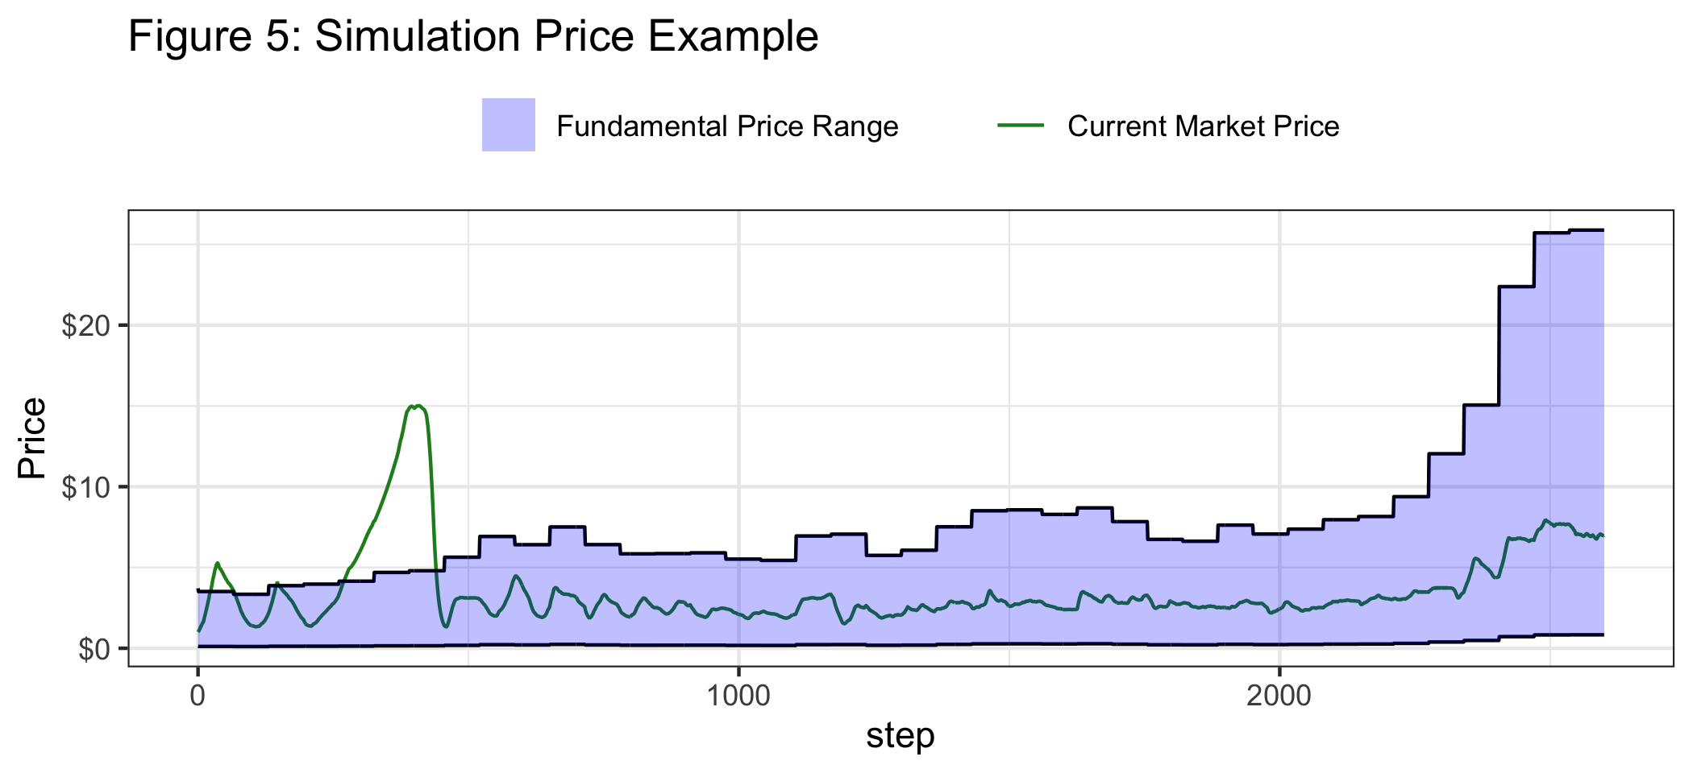

Figure 6 shows the average number of bubbles for each combination of parameters, and Figure 7 shows the average number of days in bubble territory for each combination of parameters. The results show one thing very clearly: the more rational agents there were in the model, the less likely the prices in the market were to be in “bubble territory”. This result is intuitive; since the fundamental price range is basically captures 99.7% of the possible target prices of rational agents at any given time, it makes sense that a market full of mostly rational agents would not exceed that range.

The results of the varying values of sd-ni-growth and mean-ni-growth are a bit less intuitive. The low standard deviation simulations seem to produce more days in a bubble than the high standard deviation models. This is surprising, because “risky” assets (those with high standard deviations) are often thought to be prone to bubbles. But when bubbles are defined this way, as relating to the fundamental value of an asset, it becomes clear why low standard deviation markets tended to have more days in bubble territory: a low standard deviation meant a smaller fundamental price range. In a high standard deviation market, the range of possible fundamental prices can be massive, which prevents otherwise irrational trading from leading to bubbles. Because there is so much uncertainty in the fundamental price of the asset, it is harder for the market to be labelled a “bubble”.

It is not hard to find real world examples of this today. For example, Tesla shows this dynamic perfectly. From January 7th, 2020 to December 30th, 2020, Tesla’s share price grew about 6.4 times larger. In that time span, the Tesla’s net income did not grow 6.4 times larger, but yet many institutional investors defend the stock against accusations of a bubble by citing the its huge potential growth opportunity of the electrical vehicle market (Clifford 2020). While the growth in the price of the shares may seem rapid, it reflects the huge potential that Tesla has, and the wide range of outcomes for the corporation. It is hard to define a bubble when there is so much uncertainty in the fundamental value of an asset.

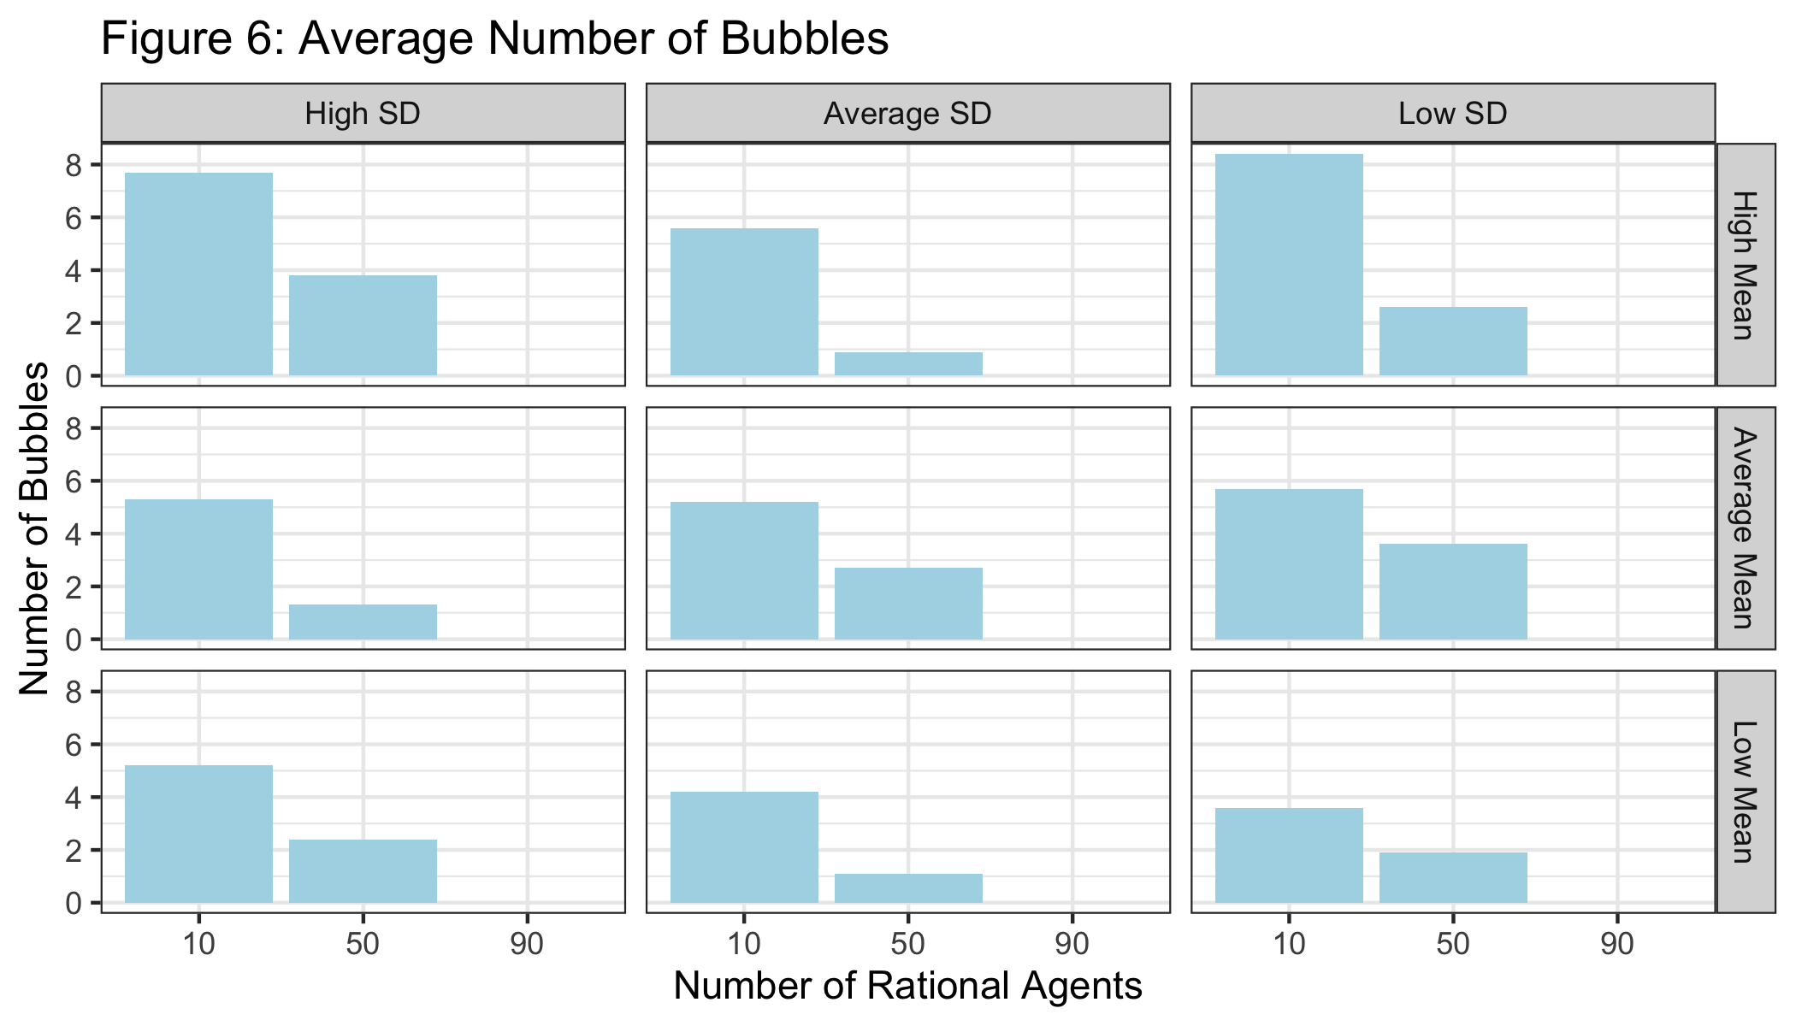

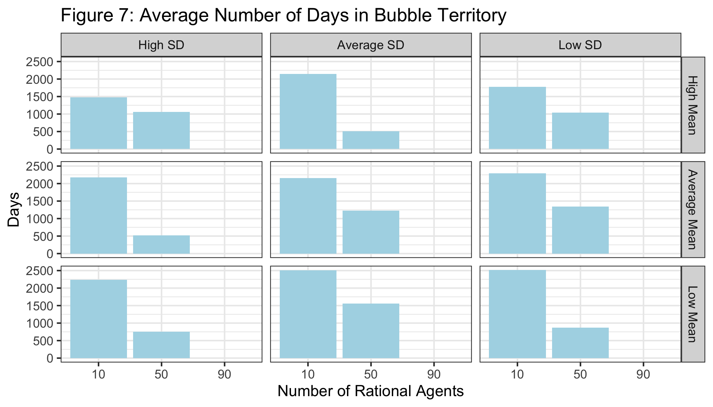

**Implications**

The results of my model provide a couple of implications for policy makers. First, having more rational agents in the market makes the market more rational. If a market tends towards bubbles, having more agents, or money, in the market that values that asset based on its fundamentals should reduce the amount of bubbles in the market. The second, more interesting implication, is that not all seemingly ludicrous valuations or asset price swings need be a sign of a bubble. Assets with a truly wide range of fundamental values, or market conditions that are especially volatile, have a wide range of fair prices. This does not reflect that the market is full of irrational traders, but instead that the market itself does not have a clear fundamental price.

**Improvements**

There are quite a few ways this model could be extended. Many of the settings are hard coded into the model. For example, the discount rate that rational agents use is hard coded as 5%, and the memory of irrational agents is hard coded as a random number between 30 and 99. These settings could be configured, either by hard coding over them, or by creating using the NetLogo user interface to make them configurable. This would allow for making the model more adaptable to real-world scenarios.

The model assumes that all rational agents stay rational, and all irrational agents stay irrational. It seems more plausible that in the real-world some rational traders would become irrational during large swings in prices, and some irrational traders might become rational during moments of calm in the market.

The model gives every agent a fixed amount of cash and shares at the beginning of the simulation. These amounts could be adjusted. It would be particularly interesting to study how the initial ratio of cash and shares between rational and irrational agents affects market outcomes.

Additionally, because the amount of cash does not change over time, the simulation really can't be run for a long amount of time - eventually the fundamental value of the company will be above what anyone in the market can afford to pay. It would be great if there was a method for introducing more cash to the market. This would also allow for starting the agents with less cash - the total amount of cash that the all the agents start with ($5,000) is enough to buy the company five times over at the start of the simulation, which seems a bit excessive, and often starts a bubble, but is necessary since there is no method to introduce more cash.

**References**

Bikhchandani, S., & Sharma, S. (2000). Herd behavior in financial markets. Washington, DC: Internat. Monetary Fund.

Blake LeBaron. (2001). A builder's guide to agent based financial markets. Quantitative Finance, 1(2), 254-261.

Jessica DiNapoli, Svea Herbst-Bayliss, Joshua Franklin. (2021). Exclusive: How GameStop missed out on capitalizing on the reddit rally. Retrieved from <https://www.reuters.com/article/us-retail-trading-gamestop-capitalraise-idUSKBN2AB14F>

Lee Clifford. (2020). Tesla stock at $780? it could happen says goldman sachs. Retrieved from <https://fortune.com/2020/12/06/tesla-stock-tsla-sp-500-outlook-golman-sachs-780-stock-market-spx/>

NYSE.NYSE: Trading information. Retrieved from <https://www.nyse.com/markets/nyse/trading-info>

Regnier, P. (2021). Stonks are bonkers, and other lessons from the reddit rebellion. Retrieved from <https://www.bloomberg.com/news/features/2021-02-04/gamestop-gme-how-wallstreetbets-and-robinhood-created-bonkers-stock-market>

Shiller, R. J. (2000). Irrational exuberance. Princeton [u.a.]: Princeton Univ. Press. Retrieved from <http://bvbr.bib-bvb.de:8991/F?func=service&doc_library=BVB01&local_base=BVB01&doc_number=013098181&sequence=000001&line_number=0001&func_code=DB_RECORDS&service_type=MEDIA>

U.S. Bureau of Economic Analysis, Corporate Profits After Tax (without IVA and CCAdj) [CP], retrieved from FRED, Federal Reserve Bank of St. Louis; https://fred.stlouisfed.org/series/CP, May 6, 2021.