Blockchain social network powered by Ethreum smart contracts

Khanh Linh Tran   
Faculty of Information Technology  
Industrial University of Ho Chi Minh City Ho Chi Minh, Viet Nam  
email: ktpmlinh2002@gmail.com

Hoang Chung Nguyen  
Faculty of Information Technology  
Industrial University of Ho Chi Minh City Ho Chi Minh, Viet Nam  
email: hoangchung35715@gmail.com Le Thien Tran  
Faculty of Information TechnologyIndustrial University of Ho Chi Minh CityHo Chi Minh, Viet Nam  
email: tranlethien2002@gmail.com

Minh Huu Cao   
Faculty of Information Technology  
Industrial University of Ho Chi Minh City Ho Chi Minh, Viet Nam  
email: caominhhuu2108@gmail.comMinh An Nguyen   
Faculty of Information TechnologyIndustrial University of Ho Chi Minh CityHo Chi Minh, Viet Nam  
email: nminhan2002@gmail.com

***Abstract***— Nowadays, the social network has become an indispensable part of everyone's life. Most applications and social networks use a centralized model to store data. The management or use of data is carried out secretly by the companies that own the social network, which can cause insecurity for the customer's data. To solve that problem, social networking projects using a decentralized model emerged. In this social network, all users can control and contribute to the management, helping to increase the security and transparency of the social network's activities. However, social networks using this model have not yet been widely used, partly due to the complexity of blockchain technology, which requires a deep understanding to be able to deploy the system. Therefore, to make it easier for everyone to access and use, we have developed a decentralized social network, applying blockchain technology to store posts, and at the same time applying We also have the function of tip and vote for the posts, the poster will receive an amount of tokens corresponding to the number of votes on the posts. The purpose of using blockchain and the voting function for posts is to make posts more trustworthy, easier to authenticate, and at the same time encourage users to actively write and improve quality posts to close contribute to the community. To implement our application based on blockchain technology, knowledge of Web programming and Smart contract.Based on the above functions to realize the social network using the decentralized model.

Keywords—Social networks, blockchain

# Introduction

Social networks are platforms for people to connect with each other on the internet, where they share information through posts. Research from Chaffey [1] shows the popularity of social networks

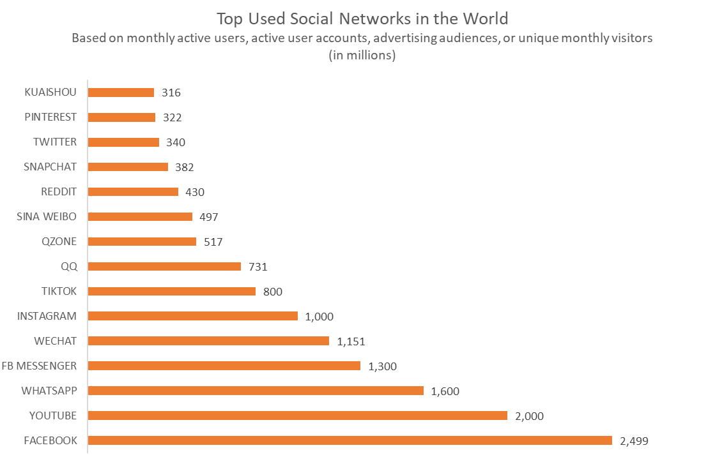

*Figure 1. Top used social networks in the world*

Nowadays, social network has become an indispensable part of everyone's life. Most applications and social networks use a centralized model to store data. The management or use of data is carried out secretly by the companies that own the social network, which can cause insecurity for the customer's data.

# Related work

Decentralized social networking projects using blockchain technology appear to solve this problem.. Because blockchain provides a secure, transparent mechanism that reduces costs by eliminating third-party verification. Tuesday. three, etc. However, social networks using this model are still not widely used, partly due to the complexity of Blockchain technology, which requires a deep understanding to be able to develop a mining system. waterfall. So, to make it easier for everyone to access and better use, we have developed a decentralized social network. Applying blockchain technology to store articles. The purpose of using blockchain and voting for posts is to make the post more trustworthy, and to support the author with money, this encourages users to actively post, improve the quality of the article, contribute to the community. Besides, to make the post easy to display, the author can register as a member of the social network.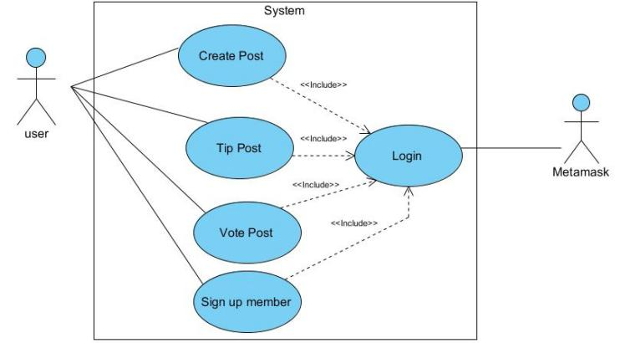

*Figure 2. Usecase*

# Methodology:

To build a social network with the above functions, we design a solution for the proposal using blockchain technology and smart contract programming. Blockchain is used to store article data, ensuring the integrity and security of the data. Smart contract is used to perform the functions of the social network.

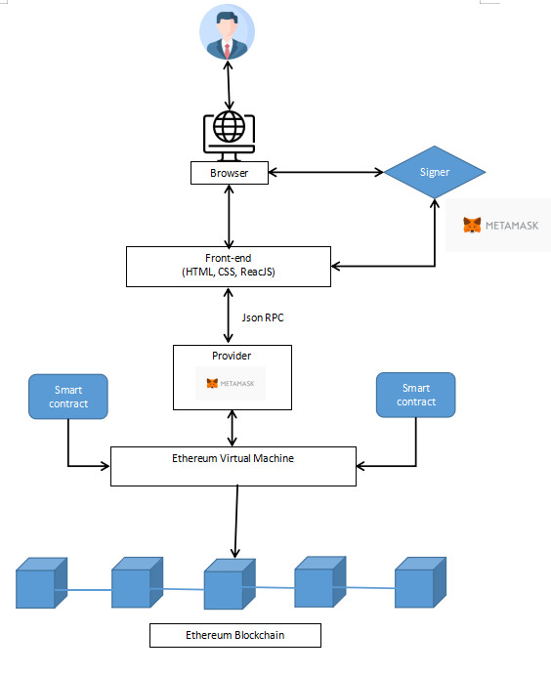

*Figure 3. system overview*

# Implementation

### Create Post

When the user creates a post, the system will check the user's balance, and if eligible, it will create a post and store the post on the blockchain.

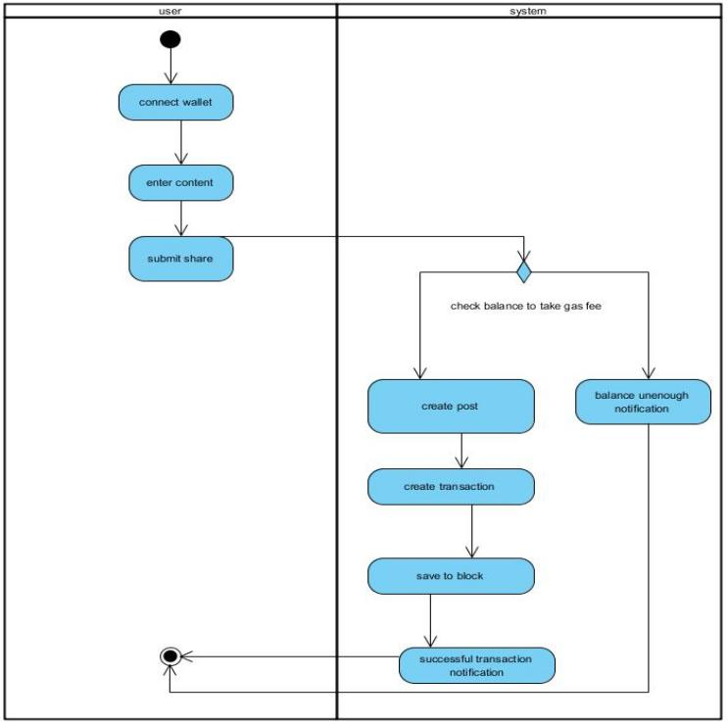

*Figure 4. activity diagram create post*

### Tip Post

Users can tip posts with good content to support the author.

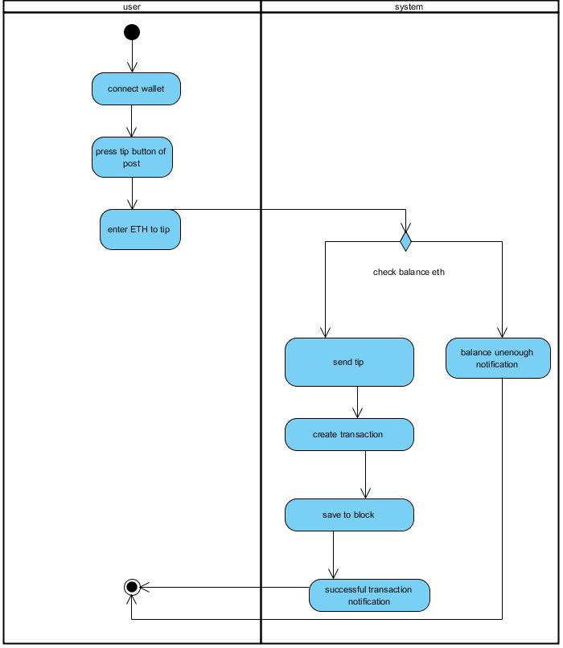

*Figure 5. activity diagram tip post*

### Vote Post

Vote for a post is like donating money to the post owner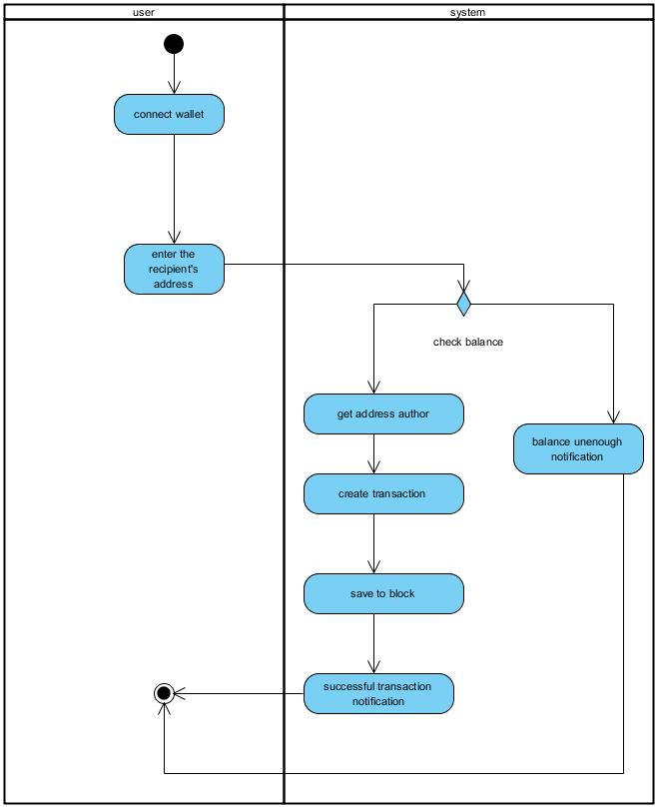

### Sign up member

Register as a member to get priority post display.

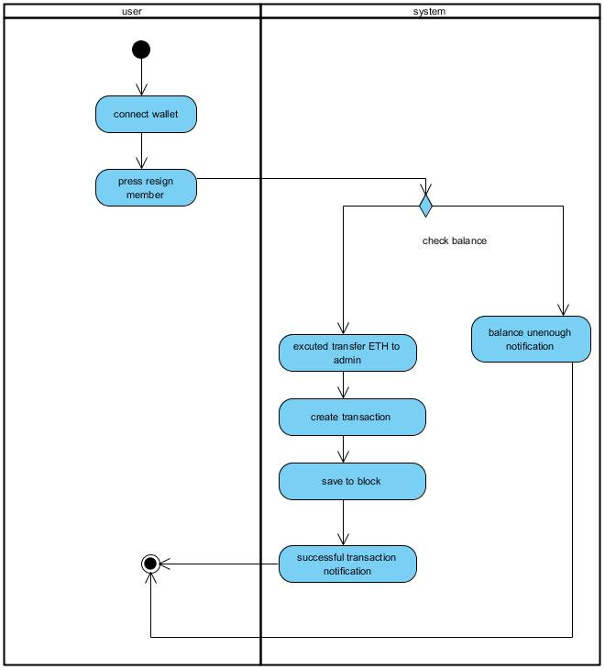

*Figure 7. activity diagram resign member*

# Result & Conclusion

We also have the function of tipping and voting for post, the poster will receive an amount of tokens corresponding to the number of votes on the articles. The purpose of using blockchain and the voting function for articles is to make articles more trustworthy, easier to authenticate, and at the same time encourage users to actively write and improve quality posts to better contribute to the community.

Link: https://github.com/tklinh2002/Group1_BuildSocialNetWork

*References*

1. D. Chaffey, "Global social media research summary 2020.

*Figure 6. activity diagram vote post*