|  |
| --- |
| CSI 5324 |
| CS Department Automated Information Timeline |
| Spring 2024 Project Group |

|  |
| --- |
| Pawan Bhandari, Sarah Faron, Matthew Hays, Tim Klimpel  1-15-2024 |

Table of Contents

Team Trello Board 2

Team Gantt Chart 3

Linked PDF of Project export 3

Table of Figures

Figure 1 - Team Trello Board screenshot as of 15-Jan-2024 2

Figure 2 - Gantt Chart as of 15-Jan-2024 3

# Team Trello Board

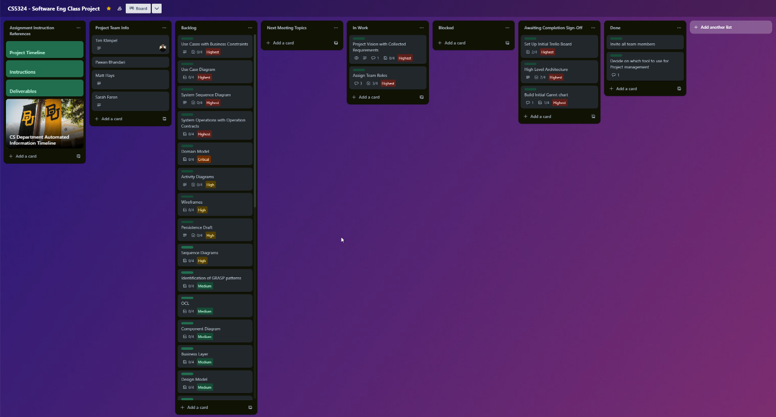A Screen shot of the teams Trello board is captured below:

Figure - Team Trello Board screenshot as of 15-Jan-2024

# Team Gantt Chart

Current view of Gantt chart, as exported from GanttProject.

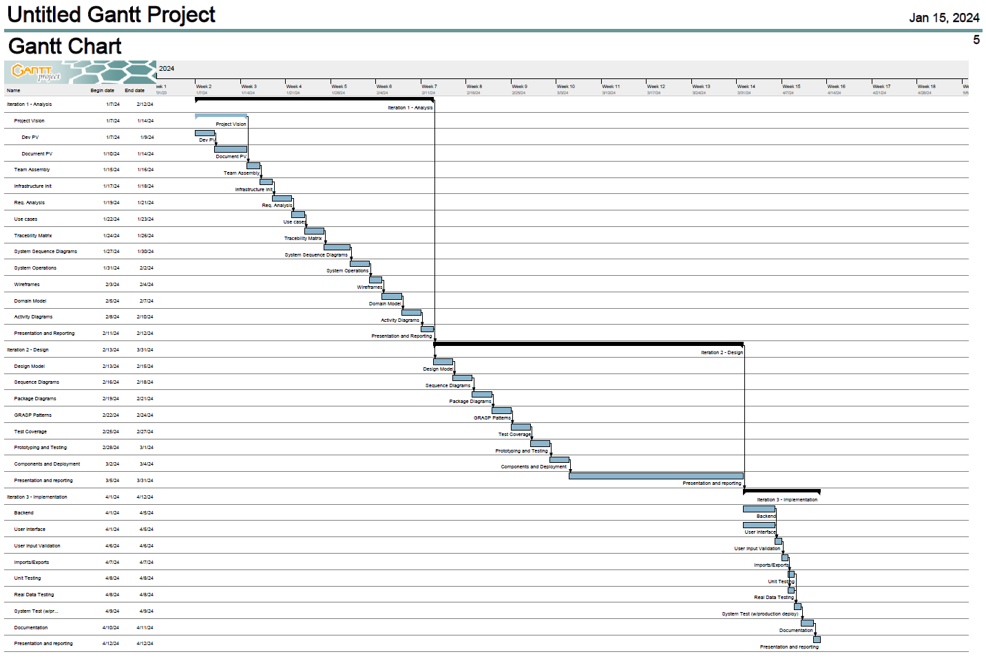

Figure - Gantt Chart as of 15-Jan-2024

## Linked PDF of Project export

Double clicking this link will open the project as a PDF for viewing

