Topology

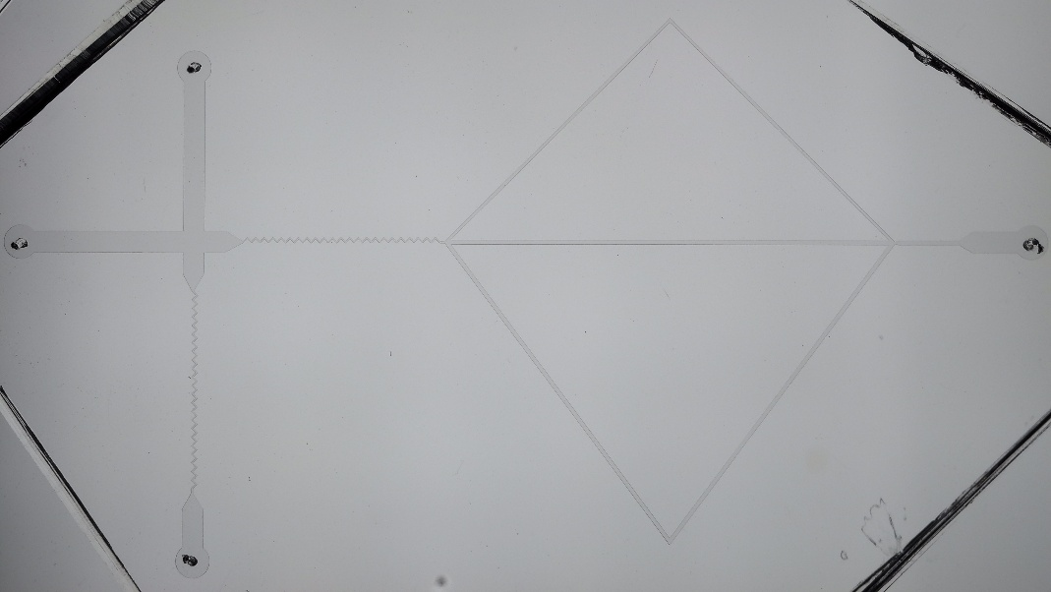

Parameters

|  |  |  |
| --- | --- | --- |
| Variable | Value | Description |
| $T_{p}$ | $500$ ms | duration of pulses |
| $m_{Tart}$ | $0.4518$ g | mass of Tratrazine for the dye solution |
| $V_{H2O}$ | $10$ mL | Volume of water for the dye solution. |
|  | 7.4 cm | Length of the hydraulic resistor of 100um diameter  connected to the supply chain |
|  | 8.5 cm | Length of the hydraulic resistor of 65 um diameter (black cable)  connected to the input gate. |
|  | 16.8 cm | Outlet pipe, circular cross-shape |
|  | 8.3 cm | Gate outlet |