Experiment of May 27, 2026
Topology
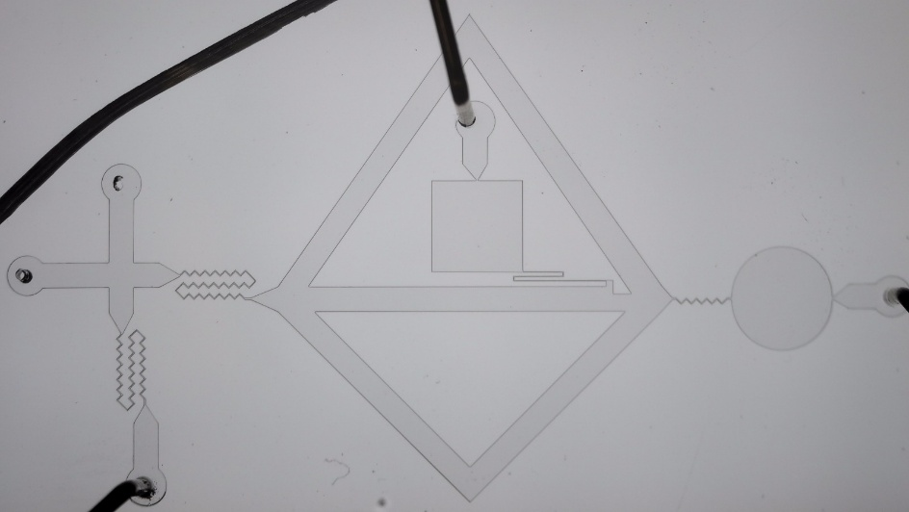

Parameters
Variable | Value | Description
$T_{p}$ | $500$ ms, $1$ s, $1.5$ s | duration of pulses
$m_{Tart}$ | $0.4518$ g  $0.4541$ g  14_Oct_2025 | mass of Tartrazine for the dye solution
$V_{H2O}$ | $10$ mL | Volume of water for the dye solution.
 | 7.4 cm | Length of the hydraulic resistor of 100um diameter  connected to the supply chain
 | 8.5 cm | Length of the hydraulic resistor of 65 um diameter (black cable)  connected to the input gate.
 | 16.8 cm | Outlet pipe, circular cross-shape
 | 8.3 cm | Gate outlet

