Layout Editor

Export your hatched design in Autocad to a dxf file.
Open the exported dxf file in Layout Editor.

Place areas to manage on different layers
- Hide unused layers as indicated in the image below. For that double clic in the Layer area and select Hide Unused Layers
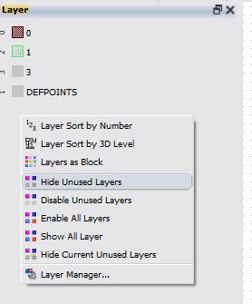
- Now you need to separate different areas into layers to perform the Boolean operation of subtraction
- Double-click on the areas you want to move to another layer, in the new window, select layer 3, see the image below. Repeat the process to locate areas to subtract in a common layer 3. After the areas are moved the design should looks like this one in Fig. 3

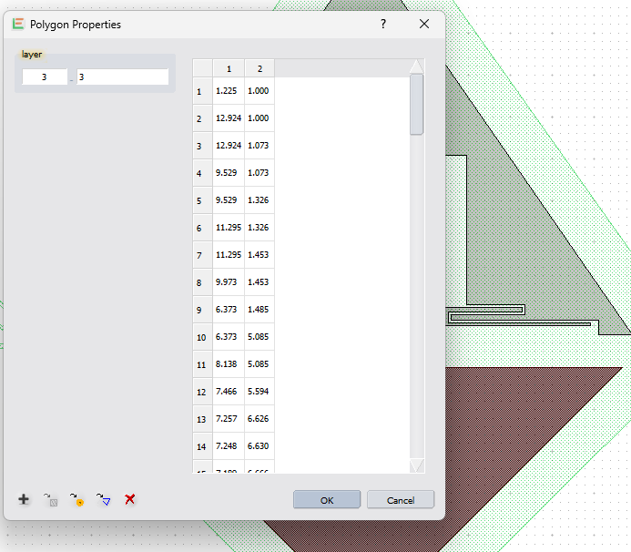

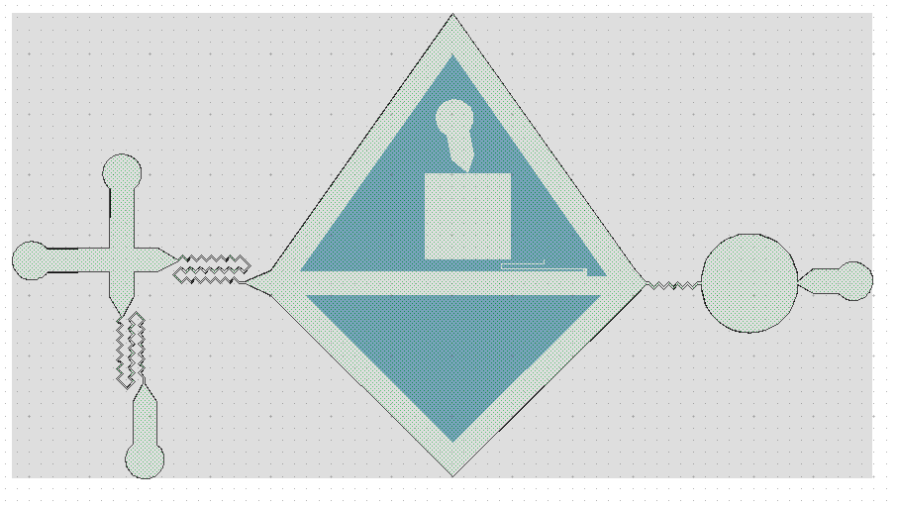
Fig. 3: Areas after moved.
Boolean operation
- Got to Menu / Utilities / Boolean Tools / A-B, see the image below.
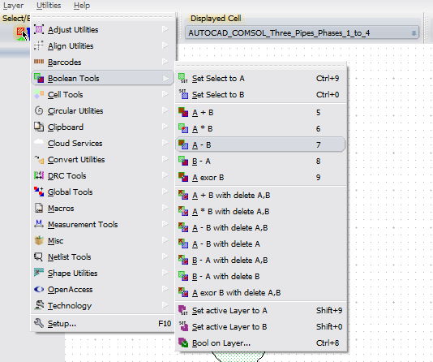
Fig. 4: Opening the Boolean Operation window

- A new window appears (Boolean Operation) where you have to select set A. To do so, you click on the area in the canvas, and later click on the button “add selection” (placed on the Boolean Operation window). See Fig. 5.
- Locate in set B the other areas you want to subtract. Select first the area, and then select add selection in the section for set B (which is placed on the Boolean Operation window)
- Select in both areas the option “delete after operation”
- Click on the Boolean operation button that indicates A-B.
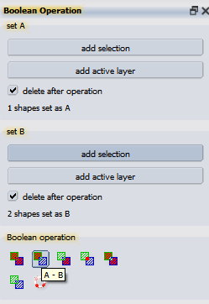
Fig. 5: Boolean Operation window.

