Two-stage IFFL differentiator, counter and neuron
Circuit specification and mapping status
Target network: Puniya2021_TNM1055 (human T cell, 5179 reactions, 3153 metabolites) · 21 October 2026

This document records the circuit as the mapping code currently builds it, the switches that define each variant, and an analysis of why the search has not yet returned a complete mapping. It is written so that the variants in §5 can be varied one at a time without re-deriving the rest.

1. Purpose and scope
The circuit computes a second derivative of a chemical input, counts the resulting events, and passes the count through a single affine neuron. It is built from four blocks:
- Block 1 — differentiator 1. Incoherent feed-forward loop (IFFL). Output m_d1 encodes the first derivative of the input.
- Block 2 — differentiator 2. The same primitive applied to m_d1. Output m_d2 encodes the second derivative.
- Block 3 — counter. Converts m_d2 into an accumulating species m_c, with reset and input sequestration.
- Block 4 — single neuron. Reads m_c catalytically, adds a bias, and produces m_out = w[m_c] + m_b.
The intended physical realisation is a cell-free reactor in which every enzyme and substrate is loaded deliberately. This matters throughout: co-substrates are saturated by design, removal steps may be supplied rather than borrowed from metabolism, and rate constants are set by enzyme loading rather than inherited from the cell.

2. Nomenclature
Every role carries a block suffix: _1 for differentiator 1, _2 for differentiator 2. Species that cross blocks keep unsuffixed names. The invariant is that a reaction and the species it produces share a name: r_Sf_1 produces m_Sf_1.
Symbol | Role
r_Fd_k | Fast arm. Produces the gate from the stage input.
m_Fd_k | Gate. Activates the degrader catalytically; never consumed by it.
r_Fr_k | Gate removal. Clears m_Fd_k so the gate can fall again.
r_Sf_k, r_Sd_k | Slow arm, two reactions, via the intermediate m_Sf_k.
m_d1, m_d2 | Stage outputs.
r_I_k | Saturated degrader of the stage output, gated by m_Fd_k.
r_lk_k | Output leak. Sets the resting level of the stage output.
r_A_2, m_in_2 | Catalytic interstage and its product, D2’s input.
r_c, m_c | Counter production and counter state.
r_I1, r_I2 | Counter reset and input sequestration.
r_Nw, r_Nb, r_Nr | Neuron weight, bias and output removal.

3. Topology as currently implemented
Reactions are nodes; metabolites are the arrows between them. Dashed edges are catalytic: the regulator is read and never consumed.

3.1 Blocks 1 and 2 — the differentiators
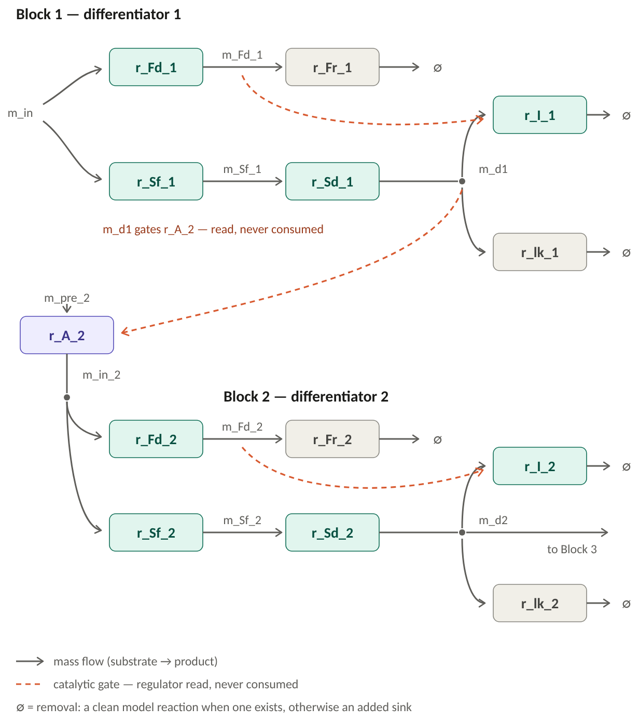
Figure 1. The two differentiator stages. Each has a one-reaction fast arm producing the gate, a two-reaction slow arm producing the output, a saturated degrader gated by m_Fd_k, and two removal steps. The stages are joined by the catalytic interstage r_A_2.
Each stage subtracts by activation: the fast arm raises the gated degradation of the output before the slow arm raises its production, so a rising input produces a transient excursion in the output. The gate appears in no stoichiometry anywhere, which is what keeps the subtraction non-consuming.

3.2 Blocks 3 and 4 — counter and neuron
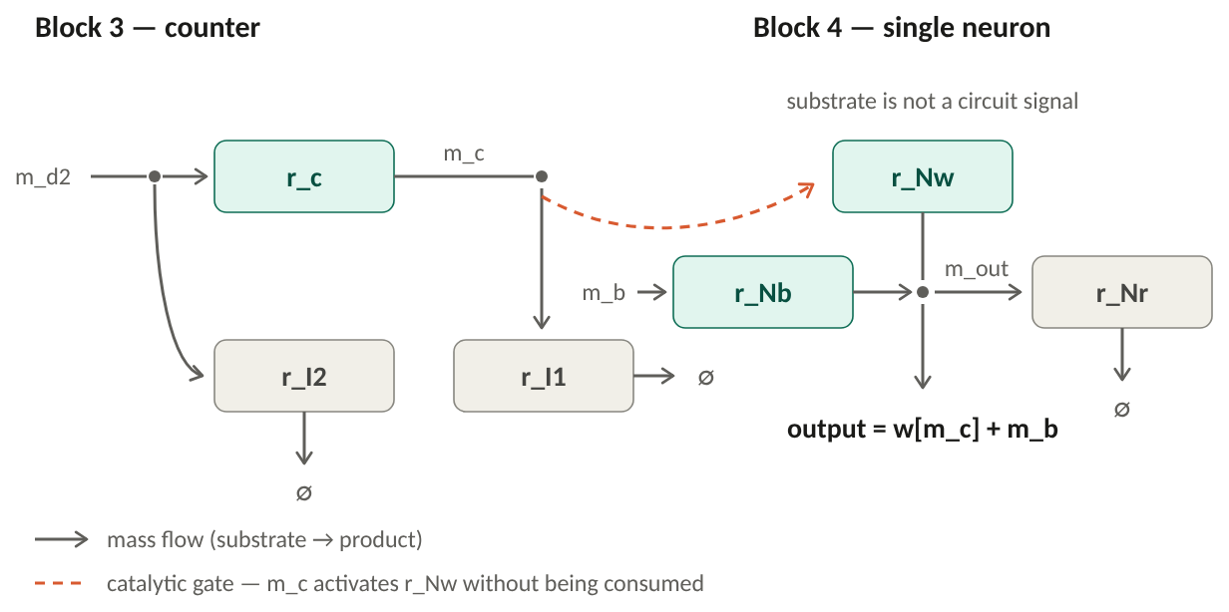
Figure 2. The counter converts m_d2 into the accumulating species m_c, with a reset and an input sequestration. The neuron reads m_c catalytically, adds the bias from m_b, and its output m_out is removed by r_Nr.
Because r_Nw is gated rather than fed by m_c, the weight w remains a free parameter set by enzyme loading, and the counter state is not depleted by being read.

4. Polarity and kinetic requirements
Each IFFL stage is inverting: a step up in the stage input drives the stage output downwards from its resting level. Two stages in series therefore give a net positive gain, so m_d1 tracks −d(m_in)/dt and m_d2 tracks +d²(m_in)/dt² — the correct sign for the counter to increment on a positive second derivative.
Two consequences follow, and neither is checked by the structural search:
- A strictly positive resting level. An inverting stage needs something to dip from: m_d* = v_Sd / (k_lk + V_I·f(m_Fd*)) must be greater than zero, so the leak and the saturated degrader together must not exceed the slow arm’s production rate at rest.
- The fast/slow split is kinetic, not structural. With a one-reaction fast arm the fast arm is also shorter, but the ordering must still be enforced by loading: τ_F < τ_S per stage, r_I saturated in the output (so it subtracts a flux), r_lk first order in the output (so it sets the baseline), and the gate below saturation at the activator site (so the gate stays graded).
Nothing in the mapping validates k_cat, K_M or activator strength. The search returns candidates whose connectivity and exclusivity are correct; feasibility is a separate step.

5. Variants
Each switch below is independent and reversible. The first column is the option name in the master script; the last column is the setting used in the most recent run.
Switch | Variants | What it changes | Current
fastArmSteps | 1 or 2 | Number of reactions in the fast arm. 2 reproduces the original drawing (with m_Ff_k); 1 removes that intermediate and makes the fast arm structurally shorter than the slow arm. | 1
catalyticInterstage | true / false | false: D2 consumes m_d1 (mass-flow cascade). true: m_d1 gates r_A_2, which makes D2’s own input from an independent precursor. | true
requireMI | true / false | Whether the counter’s two removals must share a bimolecular partner m_I. | false
requireSharedMI | true / false | Read only when requireMI is true: whether that partner must be the same species for both. | —
sinkMode | map / prefer / sink | Whether the ∅ steps must be existing model reactions, may fall back to added sinks, or are always added. | prefer
consumingN | true / false | Whether the neuron weight reaction consumes m_c instead of being gated by it. | false
compartment | 'c' / 'any' | Restricts every circuit reaction to one compartment (single-pot reactor) or allows any. | 'c'
carrierTest | true / false | Rejects an arm whose net stoichiometry regenerates its own intermediate (a conserved carrier carries no signal). | true
distinctEC | true / false | Whether two roles may be filled by the same enzyme. Reported either way. | false
noRegulatoryCrosstalk | true / false | Whether a signal may activate a circuit reaction other than its own target. Reported either way. | false

5.1 Differences from the original hand drawing
The current configuration departs from the original Block 1 sketch in four ways. Each is a switch in the table above, not a structural commitment.
- The fast arm is one reaction, so there is no m_Ff_1. The arms are deliberately asymmetric.
- The stages are joined catalytically rather than by mass flow, adding r_A_2 and m_in_2.
- The counter’s shared species m_I has been dropped. This is the one departure that is a modelling claim rather than a search convenience and should be settled explicitly.
- The ∅ steps may be added sinks (reactor outflow, a protease, a phosphatase) rather than mapped metabolic reactions.

6. Why the mapping has not yet succeeded
The search must place 19 reactions and 11 signal species such that each signal is touched only by the reactions its role declares. That exclusivity rule is the only hard constraint; everything else is either structural (it is in the drawing) or a reported annotation. The difficulty is not the rule — it is that the network offers very few places where an IFFL can be built at all.

6.1 The funnel
The search is anchored on r_I, the saturated degrader, because it is the only reaction in the motif that touches two of the three key species at once: its substrates are candidate outputs m_d, and the BRENDA activators of its EC number are candidate gates m_Fd. The third species, m_in, is then found by searching backwards for two arms that reconverge on it. Activation is not in the stoichiometric matrix; it is layered on from the annotation, and the same adjacency supplies the catalytic edges for r_c, r_Nw and r_A_2. Blocks are built stage-agnostically and assigned to D1 or D2 only at assembly.
Stage | Count | Comment
Reactions in the model | 5179 | Of these, 2270 carry an EC number.
EC numbers with BRENDA activators | 1181 | The catalytic gate must come from an activator annotation.
Seed reactions (candidate r_I) | 820 | One row per reaction, carrying every activator of its EC that exists in the model. Matched by ligand name, not by chemical identifier.
Usable anchors | 440 | After removing transport, exchange and cross-compartment reactions.
Metabolites activating a usable reaction | 143 | The raw pool of candidate gates.
Distinct gates surviving | 8 | The collapse happens here.
Differentiator blocks | 106 | 49 of them use a single gate, PIP2.
Usable hinges between stages | 1 | Phosphatidylcholine.

6.2 Where the 143 candidate gates are lost
A gate survives only if it satisfies every structural requirement of the primitive at once. Measured over 1838 (anchor, gate) pairs and 1247 (anchor, output) pairs:
- 261 — the gate has no consumer, so r_Fr cannot be built and the gate would never clear.
- 378 — no short arm produces the gate.
- 275 — the output has no consumer, so r_lk cannot be built and the output has no baseline.
- 199 — no short arm produces the output.
- 624 — the two arms share no common source. This is the largest single loss and the most informative one.
That last requirement is the defining feature of an incoherent feed-forward loop: one input must branch into two paths that reconverge on two different species. In a metabolic network such local branching is rare. It occurs where a hub metabolite feeds several short, parallel routes — which in this model means lipid metabolism, and essentially nowhere else that also carries activator annotations.

6.3 The actual problem
The phosphoinositide and phospholipid cycle is the only region of this network that can host the primitive, and it can host one comfortably, not two disjoint ones. All 106 blocks live there; 49 share a single gate; there is exactly one hinge species. Both stages are therefore forced into the same small neighbourhood, and the failures follow directly from that crowding rather than from any flaw in the circuit:
Configuration | Dominant failure | Reading
Mass-flow link, 2-step fast arm | m_Fd_1 = m_Fd_2 (948 joins) | Both stages want the same gate.
Mass-flow link, 1-step fast arm | m_Sf_1 = m_Sf_2 (480), then r_Fd_2 touches m_Sf_1 (480) | D2 starts where D1 ended and brushes its intermediates.
Catalytic link, 1-step fast arm | r_Fd_1 = r_Fd_2 (1504), and 693 joins reaching the removal step | Stages decoupled; the remaining collisions are gate scarcity.
The catalytic interstage was the decisive change: joins rose from 960 to 2325, and 693 of them assembled a complete circuit — cascade, counter and neuron all mapped — failing only on the removal steps. Those 693 are the reason sinkMode was introduced, and the run that tests it is pending.

6.4 The upstream constraint
Underlying all of this is the quality of the activator annotation. BRENDA ligands are currently matched to model metabolites by name, which is approximate and discards most of the annotation. The seed table contains 169 distinct activator ligand names, but names such as “cysteine” or “phosphatidylcholine” match a model metabolite only when the two strings happen to agree after normalisation. Matching by ChEBI or KEGG identifier instead — via MetaNetX or the BiGG metabolite file — would widen the gate pool, which is the one intervention that attacks the root cause rather than its symptoms.

7. Open decisions
- Is m_I a finite resource? If the counter’s two removals must compete for one replenished pool, that sharing is what makes the counter subtractive and requireMI must return to true — in which case this model cannot supply it. If m_I is externally clamped, dropping it changes nothing dynamically.
- Are added sinks acceptable? The ∅ steps are removals, not conversions. In a cell-free reactor they can be supplied directly, which makes their rate constants free parameters — convenient for the baseline condition, but it means those steps are not “found in metabolism”.
- Asymmetric arms. A one-reaction fast arm is more faithful to “fast” but departs from the symmetric drawing.
- Is a single-compartment circuit required? Relaxing it would admit mitochondrial copies of the same chemistry, at the cost of the single-pot interpretation.
- Inhibition as an alternative primitive. An IFFL built on BRENDA inhibitor annotations would draw on a different species pool, which may relieve the gate scarcity directly.

