**LegalEase**

**A Project Report**

***Submitted by:***

**VANI SETH (201B299)**

**TANISH KHANDELWAL (201B283)**

**Under the guidance of: Prof. Mahesh Kumar**



**July 2023- Dec 2023**

***Submitted in partial fulfillment for the award of the degree***

***of***

**BACHELOR OF TECHNOLOGY**

**IN**

**COMPUTER SCIENCE AND ENGINEERING**

**Department of Computer Science & Engineering**

**JAYPEE UNIVERSITY OF ENGINEERING & TECHNOLOGY, AB ROAD, RAGHOGARH, DT. GUNA-473226 MP, INDIA**

**Declaration by the Student**

We hereby declare that the work reported in the B.Tech. project entitled "**LegalEase**," in partial fulfillment of the award of the degree of B.Tech. (CSE) submitted at Jaypee University of Engineering and Technology, Guna, as per the best of our knowledge and belief, there is no infringement of intellectual property rights or copyright. In the event of any violation, we will solely be responsible.

**Vani Seth (201B299)**

**Tanish Khandelwal (201B283)**

**Place: Jaypee University of Engineering and Technology, Guna - 473226**

**Date: 30-11-2023**

# **CERTIFICATE**



This is to certify that the work titled "**LegalEase**,” submitted by “**Vani Seth** and **Tanish Khandelwal**” in partial fulfillment of the award of the degree of B.Tech (CSE) from Jaypee University of Engineering & Technology, Guna, has been carried out under my supervision. As per the best of my knowledge and belief, there is no infringement of intellectual property rights or copyright. Also, this work has not been submitted partially or wholly to any other university or institute for the award of this or any other degree or diploma. In case of any violation, concerned students will solely be responsible.

**Signature of the Guide**

**Place: Jaypee University of Engineering and Technology, Guna, 473226**

**Date: 30-11-2023**

**ACKNOWLEDGEMENT**

We would like to express our gratitude and appreciation to all those who gave us the opportunity to complete this project. Special thanks to our supervisor, **Prof. Mahesh Kumar,** whose help, stimulating suggestions, and encouragementhelped us throughout the development process and in writing this report. We also sincerely thank you for the time spent proofreading and correcting my many mistakes. We would also like to thank our advisor, **Mr. Anshul Jain,** for always being available for any legal queries we had during the making of this project. We would also like to thank our parents and friends, who helped us a lot in finalizing this project within the limited period. Last but not least, I am grateful to all the team members of **LegalEase**.

Thanking you,

**Vani Seth (201B299)**

**Tanish Khandelwal (201B283)**

**SUMMARY**

**LegalEase** is a revolutionary legal tool that empowers Micro, Small, and Medium Enterprises (MSMEs) and start-ups in India by simplifying legal processes, enhancing legal compliance, and accelerating their growth. It leverages the power of LangChain to extract key concepts and relationships from unstructured legal data, enabling it to provide accurate and tailored legal advice. LegalEase also generates customized legal documents, such as NDAs, evaluation agreements, master agreements, and other commonly used legal documents. Additionally, it continuously monitors changes in laws and regulations using LangChain, ensuring that the generated legal documents are always up-to-date and compliant. LegalEase offers a range of compelling benefits to MSMEs and start-ups, including accessibility, cost-effectiveness, accuracy and compliance, and scalability. It is expected to have a profound impact on these businesses by reducing legal risks, enhancing legal compliance, improving decision-making, and accelerating growth. LegalEase represents a transformative step forward in empowering MSMEs and start-ups in India to navigate the complexities of legal matters and pave the way for a more equitable and prosperous business environment.

# **LIST OF FIGURES**

|  |  |  |
| --- | --- | --- |
| **Figure** | **Title** | **Page No.** |
| Fig 1 | LegalEase System Archirecture | 19 |
| Fig 2 | Use-Case Diagram | 21 |
| Fig 3 | Document Generation Diagram | 24 |
| Fig 4 | Mock Interview in progress | 25 |
| Fig 5 | Aire getting to know the Candidate | 25 |
| Fig 6 | Features of Loom | 26 |
| Fig 7 | Code Snippets | 27 |
| Fig 8 | Understanding module code | 55 |
| Fig 9 |  |  |
| Fig 10 |  |  |
| Fig 11 |  |  |
| Fig 12 |  |  |

**Table of Contents**

|  |  |  |
| --- | --- | --- |
|  |  |  |
| Title page |  | i |
| Declaration by the Student |  | ii |
| Certificate from the Supervisor |  | iii |
| Acknowledgement |  | iv |
| Summary |  | v |
| List of Figures |  | vi |

## **Chapter-1 INTRODUCTION**

* 1. Problem Definition
  2. Project Overview
  3. Hardware Specification
  4. Software Specification

## **Chapter-2 LITERATURE SURVEY**

* 1. Existing System
  2. Proposed System
  3. Feasibility Study
     1. Introduction
     2. Technical Feasibility
     3. Economic Feasibility
     4. Operational Feasibility
     5. Legal Feasibility

## **Chapter-3 SYSTEM ANALYSIS and DESIGN**

* 1. Requirement Specification
     1. OpenAI
     2. Large Language Models
     3. LangChain
     4. PyPDF2
     5. Vector Store
     6. Pinecone
     7. Python
     8. Natural Language Toolkit
     9. Streamlit
     10. Textract
     11. Github
     12. Visual Studio Code
  2. System Architecture
  3. Use Case Diagram
  4. Document Generation Diagram

## **Chapter-4 RESULTS/OUTPUTS**

**Chapter-5 CONCLUSIONS**

**Chapter-6 REFERENCES**

**Chapter-7 PROJECT TEAM DETAILS**

# **CHAPTER-1**

## **INTRODUCTION**

* 1. **Problem Definition**

In the ever-evolving landscape of Micro, Small, and Medium Enterprises (MSMEs) and start-ups in India, the intricacies of legal documentation [1] present a significant obstacle. The challenges encompass the generation, comprehension, and compliance of critical legal documents, specifically Non-Disclosure Agreements (NDAs), evaluation agreements, and master agreements.

Due to resource limitations and a lack of experience in creating comprehensive legal documents, manual document generation is a significant challenge for these businesses. The time-consuming and error-prone nature of manual document creation hinders efficiency, particularly for entrepreneurs with limited legal knowledge.

Compounding the issue is the complex and nuanced language found in legal documents, making it challenging for those without a legal background to fully understand the implications. Misinterpretation or oversight of crucial terms can lead to legal complications and disputes, adding an additional layer of risk for MSMEs and start-ups.

Keeping legal documents updated and compliant with the latest regulations is a perpetual struggle in the dynamic legal landscape. Businesses need a solution that provides real-time monitoring and updates to mitigate unforeseen legal risks and ensure ongoing compliance.

Additionally, existing solutions frequently fail to take into account specific document features, particularly in NDAs, evaluation agreements, and master agreements. Businesses require a tool that not only automates the document generation process but also detects and customizes specific elements according to the unique needs of MSMEs and start-ups.

The existing solutions often fall short in addressing specific document features, particularly in NDAs, evaluation agreements, and master agreements. The unique needs of MSMEs and start-ups are frequently overlooked. What businesses require is a comprehensive tool that not only streamlines the document generation process but also possesses the capability to detect and customize specific elements according to the distinct requirements of these smaller enterprises. This level of customization is essential for ensuring that legal documents align precisely with the operational and strategic nuances of MSMEs and start-ups, promoting both compliance and operational efficiency in tandem

In response to these challenges, the project aims to develop LegalEase, an automated legal tool designed to address the unique needs of MSMEs and start-ups. The key goals include the creation of a system for automated document generation, leveraging advanced language processing tools for comprehensive data understanding, implementing continuous monitoring for legal compliance, and incorporating features for the precise detection and customization of document elements.

The successful implementation of LegalEase is anticipated to empower MSMEs and start-ups by offering a user-friendly, cost-effective solution for legal document management. By streamlining legal processes, enhancing document accuracy and compliance, and addressing the specific needs of businesses in the MSME and start-up sector, LegalEase aims to contribute significantly to the growth and success of these enterprises.

## **1.2 Project Overview**

"LegalEase" is an innovative and transformative legal tool that seeks to revolutionize the way Micro, Small, and Medium Enterprises (MSMEs) and start-ups in India navigate the complexities of legal processes, compliance, and growth. Drawing on the capabilities of LangChain, our cutting-edge technology extracts key concepts and relationships from unstructured legal data, providing tailored legal advice and generating customized legal documents such as NDAs, evaluation agreements, and master agreements. This project not only simplifies legal complexities but also ensures the continual monitoring of changes in laws and regulations through LangChain, keeping generated legal documents up-to-date and compliant.

Our vision for "LegalEase" transcends the traditional boundaries of legal tools. It represents a transformative step forward in empowering MSMEs and start-ups in India to overcome legal obstacles, thereby creating a more equitable and prosperous business environment. By reducing legal risks, enhancing compliance, improving decision-making, and accelerating growth, "LegalEase" aims to have a profound impact on businesses, fostering an atmosphere of innovation and progress.

In essence, "LegalEase" is more than just a legal tool; it is a comprehensive solution designed to alleviate the challenges associated with legal processes for MSMEs and start-ups. It acts as a reliable guide, simplifying the intricate landscape of legal matters and paving the way for a smoother business journey. By leveraging advanced technologies and real-time updates, "LegalEase" ensures that legal information is not only accessible but also tailored to the specific needs of each user.

Our commitment extends beyond the development of a computer system; we are crafting a transformative experience. "LegalEase" operates as a dynamic resource, utilizing intricate algorithms and technological prowess to keep users in sync with the ever-evolving legal landscape. The system is designed to be user-friendly, allowing individuals and organizations to describe their goals and preferences, and promptly receive a curated selection of the most fitting legal solutions.

The ethos of "LegalEase" aligns with the mission to simplify the grant-seeking journey by creating a harmonious synergy between technological innovation and user-centric design. We envision a world where legal processes are less daunting, more achievable, and tailored to the unique needs of each user. Our goal is to foster an environment where pursuing legal solutions becomes an empowering and fulfilling experience, allowing individuals and organizations to concentrate on their aspirations and endeavors.

"LegalEase" aims to liberate individuals and groups from the intricacies of legal processes, ensuring accuracy, accessibility, and inclusivity for all. By fostering innovation, supporting important work, and creating opportunities for those seeking legal solutions, we aspire to contribute to a world where everyone has the chance to pursue their goals and make a positive impact.

## **1.3 Hardware Specification**

* Server: Minimum of 8GB RAM (16GB recommended), Quad-Core Processor (Intel Core i5 or equivalent)
* Storage: Minimum 256GB SSD (Solid State Drive) for faster data access and improved system responsiveness
* Networking: Gigabit Ethernet or higher for robust connectivity and data transfer rates
* Redundancy: RAID (Redundant Array of Independent Disks) setup for data redundancy and fault tolerance
* Backup System: Automated backup solution for regular data backups and disaster recovery preparedness
* Scalability: Scalable architecture to accommodate increasing data volumes and user traffic

## 

## **1.4 Software Specification**

* Operating System: Linux-based OS (e.g., Ubuntu Server 20.04 LTS) for server deployment, leveraging its stability and security features
* Programming Languages: Python for data processing and Natural Language Processing (NLP) tasks, HTML and CSS will be utilized for frontend templates, ensuring a user-friendly interface for interacting with the system.
* Web Frameworks: Streamlit for Python-based backend operations
* Libraries and Modules:
* Dotenv: Load environment variables for enhanced security and configuration
* Os: Interact with the operating system, facilitating file operations and system-related tasks.
* PyPDF2: Enable reading and extraction of text content from PDF files
* textract: Extract text content from various document formats, including PDF and Word documents.
* Version Control: Git for efficient collaboration, code versioning, and management
* Web Server: Streamlit for serving web content and handling HTTP requests efficiently

**CHAPTER 2**

**LITERATURE SURVEY**

**2.1 Existing System**

In the realm of legal document creation, a meticulous and time-consuming process traditionally falls under the purview of legal professionals. Lawyers have conventionally played a central role in drafting various legal documents such as Non-Disclosure Agreements (NDAs) [2], evaluation agreements, and master agreements. This manual approach involves extensive legal research, customization, and the careful tailoring of documents to suit the specific needs of clients. The current system relies heavily on legal expertise, precedent documents, and the adherence to intricate legal nuances.

In the existing legal landscape, law firms employ word processors and document templates for the manual creation of legal documents. Lawyers are tasked with ensuring the accuracy of language, compliance with current legal standards, and customization to meet the unique requirements of each client. The responsibilities of lawyers extend to conducting legal research, mitigating potential risks, and ensuring that documents align with prevailing laws and regulations.

Specifically, Non-Disclosure Agreements (NDAs) are crafted to safeguard confidential information, outlining the scope of confidentiality, party obligations, and agreement duration. Evaluation agreements define terms for assessing assets or services, specifying the scope of evaluation and any restrictions on information use. Master agreements serve as overarching contracts governing future transactions, reducing the need for renegotiation with each new deal.

Law firms currently employ a range of tools, including legal document management systems and collaboration platforms, to facilitate document creation. However, the fundamental process remains labor-intensive and relies heavily on legal expertise.

The proposed tool addresses the inefficiencies of the current system by automating the generation of NDAs, evaluation agreements, and master agreements. Its advanced AI capabilities ensure accuracy, compliance with current laws, and adherence to legal standards. LegalEase empowers MSMEs and start-ups to independently navigate legal matters, providing scalability to accommodate the growing needs of businesses. Furthermore, the tool continuously monitors changes in laws and regulations, ensuring that generated legal documents remain up-to-date and compliant.

The existing system of legal document creation involves manual efforts by lawyers, which can be time-consuming and resource-intensive. LegalEase emerges as an innovative solution to revolutionize this process, providing efficiency, accuracy, and accessibility to MSMEs and start-ups. By automating document generation and incorporating advanced AI capabilities, LegalEase is poised to redefine the way legal documents are created, making legal processes more accessible and cost-effective for businesses in India.

The aspiration for "LegalEase" extends beyond merely aggregating grant information. It endeavors to foster a transformative experience for seekers, offering real-time updates, personalized recommendations, and simplified application procedures. By harnessing advanced technologies like Natural Language Processing (NLP) for data comprehension and blockchain integration for secure and decentralized data management, "LegalEase" aims to empower seekers with an efficient, reliable, and comprehensive tool.

In summary, the existing system's fragmented nature and inherent limitations underscore the pressing need for a holistic and centralized solution like "LegalEase." Its aim is to redefine the grant-seeking experience, ensuring accessibility, accuracy, and efficiency for seekers navigating the intricate landscape of funding opportunities.

**2.2 Proposed System**

In response to these challenges, LegalEase emerges as a transformative solution. This automated legal tool utilizes advanced technologies, including natural language processing (NLP) and machine learning, to streamline the document generation process for Micro, Small, and Medium Enterprises (MSMEs) and start-ups. LegalEase offers efficiency, accuracy, and accessibility, reducing reliance on costly legal counsel.. The key features and components of the proposed system include:

* Document Generation: Based on the insights extracted, LegalEase employs advanced algorithms to automatically generate customized legal documents. This includes commonly used documents such as Non-Disclosure Agreements (NDAs), evaluation agreements, and master agreements. The automated document generation significantly reduces the reliance on manual efforts and accelerates the document creation process [3].
* Intelligent Search: The system incorporates an intelligent search mechanism powered by Natural Language Processing (NLP) techniques. This functionality empowers users to articulate their grant requirements in natural language, allowing the system to comprehend and deliver tailored grant recommendations accurately. By leveraging NLP, "LegalEase" simplifies the search process, ensuring seekers receive precise and relevant grant options aligned with their specific needs.
* Cost-Effectiveness: By adopting a self-service approach, LegalEase reduces the reliance on expensive legal counsel, lowering the overall cost of legal compliance for MSMEs and start-ups. This cost-effectiveness aligns with the resource constraints often faced by smaller businesses.
* History Tracking: LegalEase maintains a comprehensive conversation history, allowing users to track the context of their queries and the system's responses. This feature enhances transparency and provides users with a record of their interactions.

LegalEase represents a revolutionary step forward in empowering MSMEs and start-ups in India to navigate the complexities of legal matters. By leveraging the power of LangChain and advanced AI capabilities, LegalEase provides a comprehensive, accessible, and cost-effective solution that simplifies legal processes, enhances legal compliance, and accelerates the growth of these businesses. This proposed system is poised to redefine the landscape of legal document management, making it more inclusive, efficient, and tailored to the specific needs of smaller enterprises in India's dynamic business environment.

By seamlessly blending state-of-the-art technological capabilities with an unwavering focus on user needs, "LegalEase" endeavors to offer a tool that transcends conventional grant-seeking paradigms. Its ultimate aim is to act as a catalyst, empowering seekers to navigate the multifaceted landscape of funding opportunities with ease and confidence. The system seeks to transform the grant-seeking experience into a more accessible, intuitive, and efficient endeavor, ensuring that seekers can concentrate their efforts on advancing their projects and initiatives rather than grappling with the complexities of the grant-seeking process.

**2.2 Components**

**1. Understanding Module**

The Understanding Module is a vital component within various systems and software architectures, tasked with interpreting and comprehending diverse types of input data. Its role is particularly crucial in applications involving natural language processing (NLP), computer vision, and artificial intelligence, where the ability to understand and derive meaning from data is paramount.

**Functionality:**

* **Natural Language Processing (NLP):** In NLP applications, the Understanding Module parses textual data, extracts semantic meaning, identifies entities, and discerns the intent behind user queries. It may employ machine learning techniques, such as natural language understanding (NLU) models, to enhance its comprehension of nuanced language constructs.
* **Computer Vision:** For computer vision tasks, the module analyzes visual data, such as images or videos, to extract relevant information. This includes tasks like object recognition, scene understanding, and interpretation of visual context. Deep learning algorithms, like convolutional neural networks (CNNs), are commonly employed for pattern recognition.
* **Adaptability:** The Understanding Module is designed to adapt to varying contexts and handle ambiguity within the input data. Its adaptability ensures accurate interpretation and meaningful insights, contributing to the overall effectiveness of systems.

**2. Detection Module**

The Detection Module is a fundamental component that plays a key role in identifying and recognizing specific patterns, features, or entities within input data. It is widely used across various applications, including computer vision, security systems, and natural language processing, contributing to the system's ability to automatically detect and respond to critical elements.

**Functionality:**

* **Computer Vision Applications**: In computer vision, the Detection Module is responsible for tasks such as object detection, facial recognition, and image segmentation. It utilizes techniques like deep learning to automatically learn and extract relevant features, facilitating accurate and efficient object recognition.
* **Natural Language Processing:** In NLP, the Detection Module may be employed for tasks like named entity recognition (NER) and sentiment analysis. It identifies and classifies specific linguistic elements within textual data, enhancing the system's understanding of entities and emotional tones.
* **Security Systems:** Security applications use Detection Modules for threat detection and anomaly identification. The module analyzes input data, such as network traffic or sensor readings, to identify patterns indicative of security threats, contributing to proactive risk mitigation.

**3. Generation Module**

The Generation Module is a critical component within systems and software architectures that is responsible for producing or generating specific outputs based on input or predefined conditions. It is particularly relevant in applications involving natural language processing, computer graphics, and artificial intelligence, where the creation of content, responses, or representations is essential.

**Functionality:**

* **Natural Language Processing:** In NLP applications, the Generation Module produces coherent and contextually relevant textual output. It can range from simple sentence formation to more complex tasks such as language translation, text summarization, or the creation of creative writing pieces.
* **Computer Graphics:** In computer graphics, the module might be involved in creating visual content, translating input parameters or data into visually appealing representations. This is applicable in areas such as computer-aided design, gaming, and virtual reality.
* **Artificial Intelligence**: In broader AI applications, the Generation Module can generate responses or actions based on the input it receives. This is evident in chatbots or virtual assistants where the module formulates human-like responses by understanding the context and intent behind user queries.

**Design Considerations:**

* **Flexibility and Specificity**: The Generation Module must strike a balance between flexibility and specificity to ensure that the generated content aligns with the intended purpose and meets user expectations.
* **Adaptability**: In modern machine learning applications, the module may leverage deep learning techniques to learn patterns and relationships from large datasets, allowing for more adaptive and context-aware generation.

**2.3 Feasibility Study**

**2.3.1 Introduction**

In the contemporary business landscape, the Micro, Small, and Medium Enterprises (MSMEs) and start-ups of India are navigating an increasingly intricate legal terrain. As these enterprises strive for growth and innovation, the demand for efficient and accessible legal solutions has become paramount. The proposed system, LegalEase, stands as a groundbreaking initiative aimed at transforming the traditional approach to legal document management. This introduction serves as a precursor to the feasibility report, offering an overview of LegalEase and its potential impact on the legal processes of MSMEs and start-ups.

MSMEs and start-ups, while representing the backbone of economic development, often encounter challenges in navigating legal complexities. The creation and management of legal documents, including Non-Disclosure Agreements (NDAs), evaluation agreements, and master agreements, traditionally require substantial resources, time, and legal expertise. LegalEase emerges as a response to these challenges, leveraging advanced technologies to automate and simplify the legal document generation process. By harnessing the power of natural language processing (NLP) and machine learning, LegalEase aims to empower businesses by providing a user-friendly, cost-effective, and scalable solution.

This feasibility study serves as a holistic assessment, meticulously evaluating the technical, economic, and operational underpinnings of the "LegalEase" system. It stands as a testament to the project's commitment to innovation, envisioning a future where the quest for funding becomes more accessible, intuitive, and conducive to the realization of aspirational endeavors.

**2.3.2 Technical Feasibility**

The assessment of technical feasibility for the "LegalEase" project underscores its capacity to be developed, implemented, and sustained using available technological resources. At the forefront of this evaluation lies the convergence of advanced technologies and robust infrastructure to realize the envisioned platform.

The project's technical feasibility stems from the availability and maturity of cutting-edge technologies integrated into its architecture. "LegalEase" capitalizes on sophisticated tools such as Natural Language Processing (NLP) to facilitate intelligent search capabilities. Leveraging NLP algorithms, the system can comprehend and process user queries in natural language, an innovation that promises intuitive and efficient grant exploration.

Identifying any gaps or limitations in the infrastructure is crucial for addressing potential challenges during implementation. Compatibility, both with various operating systems and devices commonly used by the target users, is a key consideration. The scalability of the system, ensuring it can grow with the expanding needs of businesses, is assessed to guarantee long-term viability. Additionally, a thorough analysis of the technical requirements, encompassing hardware, software, and network specifications, is conducted. Potential technical challenges, such as integration issues or data security concerns, are identified, and mitigation strategies are developed to ensure a smooth technological transition.

In essence, the "LegalEase" project's technical feasibility is fortified by the amalgamation of advanced technologies, robust programming languages, and established infrastructure components. The utilization of state-of-the-art tools and methodologies promises a system that not only meets but exceeds technical standards, paving the way for a sophisticated and efficient grant-seeking platform.

**2.3.3 Economic Feasibility**

The economic feasibility analysis of the "LegalEase" project revolves around assessing its financial viability and justifiability within predefined budgetary constraints, considering both the initial investment and long-term sustainability. This venture, while necessitating an upfront financial infusion, unveils a panorama of economic viability and sustainability, propelled by several pivotal elements ingrained within its operational fabric.

Initial Investment: The economic feasibility of LegalEase begins with a thorough examination of the initial investment required for its implementation. This encompasses various components such as software development, system integration, training, and potential hardware upgrades. The initial investment also includes costs related to the acquisition of necessary technologies, licensing fees, and any legal or regulatory compliance measures. An accurate estimation of the initial investment provides stakeholders with a clear understanding of the financial commitment needed to kickstart the LegalEase project.

Revenue Models: The revenue models associated with LegalEase play a pivotal role in determining the economic viability of the project. Potential revenue streams may include subscription-based models, licensing fees, or pay-per-use arrangements. Additionally, the system could offer premium features or tiered plans for users with varying needs. The identification and implementation of effective revenue models are essential for sustaining the operation, maintenance, and continuous improvement of LegalEase.

Scalability and Long-Term Viability: Scalability is a critical economic consideration, ensuring that LegalEase can adapt and expand alongside the growing needs of MSMEs and start-ups. The system's architecture must be designed to handle increased user volumes and a growing database of legal documents. Long-term viability involves assessing the sustainability of LegalEase over an extended period. This includes anticipating future technological advancements, legal landscape changes, and evolving user requirements. Strategies for continuous improvement, updates, and adaptations must be integrated to ensure the enduring relevance and success of LegalEase.s.

Cost-Benefit Analysis: The cost-benefit analysis is a fundamental aspect of economic feasibility, providing insights into the potential financial gains and benefits derived from implementing LegalEase. It involves comparing the total costs associated with the project, including development, implementation, and operational costs, against the expected benefits. Benefits may include operational cost savings, increased efficiency, and potential revenue generation. A robust cost-benefit analysis guides decision-makers in determining whether the economic returns justify the investment in LegalEase.

Risk Mitigation:Identifying and mitigating economic risks is integral to the success of LegalEase. This involves a proactive approach to anticipate potential financial challenges and implement strategies to mitigate their impact. Economic risks may include unexpected increases in development costs, slower-than-anticipated user adoption, or changes in economic conditions affecting the financial stability of MSMEs and start-ups. Risk mitigation strategies may involve establishing contingency funds, incorporating flexible pricing models, and closely monitoring economic indicators to adapt the revenue model accordingly. Continuous monitoring and adaptive strategies are crucial for navigating economic uncertainties and ensuring the resilience of LegalEase.

In summation, "LegalEase," while initiating with an initial investment, radiates promise and potential within the economic sphere. Its foreseen ROI, diverse revenue models, robust scalability, and unwavering commitment to continual enhancements collectively underscore its capacity to not only yield sustainable financial returns but also carve a niche of enduring viability within the dynamic realm of grant-seeking initiatives.

**2.3.4 Operational Feasibility**

Operational feasibility of the "LegalEase" project hinges on its ability to seamlessly integrate into existing operational structures and cater effectively to end-user needs. This evaluation scrutinizes the system's adaptability, usability, and alignment with organizational procedures and user expectations.

User-Centric Design: User-centric design is a fundamental principle in the development of LegalEase, ensuring that the system is intuitive, accessible, and aligned with the needs of its primary users—Micro, Small, and Medium Enterprises (MSMEs) and start-ups. The design process prioritizes the user experience, incorporating feedback from potential users at various stages. The user interface is crafted to be user-friendly, with clear navigation and functionalities tailored to the legal understanding of non-experts. User testing and feedback loops are integrated into the development lifecycle to continually refine the design, ensuring that LegalEase aligns seamlessly with the expectations and capabilities of its intended users.

Alignment with Organizational Procedures: LegalEase is designed to align seamlessly with existing organizational procedures within MSMEs and start-ups. The development team collaborates closely with legal experts and business professionals to understand the intricacies of current legal workflows. The system is customized to complement and enhance these procedures, rather than imposing a radical departure. Integrations with existing document management systems and collaboration tools are considered to ensure a smooth transition. By aligning with established procedures, LegalEase minimizes disruption, fosters user adoption, and enhances overall organizational efficiency.

Comprehensive Testing and Feedback Mechanisms:A robust testing and feedback framework is integral to the development and refinement of LegalEase. Comprehensive testing is conducted at each stage of development, including unit testing, integration testing, and system testing. Real-world scenarios are simulated to identify potential vulnerabilities and ensure the system's reliability and security. User testing involves soliciting feedback from diverse user groups, allowing for a thorough understanding of user interactions and expectations. Continuous feedback mechanisms, such as beta testing and user surveys, are implemented post-launch to gather insights for further enhancements. This iterative testing and feedback process ensures that LegalEase evolves in response to user needs and changing legal landscapes.

Training and Change Management: Training is a key component of the implementation strategy for LegalEase. Recognizing the diverse backgrounds of users, training programs are designed to cater to varying levels of legal familiarity. Interactive training modules, workshops, and user documentation are developed to educate users on LegalEase functionalities. Training sessions may cover topics such as document generation, data understanding, and leveraging the continuous monitoring features. A phased approach to training is adopted, ensuring that users can progressively familiarize themselves with the system without feeling overwhelmed. Training materials are made readily accessible to users for ongoing reference, contributing to a smooth onboarding process.

In essence, the operational feasibility of "LegalEase" underscores its adeptness in harmonizing with existing organizational structures, prioritizing user needs, and fostering a culture of continuous improvement. The platform's design, compatibility, user-centricity, and adaptability signify its potential to seamlessly integrate into the grant-seeking landscape, facilitating an intuitive and efficient user experience.

**2.3.5 Legal and Compliance Feasibility**

Legal and compliance feasibility ensures that LegalEase aligns with existing legal frameworks and regulations governing document management. The system is scrutinized to ensure compliance with applicable laws and regulations related to document management. Consideration is given to data privacy and security, ensuring robust measures are in place to protect sensitive legal information. Legal constraints or limitations that may impact system implementation are identified and addressed. Regulatory compliance, including industry-specific requirements, is verified, and mechanisms are established to adapt the system to changes in relevant laws and regulations. The drafting of contractual agreements between users and LegalEase is undertaken to define legal responsibilities and liabilities.

**CHAPTER 3**

**SYSTEM ANALYSIS AND DESIGN**

* 1. **Requirement Specification**

1. **OpenAI**

OpenAI [4] stands as a pioneering force in artificial intelligence (AI) research and development, renowned for its cutting-edge contributions in the field of natural language understanding and generation. The organization's advancements in AI technology have propelled transformative changes across various industries, redefining how machines comprehend and interact with human language.

At the heart of OpenAI's prowess lies its GPT (Generative Pre-trained Transformer) series of language models, among which GPT-3 stands as a significant milestone. GPT-3, a neural network-based language model, boasts an unprecedented scale of 175 billion parameters, enabling it to process and generate text with remarkable accuracy and context awareness. This model has revolutionized natural language processing (NLP), exhibiting capabilities in understanding, completing, and generating human-like text.

The primary strength of OpenAI's GPT models lies in their ability to understand and generate text in a manner that exhibits fluency, coherence, and contextuality. GPT-3's sheer size and training on diverse internet texts contribute to its proficiency in various language tasks, such as language translation, text summarization, question-answering, and content generation. Its generalized understanding of language enables it to contextually comprehend prompts and generate coherent responses or complete sentences, mimicking human-like language abilities.

One of the distinguishing features of GPT-3 is its zero-shot and few-shot learning capabilities. Zero-shot learning allows the model to perform tasks without explicit training on them, showcasing a remarkable understanding of new tasks based on minimal prompts. Few-shot learning further extends this capability by leveraging a few examples or instructions to perform tasks, highlighting the model's adaptability and flexibility in handling diverse tasks without extensive fine-tuning.

In the realm of grant-seeking and information aggregation, OpenAI's GPT models offer significant potential. These models can be leveraged to comprehend complex grant-related queries, assist in summarizing grant requirements, automate grant application procedures, and provide tailored recommendations based on a user's preferences and historical data. By integrating OpenAI's technology, the "LegalEase" platform can enhance its natural language processing capabilities, offering users a more intuitive and conversational interface for exploring and understanding grant-related information.

Despite its remarkable capabilities, challenges persist, including ethical considerations surrounding AI's potential misuse, biases inherent in training data, and ensuring responsible deployment in sensitive domains. However, OpenAI's continual research efforts and emphasis on ethical AI aim to address these concerns, fostering responsible and beneficial AI deployment for societal advancement.

1. **Large Language Models**

Large language models (LLMs) [5] are a revolutionary advancement in the field of artificial intelligence that has significantly impacted natural language processing (NLP). LLMs are powerful neural network-based models capable of understanding and generating human language with remarkable fluency and coherence.

The primary goal of LLMs is to process vast amounts of textual data, learn intricate language patterns, and perform various NLP tasks, such as text generation, translation, sentiment analysis, and question-answering. One of the most prominent examples of LLMs is OpenAI's GPT (Generative Pre-trained Transformer) series, which includes models like GPT-2 and GPT-3. These models are pre-trained on massive corpora of text data, learning from diverse sources to develop a deep understanding of language semantics and syntactics.

The diversity of LLMs is evident in applications such as machine translation, text summarization, language modeling, and sentiment analysis. LLMs have also found extensive use in chatbots and virtual assistants, where they facilitate human-like interactions and natural conversations with users. LLMs have significantly advanced the field of NLP, enabling state-of-the-art language understanding and generation capabilities. Their ability to learn from vast amounts of data has paved the way for better and more contextually relevant language processing systems.

As LLM technology continues to evolve, it holds tremendous potential for enhancing various applications, revolutionizing human-computer interactions, and driving further progress in the field of artificial intelligence.

Large language models represent a significant leap in natural language processing (NLP) capabilities, leveraging advancements in deep learning and neural network architectures. These models, are trained on massive datasets to learn the intricacies of human language, enabling them to understand context, generate coherent text, and perform various language-related tasks.

The model's advanced capabilities in feature detection contribute to the project's goal of customizing specific elements within legal documents. It can identify and incorporate unique features within NDAs, evaluation agreements, and master agreements, catering to the specific needs of MSMEs and start-ups.

1. **Langchain**

LangChain [6] is a framework designed to simplify the creation of applications using large language models (LLMs). As a language model integration framework, LangChain's use-cases largely overlap with those of language models in general, including document analysis and summarization, chatbots, and code analysis.

LangChain was launched in October 2022 as an open-source project by Harrison Chase, while working at machine learning startup Robust Intelligence. The primary objective of LangChain is to simplify the process of utilizing LLMs within applications. It provides a comprehensive set of tools, libraries, and APIs that abstract the complexities of model integration, making it more accessible to developers from various domains. This way, LangChain empowers a broader range of developers to leverage the power of LLMs and enhance their applications with advanced natural language processing capabilities.

LangChain serves as a valuable resource for developers seeking to harness the power of large language models within their applications. By providing a user-friendly and accessible framework for LLM integration, LangChain empowers developers to build sophisticated language-driven applications in areas such as document analysis, chatbots, code analysis, and beyond. Its open-source nature promotes collaboration, enabling a diverse community to collectively advance the capabilities and applications of LLMs in the realm of natural language processing.

LangChain is employed to extract key concepts and relationships from unstructured legal data. Its contextual understanding allows it to discern nuances in legal language, identifying relevant information and capturing the intricacies of legal documents, including NDAs, evaluation agreements, and master agreements.

The model's proficiency in natural language generation is harnessed for the automatic generation of customized legal documents. Based on the insights extracted from the legal data, LangChain can craft coherent and contextually relevant NDAs, evaluation agreements, and master agreements, streamlining the often complex and time-consuming process of manual document creation.

LangChain's capabilities extend to continuous monitoring of changes in laws and regulations. Its contextual understanding allows it to adapt to evolving legal landscapes, ensuring that the generated legal documents remain up-to-date and compliant with the latest legal requirements.

By leveraging the power of large language models like LangChain, the project not only addresses the challenges faced by MSMEs and start-ups in legal document management but also introduces a level of sophistication and efficiency that is unparalleled in traditional, rule-based systems. The contextual understanding and adaptability of LangChain play a pivotal role in revolutionizing the way legal processes are approached and executed within the target business sector.

1. **PyPDF2**

In the realm of document processing within Python, the PyPDF2 library [7] stands out as a versatile tool, particularly adept at handling PDFs. Tailored for simplicity and flexibility, PyPDF2 offers a suite of functionalities for reading, writing, and manipulating PDF documents. What sets it apart is its pure Python implementation, making it easily integrable into projects without the need for external dependencies.

PyPDF2 is used to read PDF documents and allows seamless extraction of text, metadata, and other information from existing PDF documents. This functionality proves invaluable in the LegalEase project, where a nuanced understanding of unstructured legal data within PDFs is essential.

Merging and Splitting PDFs is also a feature of this library. The library facilitates the merging of multiple PDFs into a single document and the splitting of a PDF into multiple files. These features play a vital role in creating a streamlined process for document generation and organization within the LegalEase project.

PyPDF2 empowers users to manipulate individual pages within a PDF document. This is particularly useful for tasks such as rearranging pages or extracting specific pages, contributing to the generation of customized legal documents.

PyPDF2 is a crucial component in the extraction of text and relevant information from PDFs within the LegalEase project. This functionality aids in the data understanding phase, enabling the system to decode the content of legal documents for accurate analysis and advice generation.

PyPDF2 emerges as a cornerstone in the LegalEase project, contributing essential functionalities for document handling, data understanding, and document security. Its capacity to read, manipulate, and secure PDFs makes it an indispensable tool in the development of a comprehensive and user-friendly legal solution tailored to the unique needs of MSMEs and start-ups.

1. **Vector Store**

The concept of a Vector Store [8] holds significant relevance within the context of the "LegalEase" project, especially concerning the efficient storage, retrieval, and manipulation of vector-based data representations. A Vector Store serves as a specialized data repository designed explicitly to manage and facilitate operations on vectors, which are numerical representations of data possessing both magnitude and direction. In the realm of the "LegalEase" platform, the Vector Store emerges as a critical component augmenting the system's capabilities for similarity search, recommendation systems, and personalized user experiences.

In the domain of laws, where information retrieval is paramount, the Vector Store plays a pivotal role in enhancing the platform's functionality. It efficiently manages the vectors representing grant information, enabling quick and accurate retrieval based on similarities, distances, or relevancy measures. By encapsulating legal data into vector-based representations, the Vector Store facilitates streamlined access, ensuring swift responses to user queries and requests. For instance, it can aid in identifying documents and key words similar to user preferences or historical grant selections by computing vector similarities, providing tailored recommendations aligned with user interests.

Furthermore, the Vector Store contributes to the platform's recommendation engine, which serves as a cornerstone for personalized grant suggestions. Through vector-based representations of grants and user profiles, the system can compute similarities, enabling it to offer pertinent document recommendations matching a user's preferences or past interactions. This mechanism not only streamlines the document exploration process but also enhances user satisfaction by delivering curated and relevant agreement options aligned with their needs and interests.

Additionally, the Vector Store's significance extends to supporting real-time updates and dynamic content delivery within the platform. As the Vector Store efficiently manages vectors representing grant data, it facilitates rapid updates and modifications, ensuring that users receive the most recent and relevant grant information. This feature aligns with the "LegalEase" project's objective of offering up-to-date and accurate data, fostering a dynamic and responsive user experience.

The Vector Store serves as the backbone for efficient data representation and manipulation within the "LegalEase" project. Its capabilities in managing vector-based representations of grant information empower the platform with enhanced search functionalities, recommendation systems, and real-time updates. Leveraging the Vector Store amplifies the platform's ability to deliver personalized and relevant grant suggestions, elevating user engagement and satisfaction while navigating the complex landscape of legal documents.

1. **Pinecone**

Pinecone represents a pivotal component in the technological landscape of the "LegalEase" project, playing a crucial role in augmenting the system's recommendation and similarity search functionalities. As an advanced vector database and similarity search engine, Pinecone's integration offers a transformative edge to the project's objective of streamlining grant exploration and recommendation.

At its core, Pinecone operates on the premise of efficiently storing and processing high-dimensional vectors, enabling rapid similarity searches and recommendations. Its robust architecture and optimized algorithms facilitate the handling of large-scale vector data, ensuring swift and accurate retrieval of similar items or recommendations based on vector representations.

Furthermore, Pinecone's ability to handle dynamic data and adapt to evolving user preferences aligns seamlessly with the project's objective of offering personalized grant suggestions. As users interact with the platform and express their preferences or interests, Pinecone facilitates real-time updates to the recommendation engine, ensuring that the suggested grants remain current and aligned with the user's evolving needs.

The integration of Pinecone within "LegalEase" amplifies the system's efficiency in traversing the vast landscape of available grants. By harnessing Pinecone's similarity search capabilities, the platform empowers users to explore legal documents that closely match their requirements, facilitating a more targeted and streamlined grant-seeking experience. Pinecone's role extends beyond mere search functionalities; it acts as a catalyst for enhancing user engagement, ensuring that the grants presented to users resonate with their specific interests and needs.

In essence, Pinecone stands as a cornerstone technology within the "LegalEase" project, empowering the system with advanced vector-based search and recommendation capabilities. Its integration significantly elevates the platform's ability to offer tailored grant suggestions, fostering a more intuitive and personalized document understaning journey.

1. **Python**

Python [9] stands as a versatile and influential programming language renowned for its simplicity, readability, and extensive library support, making it a cornerstone in various domains, including data science, web development, and artificial intelligence. In the "LegalEase" project, Python's multifaceted capabilities play a pivotal role, contributing significantly to backend functionalities, machine learning integration, and seamless system operations.

Python's readability and ease of use make it an ideal choice for backend development within the "LegalEase" ecosystem. The language's clean syntax and comprehensive standard libraries expedite the development of robust backend functionalities, ensuring efficient data processing, server operations, and API integrations. Its scalability and flexibility cater to the project's evolving needs, facilitating the seamless integration of various components and databases required for managing grant-related information.

Moreover, Python's prominence in the realm of artificial intelligence and machine learning reinforces its significance within the project. Its rich ecosystem of libraries and frameworks, such as TensorFlow, PyTorch, scikit-learn, and spaCy, empowers the "LegalEase" system with advanced machine learning capabilities. Python serves as the bedrock for developing and deploying sophisticated ML models that drive recommendation engines, natural language understanding, and data analysis within the platform.

Specifically, Python's integration with natural language processing (NLP) libraries like spaCy and NLTK (Natural Language Toolkit) enhances the system's linguistic capabilities. These libraries facilitate text processing, entity recognition, sentiment analysis, and language understanding, enabling the system to comprehend grant-related documents, extract relevant information, and provide insightful summaries or recommendations to users.

Furthermore, Python's contribution extends to enabling seamless collaboration and version control through platforms like GitHub. The language's popularity and widespread adoption among developers ensure a robust community support system, fostering collaborative coding practices and enabling efficient code management within the project.

In the context of "LegalEase," Python's significance lies not only in its technical capabilities but also in its role as an enabler of innovation. Its agility and adaptability align with the project's ethos of continual improvement and technological advancements. Python's presence as a foundational language facilitates the integration of diverse technologies, streamlines system operations, and enables the development of sophisticated functionalities crucial for transforming grant-seeking endeavors.

Overall, Python's multifaceted nature, encompassing backend development, machine learning prowess, NLP capabilities, and community support, solidifies its indispensable role within the "LegalEase" project, serving as a linchpin for the system's functionality, intelligence, and future growth.

1. **Natural Language Toolkit**

The Natural Language Toolkit (NLTK) [10] stands as a foundational library in the domain of natural language processing (NLP), offering a comprehensive suite of tools and resources for text processing and analysis. In the context of the "LegalEase" project, NLTK plays a pivotal role in enriching the system's capabilities by providing a robust framework for linguistic data processing and NLP functionalities.

NLTK, built on Python, boasts a wide array of functionalities crucial for NLP tasks, including tokenization, stemming, lemmatization, part-of-speech tagging, parsing, and semantic reasoning. These functionalities form the backbone of text processing tasks, enabling the system to dissect and comprehend grant-related textual data efficiently.

One of NLTK's significant contributions lies in its extensive corpora and lexical resources. These collections of annotated texts and lexical databases encompass various languages, genres, and domains, serving as valuable references for language modeling, information retrieval, and statistical analysis. In the context of "LegalEase," NLTK's corpora can aid in training language models, enabling the system to better understand and process diverse grant-related text data.

NLTK's tokenization capabilities, the process of breaking down text into smaller units (tokens), are essential for various NLP tasks. By segmenting text into tokens, the system can analyze and manipulate textual data at a granular level, facilitating tasks such as keyword extraction, document classification, and semantic analysis.

Furthermore, NLTK's part-of-speech tagging functionality assigns grammatical labels to words within a sentence, enabling the system to discern the syntactic structure and extract meaningful insights. This feature is instrumental in identifying key elements within grant descriptions or application guidelines, aiding in information extraction and relevance assessment.

Another critical aspect of NLTK is its robustness in supporting machine learning algorithms for text classification, sentiment analysis, and information retrieval. By leveraging NLTK's capabilities, the "LegalEase" platform can implement machine learning models to categorize grants, assess their relevance to user queries, and personalize recommendations based on user preferences.

NLTK's significance in the "LegalEase" project lies in its role as a fundamental toolset for processing, analyzing, and understanding textual grant-related data. Its versatile functionalities empower the system to handle diverse NLP tasks, enabling accurate information extraction, personalized recommendation generation, and seamless interaction between users and the grant-seeking platform. Integrating NLTK enhances the system's language processing capabilities, contributing to a more intuitive and effective grant-seeking experience for users.

1. **Streamlit**

Streamlit [11] is a Python library that has gained significant popularity for its simplicity and effectiveness in transforming data scripts into interactive web applications. It is designed with a focus on ease of use, enabling data scientists and developers to create compelling and interactive data-driven applications with minimal effort. Streamlit's declarative syntax allows users to turn data scripts into shareable web apps in just a few lines of code, making it a valuable tool in various domains, including data science, machine learning, and project prototyping.

One of Streamlit's defining features is its simplicity. It follows a declarative syntax that abstracts away the complexities of web development. Users can leverage Python scripts to create interactive apps without delving into the intricacies of HTML, CSS, or JavaScript. This simplicity is particularly advantageous for individuals with a strong data science or machine learning background who may not be experts in web development. Streamlit's syntax is intuitive, allowing users to focus on the logic and functionality of their applications.

For projects that involve machine learning, Streamlit seamlessly integrates with models, enabling users to showcase and interact with their models in real-time. This is particularly relevant in the LegalEase project, where the integration of machine learning models, such as those used for question answering, is a key component. With Streamlit, developers can create interactive interfaces that allow users to pose legal queries and receive instant, model-driven responses, enhancing the user experience and the overall functionality of the legal tool.

One of Streamlit's standout features is its ability to dynamically update content without requiring manual refreshing. This live reloading feature accelerates the development process, as changes made to the code are immediately reflected in the running application. For developers working on the project, this means faster iteration cycles and real-time adjustments to the user interface and functionality. Whether updating legal document templates or refining the question-answering mechanism, developers can see the impact of their changes instantaneously

Streamlit facilitates the integration of external data sources, enabling applications to dynamically fetch and display information. In the context of LegalEase, this capability can be leveraged to incorporate real-time legal updates, changes in regulations, or additional legal resources. The ability to seamlessly connect with external data sources enhances the project's utility by ensuring that users have access to the latest and most relevant legal information.

In the LegalEase project, Streamlit serves as the backbone for creating an accessible and user-friendly platform for MSMEs and start-ups to navigate legal processes. The integration of Streamlit allows for the seamless development of the user interface, providing an interactive environment for users to upload legal documents, input queries, and receive tailored legal advice. The simplicity of Streamlit's syntax accelerates the development of dynamic interfaces for continuous monitoring of legal updates and generating customized legal documents.

1. **Textract**

In the landscape of legal technology, the extraction of valuable information from diverse document formats is a critical challenge. The Python programming language offers a myriad of libraries designed to tackle this issue, and one such powerful tool is Textract. Textract [12] is a Python library that simplifies the extraction of text content from a wide range of document formats, including PDFs, Microsoft Word documents, and more. In the LegalEase project, Textract plays a pivotal role in seamlessly retrieving text from uploaded files, enabling the system to process and analyze legal documents with precision.

Textract serves as a unified interface for extracting text from various file formats, eliminating the need for developers to manage the intricacies of individual parsing libraries for each format. It abstracts the complexities of document extraction, providing a simple and consistent API for accessing textual content. By supporting a diverse array of formats, Textract addresses the challenge of dealing with the heterogeneity of legal documents commonly encountered in MSMEs and start-ups.

Textract serves as a unified interface for extracting text from various file formats, eliminating the need for developers to manage the intricacies of individual parsing libraries for each format. It abstracts the complexities of document extraction, providing a simple and consistent API for accessing textual content. By supporting a diverse array of formats, Textract addresses the challenge of dealing with the heterogeneity of legal documents commonly encountered in MSMEs and start-ups.

In the LegalEase project, Textract is strategically employed to handle different file types that users may upload to the platform. Whether the document is in PDF, Word, or another supported format, Textract seamlessly extracts the text, creating a unified foundation for subsequent natural language processing (NLP) tasks. This capability aligns with the project's goal of simplifying legal processes and generating tailored legal documents for users.

Textract enables LegalEase to focus on its core objectives of data understanding, document generation, and continuous monitoring. The consistency, scalability, and error-handling capabilities of Textract contribute significantly to the overall efficiency and reliability of LegalEase, making it a valuable catalyst in the realm of legal technology for smaller enterprises.

1. **Github**

GitHub [13] stands as a cornerstone platform for version control, collaboration, and software development, facilitating seamless coordination among teams and enhancing project management. Its significance within the "LegalEase" project extends beyond mere code repository management, playing a pivotal role in fostering collaborative development, ensuring code quality, and enabling efficient project workflows.

At its core, GitHub serves as a centralized hub where developers store, manage, and track changes to their codebase. Its version control capabilities empower developers to maintain a comprehensive history of modifications, allowing for easy tracing of alterations, identifying bugs, and reverting to previous versions if necessary. This version control functionality ensures code integrity and reliability throughout the project's lifecycle.

Moreover, GitHub's collaborative features facilitate team interaction and coordination. Multiple developers can concurrently work on various project components, utilizing branching and merging functionalities to manage different versions of the codebase. This concurrent development streamlines collaboration, preventing conflicts and enabling parallel progress across different project aspects.

The platform's issue tracking system is instrumental in managing tasks, bugs, and feature requests. The "LegalEase" team utilizes GitHub's issue tracker to document, prioritize, and assign tasks, ensuring systematic project management and transparency. Developers can link commits and pull requests to specific issues, fostering a streamlined development process and enhancing accountability.

GitHub's pull request mechanism serves as a linchpin for code review and quality assurance. Developers propose changes to the codebase via pull requests, enabling peers to review, comment, and suggest modifications before merging them into the main code repository. This peer-review process ensures code consistency, adherence to best practices, and the identification of potential issues, thereby enhancing code quality and robustness.

For the "LegalEase" project, GitHub's significance transcends code management; it embodies a collaborative ecosystem where developers ideate, contribute, and refine project components. The platform's integration with various development tools and continuous integration/continuous deployment (CI/CD) pipelines streamlines the deployment process, ensuring a smooth transition from development to production.

Furthermore, GitHub's open-source nature encourages community involvement and contributions. Leveraging this aspect, the "LegalEase" project fosters an environment conducive to community-driven enhancements, feedback, and potential collaborations, amplifying the project's scope, innovation, and impact within the grant-seeking domain.

1. **Visual Studio Code**

Visual Studio Code (VS Code) [14] stands as a paramount Integrated Development Environment (IDE), revered for its versatility, efficiency, and extensive feature set within the realm of software development. Its significance in the "LegalEase" project permeates through various stages, serving as the cornerstone tool for developers and contributing substantially to the project's success.

At its core, Visual Studio Code embodies a user-friendly interface, offering a seamless coding experience through its myriad of functionalities and customizable features. Its adaptability to diverse programming languages, including TypeScript, JavaScript, Python, and more, renders it an ideal choice for the multifaceted development requirements of the "LegalEase" project.

The project's development lifecycle relies extensively on VS Code's capabilities. It provides a robust environment for coding, debugging, and deploying both frontend and backend components. Its support for a wide array of extensions empowers developers to personalize their workflow, integrating essential tools and extensions tailored to specific development needs. Extensions for Git integration, code formatting, debugging, and linting enhance productivity and code quality assurance, essential facets in the project's development cycle.

Moreover, VS Code's version control capabilities, particularly its seamless integration with Git and GitHub, facilitate collaborative development among team members. The platform streamlines code collaboration, allowing developers to easily manage code repositories, review changes, and merge code seamlessly. The collaborative nature of VS Code promotes efficient teamwork, ensuring coherence and version tracking throughout the project's development phases.

VS Code's real-time collaboration extensions, such as Live Share, are instrumental in fostering collaboration among developers working on different components of the project. It allows for live editing, debugging, and collaboration in real-time, irrespective of geographical barriers, fostering a cohesive and efficient development environment.

The significance of VS Code extends beyond its core functionalities; it symbolizes agility and adaptability. Its support for various frameworks and libraries used in the "LegalEase" project, such as React.js, Node.js, and TypeScript, ensures a unified development environment for all project components. This cohesion not only streamlines development but also ensures consistency in code quality and architecture across different parts of the project.

**3.1.13 Vector Embeddings**

Vector embeddings are a powerful concept within the field of machine learning and natural language processing (NLP) that represent words, phrases, or entities as multi-dimensional vectors in a continuous space. These embeddings capture semantic relationships and contextual information, enabling algorithms to understand the meaning and similarities between different words or entities.

At its core, vector embeddings encode words or phrases into numerical representations, mapping them to points in a high-dimensional space. This transformation retains semantic relationships by placing similar words closer together and dissimilar words farther apart, creating clusters that reflect their contextual meanings. The process of generating these embeddings involves training algorithms on large datasets to learn the relationships between words based on their co-occurrence patterns.

One of the groundbreaking models in this domain is Word2Vec, which introduced the idea of learning continuous word representations. Word2Vec utilizes either the Continuous Bag of Words (CBOW) or Skip-gram architecture to generate embeddings. CBOW predicts a word based on its context, while Skip-gram predicts the surrounding words given a target word. Both approaches yield word embeddings that encode semantic and syntactic similarities.

Another influential model is GloVe (Global Vectors for Word Representation), which combines global statistics of word co-occurrences with local context information. GloVe constructs a word-word co-occurrence matrix and optimizes word vectors to capture the ratios of these co-occurrences, resulting in embeddings that encapsulate both global and local context information.

These embeddings have found diverse applications beyond NLP. In computer vision, approaches like ImageNet embeddings translate images into vector representations, enabling algorithms to understand visual similarities and perform tasks like image retrieval and classification. Similarly, graph embeddings encode nodes and edges in a graph structure into vectors, facilitating tasks such as node classification and link prediction in network analysis.

The significance of vector embeddings lies in their ability to capture intricate relationships between words or entities, enabling algorithms to perform sophisticated tasks with language and beyond. Applications range from language translation, sentiment analysis, and text summarization to recommendation systems, information retrieval, and beyond. Furthermore, advancements in deep learning and neural network architectures continue to enhance the quality and efficiency of these embeddings, opening up new possibilities for understanding and processing complex data across various domains.

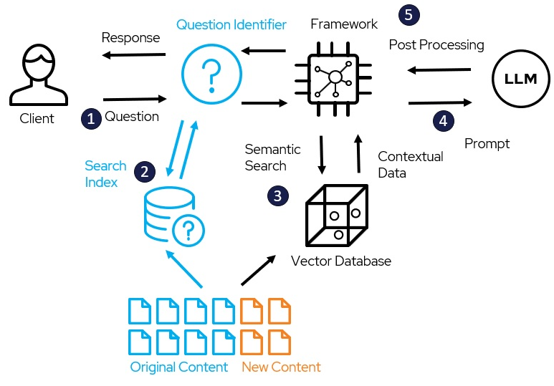

Fig.1 Retrieval-Generation Model

Figure 3 shows Retrieval-augmented generation (“RAG”) models combine the powers of pretrained dense retrieval (DPR) and sequence-to-sequence models. RAG models retrieve documents, pass them to a seq2seq model, then marginalize to generate outputs. The retriever and seq2seq modules are initialized from pretrained models, and fine-tuned jointly, allowing both retrieval and generation to adapt to downstream tasks.

It is based on the paper Retrieval-Augmented Generation for Knowledge-Intensive NLP Tasks by Patrick Lewis, Ethan Perez, Aleksandara Piktus, Fabio Petroni, Vladimir Karpukhin, Naman Goyal, Heinrich Küttler, Mike Lewis, Wen-tau Yih, Tim Rocktäschel, Sebastian Riedel, Douwe Kiela.

* 1. **System Architecture**

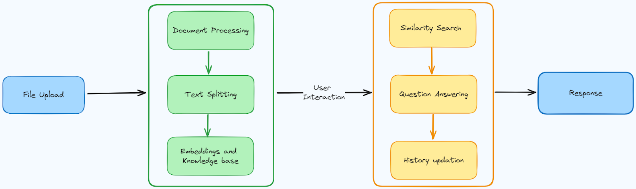

Fig. 2 LegalEase System Architecture

The depicted architecture encapsulates the fundamental workflow of the "LegalEase" project, showcasing that it can be used to generate and understand a wide variety of legal documents. The system can also be customized to meet the specific needs of different users and organizations. It outlines the systematic process of handling user inputs, performing necessary operations, and presenting relevant document information to the user.

* File Upload: This component accepts a legal document as input, either in a text file format or as a scanned document.
* Text Splitting: This component splits the input document into individual sentences or clauses.
* Embeddings and Knowledge Base: This component generates embeddings for each sentence or clause in the document, and looks up the embeddings in a knowledge base to extract relevant information, such as the legal concepts and entities involved.
* Similarity Search: This component compares the embeddings of the sentences or clauses in the document to the embeddings of known legal documents in a database, in order to identify similar documents.
* Interaction: This component provides an interface for users to interact with the system, such as to ask questions about the legal document or to request that the system generate a new legal document based on a set of requirements.
* User Question Answering: This component answers questions posed by users about the legal document, using the information extracted from the document in the Embeddings and Knowledge Base component.
* History Updation: This component updates the system's knowledge base with the new legal document or the answer to the user's question, so that the system can learn and improve over time.

This streamlined workflow encapsulates the essence of the "LegalEase" project, illustrating how user interactions trigger a sequence of meticulously orchestrated operations. From data validation to NLP-driven analysis and document presentation, the system ensures a user-centric experience, facilitating efficient and informed grant exploration.

1. **Use Case Diagram**

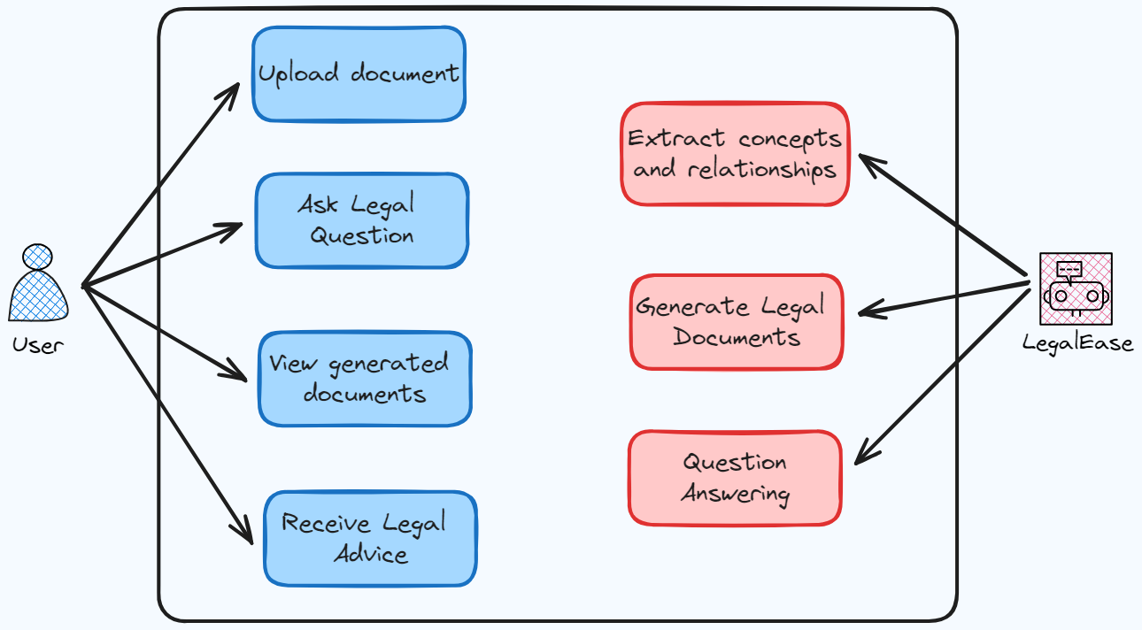

Fig. 3 Use Case Diagram

The Use Case Diagram for the "LegalEase" describes the functionality of a system for generating and understanding legal documents. The system allows users to upload legal documents, extract concepts and relationships, and receive legal advice.

**Use Cases Overview:**

* Upload Document:
  + Description: Users can upload legal documents to the system for processing.
  + Actors: User, Legal Document Repository, LangChain
  + Preconditions: User has a legal document to upload.
  + Postconditions: Document is stored in the repository, and relevant legal concepts are extracted.
* Ask Legal Question:
  + Description: Users can submit legal questions for advice.
  + Actors: User, Legal Document Repository, LangChain
  + Preconditions: User has a legal question.
  + Postconditions: Legal advice is generated and presented to the user.
* View Generated Documents:
  + Description: Users can view legal documents generated by the system.
  + Actors: User, Legal Document Repository, LangChain
  + Preconditions: User has requested to view generated documents.
  + Postconditions: Customized legal documents are presented to the user.
* Receive Legal Advice:
  + Description: Users receive tailored legal advice based on uploaded documents and submitted questions.
  + Actors: User, Legal Document Repository, LangChain
  + Preconditions: User has uploaded documents or asked a legal question.
  + Postconditions: Legal advice is provided to the user.

**Actor-Use Case Interactions:**

* Upload document: The user takes the initiative by submitting a legal document for processing. The system seamlessly processes the uploaded document using the Textract library, extracting essential textual content. Subsequently, LangChain, the natural language processing engine, comes into play, conducting a comprehensive analysis to extract key concepts and relationships embedded within the document.
* Ask Legal Question: the user engages with the system by submitting a specific legal inquiry. LangChain, leveraging its question-answering capabilities, processes the user's question, initiating a search for relevant legal information within the Legal Document Repository. Based on the extracted legal insights, the system generates tailored legal advice to address the user's query. The user, in turn, receives the advice, accompanied by clear explanations and references to pertinent legal concepts. Additionally, the user is provided with the option to seek further clarification, fostering a dynamic and interactive legal advisory experience.
* View Generated Documents: The system employs LangChain to retrieve pertinent legal concepts and relationships from the Legal Document Repository. Leveraging the user's historical data and preferences, the system generates customized legal documents tailored to meet specific requirements. These documents are then presented to the user for review, providing a transparent and user-friendly interface to assess the relevance and accuracy of the generated legal content.
* Receive Legal Advice: Users receive personalized legal advice based on the amalgamation of uploaded documents and submitted questions. LangChain processes the user's data, leveraging its natural language processing capabilities to generate insightful and tailored legal advice. The advice is then presented to the user, accompanied by detailed explanations and references to relevant legal concepts, ensuring a comprehensive understanding of the provided guidance. This user-centric approach enhances the clarity and utility of the legal advice received within the LegalEase platform.

**System Functionality:**

* Upload Legal Document: Users can upload legal documents to the system in a variety of formats, including text files, scanned documents, and PDFs.
* Extract Concepts and Relationships: The system can extract relevant legal concepts and entities from legal documents.
* Find Similar Documents: The system can identify similar legal documents from a database.
* Answer User Questions: The system can answer questions posed by users about legal documents.
* Generate Legal Documents: The system can generate new legal documents based on a set of requirements provided by the user.
* Review Legal Documents: The system allows users to review and approve legal documents generated by the system.

**User Experience:**

The system is designed to be easy to use for users with a variety of skill levels. The system provides a clear and intuitive user interface, and it provides helpful documentation and support.

1. **Document Generation Diagram**

Fig 3.3 Document Generation Diagram


Fig. 4 Document Generation Diagram

The diagram provided illustrates the various types of documents that will be generated by LegalEase. There are three types of documents that will be generated the Non-Disclosure Agreement (NDA), Evaluation Agreement, and Master Agreement. The formation of the NDA happens when starts-ups and MSMEs do their budgeting while the Evalution Agreement is formed after the testing of a particular product, this process of testing is called the pilot phase.

The documents that will be generated have the following properties:

* **Non-Disclosure Agreement (NDA):** A Non-Disclosure Agreement, commonly known as an NDA, is a legally binding contract designed to protect sensitive information shared between parties. In the business realm, NDAs are frequently employed when two or more entities enter into discussions or collaborations that involve the exchange of proprietary or confidential information. The agreement establishes a legal obligation for the receiving party to keep the disclosed information confidential and not to use it for unauthorized purposes. NDAs play a pivotal role in fostering trust and facilitating open communication between businesses, particularly in scenarios where the sharing of confidential information is essential for strategic collaborations, partnerships, or negotiations.
* **Evaluation Agreement:** An Evaluation Agreement, also referred to as a trial or test agreement, is a legal document employed when one party grants another party the opportunity to assess a product, service, or intellectual property before entering into a more comprehensive agreement. This type of agreement outlines the terms and conditions under which the evaluation will take place, including the duration of the evaluation period, the scope of the evaluation, and any restrictions on the use or disclosure of the information obtained during the evaluation. Evaluation agreements are commonly utilized in industries such as technology and manufacturing, allowing parties to assess the suitability and functionality of a product or service before committing to a more extensive contractual relationship.
* **Master Agreement**: A Master Agreement serves as a foundational document that governs the overarching terms and conditions between parties engaged in a long-term or ongoing business relationship. Unlike specific agreements that address individual transactions or aspects of a relationship, a master agreement provides a framework that streamlines the negotiation and execution of multiple transactions. Within the master agreement, key provisions such as pricing, payment terms, delivery schedules, and dispute resolution mechanisms are established. Specific transactions, referred to as exhibits or schedules, can be added to the master agreement, detailing the particulars of each transaction while maintaining consistency with the overall terms outlined in the master agreement. This approach simplifies the contracting process for parties engaged in repeated or continuous transactions, promoting efficiency and clarity in their business dealings.

**CHAPTER 4**

**RESULTS / OUTPUTS**

The "LegalEase" project's Results/Outputs encompass a multifaceted array of deliverables and achievements aimed at revolutionizing the legal doucmentation landscape. Central to its outcomes is the development of a sophisticated platform, serving as a centralized hub for legal documentation exploration, generation, and understanding.

LegalEase represents a significant leap forward in simplifying the often-intricate processes of legal document generation and understanding. By harnessing the power of advanced technologies, the project provides a user-friendly platform that caters to both civilians and legal professionals, offering streamlined solutions for document-related challenges.

One of the primary outcomes of the LegalEase project is the seamless and efficient generation of legal documents. Users are presented with two distinct options to cater to their specific needs. Firstly, users can opt to upload a document of their own, initiating a document generation process that produces a new document with similar characteristics. This functionality is particularly useful for those seeking variations of existing legal documents or looking to streamline the creation of similar agreements.

The second option within the document generation feature allows users to choose from a repository of existing templates. This repository encompasses a variety of commonly used legal documents, such as Non-Disclosure Agreements (NDAs), evaluation agreements, and master agreements. Users can select a template that aligns with their requirements, customize it as needed, and obtain a generated document tailored to their specifications. This feature not only accelerates the document creation process but also ensures accuracy and compliance with legal standards.

LegalEase extends its capabilities beyond document generation to facilitate document understanding. Users are empowered to upload legal documents and pose questions related to the content. This functionality is particularly valuable for individuals and legal professionals seeking insights, clarifications, or interpretations of legal texts. The system employs LangChain's advanced natural language processing capabilities to comprehend the nuances of the document, extracting key concepts and relationships.

Upon uploading a document and submitting questions, users receive prompt and accurate responses. The system provides valuable information related to the content of the document, offering insights that aid in comprehension and decision-making. This feature is designed to empower users with a deeper understanding of legal texts, allowing them to navigate complex documents with confidence.

In both document generation and understanding, the outputs are tailored to the user's specific preferences and needs. Generated documents are accurate, compliant, and aligned with the user's input, while responses to document-related questions are informative and precise. The result is a comprehensive legal solution that caters to the diverse requirements of both individuals and legal professionals, ultimately easing the complexities associated with legal documentation and fostering informed decision-making.

**Screenshots:**

These visuals encapsulate a comprehensive array of screens and functionalities available to users within the "LegalEase" platform. They present a diverse spectrum of key areas, showcasing the interface for legal document generation and understanding. The website is designed to help startups and MSMEs with their legal issues.

The website has a simple and user-friendly interface. The homepage has a clear and concise value proposition, which is to "Simplify legal document reading, generation, and understanding for Micro, Small, and Medium Enterprises (MSMEs) and start-ups in India."

The LegalEase website provides a variety of features, including:

* Document Understanding: LegalEase uses cutting-edge AI and natural language processing (NLP) algorithms to interpret legal documents while ensuring compliance with the Indian Constitution.
* Document Generation: LegalEase provides user-friendly tools for creating essential business documents, such as contracts and agreements, easing the burden on MSMEs.
* Irregularity Detection: LegalEase's advanced analysis features can identify inconsistencies, errors, and potential legal issues within documents, providing valuable insights to users.
* User-Friendly Interface: LegalEase offers an intuitive platform accessible to users from various backgrounds

Some ways of how startups and MSMEs can use LegalEase are:

* A startup can use LegalEase to generate a non-disclosure agreement (NDA) for use with potential investors.
* An MSME can use LegalEase to generate a contract for a new customer.
* A startup can use LegalEase to review the terms and conditions of a software license agreement before signing it.
* An MSME can use LegalEase to ensure that its website privacy policy is compliant with Indian law.

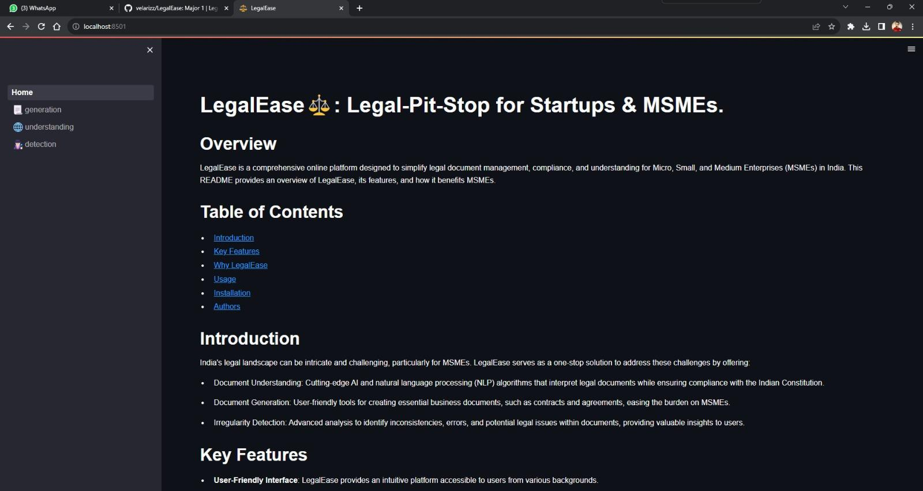

Fig. 5 Home page of LegalEase

**Video Demonstration:**

We are also presenting a captivating video demonstration showcasing the dynamic and immersive document generation and understaning offered by our project, LegalEase. This engaging video provides an insightful overview of our application, highlighting its key features, user interactions, and the seamless flow of the interview process.

This video is hosted on Loom [15], a video messaging tool that helps you get your message across through instantly shareable videos. With Loom, we can record your camera, microphone, and desktop simultaneously.



Fig. 6 Features of Loom

**Code Snippets:**

In conjunction with the visual elements, the project documentation integrates segments of the project's codebase, encapsulated as code snippets. These excerpts spotlight the intricate technical groundwork behind the "LegalEase" project, constructed through a melange of robust technologies including LangChain, Streamlit, Python, and sophisticated NLP library NLTK.

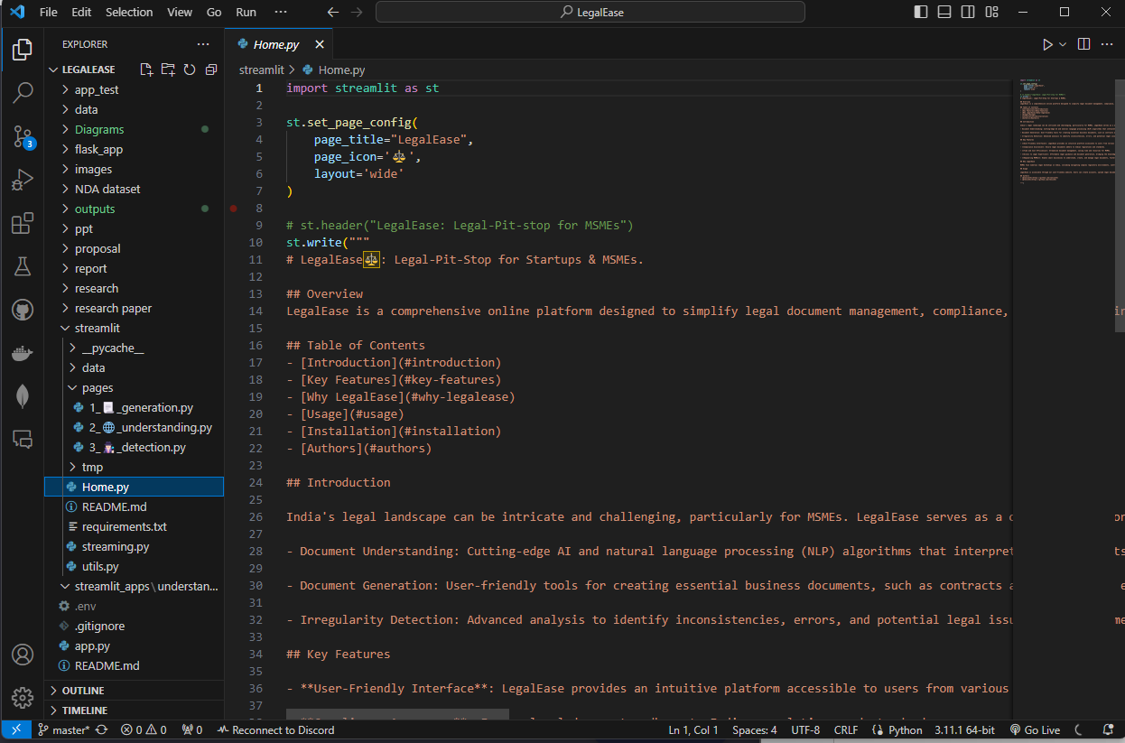

Fig. 7 Home Page Code

The figure 4.4 shows a part of the code snippet of the home page of the LegalEase Website which can be viewed in Figure 2

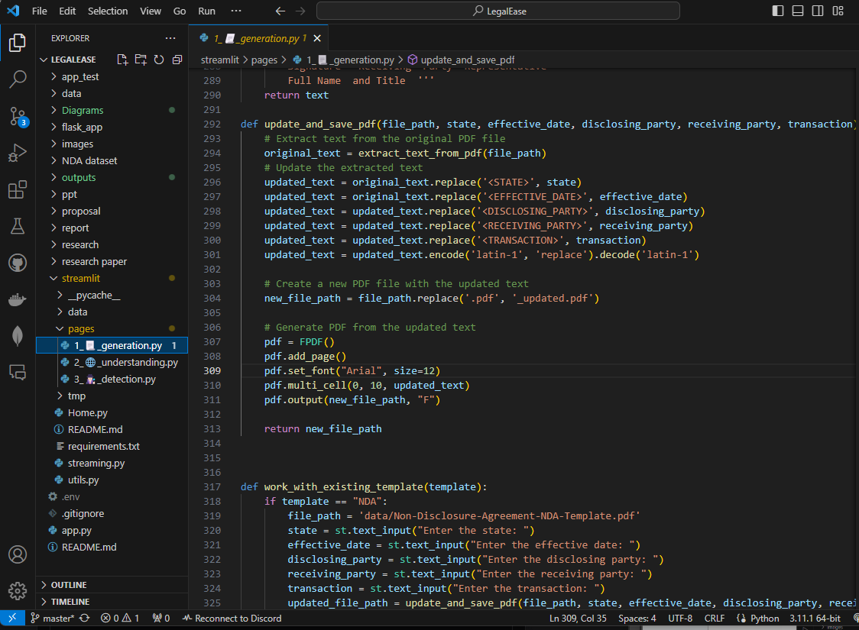

Fig. 8 Generation Module Code

The figure 8 shows a part of the code snippet from the generation module of the LegalEase Website.

These succinct code snippets act as illustrative fragments, illuminating specific functionalities, intricate algorithms, or integrations within the system. Each snippet is like a small world that shows different architectural details, data processing methods, integration frameworks that talk to outside APIs, and how to use advanced natural language processing (NLP) techniques well in the system's infrastructure.

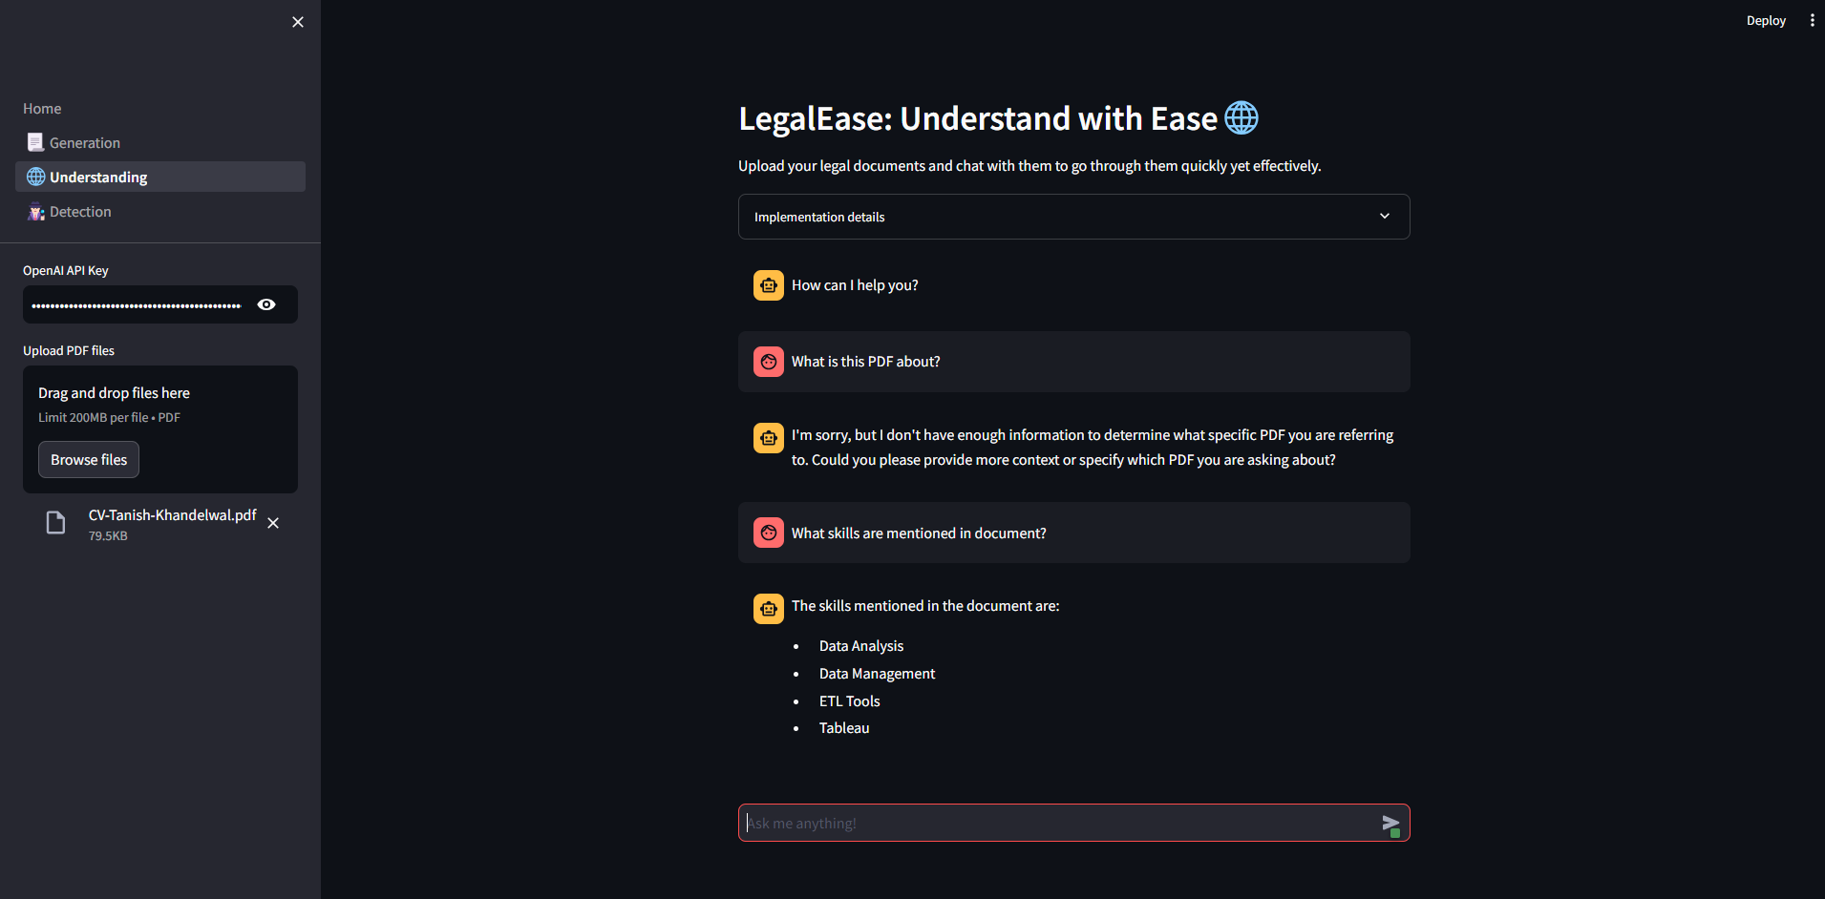

Fig. 9 Understanding Module Code

Figure 9 shows a part of the code snippet from the understanding module of the LegalEase Website. Imbued within these code fragments lies the essence of the system's operational blueprint, encapsulating the logic and mechanisms that underpin its fundamental features and capabilities. From frontend implementations leveraging the tandem strength of Streamlit to the backend robustness facilitated by Python, these snippets delineate the comprehensive tech stack employed in the development.

Moreover, these snippets are not merely technical artifacts; they also function as educational resources. They serve as informative repositories, offering a learning platform for developers, enthusiasts, and stakeholders keen on understanding the intricacies, methodologies, and underlying mechanisms steering the functionality and efficacy of the "LegalEase" platform.

# 

Fig. 10 Output for Generation Module

Figure 10 shows a Generation Module is a component within a system or software architecture that is responsible for producing or generating specific outputs based on input or predefined conditions. In various fields, such as natural language processing (NLP), computer graphics, and artificial intelligence, generation modules play a crucial role in creating content, responses, or representations.

In the context of natural language processing, a Generation Module is often associated with text generation. It takes input data, which could be in the form of structured information or context, and produces coherent and contextually relevant textual output. This can range from simple sentence formation to more complex tasks such as language translation, text summarization, or the creation of creative writing pieces.

# 

Fig. 11 Output for detection Module

A Detection Module is a fundamental component within various systems and software architectures designed to identify and recognize specific patterns, features, or entities within input data. This module plays a key role in applications ranging from computer vision and security systems to natural language processing and anomaly detection in diverse fields of artificial intelligence.

In computer vision applications, a Detection Module is responsible for identifying and locating objects or features within visual data, such as images or videos. This can involve tasks like object detection, facial recognition, and image segmentation. Advanced detection modules often leverage deep learning techniques, such as convolutional neural networks (CNNs), to automatically learn and extract relevant features from visual data, enabling accurate and efficient object recognition.

# 

Fig.12 Output for Understanding Module

# An Understanding Module is a critical component within various systems and software architectures, designed to interpret and comprehend input data, often in the form of text, images, or other types of information. This module plays a pivotal role in applications involving natural language processing (NLP), computer vision, and artificial intelligence, where the ability to understand and derive meaning from data is essential.

# In the context of natural language processing, an Understanding Module is tasked with extracting semantic meaning, relationships, and context from textual inputs. This involves parsing sentences, identifying entities, recognizing sentiment, and discerning the intent behind user queries. Advanced understanding modules may leverage machine learning techniques, such as natural language understanding (NLU) models, to enhance their ability to grasp nuanced meanings and context in human language.

# **CHAPTER-5**

## **CONCLUSIONS**

The culmination of the "LegalEase" project marks a significant milestone in revolutionizing the landscape of legal documentation. Through the integration of cutting-edge technologies, the platform has emerged as a formidable tool, simplifying the intricate process of legal document generation and understanding.

The amalgamation of LangChian, Python, and specialized NLP libraries exemplifies the project's technical prowess. The successful implementation of advanced technologies, such as LangChain's natural language processing capabilities, has resulted in a user-friendly platform that streamlines the generation and understanding of legal documents.

This harmonious integration underscores the adaptability and proficiency in leveraging a diverse range of technologies to construct a robust and versatile platform catering to users’ varied needs.

The platform's user-centric design and functionalities, spanning comprehensive grant exploration, detailed viewing, personalized filtering, and user profile management, manifest a commitment to providing an intuitive, tailored, and seamless experience for users navigating the intricate legal landscape.

The "LegalEase" project has laid a solid foundation, yet the journey towards innovation and improvement continues. The emphasis on continual development, integration of advanced technologies, fostering user engagement, ensuring robust security, and exploring collaborative opportunities remains pivotal for the sustained evolution and success of the platform in facilitating access to vital funding opportunities.

Continual improvements are essential for the ongoing development of the "LegalEase" platform, ensuring it evolves to better cater to user needs. These enhancements should focus on refining user experience, broadening the scope of available legal documents, and fine-tuning features based on user input. This iterative approach allows the platform to remain responsive, adapting to changing requirements over time.

Exploring cutting-edge technologies and integrating advanced AI features could significantly enhance the platform's capabilities. Enrich the existing template repository with a wider array of legal documents, catering to a broader spectrum of legal needs. This expansion ensures that users have access to a comprehensive set of templates relevant to various industries and legal scenarios.

Implement a system for real-time integration of regulatory updates. This ensures that generated documents are consistently up-to-date and comply with the latest changes in laws and regulations, offering users a reliable and compliant solution.

Seeking collaborations with legal professionals and organizations to gather feedback and insights. Establishing partnerships with legal experts ensures that LegalEase remains aligned with industry best practices and caters to the evolving needs of the legal community.

# **CHAPTER-6**

## **REFERENCES**

1. Micro, Small and Medium Enterprises (MSMEs) In India-Problems and Prospects, Pema Lama, Assistant Professor, Department of Commerce, University of Calcutta
2. The Role of a Non-Disclosure Agreement on the Protection of Intellectual Property Rights, Chinara Gasimova, Lund University, Faculty of Law
3. On Original Generation of Structure in Legal Documents, Steven Kimbrough, Thomas Y. Lee, Balaji Padmanabhan, Yinghui Yang, DOI: [10.1145/1047788.1047826](http://dx.doi.org/10.1145/1047788.1047826)
4. OpenAI. "OpenAI: Discover, Develop, and Deploy AI." https://www.openai.com/.
5. A Survey of Large Language Models, Wayne Xin Zhao, Kun Zhou, Junyi Li, Tianyi Tang, Xiaolei Wang, Yupeng Hou, Yingqian Min, Beichen Zhang, Junjie Zhang, Zican Dong, Yifan Du, Chen Yang, Yushuo Chen, Zhipeng Chen, Jinhao Jiang, Ruiyang Ren, Yifan Li, Xinyu Tang, Zikang Liu, Peiyu Liu, Jian-Yun Nie, Ji-Rong Wen, 31 Mar 2023, <https://doi.org/10.48550/arXiv.2303.18223>
6. LangChain Documentation. https://python.langchain.com/docs/get_started/introduction
7. PyPDF2 Documentation, “Welcome to PyPDF2” <https://pypdf2.readthedocs.io/en/3.0.0/>
8. Vector Stores Documentatation, “LangChain Vector Stores Documentation in Python” <https://python.langchain.com/docs/modules/data_connection/vectorstores/>
9. Python Documentation. "Python Programming Language." <https://www.python.org/>.
10. Natural Language Toolkit. "NLTK: Natural Language Toolkit for Python." <https://www.nltk.org/>.
11. Streamlit Documetattion in python <https://docs.streamlit.io/>
12. Textract Documentation in python <https://textract.readthedocs.io/en/stable/>
13. GitHub. "GitHub: Where the world builds software." <https://github.com/>.
14. Visual Studio Code. "Visual Studio Code: Code Editing. Redefined." <https://code.visualstudio.com/>.
15. Loom platform for video documentation, <https://www.loom.com/>

**CHAPTER – 7**

**PROJECT TEAM DETAILS**

**1.** **Vani Seth**

**Email:** 201b299@juetguna.in

**Contact:** +91 7906966199

**2.**  **Tanish Khandelwal**

**Email:** 201b283@juetguna.in

**Contact:** +91 7378427998