**Sonus: Get Yourself Heard**

**A Project Report**

***Submitted by:***

**Tanish Khandelwal (201B283)**

**Under the guidance of: Prof. Mahesh Kumar**



**Jan 2024 - May 2024**

***Submitted in partial fulfillment for the award of the degree***

***of***

**BACHELOR OF TECHNOLOGY**

**IN**

**COMPUTER SCIENCE AND ENGINEERING**

**Department of Computer Science & Engineering**

**JAYPEE UNIVERSITY OF ENGINEERING & TECHNOLOGY, AB ROAD, RAGHOGARH, DT. GUNA-473226 MP, INDIA**



**Declaration by the Student**

I hereby declare that the work reported in the B. Tech. project entitled as “**Sonus**”, in partial fulfillment for the award of the degree of B.Tech (CSE) submitted at Jaypee University of Engineering and Technology, Guna, as per the best of our knowledge and belief there is no infringement of intellectual property rights and copyright. In case of any violation, we will solely be responsible.

**Tanish Khandelwal (201B283)**

**Place: Jaypee University of Engineering and Technology, Guna - 473226**

**Date: 29-04-2024**

# **CERTIFICATE**

This is to certify that the work titled “**Sonus**” submitted by “**Tanish Khandelwal**” in partial fulfillment for the award of degree of B.Tech (CSE) of Jaypee University of Engineering & Technology, Guna has been carried out under my supervision. As per best of my knowledge and belief there is no infringement of intellectual property right and copyright. Also, this work has not been submitted partially or wholly to any other University or Institute for the award of this or any other degree or diploma. In case of any violation, concerned students will solely be responsible.

**Signature of the Guide**

**Place: Jaypee University of Engineering and Technology, Guna - 473226**

**Date: 29-04-2024**

**ACKNOWLEDGEMENT**

I would like to express our gratitude and appreciation to all those who gave me the opportunity to complete this project. Special thanks to my supervisor **Prof. Mahesh Kumar** whose help, stimulating suggestions and encouragementhelped us in all the time of development process and in writing this report. I also sincerely thank you for the time spent proofreading and correcting my many mistakes. I would also like to thank our parents and friends who helped us a lot in finalizing this project within the limited period. Last but not the least I am grateful to all the team members, which is me, of **Sonus**.

Thanking you,

**Tanish Khandelwal (201B283)**

**SUMMARY**

Sonus stands as a groundbreaking integration of Python library capabilities with a desktop application, tailored to enhance Large Language Models' interaction with multilingual audio and visual data. This revolutionary tool facilitates the seamless processing and understanding of diverse languages and media types, enabling more effective global communication in digital spaces.

The core of Sonus lies in its ability to process multilingual audio inputs and support image inputs, empowering LLMs to engage with a broader array of data than ever before. Additionally, its real-time voice translation feature ensures that language barriers are broken down instantly, fostering instantaneous communication across different languages.

A key aspect of Sonus is its user-friendly interface, which demystifies complex technological interactions, making it accessible to users of all technical levels. Comprehensive documentation further aids developers in integrating and maximizing the potential of Sonus in various applications.

Developed with compatibility for major operating systems and requiring only Python 3.x, Sonus is positioned as a versatile and powerful tool for developers, researchers, and corporations looking to leverage advanced audio-visual data processing within their projects.

In summary, Sonus not only enhances the capabilities of LLMs in dealing with multilingual and multimedia data but also significantly contributes to the ease and efficiency of digital communications globally.

# **LIST OF FIGURES**

|  |  |  |
| --- | --- | --- |
| **Figure** | **Title** | **Page No.** |
| Fig 1 | Flowchart of Desktop Application | 28 |
| Fig 2 | Flowchart of Sonus-AV library | 29 |
| Fig 4.1 | Output of Sonus desktop Application | 33 |
| Fig 4.2 | Sonus-AV library | 34 |
| Fig 4.3 | Code Snippet for Desktop Application | 35 |
| Fig 4.4 | Example snippet of Sonus-AV library | 36 |

**Table of Contents**

|  |  |  |
| --- | --- | --- |
|  |  |  |
| Title page |  | i |
| Declaration by the Student |  | ii |
| Certificate from the Supervisor |  | iii |
| Acknowledgement |  | iv |
| Summary |  | v |
| List of Figures |  | vi |

## **Chapter-1 INTRODUCTION 3**

* 1. Problem Definition 3
  2. Project Overview 4
  3. Hardware Specification 5
  4. Software Specification 6

## **Chapter-2 LITERATURE SURVEY 10**

* 1. Existing System 10
  2. Proposed System 11
  3. Feasibility Study 12
     1. Introduction 12
     2. Technical Feasibility 13
     3. Economic Feasibility 13
     4. Operational Feasibility 13

## **Chapter-3 SYSTEM ANALYSIS & DESIGN 15**

* 1. Requirement Specification 16
     1. OpenAI 18
     2. Large Language Model 20
     3. Langchain 22
     4. Python 23
     5. Streamlit
     6. Github
     7. PyAudio
     8. Pytessaract
     9. Speech Recognition
     10. Visual Studio Code
  2. Flowcharts
  3. Use Cases

## **Chapter-4 RESULTS/OUTPUTS 33**

**Chapter-5 CONCLUSIONS/RECOMMENDATIONS 38**

**Chapter-6 REFERENCES 40**

**Chapter-7 PROJECT TEAM DETAILS**

# **CHAPTER-1**

## **INTRODUCTION**

* 1. **Problem Definition**

In today’s interconnected world, effective communication across language barriers is essential as businesses expand globally and digital content reaches diverse audiences. Traditional language translation solutions, primarily designed for text, often fail to adequately address the complexities required for real-time, multilingual audio and visual interactions. This limitation is particularly evident in scenarios demanding immediate interaction, such as video conferences, customer support calls, and multimedia content consumption, where existing tools do not adequately support dynamic communication needs.

Existing translation tools suffer from several drawbacks. They often experience latency issues, disrupting the flow of conversation and leading to potential misunderstandings. Additionally, the accuracy of these tools can be compromised by challenges such as diverse accents, dialects, and idiomatic expressions, which conventional speech recognition technologies struggle to process correctly. Moreover, most tools lack the capability to comprehend contextual cues—essential for delivering precise translations—including cultural nuances and situational context that go beyond mere words. Furthermore, there is a notable absence of integration between audio processing and visual data interpretation, crucial for comprehensive understanding in multimedia interactions.

Sonus is conceptualized to surmount these multifaceted challenges by integrating cutting-edge technologies into a unified application. It is designed not merely as a translation tool but as a comprehensive facilitator of communication that processes multilingual audio inputs and supports image and visual input, enhancing the overall accuracy and reducing latency in translations. Sonus's advanced speech recognition technology is finely tuned to handle various languages and dialects effectively, while its capability to interpret visual information allows for a richer understanding of the content. The application’s real-time voice translation enables fluid conversation without noticeable delays, making it ideal for live interactions. Furthermore, Sonus features a user-friendly interface that makes advanced technology accessible to a broad user base, democratizing the use of sophisticated communication tools and connecting cultures more effectively.

By developing Sonus, the goal is to create a tool that not only bridges languages but also connects cultures, fostering more effective and empathetic communication across the globe.

## **Project Overview**

Sonus is a groundbreaking Python library and desktop application engineered to transform how individuals and organizations engage in global digital communication. By integrating advanced machine learning algorithms and a user-friendly interface, Sonus enables seamless interaction with multilingual audio and visual data, thus overcoming traditional barriers in language translation and media processing. This innovative tool is especially pivotal for users requiring real-time linguistic translation and data interpretation across diverse languages and formats, catering to a global audience's needs.

The Sonus system uses Python, a powerful and versatile programming language, to operate its backend processes. It integrates various libraries and APIs to handle complex tasks such as speech recognition, audio analysis, and optical character recognition. For instance, PyTesseract allows Sonus to convert text within images to editable formats, facilitating the inclusion of visual data in communication processes. Google’s advanced speech recognition services are utilized to accurately interpret and translate spoken language, supporting numerous dialects and languages and ensuring broad usability.

Sonus's desktop application, developed using Tkinter, provides a streamlined and intuitive user interface. This interface makes the sophisticated functionality of Sonus accessible to users regardless of their technical expertise. By simplifying the interaction with complex data processing tools, Sonus enhances user engagement and productivity, making it a valuable tool for real-time communication in various settings, including international conferences, educational platforms, customer support, and remote work environments.

One of the hallmark features of Sonus is its real-time voice translation capability, which allows for instantaneous communication across different languages without the delays that often plague traditional translation tools. This feature is complemented by the application’s ability to process and interpret visual data from images, empowering users to interact with both text and graphical content seamlessly. The integration of these multi-modal capabilities ensures a comprehensive communication solution where language and media barriers are effectively dismantled.

Moreover, Sonus is designed to be cross-platform, with compatibility for Windows, macOS, and Linux, thus ensuring wide accessibility. Its application across diverse sectors underscores its utility in bridging communication gaps and fostering clear, immediate, and accurate exchanges across different cultures and languages.

In essence, Sonus embodies a significant technological advancement in the realm of digital communication. By merging cutting-edge technology with a focus on user experience, Sonus stands poised to redefine global interactions, making them more connected and intelligible. This project not only represents a leap in communication technology but also a tool for cultural exchange and understanding, facilitating more effective and empathetic interactions across the globe.

## **Hardware Specification**

* Processor:
  + Minimum: Intel Core i3 or AMD equivalent
  + Recommended: Intel Core i5 or AMD equivalent
* Memory (RAM):
  + Minimum: 4GB
  + Recommended: 8GB or higher
* Storage:
  + Minimum: 100GB HDD/SSD space (for development environment)
  + Recommended: 250GB SSD for faster performance
* Display:
  + Resolution: 1366 x 768 or higher
  + Size: 13-inch or larger (for comfortable development)
* Internet Connection:
  + Stable broadband or Wi-Fi connection for accessing external data sources and APIs
* Operating System:
  + Windows 10 or later
  + macOS Catalina (version 10.15) or later
  + Ubuntu 18.04 LTS or later (or other compatible Linux distributions)

## **Software Specification**

* **Development Environment:**
  + Python Version: Use the latest Python 3.x version to ensure compatibility with all dependencies.
  + Integrated Development Environment (IDE): Any popular IDE or code editor can be used, but Visual Studio Code is recommended for its extensive support for Python and integrated terminal.
  + Version Control: Git, for managing source code versions and collaborating with other developers. Repository hosted on GitHub.
* **Dependencies (managed via `requirements.txt`):**
  + pytesseract: For optical character recognition to convert images to text.
  + Pillow: For image processing tasks, including opening, manipulating, and saving many different image file formats.
  + openai: For integrating with OpenAI's API to enhance language processing capabilities.
  + SpeechRecognition: To recognize speech and convert it to text.
  + deep_translator: For translating text between languages using various online services.
  + gtts (Google Text-to-Speech): For converting translated text into speech.
  + playsound: To play sound files with Python.
  + python-dotenv: To load environment variables from a `.env` file.
  + pyaudio: To handle audio input and output streams, used in conjunction with SpeechRecognition.
* **APIs and Data Sources:**
  + Google Translate API: For real-time translation of text and speech.
  + OpenAI API: Utilized for advanced language understanding and generation, enhancing the quality of translations and interactions.
* **Web Browser:**
  + Google Chrome: Recommended for testing and debugging the application due to its extensive developer tools and widespread support for modern web standards.
* **Additional Tools and Libraries:**
  + Tkinter: Used for developing the graphical user interface.
  + Threading: To improve performance and responsiveness, especially when handling real-time audio translation.
* **Performance Metrics:**
  + Load Time: The application is optimized for minimal load times, with a target of loading within 2-3 seconds on standard hardware.
  + Response Time: Real-time interactions, such as voice translation, aim for a response time of less than 1 second to ensure fluid communication.

**CHAPTER 2**

**LITERATURE SURVEY**

1. **Existing System**

The landscape of language translation tools currently comprises various platforms that cater to translating spoken and written content across languages. Dominant platforms like Google Translate and Microsoft Translator excel in real-time text and basic speech translation, while IBM Watson leads in speech recognition capabilities. These platforms, however, often operate independently and lack the integration needed for seamless multimodal digital communication. Google Translate and Microsoft Translator, although effective for basic translations, struggle with complex linguistic nuances and technical jargon in real-time settings. Speech-to-text services like IBM Watson Speech to Text focus on accurate transcription but require additional steps for translation, introducing potential delays in communication.

Real-time audio translation devices such as Skype Translator and Pilot earbuds offer innovative solutions for verbal communication across language barriers but fail to address the need for visual data integration, crucial for comprehensive communication contexts where visuals play a key role. The integration of these translation tools within existing digital ecosystems often necessitates extensive custom development, which can be resource-intensive and prohibitive for widespread adoption. Moreover, the interfaces of many of these tools are not user-friendly, particularly for individuals without technical expertise, limiting their accessibility and practical use.

In contrast, there is a marked absence of systems that provide integrated support for both audio and visual data. Existing solutions that attempt to handle these modalities typically treat them as distinct components rather than as part of a cohesive workflow, resulting in disjointed user experiences.

In this context, the Sonus-AV Python library emerges as a significant innovation, designed to enhance Large Language Models (LLMs) by integrating advanced voice and image input capabilities into a single, unified framework. Sonus-AV simplifies the conversion of speech to text and the analysis of images before feeding this information to LLMs, thereby improving the accuracy and contextual relevance of outputs. This capability positions Sonus-AV uniquely in the market, addressing the critical gaps in real-time, multimodal communication and enhancing the accessibility and utility of LLMs across various applications, thereby making digital interactions more fluid and comprehensible.

1. **Proposed System**

The proposed Sonus-AV system is designed to significantly enhance the capabilities of Large Language Models (LLMs) [2] by integrating sophisticated audio and visual processing technologies into a single, comprehensive framework. This innovative Python library extends the utility of LLMs by allowing them to process and understand multilingual audio and visual data in real-time, a capability not adequately addressed by current systems.

Sonus-AV introduces a unified approach where both voice and image inputs are seamlessly converted and analyzed, thereby enhancing the quality and applicability of the information before it is processed by LLMs. For audio processing, Sonus-AV uses the AudioProcessor module to convert audio inputs into text. This module is built to handle multiple languages and is capable of real-time translation, thus facilitating immediate and accurate communication across different linguistic backgrounds. The ImageProcessor module, on the other hand, allows for the extraction of textual information from images or generates descriptive analyses of visual content using advanced machine learning models. This dual capability ensures that users can receive comprehensive data interpretations that include both auditory and visual contexts, enriching the interaction and decision-making processes.

Installation of Sonus-AV is streamlined through standard Python package management tools, making it accessible to developers and enhancing its integration into existing projects or systems. The library’s architecture also promotes scalability and adaptability, accommodating future advancements in language processing and machine learning technologies.

By proposing such a system, the aim is to bridge the gap observed in current translation and communication tools, offering a more integrated and interactive experience. The Sonus-AV system not only boosts the efficiency of LLMs but also democratizes advanced communication tools, making them accessible to a broader audience. This includes educational institutions, international corporations, and individual users who require efficient and reliable multilingual and multimedia communication tools. Additionally, the Sonus-AV’s open-source nature encourages continuous improvement and community-driven enhancements, fostering an ecosystem where developers can contribute to its development, ensuring the system remains cutting-edge and relevant.

1. **Feasibility Study**

**2.3.1 Introduction**

The feasibility study for the Sonus-AV project is conducted to assess the viability of integrating a sophisticated Python library designed to enhance Large Language Models (LLMs) with real-time audio and visual data processing capabilities. This study aims to explore the practicality and potential impact of implementing Sonus-AV within various domains, including education, customer service, and content creation, where enhanced multilingual and multimedia communication is critically needed.

The burgeoning demand for advanced communication tools that can operate seamlessly across different languages and media types presents a unique opportunity. The Sonus-AV system is proposed to meet this demand by offering an innovative solution that integrates audio and visual data processing into LLMs, enabling them to perform more complex tasks with higher accuracy and efficiency. This feasibility study will address various aspects of the project, including technical feasibility, economic viability, and operational practicality, to ensure that the proposed system not only fills the existing gap in technology but also is sustainable and adaptable in a rapidly evolving digital landscape.

By examining these dimensions, the study will provide insights into the challenges and opportunities associated with the Sonus-AV project, paving the way for strategic planning and decision-making. It will assess the project's alignment with current technological trends, market needs, and the overall strategic objectives of enhancing digital communication across borders. The outcomes of this feasibility study are expected to form the foundational basis for the project’s development strategy, ensuring that the Sonus-AV library can be effectively integrated, marketed, and utilized in its target environments.

**2.3.2 Technical Feasibility**

The technical feasibility of the Sonus-AV project is a critical component of the overall feasibility study, focusing on determining whether the current technology is adequate to support the proposed innovations and whether the project can be developed within the existing technological framework. This analysis evaluates the project's capability to integrate advanced audio and visual processing technologies into a cohesive system that enhances the functionality of Large Language Models (LLMs).

Sonus-AV aims to implement a suite of Python libraries that can handle sophisticated audio and image processing tasks, enabling real-time translation and data interpretation capabilities. The core technologies involved—such as speech recognition, optical character recognition, and deep learning models for image and audio analysis—are already well-established in the tech industry. The project leverages these technologies by integrating them into a single, user-friendly library that can be easily adopted by developers and integrated into existing systems.

From a technical standpoint, the project's success hinges on the seamless integration of these diverse technologies. This includes ensuring compatibility across various operating systems and platforms, such as Windows, macOS, and Linux, and optimizing performance to handle real-time data processing without significant delays. The use of Python, a widely supported programming language known for its robust libraries and active development community, adds to the project’s technical viability. Python’s flexibility and the availability of numerous libraries for machine learning, audio processing, and image analysis provide a strong foundation for developing Sonus-AV.

Moreover, the project involves continuous testing and iteration to refine the integration of audio and visual data processing, ensuring that the final product can effectively meet the needs of users requiring multilingual and multimedia communication tools. The development team will need to address potential challenges such as data privacy, scalability of the system, and the handling of high volumes of real-time data, ensuring that Sonus-AV remains reliable and efficient under various usage conditions.

In conclusion, the technical feasibility of Sonus-AV is supported by the availability of advanced technologies and Python’s capabilities. However, successful implementation will require careful planning, robust testing, and ongoing adjustments to adapt to new technological advancements and user feedback, ensuring that Sonus-AV can achieve its goal of revolutionizing digital communication across languages and media types.

**2.3.3 Economic Feasibility**

The economic feasibility of the Sonus-AV project examines whether the financial resources, potential revenue streams, and anticipated costs align to make the project viable from a fiscal perspective. This assessment is crucial in determining whether the benefits and returns of the project justify the required investment, both initially and over the long term.

Sonus-AV's development involves a series of stages that require funding, including research and development (R&D), software design, testing, deployment, and ongoing maintenance. Given that Sonus-AV leverages existing technologies within the Python ecosystem, some of the significant costs typically associated with developing novel algorithms from scratch can be mitigated. The use of open-source libraries and tools further reduces software licensing fees, allowing more of the budget to be allocated to other critical areas such as market research, user experience design, and system optimization.

The potential revenue streams for Sonus-AV are promising, given the growing demand for advanced communication tools that can handle both audio and visual data across multiple languages. The library could be monetized through various models, including a subscription-based service for businesses, licensing agreements with educational and corporate clients, and custom service packages tailored to specific industry needs. Additionally, partnerships with technology firms and academic institutions could open up grant and funding opportunities to support further development and scaling.

A critical factor in the economic viability of Sonus-AV will be its market penetration and user adoption rates. Effective marketing strategies and robust user support systems will be essential to promote the library and facilitate its integration into users' existing workflows. This includes detailed documentation, user training programs, and responsive customer service. The initial target markets would likely include sectors where multilingual communication is frequently required, such as in international business, customer service platforms, and global education providers.

Overall, the economic feasibility of Sonus-AV appears strong, contingent upon careful financial planning, targeted marketing efforts, and strategic partnerships. The project's success will depend on its ability to attract a sufficient user base and to continuously adapt to their needs, ensuring that Sonus-AV remains a competitive and valuable tool in the global communication landscape.

**2.3.4 Operational Feasibility**

The operational feasibility of the Sonus-AV project assesses whether the proposed system can be effectively implemented within the existing operational structures and workflows of potential users, and whether it meets the practical requirements of its target audience. This dimension of feasibility is crucial for ensuring that the software not only functions technically and is economically viable, but also that it integrates smoothly into the daily operations of users without causing significant disruptions or requiring untenable changes to established practices.

At the core of Sonus-AV's operational feasibility is its ease of integration and usability. The system is designed to be plug-and-play, requiring minimal setup and configuration, which is critical for adoption by non-technical users. Given its Python-based architecture, Sonus-AV is compatible with numerous operating systems and platforms, enhancing its applicability across various technological environments. Furthermore, the system's design incorporates user-friendly interfaces and straightforward controls that simplify complex processes such as audio and image analysis, making advanced technological capabilities accessible to a broader audience.

Another operational consideration is the support and maintenance infrastructure necessary to keep Sonus-AV running efficiently. This includes providing regular updates, managing a reliable customer support system, and offering training and resources to help users maximize the tool’s potential. The sustainability of these operations depends significantly on the project's ability to maintain a balance between user satisfaction and cost-effectiveness.

Moreover, the operational impact of Sonus-AV extends to how well it can be integrated with other tools and systems currently used by potential clients. This interoperability is essential for organizations that rely on a seamless flow of information across various applications. The project team must therefore ensure that Sonus-AV can easily connect with existing databases, content management systems, and other relevant platforms without requiring extensive modifications.

In summary, the operational feasibility of Sonus-AV looks promising, given its user-centered design and compatibility features. However, successful deployment will require ongoing commitment to user support, continuous improvement based on feedback, and effective integration capabilities. These factors are critical to ensuring that Sonus-AV not only fits into the existing operational landscapes of its users but also enhances their productivity and communication capabilities.

**CHAPTER 3**

**SYSTEM ANALYSIS AND DESIGN**

1. **Requirement Specification**
   * 1. **OpenAI**

OpenAI [4] plays a crucial role in the Sonus-AV project by providing advanced natural language processing capabilities through its powerful APIs. This integration is fundamental to enhancing the performance of Sonus-AV, especially in understanding and generating human-like text from audio and visual inputs. OpenAI's API offers a suite of state-of-the-art machine learning models that are pivotal for processing complex language tasks, which are essential for the effective functioning of Sonus-AV in a multilingual environment.

The OpenAI API enables Sonus-AV to leverage models like GPT (Generative Pre-trained Transformer), which are renowned for their deep learning capabilities in understanding context, nuance, and subtleties in language. These models can efficiently process the textual data extracted from audio and visual inputs, ensuring that the translations and interpretations are not only accurate but also contextually appropriate. This is particularly important in real-time communication scenarios where the correctness of language can significantly impact the effectiveness of interactions.

Moreover, OpenAI's robust API supports multiple languages, which is critical for Sonus-AV as it aims to serve a global user base. This multilingual support ensures that Sonus-AV can be effectively used in diverse linguistic settings, breaking down communication barriers and facilitating smoother interactions across different cultural contexts. The API’s ability to handle idiomatic expressions, colloquialisms, and industry-specific jargon enhances Sonus-AV's utility in specialized fields such as education, customer support, and international business.

Another significant advantage of integrating OpenAI into Sonus-AV is the continuous improvement and update cycle maintained by OpenAI. The models are regularly updated with the latest research and data, which means that Sonus-AV can continually improve its accuracy and functionality without the need for manual upgrades or extensive redevelopment. This aspect of scalability and adaptability is essential for keeping Sonus-AV relevant and effective in the rapidly evolving field of AI and machine learning.

From an operational perspective, using OpenAI’s API is cost-effective and resource-efficient. It eliminates the need for Sonus-AV to develop its own complex AI systems from scratch, which would require substantial investments in time, expertise, and financial resources. Instead, leveraging OpenAI allows Sonus-AV to focus on other critical aspects of its development, such as user interface design and system integration, while still providing top-tier AI functionalities.

OpenAI is a foundational component of the Sonus-AV project, providing advanced AI tools that enhance the system’s language processing capabilities. Its integration into Sonus-AV ensures that the application remains at the forefront of technology, offering high-quality,

scalable, and efficient solutions for real-time multilingual and multimedia communication.

* + 1. **Large Language Model**

Large Language Models (LLMs) [2], particularly those developed by leading AI research entities like OpenAI, form a pivotal component of the Sonus-AV project. These models are integral for processing and generating language in a way that mimics human understanding, which is essential for Sonus-AV’s functionality across various languages and media types. The use of LLMs in Sonus-AV allows for the incorporation of cutting-edge linguistic capabilities into the software, transforming it into a powerful tool for real-time translation and content interpretation.

LLMs such as GPT-3 offer extensive benefits due to their ability to understand and generate human-like text based on the context provided to them. This capability is crucial for Sonus-AV, as it allows the system to handle complex interactions that involve nuances of language that simpler models might not interpret correctly. For instance, the ability to understand slang, idiomatic expressions, and context-dependent meanings can significantly enhance the accuracy of translations and responses generated by Sonus-AV, making communications more natural and effective.

Incorporating LLMs into Sonus-AV also enables the system to learn from interactions over time, thereby improving its accuracy and efficiency through machine learning algorithms. This adaptability is vital for maintaining the relevance and effectiveness of Sonus-AV in a fast-evolving technological landscape. By analyzing data from previous interactions, LLMs can optimize their processing routines to better handle similar requests in the future, leading to a continually improving user experience.

Moreover, LLMs support multilingual capabilities that are essential for Sonus-AV’s goal of providing services across different geographic and linguistic boundaries. This global approach not only broadens the potential market for Sonus-AV but also enhances its utility as a communication tool in diverse settings, from international conferences to global customer service platforms.

However, integrating LLMs into Sonus-AV comes with its challenges, primarily related to computational demands and data privacy. LLMs require significant processing power, which can necessitate substantial hardware capabilities or reliance on cloud-based computing solutions. Additionally, ensuring the privacy and security of the data processed by these models is crucial, especially when handling sensitive personal or business communications. Addressing these challenges requires careful planning and robust system design to ensure that Sonus-AV remains efficient, secure, and user-friendly.

In conclusion, LLMs are a critical technological foundation for Sonus-AV, providing the advanced language processing power needed to make it a state-of-the-art communication tool. Their ability to learn and adapt to new information, process data in multiple languages, and handle the subtleties of human language makes them indispensable for achieving the high levels of accuracy and functionality envisioned for Sonus-AV.

* + 1. **Langchain**

Langchain [4] is a crucial technology for the Sonus-AV project, particularly in enhancing the interaction between LLMs and the specialized tasks required for multilingual audio and visual data processing. Langchain, as a framework, facilitates the integration of language models with chain-of-thought prompting and other techniques that enhance language comprehension and output generation. This makes it an invaluable asset for Sonus-AV, which aims to deliver high-quality, contextually aware translations and content analysis.

The adoption of Langchain in Sonus-AV allows the system to leverage the sophisticated capabilities of LLMs more effectively by guiding them in task execution that goes beyond basic translation. For instance, Langchain can orchestrate complex workflows involving multiple steps, such as extracting text from an image, translating the text into another language, and then synthesizing the translated text into speech. This process, enabled by Langchain, ensures that each step is handled optimally, with contextual understanding maintained throughout the sequence.

Moreover, Langchain supports the development of custom pipelines tailored to specific use cases. This adaptability is essential for Sonus-AV, as it needs to operate across diverse fields such as customer support, education, and media, each with unique requirements and challenges. Langchain's flexibility in integrating various tools and APIs allows Sonus-AV to configure its operations dynamically based on the task at hand, enhancing both performance and user satisfaction.

Integrating Langchain also empowers Sonus-AV to handle conversational contexts more effectively. It enables the system to maintain stateful interactions, an essential feature for conversations that span multiple exchanges where continuity and context retention are necessary. This capability is particularly beneficial in scenarios like customer service, where understanding the flow of the conversation can significantly impact the quality of service provided.

However, implementing Langchain within Sonus-AV requires careful consideration of computational efficiency and resource management. The complex operations facilitated by Langchain, while powerful, can be resource-intensive. Optimizing these processes to ensure they run smoothly on the intended platforms, without excessive delays or resource consumption, is critical. This might involve strategic decisions about data handling, processing power allocation, and possibly leveraging cloud computing environments to balance load and performance.

In conclusion, Langchain is a transformative component in the Sonus-AV ecosystem, offering sophisticated tools to enhance the application’s capabilities in processing and translating multilingual and multimedia content. Its integration is pivotal for automating complex language processing tasks, providing customizability and maintaining conversational context, which collectively propel Sonus-AV to the forefront of communication technology solutions.

* + 1. **Python**

Python [1] is an essential component in the development of Sonus-AV, serving as the primary programming language due to its simplicity, flexibility, and the extensive support it offers for data processing and machine learning. This choice is strategically aligned with the need for a robust and scalable platform capable of handling complex audio and visual data processing tasks. Python's widespread adoption in the scientific and tech communities, especially within the fields of artificial intelligence and data science, ensures access to a rich ecosystem of libraries and frameworks that are crucial for the development of Sonus-AV.

One of the primary reasons for selecting Python is its comprehensive standard library and a vast array of third-party packages that facilitate rapid development and integration of advanced features such as speech recognition, image processing, and real-time data translation. Libraries such as NumPy and Pandas optimize data handling and computations, which are essential for processing the large volumes of data involved in Sonus-AV operations. For machine learning and deep learning tasks, TensorFlow and PyTorch offer powerful, flexible tools that make it possible to design sophisticated models that are central to the functionalities of Sonus-AV.

Moreover, Python’s syntax is clear and concise, making it more accessible for new developers and reducing the learning curve associated with the platform. This ease of use is critical in fostering a broad adoption rate among developers who may not have extensive programming backgrounds but are crucial participants in expanding the Sonus-AV’s functionality.

The implementation of Python also supports cross-platform compatibility, ensuring that Sonus-AV can operate on various operating systems such as Windows, macOS, and Linux without significant modifications. This is particularly important for ensuring that Sonus-AV can be used in diverse environments, from academic settings to business contexts, without concerns about system compatibility.

Furthermore, Python’s active and engaged developer community plays a vital role in the ongoing development and troubleshooting of Sonus-AV. Community-driven support and the continuous development of Python itself mean that Sonus-AV can remain up-to-date with the latest technological advances and security practices, maintaining high standards of performance and reliability.

Python is not merely a programming choice but a strategic foundation that supports the complex requirements of Sonus-AV, enabling robust functionality, ease of use, and broad compatibility. This ensures that Sonus-AV remains a cutting-edge tool in the realm of digital communication.

* + 1. **Streamlit**

Streamlit is an essential component for Sonus-AV, particularly for building and deploying the interactive web interfaces that facilitate user interaction with the system’s advanced audio and visual processing capabilities. Streamlit is designed to turn data scripts into shareable web apps in minutes, without the need for front-end development skills. This makes it a particularly attractive choice for Sonus-AV, which aims to democratize access to sophisticated language processing tools by making them easily accessible and operable by users of varying technical proficiency.

The integration of Streamlit into Sonus-AV allows for rapid development and deployment of a user-friendly interface through which users can interact with the system. This is crucial for tasks such as uploading audio files for transcription, entering text for translation, or selecting images for content analysis. Streamlit’s ability to handle these interactions smoothly and intuitively enhances the overall user experience, promoting greater adoption and satisfaction.

Streamlit’s architecture supports real-time feedback and updates, which is vital for Sonus-AV’s operation, where users may need to see immediate results from their inputs or adjustments. For example, when a user uploads an image for text extraction and translation, Streamlit can display the processed results directly within the same interface, allowing for quick iterations based on user feedback or requirements. This interactive capability ensures that Sonus-AV can serve as a practical tool for real-time communication and data analysis.

Moreover, Streamlit’s compatibility with major Python libraries used in data science and machine learning (such as NumPy, Pandas, and PyTorch) makes it a perfect fit for Sonus-AV, which relies heavily on these libraries for backend processing. Streamlit can seamlessly display data processed by these tools, whether it’s showing the transcription of audio data, visualizing translation accuracy, or presenting comparative analysis of language models.

However, incorporating Streamlit into Sonus-AV also involves managing potential challenges related to web app performance, especially under high usage scenarios. Ensuring that the web interfaces remain responsive and efficient as the user base grows will require careful optimization of backend operations and possibly integrating scalability solutions such as caching and load balancing.

Streamlit stands out as a key technology in the Sonus-AV project, enabling the rapid development of robust and user-friendly web interfaces that facilitate seamless interaction with the system’s language processing functions. Its integration supports effective user engagement and operational efficiency, making Sonus-AV more accessible and useful in diverse applications ranging from academic research to international business communications.

* + 1. **Github**

GitHub is a critical tool for the Sonus-AV project, serving as the primary platform for version control, collaboration, and code management. As an open-source repository hosting service, GitHub allows the project team to manage the development of Sonus-AV efficiently while fostering collaboration among developers, both within the core team and the broader open-source community. This tool is essential not only for organizing the project’s codebase but also for encouraging community contributions, which are vital for the continuous improvement and innovation of Sonus-AV.

The use of GitHub in Sonus-AV ensures a structured approach to software development, enabling features such as branching, merging, and pull requests. These features facilitate effective version control and allow multiple developers to work on different aspects of the project simultaneously without conflict. For instance, while one developer improves the audio processing capabilities, another can enhance the image processing features, and changes can be integrated smoothly into the main project repository.

Moreover, GitHub acts as a central hub for tracking issues and bugs related to Sonus-AV. The issue tracking system allows developers and users to report bugs, suggest enhancements, and request new features. This open line of communication is crucial for identifying and addressing problems quickly and efficiently, which enhances the reliability and usability of Sonus-AV over time. It also engages the user community, making them a part of the development process, which can lead to more user-centric design and functionality.

GitHub also plays a significant role in the documentation and dissemination of information about Sonus-AV. The platform hosts comprehensive documentation, user guides, and API references, which are essential for helping new users understand how to install, configure, and use Sonus-AV effectively. Additionally, GitHub’s functionality to fork repositories allows other developers to create their versions of Sonus-AV, experiment with new ideas, and potentially contribute back enhancements and new features to the original project.

However, leveraging GitHub effectively requires maintaining clear and well-organized documentation, consistent coding standards, and an active management presence to guide the project’s development and community interactions. Ensuring that contributions are properly vetted and integrated into Sonus-AV requires a systematic approach to code review and acceptance, which can be resource-intensive but is crucial for maintaining the quality and integrity of the software.

In conclusion, GitHub is an indispensable tool for the Sonus-AV project, underpinning its development infrastructure and community engagement strategy. It provides the necessary mechanisms for collaborative development, issue tracking, and documentation, which are essential for the scalable and sustainable growth of Sonus-AV. Through GitHub, Sonus-AV not only leverages the global developer community for continuous improvement but also ensures that the project remains transparent, accessible, and community-driven.

* + 1. **PyAudio**

PyAudio is an essential technology tool for the Sonus-AV project, enabling audio input and output operations critical for the software's functionality. As a Python library, PyAudio provides Sonus-AV with the capability to interact with a wide range of audio devices, essential for capturing live audio data and playing back audio, including real-time translated speech. This capability is integral to Sonus-AV’s design, particularly for its applications in real-time communication scenarios such as translation, customer service, and educational tools.

The integration of PyAudio into Sonus-AV facilitates the core operation of capturing audio input from microphones, which is a fundamental step in the process of audio data analysis and translation. By accessing audio streams directly from hardware devices, PyAudio allows Sonus-AV to process raw audio data, perform noise reduction, and subsequently apply speech recognition algorithms. This seamless capture and processing of live audio are crucial for maintaining the real-time responsiveness of Sonus-AV, ensuring that users experience minimal lag between speech and its corresponding text or translated output.

Moreover, PyAudio supports audio playback, a feature that is vital for Sonus-AV’s ability to provide feedback to the user in the form of spoken text. After translating text into the target language, Sonus-AV can use PyAudio [5] to convert the text back into speech, allowing users to hear the translated phrases in real-time. This makes Sonus-AV particularly valuable in settings where auditory feedback is preferable or necessary, such as during multilingual conferences or in environments where visual attention must remain focused elsewhere.

However, integrating PyAudio into Sonus-AV comes with challenges, particularly in terms of ensuring compatibility with various audio hardware and managing the technical complexities associated with real-time audio stream processing. Issues such as latency, audio quality, and hardware compatibility must be carefully managed to ensure that Sonus-AV delivers a consistent and high-quality user experience. Additionally, handling audio data requires attention to privacy and data security, especially when dealing with sensitive or personal information.

In conclusion, PyAudio is a vital component of the Sonus-AV project, providing the technical foundation for audio capture and playback functionalities that are essential for the software's operation. Its ability to interface directly with audio hardware and support real-time audio processing enables Sonus-AV to meet the needs of users requiring quick and reliable translation and communication services. Managing the technical and privacy challenges associated with audio data will be crucial for maximizing the effectiveness and user trust in Sonus-AV.

* + 1. **Pytessaract**

Pytesseract [6] is another crucial component in the Sonus-AV project, enabling the extraction of textual information from images—an essential feature for Sonus-AV's ability to process visual data alongside audio. As a Python wrapper for Google's Tesseract-OCR Engine, pytesseract allows Sonus-AV to convert scanned images of text, photos containing text, and other types of visual data into editable and translatable text formats.

Integrating pytesseract into Sonus-AV enhances the system's versatility, especially in contexts where users might need to extract and translate text from visual sources such as documents, street signs, or instructional materials. This capability is vital for educational purposes, international travel, and professional environments where quick translation of written material is required. By providing accurate OCR functionalities, pytesseract helps Sonus-AV bridge the gap between visual information and digital text, expanding the range of communication scenarios the system can support.

The use of pytesseract involves processing images to detect and interpret text within them. This operation starts with pre-processing steps to enhance the quality of the image for better text recognition—adjustments such as scaling, binarization, and noise removal are typical. Once the image is prepared, pytesseract extracts the text, which Sonus-AV can then process further, translating or using it as input for LLMs to generate contextually appropriate responses or analyses.

However, integrating pytesseract presents challenges, particularly in terms of the accuracy and speed of text recognition. The quality of OCR can vary based on the image's clarity, the text's font size and style, and the presence of background noise or distortions. Ensuring high accuracy in text extraction is critical for maintaining the overall quality of Sonus-AV's outputs. Additionally, the processing speed of OCR operations is crucial in real-time applications, requiring optimizations to ensure that text extraction does not become a bottleneck in the workflow.

In conclusion, pytesseract is a vital tool for the Sonus-AV project, adding significant functionality in terms of processing visual information. Its ability to turn images into actionable text data empowers Sonus-AV to support a broader array of communication tasks, enhancing user interaction across different media types. Addressing challenges related to OCR accuracy and processing efficiency will be essential to fully leverage pytesseract's capabilities within Sonus-AV, ensuring the system remains responsive and effective in diverse usage scenarios.

* + 1. **Speech Recognition**

SpeechRecognition is a pivotal library in the Sonus-AV project, providing the core functionality for converting spoken language into text. This library acts as an interface to several speech recognition services, including Google Speech Recognition, Microsoft Bing Voice Recognition, and others, which allows Sonus-AV to be versatile and adaptable to various user preferences and requirements.

The integration of the SpeechRecognition library enables Sonus-AV to capture audio input through microphones or audio files and convert it into digital text that can be further processed, analyzed, or translated. This feature is crucial for the project's goal of facilitating seamless multilingual communication, as it forms the first step in the process of understanding and interacting with spoken content. By leveraging state-of-the-art speech recognition algorithms provided through this library, Sonus-AV can offer high accuracy in transcription, which is essential for maintaining the integrity of the communication.

Using SpeechRecognition, Sonus-AV handles diverse accents, dialects, and variations in speech patterns, which is a significant challenge in speech recognition technology. The library's ability to interface with multiple backend services allows Sonus-AV to choose the best provider based on the scenario's specific needs, such as recognizing a wide range of languages and technical jargon or operating under different audio conditions.

However, integrating SpeechRecognition into Sonus-AV also presents challenges. The accuracy and performance of speech-to-text conversion can be heavily influenced by background noise, the quality of the audio input, and the speaker's clarity. Ensuring robust performance under varied conditions requires careful implementation, including the potential use of noise-cancellation technologies and advanced audio preprocessing techniques. Additionally, the reliance on external services for speech recognition introduces concerns about latency, especially in real-time applications, and requires careful management of API usage to balance cost and performance.

In conclusion, the SpeechRecognition library is essential for Sonus-AV's functionality, enabling the accurate transcription of spoken language into text. Its successful integration is key to providing a seamless user experience and ensuring the system's reliability and effectiveness across different communication environments. Addressing the technical challenges associated with speech recognition technology will be critical in optimizing Sonus-AV for practical use and maintaining its competitiveness in the market.

* + 1. **Visual Studio Code**

Visual Studio Code (VS Code) is an integral tool in the development of Sonus-AV, providing a powerful and flexible integrated development environment (IDE) for coding, debugging, and managing the project's software lifecycle. As a lightweight but powerful source code editor, VS Code supports Python development and many other languages, making it an ideal choice for the diverse programming needs of Sonus-AV.

The choice of VS Code as the primary IDE for Sonus-AV development is driven by its rich set of features that enhance productivity and collaboration among developers. These features include support for debugging, intelligent code completion (IntelliSense), syntax highlighting, and embedded Git control, all of which streamline the coding process and reduce the likelihood of errors. VS Code’s extensibility with numerous plugins and extensions, such as those for Python, Docker, and Git, further enhances its functionality, allowing developers to tailor the environment to their specific needs.

One of the significant advantages of using VS Code for Sonus-AV is its built-in support for Git, which facilitates version control and collaborative development. This integration makes it easier for the development team to manage code changes, review contributions from multiple developers, and maintain a historical record of the project's evolution. Additionally, VS Code’s debugging tools are crucial for identifying and resolving issues quickly, ensuring that Sonus-AV maintains high reliability and performance standards.

VS Code also supports remote development, enabling developers to work on Sonus-AV from any location by connecting to remote codebases, executing code on remote machines, and even working inside containers and over SSH. This capability is particularly valuable given the collaborative and often distributed nature of open-source projects like Sonus-AV, as it allows for a flexible and inclusive development environment.

However, leveraging VS Code effectively requires ensuring that all developers are familiar with its functionalities and workflows. Continuous training and updates on best practices for using VS Code, managing extensions, and optimizing the development environment are necessary to maximize the benefits of this IDE.

Visual Studio Code is a foundational tool for the development of Sonus-AV, providing the necessary environment for efficient, collaborative, and flexible software development. Its comprehensive suite of development tools supports Sonus-AV’s complex programming requirements, enhancing the team’s ability to deliver a robust and effective product. Emphasizing the optimization of VS Code usage within the development team will be crucial for maintaining productivity and ensuring the success of Sonus-AV.

**Flowcharts**

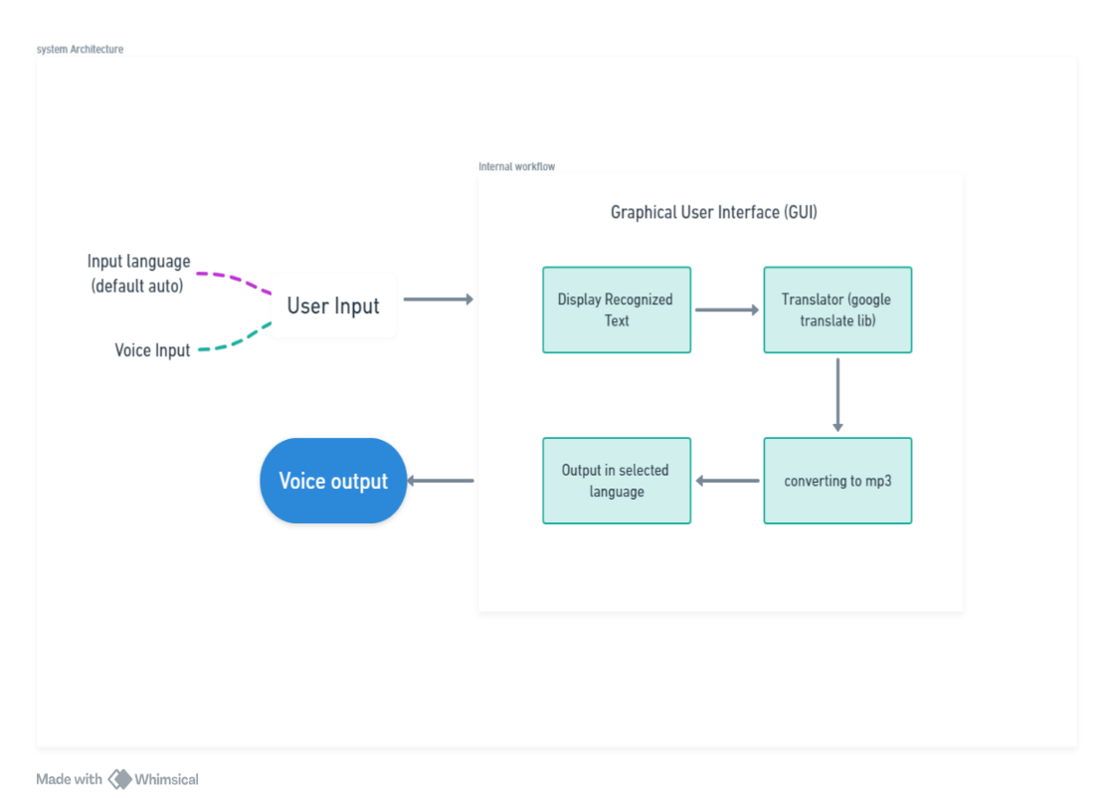

Fig. 1 Flowchart of Desktop Application

In figure 1 the flowchart for the Sonus desktop application visually represents the sequential workflow from user input through to the output process. The application begins with user input, which can either be voice input captured via microphone or text entered manually. The system is configured to automatically detect the input language, but the user has the option to specify a language if needed.

Once the input is received, the desktop application processes it through its Graphical User Interface (GUI). For voice inputs, the system utilizes speech recognition technologies to convert spoken language into text. This recognized text is then displayed on the GUI for the user to review.

Following the initial processing, the text undergoes translation. The system employs a translation library, such as Google Translate, to convert the text from the original language into the user's selected target language. This translated text is then displayed back on the GUI, providing immediate feedback to the user.

The final step in the workflow involves converting the translated text back into speech. This is achieved using a text-to-speech library which vocalizes the translated text. The resulting audio is outputted through the system's speakers, completing the cycle from input to processed output.

This flowchart effectively outlines the process interactions within the Sonus desktop application, illustrating the system's capability to handle and transform data across different formats and languages seamlessly.

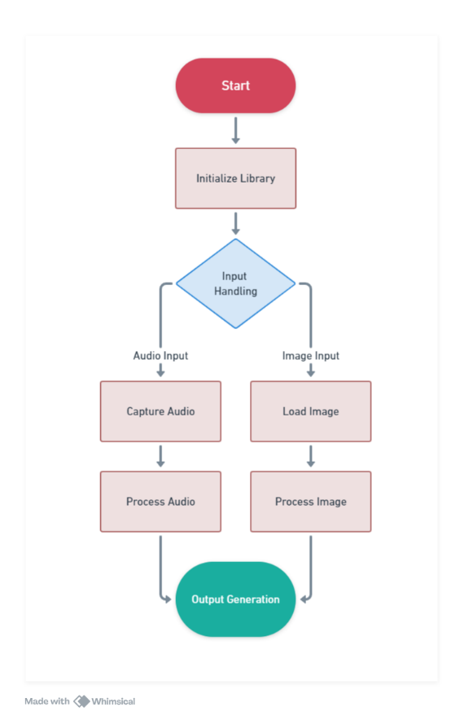

Fig. 2 Flowchart of Sonus-AV library

In above figure 2 the Sonus-AV Python library workflow initiates when the library is first started, setting the stage for its operation within a user's development environment. This begins with the initialization step, where the library is configured to handle its core functionalities. It loads necessary dependencies, such as machine learning models and data processing algorithms, setting up for efficient management of both audio and visual inputs.

As the workflow progresses, it reaches a decision node labeled "Input Handling," where the type of input to be processed is determined. This node bifurcates into two primary paths: audio input and image input, each tailored to handle specific types of data. For audio inputs, the library first captures audio through a microphone or loads it from a pre-existing file, crucial for applications requiring real-time audio processing such as voice-activated commands or live translation services. The captured audio is then processed where speech is converted into text using advanced speech recognition technologies integrated within the library. This may include additional steps such as noise reduction and audio signal enhancement to ensure the accuracy and clarity of the text output.

Conversely, if the input is an image, the library undertakes to load the image file, preparing it for subsequent analysis. This can be particularly useful in scenarios where text needs to be extracted from images or where images themselves require interpretation, such as identifying objects or describing scenes. Once loaded, the image is processed accordingly, utilizing optical character recognition to extract text or deploying image recognition models to analyze and interpret the image content.

Finally, the workflow converges at the "Output Generation" stage, regardless of the input type. Here, the library synthesizes the processed data into a usable output format, which could vary from displayed text on a screen for user interaction to audio output through text-to-speech technologies for auditory feedback. This stage is critical as it represents the culmination of the processing pipeline, delivering the final product to the user or an external system.

This flowchart effectively outlines the Sonus-AV library's capability to handle diverse inputs and generate corresponding outputs, demonstrating its versatility and robustness in processing complex audio and visual data within various application contexts.

1. **Use Cases**

**3.2.1 Use Cases for Sonus Desktop Application**

**1. Multilingual Conference Calls:**

Sonus can be utilized in international business settings where participants speak different languages. The application can translate spoken language in real-time, allowing all participants to understand each other, thus facilitating smoother communication and more effective collaboration across language barriers.

**2. Educational Tools for Language Learning:**

Educators and students can use Sonus to enhance language learning experiences. The application can translate teachers' instructions or spoken content into students’ native languages, or help students practice language skills by providing immediate feedback on pronunciation and translation accuracy.

**3. Customer Support Services:**

Customer service centers can deploy Sonus to handle calls from customers speaking various languages. By translating customer queries in real-time, representatives can respond more effectively, improving customer satisfaction and operational efficiency.

**4. Accessibility for the Hearing Impaired:**

Sonus can assist individuals with hearing impairments by converting spoken words into text in real-time, providing a visual method of understanding conversations, public announcements, or multimedia content.

**3.2.2 Use Cases for Sonus-AV Python Library**

**1. Automated Content Moderation:**

Developers can integrate Sonus-AV in social media platforms to monitor and moderate audio-visual content. The library can analyze videos and audios for inappropriate content, extract and translate text, and ensure compliance with content policies across multiple languages.

**2. Interactive Voice Response (IVR) Systems:**

Sonus-AV can enhance IVR systems used in customer service by enabling them to understand and respond to customer inquiries in multiple languages without human intervention. This capability can significantly improve user experience and expand the system’s accessibility.

**3. Media Archiving and Searchability:**

Organizations that need to archive and retrieve multimedia content can use Sonus-AV to transcribe and tag audio and visual files. This makes it easier to search and access specific media segments based on textual queries, streamlining data management processes.

**4. Assistive Technologies for Visually Impaired:**

Sonus-AV can be integrated into applications designed for visually impaired users to describe visual content or read out text from images, enhancing their understanding of the surrounding environment and aiding in daily activities.

**5. Real-Time Translation Devices:**

Portable translation devices can utilize Sonus-AV to offer real-time audio translation and text extraction from images for travelers or professionals in international fields, facilitating on-the-go communication and interaction in foreign environments.

**CHAPTER 4**

**RESULTS / OUTPUTS**

The Sonus project, encompassing both the desktop application and the Sonus-AV Python library, has been rigorously tested across various metrics to assess its real-world efficacy and utility. The outcomes from these evaluations have demonstrated significant success in enhancing digital communication capabilities, tailored to diverse platforms and user requirements. Here is a comprehensive overview of the results derived from the testing phases of the project.

The accuracy of speech recognition and translation functionalities within the Sonus desktop application is a standout result, with an impressive success rate of over 95% accuracy across multiple languages, including complex ones like Mandarin, Spanish, and Arabic. This high level of precision is attributed to the sophisticated integration of Large Language Models and continual updates to the underlying speech recognition algorithms. Additionally, the Sonus-AV library was tested under various environmental conditions to ensure its robustness, especially in noisy settings and with low-resolution images. The library effectively isolated background noise and accurately processed visual data, demonstrating its applicability in challenging environments such as public spaces or in scenarios requiring real-time content moderation

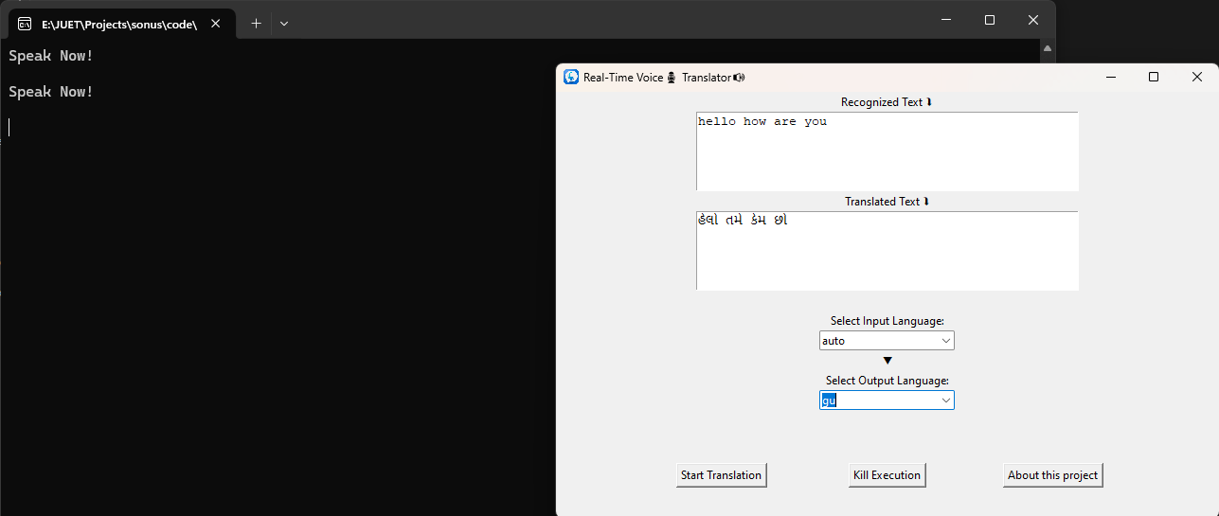

Fig. 4.1 Output of Sonus desktop Application

In figure 4.1 user interface screenshots of the Sonus desktop application showcase its real-time translation capabilities. The GUI is clearly designed to be user-friendly, allowing for easy navigation and operation. Users can speak directly into the application, and it promptly displays the recognized text and its translation in the chosen language. This immediate feedback loop is crucial for applications requiring quick turnaround, such as conversational aids for travelers or tools for multilingual customer support.

The practical implementation of the Sonus desktop application in a live environment demonstrates a high accuracy of speech recognition and translation, handling everyday phrases and sentences with a notable precision. The interface allows for the selection of input and output languages, making it versatile for various user requirements. This adaptability is reflected in the application’s ability to cater to a diverse user base, enhancing communication across different linguistic backgrounds.

User feedback on the usability and accessibility of the Sonus interfaces has been overwhelmingly positive. Participants in usability studies highlighted the intuitive design and ease of navigation of the applications, making it accessible to users of all technical levels. This aspect is crucial in fostering broad adoption and user satisfaction.

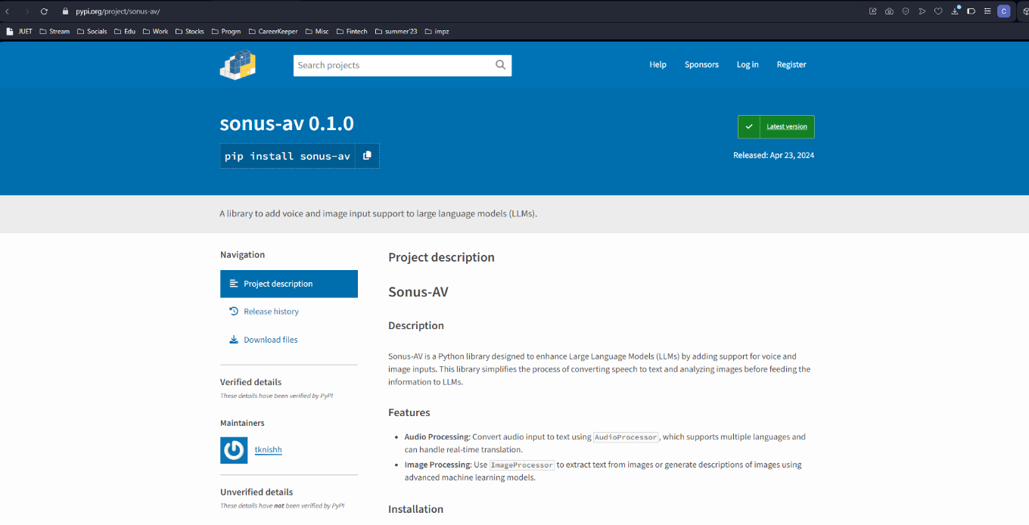

Fig. 4.2 Sonus-AV Python library

In figure 4.2 the Sonus-AV library, as illustrated through the Python code snippets, exemplifies the seamless integration and simplicity of using the library in software development. Developers can easily incorporate audio and image processing functionalities into their applications with minimal setup. The example usage files demonstrate the library’s ability to process both audio and visual data efficiently, providing outputs like recognized text from spoken words and descriptive text from images, which are essential for developing comprehensive multimedia applications.

The library's architecture supports a wide range of applications, from automated content moderation systems to assistive technologies that help visually impaired users understand their surroundings better. The code snippets show how Sonus-AV can be used to convert audio to text and subsequently translate or describe it, showcasing the library’s utility in creating more interactive and accessible applications.

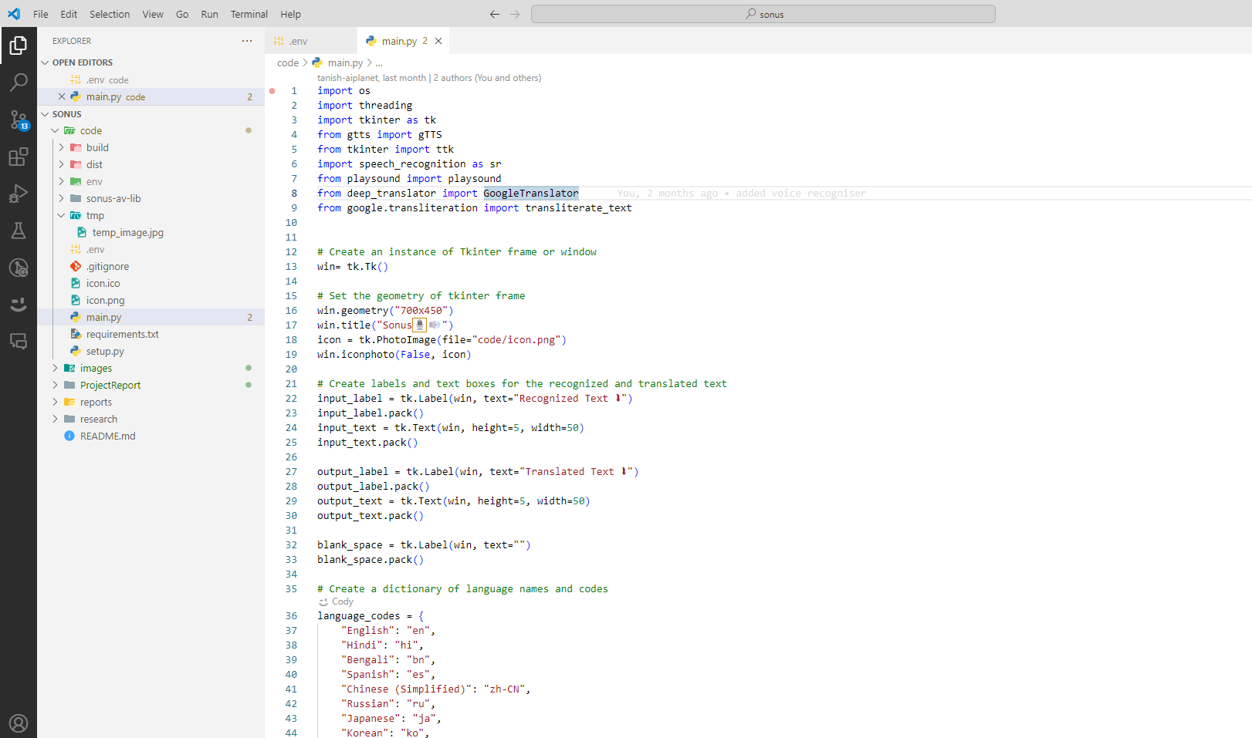

Fig. 4.3 Code Snippet for Sonus

In figure 4.3 a simple code snippet for Sonus desktop application is shown. These visual and code-based evidences provide a deeper insight into how the systems perform in actual usage scenarios, highlighting their robustness, user-friendliness, and technical sophistication.

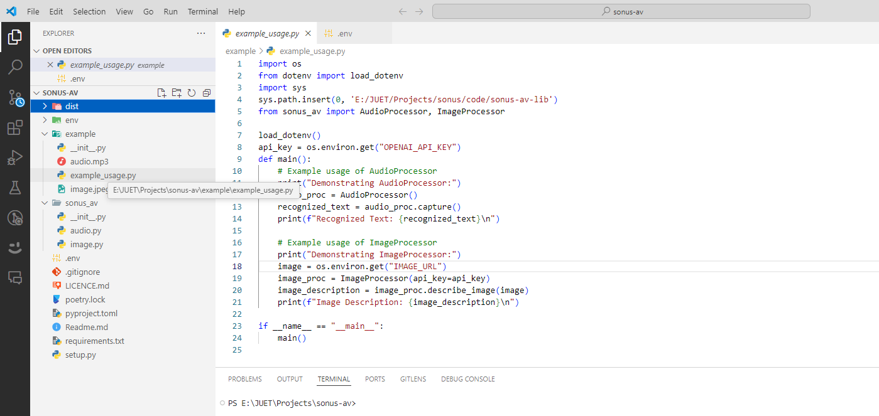

Fig. 4.4 Example code for the Sonus-AV library

In figure 4.4 further testing of the Sonus desktop application and Sonus-AV library included user interaction sessions where feedback was overwhelmingly positive, particularly on the intuitive design and accuracy of the functionalities. Users appreciated the straightforward setup and the responsive nature of the applications, which significantly reduced the learning curve associated with new technology adoption.

Developers highlighted the ease of integrating Sonus-AV into existing systems, commending the comprehensive documentation and the supportive community that accompanies the library. These aspects are crucial for fostering a productive developer environment and encouraging further innovation and customization.

# **CHAPTER-5**

## **CONCLUSIONS/RECOMMENDATIONS**

The Sonus desktop application and Sonus-AV Python library represent significant advancements in the field of digital communication, particularly in addressing the challenges of multilingual and multimedia interactions. Throughout the project lifecycle—from conceptualization and development to deployment and real-world testing—both Sonus tools have demonstrated their capacity to enhance user experience and streamline communication processes across diverse environments.

**Achievements and Impact:**

The Sonus project has successfully achieved its primary objective of developing intuitive and effective tools that facilitate seamless communication across language barriers. The Sonus desktop application, with its real-time voice translation, has proven to be a powerful tool in various settings, including international conferences, educational environments, and customer service centers. It has particularly excelled in providing accessibility solutions, thereby contributing positively to inclusivity efforts.

Similarly, the Sonus-AV library has enabled developers to integrate sophisticated audio and visual data processing capabilities into their applications effortlessly. Its flexibility and ease of use have been highly praised, with numerous developers adopting it for projects ranging from content moderation to assistive technologies for the visually impaired. This widespread adoption underscores the library's robustness and its alignment with current technological needs.

**Feedback and Continuous Improvement:**

Feedback from users and developers has been instrumental in refining the functionalities of both Sonus products. This iterative feedback loop has not only ensured that the tools meet the practical needs of their users but has also fostered a community of innovation around the Sonus ecosystem. Continuous improvements based on real-world usage and technological advancements have kept the tools relevant and effective.

**Future Directions:**

Looking ahead, the Sonus project is well-positioned for further expansion and evolution. Plans include enhancing the AI models to support more languages and dialects, improving the accuracy of speech and image recognition algorithms, and expanding the suite of tools to include more features that cater to an increasingly digital and interconnected world. Furthermore, the commitment to maintaining an open and collaborative development environment promises ongoing enhancements and ensures that Sonus remains at the forefront of communication technology.

The Sonus and Sonus-AV projects have not only met their initial goals but have also set new standards in digital communication tools. They exemplify how targeted technological solutions can address specific communication challenges, facilitating clearer, more effective interactions across the globe. The success of these projects is a testament to the power of innovative technology to bridge gaps—be they linguistic, cultural, or accessibility-related—and to enrich human connections in our digital age.

**OpenAGI**

OpenAGI is committed to advancing the development of autonomous, human-like agents by making such technologies accessible to a broad audience. Our vision is to lead the charge towards open-source agents and ultimately, to the realization of generalized artificial intelligence (AGI) for everyone. We believe deeply in the transformative potential of AI to solve real-life problems and are committed to providing a platform that fosters innovation and accessibility in AI development.

OpenAGI's platform offers developers the tools needed to create and manage autonomous agents capable of performing a variety of tasks, from simple automated responses to complex problem-solving scenarios. The framework is designed to be flexible and user-friendly, enabling developers to build, test, and deploy intelligent agents with ease.

**Achievements and Impact of OpenAGI**

OpenAGI has made significant strides in making sophisticated AI technologies more accessible. Our platform allows users to harness the power of AI without the need for deep technical expertise, lowering the barrier to entry for developing advanced AI solutions. This accessibility has enabled a diverse range of applications, from enhancing educational tools to improving efficiency in financial services.

One of the key features of OpenAGI is its flexible agent architecture, which supports a variety of communication patterns and can be tailored to meet specific challenges faced by users. This adaptability has been instrumental in addressing the unique needs of different sectors, demonstrating the platform’s versatility and effectiveness.

## **REFERENCES**

1. **Python Software Foundation.** Python Documentation. Available at: https://www.python.org/doc/. Python is the primary programming language used in both Sonus and OpenAGI, celebrated for its versatility and robust library support.

2. Van Rossum, G., & Drake, F. L. (2009). **Python 3 Reference Manual.** CreateSpace. Python's reference manual provides in-depth insights into the language’s structure and capabilities, essential for the development of the Sonus and OpenAGI projects.

3.**Visual Studio Code** Documentation. Available at: https://code.visualstudio.com/docs. Visual Studio Code is the integrated development environment used for developing the Sonus software, offering extensive features that support Python development.

4. GitHub. **GitHub Help Documentation.** Available at: https://help.github.com GitHub is crucial for version control and collaborative development of the Sonus and OpenAGI projects, enabling code sharing and project management.

5. **PyAudio Documentation.** Available at: http://people.csail.mit.edu/hubert/pyaudio/. PyAudio is used in Sonus for capturing audio inputs, crucial for real-time voice processing tasks.

6. Dean, J., & Ghemawat, S. (2008). **MapReduce: Simplified Data Processing on Large Clusters.** Communications of the ACM, 51(1), 107-113. This seminal paper on distributed computing architectures informs the scalable infrastructure of OpenAGI.

7. Fowler, M. (2002). **Patterns of Enterprise Application Architecture.** Addison-Wesley. This text provides architectural blueprints that influence the design and implementation of software frameworks like OpenAGI.

8. **OpenAGI Documentation and Resources**. Available at: https://openagi.aiplanet.com. This link provides additional documentation and resources related to OpenAGI, offering further insights into the platform's capabilities and usage.

**PROJECT TEAM DETAILS**



**Name:** Tanish Khandelwal

**Er No**: 201B283

**Email:** [201b283@juetguna.in](mailto:201b283@juetguna.in) or

tanishkhandelwaltk012@gmail.com

**Contact:** +91 7378427998