**PROTOCOL VISUALIZATION**

**A SUMMER INTERNSHIP PROJECT REPORT**

***Submitted by***

# Tanish Khandelwal (201B283)

***Submitted in partial fulfilment for the award of the degree***

***of***

# BACHELOR OF TECHNOLOGY

**IN**

**COMPUTER SCIENCE AND ENGINEERING**

at



**August & 2024**

**Department of Computer Science & Engineering**

**JAYPEE UNIVERSITY OF ENGINEERING & TECHNOLOGY,**

**AB ROAD, RAGHOGARH, DT. GUNA-473226 MP, INDIA**

# DECLARATION

I hereby declare that the project entitled “**PROTOCOL VISUALIZATION**” was submitted for the B. Tech. (CSE) degree is my original work and the project has not formed the basis for the award of any other degree, diploma, fellowship or any other similar titles.

**Signature of the Student**

**Place:**

**Date:**

**TRAINING COMPLETION CERTIFICATE:**

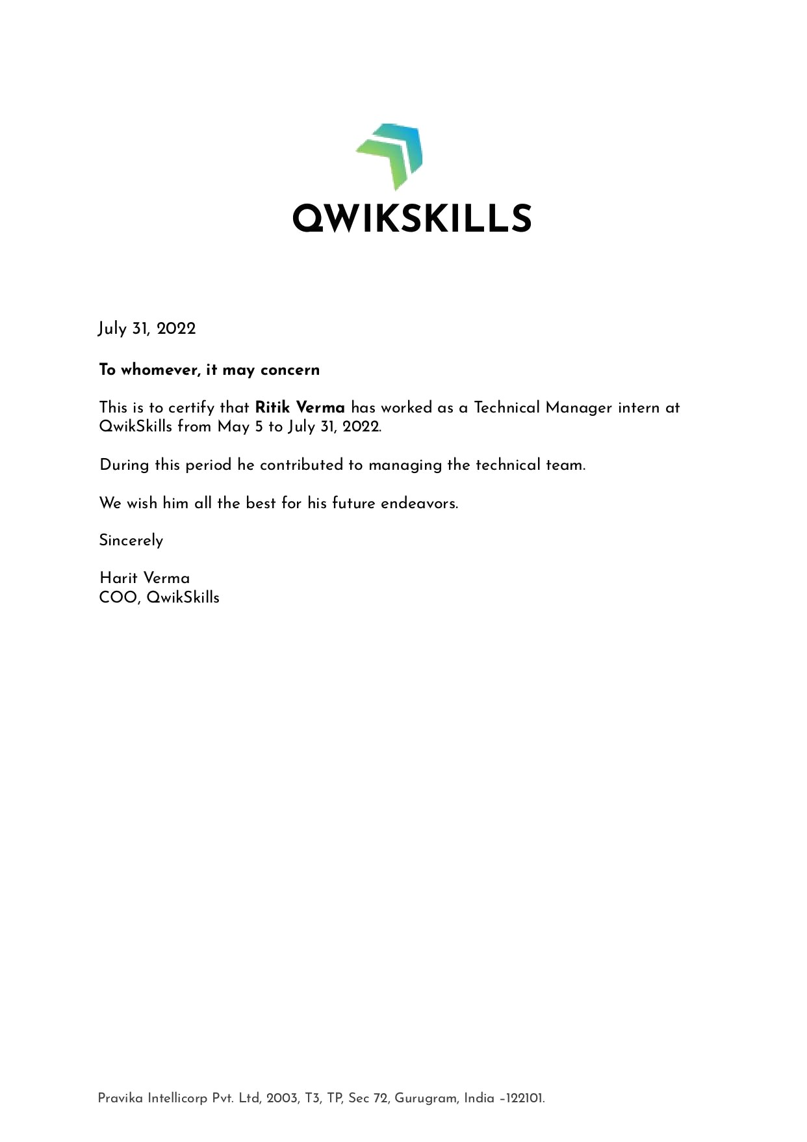



# ACKNOWLEDGEMENT

I express my deep & sincere gratitude to Mr. Harit Verma (Co-Founder of Qwikskills), Mr. Amit Kumar (senior enterprise architect (deep learning) at NVIDIA), and Mr. Ashutosh Pawar (Course Instructor), for their expert suggestion & encouragement which helped me to tide over the hard concepts encountered during the project.

My special thanks to Mr. Amit Kumar, for providing me an environment to learn deep learning concepts over SDKs so that I can perform medical Imaging and training exercises for completing my assignments. I like to express my sincere gratitude to them for providing me with the most valuable guidance. I would also like to extend our thanks to Jaypee University of Engineering and Technology, Guna for ensuring a good environment and providing the necessary experience

and assistance for us to work on this project

**Ritik Verma**

**ABSTRACT**

Medical imaging is the technique and process of imaging the interior of a body for clinical analysis and medical intervention, as well as visual representation of the function of some organs or tissues (physiology). Medical imaging seeks to reveal internal structures hidden by the skin and bones, as well as to diagnose and treat disease. Medical imaging also establishes a database of normal anatomy and physiology to make it possible to identify abnormalities. Although imaging of removed organs and tissues can be performed for medical reasons, such procedures are usually considered part of pathology instead of medical imaging.

In the clinical context, "invisible light" medical imaging is generally equated to radiology or "clinical imaging". "Visible light" medical imaging involves digital video or still pictures that can be seen without special equipment. Dermatology and wound care are two modalities that use visible light imagery. Interpretation of medical images is generally undertaken by a physician specializing in radiology known as a radiologist

# Table of Contents

Title Page i

Declaration of the Student ii

Course Completion Certificate Iii

Acknowledgement Iv

Executive Summary v

1. **INTRODUCTION**
   1. Problem Definition
   2. Project Overview/Specifications
   3. Hardware Specification
   4. Software Specification
2. **LITERATURE SURVEY**
   1. Project
   2. Proposed System
   3. Feasibility Study
      1. Technical Feasibility
      2. Economic Feasibility
3. **SYSTEM ANALYSIS & DESIGN**
   1. Requirement Specification
   2. Flowcharts / DFDs / ERDs
   3. Design and Test Steps / Criteria
4. **RESULTS / OUTPUTS**
5. **CONCLUSIONS**
6. **REFERENCES**
7. **APPENDICES**

**CHAPTER-1**

## INTRODUCTION

### 1.1 What is Medical Imaging:-

Deep learning technology has been used for analyzing medical images in various fields, and it shows excellent performance in various applications such as segmentation and registration. The classical method of image segmentation is based on edge detection filters and several mathematical algorithms. Using several techniques to improve targeted segmentation performance such as dependent thresholding and close-contour methods [33]. Alternatively, registration was attempted for segmentation [34]. To improve segmentation performance associated with medical images, DNNs, especially CNNs, have been gradually introduced. Attempts have been made for the segmentation of the tumors and other structures in the brain, lungs, biological cells, and membranes.

What can CNN do? a most reasonable question since deep learning took a peak in image analysis-

At a high level, in order for a network to perform image classification (which this network has been trained to do), it must understand the image. This requires taking the raw image as input pixels and building an internal representation that converts the raw image pixels into a complex understanding of the features present within the image. Starting from the network's input layer, the first few layer activations represent low-level features like edges and textures. As you step through the network, the final few layers represent higher-level features—object parts like wheels or eyes. Since the CNNs try to understand the images, they are able to generalize well: they’re able to capture the invariances and defining features within classes (e.g. cats vs. dogs) that are agnostic to background noise and other nuisances. Thus, somewhere between where the raw image is fed into the model and the output classification label, the model serves as a complex feature extractor.

# 1.2 TRAINING SPECIFICATIONS:-

There were 8 people in my team including me, everyone was working on different SDKs of NVIDIA. For example, there were Omniverse, Dali, 3D Graphics, DeepStream, Metropolis, and Clara(Mine).

NVIDIA Clara is an Application Framework Optimized for Healthcare and Life Sciences Developers and it’s a healthcare application framework for AI-powered imaging, genomics, and the development and deployment of smart sensors. It includes full-stack GPU-accelerated libraries, SDKs, and reference applications for developers, data scientists, and researchers to create real-time, secure, and scalable solutions.

[**https://developer.nvidia.com/clara**](https://developer.nvidia.com/clara)

Clara can be used for different purposes like 1. Clara for Medical Devices, in which we can develop an end-to-end streaming workflow for Medical Imaging and can deploy healthcare AI and imaging applications with the Clara Holoscan.

1. Drug Discovery - Many know that drug discovery used for medicinal purposes to verify the contributions of the composition of medicines or I must say Drugs. Clara combines the power of accelerated computing, AI, and Machine Learning to very this process.
2. Smart Hospitals - Building edge AI applications to improve patient care and operational efficiency using everyday sensors like cameras and mics so that if an infected person traveling through corridors of hospitals due to his/her fellow patient mate and don’t know about their temperature then this thermal camera sensors can automatically detect the temperature of the patient. It can also leverage high-performing pre-trained models.
3. Medical Imaging - Now here we come on which I worked the most where I just learned about ML techniques like AutoML, Federated Learning, and Transfer Learning. One term which I heard for the first time Active Learning, I did some of the research work on this too. It helps to deploy an AI model into an app to enable interference in a hospital-like environment.

# 1.3 HARDWARE SPECIFICATION

|  |  |
| --- | --- |
| Processor | : Intel Core i5 processor or above |
| RAM | : Minimum 4 GB or more. |
| Hard Disk | : Minimum 20 GB of space |

Storage Device : SSD of 128 GB

Input Device : Keyboard

# 1.4 SOFTWARE REQUIREMENTS

Operating system : Window, iOS

IDE : Anaconda, Command Prompt

Language : Python

Framework : Pytorch

Tech stacks : Deep Learning, Federated learning , Active Learning and

AutoML, Segmentation, and Annotation.

**CHAPTER -2**

# LITERATURE SURVEY

## 2.1 EXISTING SYSTEM / PROJECT:-

Working on MONAI (Medical Open Network on Artificial Intelligence)

The MONAI framework is the open-source foundation being created by Project MONAI. MONAI is a freely available, community-supported, PyTorch-based framework for deep learning in healthcare imaging. It provides domain-optimized foundational capabilities for developing healthcare imaging training workflows in a native PyTorch paradigm.

Project MONAI also includes MONAI Label, an intelligent open source image labeling and learning tool that helps researchers and clinicians collaborate, create annotated datasets, and build AI models in a standardized MONAI paradigm.

MONAI is an Open Source Design and standardized - Aiming to capture best practices of AI

Development for healthcare researchers, with an immediate focus on medical imaging.

User Friendly - Providing users with understandable errors so that a user can easily interpret and code accordingly.

Reproducible - It provides the reproducibility of research experiments for comparison.

Easy Integration and High Quality - Talking about software with enterprise-grade development.

## 2.2 PROPOSED SYSTEM:-

We have now everything but can't detect brain tumors or spleen segmentation with accuracy so we have to train images that have been taken from XRay or Scans. First, we have to annotate and then segment that area to get high trainable images.

Now for that, we should have 3rd user client server so that a person can work over it. That’s why we will use the Monai Label plug-in to integrate our trained images in a 3d slicer or OCIF. These are also open source so that anyone can use them using some loaded images.

One medical center can easily detect cancer or tumors after getting trained by us and can work with patients to cure their diseases and this can save their time in identifying diseases.

## 2.3 FEASIBILITY STUDY:-

### 2.3.1 TECHNICAL FEASIBILITY

Each of the technologies used is freely available in the market and the technical skills required to handle them are manageable All the data of an individual are on a site that is hosted over a reliable server, Keeping the environment safe.

### 2.3.2 ECONOMIC FEASIBILITY

Being an open source software it will be trained online or on the server, using MONAI deploy and Docker.

Minimal cost or almost no cost will be charged. One medical center can easily detect cancer or tumors after getting trained by us and can work with patients to cure their diseases and this can save their time in identifying diseases.

**CHAPTER-3**

# SYSTEM ANALYSIS & DESIGN:-

## 3.1 Requirement Specification

**Python** - Language to code commands in a notebook and it is usually used in Machine Learning.

**Pytorch** - Pytorch is used in this as MONAI is an open source application and this is written in the Pytorch framework.

**Docker** - To host client-server online

**3D Slicer** - It’s a tool to train images for accuracy

## 3.2 Flowcharts

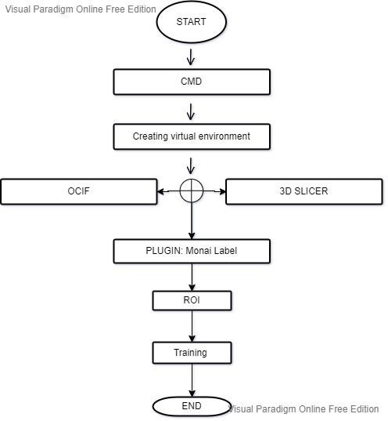

## 3.3 Design and Test Steps

**Step 1 – Installing Monai Label** *pip install monailabel*

*conda activate monai* (Making Virtual Environment on Conda)

*pip install monailabel* (if you were getting an error in starting)

**Developer Mode:**

*git clone https://github.com/Project-MONAI/MONAILabel pip install -r MONAILabel/requirements.txt set PATH=$PATH:pwd/MONAILabel/monailabel/scripts*

**Step 2 – Initiating Docker** *docker run --gpus all --rm -ti --ipc=host --net=host projectmonai/monailabel:latest bash*

**Step 3 – Initiating server** download the radiology app and sample dataset *monailabel apps --download --name radiology --output apps*

*monailabel datasets --download --name Task09_Spleen --output datasets*

start server using radiology app with deepedit model enabled

*monailabel start_server --app apps/radiology --studies datasets/Task09_Spleen/imagesTr --conf models deepedit*

Now run it on the local host

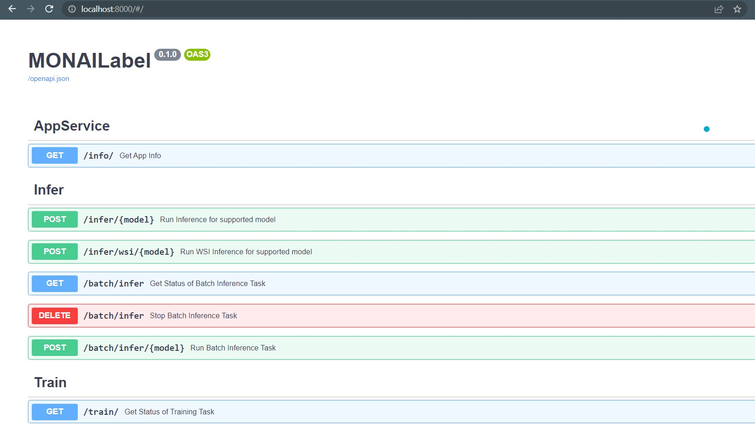

Copy the url or address of local host and now open 3D Slicer. In 3D slicer after installing MONAILABEL in Active Learning, select Module - MONAILabel from module list. Now plugin your address that you had copied in MONAILabel Server. your dataset of spleen will be visible after 'hitting click on Next Sample,

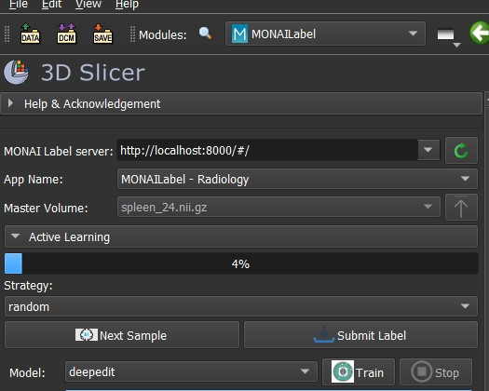

After plugin just check on your server is it, it will look something like the resulted image, After this select ROI(Region of Interest and paint it for training) then just update the selected area and train it.

# RESULTS / OUTPUTS:-

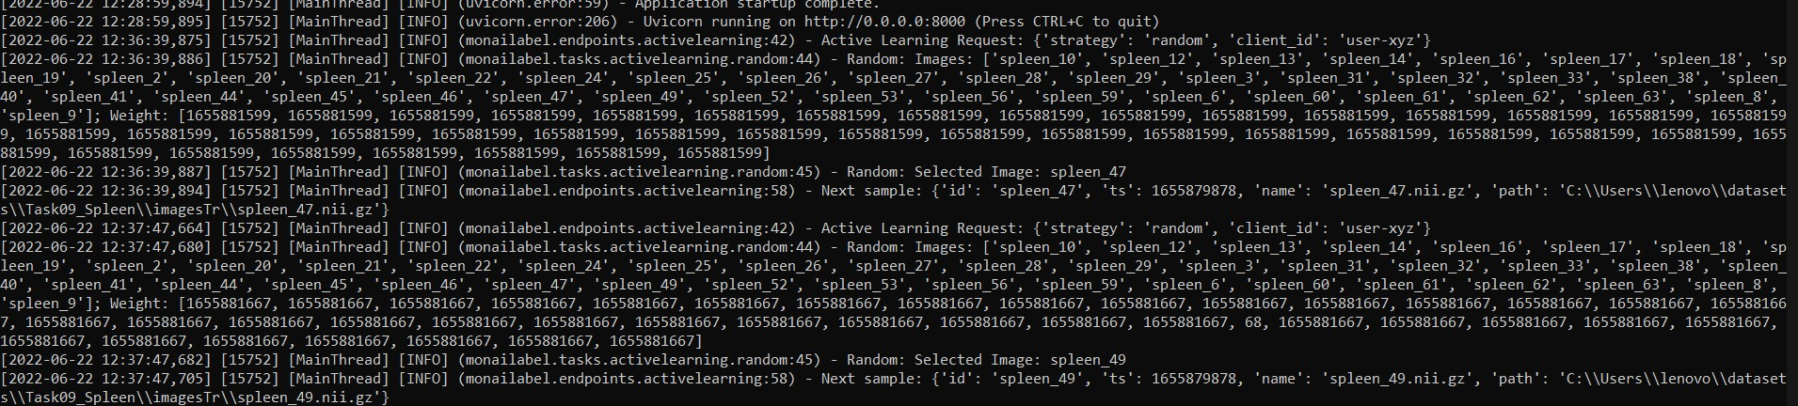

# CONCLUSIONS

NVIDIA Clara for Medical Imaging helps accelerate a typical imaging workflow that starts with labeling data, creating AI models, developing applications that include one or several AI models, and finalizing their deployment at an institution or across multiple institutions. NVIDIA Clara Train SDK provides over 20 pre-trained AI models for radiology and digital pathology that are ready to download and use immediately or be tailored to an institution’s data via the transfer learning toolkit or trained on various institutions’ data via our Federated Learning framework. With Federated Learning, a trained local model can be trained on diverse patient data across regions and institutions by sharing a subset of model weights without sharing patient information.

Hence, It eased the work for doctor and clinical purposes.

# REFERENCES

https://github.com/ritikverma23/monai-label-3d https://monai.io/ https://developer.nvidia.com/clara-medical-imaging https://en.wikipedia.org/wiki/3D_Slicer

# APPENDICES

## DETAILS OF A SOFTWARE/SIMULATOR USED

**VS Code**: 3D Slicer (Slicer) is a free and open-source software package for image analysis and scientific visualization. Slicer is used in a variety of medical applications, including autism, multiple sclerosis, systemic lupus erythematosus, prostate cancer, lung cancer, breast cancer, schizophrenia, orthopedic biomechanics, COPD, cardiovascular disease, and neurosurgery.

Slicer's capabilities include:

* Handling DICOM images and reading/writing a variety of other formats
* Interactive visualization of volumetric Voxel images, polygonal meshes, and volume renderings
* Manual editing
* Fusion and co-registering of data using rigid and non-rigid algorithms
* Automatic image segmentation
* Analysis and visualization of diffusion tensor imaging data ● Tracking of devices for image-guided procedures.