For example one of the thermostat ID is 4729,

1. you need to use the [formula](http://www.baidu.com/link?url=_DW7EIF3nyD_M5W2n7YSyO_xnKUd5ebKVMKTxeG-5ClHMN4uomVobGnitBLzWbH-ljus_ojOcE2G6_NUVE8j0UTOV8QDt5P34zE6h67X6ta8_5WxcySOlgFE6f8tTDK7" \t "https://www.baidu.com/_blank) calculate ID_Effect=(ID+1)*65535+65535=310046085(data in decimal）=12 7A ED 85 (data in HEX bytes).

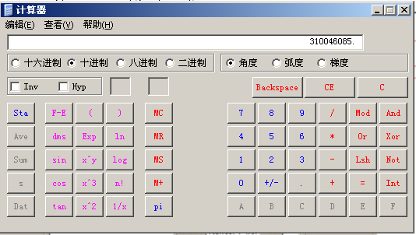

(data in decimal)

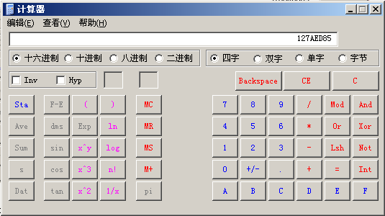

(data in HEX bytes)

2、open the tcp sofeware( we use the USR-TCP232-TEST),and set pc as tcp client and wifi thermostat sever ip(59.110.30.249) ,port(25565),and click connect button.

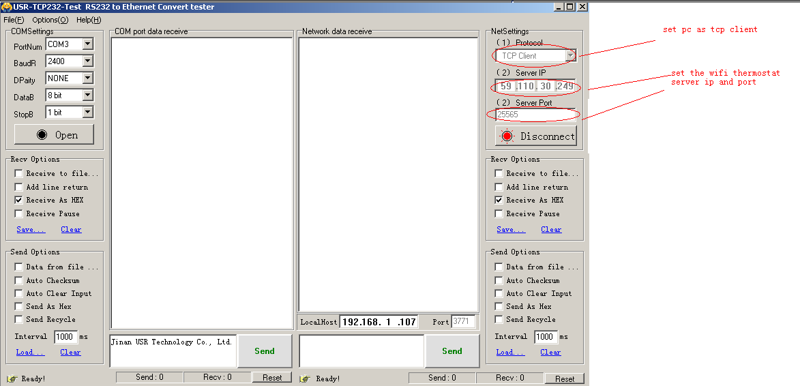3、write the ID_effect(12 7A ED 85),and click send for register the device.

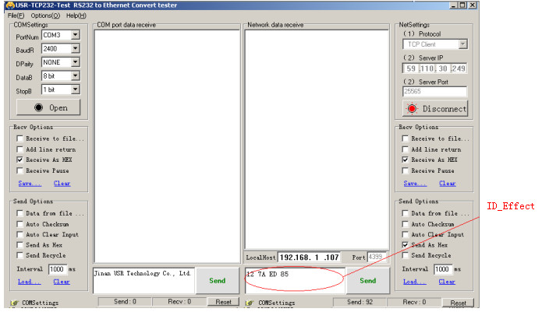

1. after that,you can communicate with ID(4727) wifi thermostat ,for example we send

A0 01 01 01 01 01 00 00 comand to read the thermostat status.

