**Supporting Information**

**Design and Fabrication of Cap Removal Tool via CNC Machining**

We have designed and fabricated a cap-removal tool (**Fig. S1**) for a 7 mm rotor system. The tool was designed on Autodesk Inventor (see supplementary data for the model), and it can be easily adapted for any rotor sizes. The tool consists of only two pieces, which were held together with a screw and a nut. We used Fusion360 as the Computer-Aided Manufacturing (CAM) software for simulating the toolpath. The g-code is later loaded into the Grbl software, which guides the CNC machine (Genmitsu PROVerXL 4030). We machined the cap-removal tool on a 5 mm aluminum sheet using a 3 mm titanium nitride (TiN) coated end mill loaded to an ER 11 collet on a 300 W spindle capable of spinning up to 10,000 rpm. The manufacturing time was ~ 3 hr per piece, and it has successfully removed several drive caps from the 7 mm rotor.

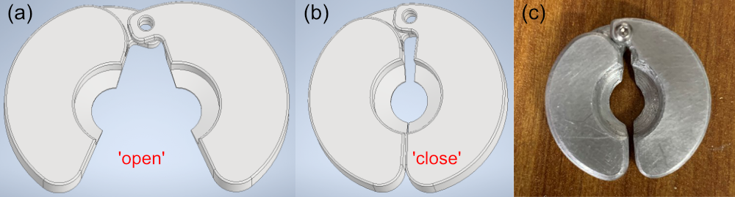

**Figure S1:** The (a & b) CAD design and (c) CNC-machined part of the cap-removal tool. The rotor is first inserted into the tool in an (a) ‘open’ configuration, and can be pulled away from the drive cap in the (b) ‘close’ configuration.

**Design of MAS Drive Caps**

We have included the ‘*.ipt’ (Autodesk Inventor) ‘*.stl’ files for the 1.3, 2.5, 3.2, 4, and 7-mm drive caps, as well as the cap-removal tool for the 7 mm system (adaptable to other dimensions). Note that the dimensions of all drive caps were reiteratively optimized to be printed using Clear V4 resins and Form 3+ (Formlabs), except the 4 mm, which was printed using Elegoo Saturn. Moreover, note that the shape of the slab in the 2.5 mm cap and the fins of the 1.3 mm were also optimized for better MAS performances. Note that the shape of the printed parts depends on the ambient environment surrounding the 3D printer, i.e., temperature, ambient light condition, etc. Hence, some minor alterations to the design might be necessary to yield satisfactory results.