Data Cleaning steps performed:
1. Revenues Tab
Relevant columns: Company, Customer, Date, Value EUR
- Check for missing values: Look for blanks in any of these columns.
- Duplicates: Remove any rows where all these columns have identical values.
- Date columns: Ensure Date is in a valid date format (not text).
- Revenue columns: Fill missing Value EUR with 0 or as appropriate.
2. Recurring Revenue Waterfall Tab
Relevant columns: Company, Customer, Date, Value EUR, Category
- Do the same data cleaning as above.
- Ensure Category is consistent and never blank (fill with 'Unknown' if necessary).
- Remove rows with missing Company, Customer, or Date values.
3. Category Tab
Relevant columns: Category, Category Subgroup, Category Group, Gross Increase, Net Increase
- Ensure no blanks for the columns (except perhaps increase fields if that’s valid).
- Check that numbers are numeric.
- Remove duplicates if there are any.
4. Customer Tab
Relevant columns: Customer, Country ID
- Make sure every customer has a Country ID.
- Remove duplicates.
Outcome: Revenues missing values:
Company 0
Customer 0
Date 0
Value EUR 0
dtype: int64
Recurring Revenue Waterfall missing values:
Company 0
Customer 126
Date 0
Value EUR 0
Category 0
dtype: int64
Category missing values:
Category 0
Category Subgroup 0
Category Group 0
Gross Increase 0
Net Increase 0
dtype: int64
Customer missing values:
Customer 0
Country ID 0
dtype: int64
Cleaned file saved to: processed\case_study_original.xlsx

Customers are missing in Recurring Revenue Waterfall I should not just drop this value create an Unknown customer category

Because financial data must preserve total revenue accuracy. Instead of deleting records, I categorized them as Unknown to maintain reconciliation between source data and reporting outputs.

Date is in short format’

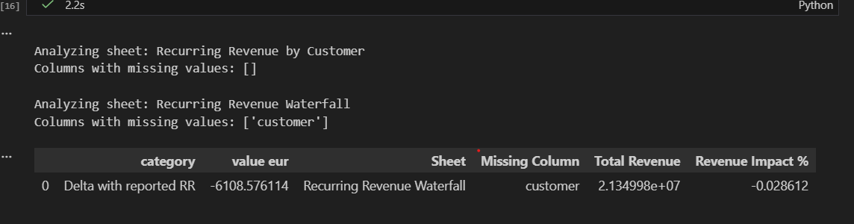

Interpretation:
There are no missing values in this sheet in the original file.
So:
- No data-quality revenue risk
- No revenue tied to incomplete records
- This sheet is structurally complete
- Revenue Impact Result
category | value eur | Revenue Impact %
Delta with reported RR | -6108.576114 | -0.028612

This means:
Records with missing customers account for -6,108.58 in revenue,
which represents -0.0286% of total revenue.
Key insight:
- The impact is negative, meaning those rows reduce revenue.
- The magnitude is very small (< 0.03%).
- The issue is limited to category: Delta with reported RR.
The Recurring Revenue Waterfall sheet contains missing values in the customer field. These records account for approximately -6.1k EUR, representing -0.03% of total revenue. While financially immaterial, the absence of customer attribution impacts customer-level reporting accuracy.

- Surrogate key:
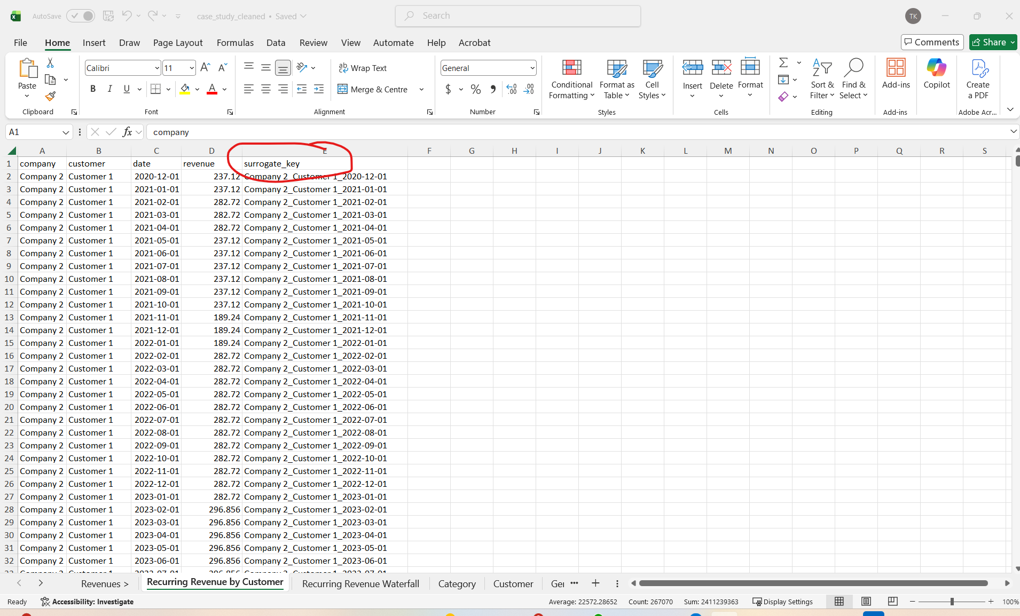
“Revenue of Customer 1 from Company 2 for December 1st, 2020” Synthetic unique identifier
Composite natural key used as surrogate identifier
• Detect duplicates
• Perform joins safely
• Track individual revenue records
• Identify row-level uniqueness
• Debug aggregation issues
A composite surrogate key was generated using Company, Customer, and Date to uniquely identify each recurring revenue record. This ensures row-level uniqueness and enables reliable joins and duplicate detection.
- EDA

  - Data Modelling: Describe which are fact tables and which table are dimensions
  - Prepare the data with SQL, Python, or Excel for import into Power BI
  - Import the data in Power BI and create necessary relationships between

FACT TABLES
Fact tables contain:
- Numeric measures
- Transactional or event-level data
- Foreign keys to dimensions
🔹 Fact 1: fact_recurring_revenue
Grain:
One row per company–customer–month
Columns:
- surrogate_key (PK)
- company_key (FK)
- customer_key (FK)
- date_key (FK)
- revenue
This is your core analytical fact table.

Fact 2: fact_revenue_movements (from Waterfall)
Grain:
One row per company–customer–month–movement category
Columns:
- surrogate_key
- company_key
- customer_key
- date_key
- category_key
- revenue
Used for waterfall visualization.
✅ DIMENSION TABLES
Dimensions describe the facts.

🔹 dim_company
company_key | company

🔹 dim_customer
| customer_key | customer | company_key |

🔹 dim_date
| date_key | date | year | month | quarter |
Very important for time intelligence in Power BI.

🔹 dim_category (for waterfall)
| category_key | category |
Target Star Schema
dim_company
|
dim_customer
|
dim_date — fact_recurring_revenue — dim_category
Simple, clean, professional.

Code | Explanation
# DIM COMPANY  dim_company = rr_customer[["company"]].drop_duplicates().reset_index(drop=True)  dim_company["company_key"] = dim_company.index + 1 | Company key acts as a surrogate key  The order depends on first appearance in the dataset, not alphabetical order.  The purpose of this code is to create a company dimension table with unique numeric IDs so it can be used properly in a data model (especially in a data warehouse or Power BI model).
# DIM CUSTOMER  dim_customer = rr_customer[["customer", "company"]].drop_duplicates().reset_index(drop=True)  dim_customer = dim_customer.merge(dim_company, on="company", how="left")  dim_customer["customer_key"] = dim_customer.index + 1 | It is a dimension table.  • Keeps unique customers  • Links each customer to a company (via company_key)  • Assigns each customer a unique customer_key  To create a clean Customer dimension table, link it to the Company dimension, and assign each customer a unique numeric key for efficient data modeling.  One company → many customers.  Customer 430:  - Belongs to Company 1  - Company 1 has company_key = 2  - This customer’s unique ID is 431
# DIM DATE (combine all unique dates from both tables)
dim_date = pd.DataFrame({"date": pd.concat([rr_customer["date"], rr_waterfall["date"]]).drop_duplicates().sort_values().reset_index(drop=True)})
dim_date["date_key"] = dim_date.index + 1
dim_date["year"] = dim_date["date"].dt.year
dim_date["month"] = dim_date["date"].dt.month
dim_date["month_name"] = dim_date["date"].dt.month_name()
dim_date["quarter"] = dim_date["date"].dt.quarter

dim_date = pd.DataFrame({"date": pd.concat([rr_customer["date"], rr_waterfall["date"]]).drop_duplicates().sort_values().reset_index(drop=True)}) dim_date["date_key"] = dim_date.index + 1 dim_date["year"] = dim_date["date"].dt.year dim_date["month"] = dim_date["date"].dt.month dim_date["month_name"] = dim_date["date"].dt.month_name() dim_date["quarter"] = dim_date["date"].dt.quarter  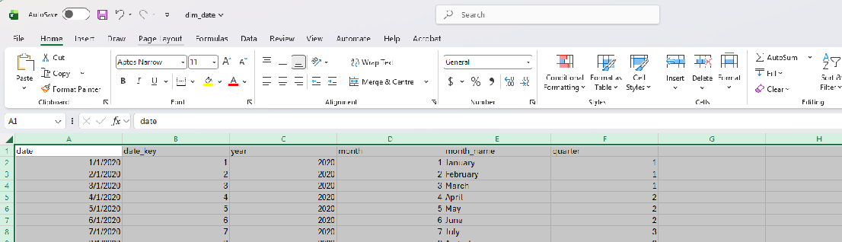 | Collects all unique dates from two datasets  Sorts them chronologically  Assigns each date a numeric key  Extracts useful time attributes (year, month, quarter)
# DIM CATEGORY  dim_category = rr_waterfall[["category"]].drop_duplicates().reset_index(drop=True)  dim_category["category_key"] = dim_category.index + 1  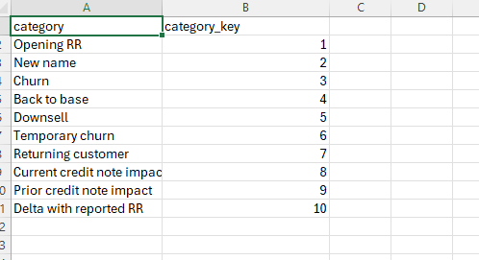 | Assign keys to unique categories
# FACT RECURRING REVENUE  fact_recurring_revenue = rr_customer.merge(dim_company, on="company", how="left") \  .merge(dim_customer[["customer", "customer_key"]], on="customer", how="left") \  .merge(dim_date[["date", "date_key"]], on="date", how="left")  fact_recurring_revenue = fact_recurring_revenue[["company_key", "customer_key", "date_key", "revenue"]]  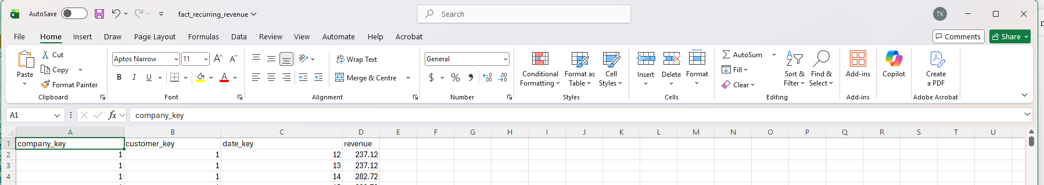 | Converts your raw recurring revenue data into a proper fact table by replacing descriptive text fields with numeric surrogate keys and keeping only the measurable value (revenue).  The recurring revenue amount (237.12) generated by a specific customer, from a specific company, on a specific date.
# FACT WATERFALL  fact_waterfall = rr_waterfall.merge(dim_company, on="company", how="left") \  .merge(dim_customer[["customer", "customer_key"]], on="customer", how="left") \  .merge(dim_date[["date", "date_key"]], on="date", how="left") \  .merge(dim_category, on="category", how="left")  fact_waterfall = fact_waterfall[["company_key", "customer_key", "date_key", "category_key", "revenue"]]  company_key customer_key date_key category_key revenue  1 4 12 2 -300  Revenue impact for a specific customer, company, date, and category. | Revenue impact for a specific customer, company, date, and category.

• 4 dimension tables
• 2 fact tables

- Power BI
- Dimensions should NOT connect to other dimensions.
- Only fact tables should connect to dimensions.
- Dual schema:
🔹 fact_recurring_revenue connected to:
- dim_company
- dim_customer
- dim_date
🔹 fact_waterfall connected to:
- dim_company
- dim_date
- dim_category
✔ All relationships are:
- Solid lines (active)
- Many-to-One (* → 1)
- Single cross-filter direction
- No dotted (inactive) lines
- No loops
- No dimension-to-dimension connections
This is a proper dual-star schema.

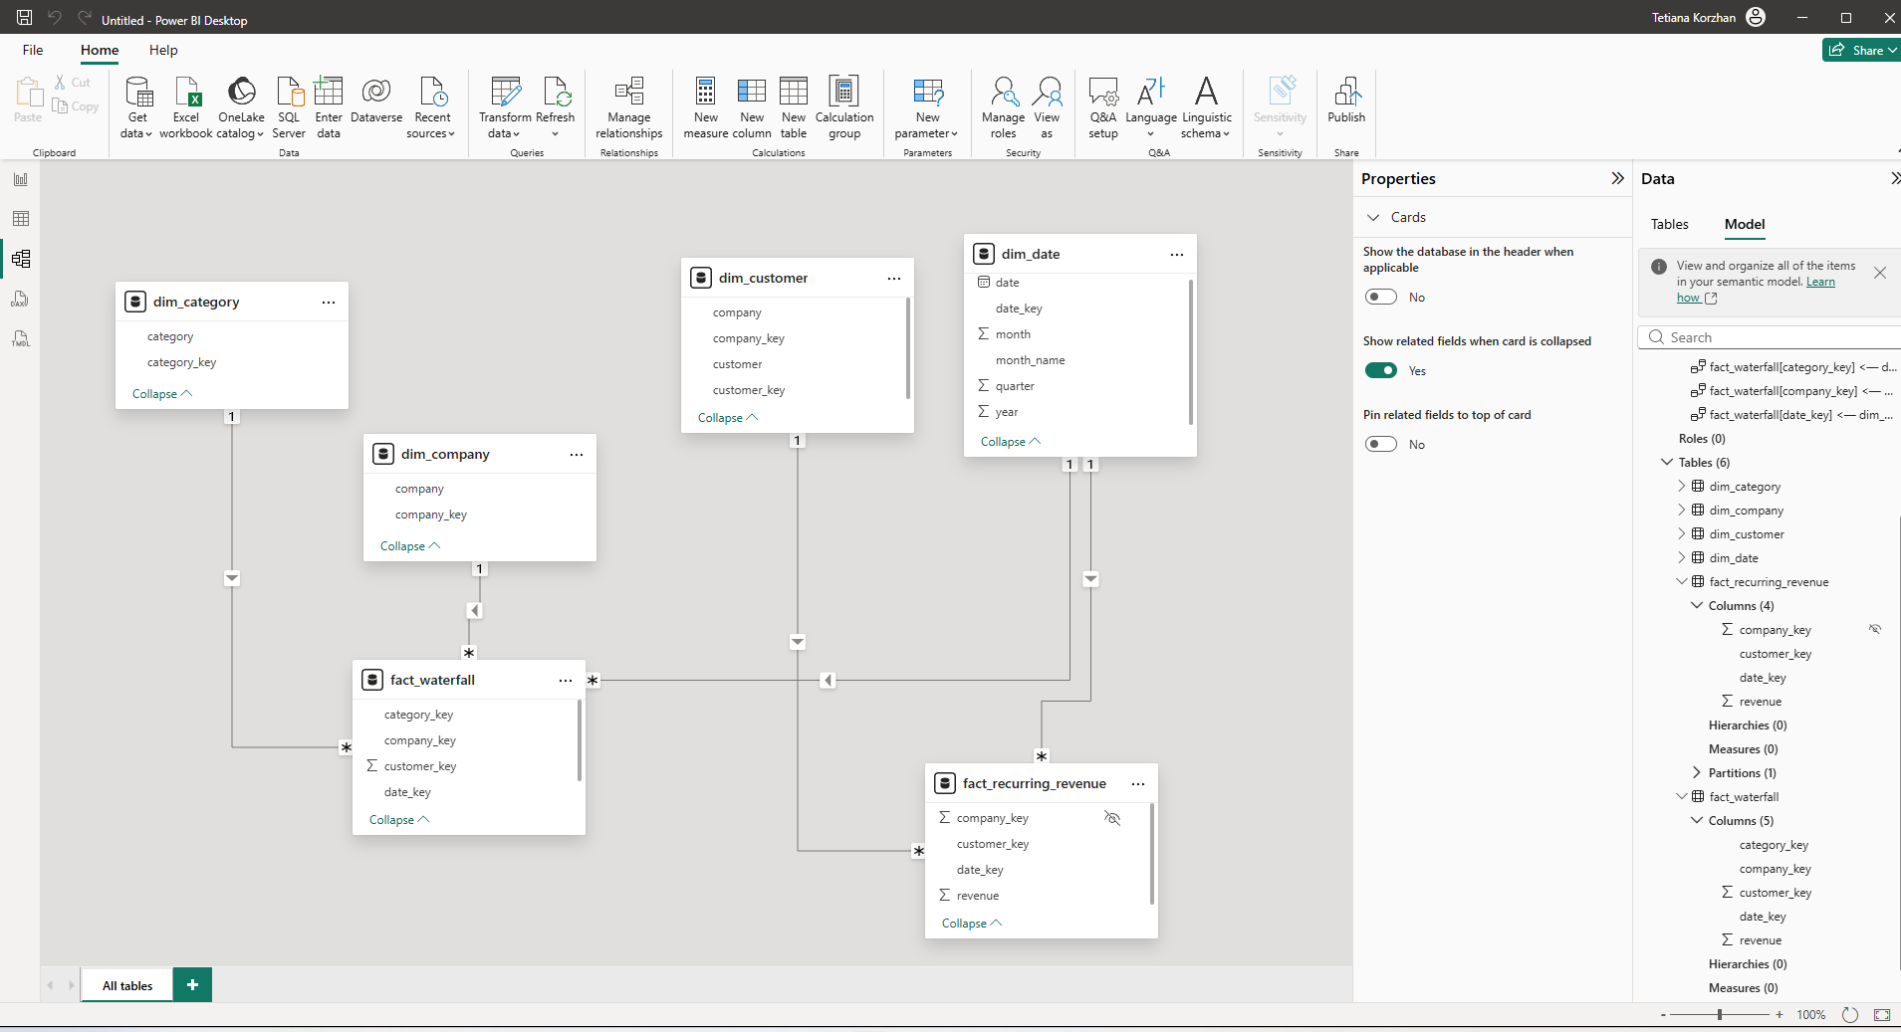

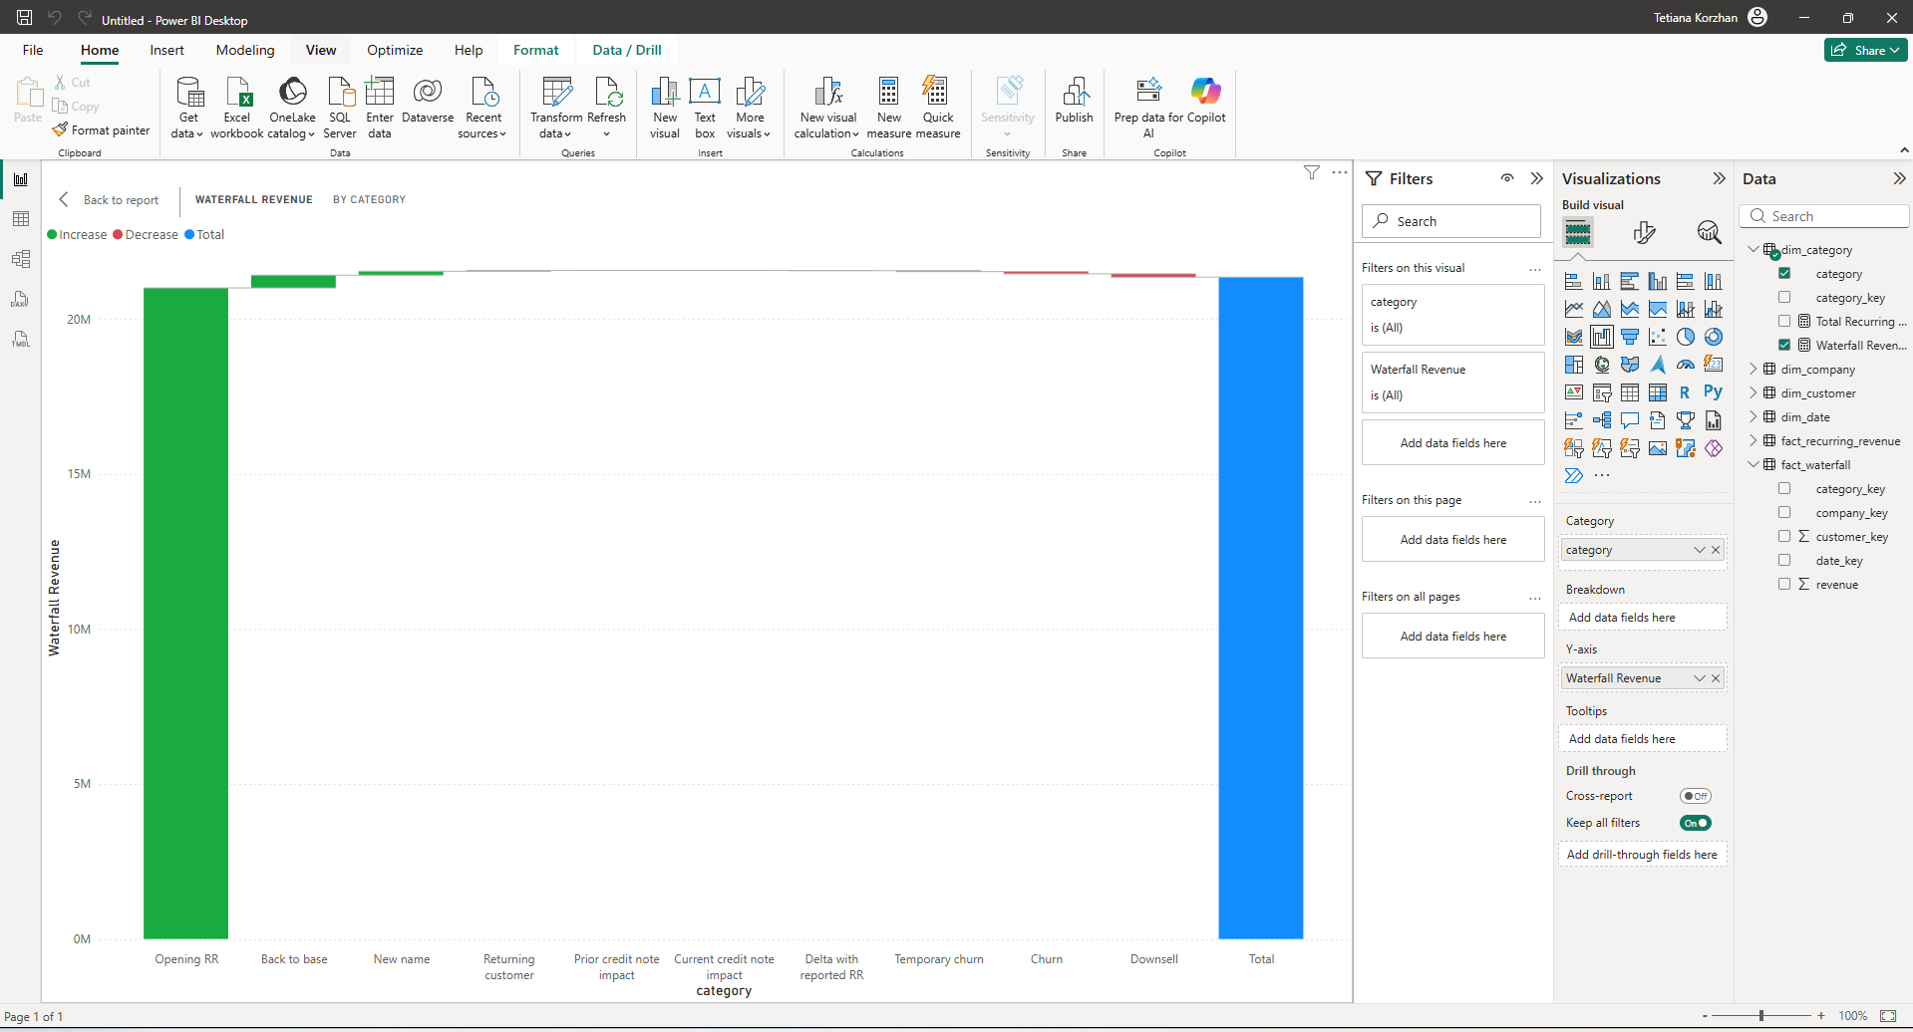
Sort by category key

“Display the text values of category, but use the numeric order from category_key to decide their position.”

🟢 1️⃣ Opening RR (Green Bar)
This is your starting revenue for the period.
It answers:
“How much recurring revenue did we start with?”
In your chart it looks around ~21M.
➕ 2️⃣ Positive Categories (Green Increases)
Examples:
- Back to base
- New name
- Returning customer
These bars show revenue increases.
They mean:
“Revenue grew because of these factors.”
Each green bar adds on top of the previous value.
🔴 3️⃣ Negative Categories (Red Decreases)
Examples:
- Churn
- Downsell
- Temporary churn
These represent revenue losses.
They answer:
“Revenue decreased due to these factors.”
Each red bar subtracts from the running total.
🔵 4️⃣ Total (Blue Bar)
This is the final revenue after all increases and decreases.
It explains the why behind revenue change.
So the story is:
Revenue slightly increased overall.
Gains slightly outweighed losses.

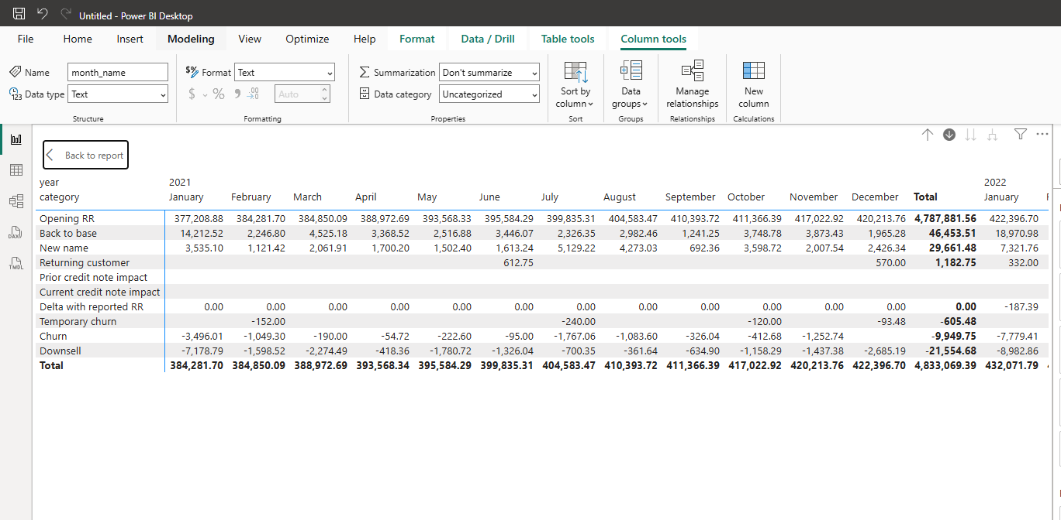

✅ STEP 4 — Formatting (Make It Look Professional)
Waterfall:
- Turn on Data labels
- Format positive bars → Green
- Format negative bars → Red
- Increase label size slightly
- Remove unnecessary gridlines
Matrix:
- Turn off subtotals if not required
- Format numbers with thousands separator
- Align values right
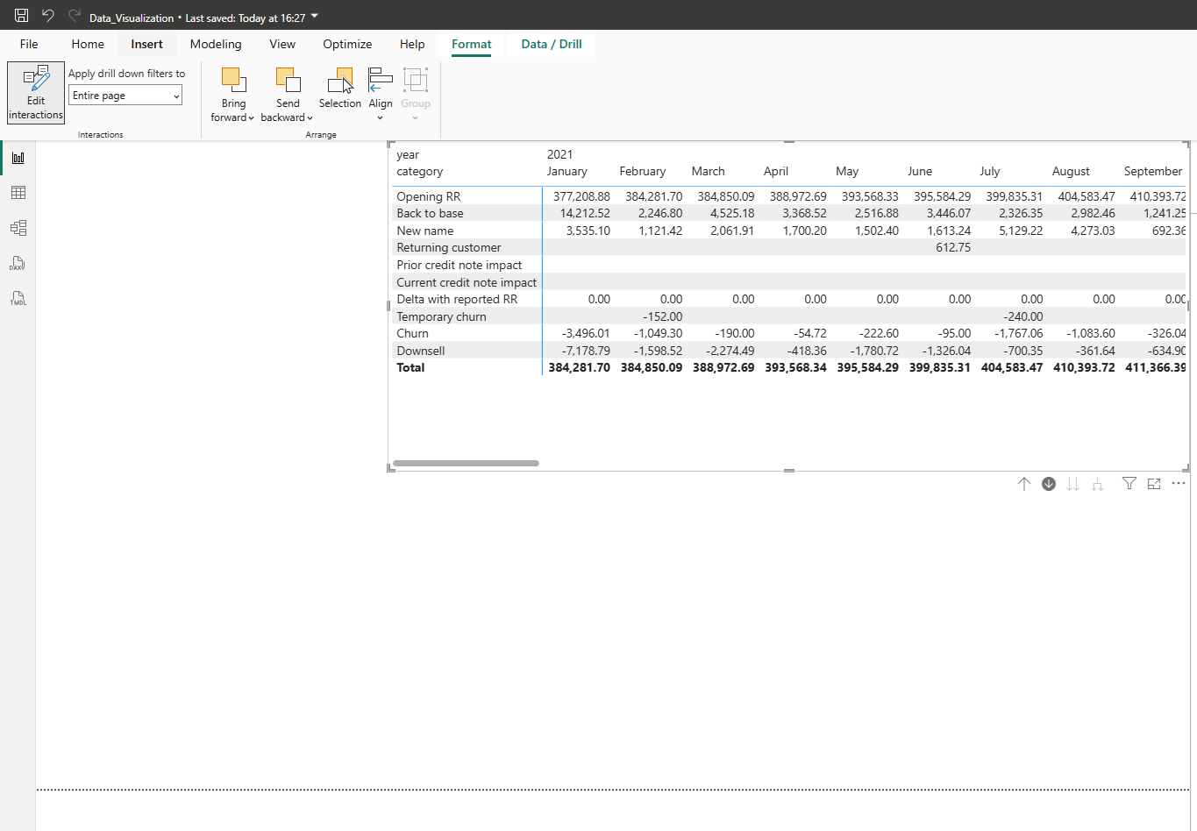
Alignment to the right

Why specifically churn and downsell?
Because they represent:
- Revenue loss
- Customer contraction
- Long-term risk to portfolio stability
Even though they are "only" -0.1M each here, in recurring revenue businesses:
Small retention deterioration compounds over time.
Retention risk is strategically more important than minor accounting adjustments.

