GITHUB..

1. Created a repository by name MobileCloud Computing

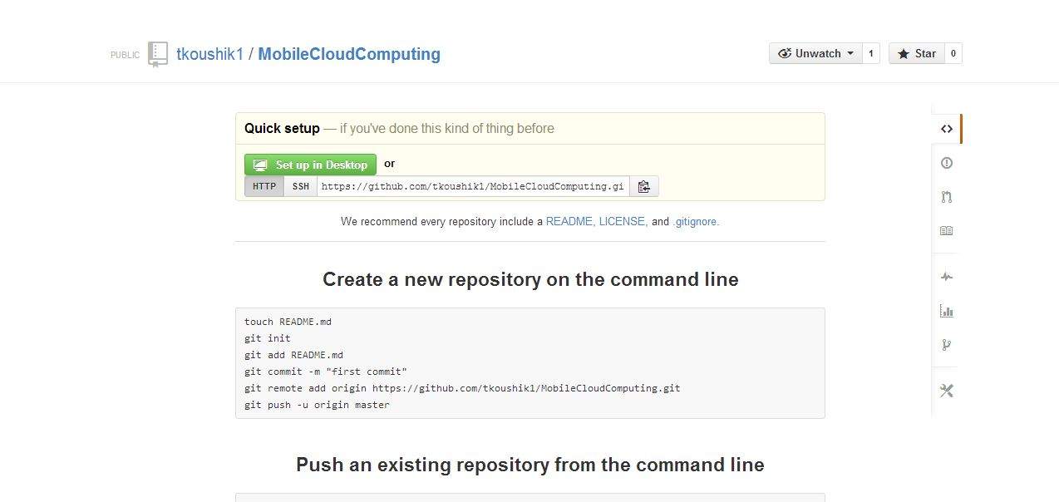

1. Cloned the repository into the desktop and working on it locally

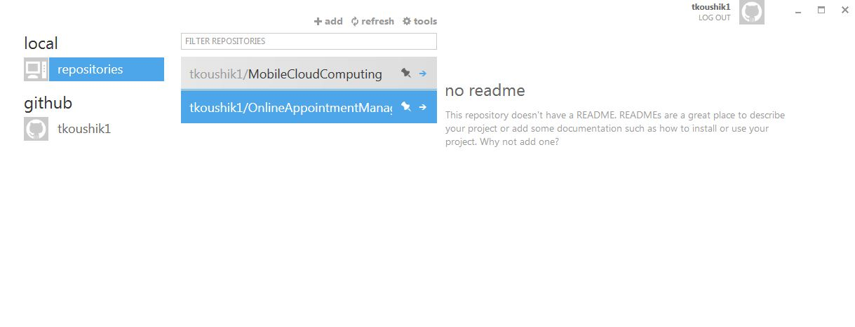

1. Before committing making sure that the email address and name by which the changes are made are correct.

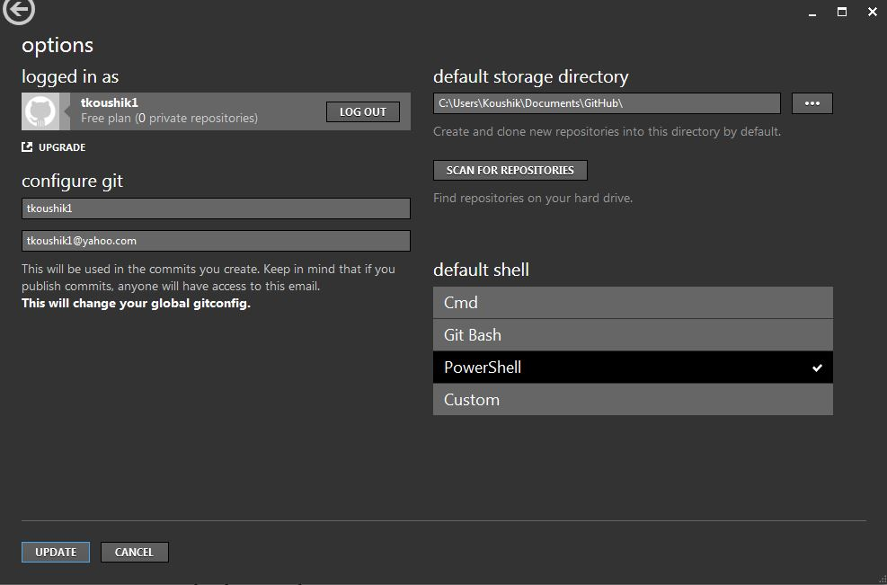

1. Creating some files and folders inside a local repository through shell and committing it and pushing it to the git.

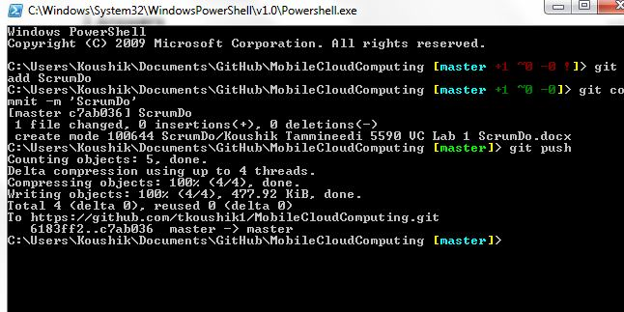

1. Showing the commit that I have done in the git and in the local repository.

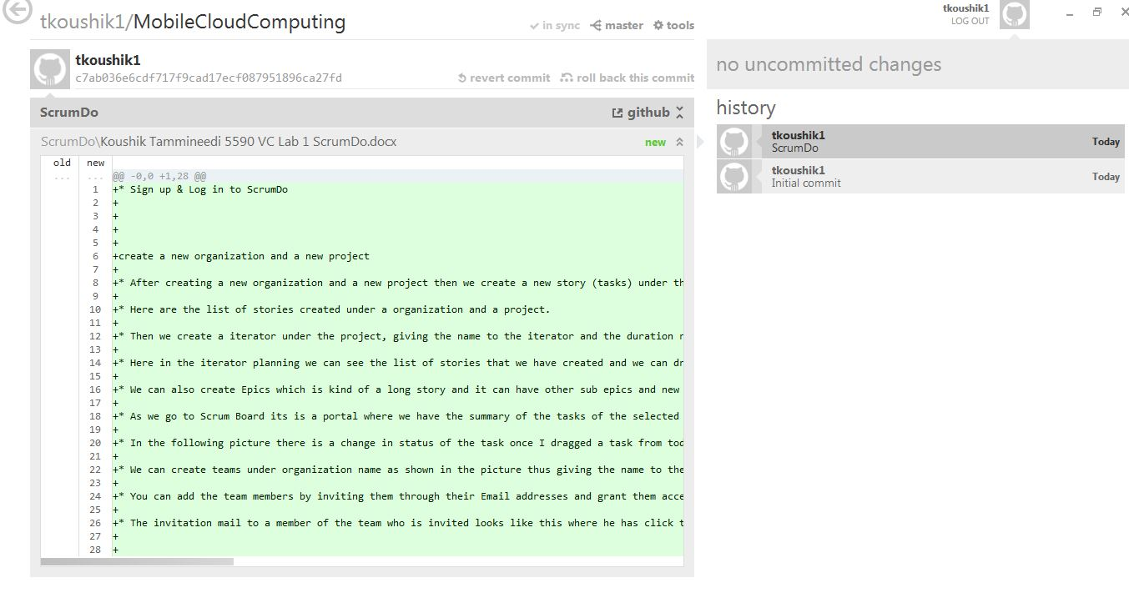

1. Creating an organization in Git and adding members to the team and the repository that the members have access to by granting them the push and pull operations.

