**LAB 3**

**By**

**Koushik Tammineedi**

2. Install glassfish server:

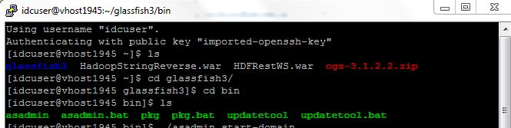

Start the Server:

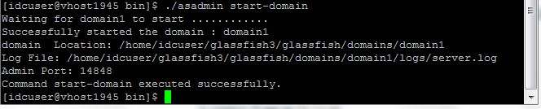

Deploy the Service Using the Cloud linux instance URL and the port (Admin Console of Glassfish)

<http://vhost1945.site1.compute.ihost.com:14848>

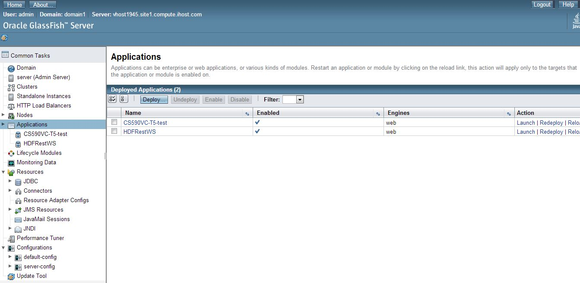

Results from executing the service in the browser:

