Lab4- Koushik Tammineedi

1. Hadoop Command Line: Follow the steps of  running hadoop WordCounting operation using your own input file

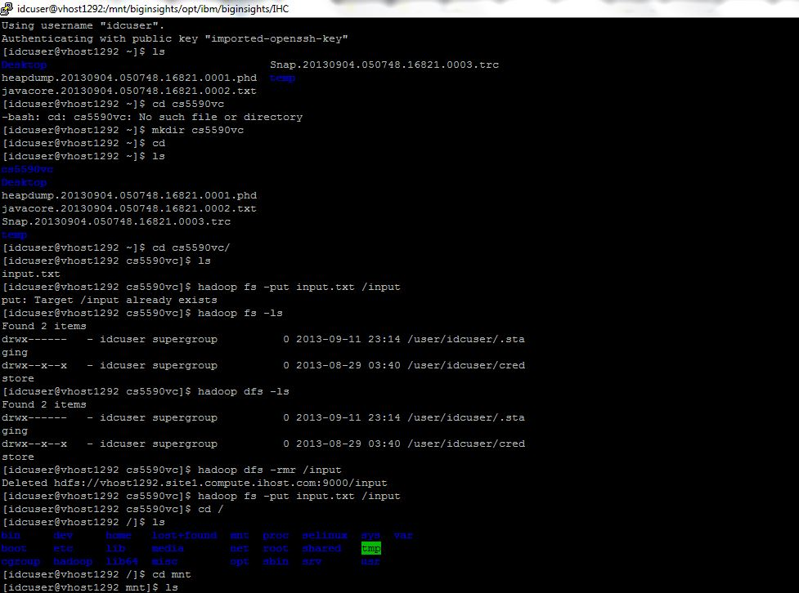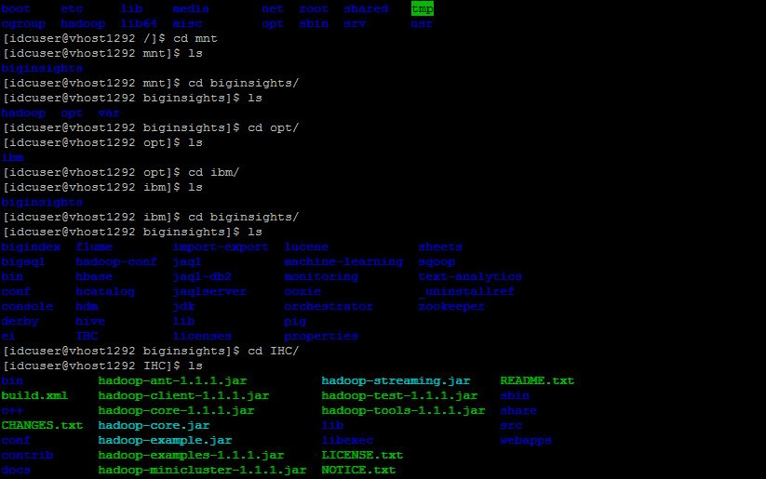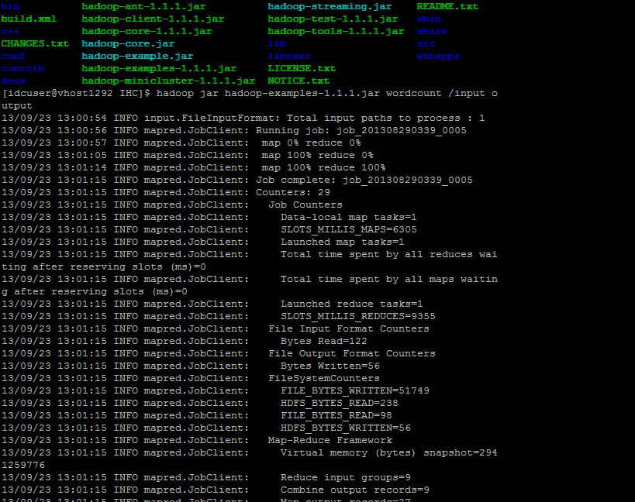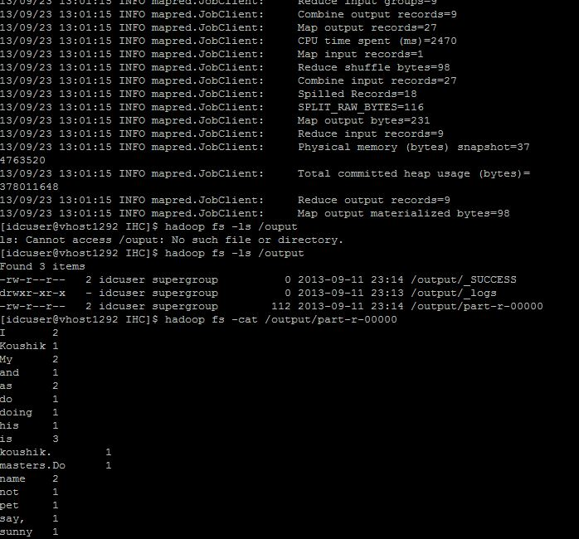

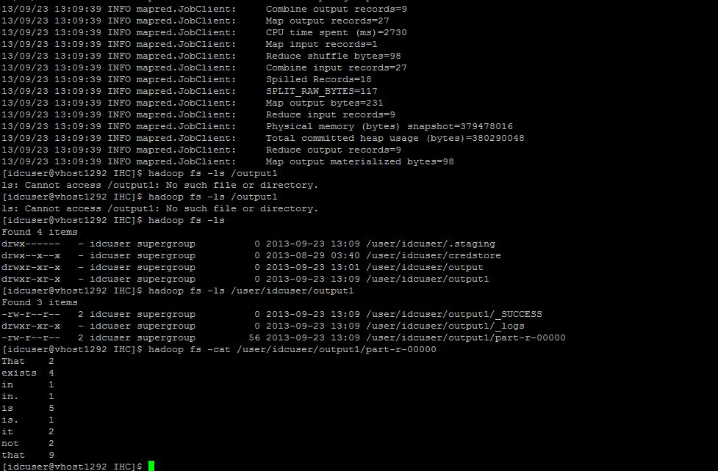

2. Hadoop Java Based Approach: Refer to the additional Tutorial 6 ppt and follow the steps to create the jar file of your own WordCount MapReduce and deploy/run it to your own Hadoop instances.

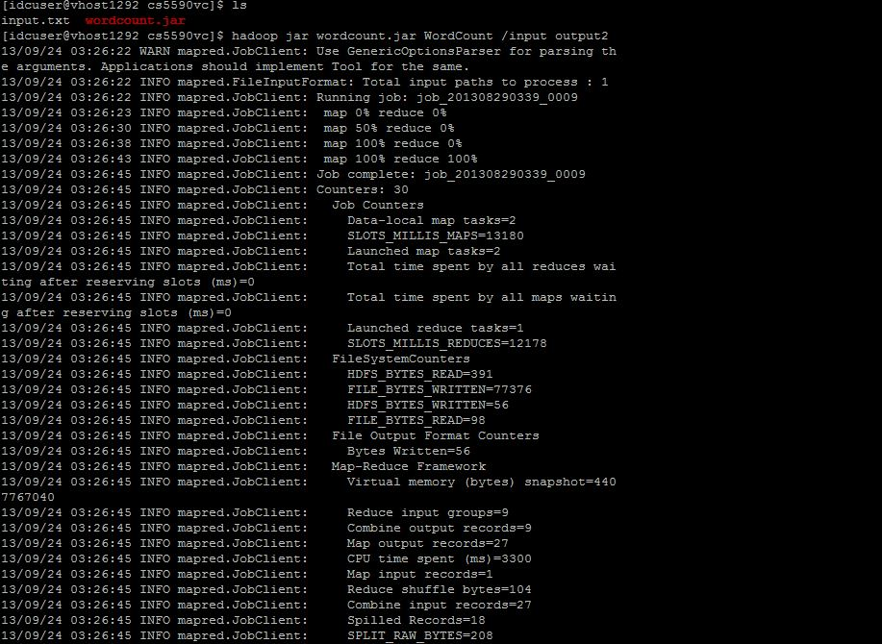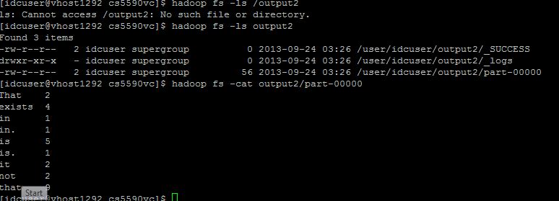

3. Implement a new MapReduce Algorithm

I have Implemented the mapreduce program to reverse the input of the string that you enter.

