Master Project — Research Notes
Analytical Characterisation of Inputs for GNN Surrogate Models
Alois Henom — Imperial College London — March 2026

1. Project Context

1.1 Industrial motivation
Hydrogen is a promising clean energy carrier but presents major safety risks. In industrial environments, an accidental hydrogen leak can cause a deflagration (explosion), generating dangerous pressure waves. To design safe installations, engineers need to simulate these events for many scenarios.
The problem: a single CFD simulation (using OpenFOAM) can take days to weeks of computation. This makes large-scale safety studies practically infeasible.

1.2 The GNN surrogate model
The research group at Imperial College (Tagarielli, Covoni et al.) developed a Graph Neural Network (GNN) surrogate model that can replace CFD simulations. The GNN is trained on existing CFD data and can then predict the outcome of new explosions in seconds rather than days — up to 6200x faster.

Two papers have been published on this work:
- AMOS 2024 (Covoni et al.): first proof of concept on air explosions without combustion.
- IJHE 2025 (Covoni et al.): extension to hydrogen deflagrations with full combustion physics.

The model is implemented in Python using TensorFlow, TensorFlow Probability, and dm-sonnet. It uses the MeshGraphNets architecture (Encode-Process-Decode) operating on the CFD mesh treated as a graph.

1.3 Current inputs and outputs of the GNN
Each mesh node carries the following input variables at time t:
- p — pressure (Pa)
- T — temperature (K)
- vx, vy, vz — velocity components (m/s)
- ft — fuel fraction
- b — combustion regression variable
- k — turbulent kinetic energy
- n — boundary flag (0 or 1)

The model predicts, for each node, the increments over one time step: delta_p, delta_T, delta_vx, delta_vy, delta_vz, delta_ft, delta_b, delta_k.

2. Project Objective

The choice of input variables for the GNN was made empirically. The key question is: are these inputs optimal? Could some be removed? Should others be added?

Testing this by training the full GNN for each candidate input set is too expensive (each training takes days on GPU). The goal of this project is to develop fast metrics that can assess the quality of a set of inputs without training the neural network.

These metrics should answer: given a dataset of CFD simulations and a candidate set of input variables, can we quickly determine whether these inputs are informative for predicting the outputs?

This was explicitly requested by Vito Tagarielli in an email (March 2026), where he introduced this project and specifically asked to study the fractal dimension and MIC statistics as the two main tools.

3. GNN Architecture — MeshGraphNets

3.1 Overall structure
MeshGraphNets uses an Encode-Process-Decode architecture operating on the CFD mesh treated as a graph G = (V, E), where V are the mesh nodes and E are the mesh edges.

3.2 Encoder
Two separate MLPs encode the raw inputs into a latent space of dimension 32:
- Node encoder: 9D input -> 32D latent vector (2 hidden layers, ReLU activation)
- Edge encoder: 4D input (relative displacement + norm) -> 32D latent vector

All input variables are standardised (mean 0, std 1) before encoding. The latent dimension was chosen as 32 due to GPU memory constraints (48GB NVIDIA RTX 6000) — the original MeshGraphNets used 128.

3.3 Processor
15 identical message-passing steps are applied. Each step consists of:
- Edge update: MLP taking [node_i, node_j, edge_ij] (96D) -> 32D + residual connection
- Edge aggregation: sum of all updated edge messages for each node
- Node update: MLP taking [node_i, aggregated_messages] (64D) -> 32D + residual connection

After 15 iterations, each node has effectively seen information from all nodes within 15 hops in the graph — corresponding to the physical zone of influence of the pressure wave over one time step.

3.4 Decoder
A single MLP maps the 32D processed node features to 8 output values (the physical increments delta_q). An integrator then adds these increments to the current state to obtain the state at t + delta_t. This process is repeated iteratively to simulate the full explosion.

4. Metrics Implemented

The following metrics were implemented and tested on a synthetic dataset mimicking the GNN problem structure (5000 nodes, 7 input variables including one deliberately useless noise variable, 1 output).

4.1 Mutual Information (MI)
Measures how much knowing X reduces uncertainty about Y. Unlike Pearson correlation, it detects non-linear relationships. MI = 0 means independence; higher values mean stronger dependency.

Implementation: sklearn.feature_selection.mutual_info_regression (kNN-based estimator).

Limitation observed: MI can miss very weak effects (e.g. T had a very small coefficient and was not detected), and can give small non-zero values for independent variables due to estimation variance.

4.2 Ridge Regression Gain
Trains two fast ridge regression models — one baseline and one with candidate features added — and compares their prediction error on a held-out test set. The gain is expressed as a percentage: (error_A - error_B) / error_A.

Key design choice: time-based split (not random) to avoid data leakage between consecutive time steps.

Result: correctly identified that adding ft and vx gives a large gain (~70%), while adding noise gives no additional gain.

4.3 Intrinsic Dimension (PCA)
PCA was used as a fast proxy for intrinsic dimension: how many components are needed to explain 95% of the variance? If this number is much smaller than the nominal dimension, the data has structure that makes learning easier.

Note: on the synthetic dataset with independently generated variables, all 7 components were needed (no redundancy by construction). On real CFD data with physics correlations, we expect far fewer components to be sufficient.

4.4 Correlation Matrix
Pearson correlation computed for all pairs of variables. Fast and interpretable, but only detects linear relationships. Useful as a first screening tool to identify potentially redundant input variables.

4.5 Random Forest Feature Importance
A random forest regressor trained on the data provides automatic feature importance scores. More powerful than MI because it captures interactions between variables. Still much faster than training the full GNN.

Result: correctly ranked ft as the most important variable, and gave near-zero importance to noise.

5. Fractal Dimension — Main Investigation

5.1 Key concept
Tagarielli's key idea (from email, March 2026): given a model with n inputs and m outputs, consider the joint training dataset of dimension n+m and compute its fractal dimension (FD).
- FD ~ n -> the outputs are well explained by the inputs (good choice)
- FD < n -> too many inputs, some are redundant
- FD >> n -> bad input choice, outputs not well predicted by inputs

5.2 Methods compared
Three estimation methods were implemented and compared on all test cases:

Levina-Bickel: kNN-based MLE estimator. Formula: d = (k-1) / sum_j log(r_k/r_j). Complexity O(N x k). Tested with k = 2, 5, 10, 20, 50, 100 to study sensitivity.
- Levina-Bickel

Following the formula :
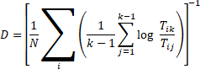

Two-NN (Facco et al., 2017): uses only the 2 nearest neighbours. Ratio mu = r2/r1 follows a Pareto distribution with parameter d. MLE estimate: d = N / sum(log(mu)). Fastest method, O(N x 2).

Grassberger-Procaccia: counts pairs within distance epsilon, fits slope of log(C) vs log(epsilon). Exact version is O(N^2) — impossible at scale. Implemented with subsampling approximation (50,000 random pairs).
- Grassberger-Procaccia
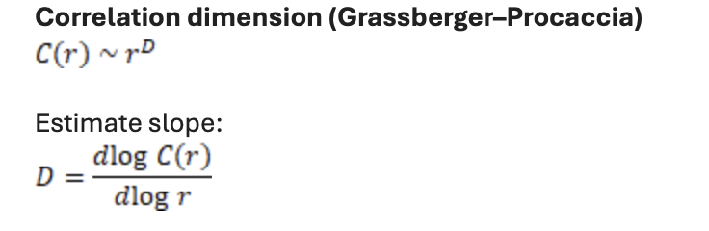

Test of the methods :
Intuition verified with simple examples:
- Straight line z = 2t+1: FD ~ 1 (1D structure embedded in 2D space)
- Smooth surface z = sin(xy): FD ~ 2 (2D structure embedded in 3D space)
- Noisy surface: FD slightly > 2 (noise inflates the dimension)
- Completely random: FD ~ 3 (fills the full 3D space)

To verify this, we used different methods :

Using these methods, we tried to test if they are reliable depedning on the intrinsic dimension of the system.
For the Levina—Bickel method :
Data live on a line
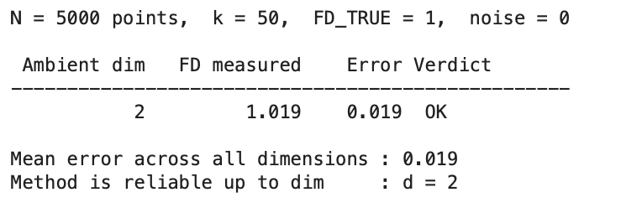
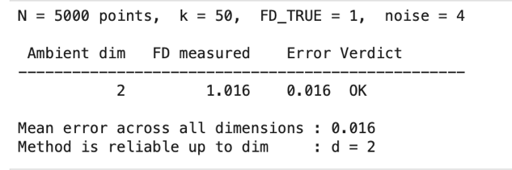
Data live on a surface
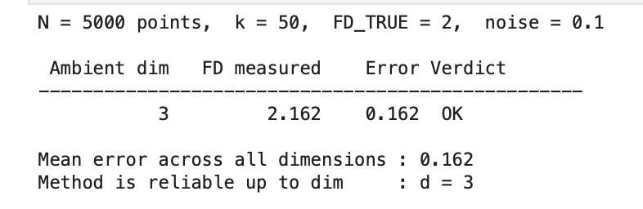

Data live in a volume
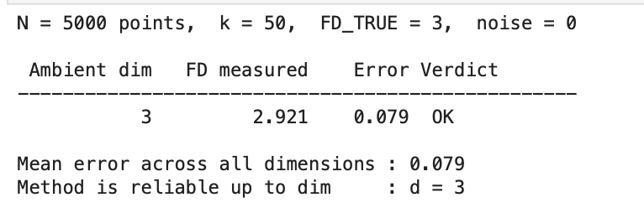

The method seems good to predict for low fractal dimensions, but with D=17 and FD =9, the method sttrugles a lot to find it :
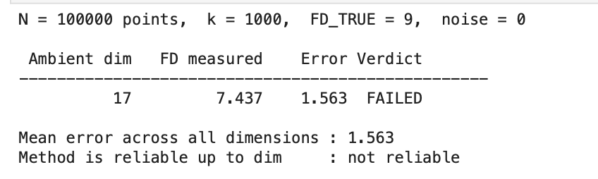

Two-NN method :

5.3 Results on synthetic test cases (N = 2000 points)
Summary of Mean Absolute Error (MAE) and mean computation time per method:
- Two-NN: MAE = 0.172, mean time = 0.0018s -> winner (fastest AND most accurate)
- Grassberger-Procaccia: MAE = 0.192, mean time = 0.0031s -> second
- Levina-Bickel (k=10): MAE = 0.306, mean time = 0.0109s -> least accurate with default k

Sensitivity analysis on Levina-Bickel: accuracy improves significantly with larger k. This suggests the poor performance at k=10 is due to insufficient neighbourhood size, not a fundamental limitation of the method.

6. MIC — Maximal Information Coefficient

6.1 Definition
MIC (Reshef et al., 2011) detects any kind of relationship between two scalar variables by finding the optimal grid partition of the 2D scatter plot that maximises mutual information. Output is always in [0, 1]: 0 = independent, 1 = perfect relationship of any kind.

Unlike Pearson correlation, MIC detects linear, quadratic, periodic, and other non-linear relationships equally well.

6.2 Extension to vector inputs/outputs
MIC is defined between two scalar variables. For the GNN problem with n inputs and m outputs, MIC produces an n x m matrix of pairwise scores.

Tagarielli's suggestion: sum all n x m values to get one global score.

Our additional idea: compute the row sum for each input variable (sum of MIC across all outputs). This gives a per-input informativeness score and allows ranking inputs from most to least informative — directly actionable for input selection.

6.3 Implementation note
The minepy library (standard MIC implementation) failed to install on Mac M3 due to a compilation issue with pkg_resources. An alternative approach using sklearn's kNN-based MI estimator was adopted, which is mathematically equivalent for our purposes.

7 – using machine Learning to reduce the number of information contained in a lot of points
Le réseau de neurones global
Il me faut un réseau de neurones global dont les inputs et outputs sont :
Inputs : un tableau avec les valeurs tout le long de la poutre de Uxx (dérivée seconde spatiale du délplacment et dU/dt la dérivée

Outputs :

We can use the gradient to reduce the number of information contained in 10000 points.

The objective : réduire les informations contenues dans 10000 points, appliquer l’équation pour faire la simulation sur ce nombre réduit de points, puis appliquer la réduction dans le sens inverse pour avoir des nouvelles informations sur tous les autres points.

Encoder => simulation => décoder

Code pour déterminer le deltaU après un instant court deltat
Code 1 : Creation du training dataset
- Formule : u(t+1) = 2*u(t) - u(t-1) + CFL² * (u_gauche - 2*u + u_droite)
  - Pourquoi celle-ci ?

Choix des paramètres pour mon code (« entraînement du modèle »)
- 3 couches cachées, standard pour ce genre de problème, c’est un choix arbitraire
- 64 neurones par couche : choix classique pour ce genre de problème encore
- Fonction d’activation
  - A choisir entre Tanh ou ReLu : à tester et comparer les erreurs
- Learning rate :
  - Universal number
- Epochs : 200 to avoid an over learning of the network

