Efficient Route Planning under Uncertainty

Teekayu Klongtruajrok, Zhou Fanyi   
Department of Computer Science National University of Singapore Singapore

*Abstract*—Classical route planning such as shortest path planning using deterministic approach usually fail to factor in unexpected scenarios that could affect traffic conditions during a trip, hence do not perform well in guiding the drivers to reach their destination in the shortest possible time. In this paper, we present our alternative approach of dynamically solving the route planning problem using Markov Decision Process, which takes into account the effect of unexpected events. In particular, we investigate how efficient route planning can help drivers of ride-hailing services maximize their revenue velocity in the presence of uncertainty.

Keywords—Markov Decision Price, Route Planning)

# Introduction

With a rising vehicle population in urban areas, there is a growing need for efficient route planning, especially in the presence of unexpected events such as traffic accidents that could occur in the trip duration. It is an especially prominent problem for ride-hailing service providers such as Uber, Grab, Lyft, etc., which aim to maximize profit by having their drivers completing as many trips as possible in a given period. With the location data of all passengers and drivers available, these companies face a multi-agent planning problem including dispatch of drivers to passengers as well as optimal path to send the passengers to destination. However, as we recognize that a company’s total profit is based on the sum of individual driver’s contribution, in this project we simplify the planning problem to a single-agent case. Effects of multi-drivers are incorporated into the problem as part of the environment such as road congestion events, which would subsequently affect the single driver’s behaviour as well. In addition, from experience, the driver typically does not have a choice over which particular passenger to pick up. Instead, he will be allocated based on proximity to the passenger by the ride-hailing platform. Hence, the problem this paper tries to investigate would be efficient route planning for a single driver who needs to pick up a particular passenger and then send the passenger to the predetermined destination.

# Approach

## Problem Formulation

In solving the problem, we have chosen to model the real-world map using a grid map, the length and width of which can be set to different value to match different problem sizes. The default map size is 5 x 5, but it could be scaled up to 100 x 100 and is still solvable within reasonable time limit.

The driver is allowed to drive in four directions at each time step: North, East, West and South, which will allow him to move in the grid map accordingly. In situation where the driver is at the map’s border, an action attempting to drive outside of the map would be disallowed.

Unexpected events such as traffic accidents or extreme weather conditions can occur during the trip at any time step. It is possible for multiple events to occur at the same time and location as well. In order for the driver to plan his route according to the event occurrences, the optimal plan is updated by policy iteration whenever there is new event occurring. Subsequently, the driver would follow the updated action plan in his journey. This way, we allow the driver to follow the optimal path at any given point in time, instead of an outdated travel plan that is often suboptimal.

## Markov Decision Process Model

Markov Decision Process offers an ideal framework for modelling this route planning problem because the driver needs to make a series of driving decisions in a stochastic environment where he may or may not reach the intended destination at each time step, depending on the traffic condition he is in. The environment is most likely to be fully observable due to the use of GPS and the amount of traffic data (e.g. weather conditions) available on the platform. At each time step, the driver incurs a loss due to fuel usage or gain a profit by completing a trip, thus there is a reward associated with each location on the grid map.

The different components of the MDP are as follows:

#### Set of state S: Driver’s location. In an n × m grid map, there are n × m possible states.

#### Set of actions A: {North, East, West, South}

#### Reward, R(s): Monetary reward at each state, which is negative at all states except when the driver drops off passenger at the goal position. Represented by a |S| x 1 vector.

#### Transition probabilities T: Probability of reaching the next location given the direction of driving and current location, i.e. P(s’|s,a), based on traffic congestion and unexpected scenarios.

# Implementation

## Default Transition Probability

In the absence of special events, transition probability of reaching the intended position is set to a default value of 0.9, while there is a 0.1 chance of staying in the original location. The rationale for this is that even under normal traffic conditions, there could be factors that affect the movement of a driver. For example, a driver might need to wait for traffic lights in order to enter the next road junction, thus staying in the current location in the next time step as well. In addition, the driver is assumed to have zero probability of ending somewhere other than his current location or intended next location, such as the positions to the left and right of his driving direction. This assumption is based on the fact that most drivers on ride-hailing platforms are experienced enough to avoid going down a wrong path accidentally.

## Events Update

To avoid the curse of dimensionality, events are not modelled as part of the state. Instead, as each event occurs, it is used to update the transition probability T. Each event is associated with a particular location as well as a severity level in the range of (0, 1). In particular, if an event occurred at location (1, 1), the chance of entering (1, 1) from neighbouring cells will be reduced by the value of the severity level. At the same, for a driver currently at location (1, 1), the chance of leaving (1, 1) successfully will also be reduced in a similar manner. If there are multiple events, their effects on T will be accumulated. When there is any event update, MDP solver is run to find the current optimal policy, which is used for subsequent decision making until a new event occurs.

## Simulation UI

* Tech Stack: Python 3.6, PyQt5
* Source of truth: Global variables for transition probability, reward, driver position, client position, and destination position.
* Map: Grid world represented by rectangles. The color changed depending on whether the block is driver (yellow), client (blue), destination (green), past location after the driver moved (black), incidents (red), or empty (grey). There are two options to display value: reward or transition probability for certain actions for certain driver location. Each block has the following properties: x coordinate, y coordinate, flattened index, width, height, reward value, and transition probability value. The block has the following states: show reward value, show transition probability value, is driver, is client, is destination, is incident, and is previously traversed. Receive events to change status of each block and change of numerical value to be either reward or transition probability.
* Settings: container UI for all the settings to modify the map and run the simulation. Also provide a reset functionality to clear the settings and the map. The following are widgets available in the setting:
  + Simulation: runs the simulation with the given transition matrix, reward matrix, discount value, and driver location. Can set view option: show reward or transition probability. Track status of the driver, whether driver reached client and/or destination. Emits 3 events: simulation ran, show reward, and show transition probability.
  + Driver: change the driver position (the agent of the model). Emit one event: position changed, when either row or column value changed. Mutate the driver global variable. Default value is (0, 0).
  + Client: change the client position. Emit one event: position changed, when either row or column value changed. Mutate the client global variable.
  + Destination: change the destination position (the terminal state of the model). Emit one event: position changed, when either row or column value changed. Mutate the destination global variable.
  + Incidents: add incidents to the map, making the state repellent to incoming driver (eg. avoiding traffic) and attractive to outgoing driver (eg. stuck in pothole). Can add incident name, position, and severity probability. Emit one event: incident added, when an incident had been added to the table. Mutate transition probability global variable.
  + Rewards: modify rewards for a particular state. Can modify reward value and the position. Emit one event: reward added, when a reward for a certain state had been modified. Default rewards for all states is -0.1.
* Setting:
* 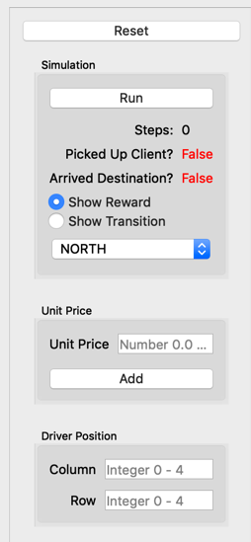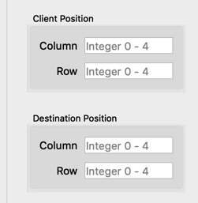
* 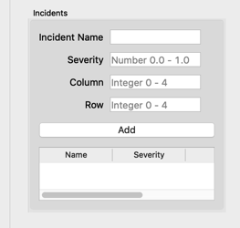
* 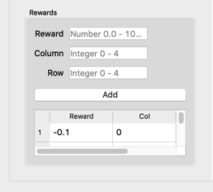
* Simulation:

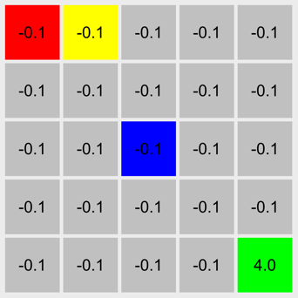

Identify applicable funding agency here. If none, delete this text box.

## Equations

The equations are an exception to the prescribed specifications of this template. You will need to determine whether or not your equation should be typed using either the Times New Roman or the Symbol font (please no other font). To create multileveled equations, it may be necessary to treat the equation as a graphic and insert it into the text after your paper is styled.

Number equations consecutively. Equation numbers, within parentheses, are to position flush right, as in (1), using a right tab stop. To make your equations more compact, you may use the solidus ( / ), the exp function, or appropriate exponents. Italicize Roman symbols for quantities and variables, but not Greek symbols. Use a long dash rather than a hyphen for a minus sign. Punctuate equations with commas or periods when they are part of a sentence, as in:

*a*  *b*    

# Results

After the text edit has been completed, the paper is ready for the template. Duplicate the template file by using the Save As command, and use the naming convention prescribed by your conference for the name of your paper. In this newly created file, highlight all of the contents and import your prepared text file. You are now ready to style your paper; use the scroll down window on the left of the MS Word Formatting toolbar.

## Authors and Affiliations

**The template is designed for, but not limited to, six authors.** A minimum of one author is required for all conference articles. Author names should be listed starting from left to right and then moving down to the next line. This is the author sequence that will be used in future citations and by indexing services. Names should not be listed in columns nor group by affiliation. Please keep your affiliations as succinct as possible (for example, do not differentiate among departments of the same organization).

## Identify the Headings

Headings, or heads, are organizational devices that guide the reader through your paper. There are two types: component heads and text heads.

Component heads identify the different components of your paper and are not topically subordinate to each other. Examples include Acknowledgments and References and, for these, the correct style to use is “Heading 5”. Use “figure caption” for your Figure captions, and “table head” for your table title. Run-in heads, such as “Abstract”, will require you to apply a style (in this case, italic) in addition to the style provided by the drop down menu to differentiate the head from the text.

Text heads organize the topics on a relational, hierarchical basis. For example, the paper title is the primary text head because all subsequent material relates and elaborates on this one topic. If there are two or more sub-topics, the next level head (uppercase Roman numerals) should be used and, conversely, if there are not at least two sub-topics, then no subheads should be introduced. Styles named “Heading 1”, “Heading 2”, “Heading 3”, and “Heading 4” are prescribed.

## Figures and Tables

#### Positioning Figures and Tables: Place figures and tables at the top and bottom of columns. Avoid placing them in the middle of columns. Large figures and tables may span across both columns. Figure captions should be below the figures; table heads should appear above the tables. Insert figures and tables after they are cited in the text. Use the abbreviation “Fig. 1”, even at the beginning of a sentence.

1. Table Type Styles

| Table Head | Table Column Head | | |
| --- | --- | --- | --- |
| Table column subhead | Subhead | Subhead |
| copy | More table copya |  |  |

1. Sample of a Table footnote. (*Table footnote*)
2. Example of a figure caption. (*figure caption*)

Figure Labels: Use 8 point Times New Roman for Figure labels. Use words rather than symbols or abbreviations when writing Figure axis labels to avoid confusing the reader. As an example, write the quantity “Magnetization”, or “Magnetization, M”, not just “M”. If including units in the label, present them within parentheses. Do not label axes only with units. In the example, write “Magnetization (A/m)” or “Magnetization {A[m(1)]}”, not just “A/m”. Do not label axes with a ratio of quantities and units. For example, write “Temperature (K)”, not “Temperature/K”.

##### References

The template will number citations consecutively within brackets [1]. The sentence punctuation follows the bracket [2]. Refer simply to the reference number, as in [3]—do not use “Ref. [3]” or “reference [3]” except at the beginning of a sentence: “Reference [3] was the first ...”

Number footnotes separately in superscripts. Place the actual footnote at the bottom of the column in which it was cited. Do not put footnotes in the abstract or reference list. Use letters for table footnotes.

Unless there are six authors or more give all authors’ names; do not use “et al.”. Papers that have not been published, even if they have been submitted for publication, should be cited as “unpublished” [4]. Papers that have been accepted for publication should be cited as “in press” [5]. Capitalize only the first word in a paper title, except for proper nouns and element symbols.

For papers published in translation journals, please give the English citation first, followed by the original foreign-language citation [6].

1. G. Eason, B. Noble, and I. N. Sneddon, “On certain integrals of Lipschitz-Hankel type involving products of Bessel functions,” Phil. Trans. Roy. Soc. London, vol. A247, pp. 529–551, April 1955. *(references)*