U.S. Coast Guard Research and Development Center

1082 Shennecossett Road, Groton, CT 06340-6096

Report No. (CG-D-XX-99)

LEEWAY DIVERGENCE




FINAL REPORT

AUGUST 1999

This document is available to the U.S. public through the
National Technical Information Service, Springfield, VA 22161

Prepared for:

U.S. Department of Transportation

United States Coast Guard
Operations, (G-O)
Washington, DC 20593-0001

N O T I C E

This document is disseminated under the sponsorship of the Department of Transportation in the interest of information exchange. The United States Government assumes no liability for its contents or use thereof.

The United States Government does not endorse products or manufacturers. Trade or manufacturers’ names appear herein solely because they are considered essential to the object of this report.

The contents of this report reflect the views of the Coast Guard Research and Development Center. This report does not constitute a standard, specification, or regulation.


Marc B. Mandler, Ph.D.

Technical Director
United States Coast Guard
Research & Development Center
1082 Shennecossett Road
Groton, CT 06340-6096

Technical Report Documentation Page
1. Report No. |  | 2. Government Accession Number |  |  | 3. Recipient’s Catalog No.
4. Title and Subtitle  Leeway Divergence |  |  |  |  | 5. Report Date  August 1999  6. Performing Organization Code  Project No. 1012.3.16 / UDI xxx
7. Author(s)  Arthur A. Allen |  |  |  |  | 8. Performing Organization Report No.  R&DC (to be provided by COTR)
9. Performing Organization Name and Address  U.S. Coast Guard  Research and Development Center  1082 Shennecossett Road  Groton, CT 06340-6096 |  |  |  |  | 10. Work Unit No. (TRAIS)  11. Contract or Grant No.
12. Sponsoring Organization Name and Address  U.S. Dept of Transportation  United States Coast Guard  Commandant (G-OPR)  Washington, DC 20593-0001 |  |  |  |  | 13. Type of Report & Period Covered  Final  14. Sponsoring Agency Code  Commandant (G-OPR)  U.S. Coast Guard Headquarters  Washington, DC 20593-0001
15. Supplementary Notes
The R&D Center's technical point of contact is Arthur Allen, 860-441-2747, email: aallen@rdc.uscg.mil..

16. Abstract
A key to accurately determining search areas is an understanding of leeway divergence. To fully understand a craft’s leeway divergence we must address two basic questions. (1) What factors influence the magnitude of the crosswind component of leeway drift? (2) What factors influence whether the craft will drift to right or left of downwind direction?

The magnitude of the crosswind component of leeway drift as a function of wind speed has been reported on in the literature for 23 categories of leeway drift objects. The downwind and crosswind components for two additional leeway categories are analyzed in this report. The optimal relationships between downwind and crosswind components of leeway coefficients and leeway speed and divergence angle values are derived empirically using the 25 categories that contained both sets of coefficients. Downwind and crosswind leeway coefficients were generated for an additional 38 leeway categories based on the estimates from standard error relationships. The entire set of downwind and crosswind components of leeway coefficients is presented for 63 leeway categories.

The crosswind component of leeway has been observed to be either positive (right of the downwind direction) or negative (left of the downwind direction) for the duration of each individual drift run. The observations of two confirmed jibing events are described; guidance for the prediction of jibing events is provided.

Recommendation are:
- Incorporate into numerical search planning tools the use of downwind and crosswind components of leeway as a function of wind speed adjusted to the 10-meter height, which are provided for 63 leeway categories.
- Incorporate into numerical search planning tools the use a simple jibing model (that is a function of target type, wind speed and wind direction change) for switching between positive and negative crosswind component equations.
3) Incorporate into manual search planning tools the use of divergence angle divided by 1.35.
17. Key Words  leeway jibing  leeway angle downwind component  leeway divergence crosswind component  divergence angle |  |  |  | 18. Distribution Statement  This document is available to the U.S. public through the National Technical Information Service,  Springfield, VA 22161
19. Security Class (This Report)  UNCLASSIFIED | 20. Security Class (This Page)  UNCLASSIFIED |  |  |  | 21. No of Pages | 22. Price
Form DOT F 1700.7 (8/72) Reproduction of form and completed page is authorized.

ACKNOWLEDGEMENTS

The comments of Penny Herring, Dr. Jennifer Dick-O’Donnell, LT Harlan Wallace, Gary Hover, LT Gregory Purvis, Jack Frost, Quincy Robe and Vonnie Summers are appreciated and helped to improve this report.

EXECUTIVE SUMMARY

The hunt for any lost object in the maritime environment typically requires the determination of search areas. It is well established that survivors and their craft follow the direction of general downwind motion due to leeway effects. However, it is now understood that leeway drift is not always directly downwind, but that there is often a significant component of drift perpendicular to the downwind direction. This perpendicular motion is the crosswind component of leeway drift. The crosswind component of leeway leads an object to diverge from the downwind direction. A key to accurately determining search areas is an understanding of this behavior. This study discusses the importance of the leeway crosswind component and documents how existing search planning tools inappropriately apply leeway divergence in their determination of search areas. The result of this inappropriate application are search areas that may be incorrectly centered, or focusing resources in the areas were the survivors are least likely to be found.

It is now evident from recent studies that to fully understand and properly model a craft’s leeway divergence, two basic questions must be addressed. (1) What factors influence the magnitude of the crosswind component of leeway drift? (2) What factors influence whether an object will drift to the right or to the left of the downwind direction?

This report discusses the answers to these two questions. It is a follow on work to Allen and Plourde (1999) with a particular emphasis on the relationship among leeway angle, divergence angle, and crosswind components of leeway and their roles in describing and modeling leeway motion. In addition, this report provides the necessary background and framework for on-going efforts to incorporate crosswind components of leeway into the search area determination model (AP98) introduced by Allen and Plourde (1999) and to modify the presently used manual method.

In the past, the unclear relationship between leeway angle and leeway divergence combined with the lack of crosswind information has hindered the proper implementation of leeway behavior into search planning tools. This report clarifies leeway divergence terms, discusses crosswind behavior, and ultimately presents components of leeway drift, as a function of wind speed, for 63 categories of leeway drift objects. The entire set of downwind and crosswind components of leeway coefficients are presented in Table 4-1 of Chapter 4. It is proposed that incorporating this information into search planning tools will result in better-centered and more appropriately sized search areas.

The net displacement from the downwind direction is dependent on the magnitude of the crosswind component of leeway and the frequency of sign changes. To date, with only two exceptions, crosswind components of leeway have been experimentally observed to be either persistently positive (right of the downwind direction) or persistently negative (left of the downwind direction) for the duration of each individual drift. In the cases of the two exceptions, the drift object jibbed or changed the sign of the crosswind component of leeway. These changes from one stable orientation relative to the wind lead to sign changes of the crosswind component of leeway. The observations of the two confirmed jibing events are described in chapter two along with some rather speculative guidance for the prediction of jibing events.

How the Automated Manual Solution (AMS), CASP 1.1X, and the new International Aviation and Maritime Search and Rescue Manual (IAMSARM) method use either leeway or divergence angle is illustrated in Chapter 5. In addition, a modification to the AMS is proposed. The divergence angle is divided by 1.35, the optimum factor determined in Chapter 3. This aligns the initial distribution sub-areas of the AMS solution with arcs generated by CASP 1.1X. Efforts are on-going to incorporate crosswind and downwind components of leeway into the search area determination model (AP98) introduced by Allen and Plourde (1999) and to then compare results of that model to those presented in chapter 5.

RECOMMENDATIONS

- Incorporate into numerical search planning tools the use of downwind and crosswind components of leeway, as a function of wind speed adjusted to the standard 10-meter height, for the 63 categories of leeway targets presented in Table 4-1.

- Incorporate into numerical search planning tools the use of a simple jibing model for switching between positive and negative crosswind component equations.

- Incorporate into manual search planning tools the use of divergence angles provided by Allen and Plourde (1999) divided by 1.35.

- Continue efforts to fully understand and model the drift of survivors and survivor craft by studying targets over more drift runs and in a variety of wind conditions. The conditions should include wind speeds less than three m/s and greater than 20 m/s and periods of rapid wind direction shifts. With more drift runs the question of initial distribution between left and right divergence can be addressed. Collecting leeway data under a variety of wind conditions will also allow the observation of changes between left and right divergence – jibing events.

- Continue efforts to complete the incorporation of crosswind and downwind components of leeway into the search area determination model (AP98) introduced by Allen and Plourde (1999) and then operationally test that model against previous models in order to measure any increase in ultimate search performance.

Table of Contents
Page

EXECUTIVE SUMMARY v

1.0 BACKGROUND of LEEWAY ANGLE and DIVERGENCE ANGLE 1-1

1.1 General Introduction 1-1

1.2 Definitions 1-2

1.3 Brief History of Leeway Angle 1-4

2.0 DIVERGENCE SIGN CHANGES – JIBES 2-1

2.1 Introduction 2-1

2.2 Description of Jibing Events 2-1

2.3 Prediction of Jibing Events 2-4

3.0 CONVERSION of LEEWAY SPEED and DIVERGENCE ANGLE to DOWNWIND and CROSSWIND COMPONENTS of LEEWAY 3-1

3.1 Introduction 3-1

3.2 Estimation of Downwind and Crosswind Components 3-2

3.3 Estimation of Standard Error Terms (S_{y/x}) 3-6

4.0 LEEWAY GUIDANCE FOR NEW GENERATION OF NUMERICAL SEARCH AREA DETERMINATION METHODS 4-1

4.1 Introduction 4-1

4.2 Recommendations for Leeway Guidance for Numerical Methods 4-1

5.0 IMPLEMENTATION OF DIVERGENCE ANGLE 5-1

5.1 Present Search Tools 5-1

5.2 Modified Automated Manual Solution 5-3

6.0 CONCLUSIONS AND RECOMMENDATIONS 6-1

6.1 Conclusions 6-1

6.2 Recommendations 6-1

6.3 Future Work 6-2

REFERENCES R-1

APPENDIX A: LEEWAY COMPONENTS OF MARITIME LIFE RAFTS
(DEEP BALLAST, CANOPY, 15-25 PERSON CAPACITY) A-1

A.1 Introduction A-1

A.1.1 Maritime Life Raft (Deep Ballast, Canopy, 15-25 Person Capacity, No Drogue, Light Loading) A-1

A.1.2 Maritime Life Raft (Deep Ballast, Canopy, 15-25 Person Capacity, With Drogue, Heavy Loading) A-4

List of Illustrations
Figure Page

1-1 Relationship between the Leeway Speed and Angle and the Downwind and Crosswind Components of Leeway 1-3

1-2 Leeway angle versus wind speed from Hufford and Broida (1974) data set for four small craft. 1-5

2-1 The jibing 5.5-m open boat during Leeway Drift Run 31. [A] is the crosswind component of leeway versus time. [B] is the relative wind direction versus time, and [C] is the 10-meter wind speed versus time. 2-2

2-2 The progressive vector diagram of the displacement vector rotated to the downwind and crosswind coordinate frame for Leeway Drift Run 38 of the
5-sided 4-person Beaufort Life Raft. 2-3

2-3 The jibing 5-sided 4-person Beaufort Life Raft during Leeway Drift Run 38.
[A] is the crosswind component of leeway versus time. [B] is the relative wind direction versus time, and [C] is the 10-meter wind speed versus time. 2-4

2-4 An illustration of a candidate jibing model for three objects of low, moderate and high resistance to jibing. 2-6

3-1 The Slope Coefficients of the Downwind and Crosswind Components of Leeway regressed against the Actual Coefficients of the Downwind and Crosswind Components of Leeway as a function of the Adjustment Factor. 3-3

3-2 The Predicted Coefficients of the Downwind Components of Leeway versus the Actual Coefficients of the Downwind Components of Leeway. The Adjustment is Factor 1.35. 3-5
3-3 The Predicted Coefficients of the Crosswind Components of Leeway versus the Actual Coefficients of the Crosswind Components of Leeway. The Adjustment is Factor 1.35. 3-5

3-4 The Standard Error of Estimate (S_{y/x}) of the Downwind and Crosswind Components of Leeway Equations versus the Standard Error of the Estimate
(S_{y/x}) of the Leeway Speed Equations. 3-6

5-1 The leeway drift areas for CASP 1.1X and the AMS for a target with a divergence angle of 35 degrees and leeway speed of 3.5% of the wind. 5-2

5-2 The leeway drift areas for CASP 1.1X, AMS and IAMSARM AMS for a target with a divergence angle of 35 degrees and leeway speed of 3.5% of the wind. 5-3

5-3 The leeway drift areas for CASP 1.1X and the AMS and modified AMS for a target with a divergence angle of 35 degrees and leeway speed of 3.5% of the wind 5-4

5-4 The leeway drift areas for IAMSARM, CASP 1.1X and the AMS and modified AMS for a target with a divergence angle of 35 degrees and leeway speed of 3.5% of the wind. 5-5

A-1 Beaufort circular 20-person life raft A-1

A-2 The Unconstrained Linear Regression and 95% Prediction Limits of the Downwind Component of Leeway as function of Wind Speed at 10 m, Maritime Life Rafts, Deep Ballast Systems, Canopy, 15-25 Person Capacity, No Drogue, Light Loading. A-3

A-3 The Unconstrained Linear Regression and 95% Prediction Limits of the Positive and Negative Crosswind Component of Leeway as function of Wind Speed at 10 m, Maritime Life Rafts, Deep Ballast Systems, Canopy, 15-25 Person Capacity, No Drogue, Light Loading. A-3

A-4 The Unconstrained Linear Regression and 95% Prediction Limits of the Downwind Component of Leeway versus Wind Speed at 10 m, Maritime Life Rafts, deep ballast systems, canopy, 15-25 person capacity, with a drogue, and heavy loading. A-5

A-5 The Unconstrained Linear Regression and 95% Prediction Limits of the Positive and Negative Crosswind Component of Leeway versus Wind Speed at 10 m, Maritime Life Rafts, deep ballast systems, canopy, 15-25 person capacity, with a drogue, and heavy loading. A-5

List of Tables

Table Page

1-1 Leeway Angle (degrees) Hufford and Broida's (1974) four small craft 1-5

  - Methods for Determining Divergence Angle for Allen and Plourde's
(1999) Sixty-three Categories of Leeway Objects 1-7

3-1 Coefficients of Linear Unconstrained Regression of Predicted DWL
versus Actual DWL Predicted CWL versus Actual CWL for 25 Leeway Categories 3-4

4-1 Recommended Downwind and Crosswind Components of Leeway Values for Numerical Search Planning Tools 4-3

A-1 Unconstrained Linear Regression of the Downwind and Crosswind
Component of Leeway (cm/s) of Beaufort 20-person life raft with light
loading and no drogue on W_{10m} (m/s) A-2

A-2 Unconstrained Linear Regression of the Downwind and Crosswind Component
of Leeway (cm/s) of Beaufort 20-person life raft with heavy loading and
with a drogue on W_{10m} (m/s) A-4

CHAPTER 1

BACKGROUND of LEEWAY ANGLE and DIVERGENCE ANGLE

1.1 GENERAL INTRODUCTION

The starting point for a maritime search for survivors and survivor craft is the determination of probable search areas. The search areas are established based upon an evaluation of Last Known Position (LKP), ocean surface currents, and leeway drift. In this report, we are concerned with leeway. That survivors and their craft drift downwind due to leeway effects is well established as is the fact that not all leeway drift is directly downwind. There is often a significant component of drift perpendicular to the downwind direction. This motion perpendicular to the downwind direction is the crosswind component of leeway drift. The crosswind component of leeway leads to the object diverging from the downwind direction. A key to accurately determining search areas is an understanding of this leeway divergence. The divergence from the downwind direction is dependent on both the object and its environment. The asymmetric shape of all drift objects leads to a net side force, (Hodgins and Hodgins, 1998), which in turn results in a motion perpendicular to the downwind direction.

To fully understand a craft’s leeway divergence we must address two basic questions. (1) What factors influence the magnitude of the crosswind component of leeway drift? In addition, (2) what factors influence whether the craft will drift to right or left of downwind direction?

The magnitude of the crosswind component of leeway drift as a function of wind speed has been reported on in the literature for twenty-three categories of leeway drift objects. (Two additional leeway categories, two configurations of 20-person maritime life rafts, are analyzed in Appendix A to provide their coefficients of downwind and crosswind components of leeway versus 10-meter wind speed.) The crosswind component of leeway has been observed to be either persistently positive (right of the downwind direction) or persistently negative (left of the downwind direction) for the duration of each individual drift run.

To properly model leeway divergence, the following factors should be included: (1) The magnitudes, both positive and negative, of crosswind leeway components as functions of wind speed adjusted to the 10-meter height. (2) The confidence bounds of the two functions above. (3) The factors that influence the percentage of craft, for each leeway category to drift to either to the right of or the left of the downwind direction. (4) The factors that influence the frequency of shifting from positive to negative crosswind leeway or vise versa.

In this report, we lay the groundwork for future efforts to model leeway divergence for the determination of maritime search areas. Definitions and a brief review of the relationship between leeway angle and leeway divergence are presented in Chapter 1. Only two jibes of leeway drift objects have been observed to date. They are described In Chapter 2, to provide initial guidance on how jibing might be modeled. Parameters for estimating jibing frequency are estimated for the 63 leeway categories presented in Allen and Plourde (1999). Next, the relationship between downwind (DWL) and crosswind (CWL) components and the leeway speed / divergence angle was established, in Chapter 3. We use the 23 categories of leeway objects that have values reported (plus the two additional categories analyzed in Appendix A) that contained values for both the downwind and crosswind components of leeway and leeway speed and divergence angle. We assume that these relationships established for the 25 leeway categories hold true for additional 38 leeway categories, provided by Allen and Plourde (1999), that only contain values for leeway speed and divergence angle. Thus assuming this consistency, a procedure was established, for estimating the downwind and crosswind components of leeway for these additional 38 leeway categories. Future search planning tools that use numerical methods will use downwind and crosswind components of leeway rather than leeway speed and divergence angle. Therefore, the entire set of downwind and crosswind components of leeway for all 63 leeway categories, along with initial parameters for estimating jibing frequency are provided in a table in Chapter 4. In Chapter 5, the use of divergence angle by the present U.S. Coast Guard search-planning tools is reviewed, and a suggestion modifying how divergence angle should be incorporated into manual search planning tools is provided. Summary and recommendations are provided in Chapter 6.

1.2 DEFINITIONS

That survivors and survivor craft do not drift directly downwind has been observed and reported on since Chapline (1960). The leeway vector of a drifting object can be represented in polar or rectangular coordinates relative to the wind velocity vector, as shown in Figure 1-1. Leeway speed and angle are the polar coordinate representation for the leeway velocity vector. Downwind and crosswind components of leeway are the components of the leeway velocity vector expressed in rectangular coordinates.

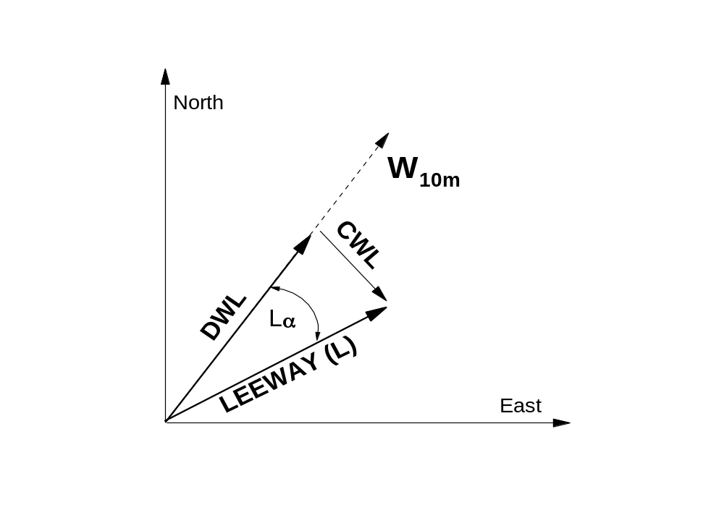

W_{10m} = Wind velocity vector adjusted to 10m height,
L = Leeway vector,
Lα = Leeway angle,

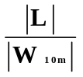 = Leeway rate,

DWL = 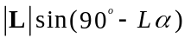 = Downwind Leeway component,

CWL = 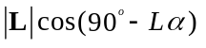 = Crosswind Leeway component.

Figure 1-1. Relationship between the Leeway Speed and Angle and the Downwind and Crosswind Components of Leeway

Most early experiments and the resulting reports include data and analysis of the leeway speed as a function of wind speed for that object. A few of these early reports also include data and analysis of leeway angle. All of the recent leeway studies collected data on leeway angle. Leeway angle has been defined as leeway drift direction minus the direction towards which the wind is blowing with a deflection to the right of downwind being positive and to the left being negative. A leeway angle datum is determined for a single sampling period for a specific leeway test object, i.e. a single measurement.

Divergence angle arises from the analysis of leeway angle data. Search-planning tools have used the term "Divergence Angle" to provide guidance for the prediction of the portion of leeway drift that is not directly downwind. Unfortunately, there is no clear and definitive definition for "Divergence Angle". Consequently, each search planning method handles the drift of objects off the downwind direction in a slightly different way. Lacking a clear definition of divergence angle also means that there is no standard method of presenting the analysis of an object’s leeway angle data in terms of its divergence angle.

There is both a distinction and a relationship between leeway angle and divergence angle. As stated above, leeway angle refers to an angle off the downwind direction for a single sampling period for a particular drift object. Divergence angle refers to a time-integrated angle off the downwind direction for a category of leeway objects. Two problems exist with the relationship between leeway angle and divergence angle. The first problem is that there is no clear pathway for converting leeway angle statistics or analysis to a divergence angle estimate for a given leeway category. The second problem is that there are inconstancies among search-planning tools' use of divergence angle. However, both of these problems are avoided by using the downwind and crosswind components of leeway versus wind speed equation, rather than the more traditional use of leeway speed versus wind speed and a divergence angle approach.

The nautical definitions given here are the definitions used throughout this report. Jibe (jibed, jibing) also spelled gibe or gybe, occurs when the stern of the vessel passes through the direction from which the wind is blowing. In contrast, a jib is triangular fore and aft sail set forward of the foremast. Tack is the direction relative to the wind where a sailing vessel goes. To tack is to change direction where the bow of the vessel passes through the direction from which the wind is blowing.

1.3 BRIEF HISTORY of LEEWAY ANGLE

Chapline (1960) was the first to observe that leeway drift objects did not drift directly downwind. Chapline reported that "many of the boats did not make their leeway directly down wind." He also observed that those vessels with large underwater lateral planes had an increased tendency to move off the downwind direction. He reported relative wind direction for sailing vessels of 9 to 13 points (101 to 146 degrees) but did not include what their leeway angle or direction was. However, for fishing sampans he reported relative wind direction of 10 points (112 ½ degrees) and a leeway directly abeam. Chapline provided the first reported leeway angle (2 points or 22 ½ degrees) for a commercial fishing vessel – Hawaii sampan.

Hufford and Broida (1974) provided leeway data in tabular form for four small (12 to 21 ft) craft and a 12-foot rubber raft. Four of the five targets were tested with and without drogues; the 12-foot Barge was tested only without a drogue. Hufford and Broida's data for the four small craft was analyzed and is presented in Table 1-1 and Figure 1-2. (The leeway angle statistics for the 12-foot rubber raft are presented in Allen and Plourde’s (1999), Chapter 3.)

Table 1-1
Leeway Angle (degrees)

Hufford and Broida's (1974) four small craft

Hufford  & Broida | # | Wind  Speed | Leeway Angle |  |  |  | Abs. Angle
(1974) | samples | (m/s) | mean | s.dev. | min | max | mean | s.dev.
four | 73 | 1.1 – 5 | 4.8 | 32.2 | -105 | 73 | 26.1 | 19.3
small | 127 | 5 – 9.8 | 4.9 | 25.7 | -60 | 67 | 20.7 | 15.7
craft | 200 | 1.5 – 9.8 | 4.8 | 28.2 | -105 | 73 | 22.8 | 17.2
Three craft with drogues | 38 | 2.8 – 9.8 | 9.3 | 21.1 | -38 | 55 | 17.6 | 14.7
Four craft without drogues | 162 | 1.1 – 8.4 | 3.8 | 29.6 | -105 | 73 | 24.0 | 17.6

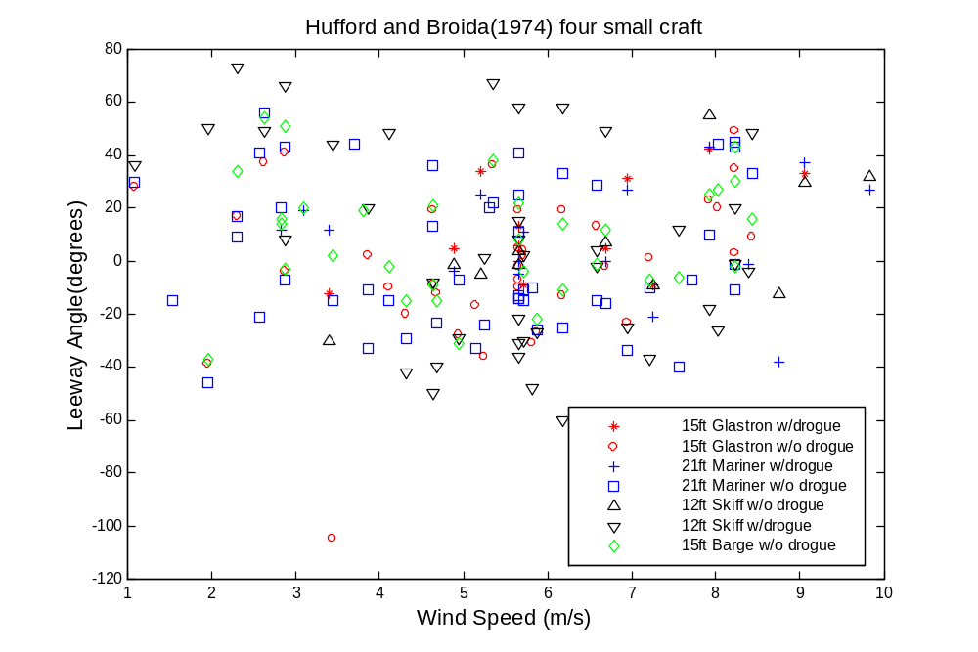

Figure 1-2. Leeway angle versus wind speed from Hufford and Broida (1974) data set for four small craft.

It is clear from the statistics and Figure 1-2 that Hufford and Broida have a rather limited leeway angle data set that contains considerable noise.

Allen and Plourde (1999) reviewed the guidance for use of leeway direction (“maximum angle off downwind”) provided by the National SAR Manual. The apparent source of the present leeway divergence guidance in the National SAR Manual is from Hufford and Broida (1974), and Nash and Willcox (1985). The reason that the source of the guidance in the National SAR Manual is uncertain is that no references are quoted and the wording attempts to combine ideas from several sources. However, this guidance shall be replaced by the recommendations provided by Allen and Plourde (1999).

Allen and Plourde (1999) have presented coefficients for leeway speed as a function of 10-meter wind speed and divergence angles. References for the origins of the leeway values for sixty-three categories of leeway objects are provided. Five different methods were used to determine divergence angles were used by Allen and Plourde (1999) or provided to them by previous leeway studies. Three of the methods used relationships between leeway angle statistics and divergence angle and two were interpolation / extrapolation methods.

Leeway angle statistics were available to derive leeway divergence for thirty-eight of the categories. Three basic combinations were used to provide an estimate of the relationship between leeway angle statistics and divergence angle. The three combinations were: (1) twice the standard deviation of the leeway angle, (2) mean of the leeway angle plus twice the standard deviation, and (3) mean of the leeway angle plus one standard deviation. When there were sufficient data, the data set was sorted by wind speed, and leeway angle statistics were determined for only those values above a wind speed threshold, typically 5 m/s. This was done to reduce the effect of the wide scatter in leeway angle as wind speed approaches zero. The reason for three different methods is that there are three basic types of leeway angle data sets. The first type of data set has mean leeway angle close to zero and has little or no bifurcation of the data set about the abscissa of leeway angle as function wind speed. Plus or minus two standard deviations should include approximately 95% of the distribution of observed leeway angles for this data set that has a normal-like distribution. The second type of data set has a non-zero mean, but is limited to one side of the abscissa due to data constraints. The third type is similar to the second, except that the data was collected on both tacks, and the entire data set is becomes bifurcated at higher winds speeds. These later two types of leeway angle data sets require an inclusion of a mean angle or mean of the absolute angle (if the bifurcation is symmetrical) plus either one or two standard deviations. The appropriate method depends on the nature of the leeway angle data set available, and which relationship is applied is left to the discretion of the researcher.

Two non-statistical methods were used to estimate divergence angle, when leeway angle data was not available in the original reports. The fourth method used figures from the report to visually estimate the scatter in the leeway angle data set. Allen and Plourde (1999) estimated three divergence angles from Nash and Willcox's (1991) figures of leeway angle versus wind speed. The fifth method was used for the remaining 25 categories by Allen and Plourde (1999). Divergence angles were extrapolated from the nearest neighboring leeway category in the taxonomy table. Where more than one neighboring category contained a divergence angle, the category with the greater divergence angle was used. The numbers of leeway categories determined by each of the five different methods are summarized in Table 1-2.

Table 1-2.
Methods for Determining Divergence Angle
for
Allen and Plourde's (1999)
Sixty-three Categories of Leeway Objects

Method of Determining Divergence Angle | Number of Categories that were determined by that Method.
Twice the standard deviation of leeway angle | 18
Mean of leeway angle plus one standard deviation | 9
Mean of leeway angle plus twice the standard deviation | 8
Interpolated from a figure of leeway angle | 3
Extrapolated from neighboring leeway category | 25

In summary, Allen and Plourde (1999) and previous studies had a variety of information and data on leeway angle available to them. For some leeway targets, the mean leeway angle was clearly not zero. While this maybe partially explained by limited data sets that were biased by logistical considerations, some targets clearly were observed to drift off the downwind direction in a consistent manner. Without a clear definition of divergence angle or single acceptable method of using leeway angle statistics to determine divergence angle, Allen and Plourde (1999) and previous studies used three different methods to provide an estimate of divergence angle from the leeway angle statistics.

[BLANK]

CHAPTER 2
DIVERGENCE SIGN CHANGES - JIBES

  - INTRODUCTION

The frequency for the occurrence of jibing events is an important element in how search areas are modeled. In the complete absence of jibing, search objects will maintain throughout the drift, the tack that the objects had initially. In this case, only the initial proportion of the Monte Carlo replications needs to be modeled, and then each replication maintains its tack, which specifies its crosswind leeway equation. If the possibility of a left or right tack is approximately equal, two high probability search areas will form and separate from each other over time. If a search object jibes frequently, on the order of once a time step, then the search model should include a random function that is invoked every time step to select the crosswind leeway equation. The two areas of high probability will start to diverge. After a few time steps the two areas will then converge to the downwind direction based upon the effect of jibing (Frost, 1997), as a consequence of the Central Limit Theorem. If however, there is some jibing, but it is not very frequent, it still is an important factor. Jibing directly influences the spreading of the search area outward and inward from the two major probability areas.

What follows are descriptions of two jibing events (the only two observed in the data) and then a preliminary analysis to provide some bases for modeling of this important leeway behavior.

  - DESCRIPTION OF JIBING EVENTS

Since 1992 there have been 5,379 10-minute leeway samples collected for life rafts for a total of 37.4 days of data, (Allen and Plourde, 1999). In this data set, one jibing of a life raft, one swamping of a life raft, and four capsizing of life rafts were observed (Allen and Fitzgerald, 1997). In 172.5 hours of data collected on a 5.5-m open boat, there is one confirmed jibing, and one confirmed and two assumed swampings (Allen and Fitzgerald 1997). Allen and Fitzgerald describe the swamping and the capsizing events, but not the two jibing events. The two jibing events are described below.

The 5.5-meter open boat jibed during Leeway Run 31. The 10-meter wind speed was just under 3 m/s, when the relative wind direction switched from coming across the port quarter (-120º to –140º RWD) to the starboard quarter (+130º). The crosswind component of the leeway was slowly decreasing from +10 cm/s to –10 cm/s over the 5 hours of drift. Before the jibe, the wind speed had been decreasing and along with it the crosswind component of leeway, which was positive (right of downwind direction). When the winds reached their minimum, near 236.71 UTC yearday, apparently the wind shifted across the stern of the boat, this was effectively a jibe. After the jibe, the wind speed increased and the crosswind component of leeway increased in magnitude. However, now the crosswind component of leeway was negative (left of the downwind direction).

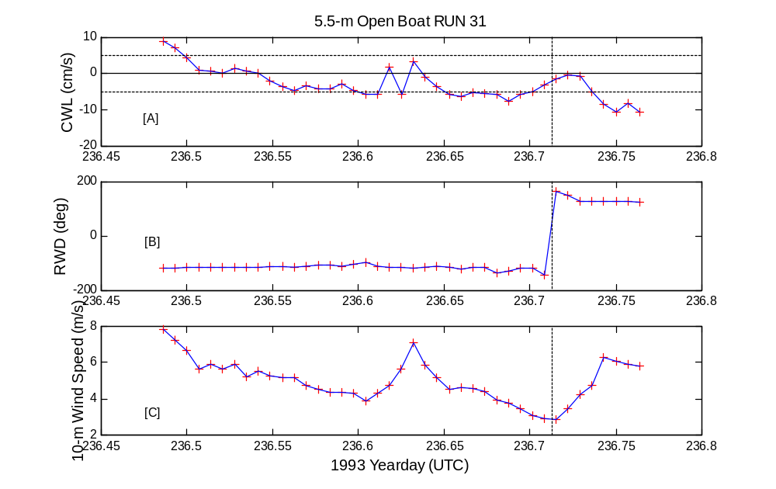

Figure 2-1. The jibing 5.5-m open boat during Leeway Drift Run 31 (indicated by the dashed vertical line). [A] is the crosswind component of leeway versus time. [B] is the relative wind direction versus time, and [C] is the 10-meter wind speed versus time.

Other positive to negative (or vise versa) changes in RWD of the boat were observed, however, this jibe was the only one associated with a corresponding change in CWL. During the latter portion of Leeway Drift Run 60, several possible jibes were ruled out. The wind data for Drift Run 60 was from a near-by MiniMet buoy, since wind monitoring on board the open boat was lost. A major storm that swamped the 5.5-m open boat and sank two other test open boats caused damage to the wind monitoring system of the MiniMet buoy. The wind direction data were therefore suspect, due to loosening of the MiniMet buoy’s wind vane from its mount.

During Leeway Run 38, a Beaufort 5-sided, 4-person life raft, with no drogue and light loading, jibed. This jibe is clearly seen in the progressive vector diagram of the displacement vectors rotated to the downwind and crosswind coordinate frame, as shown in Figure 2-2.

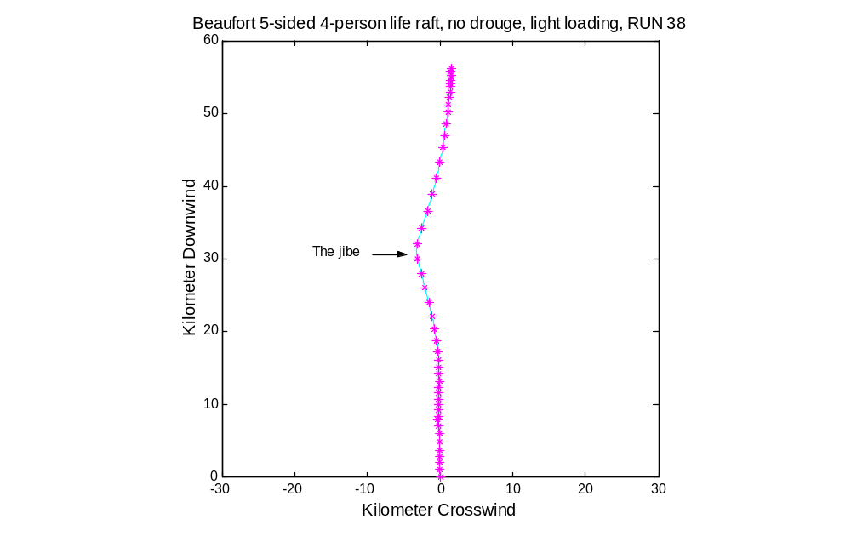

Figure 2-2. The progressive vector diagram of the displacement vector rotated to the downwind and crosswind coordinate frame for Leeway Drift Run 38 of the 5-sided 4-person Beaufort Life Raft.

This jibed occurred when the 10-meter wind speed exceeded 10 m/s as shown in Figure 2-3. The significant wave height during this time was 2.8 meter and rising.

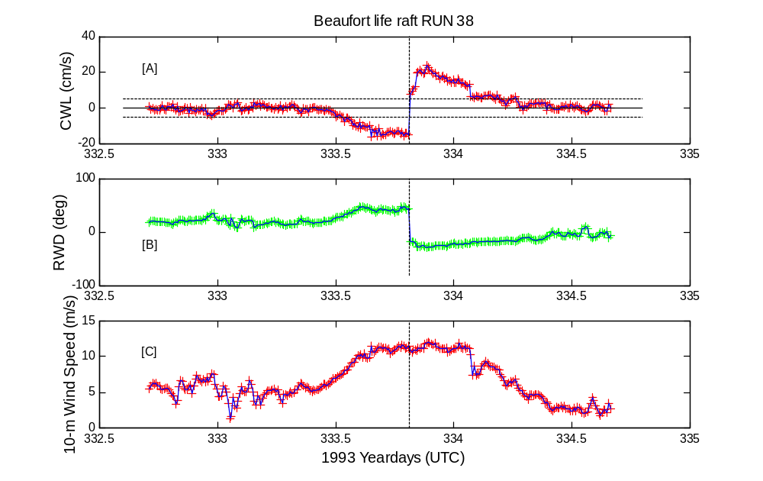

Figure 2-3. The jibing 5-sided 4-person Beaufort Life Raft during Leeway Drift Run 38 (indicated by the dashed vertical line). [A] is the crosswind component of leeway versus time. [B] is the relative wind direction versus time, and [C] is the 10-meter wind speed versus time.

No other occurrence of a life raft jibing was observed. Having observed only one jibe during the 300 hours of observations for life rafts with winds in excess of 10.0 m/s. This represents 0.3% chance of a jibe per hour for life rafts.

The one open-boat jibing event occurred during 9.0 hours of observations with winds speeds less than 3.0 m/s. This represents a 11% chance of jibing per hour for open boats with winds less than 3 m/s.

2.3 PREDICTION OF JIBING EVENTS

Hodgins and Hodgins (1998) studied the yaw of a 5.5-meter open boat and established the relationships between yaw, torque, object orientation to the wind, and crosswind components of leeway. Yaw is the rotation about the vertical axis of an object. Yaw is induced by wave and wind forces varying along the length of the hull, which result in a rotation force or torque. Yaw is resisted by the rotational inertia of the object and water resistance. The net torque on the object is given by the sum of moments about a point of rotation. When net torque, as a function of orientation of the object to the wind, changes sign (zero-crossing), the object is restored to the zero-crossing orientation. The opposing torques work against each other to maintain a preferred orientation to the wind. It is therefore the imbalance of these opposing torques, when net torque is non-zero that inhibit a object from shifting from one stable orientation to another stable orientation. The shifting from one stable orientation to another may result in a sign change of crosswind component of leeway, i.e. jibing.

Rotational inertia of the object and water resistance are the major factors which determine an object’s resistance to change from one stable orientation to another stable orientation. An object’s rotational inertia and water resistance are functions of the object’s (1) length to width ratio, (2) total displacement, and (3) underwater lateral area. Therefore, we expect that round, shallow and light displacement objects can more easily shift from one stable orientation to another than long narrow, deep and heavy displacement objects.

Therefore, we propose simple guidelines for the prediction of jibing. Jibing should be a function of wind speed, changes in wind direction, and size and shape of the drift object. There appears to be two basic forms of jibing. Either, (1) the winds change angle of attack relative to the object faster than the object can respond to the winds or (2) the object changes orientation to relatively steady winds. The probability of both types of jibing will also be dependent on the size and shape of the drift object.

The probability of jibing should increase at very low wind speeds due to the weak coupling between wind forcing and the objects. When winds speed decreases below an object’s threshold of response to the wind, the wind may shift direction and therefore set up a new orientation to the object. Thus, the lighter the winds and the greater the wind direction shift, the greater the probability that objects of that leeway category would experience a jibe during that time period. The jibing of the 5.5-meter open boat during Leeway Run 31 was this type of jibing.

The probability of jibing will also increase at high wind speeds as wave action increasingly provides energy to move the drift object from one stable orientation to another. The jibing of the 5-sided 4-person Beaufort life raft during Leeway Run 38 is an example of this type of jibing. There should be a threshold below which there is insufficient wave energy to shift the object from one orientation to another.

This suggests that each object may have two thresholds for jibing. A threshold below which the probability of jibing is inversely proportional to wind speed. In addition, a second threshold above which the probability of jibing is proportional to wind speed. Both of these thresholds are dependent on the object’s size and shape. Both thresholds occur at lower wind speeds for lighter, rounder objects than heavier, elongated objects. Moderately heavy or elongated objects would have intermediate thresholds.

Figure 2-4 illustrates the probability of jibing for three objects with low, moderate and high resistance to jibing.

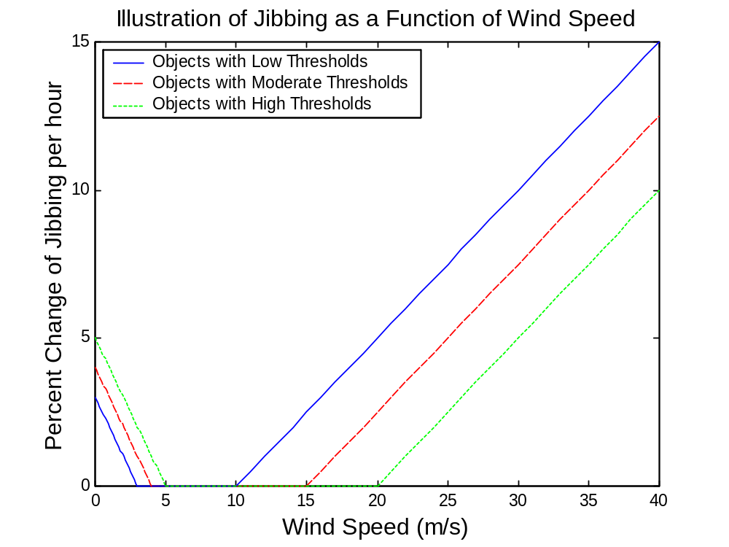

Figure 2-4. An illustration of a candidate jibing model for three objects of low, moderate and high resistance to jibing. The object with a low threshold for jibing has a lower threshold of 3 m/s and an upper threshold of 10 m/s (solid line). The object with a moderate threshold has a lower threshold of 4 m/s and an upper threshold of 15 m/s (dash line). An object with a high threshold has a lower threshold at 5 m/s and an upper threshold of 20 m/s (dotted line).

Each of the 63 leeway categories presented by Allen and Plourde (1999) can be tentatively classified by their (1) length to width ratio, (2) total displacement, and (3) underwater lateral area. This will allows us to estimate for each leeway category whether it has low, moderate or high resistance to jibing. Leeway categories that are estimated to have a low resistance to jibing include: PIWs, maritime and aviation life rafts with no or shallow ballast systems, flat bottom skiffs, fishing vessel debris, sewage floatables and medical waste. Leeway categories that are estimated to have a moderate resistance to jibing include: Maritime Life Rafts with deep ballast systems, other maritime survival craft, person-powered craft, v-hull skiffs, sport boats and fishers, bait boxes, and Cuban refugee rafts. Leeway categories that are estimated to have a high resistance to jibing include: sailing vessels, commercial fishing vessels and coastal freighters.

CHAPTER 3

CONVERSION of LEEWAY SPEED and DIVERGENCE ANGLE to DOWNWIND and CROSSWIND COMPONENTS of LEEWAY

3.1 INTRODUCTION

Allen and Plourde (1999) present leeway values for sixty-three categories of leeway objects. Allen and Plourde’s Table 8-1 includes coefficients for the leeway speed versus the wind speed adjusted to a height of 10 meters (W_{10m}), divergence angle and standard error of the leeway speed equation. Present manual and numerical search planning tools use leeway speed equations and divergence angle for determining the leeway drift of survivor craft. There are inherent limitations when using leeway speed and divergence angle for prediction of an object leeway behavior. However, expressing leeway behavior in terms of downwind and crosswind components of leeway as functions of W_{10m} overcome these limitations.

New tools that use numerical methods to estimate search distribution areas are going to use downwind and crosswind component of leeway as functions of W_{10m}, rather than leeway speed as a function of W_{10m} and divergence angle. The purpose of this chapter is to estimate downwind and crosswind components of leeway for those leeway categories for which only leeway speed and divergence angle information is presently available.

Downwind (DWL) and crosswind (CWL) components of leeway express leeway in terms of Cartesian coordinates rotated to the downwind direction. Leeway speed and leeway angle express leeway in terms of polar coordinates referenced to the downwind direction. This relationship is shown in figure 1-1 for a single leeway datum. There is a similar relationship between downwind and crosswind components (as functions of W_{10m}) and leeway speed (as a function W_{10m}) and divergence angle. However, this exact relationship is unknown.

The coefficients for downwind and crosswind leeway versus W_{10m} equations for twenty-three of the sixty-three leeway categories have been determined experimentally and can be found in the literature, (Allen, 1996; Allen and Fitzgerald, 1997; Allen and Plourde, 1999; Allen et al. 1999; and Kang 1999). The DWL and CWL as functions of W_{10m} for two additional leeway categories are analyzed from experimental data and are presented in Appendix A. The two categories analyzed in Appendix A are Maritime Life Rafts (Deep Ballast, Canopy, 15-25 Person Capacity) with either no drogue and light loading or with a drogue and heavy loading. In order to present a complete set of coefficients for all sixty-three leeway categories, the remaining thirty-eight categories required estimation of the coefficients for the downwind and crosswind components of leeway equations. The complete set of coefficients for all sixty-three leeway categories are presented in Table 4-1. Reference notes for Table 4-1 indicate the sources of the coefficients for each leeway category and the techniques used in their estimation.

The relationship between downwind and crosswind coefficients and leeway speed and divergence angle values was derived empirically using the twenty-five categories that contained both set of coefficients. The relationships between the standard errors of the leeway speed equation derived from experimental leeway field data and the DWL and CWL equations were also estimated. Using these relationships, the DWL and CWL coefficients were estimated for thirty-eight categories that lacked these values. The entire set of DWL and CWL coefficients is presented in Chapter 4.

3.2 ESTIMATION OF DOWNWIND AND CROSSWIND COMPONENTS

The downwind and crosswind components of leeway for the thirty-eight categories without data were estimated as follows.

Predicted DWL slope = Leeway speed slope x cosine (Divergence Angle
Adjustment Factor) 3-1

Predicted CWL slope = Leeway speed slope x sine (Divergence Angle
Adjustment Factor) 3-2

The Divergence Angles are from Allen and Plourde’s Table 8-1 and the slope of the leeway speed as a function of W_{10m} were from experimental field data. The operating assumption was that the slope of the DWL (CWL) regression was related to the slope of the leeway speed regression by the cosine (sine) of an angle proportional to the divergence angle. The constant of proportionality is called the adjustment factor. A further assumption was that this relationship derived from the experimental data for 25 leeway categories would hold for the remaining 38 leeway categories of Allen and Plourde’s (1999) 63 leeway categories.

The Adjustment Factor was determined empirically. The Adjustment Factor was varied from 1.0 to 2.0 as shown in Figure 3-1. The predicted values of DWL and CWL were then compared to the actual values of DWL and CWL for the twenty-five leeway categories for which both sets of coefficients (both DWL and CWL and leeway speed/divergence Angle) were measured directly. A linear unconstrained regression of the predicted values of DWL and CWL against the actual values of DWL and CWL were calculated. If equation 3-1 and 3-2 were perfect predictors of DWL and CWL the regressions would have slopes of 1.0, zero intercepts, r² of 1.0 and S_{y/x} of 0.0. Coefficients of the regression of the predicted DWL and CWL versus actual DWL and CWL are shown in Table 3-1, and the slopes as functions of adjustment factor shown in Figure 3-1.

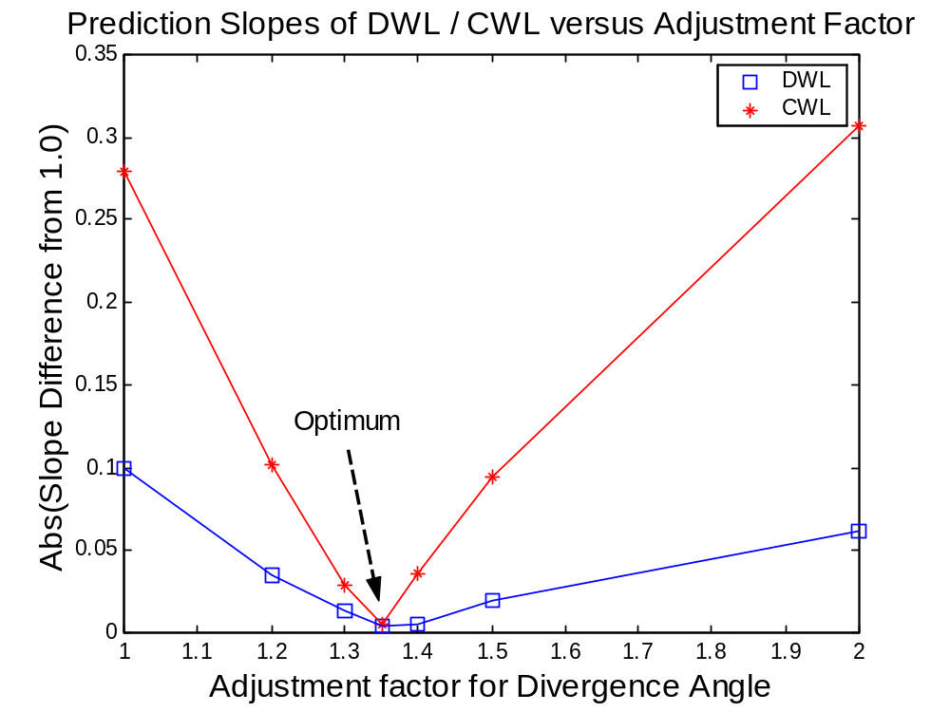

Figure 3-1. The Absolute Difference from One of the Slope Coefficients of the Regression of the Downwind and Crosswind Components of Leeway against the Actual Coefficients of the Downwind and Crosswind Components of Leeway as a function of the Adjustment Factor.
.

The optimum prediction of DWL and CWL occurred when the adjustment factor was 1.35. The optimum adjustment factor turned out the be the same for both DWL and CWL. The regression fit for the DWL’s slope with an adjustment factor of 1.35 is excellent with an r² of 0.95. The regression fit for the CWL component with an adjustment factor of 1.35 is only fair with an r² of 0.51. The predicted versus actual slope coefficients of DWL and CWL along with the linear unconstrained regressions and their 95% prediction limits are shown in Figures 3-2 and 3-3.

Table 3-1.
Coefficients of Linear Unconstrained Regression of
Predicted DWL versus Actual DWL
Predicted CWL versus Actual CWL
For 25 Leeway Categories

Adjustment  Factor | Leeway  Variable | Slope | y-intercept | r² | S_{y/x}
1.0 | DWL | 0.9006 | 0.0025 | 0.9515 | 0.2909
 | CWL | 1.2791 | 0.1348 | 0.5102 | 0.8194
1.2 | DWL | 0.9650 | -0.0701 | 0.9564 | 0.2949
 | CWL | 1.1021 | 0.0995 | 0.5106 | 0.7055
1.3 | DWL | 0.9871 | -0.0951 | 0.9549 | 0.3070
 | CWL | 1.0286 | 0.0878 | 0.5107 | 0.6583
1.35 | DWL | 0.9964 | -0.1057 | 0.9538 | 0.3136
 | CWL | 0.9951 | 0.0829 | 0.5107 | 0.6368
1.4 | DWL | 1.0047 | -0.1152 | 0.9527 | 0.3202
 | CWL | 0.9636 | 0.0785 | 0.5108 | 0.6166
1.5 | DWL | 1.0191 | -0.1315 | 0.9504 | 0.3330
 | CWL | 0.9057 | 0.0710 | 0.5108 | 0.5795
2.0 | DWL | 1.0619 | -0.1805 | 0.9412 | 0.3799
 | CWL | 0.6934 | 0.0482 | 0.5109 | 0.4436

The slope coefficients of the downwind and crosswind components of leeway as functions of W_{10m} for the remaining 38 leeway categories were estimated using the following equations.

Predicted DWL = Leeway speed slope x cosine (Divergence Angle/1.35) 3-3

Predicted CWL = Leeway speed slope x sine (Divergence Angle/1.35) 3-4

The y-intercepts for both DWL and CWL are assigned to zero, since we have no experimental data.
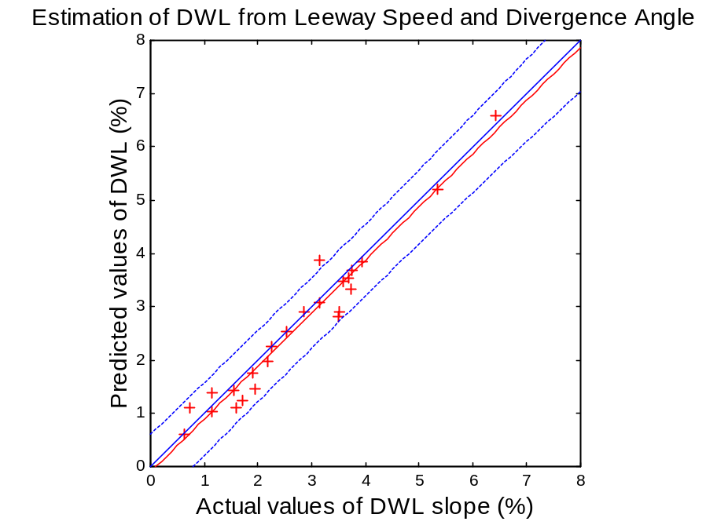

Figure 3-2. The Predicted Coefficients of the Downwind Components of Leeway versus the Actual Coefficients of the Downwind Components of Leeway. The Adjustment is Factor 1.35.

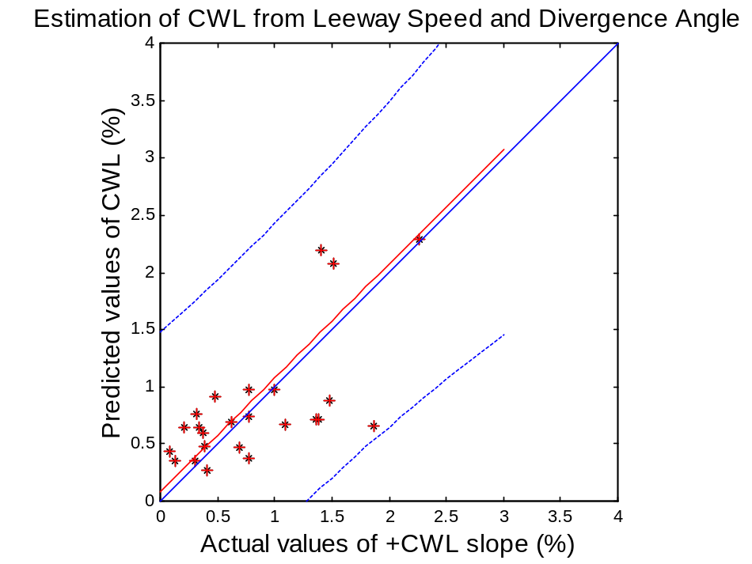

Figure 3-3. The Predicted Coefficients of the Crosswind Components of Leeway versus the Actual Coefficients of the Crosswind Components of Leeway. The Adjustment Factor is 1.35.
3.3 ESTIMATION of STANDARD ERROR TERMS (S_{y/x})

In addition to the estimation of the DWL/CWL terms for the thirty-eight leeway categories, estimations of the standard error terms for downwind and crosswind leeway equations are needed. The relationships of the S_{y/x} of the leeway speed equations and the S_{yx} of the leeway component equations were determined for the twenty-five leeway categories for which there is experimental data (Figure 3-4). Unconstrained linear regressions and their respective 95% prediction limits were also calculated.

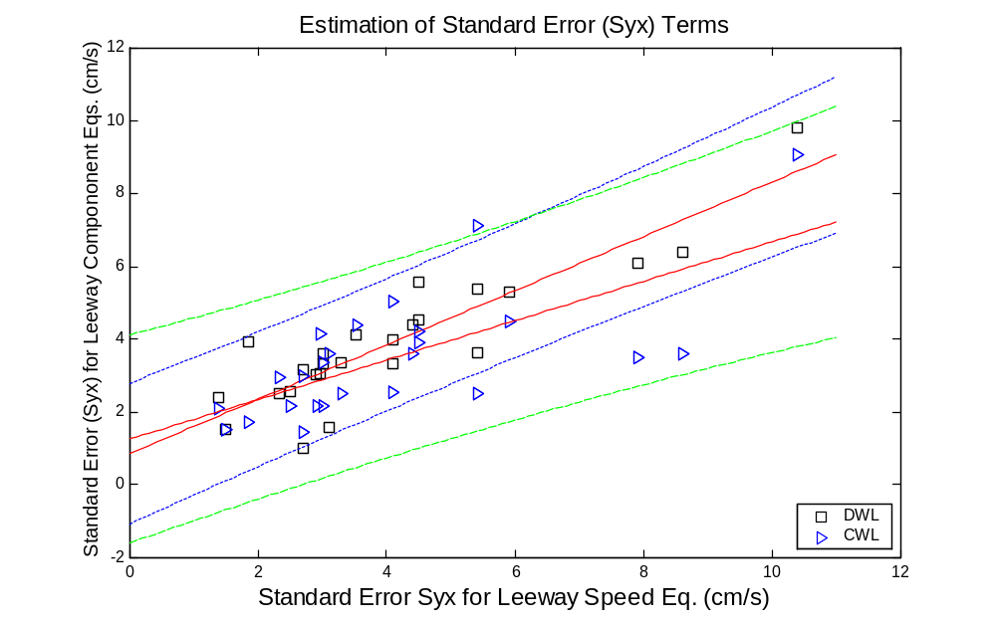

Figure 3-4. The Standard Error of Estimate (S_{y/x}) of the Downwind (squares) and Crosswind (triangles) Components of Leeway Equations versus the Standard Error of the Estimate (S_{y/x}) of the Leeway Speed Equations.

Estimated S_{yx} for DWL equation = Leeway speed's S_{yx} * 0.745 + 0.86 cm/s 3-5
(r² = 0.79 and S_{yx} = 0.86 cm/s)

Estimated S_{yx} for CWL equation = Leeway speed's S_{yx} * 0.54 + 1.26cm/s 3-6
(r² = 0.48 and S_{yx} = 1.27 cm/s)

The regression equations (3-5 and 3-6) were then used to estimate the S_{y/x} terms for the DWL and CWL equations of the remaining thirty-eight leeway categories.

This analysis produced estimates of the slope, y-intercept, and S_{y/x} coefficients for downwind and crosswind components of leeway equations for thirty-eight leeway categories. The two additional coefficients, wind speed of the crosswind component equation intersection and the rule for applying CWL were both set to zero. Thus, Table 4-1 was filled in with optimally estimated leeway coefficients. Twenty-three coefficients were from the values available in the literature and two are from Appendix A, and the remanding thirty-eight were determined by equations 3-3, 3-4, 3-5, and 3-6. Table 4-1 includes reference notes that detail the sources for each coefficient for each of the 63 leeway categories.

[BLANK]

CHAPTER 4

LEEWAY GUIDANCE FOR NEW GENERATION OF NUMERICAL SEARCH AREA DETERMINATION METHODS

4.1 INTRODUCTION

Allen and Plourde (1999) present a table of 63 leeway categories and their leeway values. Their table was based upon the concept of leeway taxonomy. The Allen and Plourde's Table 8-1 present categories of drift objects, their coefficients for leeway speed versus wind speed equation; their divergence angles; their estimates of standard error for the leeway speed equation, and reference notes. The leeway values presented by Allen and Plourde (1999) are intended to be used by manual search planning tools and current numerical search-planning tools. However, new methods of predicting search area are being developed that use the downwind (DWL) and crosswind (CWL) components of leeway versus wind speed equations instead of the leeway speed equation and divergence angle. Thus, there is a need for DWL and CWL regression coefficients and standard error terms for all sixty-three leeway categories.

Table 4-1 presents leeway categories and their values for proposed numerical search area prediction methods. Table 4-1 follows the leeway classes recommended by Allen and Plourde (1999) for the National SAR Manual, CASP and the AMM. The major difference of this table from that in Allen and Plourde (1999), Table 8-1, is the use of downwind and crosswind components of leeway rather than leeway speed and divergence angle. The chart below provides the organizational structure of the first two levels of the leeway categories used in Table 4-1.

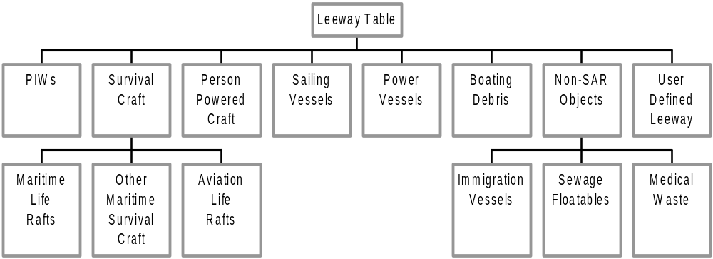

4.2 RECOMMENDATIONS FOR LEEWAY GUIDANCE FOR THE NUMERICAL METHODS

The first four columns of Table 4-1 are organized by the leeway taxonomy introduced by Allen and Plourde (1999). The bold horizontal lines separate Level 1 categories.

In the fifth column of Table 4-1 are the slope coefficients (in units of cm/s per m/s, which can be reduced to %) of the downwind component of leeway versus 10-m wind speed (W_{10m}) unconstrained linear regression equation, equation 4-1. The sixth column contains the y-intercept term (cm/s) of equation 4-1. The seventh column is the standard error of estimate (S_{y/x}, in units of cm/s) for equation 4-1 for those categories based upon experimental data, or the estimated standard errors from equation 3-5.

Downwind Leeway (cm/s) = [Slope (%) x W_{10m}(m/s)] + y-intercept (cm/s) 4-1

The eighth and ninth columns of Table 4-1 are the coefficients (slope and y-intercept, respectively) of the positive crosswind component of leeway versus 10-m wind speed (W_{10m}) unconstrained linear regression equation, equation 4-2. The tenth column is the standard error of estimate (S_{y/x}, in units of cm/s) for equation 4-2 for those categories based upon experimental data, or the estimated standard errors from equation 3-6.

Positive crosswind Leeway (cm/s) = [Slope (%) x W_{10m}(m/s)] + y-intercept (cm/s) 4-2

The eleventh and twelfth columns of Table 4-1 are the coefficients (slope and y-intercept, respectively) of the negative crosswind component of leeway versus 10-m wind speed (W_{10m}) unconstrained linear regression equation, Eq. 4.3. The thirteenth column is the standard error of estimate (S_{y/x}, in units of cm/s) for Eq. 4.3 for those categories based upon experimental data, or the estimated standard errors from equation 3-6.

Negative crosswind Leeway (cm/s) = [Slope (%) x W_{10m}(m/s)] + y-intercept (cm/s) 4-3

The fourteenth column is the wind speed (m/s) at the intersection of the two crosswind regression equations. The fifteenth column contains the rule for applying the crosswind components for winds speeds below the intersection wind speed. If column fifteen is negative-one (-1) then the negative crosswind equation alone is used when the wind speed is below the intersection wind speed. If column fifteen is positive-one (+1) then the positive crosswind equation alone is used when the wind speed is below the intersection wind speed. If column fifteen is zero (0), then both crosswind equations are used equally for all wind speeds.

The sixteenth column contains an index of jibing susceptibility for that leeway category: low (1), moderate (2) or high (3).

The last column includes the reference notes for that leeway category.

To convert leeway speed in cm/s to knots multiply by 0.0194385.

Table 4-1
Recommended Downwind and Crosswind Components of Leeway Values for Numerical Search Planning Tools
Leeway Target Category |  |  |  | DWL |  |  | +CWL |  |  | -CWL |  |  | J | R | Jib | Note
Level 1 | Level 2 | Level 3 | Level 4 | Slope | Y | S_{y/x} | Slope | Y | S_{y/x} | Slope | Y | S_{y/x}
 |  |  |  | 0.96 | 0.0 | 12.0 | 0.54 | 0.0 | 9.4 | - 0.54 | 0.0 | 9.4 | 0 | 0 | 1 | [1]
 | Vertical |  |  | 0.48 | 0.0 | 8.3 | 0.15 | 0.0 | 6.7 | - 0.15 | 0.0 | 6.7 | 0 | 0 | 1 | [2]
PIW | Sitting |  |  | 1.60 | -3.98 | 2.42 | 0.13 | 0.33 | 2.11 | - 0.13 | -0.33 | 2.11 | 0 | 0 | 1 | [3]
 |  | Survival Suit |  | 1.71 | 1.12 | 3.93 | 1.36 | -3.30 | 1.71 | - 0.13 | -2.65 | 1.62 | 0 | 0 | 1 | [4]
 | Horizontal | Scuba Suit |  | 0.63 | 0.0 | 5.3 | 0.31 | 0.0 | 4.5 | - 0.31 | 0.0 | 4.5 | 0 | 0 | 1 | [5]
 |  | Deceased |  | 1.30 | 0.0 | 8.3 | 0.74 | 0.0 | 6.7 | - 0.74 | 0.0 | 6.7 | 0 | 0 | 1 | [6]
 |  | No |  | 3.70 | 0.0 | 12.0 | 1.98 | 0.0 | 9.4 | - 1.98 | 0.0 | 9.4 | 0 | 0 | 1 | [7]
 |  | Ballast | no canopy, no drogue | 5.34 | 9.91 | 9.82 | 2.26 | 1.04 | 9.08 | -2.26 | -1.04 | 9.08 | 0 | 0 | 1 | [8]
 | Maritime |  | no canopy, w/ drogue | 3.15 | -4.47 | 4.0 | 1.51 | 0.0 | 5.0 | - 1.51 | 0.0 | 5.0 | 0 | 0 | 1 | [9]
 |  | Systems | canopy, no drogue | 3.39 | 0.0 | 2.4 | 1.49 | 0.0 | 2.4 | - 1.49 | 0.0 | 2.4 | 0 | 0 | 1 | [10]
Survival |  |  | canopy, w/ drogue | 2.65 | 0.0 | 12.0 | 1.42 | 0.0 | 9.4 | - 1.42 | 0.0 | 9.4 | 0 | 0 | 1 | [11]
 | Life | Shallow |  | 2.68 | 0.0 | 12.0 | 1.10 | 0.0 | 9.4 | - 1.10 | 0.0 | 9.4 | 0 | 0 | 1 | [12]
 |  | Ballast | no drogue | 2.96 | 0.0 | 1.5 | 1.21 | 0.0 | 1.7 | - 1.21 | 0.0 | 1.7 | 0 | 0 | 1 | [13]
Craft |  | Systems & | with drogue | 2.31 | 0.0 | 4.0 | 0.95 | 0.0 | 3.5 | - 0.95 | 0.0 | 3.5 | 0 | 0 | 1 | [14]
 | Rafts | Canopy | Capsized | 1.68 | 0.0 | 2.4 | 0.24 | 0.0 | 2.4 | - 0.24 | 0.0 | 2.4 | 0 | 0 | 1 | [15]
 |  | Deep Ballast Systems &  Canopies (See Table 3-1A for Levels 4-6) |  | 3.52 | -2.5 | 6.1 | 0.62 | -3.0 | 3.5 | -0.45 | -0.2 | 3.6 | 2.62 | -1 | 2 | [16]
Slope = Slope of W_{10m} (%); Y = Y-intercept (cm/s); S_{y/x} = Std. Error of Estimate (cm/s); J = Junction W_{10m} (m/s) for +/- CWL equations;
R = Rule (–1, 0, +1) for applying CWL equation below Junction W_{10m}; Jib = Resistance to jibing (1 = low, 2 =moderate, 3 = high);
Note = Number of reference note following table.
Table 4-1 (Continued)
Recommended Downwind and Crosswind Components of Leeway Values for Numerical Search Planning Tools

Sub -Table 4-1A
(Sub-table for Maritime Life Rafts with Deep Ballast Systems and Canopies)

Leeway Target Category |  |  |  | DWL |  |  | +CWL |  |  | -CWL |  |  | J | R | Jib | Note
Level 3 | Level 4 | Level 5 | Level 6 | Slope | Y | S_{y/x} | Slope | Y | S_{y/x} | Slope | Y | S_{y/x}
 | 4-6 |  |  | 3.50 | -1.8 | 6.4 | 0.78 | -3.6 | 3.6 | -0.47 | -0.1 | 3.9 | 2.80 | -1 | 2 | [17]
Maritime |  | without |  | 3.75 | -2.3 | 4.4 | 0.78 | -3.6 | 3.6 | -0.47 | -0.1 | 3.9 | 2.80 | -1 | 2 | [18]
Life Rafts | person | drogue | light loading | 3.75 | -2.32 | 4.51 | 1.00 | -5.31 | 3.91 | -0.47 | -0.14 | 3.91 | 3.52 | -1 | 2 | [19]
with |  |  | heavy loading | 3.59 | -1.92 | 2.56 | 0.48 | -0.16 | 2.17 | -0.48 | 0.16 | 2.17 | 0 | 0 | 2 | [20]
Deep |  | with |  | 1.91 | 0.9 | 1.6 | 0.78 | -3.6 | 3.6 | -0.47 | -0.1 | 3.9 | 2.80 | -1 | 2 | [21]
Ballast | capacity | drogue | light loading | 1.95 | -0.53 | 3.59 | 0.21 | 1.29 | 2.15 | -0.21 | -1.29 | 2.15 | 0 | 0 | 2 | [22]
Systems |  |  | heavy loading | 2.19 | -0.96 | 1.01 | 1.39 | -7.9 | 1.46 | -1.39 | 7.9 | 1.46 | 0 | 0 | 2 | [23]
and | 15-25 |  |  | 3.68 | -4.96 | 5.37 | 0.34 | -1.85 | 2.50 | -0.49 | 1.58 | 2.63 | 4.13 | -1 | 2 | [24]
Canopies | person | w/o drogue | light loading | 3.93 | -3.30 | 3.01 | 0.38 | -3.33 | 2.16 | -0.59 | 1.59 | 2.28 | 5.07 | -1 | 2 | [25]
 | capacity | with drogue | heavy loading | 3.15 | -4.49 | 3.35 | 0.39 | -1.80 | 2.50 | -0.38 | 2.98 | 1.64 | 6.28 | 1 | 2 | [26]
 | Capsized |  |  | 0.88 | 0.0 | 2.5 | 0.18 | 0.0 | 2.4 | - 0.18 | 0.0 | 2.4 | 0 | 0 | 2 | [27]
 | Swamped |  |  | 0.99 | 0.0 | 2.4 | 0.14 | 0.0 | 2.3 | - 0.14 | 0.0 | 2.3 | 0 | 0 | 2 | [28]

Slope = Slope of W_{10m} (%); Y = Y-intercept (cm/s); S_{y/x} = Std. Error of Estimate (cm/s); J = Junction W_{10m} (m/s) for +/- CWL equations;
R = Rule (–1, 0, +1) for applying CWL equation below Junction W_{10m}; Jib = Resistance to jibing (1 = low, 2 =moderate, 3 = high);
Note = Number of reference note following table.
Table 4-1 (Continued)

Recommended Downwind and Crosswind Components of Leeway Values for Numerical Search Planning Tools

Leeway Target Category |  |  |  |  | DWL |  | +CWL |  |  | -CWL |  |  | J | R | Jib | Note
Level 1 | Level 2 | Level 3 | Level 4 | Slope | Y | S_{y/x} | Slope | Y | S_{y/x} | Slope | Y | S_{y/x}
 | Other | Life Capsule |  | 3.52 | 0.0 | 1.9 | 1.44 | 0.0 | 2.0 | -1.44 | 0.0 | 2.0 | 0 | 0 | 2 | [29]
Survival | Maritime | USCG Sea Rescue Kit |  | 2.48 | 0.0 | 3.8 | 0.32 | 0.0 | 3.4 | -0.32 | 0.0 | 3.4 | 0 | 0 | 2 | [30]
Craft  (cond't) | Aviation | No Ballast w/canopy  4-6 person w/o drogue |  | 3.39 | 0.0 | 2.4 | 1.49 | 0.0 | 2.4 | -1.49 | 0.0 | 2.4 | 0 | 0 | 1 | [31]
 | Life Rafts | Evac/Slide 46-person |  | 2.71 | 0.0 | 3.8 | 0.72 | 0.0 | 3.4 | -0.72 | 0.0 | 3.4 | 0 | 0 | 2 | [32]
Person- | Sea Kayak W/ Person on aft deck |  |  | 1.16 | 11.12 | 4.12 | 0.41 | 0.00 | 4.39 | -0.41 | 0.00 | 4.39 | 0 | 0 | 2 | [33]
Powered | Surf board w/ person |  |  | 1.93 | 0.0 | 8.3 | 0.51 | 0.0 | 6.7 | -0.51 | 0.0 | 6.7 | 0 | 0 | 2 | [34]
Craft | Windsurfer Mast & sail in water |  |  | 2.25 | 5.03 | 2.50 | 0.69 | -1.30 | 2.96 | -0.69 | 1.30 | 2.96 | 0 | 0 | 2 | [35]
Sailing | Mono-hull | Full Keel | Deep Draft | 2.00 | 0.0 | 8.3 | 2.23 | 0.0 | 6.7 | -2.23 | 0.0 | 6.7 | 0 | 0 | 3 | [36]
Vessels |  | Fin Keel | Shoal Draft | 2.67 | 0.0 | 8.3 | 2.98 | 0.0 | 6.7 | -2.98 | 0.0 | 6.7 | 0 | 0 | 3 | [37]
 |  | Flat Bottom | Boston whaler | 3.15 | 0.0 | 2.2 | 1.29 | 0.0 | 2.2 | -1.29 | 0.0 | 2.2 | 0 | 0 | 1 | [38]
 | Skiffs | V-hull | Std. Conf. | 2.87 | 3.98 | 3.33 | 0.32 | -2.93 | 2.53 | -0.62 | 1.03 | 3.05 | 4.2 | -1 | 2 | [39]
Power |  |  | Swamped | 1.65 | 0.0 | 3.1 | 0.39 | 0.0 | 2.9 | -0.39 | 0.0 | 2.9 | 0 | 0 | 2 | [40]
Vessels | Sport Boats | Cuddy Cabin | Modified V-hull | 6.54 | 0.0 | 3.0 | 2.19 | 0.0 | 2.8 | -2.19 | 0.0 | 2.8 | 0 | 0 | 2 | [41]
 | Sport Fisher | Center Console | Open cockpit | 5.55 | 0.0 | 3.3 | 2.27 | 0.0 | 3.0 | -2.27 | 0.0 | 3.0 | 0 | 0 | 2 | [42]

Slope = Slope of W_{10m} (%); Y = Y-intercept (cm/s); S_{y/x} = Std. Error of Estimate (cm/s); J = Junction W_{10m} (m/s) for +/- CWL equations;
R = Rule (–1, 0, +1) for applying CWL equation below Junction W_{10m}; Jib = Resistance to jibing (1 = low, 2 =moderate, 3 = high);
Note = Number of reference note following table.

Table 4-1 (Continued)
Recommended Downwind and Crosswind Components of Leeway Values for Numerical Search Planning Tools

Leeway Target Category |  |  |  | DWL |  |  | +CWL |  |  | -CWL |  |  | J | R | Jib | Note
Level 1 | Level 2 | Level 3 | Level 4 | Slope | Y | S_{y/x} | Slope | Y | S_{y/x} | Slope | Y | S_{y/x}
 |  |  |  | 2.47 | 0.0 | 12.0 | 2.76 | 0.0 | 9.4 | -2.76 | 0.0 | 9.4 | 0 | 0 | 3 | [43]
Power | Commercial | Hawaiian Sampans |  | 2.67 | 0.0 | 8.3 | 2.98 | 0.0 | 6.7 | -2.98 | 0.0 | 6.7 | 0 | 0 | 3 | [44]
 | Fishing | Japanese  Side-stern Troller |  | 2.80 | 0.0 | 8.3 | 3.13 | 0.0 | 6.7 | -3.13 | 0.0 | 6.7 | 0 | 0 | 3 | [45]
Vessels |  | Japanese Longliners |  | 2.47 | 0.0 | 8.3 | 2.76 | 0.0 | 6.7 | -2.76 | 0.0 | 6.7 | 0 | 0 | 3 | [46]
 | Vessels | Korean F/V |  | 1.80 | 0.0 | 3.79 | 2.01 | 0.0 | 3.3 | -2.01 | 0.0 | 3.3 | 0 | 0 | 3 | [47]
 |  | Gill-netter  w/rear reel |  | 3.72 | -0.87 | 3.33 | 1.41 | 2.00 | 3.36 | -1.41 | -2.00 | 3.36 | 0 | 0 | 3 | [48]
 | Coastal Freighter |  |  | 1.87 | 0.0 | 8.3 | 2.09 | 0.0 | 6.7 | -2.09 | 0.0 | 6.7 | 0 | 0 | 3 | [49]
 | F/V debris |  |  | 1.97 | 0.0 | 8.3 | 0.36 | 0.0 | 6.7 | -0.36 | 0.0 | 6.7 | 0 | 0 | 1 | [50]
Boating | Bait/wharf box |  |  | 0.72 | 15.18 | 5.59 | 1.86 | -5.26 | 4.20 | -1.86 | 5.26 | 4.20 | 0 | 0 | 2 | [51]
Debris | holds a cubic meter of ice | lightly loaded |  | 2.53 | 9.01 | 3.05 | 1.09 | -2.76 | 4.14 | -1.09 | 2.76 | 4.14 | 0 | 0 | 2 | [52]
 | holds a cubic meter of ice | full loaded |  | 1.15 | 7.94 | 3.17 | 1.48 | -0.32 | 2.99 | -1.48 | 0.32 | 2.99 | 0 | 0 | 2 | [53]

Slope = Slope of W_{10m} (%); Y = Y-intercept (cm/s); S_{y/x} = Std. Error of Estimate (cm/s); J = Junction W_{10m} (m/s) for +/- CWL equations;
R = Rule (–1, 0, +1) for applying CWL equation below Junction W_{10m}; Jib = Resistance to jibing (1 = low, 2 =moderate, 3 = high);
Note = Number of reference note following table.

Table 4-1 (Continued)

Recommended Downwind and Crosswind Components of Leeway Values for Numerical Search Planning Tools

Leeway Target Category |  |  |  | DWL |  |  | +CWL |  |  | -CWL |  |  | J | R | Jib | Note
Level 1 | Level 2 | Level 3 | Level 4 | Slope | Y | S_{y/x} | Slope | Y | S_{y/x} | Slope | Y | S_{y/x}
 | Immigration Vessel |  | w/o sail | 1.56 | 8.30 | 1.53 | 0.078 | 2.70 | 1.52 | -0.078 | -2.70 | 1.52 | 0 | 0 | 2 | [54]
Non- | Cuban refugee raft |  | w/ sail | 6.43 | -3.47 | 3.63 | 2.22 | 0.00 | 7.12 | -2.22 | 0.00 | 7.12 | 0 | 0 | 2 | [55]
SAR | Sewage Floatables  Tampon Applicator |  |  | 1.79 | 0.0 | 3.1 | 0.16 | 0.0 | 2.9 | -0.16 | 0.0 | 2.9 | 0 | 0 | 1 | [56]
Objects |  |  |  | 2.75 | 0.0 | 12.0 | 0.50 | 0.0 | 9.4 | -0.50 | 0.0 | 9.4 | 0 | 0 | 1 | [57]
 |  |  |  | 3.64 | 0.0 | 12.0 | 0.67 | 0.0 | 9.4 | -0.67 | 0.0 | 9.4 | 0 | 0 | 1 | [58]
 |  | Vials | Large | 4.34 | 0.0 | 3.1 | 0.74 | 0.0 | 2.9 | -0.74 | 0.0 | 2.9 | 0 | 0 | 1 | [59]
 | Medical |  | Small | 2.95 | 0.0 | 5.4 | 0.54 | 0.0 | 4.5 | -0.54 | 0.0 | 4.5 | 0 | 0 | 1 | [60]
 |  |  |  | 1.79 | 0.0 | 12.0 | 0.16 | 0.0 | 9.4 | -0.16 | 0.0 | 9.4 | 0 | 0 | 1 | [61]
 | Waste | Syringes | Large | 1.79 | 0.0 | 3.1 | 0.16 | 0.0 | 2.9 | -0.16 | 0.0 | 2.9 | 0 | 0 | 1 | [62]
 |  |  | Small | 1.79 | 0.0 | 2.4 | 0.16 | 0.0 | 2.3 | -0.16 | 0.0 | 2.3 | 0 | 0 | 1 | [63]
User Defined Leeway |  |  |  | [64] | [65] | [66] | [67] | [68] | [69] | [70] | [71] | [72] | [73] | [74] | [75]

Slope = Slope of W_{10m} (%); Y = Y-intercept (cm/s); S_{y/x} = Std. Error of Estimate (cm/s); J = Junction W_{10m} (m/s) for +/- CWL equations;
R = Rule (–1, 0, +1) for applying CWL equation below Junction W_{10m}; Jib = Resistance to jibing (1 = low, 2 =moderate, 3 = high);
Note = Number of reference note following table.

Reference Notes for Table 4-1.

[1] Values (slope, y-intercept, and S_{yx}) for DWL and CWL were estimated from the leeway speed and divergence angle values from Allen and Plourde's (1999) Table 8-1, by the procedure outlined in section 3.2.

[2] Values (slope, y-intercept, and S_{yx}) for DWL and CWL were estimated from the leeway speed and divergence angle values from Allen and Plourde's (1999) Table 8-1, by the procedure outlined in sections 3.2 and 3.3.

[3] Values (slope, y-intercept, and S_{yx}) for DWL and +CWL are from Allen et al. (1999). The values for –CWL are assumed by Allen et al. (1999) to be equivalent to the values for +CWL.

[4] Values (slope, y-intercept, and S_{yx}) for DWL and +CWL are from Allen et al. (1999). The values for –CWL are assumed by Allen et al. (1999) to be equivalent to the values for +CWL.

[5] Values (slope, y-intercept, and S_{yx}) for DWL and +CWL are from Kang (1999). The values for –CWL are assumed by Kang (1999) to be equivalent to the values for +CWL.

[6] Values (slope, y-intercept, and S_{yx}) for DWL and CWL were estimated from the leeway speed and divergence angle values from Allen and Plourde's (1999) Table 8-1, by the procedure outlined in sections 3.2 and 3.3.

[7] Values (slope, y-intercept, and S_{yx}) for DWL and CWL were estimated from the leeway speed and divergence angle values from Allen and Plourde's (1999) Table 8-1, by the procedure outlined in sections 3.2 and 3.3.

[8] Values (slope, y-intercept, and S_{yx}) for DWL and +CWL were from Allen and Plourde's (1999) re-analysis of Hufford and Broida's (1974) leeway data. The values for –CWL were assumed by Allen and Plourde (1999) to be equivalent to the values for +CWL.

[9] Values (slope, y-intercept, and S_{yx}) for DWL and +CWL were from Allen and Plourde's (1999) re-analysis of Hufford and Broida's (1974) leeway data. The values for –CWL were assumed by Allen and Plourde (1999) to be equivalent to the values for +CWL.

[10] Values (slope, y-intercept, and S_{yx}) for DWL and CWL were estimated from the leeway speed and divergence angle values from Allen and Plourde's (1999) Table 8-1, by the procedure outlined in sections 3.2 and 3.3.

[11] Values (slope, y-intercept, and S_{yx}) for DWL and CWL were estimated from the leeway speed and divergence angle values from Allen and Plourde's (1999) Table 8-1, by the procedure outlined in sections 3.2 and 3.3.

[12] Values (slope, y-intercept, and S_{yx}) for DWL and CWL were estimated from the leeway speed and divergence angle values from Allen and Plourde's (1999) Table 8-1, by the procedure outlined in sections 3.2 and 3.3.

[13] Values (slope, y-intercept, and S_{yx}) for DWL and CWL were estimated from the leeway speed and divergence angle values from Allen and Plourde's (1999) Table 8-1, by the procedure outlined in sections 3.2 and 3.3.

[14] Values (slope, y-intercept, and S_{yx}) for DWL and CWL were estimated from the leeway speed and divergence angle values from Allen and Plourde's (1999) Table 8-1, by the procedure outlined in sections 3.2 and 3.3.

[15] Values (slope, y-intercept, and S_{yx}) for DWL and CWL were estimated from the leeway speed and divergence angle values from Allen and Plourde's (1999) Table 8-1, by the procedure outlined in sections 3.2 and 3.3.

[16] Values (slope, y-intercept, and S_{yx}) for DWL, +CWL and -CWL are from Allen and Plourde (1999).

[17] Values (slope, y-intercept, and S_{yx}) for DWL, +CWL and -CWL are from Allen and Plourde (1999).

[18] Values (slope, y-intercept, and S_{yx}) for DWL, +CWL and -CWL are from Allen and Plourde (1999).

[19] Values (slope, y-intercept, and S_{yx}) for DWL, +CWL and -CWL are from Allen and Plourde (1999).

[20] Values (slope, y-intercept, and S_{yx}) for DWL, and +CWL are from Allen and Plourde (1999). The values for –CWL are assumed by Allen and Plourde (1999) to be equivalent to the values for +CWL.

[21] Values (slope, y-intercept, and S_{yx}) for DWL, +CWL and -CWL are from Allen and Plourde (1999).

[22] Values (slope, y-intercept, and S_{yx}) for DWL, and +CWL are from Allen and Plourde (1999). The values for –CWL are assumed by Allen and Plourde (1999) to be equivalent to the values for +CWL.

[23] Values (slope, y-intercept, and S_{yx}) for DWL, and +CWL are from Allen and Plourde (1999). The values for –CWL are assumed by Allen and Plourde (1999) to be equivalent to the values for +CWL.

[24] Values (slope, y-intercept, and S_{yx}) for DWL, +CWL and -CWL are from Allen and Plourde (1999).

[25] Values (slope, y-intercept, and S_{yx}) for DWL, +CWL and -CWL are from this report, Appendix A.

[26] Values (slope, y-intercept, and S_{yx}) for DWL, +CWL and -CWL are from this report, Appendix A.

[27] Values (slope, y-intercept, and S_{yx}) for DWL and CWL were estimated from the leeway speed and divergence angle values from Allen and Plourde's (1999) Table 8-1, by the procedure outlined in sections 3.2 and 3.3.

[28] Values (slope, y-intercept, and S_{yx}) for DWL and CWL were estimated from the leeway speed and divergence angle values from Allen and Plourde's (1999) Table 8-1, by the procedure outlined in sections 3.2 and 3.3.

[29] Values (slope, y-intercept, and S_{yx}) for DWL and CWL were estimated from the leeway speed and divergence angle values from Allen and Plourde's (1999) Table 8-1, by the procedure outlined in sections 3.2 and 3.3.

[30] Values (slope, y-intercept, and S_{yx}) for DWL and CWL were estimated from the leeway speed and divergence angle values from Allen and Plourde's (1999) Table 8-1, by the procedure outlined in sections 3.2 and 3.3.

[31] Values (slope, y-intercept, and S_{yx}) for DWL and CWL were estimated from the leeway speed and divergence angle values from Allen and Plourde's (1999) Table 8-1, by the procedure outlined in sections 3.2 and 3.3.

[32] Values (slope, y-intercept, and S_{yx}) for DWL and CWL were estimated from the leeway speed and divergence angle values from Allen and Plourde's (1999) Table 8-1, by the procedure outlined in sections 3.2 and 3.3.

[33] Values (slope, y-intercept, and S_{yx}) for DWL and +CWL are from Allen et al. (1999). The values for –CWL are assumed by Allen et al. (1999) to be equivalent to the values for +CWL.

[34] Values (slope, y-intercept, and S_{yx}) for DWL and CWL were estimated from the leeway speed and divergence angle values from Allen and Plourde's (1999) Table 8-1, by the procedure outlined in sections 3.2 and 3.3.

[35] Values (slope, y-intercept, and S_{yx}) for DWL and -CWL are from Allen et al. (1999). The values for +CWL are assumed by Allen et al. (1999) to be equivalent to the values for -CWL.

[36] Values (slope, y-intercept, and S_{yx}) for DWL and CWL were estimated from the leeway speed and divergence angle values from Allen and Plourde's (1999) Table 8-1, by the procedure outlined in sections 3.2 and 3.3.

[37] Values (slope, y-intercept, and S_{yx}) for DWL and CWL were estimated from the leeway speed and divergence angle values from Allen and Plourde's (1999) Table 8-1, by the procedure outlined in sections 3.2 and 3.3.

[38] Values (slope, y-intercept, and S_{yx}) for DWL and CWL were estimated from the leeway speed and divergence angle values from Allen and Plourde's (1999) Table 8-1, by the procedure outlined in sections 3.2 and 3.3.

[39] Values (slope, y-intercept, and S_{yx}) for DWL, +CWL and -CWL are from Allen and Fitzgerald (1997).

[40] Values (slope, y-intercept, and S_{yx}) for DWL and CWL were estimated from the leeway speed and divergence angle values from Allen and Plourde's (1999) Table 8-1, by the procedure outlined in sections 3.2 and 3.3.

[41] Values (slope, y-intercept, and S_{yx}) for DWL and CWL were estimated from the leeway speed and divergence angle values from Allen and Plourde's (1999) Table 8-1, by the procedure outlined in sections 3.2 and 3.3.

[42] Values (slope, y-intercept, and S_{yx}) for DWL and CWL were estimated from the leeway speed and divergence angle values from Allen and Plourde's (1999) Table 8-1, by the procedure outlined in sections 3.2 and 3.3.

[43] Values (slope, y-intercept, and S_{yx}) for DWL and CWL were estimated from the leeway speed and divergence angle values from Allen and Plourde's (1999) Table 8-1, by the procedure outlined in sections 3.2 and 3.3.

[44] Values (slope, y-intercept, and S_{yx}) for DWL and CWL were estimated from the leeway speed and divergence angle values from Allen and Plourde's (1999) Table 8-1, by the procedure outlined in sections 3.2 and 3.3. .

[45] Values (slope, y-intercept, and S_{yx}) for DWL and CWL were estimated from the leeway speed and divergence angle values from Allen and Plourde's (1999) Table 8-1, by the procedure outlined in sections 3.2 and 3.3.

[46] Values (slope, y-intercept, and S_{yx}) for DWL and CWL were estimated from the leeway speed and divergence angle values from Allen and Plourde's (1999) Table 8-1, by the procedure outlined in sections 3.2 and 3.3.

[47] Values (slope, y-intercept, and S_{yx}) for DWL and CWL were estimated from the leeway speed and divergence angle values from Allen and Plourde's (1999) Table 8-1, by the procedure outlined in sections 3.2 and 3.3.

[48] Values (slope, y-intercept, and S_{yx}) for DWL, and -CWL are from Allen (1996). The values for +CWL are assumed by Allen (1996) to be equivalent to the values for –CWL.

[49] Values (slope, y-intercept, and S_{yx}) for DWL and CWL were estimated from the leeway speed and divergence angle values from Allen and Plourde's (1999) Table 8-1, by the procedure outlined in sections 3.2 and 3.3.

[50] Values (slope, y-intercept, and S_{yx}) for DWL and CWL were estimated from the leeway speed and divergence angle values from Allen and Plourde's (1999) Table 8-1, by the procedure outlined in sections 3.2 and 3.3.

[51] Values (slope, y-intercept, and S_{yx}) for DWL and +CWL are from Allen et al. (1999). The values for –CWL are assumed by Allen et al. (1999) to be equivalent to the values for +CWL.

[52] Values (slope, y-intercept, and S_{yx}) for DWL and +CWL are from Allen et al. (1999). The values for –CWL are assumed by Allen et al. (1999) to be equivalent to the values for +CWL.

[53] Values (slope, y-intercept, and S_{yx}) for DWL and +CWL are from Allen et al. (1999). The values for –CWL are assumed by Allen et al. (1999) to be equivalent to the values for +CWL.

[54] Values (slope, y-intercept, and S_{yx}) for DWL, and -CWL are from Allen (1996). The values for +CWL are assumed by Allen (1996) to be equivalent to the values for –CWL.

[55] Values (slope, y-intercept, and S_{yx}) for DWL, and -CWL are from Allen (1996). The values for +CWL are assumed by Allen (1996) to be equivalent to the values for –CWL.

[56] Values (slope, y-intercept, and S_{yx}) for DWL and CWL were estimated from the leeway speed and divergence angle values from Allen and Plourde's (1999) Table 8-1, by the procedure outlined in sections 3.2 and 3.3.

[57] Values (slope, y-intercept, and S_{yx}) for DWL and CWL were estimated from the leeway speed and divergence angle values from Allen and Plourde's (1999) Table 8-1, by the procedure outlined in sections 3.2 and 3.3.

[58] Values (slope, y-intercept, and S_{yx}) for DWL and CWL were estimated from the leeway speed and divergence angle values from Allen and Plourde's (1999) Table 8-1, by the procedure outlined in sections 3.2 and 3.3.

[59] Values (slope, y-intercept, and S_{yx}) for DWL and CWL were estimated from the leeway speed and divergence angle values from Allen and Plourde's (1999) Table 8-1, by the procedure outlined in sections 3.2 and 3.3.

[60] Values (slope, y-intercept, and S_{yx}) for DWL and CWL were estimated from the leeway speed and divergence angle values from Allen and Plourde's (1999) Table 8-1, by the procedure outlined in sections 3.2 and 3.3.

[61] Values (slope, y-intercept, and S_{yx}) for DWL and CWL were estimated from the leeway speed and divergence angle values from Allen and Plourde's (1999) Table 8-1, by the procedure outlined in sections 3.2 and 3.3.

[62] Values (slope, y-intercept, and S_{yx}) for DWL and CWL were estimated from the leeway speed and divergence angle values from Allen and Plourde's (1999) Table 8-1, by the procedure outlined in sections 3.2 and 3.3.

[63] Values (slope, y-intercept, and S_{yx}) for DWL and CWL were estimated from the leeway speed and divergence angle values from Allen and Plourde's (1999) Table 8-1, by the procedure outlined in sections 3.2 and 3.3.

[64] User defined slope coefficient (percent) for the regression of the downwind component of leeway versus W_{10m}. The values usually assigned range from 0.5 to 7.0%, or a default value of 3%.

[65] User defined y-intercept coefficient (cm/s) for the regression of downwind component of leeway versus W_{10m}. This value is usually assigned a value of zero.

[66] User defined standard error of estimate term, S_{y/x} (cm/s) for the regression of downwind component of leeway versus W_{10m}. The values usually assigned range from 1 to 15 cm/s, or a default value of 10 cm/s.

[67] User defined slope coefficient (percent) for the regression of the positive crosswind component of leeway versus W_{10m}. The values usually assigned range from 0.5 to 3.0%, or a default value of 1.5%.

[68] User defined y-intercept coefficient (cm/s) for the regression of positive crosswind component of leeway versus W_{10m}. This value is usually assigned a value of zero.

[69] User defined standard error of estimate term, S_{y/x} (cm/s) for the regression of positive crosswind component of leeway versus W_{10m}. The values usually assigned range from 1 to 15 cm/s, or a default value of 10 cm/s.

[70] User defined slope coefficient (percent) for the regression of the negative crosswind component of leeway versus W_{10m}. The values usually assigned range from 0.5 to 3.0%, or a default value of 1.5%.

[71] User defined y-intercept coefficient (cm/s) for the regression of negative crosswind component of leeway versus W_{10m}. This value is usually assigned a value of zero.

[72] User defined standard error of estimate term, S_{y/x} (cm/s) for the regression of negative crosswind component of leeway versus W_{10m}. The values usually assigned range from 1 to 15 cm/s, or a default value of 10 cm/s.

[73] User defined value for the wind speed (m/s) where the two regression equations of the crosswind components of leeway versus W_{10m} intersect. This value is usually assigned a value of zero.

[74] User defined value for the rule (-1,0, +1) for choosing which crosswind component of leeway equation versus W_{10m} is used below the wind junction speed given in 73. This value is usually assigned a value of zero.

[75] The resistance to jibing parameter is based upon the object’s size and shape (1 = low, 2 = moderate, 3 = high resistance to jibing).

Provided in Table 4-1 are a complete set of downwind and crosswind coefficients for the same 63 leeway categories for which Allen and Plourde (1999) presented coefficients for leeway speed and divergence angles. The values presented in Table 4-1 are intended to be incorporated into numerical tools for the determination of maritime search areas.

CHAPTER 5
IMPLEMENTATION OF DIVERGENCE ANGLE

5.1 PRESENT SEARCH TOOLS

At the present time there are two manuals that provide guidance on how to determine a search area. There are also two computer search-planning tools available to the U.S. Coast Guard that will generate search areas. The two manuals are the National SAR Manual and the new International Aviation and Maritime Search and Rescue Manual (IAMSARM). The two computer search-planning tools are CASP 1.1X and the Automated Manual Method (AMM) or Automated Manual Solution (AMS). It will be referred to hereafter as the Automated Manual Solution.

The National SAR Manual does not use the term divergence angle, but refers to the "maximum angles of the downwind" direction. Over the years, the search planning guidance of the National SAR Manual was coded onto personal computers by various Coast Guard personnel working at the District or Group Operation Centers. Eventually, these programs were coded into GDOC as the AMS. AMS resides on the US Coast Guard standard workstation. AMS uses the divergence angle to center the left and right tracks. The portion of AMS that generates search areas was coded into Matlab by the author.

CASP 1.1X is on a mini-computer at the US Coast Guard Operational Systems Center in Martinsburg, WV and accessed through the Coast Guard standard workstation. CASP 1.1X uses Monte Carlo simulations to generate probability search area distributions. CASP 1.1X uses the divergence angle to limit the drift region. The logic used by CASP 1.1X to generate search areas without wind or current variability was coded into Matlab by the author for comparison purposes.

To illustrate the differences among the different search planning tools a typical target was drifted for a simple search scenario. In the scenario, the target had a leeway speed of 3.5% of the wind speed and a divergence angle of 35 degrees. The winds were constant from the south at 10 m/s (19.4 knots) with no uncertainty in either speed or direction. The drifted period was 24 hours. There were no currents or current uncertainty. The initial position for this example is a point in space and time with no uncertainty. The search response unit (SRU) is assumed to have no navigation errors. Allen and Plourde (1999) provide a description of how CASP and AMS generate search areas for just such an example. For this example, both the AMS solution and the CASP leeway portion of the solution are shown in Figure 5-1.

The two displacement circles of the AMS clearly include a region outside that of the drift area generated by CASP 1.1X. It should be noted that the CASP 1.1X drift area shown in Figure 5-1 does not include any variance due to winds or currents. Also note that the overall size of the AMS solution is much larger than the CASP solution for this example.

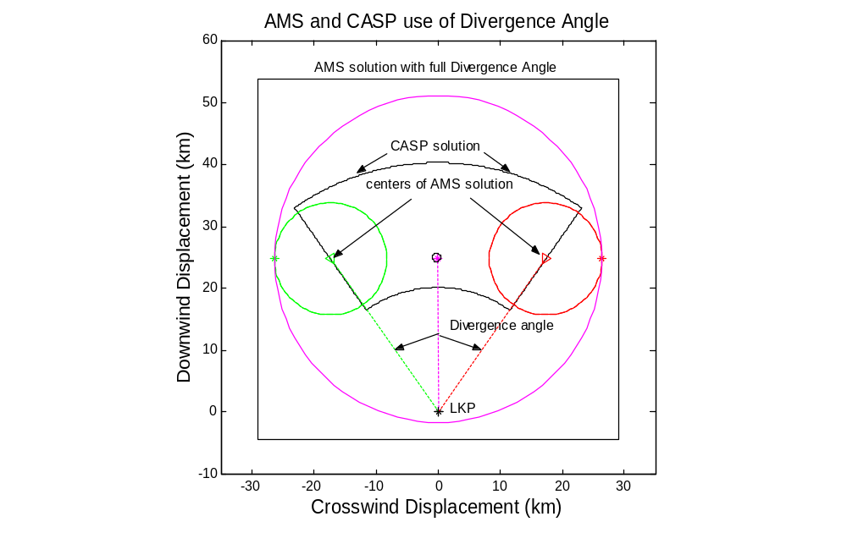

Figure 5-1. The leeway drift areas for CASP 1.1X and the AMS for a target with a divergence angle of 35 degrees and leeway speed of 3.5% of the wind. (Winds from 180 at 10 m/s for 24 hr.)

The IAMSARM, released on 1 January 1999, contains a manual search-planning tool, but does not include any leeway divergence in that tool. Therefore for the IAMSARM solution only a single leeway vector is determined, and that vector is directly downwind. The drift error for the IAMSARM method is a circle with a radius equal to 0.3 times the net displacement vector length. The Total Probable Error is derived from the drift error, initial position error and the SRU error by the same method used in the present National SAR Manual, (equation 5-1).

Total Probable Error = 5-1

The guidance provided by the IAMSARM was coded into Matlab by the author in order to present its results here. The coded IAMSARM solution for the scenario used in Figure 5-1 is shown along with the AMS and CASP solutions in Figure 5-2.

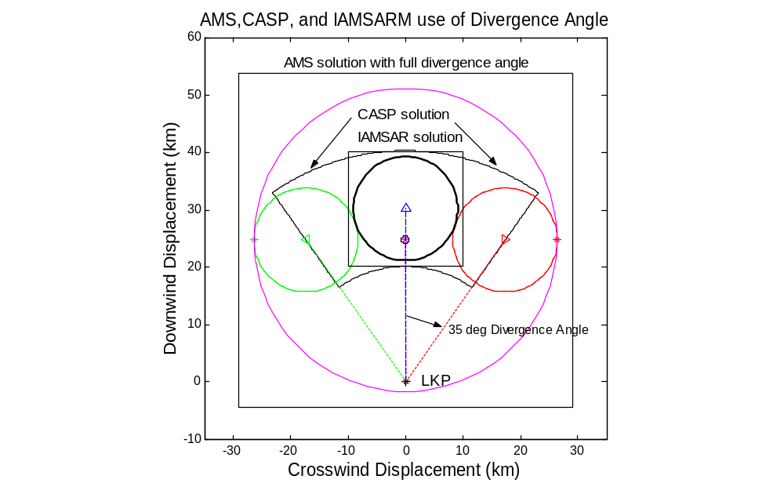

Figure 5-2. The leeway drift areas for CASP 1.1X, AMS, and the IAMSARM method for a target with a divergence angle of 35 degrees and leeway speed of 3.5% of the wind. (Winds from 180 at 10 m/s for 24 hr.)

Clearly the three methods generate three different sized and shaped search areas. The AMS solution is by far the largest and the IAMSARM solution is the smallest. Even the centers of the three search areas are not co-located. The AMS area is up wind of the CASP and IAMSARM solutions.

5.2 MODIFIED AUTOMATED MANUAL SOLUTION

The relationship between CWL and divergence angle is explored in Chapter 3 and is best expressed by equation 3-2. Equation 3-2 uses Divergence Angle divided by 1.35. Now let us re-do Figure 5-1, except where the divergence angle used by the AMS is 35 degrees / 1.35 or 25.93 degrees. This modified AMS solution using 25.93 degrees is shown in Figure 5-3 with the unmodified AMS solution.
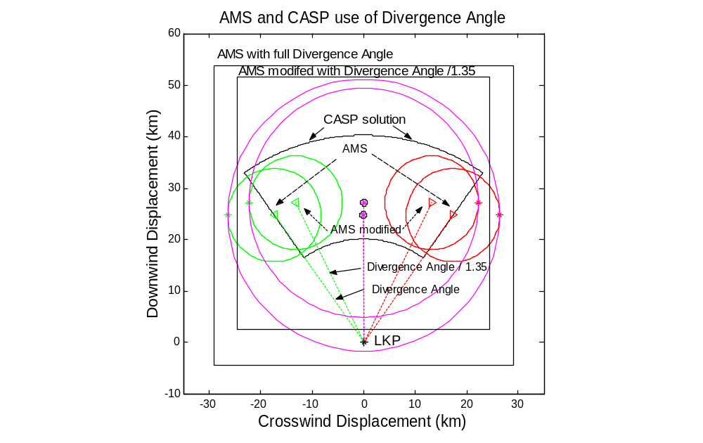

Figure 5-3. The leeway drift areas for CASP 1.1X and the AMS [old (divergence angle = 35 degrees) and new (divergence angle = 35/1.35 degrees)] for a target with a divergence angle of 35 degrees and leeway speed of 3.5% of the wind. (Winds from 180 at 10 m/s for 24 hr.)

The modified AMS solution is more closely aligns with right and left boundaries of CASP than the unmodified AMS solution.

Figure 5-4 below shows all four methods of solving the example search.

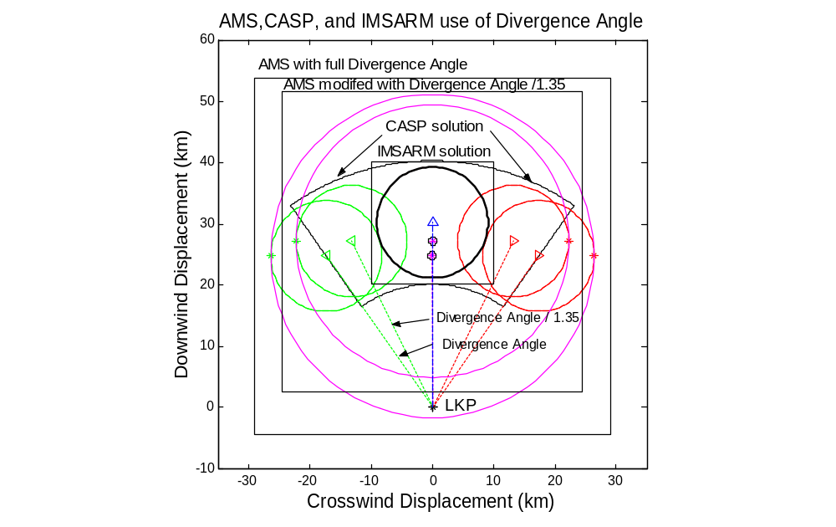
Figure 5-3. The leeway drift areas for IAMSARM, CASP 1.1X and the AMS [old (divergence angle = 35 degrees) and new (divergence angle = 35/1.35 degrees)] for a target with a divergence angle of 35 degrees and leeway speed of 3.5% of the wind. (Winds from 180 at 10 m/s for 24 hr.)

At this point there are four tools for determining search areas, and no two of them handle divergence of leeway targets from the downwind direction in the same manner. The IAMSARM method does not use any divergence. CASP uses divergence angle to establish the maximum left and right bounds of its search area. The two AMS method uses the divergence angle to center the left and right displacement circles.

None of these four tools for determining search areas use downwind and crosswind components of leeway, rather they all use leeway speed and divergence angle. None of these four tools includes a simple model for jibing of the target(s).

[BLANK]

CHAPTER 6
CONCLUSIONS AND RECOMMENDATIONS

  - CONCLUSIONS

The prediction of the divergence of search objects from the downwind direction is a critical component to the accurate establishment of a search area. The somewhat murky relationship among leeway angle, divergence angle, and leeway divergence has hindered the proper implementation of leeway divergence into search planning tools. Based upon recent studies, this report provides a review and analysis to determine an appropriate approach to model leeway divergence. The conclusions of this report is that an Coast Guard search planning tools should implement the use of downwind and crosswind components of leeway (Cartesian coordinates) in place of the existing methods that use leeway speed and divergence angles (polar coordinates).

The use of downwind and crosswind components of leeway as the method for determining the divergence of leeway targets from the downwind direction overcomes the major shortcoming of the use of divergence angles. The basic assumption for the use of divergence angles by present search planning tools is that the average leeway drift is essentially directly downwind. Divergence angle is used to express the uncertainty or variance of the net leeway drift about the downwind direction. The results of this assumption are that the area of highest probability is centered on the downwind vector and therefore the search area is centered on the downwind vector. This assumption is reasonable only for heavy ballasted symmetrical or nearly symmetrical leeway drift objects such as drogued heavily-loaded deep-ballasted canopied life rafts. However, many drift objects are asymmetrical and clearly do not drift directly downwind. These drift objects will be found along the downwind vector only if the object jibed frequently. However, present evidence indicates that jibing does not happen frequently. Thus asymmetrical drift objects will have a net drift to either left or the right of the downwind vector. Therefore, two areas of high probability will emerge from the initial distribution and eventually separate from each other. The present search planning tools can not generate two areas of high probabilities due to leeway divergence. However, this behavior can be modeled using downwind and crosswind components of leeway as illustrated by Allen and Plourde (1999, chapter four).

  - RECOMMENDATIONS

1) Incorporate into numerical search planning tools the use of downwind and crosswind components of leeway, as a function of wind speed adjusted to the standard 10-meter height, for the 63 categories of leeway targets presented in Table 4-1.

2) Incorporate into numerical search planning tools the use of a simple jibing model for switching between positive and negative crosswind component equations.

3) Incorporate into manual search planning tools the use of divergence angles provided by Allen and Plourde (1999) divided by 1.35.

4) Continue efforts to fully understand and model the drift of survivors and survivor craft by studying targets over more drift runs and in a variety of wind conditions. The conditions should include wind speeds less than three m/s and greater than 20 m/s and periods of rapid wind direction shifts. With more drift runs the question of initial distribution between left and right divergence can be addressed. Collecting leeway data under a variety of wind conditions will also allow the observation of changes between left and right divergence – jibing events.

5) Continue efforts to complete the incorporation of crosswind and downwind components of leeway into the search area determination model (AP98) introduced by Allen and Plourde (1999) and then operationally test that model against previous models in order to measure any increase in ultimate search performance.

  - FUTURE WORK

This report is a follow on work to Allen and Plourde (1999) with a particular emphasis on the relationship among leeway angle, divergence angle, components of leeway and the their roles in describing and modeling the leeway divergence. In addition, this report provides the necessary background and framework for on-going efforts to extend the search area determination model (AP98) used by Allen and Plourde (1999) and to modify the presently used manual method.

There are four major revisions being made to Allen and Plourde’s AP98 model. (1) AP98 which includes variances of the leeway components, has been upgraded to include variances of the wind and sea currents. These variances are for either speed and direction or east and north components of both the wind and sea current. (2) The mix of systematic and random errors has been revised. (3) A jibing module as been incorporated. In addition, (4) modules for complex initial conditions, that include variations in space, time and drift object type, have been added. These revisions will extend the range of search scenarios that can investigated.

Other on-going efforts are concentrated on revising the present manual method. There are three basic revisions to the manual method. (1) The variances of the wind, sea currents, and leeway of the drift object are included to provide inputs into determination of drift error circles that grow with time. (2) The divergence angles provided by Allen and Plourde (1999) are divided by 1.35 to appropriately align the two error circles with the two areas of highest probability. (3) The search area was modified from a square centered on a single area of high probability to a rectangle that encompasses the two areas of high probability. The conditions for which the new manual method generates predictable Probability of Containment (POC) values relative to the new numerical method will be defined.

Both the new numerical and manual methods of determining search area distributions will need to be extensively tested with a wide range of input parameters. In addition, the presently used numerical and manual methods will also be tested with the same input parameters. The goals are to expose any weakness of any of the methods for determining maritime search areas and to provide a basis for comparing the relative merits of the different methods. From this sensitivity analysis, guidance can be provided for the upgrading of Coast Guard search planning tools

If the new manual method is to be adopted, then the National SAR manual will need to be updated to reflect those modifications. Three sections of the National SAR manual will have to be greatly revised. (1) The section on how to use the manual method will have to upgraded to reflect the new method. (2) There will need to a new section added on global environmental data sources and their associated variances. This section will provide the wind and current error estimates necessary for the new manual method. Finally, (3) the section on leeway will have to be modified to include the new leeway data proposed by Allen and Plourde (1999). For an idea of how the new leeway section in the National SAR Manual might look see Schneider (1999).

REFERENCES

Allen, A. A., 1996. “The Leeway of Cuban Refugee Rafts and a Commercial Fishing Vessel,” U.S. Coast Guard Report No. CG-D-21-96.

Allen, A. A., and R.B. Fitzgerald, 1997. “The Leeway of an Open Boat and Three Life Rafts in Heavy Weather,” U.S. Coast Guard Report No. CG-D-03-98.

Allen, A. A., and J.V. Plourde, 1999. “Review of Leeway: Field Experiments and Implementation,” U.S. Coast Guard Report No. CG-D-08-99.

Allen, A.A., R.Q. Robe and E.T. Morton, 1999. "The Leeway of Person-In-the-Water and Three Small Craft," U.S. Coast Guard Report No. CG-D-09-00.

Chapline, W. E., 1960. "Estimating the Drift of Distressed Small Craft." Coast Guard Alumni Association Bulletin, U.S. Coast Guard Academy, New London, CT Vol. 22, No. 2, March-April 1960, pp 39-42.

Fitzgerald, R. B., D. J. Finlayson, and A. Allen, 1994. "Drift of Common Search and Rescue Objects - Phase III." Contract report prepared for Canadian Coast Guard, Research and Development, Ottawa, TP# 12179.

Frost, J. R., 1997. "The Theory of Search: A Simplified Explanation." Contract report prepared for U.S. Coast Guard.

Hodgins, D. O. and S. L. M. Hodgins, 1998. “Phase II Leeway Dynamics Study Program Development and Verification of a Mathematical Drift Model for Liferafts and Small Boats.” prepared for Canadian Coast Guard College, Dept. Fisheries and Oceans.

Hufford, G.L., and S. Broida, 1974. "Determination of Small Craft Leeway." U.S. Coast Guard Research and Development Center Report No. 39/74, December 1974.

Kang, S.Y., 1999. “A Field Experiment for the Determination of Drift Characteristics of Person-in-Water”, 'Journal of the Society of Maritime Safety’, Vol. 5, No.1, pp. 29-36 (Abstract in English, text in Korean).

Nash, L., and J. Willcox, 1985. "Summer 1983 Leeway Drift Experiment,” U.S. Coast Guard Report CG-D-35-85.

Nash, L., and J. Willcox, 1991. "Spring 1985 Leeway Experiment," U.S. Coast Guard Report CG-D-12-92.

Schneider, T. L., 1999. “The Latest on Leeway”, On Scene, U.S. Coast Guard, Commandant (G-OPR), 2100 Second St. Washington, DC 20593, pp. 11-13, Winter 98/99.

Smith, S.D., 1988. “Coefficients for Sea Surface Wind Stress, Heat Flux, and Wind Profiles as a Function of Wind Speed and Temperature,” J. Geophysical Res. Vol. 93, No. C12, pp. 15,467-15,472, 5 December 1988.

U.S. Coast Guard, Commandant Instruction M16120.5A, "National Search and Rescue Manual," Washington D.C. 1 February 1991.

APPENDIX A

LEEWAY COMPONENTS OF
MARITIME LIFE RAFTS
(DEEP BALLAST, CANOPY, 15-25 PERSON CAPACITY)

A.1 INTRODUCTION

A Beaufort 20-person circular life raft, shown in Figure A-1, was drifted six times in two configurations. Three leeway drift runs were performed with light loading and no drogue and three drift runs were with heavy loading and a drogue deployed (Fitzgerald et al., 1994 and Allen and Plourde, 1999). Fitzgerald et al. (1994) presented results for the downwind component of leeway for the two configurations, while Allen and Plourde presented results for the combined class. The results of the analysis for both components of leeway are presented here for the two configuration of the twenty-person life raft. The configurations follow the leeway taxonomy convention of Allen and Plourde (1999). The analysis procedure follows Allen (1996), Allen and Fitzgerald (1997), Allen and Plourde (1999) and Allen et al. (1999).

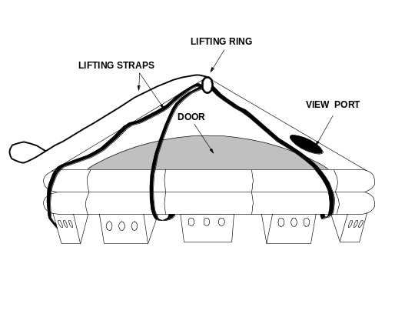

Figure A-1. Beaufort circular 20-person life raft

A.1.1 MARITIME LIFE RAFT (Deep Ballast, Canopy, 15-25 Person Capacity, No Drogue, Light Loading).

The first leeway drift configuration of the Beaufort 20-person circular life raft was with light loading and no drogue attached. Three drift runs (Leeway Drift Runs 37, 43, and 48) in this configuration combined for a total of 816 ten-minute samples or 136 hours of data. In Figure A-2, the unconstrained linear regression of the downwind component of leeway (DWL, in cm/s) versus wind speed (m/s) adjusted by Smith (1988) to the 10-meter reference level (W_{10m}). Also presented in Figure A-2 are the 95% prediction limits for the 20-person lifer raft with no drogue and light loading. The value of 0.94 for r² indicates that the regression of DWL versus W_{10m} accounts for 94% of the variance of the DWL, which is an excellent fit.

The crosswind components into positive and negative components are separated by drift runs. The unconstrained linear regression of the crosswind components of leeway (separated by positive (+CWL, in cm/s) and negative components (-CWL, in cm/s)) versus W_{10m} along with the 95% prediction limits are shown in Figure A-3. The r² value indicate that regression of +CWL (-CWL) versus W_{10m} accounts for 20% (38%) of the variance of the +CWL (-CWL), which is a poor (fair) fit. The intersection wind speed of the two crosswind regression equations occurs at a W_{10m} of 5.07 m/s. Below this wind speed, the data points were primarily described by the negative crosswind regression. Table A-1 summarized the coefficients for the three regression equations.

All regression analysis and parameters follow (Allen and Fitzgerald 1998, Allen and Plourde 1999, and Allen et al. 1999), where r² and S_{y/x} are the coefficients of determination and the standard errors of the estimate, respectively.

Table A-1

Unconstrained Linear Regression of the Downwind and Crosswind Components of Leeway (cm/s)
of
Beaufort 20-person life raft with light loading and no drogue
on W_{10m} (m/s)

Dependent | # | Slope | y-intercept | r² | S_{y/x} | W_{10m}
Variable | samples | (%) | (cm/s) |  | (cm/s) | (m/s)
DWL | 816 | 3.9349 | 3.9349 | 0.9386 | 3.0070 | 2.0 – 16.3
+CWL | 276 | 0.3847 | -3.3346 | 0.1974 | 2.1583 | 2.0 – 14.1
-CWL | 540 | -0.5863 | 1.5915 | 0.3846 | 2.2767 | 2.3 – 16.3

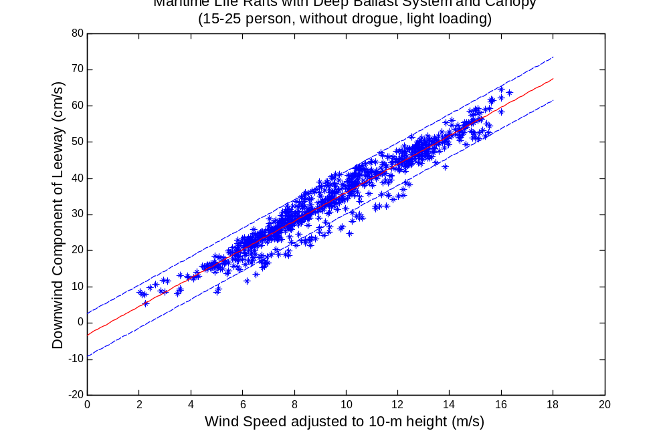
Figure A-2. The Unconstrained Linear Regression and 95% Prediction Limits of the Downwind Component of Leeway as function of Wind Speed at 10 m, Maritime Life Rafts, Deep Ballast Systems, Canopy, 15-25 Person Capacity, No Drogue, Light Loading.

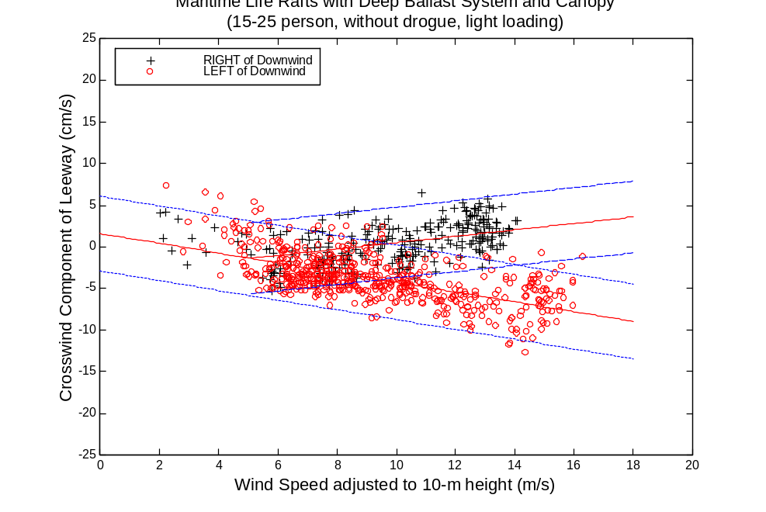
Figure A-3. The Unconstrained Linear Regression and 95% Prediction Limits of the Positive and Negative Crosswind Components of Leeway as function of Wind Speed at 10 m, Maritime Life Rafts, Deep Ballast Systems, Canopy, 15-25 Person Capacity, No Drogue, Light Loading.

A.1.2 MARITIME LIFE RAFT (Deep Ballast, Canopy, 15-25 Person Capacity, With Drogue, Heavy Loading)

The second leeway drift configuration of the Beaufort 20-person circular life raft was with heavy loading and with a drogue attached to the raft. Three drift runs (Leeway Drift Runs 40, 42, and 47) combined for a total of 794 ten-minute samples or 132.3 hours of data. In Figure A-4, the unconstrained linear regression of the downwind component of leeway as function of W_{10m} along with the 95% prediction limits are presented for the 20-person life raft with a drogue and heavy loading. The value of 0.94 for r² indicates that the regression of DWL versus W_{10m} accounts for 89% of the variance of the DWL, which is an excellent fit.

The crosswind components into positive and negative components are separated by drift runs. However, during the beginning of leeway drift run 47 the life raft had a negative component of crosswind. After 32.0 hours to positive crosswind components for the remainder of the drift run. The switched occurred with a single 10-minute sample period. Therefore, analysis of this run was divided into two sections before being used in the crosswind regression. The unconstrained linear regression of the crosswind components (separated into positive and negative components) versus W_{10m} along with the 95% prediction limits are shown in Figure A-5. The r² value indicate that regression of +CWL
(-CWL) versus W_{10m} accounts for 20% (21%) of the variance of the +CWL (-CWL), which is a poor (poor) fit. The intersection wind speed of the two crosswind component regression equations occurs at a W_{10m} of 6.28 m/s. Below this wind speed, the data points were primarily described by the positive crosswind regression. Table A-2 summarized the coefficients for the three regression equations.

Table A-2

Unconstrained Linear Regression of the Downwind and Crosswind Components of Leeway (cm/s) of
Beaufort 20-person life raft with heavy loading and with a drogue
on W_{10m} (m/s)

Dependent | # | Slope | y-intercept | r² | S_{y/x} | W_{10m}
Variable | samples | (%) | (cm/s) |  | (cm/s) | (m/s)
DWL | 794 | 3.1543 | -4.4935 | 0.8942 | 3.3529 | 0.4 – 15.3
+CWL | 601 | 0.3853 | -1.7991 | 0.1974 | 2.5014 | 0.4 – 15.3
-CWL | 193 | -0.3756 | 2.9819 | 0.2092 | 1.6443 | 5.5 – 13.5

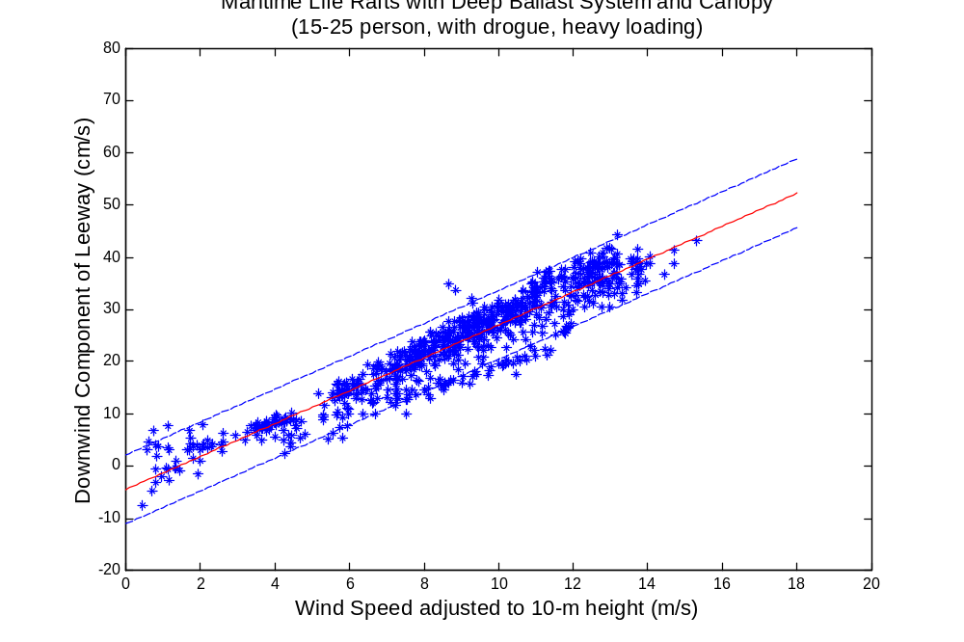
Figure A-4. The Unconstrained Linear Regression and 95% Prediction Limits of the Downwind Component of Leeway versus Wind Speed at 10 m, Maritime Life Rafts, deep ballast systems, canopy, 15-25 person capacity, with a drogue, and heavy loading.

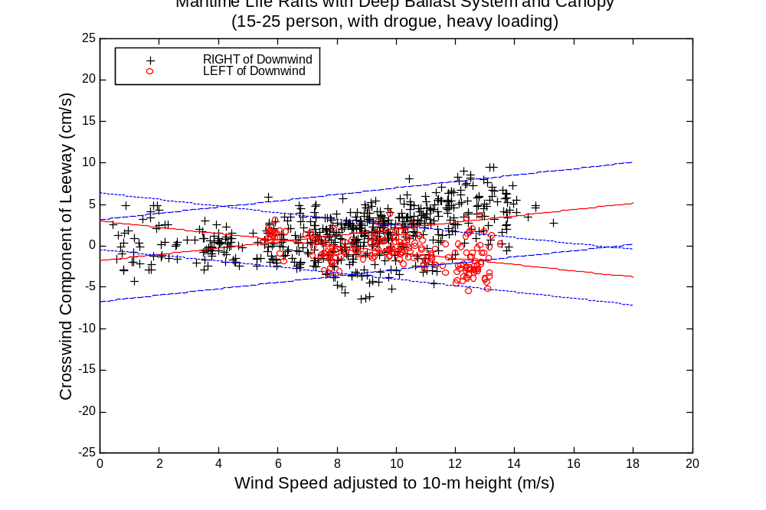
Figure A-5. The Unconstrained Linear Regression and 95% Prediction Limits of the Positive and Negative Crosswind Components of Leeway versus Wind Speed at 10 m, Maritime Life Rafts, deep ballast systems, canopy, 15-25 person capacity, with a drogue, and heavy loading.

