CHAPTER 3
SEARCH PLANNING

3.1 SAR Planning and Operations Overview
3.1.1 SAR Incidents Profile
3.1.2 SAR Incident Data Collection; The Watchstander's Art
3.1.3 Standard Checksheet Formats
3.2 Search Planning Methods and Tools
3.2.1 Manual Solution Model
3.2.2 Automated Manual Solution Model
3.2.3 Operational Search Planning Computer Systems
3.2.4. Commence Search Point Guidance
3.2.5 Search Area Designation
3.3 Search Planning Variables
3.3.1 Drift Theory
3.3.2 Distress State Transition
3.4 Initial Response, Search Planning and Search Operations
3.4.1 Offshore Incidents
3.4.2 Coastal Incidents
3.4.3 Flare Incidents
3.4.4 Distress Beacon Incidents
3.4.5 Night and Reduced Visibility Searches
3.4.6 Electronic Sensors And Sensor Searches
3.4.7 Searches for Bodies
3.4.8 Aircraft Incidents
3.4.9 Uncorrelated Distress Broadcasts
3.4.10 False Alarms, Hoaxes and Suspected Hoaxes
3.4.11 Mass Rescue Operations
3.4.12 Search Action Plans
3.5 Rescue Planning and Operations
3.5.1 Overview
3.5.2 Rescue and the MSAP
3.5.3 Disposition of Lifesaving Devices
3.6 Measures of Search Effectiveness
3.6.1 Probability of Success (POS)
3.6.2 The Value of Using POS
3.6.3 Determining POS
3.7 Aspects of Survival
3.7.1 Hypothermia Survival
3.7.2 Will to Live
3.8 Conclusion of SAR Operations
3.8.1 Case Closed
3.8.2 Case Pends
3.8.3 Active Search Suspended Pending Further Developments
3.8.4 Close/Suspend when Other Agencies are SMC
3.9 Case Documentation
3.9.1 SAR Case Claiming
3.9.2 SAR Case Situation Reports (SITREPs)
3.9.3 MEDical EVACuation (MEDEVAC) Report
3.9.4 SARMIS Reports
3.9.5 SAR Case Studies
Section 3.1
SAR Planning and Operations Overview

3.1.1 SAR Incidents Profile
More than 95 percent of all Coast Guard SAR cases occur within 20 nautical miles of shore. Coast Guard helicopters and boats, our primary quick response assets, handle the majority of incidents to which the Coast Guard dispatches its own resources. Approximately 90 percent of all cases involve assist or rescue only -- no searching. Of all cases, 8 percent involve minor searches (less than 24 hours) and 2 percent of all cases involve major searches lasting more than 24 hours.
While a total of only 10 percent of Coast Guard cases involve searches, annually, the Coast Guard spends more than $50 million on these searches in operating costs. Therefore, it is advantageous to reduce the time spent searching whenever possible. Reliable and timely distress alerting, accurate position indicating, and efficient locating will reduce search time for those in distress before the rescue. Search planning tools, such as Computer Assisted Search Planning (CASP), coupled with accurate environmental data, are essential for proper search planning. Efficient planning can significantly reduce the time Coast Guard units spend on searching.

3.1.2 SAR Incident Data Collection: The Watchstander’s “Art.”
The collection of accurate, detailed incident data upon notification of a potential distress is a crucial element of the “Awareness” stage of a SAR incident. For example, communications with people in distress may be terminated abruptly, and the initial information collected may be the only means to affect a search and rescue effort. Despite this, the time taken to collect all of the information on the SAR incident checksheet delay’s the Coast Guard’s initial response and could unnecessarily put those in distress at greater risk. When responding to calls for assistance, watchstanders should focus on initially collecting only the most critical and relevant information necessary to determine the severity of the situation and an appropriate response. Usually, this information consists of the following items on the Initial SAR Incident Checksheet:

- vessel’s position,
- vessel's description,
- nature of distress,
- number of persons on board.

For most cases, this will be sufficient information to determine an appropriate initial response and dispatch resources to assist. Those in distress should then be notified as soon as Coast Guard or other resources are dispatched, so that they know that help is on the way. Once these steps are completed, watchstanders can then continue the process of completing the Initial SAR Incident Checksheet, and any supplemental checksheets as necessary.

3.1.2.1 The ability to effectively communicate with persons in distress requires both skill and experience. Mariners whose stress level is high may speak quickly or incoherently; resulting in crucial information being passed that is not easily understood. Coast Guard radio watchstanders must be acute listeners and clear speakers. Watchstanders who speak in a clear, calm voice can often reduce the stress level of those with whom they are communicating. This in turn can help ensure that crucial information passed by the boater is more easily understood.

3.1.3 Standard Checksheet Formats
The use of SAR incident checksheets for the collection of SAR case data is required. The standard formats for Coast Guard SAR Incident Checksheets are provided in Appendix G. The sheets provided detail the minimum amount of information to be gathered for each situation.
3.1.3.1 This standard formats are strongly recommended. Modifications in format, or the creation of additional data fields, are authorized as deemed necessary by the operational commander to accommodate local practices. Any modifications shall not eliminate any information.
3.1.3.2 The “Initial SAR Incident Checksheet” should be completed for all incidents. The “Supplemental SAR Checksheet” contains other information that should be collected as circumstances warrant. Standard checksheets are also provided for specific incident types.
3.1.3.3 SAR Controllers shall not hesitate to launch resources prior to completing the checksheets. If the situation dictates, launch first then make all attempts to complete the checksheets when time permits.
3.1.3.4 At specific points indicated on the checksheets, while completing the sheets, SAR Controllers should ascertain the wearing of personnel flotation devices by persons on board and advise the reporting source of the intended action of the Coast Guard.
Section 3.2
Search Planning Methods and Tools

Nationally and internationally there are a number of recognized search planning methods. The Coast Guard has historically used the “Minimax” method for manual search planning, and CASP for high-end computer planning. The IAMSAR Manual has an alternate manual method with enhancements that can result in smaller search areas. Currently there is no automated computer implementation of the IAMSAR method. This Addendum provides the current method used by the Coast Guard (Appendix H) which may be used in conjunction with the Automated Manual Solution (AMS) provided with the C2PC tools. With the improvement in leeway and sea current data now available, the AMS solutions will lead to smaller more accurate search areas.
When search planning is required, one of the approved methods (manual sheets (Appendix H), AMS, IAMSAR, CASP) shall be used. Planners shall fully document their search planning regardless of the method they select.
When developing a search plan, search planners must be detectives and information distillers. They must aggressively pursue leads and obtain all information available. They must continually think "outside the box."

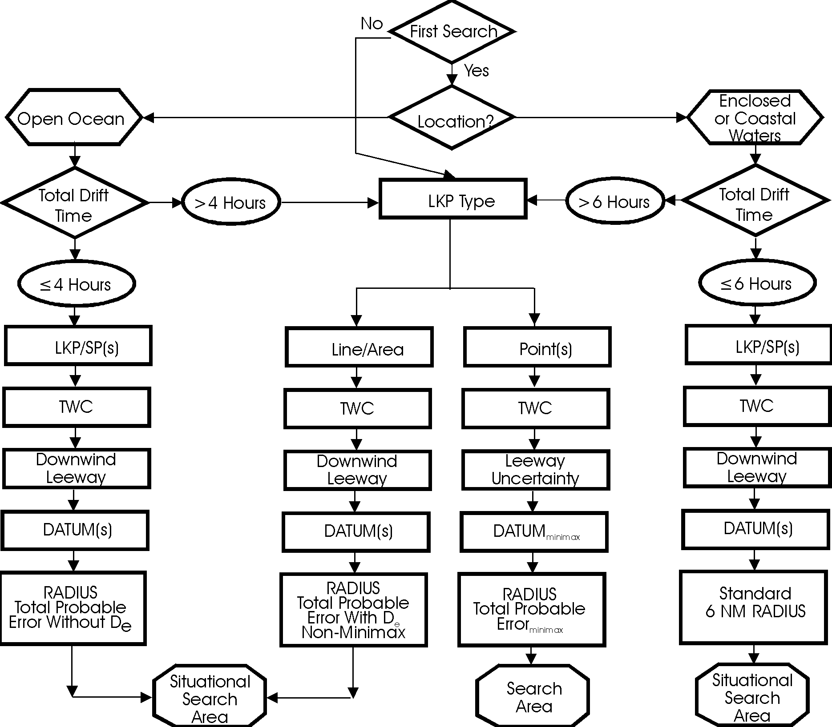

Figure 3-1 Search Planning Decision Matrix

3.2.1 Manual Solution Model
Reference (b) provides guidance for determining SAR planning steps based upon time of drift and physical location factors. The Search Planning Decision Matrix (Figure 3-1) illustrates the four methodologies for determining appropriate search areas based on the planning factors of the SAR case.

3.2.1.1 The methodologies are used as follows:

- First search/subsequent searches
- If planning a first search, consider the search location. For subsequent searches, determine last known position (LKP) type as discussed below.

- Determine Location
- Is the search object in coastal waters or the oceanic environment?

- Drift Time
- How long has the search object been adrift?

- Determine LKP Type
- Establish a Last Known Position Type. Are you planning for a Single Point, Multiple Points, Area, or Trackline?

- Compute Total Water Current
- Did you consider all the water currents (sea current, tidal currents, wind driven current, etc.)?

- Compute Leeway
- Leeway is applied downwind in coastal waters, and in cases in the oceanic environment where the LKP is determined to be an area or trackline, or if the total drift time is four hours or less. Leeway Uncertainty is applied in situations where the LKP is a single point or multiple points and the total drift time is greater than four hours.

NOTE: For the oceanic environment, if the drift is less than four hours, compute search radius without considering drift error. If more than four hours, compute the search radius using total probable error.

NOTE: For the oceanic environment, Search Area (minimax solution) is determined by the Search Radius. For non-minimax solutions, Search Area will be determined by drawing search radii about multiple DATUM positions as in the Coastal Solution.

- Determine DATUM(s) or DATUM_{minimax}
- If you used Downwind Leeway, then you will determine DATUM (one position per LKP). If you used Leeway Uncertainty, you will determine DATUM_{minimax} (generate two positions - D_{min} & D_{max} and solve for DATUM_{minimax} (Chapter 5 of reference (a)).

- Determine Search Radius
- For Coastal Waters with less than six hours of drift, use a six nautical mile (NM) radius. If more than six hours of drift, use Oceanic methodology.

- Search Areas
- For Coastal Waters with less than 6 hours of drift, a 6-mile radius around DATUM(s) will normally create your desired search area. If these radii are drawn about multiple positions, such as a trackline DATUM, then the Search Area can be determined from a chart plot.

3.2.1.2 Appendix H contains the Manual Solution worksheets and detailed job aides for filling them out.

3.2.2 Automated Manual Solution Model
The Manual solution is time consuming and error prone due to the volume of calculations involved. The Automated Manual Solution is an application that has computerized the worksheets and computations.

3.2.3 Operational Search Planning Computer Systems
The SAR community has computer assistance for SAR planning available through the Coast Guard Operations Systems Center. Policy for the operation and administration of the Amver System is provided in reference (n). Guidance for the Computer Assisted Search Planning (CASP) system is being revised. Various levels of guidance on use of and products of these systems are available through the Operations Systems Center telephone hotline.

NOTE: Operations Systems Center Hotline: (304) 264-2500.

3.2.3.1 Amver System. Amver is a computerized system for maintaining the dead reckoning position of participating vessels worldwide. Merchant vessels, including some commercial fishing vessels and megayachts, of all nations making coastal and oceanic voyages are encouraged to send movement reports (sailing plan, periodic position updates, and final report) to the Amver Center at the OSC via assigned coast or international radio stations or satellite service providers. Norway, Poland, and U.S. (for certain vessels) require their merchant vessels to participate; other vessels participate voluntarily. The information is stored in the database at the Amver Center and used for SAR efforts. Recognized RCCs worldwide handling an oceanic SAR operation can request Amver information from any U.S. Coast Guard RCC. Instructions for RCC/RSC access and use are provided in the End User Manual for the Amver System. Amver information is available to RCC/RSC SAR planners is in three categories:

- SURPIC: SURface PICture is a program that identifies and plots Amver vessels worldwide. This is especially useful in the event of a maritime emergency. RCC input includes the distressed vessel’s position, type and time of SURPIC. Output is a text list of the closest vessels within a defined area and a selected subset of available vessel information. A graphic display of the information is available for U.S. Coast Guard RCCs. SURPIC information can be faxed or e-mailed (press the Ctrl-Alt-Print Scrn buttons on the standard workstation and paste the text or graphic into the e-mail) to a foreign RCC requesting help. SURPICs can be generated for the current time, a point up to 30 days in the past, or a point up to 14 days in the future. The four types of SURPICs are:

- Radius SURPIC: A surface picture defined by a distress position, a distance from the distress position (radius), and a Date Time Group (DTG) for the SURPIC.
- Rectangle SURPIC: A surface picture of a specific area defined by a northwest corner and a southeast corner, and a DTG for the SURPIC.
- Snapshot Trackline: A surface picture defined by the starting and ending position of a trackline, a distance from the trackline, and a DTG for the SURPIC. This SURPIC is useful in determining which vessels will be in a given area at a certain time (e.g., a space shuttle launch, an aircraft that may have to ditch, or an overdue vessel on a known course).
- Moving Point: The Moving Point SURPIC provides the user the capability to obtain a surface picture around a vessel’s trackline with time variant. This SURPIC is defined by the starting and ending position of the vessel’s trackline, and the estimated departure of the vessel. This SURPIC is useful when a vessel is overdue at its destination. If the vessel’s trackline and departure can be estimated, a SURPIC can be generated the along trackline for each increment of time. Thus, the RCC can obtain a list of vessels that may have sighted the missing vessel.

- Lloyd’s Vessel Data: The Lloyd’s Vessel Data displays static information from the Lloyd’s Registry describing the vessel such as: vessel name, international radio call sign, the Inmarsat number, Lloyd’s number, hull ID (official number of registry), length, width, the year and month in which the vessel was built, and the true and registered nationality and address of the owner company. Data on tens of thousands of vessels are obtained from Lloyd’s and updated monthly.
- Voyage Information: Includes information on the current voyage; the vessel’s current predicted position; a record of the most recent Amver reports received; and Amver and Lloyd’s vessel data.

3.2.3.2 Computer Assisted Search Planning (CASP) is a computerized system used by search planners to identify probable search areas and plan resource allocation. When supplied with appropriate information (the search object's characteristics and uncertainties of the situation), the computer uses information from on-line environmental databases to simulate drift. CASP is run for foreign RCCs upon request.

- CASP version 1.x is now deployed. A replacement for CASP is under development.
- After simulation is complete, a probability distribution (a "picture" of the area) describing possible locations of the search object can be generated. After a search is conducted, CASP can recalculate the drift and establish new probabilities based on the previous search results.
- CASP shall be used by all area and district RCCs to provide search planning guidance on cases involving incidents in open waters outside the 30 fathom mark (depth of 180 feet or more) whenever:

- the duration of an incident has or could have exceeded 24 hours, and
- there is uncertainty concerning the incident time, incident location, type of search object(s) involved, etc.

- CASP should be applied with caution among/near island chains or within 3 nautical miles (NM) of shore.
- CASP information is available for use by the SAR planner. As with any other information that bears on a distress incident, it is the SAR planner's decision as to what information to utilize.
- The benefits of CASP with regard to search planning and evaluation are discussed in Section 3.6, Measures of Search Effectiveness.

3.2.4 Commence Search Point Guidance
All factors, including environmental conditions and available resources, should be carefully considered when determining where to place the commence search point (CSP) for particular search areas.

3.2.4.1 Other factors to consider include:

- What is the resource’s (includes aircraft, small boat and other available assets) proximity to the search area? The decision may be made to place the CSP at the point closest to the SRU’s departure point in order to facilitate the start of searching as quickly as possible.
- The decision may be made to place the CSP at a point farthest away from the departure point, so as to have the SRU finish its search as close to its recovery point as possible. This addresses other considerations, such as: having the SRU pass through datum prior to searching; inserting a DMB at datum prior to searching; and having the SRU finish its search as close as possible to a logistics base, which would make the DMB available for the next search or another mission.
- For missions with multiple air SRUs, all CSPs should be coordinated so that they are positioned at the same geographic corner for each individual search area (e.g. search areas A1-A5 will all have a CSP in the southeast corner). It is paramount to risk assessment and safety of flight issues that strict adherence to this rule is followed. The only caveat to the rule of adjacent CSPs would be if the SRUs for adjoining search areas were to commence their searches at significantly different times. It may be appropriate to consider separation for surface assets in situations where visibility is reduced (fog, night, and heavy precipitation).

3.2.4.2 Other considerations include orienting the search areas, patterns and particularly the CSP to account for environmental factors such as looking into or away from the sun while searching, or searching into or down swell vice in the trough. The type of search pattern, as well as the search object’s drift (direction and speed) must also be considered when determining where to place the CSP.

3.2.4.3 There are many factors to consider prior to making a final decision about where to place the CSP. Each SMC must maintain communications with on scene units or the OSC to determine if the planned CSPs are in their proper places or if positions need to be modified.

3.2.5 Search Area Designation
Search areas shall be designated using a letter (A, B, C…) sequentially for the overall search area. A new letter shall be assigned each time the search planner establishes a datum or drifts a datum. In the course of a search if a new independent datum is established due to new information or other circumstances, that datum shall continue with the next search letter designation for that case. Sub-areas to be searched by specific search units (or combination of units) shall be numbered sequentially and associated with the overall search area by preceding the number with the letter designation of the overall search (A-1, A-2, etc.).

(This page intentionally blank)

Section 3.3
Search Planning Variables

Search planning is based on a myriad of variables including environmental factors, the nature of the distress incident, and the available search platforms and their capabilities. Search planners can improve the likelihood of locating the search objects by doing the following:

- Accurately estimate the drift or total water current within the general search area.
- Approximate the time at which a distress incident occurred, and subsequently the times at which the search object changed states, i.e., from a disabled vessel to a raft, to a person in the water.
- Determine the availability and capabilities of search and rescue units (SRUs).

3.3.1 Drift Theory
On average, the Coast Guard conducts more than 5,000 searches annually, at a cost of about $50M. Most of the expense is in aircraft usage. A fifth of the searches continue longer than 12 hours. These longer searches, which usually involve multiple resources, are much more expensive than short searches. In the longer searches, knowledge of the drift of the search object becomes very important to the search planner. If the search object is not in the region covered by the search, there is no chance of finding the search object. Thus, the better the drift of an object is known, the more likely it will be found. Shortening the search saves SAR resources, but more importantly, a shorter search increases the probability that the person(s) in distress will survive. Datum Marker Buoys (DMBs), both radio and self-locating, are tools for determining total water current in a search area. When using DMBs, search planners should use their best judgement to estimate the sphere of influence for which the DMB information is valid. The sphere of influence is smaller in the vicinity of high currents; i.e., the Gulf Stream, Florida Straits, or known variable current areas such as Georges Banks off of New England. Time is also a consideration. Marine science experts, such as those at the International Ice Patrol (IIP) are available to assist in estimates. As a rule, the sphere of influence should be no larger than that for water current information already available, such as system environmental information provided to CASP.

3.3.1.1 Datum Marker Buoy (DMB). Since on-scene ocean currents are so poorly known and hard to predict, the Coast Guard uses DMBs to provide a measure of the currents in search areas. Some DMBs now in use are located by radio direction finding (RDF) from the search unit, which must relocate the RDF/DMB for each ocean current estimate.

3.3.1.2 Self-locating Datum Marker Buoys (SLDMB) utilize satellite-based technology to determine buoy position. SLDMBs provide frequent, high-resolution position information independent of the search unit (search unit does not have to relocate the DMB). The SLDMBs drift with the water mass, providing high quality current information. The use of satellite technology greatly reduces the cost of a position determination in comparison to the cost associated with the RDF/DMB.

- SLDMBs will improve the efficiency and effectiveness of Coast Guard SAR operations. The goal of the search is to find people so they can be saved. The use of SLDMBs offers the opportunity of doing the job better, while also saving money.
- Search planners should use SLDMBs whenever possible. Planners must specifically request that air stations use SLDMBs.

3.3.2 Distress State Transition
Planning for search and rescue cases is complicated by uncertainty over the “state” of the search object. In many ways, the SAR Controller performs as a detective. This concept is best illustrated by the following example.

3.3.2.1 A fishing vessel departs Boston for a ten-day fishing trip south of Cape Cod. On the third day, the vessel breaks down and begins to drift, unable to contact anyone. On the fifth day, during a severe storm, the vessel takes on water and begins to sink; the crew abandons ship into a life raft. On the sixth day, the life raft capsizes and the crew begins to drift in their survival suits.

- In this example, the distressed craft changed state from a deep draft fishing vessel underway, to a deep draft fishing vessel adrift, to a life raft with drogue, to several PIW.
- The uncertainty surrounding the times when these state transitions occurred greatly increases the complexity of the search planning problem.
- Search planners should use their best estimates for when distress state transitions occur in planning searches. When possible, search planners should develop several scenarios that cover all possibilities. Search planning tools such as CASP are invaluable in this regard.
Section 3.4
Initial Response, Search Planning, and Search Operations

Effective, efficient prosecution of a SAR incident requires well thought out procedures. Not every incident will develop into a full-blown SAR case, but every case has the potential to greatly expand. Guidance within this section will aid the SAR Controller in developing the thought process for a rapid and thorough reaction upon receiving notification of a potential or actual distress.

3.4.1 Offshore Incidents
As defined in reference (a), the Commandant has divided the Maritime SAR area into two sections, Atlantic Area and Pacific Area Commands, responsible for efficient coordination between all SAR regions and sectors within their sections. The Area and District RCCs generally have responsibility for offshore incidents.

3.4.2 Coastal Incidents

3.4.2.1 Initial Response Search Area. The Group OPCEN generally has the responsibility for coastal incidents. If the search object is not located upon on scene arrival, the SRU is to assume the distressed vessel is adrift if they did not indicate it was at anchor. Draw a circle with a 6 NM radius centered at the last known position (LKP). If drift is considered to be significant, the SRU should estimate the drift based on local knowledge and/or on scene conditions, and center the 6 NM circle on the drifted LKP. Next, draw a square search area with side’s tangent to the circle. Orient the search area in the direction of drift, that is, in the same direction as the total drift vector (Figure 3-2). If the reported position of the distressed craft is in shallow water, it could be at anchor, and a search down the drift line may be appropriate.

3.4.2.2 The SRU shall also keep the SMC constantly updated on conditions, findings, and when nearing completion of the initial response search. This direction should not preclude a SRU from using an alternate search pattern or area when it is clearly indicated (e.g., narrow waterway or other physical barrier).

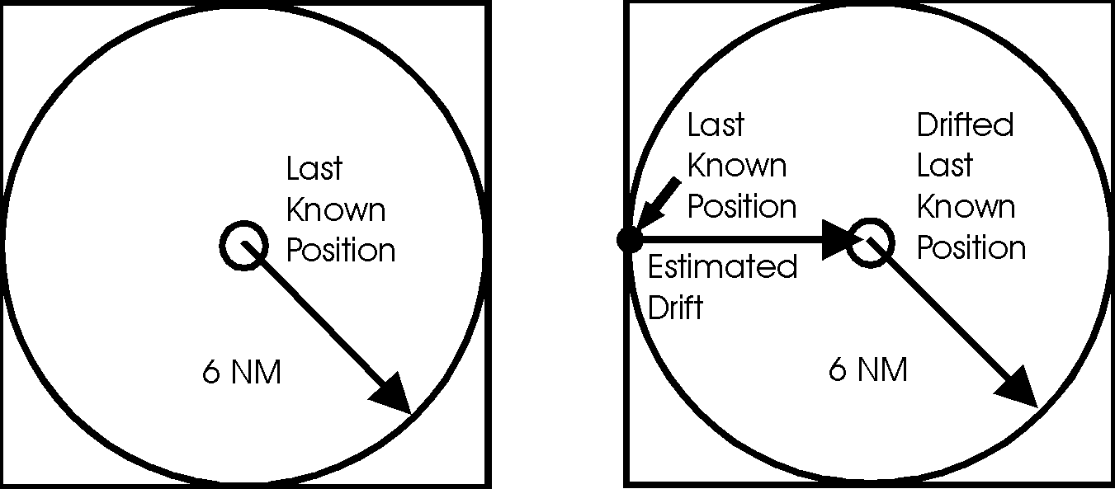

Figure 3-2 Initial Response Search Area

3.4.2.3 First SRU on scene procedures. Pre-established operations and search procedures for the first SRU on scene are to immediately report the on-scene conditions and findings to the SMC. If the object of the SAR incident is not initially seen (or located), begin appropriate search pattern.

(a) For surface SRUs -- usually an expanding square search (SS) is executed. If the search area is confined or there is reason to have a high degree of confidence for the selected datum (i.e., debris found), the surface SRU may use a sector search (VS). For an initial search, use the appropriate track spacing from Table 3-1.
(b) For helicopter SRUs. Helicopters are a suitable platform to execute SS and VS pattern searches. Depending on the proximity to the coast and environmental conditions, a radius larger than 6 NM may be appropriate for a helicopter during the initial search due to a higher search speed. For an initial search, use the appropriate track spacing from Table 3-1.

Table 3-1 Initial Track Spacing

Initial Track Spacing (NM)
 | Good Conditions | Poor Conditions
Search | wind < 15 kts | Wind > 15 kts
Object | seas < 3 ft | seas > 3 ft
PIW | 0.1* | 0.1*
< 15 ft | 0.5 | 0.2
> 15 ft | 1.0 | 0.5
* > 0.1 up to SRUs minimum navigational accuracy

3.4.2.4 SMC Action. In coastal SAR, the initial datum shall be quickly established. The initial datum is determined by calculating drift using the object's last known position and the effects of water current and wind without considering leeway divergence (Figure 3-3). Time of datum must take the underway and transit times for the SRU into consideration.

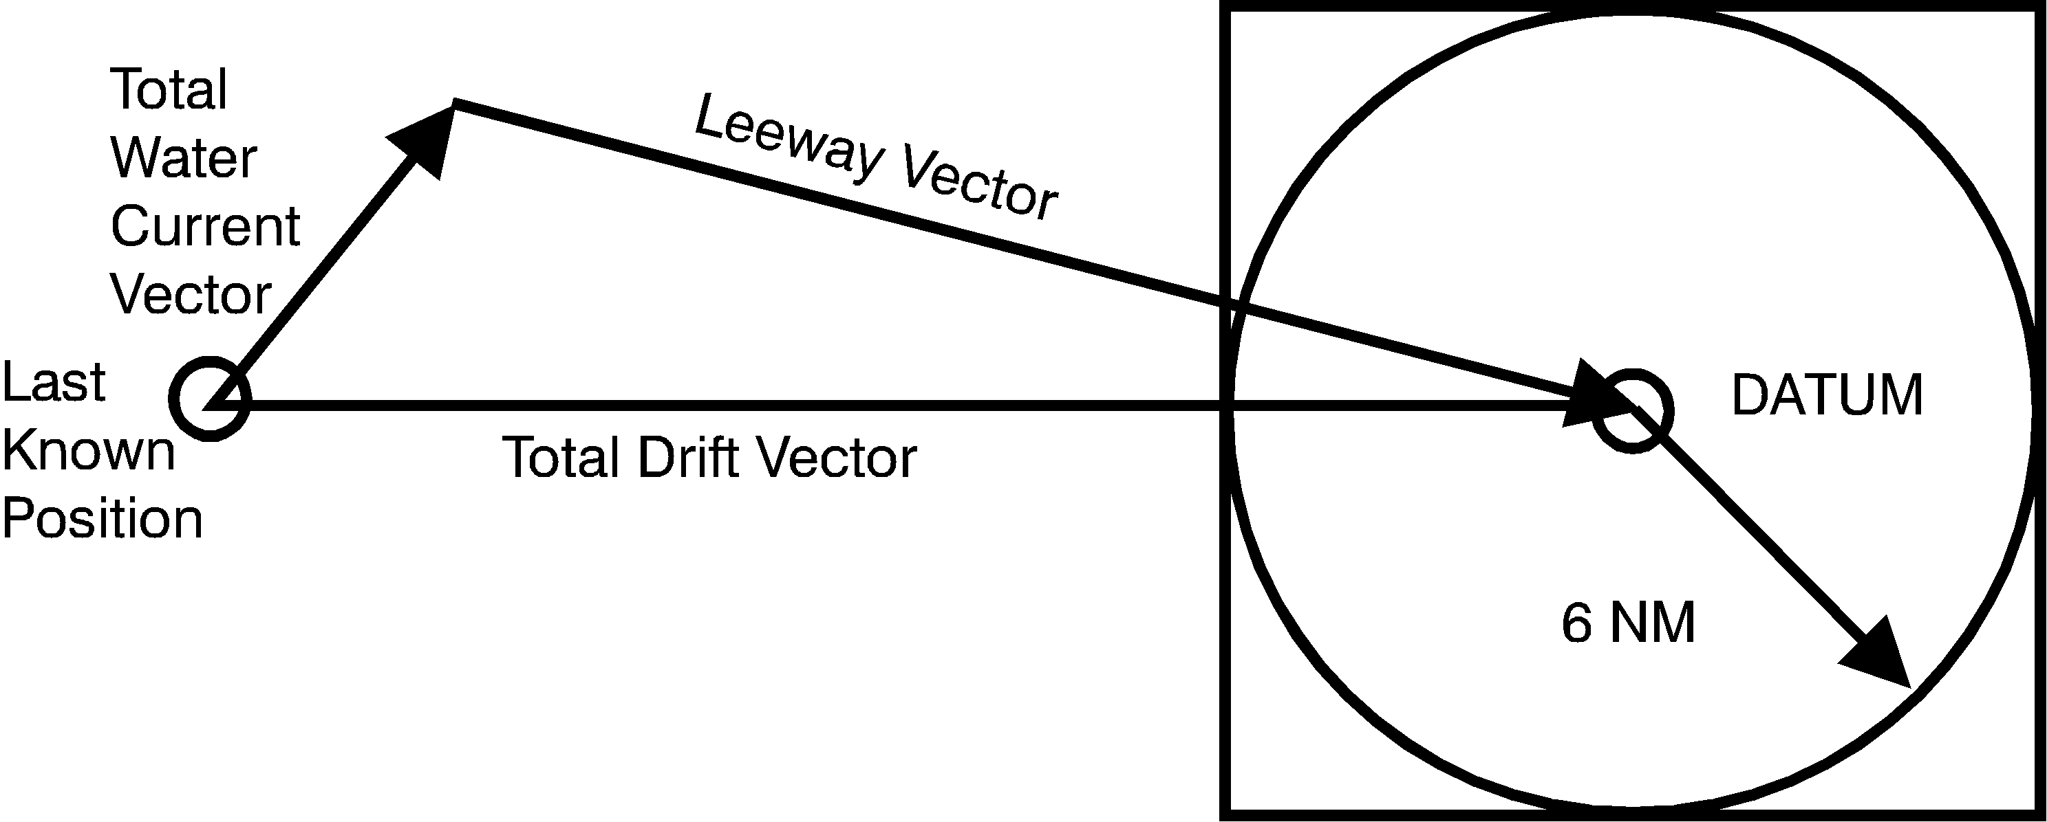

Figure 3-3 Vessel Adrift

(a) Factors to be considered for establishing this initial datum in coastal conditions are primarily tidal, river, coastal, longshore and wind driven currents. SMCs shall maintain data on water currents applicable to their local SAR environment. The annotated bibliography contained within Appendix M has excellent sources of such information.
(b) Local sources such as marinas, Coast Guard Auxiliarists, harbor masters, sailing and yacht clubs, pilot stations, oceanographic research institutions, state fish and game or park services, local sheriff and marine police, fishermen, marine operations and salvage companies may all contribute to develop a local data base of knowledge.
(c) Other references and sources of information regarding water current are outlined in reference (a). Stations and search planners are reminded that one way to determine water current and drift is by using a DMB.
(d) An extremely important source of local, real-time on-scene environmental data is fishermen and other boaters. Timely, on scene environmental data from any source should not be overlooked.

3.4.2.5 Search Area. In the coastal environment, drawing a 6 NM radius circle around datum with resulting search area is usually large enough to include most targets if 6 or less hours have elapsed. If more than 6 hours have elapsed, or other conditions indicate (position is line/area, target is unknown), the methods for determining search area as described in reference (a) should be used.

3.4.2.6 Determining the 6 NM radius. The purpose of drawing a radius around datum is to describe the geographical area most likely to contain the search object. One calculation, from reference (a), determines the radius for cases when total mission time (maximum time the search object(s) has possibly been drifting) has not been more than 4 hours. The formula uses the Total Probable Error (E), which includes the Initial Position Error (X) of the distressed craft and the Navigation Error of the SRU (Y), but does not include Drift Error (De).

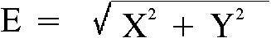

For coastal SAR cases when a SRU arrives on scene and the search object is not seen, a 5 NM position error for the distressed craft and a 1 NM navigation error for the SRU may be assumed. Using the formula, when X = 5 NM and Y = 1NM, then:





Applying the safety factor for the first search (fs = 1.1), then:







Purely for ease of calculation and plotting by initial on scene units, and past common use/familiarity by SAR planners, the SAR Program has rounded up to 6 NM.

3.4.2.7 Search Patterns. The search patterns, listed in Appendix H of reference (a) and Chapter 5 of reference (b), can be used by any search unit. The complexity of some may preclude their use by SRUs with limited navigational capability. The Square Pattern (sometimes called Expanding Square) and Sector Pattern are often the patterns used for initial search efforts. The information in the following paragraphs is provided as an aid to using these two patterns. A Course and Leg Identifier tool for these patterns is available and should be carried in SRUs for easy calculation of courses and times for each search pattern leg. This tool may be obtained through the federal supply system under DEPT. of TRANSP., USCG-PLOTTER (6-79) SN 7530-01-GF2-9010.

(a) Square Single Unit -- Sierra Sierra (SS).

- Use this pattern when confident the datum is within close limits. The first leg is normally in the direction of the search object's drift. All course changes are 90 degrees to the right.
- The pattern shown in Figure 3-4 has 1 NM track spacing. The length of each leg is indicated. For different track spacing, multiply the distances shown in the pattern by the desired track spacing to find the length of each search leg.

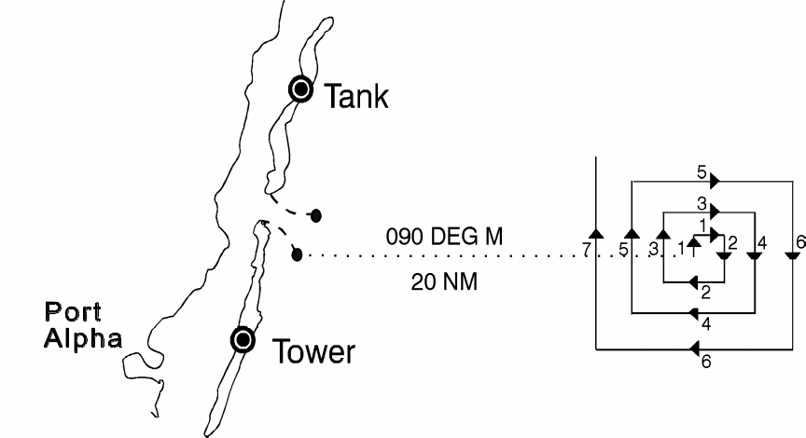

Figure 3-4 Square Pattern: Single Unit

To determine the time required to transit each leg, use Table 3-2, Square Pattern Computations. Enter the Table with the track spacing and SRU speed. Multiply the number from the Table by the length of the search leg shown in Figure 3-4 to get the time required to complete that leg at the given search speed.

EXAMPLE: Track spacing = 3 NM, speed = 10 kts:

      - Find the length of the second southerly leg. Solution: Multiply the length of the second southerly leg of Figure 3-4 (4) by the 3 NM track spacing to get 12 NM.
      - Find the time required to complete this search leg. Example: Enter Table 3-2 with a track spacing of 3 NM and a search speed of 10 knots and read the value "18:00" (18 minutes and zero seconds). Multiply this value by 4 (leg factor in Figure 3-4). The result is 72 minutes to complete the leg.

Table 3-2 Square Pattern Computations

Track Spacing | Speed (kts)
Track Spacing | 3 | 5 | 8 | 10 | 15 | 20 | 60 | 80 | 90
0.5  1.0  1.5  2.0  2.5  3.0  3.5  4.0  4.5  5.0  6.0  7.0  8.0 | 10:00  20:00  35:00  40:00  50:00  60:00 | 6:00  12:00  18:00  24:00  30:00  36:00  42:00  48:00  54:00  60:00 | 3:45  7:30  11:15  15:00  18:45  22:30  26:15  30:00  33:45  37:30  45:00  52:30  60:00 | 3:00  6:00  9:00  12:00  15:00  18:00  21:00  24:00  27:00  30:00  36:00  42:00  48:00 | 2:00  4:00  6:00  8:00  10:00  12:00  14:00  16:00  18:00  20:00  24:00  28:00  32:00 | 1:30  3:00  4:30  6:00  7:30  9:00  10:30  12:00  13:30  15:00  18:00  21:00  24:00 | 0:30  1:00  1:30  2:00  2:30  3:00  3:30  4:00  4:30  5:00  6:00  7:00  8:00 | 0.225  0:45  1:075  1:30  1:555  2:18  2:405  3:03  3:255  3:48  4:33  5:18  6:03 | 0:20  0:40  1:00  1:20  1:40  2:00  2:20  2:40  3:00  3:20  4:00  4:40  5:20
Note: All times in minutes and seconds
Note: Interpolation may be used in this table

(b) Sector Search Patterns. These patterns may be used when datum is established within close limits and the area to be searched is not extensive. The patterns resemble the spokes of a wheel and cover circular search areas. Datum is located at the center of the wheel and should be marked with a suitable floating marker. By marking datum, the SRU has a navigation check each time the SRU passes through the center of the search area. While there are many types of sector search patterns, a six-sector pattern is usually used. It consists of three equilateral triangles with one corner of each triangle at datum. See Figures 3-5 and 3-6. The search radius is also the length of the crossleg. The track spacing ranges from zero at datum to a maximum equal to the search radius at the end of each search leg. This search pattern can be used in both single and multi- unit searches. Sector searches have high Probability of Success (POS) near datum assuming the object is in the search area.
(1) Sector Search Pattern: Single Unit -- Victor Sierra (VS), Figure 3-5. When practical, the first leg of the search is normally in the direction of search object drift. All turns in this pattern are 120 degrees to the right. All legs of the search pattern are equal to the chosen radius. Upon completion of the pattern, a second pattern is started with the heading of the new first leg 30 degrees to the right of the final course of the first pattern.

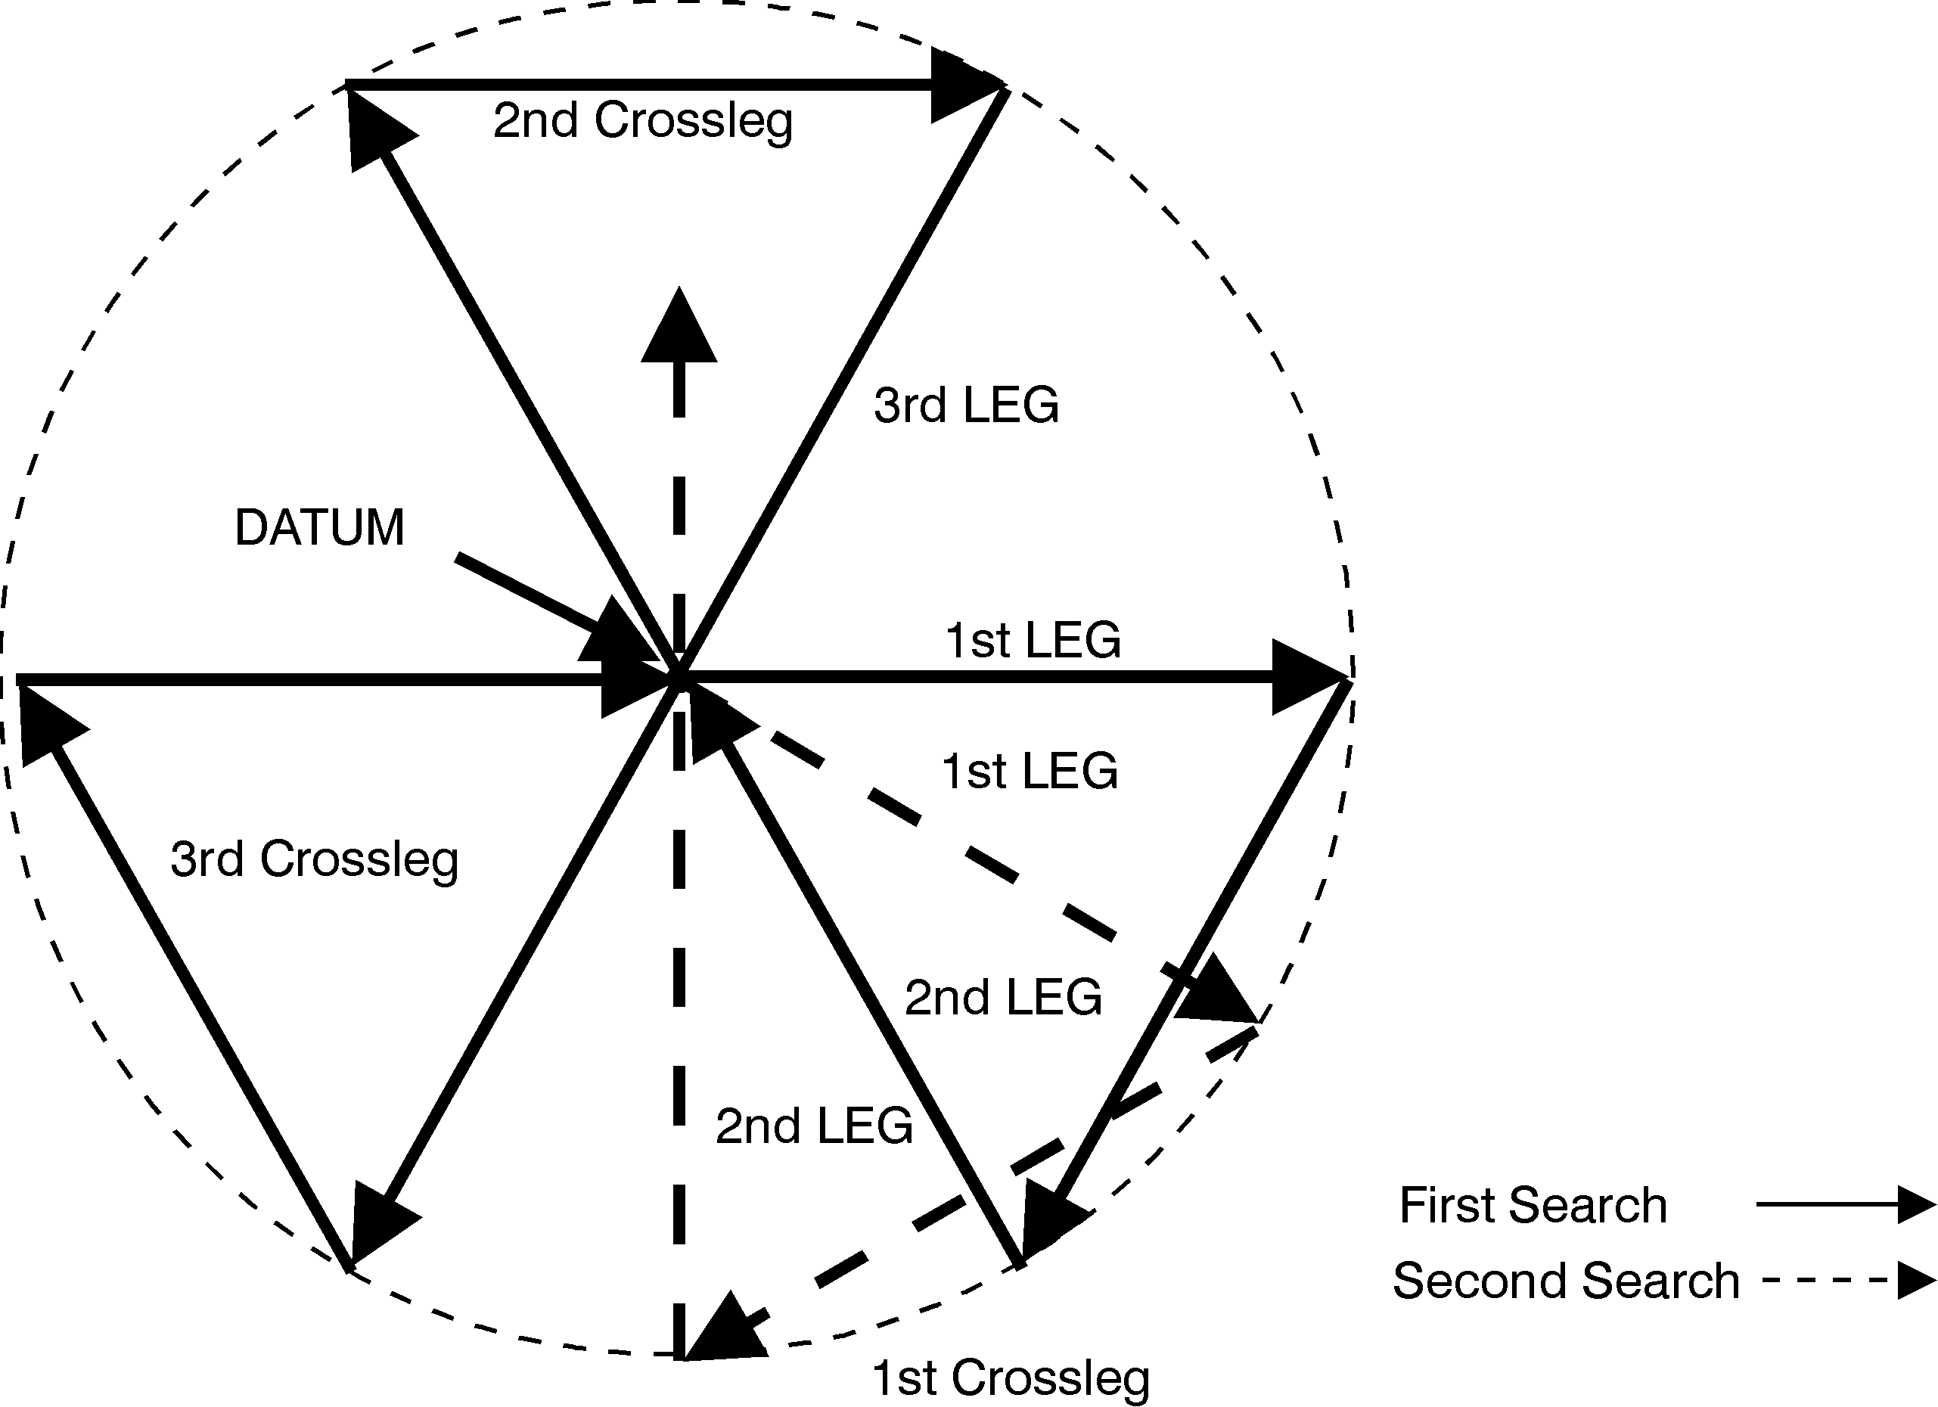

Figure 3-5 Sector Pattern: Single-Unit

(2) Sector Search Pattern: Two-Units -- Victor Mike (VM). The VM pattern is used when two SRUs are available, Figure 3-6. As the first SRU begins a Victor Sierra search, the second begins its pattern at datum in a direction of 90 degrees to the left of the first leg of the first SRU. If the SRUs arrive at datum to begin the search at the same time, the second starts at a lower speed than the first. When the first SRU is about one leg ahead of the second, the second accelerates to search speed. The slow start of the second SRU prevents the SRUs from arriving at datum at the same time. When both have completed one VM pattern, the coverage is the same as if a single SRU had completed two VS patterns.

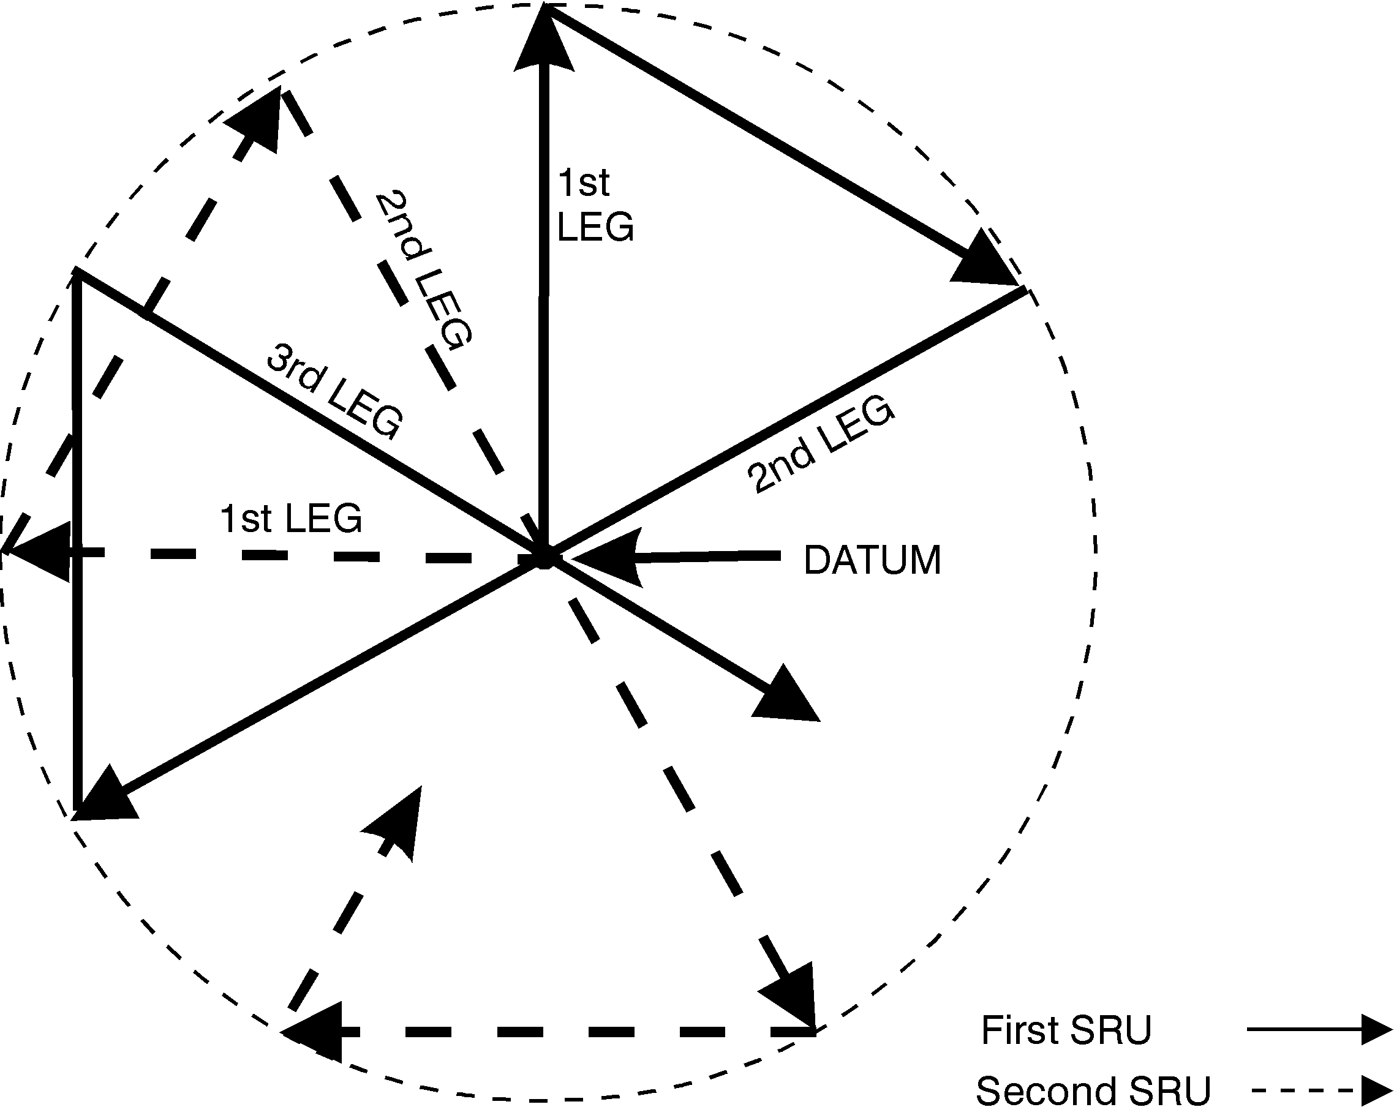

Figure 3-6 Sector Pattern: Two-Unit
(3) The sector search pattern becomes too complicated for more than two SRUs. When more than two SRUs are available, consider using a multi-unit parallel track (PM) search pattern, or dividing the search area into smaller areas and conducting single unit searches. Sector search distance and time calculations are as follows:
- To determine the distance traveled by each SRU completing a sector search, multiply the radius (R) by nine. (Trackline = 9 x R NM)
- To determine the Total Time (T) for a search, multiply the time (t) for one leg from Table 3-3 by nine. (T = 9 x t)
- To determine Total Area (A) covered in a search, square the radius (multiply the radius (R) by itself), then multiply the resultant by pi (3.14). (A = R x R x 3.14)

Table 3-3 Sector Search Computations

Radius | Speed (kts)
Radius | 3 | 5 | 8 | 10 | 15 | 20 | 60 | 80 | 90
0.5  1.0  1.5  2.0  2.5  3.0  3.5  4.0  4.5  5.0  6.0  7.0  8.0 | 10:00  20:00  30:00  40:00  50:00  60:00 | 6:00  12:00  18:00  24:00  30:00  36:00  42:00  48:00  54:00  60:00 | 3:45  7:30  11:15  15:00  18:45  22:30  26:15  30:00  33:45  37:30  45:00  52:30  60:00 | 3:00  6:00  9:00  12:00  15:00  18:00  21:00  24:00  27:00  30:00  36:00  42:00  48:00 | 2:00  4:00  6:00  8:00  10:00  12:00  14:00  16:00  18:00  20:00  24:00  28:00  32:00 | 1:30  3:00  4:30  6:00  7:30  9:00  10:30  12:00  13:30  15:00  18:00  21:00  24:00 | 0:30  1:00  1:30  2:00  2:30  3:00  3:30  4:00  4:30  5:00  6:00  7:00  8:00 | 0.225  0:45  1:075  1:30  1:555  2:18  2:405  3:03  3:255  3:48  4:33  5:18  6:03 | 0:20  0:40  1:00  1:20  1:40  2:00  2:20  2:40  3:00  3:20  4:00  4:40  5:20
Note: Time to complete one leg (t) in minutes and seconds
Note: Interpolation may be used with this table

3.4.2.8 Describing Search Areas. Search areas are described through various methods falling within the general categories of Corner Point, Boundary, Trackline, Center Point, Grid, and Georef. Chapter 5 of reference (a) provides a full description of each of these methods. In addition, the specific methods below may be useful.

(a) Center Point-Landmark. The center point, or datum, may be designated by a bearing and distance from a geographic landmark. For example: Datum bears 060 degrees M, 10 NM from "Port Alpha" South Jetty light, major axis 000 degrees M, 6 NM by 6 NM (Figure 3-7).

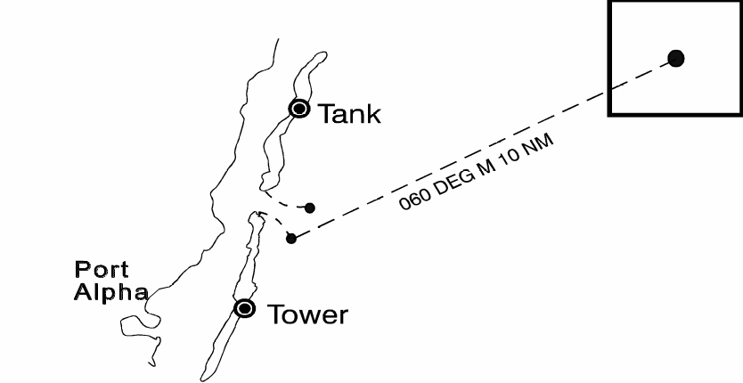

Figure 3-7 Center Point-Landmark
(b) Landmark Boundaries Method. Two or more landmarks are given as boundaries of the search area along a shoreline. For example: Search area from "Port Alpha" South Jetty, south to the Tower to 10 NM offshore (Figure 3-8).

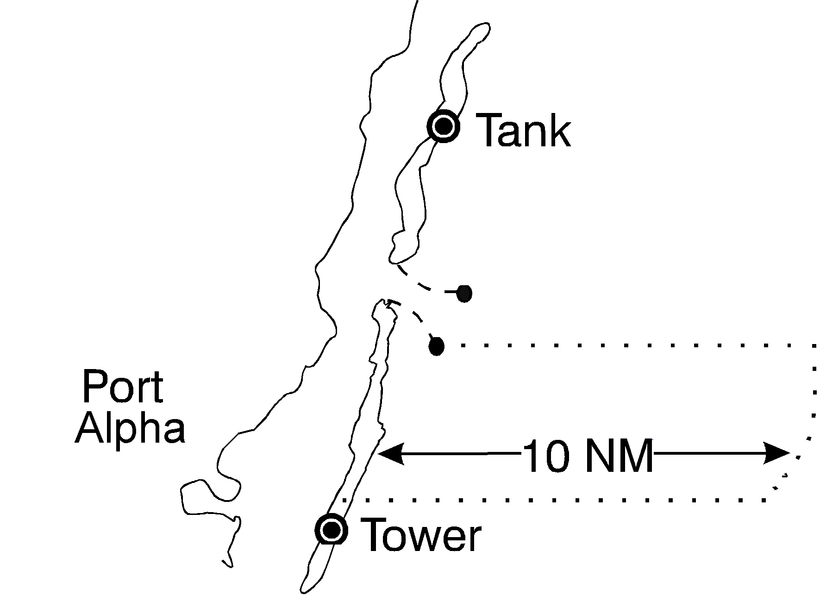

Figure 3-8 Landmark Boundaries Method

3.4.2.9 Track Spacing. Track spacing (S) is the distance between adjacent parallel search legs. The desired track spacing is a function of corrected sweep width, which is a measure of detection capability and will vary with search target type and environmental conditions. The more difficult a target is to detect, the closer together the search legs should be.
NOTE: In darkness or extremely low visibility, surface search craft should periodically stop their engines and conduct an auditory search. If it is known or if there is a high probability that the PIW has night detection aids, a search may be conducted with track spacing compatible with the sweep width for the type of detection aid.

(a) Track Spacing by target type, size and search unit. Detection capability also varies by search unit. The Tables and Graphs in Appendix H show the uncorrected visual sweep widths for search platforms for certain targets and correction factors for weather, fatigue and altitude in the case of aircraft. The most frequent search platforms used by Coast Guard resources for coastal SAR cases are small cutters (WPB), boats (MLB/UTB/UTM), and helicopters (HH-65/HH-60J). It is recommended that Coast Guard units should copy and laminate the appropriate tables from Appendix H for each SRU and include them in the SRU pilot or coxswain kit as a quick on scene reference for initial searching while more thorough search planning is being conducted.
(b) Persons in the Water (PIWs). In most cases, a track spacing of 0.1 NM is the lower practical limit for accurate surface navigation, and is recommended for coastal surface PIW searches. Helicopter SRUs should use 0.1 NM for unassisted visual searches.

3.4.3 Flare Incidents
Now that Federal law requires flares on all vessels, assistance cases are routinely affected as a result of response to flare sightings. The nature of flare distress signaling makes planning and execution of searches difficult due to: the wide variation of flare types; possible altitudes; the skill level and position of the reporting source/observer; the weather; and several other factors. For that reason, the accuracy of the initial information received from a reporting source and/or observer is most critical. As with all SAR cases, a prompt, thorough and proper response yields the greatest chance of effecting a rescue. Otherwise, the search planner may have no choice but to dispatch SRUs to search a large area to account for long range sighting possibilities. For example, a hand-held flare in a recreational boat seen on the horizon by a beach observer will be approximately 4 NM away while a parachute flare rising to 1200 feet and seen on the horizon by the same beach observer could be more than 30 NM away. Specific policies regarding response to flare incidents follow. Guidance on evaluating and planning for distress flare incidents is provided in Appendix I.
3.4.3.1 Red and orange flares and pyrotechnics are recognized as marine and aviation emergency signals and shall be treated as a distress and responded to unless available information indicates otherwise. Unresolved (insufficient information to either close or suspend) red or orange flares require first-light searches.
3.4.3.2 Searches and follow-up searches of other than red or orange flares will depend on the specifics of the case. These sightings should be carefully investigated to determine the appropriate level of response.

3.4.3.3 Initial Search Object. When a flare is observed at night, the initial search object should be the distress signaling device unless other information indicates a specific object, such as the reporting source observing the point of origin (vessel, PIW, etc.).

(a) If search object drift is required, the same provisions for target drift for first light searches should be followed.
(b) The provisions of section 3.4.5, which covers night and reduced visibility searches, should guide subsequent night searches.
(c) When a flare is observed in the day, the guidance provided for first light search objects should be followed.

3.4.3.3 First Light Search Object. When planning a first light search following a flare sighting, in the absence of local information on probable search objects, the planner should use the factors for drift associated with the object listed in Table H-3 as: power vessel/sport boats/cuddy cabin /modified v-hull. A similar object for sweep width should be chosen (power boat 20 foot) unless local information would justify another object.

3.4.4 Distress Beacon Incidents
Distress beacons are one of the most important tools available to SAR authorities. The various distress beacon systems are covered in Chapter 3 of reference (a) and Section 2.1.1.4 of this Addendum.

3.4.4.1 Risk Management Regarding Remote Alert Positions. In some instances, the indicated position for an alert is so significantly distant from available SAR resources that it is impractical to immediately dispatch resources to assist. Similarly, there are situations in which distress alert information is sketchy and the immediate dispatch of SAR resources would jeopardize the safety of others or leave a relatively large area of responsibility (AOR) without SAR coverage. In these situations, RCCs should spend a reasonable amount of time investigating and evaluating the situation prior to dispatching resources. Additionally, RCCs may attempt to alert alternative resources (e.g., Good Samaritans, Amver participants, other agencies, etc.), which may be in a position to assist.

3.4.4.2 Response Policy. In response to beacon alerts, RCCs should consider all available information such as position information, registration information, and the presence of corroborating information. RCCs should evaluate reports and attempt to correlate them with other indications of distress. Concurrently, they should attempt to obtain additional information on those involved. RCCs should expand their investigations as necessary to aggressively pursue the cause of alert signals and dispatch resources to assist, as circumstances require. Types of beacon alerts and response policy guidance are presented in Table 3-4 below.
Table 3-4 Beacon Alert and Corresponding Emergency Phase

BEACON ALERT | EMERGENCY PHASE
- 121.5/243 MHz Second Composite alert  - 406.025 MHz GEO registered alert  - 406.025 MHz LEO “A” solution alert  - 406.025 MHz LEO registered, unlocated alert | Initially evaluate as Distress
- 121.5/243 MHz First report of audible alert  - 121.5/243 MHz First Composite alert  - *406.025 MHz LEO “B” solution alert with probabilities >20% | Initially evaluate as Alert. Investigate, reevaluate and respond as facts and circumstances warrant.
- 121.5/243 MHz first alert  - *406.025 MHz LEO “B” solution alert with probabilities <20% | Initially evaluate as Uncertainty. Investigate, reevaluate and respond as facts and circumstances warrant.
*All “B” solutions should be coordinated with the “A” solution cognizant RCC in evaluating and/or responding to alert/distress candidate “B” solutions. Always check vessel type/description and homeport/registration POC data against alert position. This practice can help flag correct “B” solutions.

(a) Audible beacon alerts don't always indicate distress. Historically, many of these alerts have been false alarms resulting from hard aircraft landings or caused by crew error during vessel maintenance. Reports of audible beacon alerts indicate a beacon has been activated. SAR response to an audible beacon signal should be similar to the type of response provided for flare sightings. In cases where Coast Guard resources hear the beacon, they normally respond immediately and determine the signal source. Most other audible signal reports come from commercial aircraft and will help determine general beacon location.
(b) 406.025 MHz Beacon COSPAS-SARSAT Alerts. Since 1990, the marine community has been moving EPIRBs to a solely dedicated frequency for satellite distress beacons, 406.025 MHz. Use of this frequency will minimize interference problems. In addition, satellite software recognizes and relays only coded 406 MHz beacon signals, minimizing false alerts. The Coast Guard endorses the 406.025 MHz EPIRB as the preferred beacon type. Accordingly, response to 406.025 MHz beacon alerts is immediate, keeping in mind the precepts of risk management.

(1) First alerts and composite solutions for 406 MHz beacons indicate a beacon has been activated. SAR response to a 406 MHz beacon alert should approximate response to a MAYDAY. The 406 MHz COSPAS-SARSAT system and equipment yield high confidence alerts and positions. However, factors such as satellite pass geometry, atmospheric anomalies, and beacon oscillator stability may degrade the beacon signal and position data. Any alert degradation is usually reflected in the split between A and B solution probabilities on first alert messages.
(2) Registered but Unlocated 406 MHz Alerts. Treat registered, but unlocated 406 MHz alerts as distress, exploit all reasonable means to ascertain distress position and assist the party in distress, including issuing a UMIB.

- Registered, but unlocated 406 MHz alerts signal distress, but contain no position information. In order to render assistance we must exploit all reasonable means to ascertain at least a general distress position. Armed with a general position or usual operating area and suitable homing capable response assets, we are able to render timely, effective assistance.
- EPIRB registration points of contact are usually the most promising leads for information, particularly for position, situation and further points of contact. In addition, UMIBs should be used as a means to determine distress position and to maximize resource of opportunity response, unless there are compelling reasons to the contrary. When only general position information is available, suitable aircraft should be launched to exploit the 406 MHz beacon's 121.5 homing signal.
- For incidents where no position information other than homeport is available, issuing a UMIB in the vessel's homeport area is appropriate.

(3) 50/50 Split Solutions. 50/50 splits are no different then other A/B solutions and merely indicate the relative probability is for either solution to be the actual location of the beacon.

(c) 121.5/243 MHz Beacon COSPAS-SARSAT Alerts. 121.5/243 MHz first alerts and even composite solutions don't always indicate a beacon has been activated. On average only 1% of first alerts are actual distresses. Spurious signal detections, due mainly to non-beacon emissions, cause numerous false alerts. Spurious signal sources include voice transmissions on 121.5/243 MHz, garage door openers, microwave transmissions, pachinko machines, satellite TV systems, computers and other systems.

- Because of their high false alert and false alarm rates, 121.5/243 MHz First Alerts, in and of themselves, initiate the Uncertainty Emergency Phase. RCCs should aggressively attempt to corroborate 121.5/243 MHz first alerts with any other potential distress information. RCCs should normally dispatch resources when they obtain amplifying information such as highflier audible reports and overdue or other distress reports. Following a first alert, RCCs will normally receive a composite solution, provided the beacon continues to transmit, within 48 minutes (average range from 30 - 90 minutes).
- The first Composite solution from a 121.5/243 MHz beacon alert corresponds, at a minimum, to the Alert Emergency Phase. RCCs should track the geographic position of composite solutions and respond accordingly. While composite solutions located at or near local airports are often non-distress, some have been caused by unreported aircraft crashes. A Second composite solution from a 121.5/243 MHz beacon alert corresponds, at a minimum, to the Distress Emergency Phase.

(d) Alert Query Reports. In pursuing amplifying distress information, RCCs may query the USMCC database to see whether or not a particular 406 MHz beacon has been activated, or to check for all beacon activations over a specific time period or in a specific area. RCCs may do so by requesting an Alert Query Report from the USMCC. The USMCC user's manual, reference (r), has more information on this process and guidelines for interpreting these reports.

(e) Limitations of the System. As with any tool, search planners must be aware of system limitations. False alarms (inadvertent activations or hoaxes), non-beacon alerts, and unresolved beacon alerts reduce the efficiency of the C-S system. Operator misuse, equipment malfunctions, improper testing, and hoaxes may downgrade beacon effectiveness. Unresolved alerts are predominantly associated with 121.5/243 MHz, which is a congested aviation distress frequency. In addition, many false alerts are caused by non-beacon emissions, harmonics emanating from transmissions on those frequencies, and numerous other signal sources in this frequency band. While 121.5/243 MHz beacon alerts provide two equally possible beacon positions, requiring the RCC to wait for another satellite pass prior to dispatching resources, the A solution on a 406 MHz first alert will be the correct position 95% of the time. SAR resources can reasonably be dispatched immediately upon receipt of a 406 MHz first alert. A composite solution will be received, provided the beacon continues to transmit, usually within 60 minutes (average range from 45 - 90 minutes). Table 3-5 compares 121.5/243 MHz and 406 MHz beacons.

3.4.4.3 Policy on Follow-up to False Alarms. Results of beacon activation investigations are essential to improve the system. Units should ensure personnel aggressively pursue and document the cause of all accidental and inadvertent beacon alerts.

- Historically, problem areas include bracket failures, improper switch setting and marking, operator error, and water intrusion. False alarm information obtained by the Coast Guard should be passed to beacon manufacturers to improve beacon/bracket design or to improve national and international standards.

Table 3-5 406 MHz and 121.5 MHz Beacons Comparison Table
406 MHz Beacons | 121.5 MHz Beacons
Coverage:  Global | Coverage:  Ground station dependent; ground stations have an effective radius of about 1800NM. Current coverage: about one-third of the world.
Reliability -- False  Alerts/False Alarms:  All alerts come from beacons. Satellite beacon transmissions are digital, coded signals. Satellites process only coded data, other signals are rejected.  About 1 in 10 alerts are actual distresses.  Individual beacon-unique coding and registration allow rapid incident corroboration. About 70% of 406 MHz beacons are registered. More than 80% of 406 MHz false alarms are resolved by a phone call. | Reliability -- False  Alerts/False Alarms:  Only about 1 in 4 alerts come from beacons. Satellites cannot discern beacon sources from many non-beacon 121.5 MHz sources.  Fewer than 1 in 100 alerts are actual distress.  121.5 MHz beacons transmit anonymously. The only way to ascertain the situation is to dispatch resources to investigate -- a costly disadvantage.
Alerting:  First alert confidence is sufficient to warrant launch of SAR assets. Earlier launches put assets on scene earlier—average 2 hrs saved in maritime, 6 hrs in inland. These savings are survival significant. Estimates put 406 MHz ELT lives saved potential at more than 100 per year in the U.S. alone.  Average initial detection/alerting by orbiting satellites is about 45 minutes -- worst case about 60 minutes.  Average time between subsequent satellite passes is about 60 minutes.  Vessel/aircraft ID, point of contact information provided with alerts allows rapid corroboration or stand-down.  Allows false alarm follow-up to continuously improve system integrity/reliability.  Near instantaneous detection by geostationary satellites. | Alerting:  High false alarm rate makes first-alert launch infeasible. Absent independent distress corroboration RCCs must wait for additional alert information. 121.5 MHz beacon launch decisions take six hours longer than for 406 MHz beacons on average (based on inland region data). Almost half of aviation accident survivors perish in the first six hours after the incident.  Same as 406 MHz  Same as 406 MHz  Alerts are anonymous. 121.5 MHz technology not capable of transmitting data.  No capability  No capability
Position Information:  2-5 km accuracy on average. Position calculated by doppler shift analysis.  Capable of processing beacon transmitted position information from independent source, e.g.: GPS. | Position Information:  10-20 km accuracy on average. Position calculated by doppler shift analysis.  No capability
Locating the Target:  Superior alert position accuracy limits initial position uncertainty to about 40 sq. km.  121.5 MHz homing signal facilitates target location by radio detection finder equipped search units. | Locating the Target:  Initial position uncertainty is about 700 sq. km. on average.  Same as 406 MHz

- In all cases, investigating personnel should educate beacon users on proper registration procedures and beacon usage. Coast Guard personnel should follow guidance in reference (o) and other appropriate directives in reporting all incidents to the FCC, advising them of the incident and of the actions taken. In the case of first-time offenders, the District Commander in which the vessel is registered should send an administrative letter to the owner expressing concern from a SAR and safety perspective. This letter should remind them of the importance of up-to-date beacon registration (for 406 MHz and other "registered" beacons), and user training and knowledge of EPIRB and ELT systems. In the case of repeat offenders, close coordination with the beacon owner and the manufacturer can help identify beacon problems and operator errors.

3.4.4.4 Registration/Follow-up Policy. All Coast Guard and Coast Guard Auxiliary units should have spare 406 MHz EPIRB registration cards for users to fill out and mail to the USMCC. A sample registration card is in Appendix J. It is mandatory for the owner to register the 406 MHz beacon. Coast Guard personnel shall provide registration cards and encouragement for owners to complete their beacon registrations. In addition, units should relay registration information to the USMCC. Other beacon types are registered in various ways. Units should strongly encourage beacon owners to "register" as soon as possible.

3.4.4.5 Improper Use of EPIRBS as DMBs. EPIRBs are distress beacons. As such, search planners shall not normally use them as DMBs. While it may seem convenient at times to leave an EPIRB drifting to mark datum during a SAR case, that beacon's signal may prevent another distress beacon from being properly tracked or heard.

- SLDMBs are the appropriate tools for marking datum in extended search cases. When located, EPIRBs shall be recovered and, whenever necessary and possible, SLDMBs deployed in the same position to mark datum. Standard radio DMBs work fairly well when no SLDMBs are available.
- In situations where the EPIRB is the only means of marking datum, close coordination between the SMC and the USMCC will be required.

3.4.5 Night and Reduced Visibility Searches
Reduced visibility, either due to night or weather, significantly reduces the effectiveness of a search, particularly for objects that are not readily located using radar or other electronic sensors. For planning and conducting searches during night or under otherwise reduced visibility conditions, the following guidance is provided.

3.4.5.1 Timeliness. In addition to SAR incidents occurring at night, it is common for incidents to occur towards the end of the day when mariners are returning (or due to return) from a day on the water. A rapid response with a full search using the remaining daylight may obviate the need for a night search. For searches with reduced visibility in daylight hours, getting search units into the area rapidly will provide some search coverage and facilitate a rapid resumption of full search capability should conditions improve.

3.4.5.2 Search units. The choice of search units, air or surface, depends greatly on safety of operations under the given conditions, the search object, and the sensors available on the various search units.

(a) With reduced visibility it is imperative to employ those search units with the best sensors for the conditions.
(b) The expected duration of reduced visibility conditions will also dictate, to some degree, the choice of search units. If reduced visibility is expected for only a short period, surface units may proceed into the search area immediately while air units, which can arrive more rapidly, may be timed to arrive when conditions are improved. For reduced visibility of longer duration, the decision to use surface and air search units will be more dependent on search object, the sensors available on each search unit, and the effectiveness of those sensors for existing weather conditions.
(c) There may be times when conditions do not permit units to conduct a search such as severe storms. Although not able to effectively search, deploying a surface unit in the search area ready to respond rapidly to a signal or chance sighting should be considered. When this occurs, risk management mitigation strategies must be employed.
(d) Keeping a search unit in the area during reduced visibility is also important for survivor confidence. Sighting a search unit in the area lets survivors know the search is still on and will bolster their will to live.

3.4.5.2 Search object. The ability to detect an object is based on the sensors available on assigned search units. Depending on the incident and sensors available, the primary search object may be something other then the overall object of the search.

(a) Unaided visual searches at night will not readily detect unlit objects. Even large vessels may be hard to detect if not illuminated and smaller objects such as rafts and persons in the water are nearly impossible to see. Under such conditions the primary search object should be a night signaling device (flare, strobe, light).
(b) Enhanced visual searches using night vision goggles under favorable conditions will permit searchers to keep a PIW or small craft as the primary search object. The night vision goggles can take advantage of less bright light sources and reflective surfaces or materials.
(c) Night searches following a flare should have a primary search object of additional signaling devices. Sensors for other then visual search should also be utilized so that objects of interest within the search area may be investigated.

3.4.5.3 Search tactics. Searchers should utilize all possible means of detecting search objects, visual, electronic, and aural. These tactics are dependent on accurate search planning and coordination. The following should be considered in the planning and conduct of a reduced visibility search:

(a) The SMC should be fully aware of on scene conditions, as searches begin and any changes that occur during the search. Search units should pass to the SMC (or OSC if one is assigned), conditions upon arrival on scene and any changes. This information is critical to assigning appropriate track spacing to achieve the desired search results.
(b) At night all unnecessary lighting on search units should be secured, electronics lighting should be shifted to low light mode to minimize glare on the inside of windows and to preserve night vision.
(c) If the distressed craft or survivors are known to have distress signals, it is important for search units to make their presence known in hopes of getting the survivors to signal. Often the navigation lights alone may not be enough and additional lighting (blue light, search light) may be necessary to get a response. This tactic may be most appropriate for early on searches. The need to limit excess light for night vision considerations may be more appropriate for later searches where there has been ample opportunity for survivors to discharge or use any signaling devices.
(d) If a debris field is discovered, it may be appropriate for search crews to use lights or flares to illuminate the area to enable a better visual search of the concentrated area. This may mean sacrificing night vision for the crew in hopes of spotting PIWs or reflective material that the lights may illuminate.
(e) Ambient light sources should be exploited in a search.

(1) With bright shoreline lights, light colored objects or objects with reflective material in particular may be illuminated enough for the unaided eye to detect, while detection using NVGs will be greatly improved.
(2) A full or near full moon can also provide enough light for the unaided eye to detect a target and greatly improves NVG effectiveness. The reflection of the moon on the water also can be used to search for objects as it “moves” across the surface with the search unit’s motion. This is particularly effective in calm conditions with the moon low in the sky.
(3) Large backlit objects may also provide a detectible profile when searching along a well-lit shoreline.

(f) Electronic sensors should be set according to search object as discussed in 3.4.6 below.
(g) On surface search units the engines should be secured (brought to idle if securing not possible) and all other noise minimized in order to call out to and hear calls from survivors. This is a particularly good practice when encountering a debris field or at regular intervals even though no debris is present.
(h) Search units should check buoys and fixed aids in the vicinity. PIWs may swim to something that floats or provides them some form of stability.

3.4.6 Electronic Sensors and Sensor Searches

3.4.6.1 Surface Vessel Radar. Appendix H contains recommended sweep width tables for surface vessel radar. In addition, the following information should be considered when planning searches utilizing surface vessel radars:

- The effective search range of radars varies greatly. (The AN/SPS-64(V) was found to be more effective for small targets than the AN/SPS-66 model.)
- The AN/SPS-64(V) and AN/SPS-66 models both provided better search performance at the 3 NM scale than the 6 NM scale.
- Radar range sweep widths for small targets should only be applied in low sea states.
- Radar reflective devices significantly improved target detection probability.
- The decision of whether or not to utilize the surface vessel radar in a search, especially if it requires dedicating a crewperson who could be used for visual search, should be based on a comparison of the radar sweep width to those for other available sensors. Surface radar searches will generally be preferred when visibility is poor, sea state is low to moderate, and the target is equipped with a radar reflector. Radar sweep widths deteriorate rapidly with the onset of precipitation and/or seas of greater than 4 feet.
- Visual scanners should concentrate on the area in the immediate vicinity of the search unit during low visibility radar searches to avoid missing targets that pass through the area of heavy sea return.

3.4.6.2 Forward-Looking Airborne Radars (FLAR). The Coast Guard Research and Development Center has conducted research on Coast Guard fixed wing aircraft to determine detection capabilities of FLARs for SAR operations. From detection data collected under realistic search scenarios estimates of sweep width have been calculated. Appendix H includes the recommended sweep widths for the AN/APS-137, AN/APN-215, AN/APS-127, and RDR-1300.

(a) The AN/APS-137 radar, installed on the Coast Guard's HC-130 fleet, was evaluated for SAR target detection during three field tests conducted by the Coast Guard R&D Center and were reported on in Coast Guard R&D Reports CG-D-14-93, CG-D-07-94, and CG-D-18-94. The AN/APS-137 FLAR is an X-band, air-to-surface Inverse Synthetic Aperture Radar (ISAR) that provides high resolution, small-target detection, weather avoidance, sea surveillance, and Doppler display. The AN/APS-137 system has special selectable features that enhance system performance against weak targets. Sweep width recommendations for conducting and planning AN/APS-137 (aircraft) SAR searches are provided in Appendix H.
(b) The RDR-1300 model radar is found on the HH-65 and HH-60J aircraft. This radar is comparable to the APS-215 and the sweep width tables corresponding to the APS-215 are applicable for searches conducted using the RDR-1300 radar.

3.4.6.3 Side-Looking Airborne Radar (SLAR). Side-looking airborne radar is installed on some Coast Guard fixed wing aircraft. The AN/APS-135 model is currently installed on two C-130s at CGAS, Elizabeth City and the AN/APS-131 model is found on the HU-25Bs at CGAS, Cape Cod. The main difference between the models is the length of the antenna.

(a) The AN/APS-131 model SLAR on the HU-25B aircraft is part of the AIREYE system. The AIREYE system was developed primarily as an oil pollution surveillance resource. The system includes infrared/ultraviolet (IR/UV) line scanning device and a KS-87B Aerial Mapping camera. The IR/UV and camera have very limited applicability to SAR. When doing electronic searches the HU-25B aircraft should rely on the AN/APS-131 in combination with its FLAR, the AN/APS-127, and not the IR/UV or mapping camera.
(b) Recommended sweep widths for SLAR on Coast Guard aircraft are shown in Appendix H. Specific findings of the research that are of interest to SAR planners are:

- SLAR models tested are capable of detecting 180-foot ships nearly 100% of the time in seas up to at least 6 feet and ranges up to 30 NM.
- Targets as small as 16-foot boats with metal equipment (engine, gas tanks, frames, etc.) can be detected better than 90% of the time in seas less than 3 feet and 30% - 50% of the time in seas of 3-6 feet. These targets can be detected in low sea states out to the 30 NM swath width limit.
- Four to ten person life rafts can be detected 40% to 70% of the time in seas less than 3 feet, but can be detected less than 15% of the time in seas of 3 to 6 feet.

(c) Presently these SLAR equipped aircraft are the primary iceberg surveillance platforms for the International Ice Patrol.
(d) SLAR has limited use during a search. SLAR is essentially an aerial surveying system. To adequately survey an area, the aircraft must fly level and straight. The SLAR aircraft or other SRUs can then identify the resultant SLAR film’s targets.

3.4.6.4 Forward-Looking Infrared System (FLIR). FLIR data was collected in experiments conducted by the Coast Guard Research and Development Center. These studies tested the Northrop Corporation SeaHawk FLIR system, which is not being carried on any Coast Guard aircraft. Chapter 4 of this Addendum lists which Coast Guard aircraft carry FLIR capability.

(a) Extensive testing of FLIR as a SAR search resource with various targets has not been conducted. FLIR has a very narrow field of view. Most units operate with a 7-15 degree field of view. Recommended sweep widths and altitudes for use of FLIR are contained in Appendix H. Sweep widths should not exceed the effective azimuthal coverage of the system in use. Appendix H also contains illustrations of how to estimate a sweep width for a FLIR unit.

3.4.6.5 Night Vision Goggles (NVG). Many SAR incidents occur or become known to the Coast Guard during the afternoon or night. The greatest benefit of NVG is that this sensor enables searchers to conduct effective searches at night, thus search planners will not have to wait until first light the following day to begin effective visual searches. This will increase the probability of survival for those persons in distress. Research showed NVG searches from UTBs are not recommended because the lookouts are prone to seasickness when using NVG, but they are effective from aircraft. Sweep Width Tables for NVG Searches are provided in Appendix H.

3.4.6.6 Photo Reconnaissance Support. Photo reconnaissance is one resource that may have limited benefit in locating those in distress in a large maritime search area. Aircraft equipped for highflying photography include the Coast Guard HU-25B with a KS-87B camera and U.S. Air Force aircraft.

(a) High flying reconnaissance aircraft have the capability of covering large areas, up to 20,000 square nautical miles for example, with photographs that are developed and interpreted by technicians. If the sky is cloud free, the cameras cover the area thoroughly; however, specially trained technicians have to search the photographs, not unlike a crewmember on a search aircraft.
(b) The technicians thoroughly review the photographs looking for the search object; difficult and time-consuming work. Interpreting technicians have little experience with photographs of open ocean, since they usually look for ground sites using various reference points such as roads, forests, communities, etc. There are no such reference points at sea and this makes the "photograph search" more difficult. Also, they are often unfamiliar with what search objects look like from the air for identification purposes. The successful outcome of a search by these reconnaissance aircraft is solely dependent on the interpreting technician finding the object.
(c) In past SAR cases, the Coast Guard has requested Air Force aircraft use colored film. These requests were made under the assumption that the search objects will be more easily found due to the color contrast with the surface of the water than by the contrast on black and white film. Some limited testing by the Air Force was done with color film and high altitude aircraft during 1987. These tests were conducted under ideal weather conditions with minimal cloud cover and known targets in fixed positions. It was determined that small, brightly colored objects, such as a one-man yellow life raft could be detected, but dark objects were more difficult to find, and a one-man black life raft failed to be detected at all. Black and white film has not been tested for maritime searches, though it might be most suitable for large craft such as a fishing vessel. Coast Guard HU-25B aircraft equipped with a KS-87B camera will take black and white pictures only.
(d) Planners can assume that it will take at least one day to get the approval and establish the operations plan for the aircraft. After completion of the flight it may be another day for black and white film to be processed and interpreted. If color film is used the process may take longer because of the special processing that has to be done by one of the limited number of resources. Black and white film is normally processed and interpreted at the home base of the Air Force aircraft.
(e) Due to limited testing and low historical success rate, the Air Force, by agreement with the Coast Guard, will provide aircraft for photo reconnaissance support of SAR, only if requested by proper authority and under certain conditions. USAF policy regarding use of these aircraft for SAR support was promulgated by reference (s). The guidelines established by this directive are as follows:

- Use of high flying reconnaissance aircraft for all SAR efforts will be on a strict noninterference minimum cost basis. Scheduled operational requirements and priority training will normally not be rescheduled.
- U.S. Air Force Strategic Air Command (SAC/DORS) shall determine the availability of aircraft support based on area coverage, range, weather, type of film requested, mission and training impacts, etc.
- Unless directed by higher authority, only black and white film products shall be used. If color film is specifically required, the requester must coordinate handling procedures and possible cost reimbursement for film processing and exploitation.
- SAC/DORS will advise Air Force Headquarters of the SAR request and intended plan of action.
- "Special interest" situations involving Headquarters USAF or USCG, or Congressional directed SAR support shall be approved on a case-by-case basis at the air staff level. Air Force Headquarters will coordinate such cases with appropriate major commands, Headquarters ACC and Headquarters USCG, as required.

(f) The following procedures apply to Coast Guard commands:

- All Coast Guard requests for photo reconnaissance support of SAR are to be made through the operational chain of command to the appropriate Area OPCEN. If the Area determines that this type of support is appropriate for the case, the Area shall initiate a request to USAF Headquarters Strategic Air Command (SAC)/DORS via AFRCC, Langley AFB, VA. If high flying assets are made available, the SMC will then be authorized direct liaison for passing SAR planning/execution information. The Area is to be kept informed of the status of the mission.
- Initial communications should be made by telephone, followed by formal request message. This will give the Area and SAC a heads up to an incoming request so time will not be lost waiting for record traffic. Commandant (G-OPR) shall be information addressee on all message communications involving a request for photo reconnaissance support.

(g) The above guidance is meant to be restrictive due to the expense of using these resources and their limited application to maritime SAR. However, when it is determined that a particular case may benefit by utilizing these resources, search planners should begin the request process as early as possible. These resources take considerable time to arrange and receive the final result of interpretation. An example of a beneficial use may be when the forecast is for bad weather that will preclude normal searching. Photo imagery collected before weather sets in could be studied while other resources are grounded.
(h) Applicable USAF phone contact numbers (SAC/DORS) are:

- During working hours: Autovon 271-5417, Commercial (402) 294-5417
- After working hours: Autovon 271-5707, Commercial (402) 294-5707

(i) The USAF message address is:

- STRATRECONCEN OFFUTT AFB NE//DORS//

3.4.7 Searches for Bodies
Coast Guard units are often requested to search for bodies. However, Coast Guard units are not provided the specific gear (e.g., dragging equipment, etc.) or training to conduct such searches. As per Chapter 4 of the USCG Regulations, "when it has become definitely established, either by time or circumstances, that persons are dead, the Coast Guard is not required to conduct searches for bodies. If, however, requests are received from responsible agencies, such as local police, military commands, etc., Coast Guard units may participate in body searches provided that these searches do not interfere with the primary duties of the units." The participation normally is confined to a surface search or support platform for other agencies to use their equipment.

3.4.8 Aircraft Incidents
Aircraft incidents present a particular challenge to SAR planners. The speed of aircraft and the distance they can travel in a short period of time often makes determining datum difficult. Once determined, the datum is rarely a well-defined point and results in a large initial search area. Various systems associated with aviation safety and tracking can assist in narrowing initial datum and reduce the area to be searched.

3.4.8.1 Emergency Locator Transmitters (ELTs), if operating properly following an aircraft crash or ditching, may provide a position through Sarsat or direction finding by SAR assets. However, once in the water aircraft rarely stay afloat and submerged ELTs will cease to provide a signal.

3.4.8.2 Aviation tracking radar systems are present throughout the United States and along the coast for defense and tracking of civil aviation. Several radar-tracking systems are covered in Chapter 2 of reference (a).

(a) Hill AFB provides technical certification and service for a nationwide array of linked air defense radar’s that may provide valuable “near real-time” information to search and rescue planners prosecuting maritime and/or inland aircraft incidents. The radar information is fully archived for a 90-day period and playback of the event can give a “near real-time” dynamic picture of the subject aircraft’s activities leading up to, and at the time of, the incident. Some of this information may be available from the local Air Route Traffic Control Center (ARTCC), which provides greater radar coverage, both in geographic areas and in lower altitudes. It archives “RAW” or “SKIN PAINT” aircraft radar contact information, while the information that is available to ARTCC systems is generally filtered to show only radar information from aircraft that are using a transponder. RCC requests for this information should be made directly to one of the three points of contact given below. If the incident did not occur within that particular Air Defense Sector’s (ADS) AOR, they will refer the RCC to the appropriate ADS for the incident.

CONTACTS
SAR requests (24 hours): Air Defense Sector (ADS)
Mission Crew Commander (MCC)
Western ADS | (253) 984-4311/4312
Southeast ADS | (850) 283-5205/5206
Northeast ADS | (315) 334-6802
84 RADES:
Director of Operations | (801) 777-2047
Fax | (801) 777-3268
Hill AFB Command Post 24 hr pager to 84 RADES | (801) 777-3007

(b) Shortly after contact, the ADS should be able to furnish a last known position of the incident aircraft. Give ADS as much information as possible, as the radar system archives ALL air contacts received, and the incident aircraft must be selected from the data available. Within a period of up to a few hours, they will be able to call in an analyst who will review the radar system’s archived information, review the available data and update the information. ADS will provide an electronic copy of the aircraft incident to the RCC, and assist in its interpretation. This playback will generally fit on a single floppy diskette and/or may be sent electronically. No special hardware or software is required to perform the playback; it will perform well on CGSWIII. The playback may be advanced rapidly, slowed, and paused as required. Each data point of the incident may be “clicked” to show that data point’s related information, such as altitude, etc. Copies of the given screen pictures are also easily made using the existing “ALT-PRINT SCREEN” buttons on your PC (for Windows95 and Windows NT systems) and copying that information into the program of your choice. NO special training is required.

3.4.9 Uncorrelated Distress Broadcasts
This section provides the standard Coast Guard procedures to be used in prosecuting uncorrelated distress broadcasts. An uncorrelated distress broadcast is a distress broadcast that does not include position and/or identification information sufficient to generate a reasonable search area. A distress broadcast may use the internationally recognized distress word "MAYDAY" or any number of words that would indicate a need for assistance including, but not limited to, help, emergency, trouble, sinking, etc.

3.4.9.1 Thousands of distress broadcasts are received on VHF-FM channel 16 by Coast Guard units each year. Some are made by mariners who may not be able to transmit more than a single broadcast before the condition of their vessel, communication gear or a person renders them unable to transmit additional information. In these cases, we do not have the opportunity to establish direct communications with the caller, and may not be able to ascertain a location or identification. These situations severely hamper the Coast Guard’s search planning and rescue coordination efforts. Regrettably, we also receive distress calls from calling parties with the clear intention to mislead or deceive our watchstanders. Despite this fact, all distress broadcasts shall be treated as legitimate distress calls unless determined otherwise.

3.4.9.2 Watchstanders shall initially treat all distress broadcasts as distress incidents. All distress broadcast incidents shall be aggressively prosecuted and carefully documented.

- The SAR mission coordinator (SMC) shall issue an urgent marine information broadcast (UMIB) for all distress situations, unless clearly not warranted. This is the minimum response requirement for uncorrelated distress broadcasts – callouts are not sufficient. The UMIB shall include text requesting mariners and shore stations that heard the distress broadcast to contact the Coast Guard with their position. The UMIB shall be broadcast for at least one hour at 15-minute intervals.
(1) Based on information provided as feedback or lack of feedback, the UMIB should be modified to take advantage of this information.
- When sufficient information exists to establish a reasonable search area, the SMC shall launch appropriate resources to respond to a distress broadcast. In the absence of such information, search planners shall engage in aggressive detective work, using all means at their disposal to narrow down a search area, including:

  - Analysis of high site reception. When an uncorrelated distress broadcast is received on two intersecting hi-sites, a reasonable search area may be developed from the overlapping area (depending on the size of overlapping area). In some cases reception on a single hi-site may result in a searchable area due to the form of the geographic area in relation to hi-site location. Not receiving the distress broadcast on adjacent hi-sites may also allow elimination of overlap areas in initial search efforts.
  - Queries to ascertain if other boats or shore based radios heard the call over low-level antennas. This should be accomplished via the UMIB. Additional queries may be made to refine this information. Knowledge of low-level antenna reception may yield additional reception area arcs, further narrowing the probable location of the distressed caller.
  - Replay the transmission. For all uncorrelated distress broadcast cases, the SMC should immediately review recorded transmissions. The SMC should also immediately review all channel 16 transmissions addressed to the Coast Guard that cannot be readily identified as non-emergent. If possible, several different individuals should listen to the transmission to aid in verifying information. The SMC should be prepared to replay a tape of the distress call for the District command center upon request.

3.4.9.3 Auto-Distress Communications. Recently, the Coast Guard has experienced an increase in the number of S-O-S transmissions and electronically synthesized MAYDAY calls on VHF-FM, as well as 2182 kHz distress alarms on MF/HF radio. Experience shows that these types of auto-distress transmissions are often triggered accidentally, creating potentially dangerous safety of life issues for the public and Coast Guard. For uncorrelated auto-distress notifications and alarms, the SMC does not need to launch unless there is a reasonable search area AND there are additional factors that would lead a controller to conclude that a mariner may be in distress. The reasoning is that a voice MAYDAY is an intentional act on the part of the mariner, whereas automatic broadcasts and alarms can be, and often are, triggered inadvertently.

- Auto-Distress Broadcasts. All Morse Code S-O-S transmissions and automated/synthesized voice MAYDAY broadcasts on Channel 16 VHF-FM are transmitted without position or vessel identification and shall be treated as uncorrelated MAYDAYs. Upon receipt of an S-O-S transmission or automated/synthesized voice MAYDAY broadcast, the SMC shall thoroughly investigate the incident and broadcast a UMIB as a minimum response in accordance with the policy and discussion noted in paragraph 3.4.9.2. Assets need not be immediately launched based solely on a single S-O-S or synthesized MAYDAY broadcast. Launching an asset would be appropriate if a reasonable search area can be determined and there are additional factors that may indicate an actual distress situation, i.e. voice MAYDAY, overdue vessels, flare sightings, local conditions or circumstances, etc. Note that this is a slight departure from the policy in 3.4.9.2(b) that requires assets to be launched based on establishing a reasonable search area alone. However, this policy does not preclude Districts from establishing the level of apprehension that will require a launch within their AOR; in fact they are encouraged to do so.
- Auto-Distress Alarms. Distress calls on 2182 kHz are often preceded by a radiotelephone alarm signal (a tone alternating between 1300 and 2200 Hz four times each second lasting for 30-60 seconds) that alerts listeners to the forthcoming distress message, and are no different from voice radio transmissions of "MAYDAY" or "Coast Guard, Coast Guard come in". In cases where 2182 kHz alarms are sent with no accompanying distress message (regardless of how long the alarm is sounded), they shall be treated in the same manner as uncorrelated Auto-Distress Broadcasts above.

      - The principles of aggressive prosecution and full use of available investigative tools applied for VHF-FM, MF and HF uncorrelated distress broadcasts shall be applied to the receipt of all forms of distress signals (e.g., SARSAT, cell phone, flares, etc.). The review process for case suspension or evaluation as a probable hoax should be equally rigorous.

      - Reasonable Search Area. In responding to uncorrelated distress broadcasts the SAR planner is faced with the decision to search or not search under the given circumstances. Search planners should keep in mind that the distress broadcast may be the only opportunity the mariner has to indicate a distress situation. A search for the source of the broadcast, if at all possible, should be the foremost objective. Coast Guard policy is to search if a reasonable search area can be determined. There are however, situations where a reasonable search area cannot be established. The following guidance is provided to assist in determining if an area is reasonable or not. As guidance, it does not relieve SMC’s from making a decision, based on all the facts available, for each individual case. What may be a reasonable amount of time to devote to a search in one set of circumstances may not be true under another set of circumstances.

(a) Search Resource: SMC should select the resource most appropriate for searching in the general area of the uncorrelated distress signal (i.e. boat in bays/inlets, bounded or near coastal waters may be appropriate while a fixed-wing aircraft may be appropriate for open ocean area.).
(b) Search Object: First choice is the search object as included in the distress alert. If the distress alert does not mention a specific object, the second choice is an object selection based on local knowledge of craft, which typically operate in the general area of the alert. If no specific object can be selected based on local knowledge, the final choice is to use a 20-foot powerboat as the initial search object.
(c) Search Area: The SMC should determine from the transmission method of distress alert and any information contained in the alert, the probable area. Methods to do this are included in para. 3.4.9.2(b).
(d) Search Time: Calculate the time that would be required to complete a search with the chosen search resource, object and area.
(e) Reasonable Decision: If the search can be completed with 2 hours of on scene search time by a surface vessel and one hour by aircraft, it is reasonable to conduct the search. This equates to approximately a full sortie of search for an HH-65 being reasonable. Clearly the area that can be searched by other resources will not equal that of an HH-65, the same amount of time should be applied, and based on choice of appropriate search resource will determine the area that will be covered in a reasonable search. The 2 hours should not be considered a hard cutoff for when to conduct a search or not, rather an indicator considered with all the other facts of the case in making the decision.

3.4.10 False Alarms, Hoaxes and Suspected Hoaxes.
False alarms and hoaxes waste valuable operational resource dollars, frustrate SAR response personnel, and may adversely affect the Coast Guard's ability to respond to real distress calls. The situation is complicated by the fact that it is often very difficult to determine if an incident is a false alarm, hoax, or real distress due to sketchy and/or contradictory information.

3.4.10.1 The following definitions apply:

- False Alarm: A case where the subject reported to be in distress is confirmed not to be in distress and not to be in need of assistance. In a false alarm case, the reporting source either misjudged a situation or inadvertently activated a distress signal or beacon resulting in an erroneous request for help, but did not deliberately act to deceive.
- Hoax: A case where information is conveyed with the intent to deceive.
NOTE: Until determined otherwise, Coast Guard units shall appropriately respond without delay to any notification of distress, even if suspected to be a false alarm or hoax.

3.4.10.2 Distress broadcasts suspected to be hoaxes shall be thoroughly evaluated. The conclusion that a particular distress call is a probable hoax must be based on several articulable factors that would lead a reasonable person to conclude that the distress broadcast is false and there is no distress. Until that determination is made, the distress broadcast shall be responded to as a distress. At a minimum the following procedures shall be used in the evaluation to determine a probable hoax distress:

- Locate and replay the suspected hoax distress broadcast on the unit's voice logging recorder. Use of sound manipulation software, if available, is encouraged to enhance or clarify the distress call. If used, the original and enhanced versions must be documented and saved as per Section 2.10.2.
- Analyze the call and consider all possible correlating SAR scenarios that could be associated with the event.
- If still deemed a probable hoax by the watchstander, replay the call to each level up the SAR chain of command. Each level should consider possible SAR scenarios. The final level of review is the District command center prior to final disposition by SMC.
- After all levels of review, if the consensus remains that the call is in fact a probable hoax, no other action will be required. If there is not consensus that the broadcast is a probable hoax, or if a recording was not made, the procedures for an uncorrelated distress broadcast will be followed.

3.4.10.3 Closing or Suspending a False Alarm/Hoax Case. When the source of a hoax or false alarm has been confirmed, SMC or the SC should close the case. However, when the source of a suspected false alarm or hoax remains unknown, the case cannot be closed, but only suspended. Either the SC or SMC (with concurrence from the SC) may do this. In the event Coast Guard resources responded to a suspected hoax at the request of another agency, Coast Guard active involvement should only be withdrawn or reduced when the SC so directs.

3.4.10.4 Investigation/Follow-up. False alarms and hoaxes significantly drain our limited resources. All Coast Guard personnel are encouraged to find innovative ways to reduce the occurrence of these incidents. In the case of hoaxes, aggressive efforts to identify and prosecute offenders are important. To that end, all pertinent information relating to a suspected hoax shall be reported as soon as possible to the SC's RCC. The RCC shall evaluate the reports as they are received and determine the need for additional investigation. Early contact with their servicing legal office and coordination with CGIS will greatly enhance the likelihood of a successful criminal prosecution.

        - Federal Communications Commission (FCC) or other agency involvement. The FCC can be an invaluable resource in efforts to identify a hoax caller. All RCCs should maintain a close relationship with the nearest FCC office and be familiar with its capabilities to assist in locating the source of a hoax call. The original recordings of a suspected hoax call shall be retained for use as part of the distress case evaluation and/or evidence for legal action. Legal action can result in penalties as discussed in Chapter 1 of this Addendum.
        - Coast Guard Investigative Services (CGIS). CGIS is also a good source to relay information regarding hoax or suspected hoax cases. Often, they can follow-up with FCC and possibly assist in the investigation.

NOTE: 14 U.S.C. §88 (c) makes it a federal felony, punishable by significant imprisonment and/or a monetary fine, for anyone to knowingly and willfully communicate a false distress message to the Coast Guard or cause the Coast Guard to attempt to save lives and property when no help is needed. The statute also provides for a civil penalty of not more than $5,000 and holds the individual liable for all costs the Coast Guard incurs as a result of the individual’s actions.

3.4.10.5 This policy does not attempt to define what is or is not an appropriate response in any given case. Operational commanders on a case-by-case basis must make that determination. This policy should not be interpreted by the public as creating any duty or obligation of the Coast Guard to respond to false alarm or hoax cases, and is intended only for internal agency administration, and is subject to change without notice. If public inquiry is received, the public may be informed of the policy. If informed, the public should be cautioned that it is solely for internal Coast Guard use, and that public reliance on the policy is not intended.

3.4.11 Mass Rescue Operations
Mass Rescue Operations (MROs) are civil SAR services characterized by the need to provide immediate assistance to large numbers of persons in distress, and doing so would exceed the capabilities normally available to SAR authorities. MRO planning, preparations and exercises are challenging and relatively complex. Effective arrangements for use of national and often international resources beyond those normally used for SAR are essential. MRO preparations require substantial commitments and partnerships among SAR authorities, regulatory authorities, transportation companies, military, commercial assistance and others.
MROs often need to be carried out and coordinated within a broader emergency response context that may involve hazards mitigation, damage control and salvage operations, pollution control, complex traffic management, large-scale logistics, medical and coroner functions, accident-incident investigation, and intense public and political attention, etc. Efforts often start immediately at an intense level and may need to be sustained for days or weeks.
The Coast Guard, as appropriate, should coordinate MRO plans with companies that operate aircraft and ships designed to carry large numbers of persons. Companies such as cruise ship or ferry operators should share in preparations to minimize the chances that MROs will be needed, and to ensure success if they are.
What the media reports may matter more than what SAR services do for shaping of public opinion about MROs. There should be no unwarranted delays in providing information to the media. Information must be readily available, and freely exchanged among emergency service providers, shipping, airline or other primary companies involved. Since opportunities to handle actual incidents involving mass rescues are rare and challenging, exercising MRO plans is particularly important.
Scenarios that could lead to an MRO include:
- hurricanes,
- heavy flooding,
- tornados,
- earthquakes,
- avalanches,
- weapons of mass destruction incident,
- hazardous material incidents,
- passenger ship or large airliner disasters.

3.4.11.1 An MRO focuses on the lifesaving aspects (rescue phase) of an incident response.

- The National SAR Plan (NSP) and the Federal Response Plan (FRP) provide basic guidance for immediate multi-agency MRO response. However, response to an MRO under the FRP is in addition to the SAR response, not in lieu of it. More detailed information and interagency guidance on this topic will be developed in the U.S. National Search and Rescue Supplement (NSS) to the IAMSAR Manual.
- Whenever a situation may lead to an MRO and require a surge in response resources, the District or Area RCC, as determined by consultation, should normally handle SAR mission coordination. The SMC function may be shifted to or from another RCC (e.g., the Area or Air Force Rescue Coordination Center (AFRCC)) as appropriate, based on either geographic responsibilities or who is in the best position to coordinate the response.
- When a Coast Guard RCC is the organization responsible for response, it should immediately notify applicable federal, state or local resources in the area for assistance. DOD Directive 3025.1, Military Support to Civil Authorities, provides guidance to local military commanders for DOD response authority and procedures. The Coast Guard RCC shall also immediately contact the USCG Command Center (G-OPF) and, if the RCC is at the District level, the Area command, with the available information on the incident. Faxing the initial SAR check sheets and other relevant documentation should follow up the initial call. Timely initial notification is critical; the report should not be delayed simply to gather additional information. The Command Center Duty Officer will initiate a conference call between USCG (G-OPR), DOD’s Director of Military Support (DOMS), U.S. Joint Forces Command, the Federal Emergency Management Agency (FEMA), the National Guard Bureau and the AFRCC. The purpose of this telephone call is to synchronize available response capabilities and, if appropriate, expedite a federal disaster declaration.
- For overall coordination of lifesaving and other missions, an incident involving an MRO will often warrant designating an Incident Commander (IC) within or outside of the Coast Guard. In this case, until the rescue efforts are terminated or suspended, the RCC-designated SMC working under the organizational structure of the ICS should normally coordinate the MRO portion of the response.
- Coordination of SAR functions with other functions is usually achieved by assigning a representative of the SAR agency or of the SMC to the Operations Section of the ICS organization. This allows SAR services to be plugged into ICS and overall operations while still being able to function with relative independence in accordance with normal SAR procedures. ICS has an overall incident focus, while SAR services must remain focused on lifesaving. Except when functions other than SAR are relatively insignificant to the incident response, the IC should normally be someone other than the SMC. The priority mission will always be lifesaving, and the SMC should normally remain unencumbered by additional non-SAR duties. In some cases involving MROs, it may be better to locate the SMC near the incident site rather than at the RCC.
3.4.11.2 SAR Plan onboard Passenger Vessels
- The International Convention for the Safety of Life At Sea (SOLAS) requires certain passenger ships to have onboard a plan for cooperation with the SAR services in event of an emergency. The plan is sometimes referred to as a “SAR Plan” and is developed in cooperation between the ship, its company and the SAR service (U.S. Coast Guard for the U.S.). Also, the plan must include provisions for periodic exercises to test its effectiveness. Passenger ships falling under this SOLAS requirement are typically passenger ships and ferries on international voyages.
- To meet this SOLAS requirement, G-OPR, in conjunction with cruise industry input, developed the “Search and Rescue Information Form” (Figure 3-9) based on guidelines developed by IMO. The intent was to have the essential information needed to make an initial SAR response while maximizing access to the more detailed information available elsewhere (e.g., ship engineering plans). The “Search and Rescue Information Form” serves as the SAR Plan for a cruise ship and will be incorporated into the G-M inspection process for carriage of the plan by cruise ships and ferries under SOLAS. The form serves as a template but additional information may be included at the company’s discretion. Other countries may require more extensive information as provided for in the IMO guidelines. Cruise ship companies will provide the completed form, and updated versions as needed, to G-OPR for forwarding to all the RCCs. The RCC will distribute within its district, as deemed necessary. In turn, G-OPR will provide any changes to the general Coast Guard information to a central point in the cruise industry for further distribution.
- SAR exercises will include passenger vessels. RCC and port-level contingency preparedness planning will incorporate the need for a passenger vessel SAR Plan into their exercise planning and their efforts with other emergency responders for SAR exercises.
3.4.12 Search Action Plans. A standard SAP allows the reader to quickly find critical information by knowing that it will always be in a certain place and to identify vital information that is missing. Equally as important, the drafter of the SAP only needs to learn the format once, since it is standardized throughout the Coast Guard. The standard SAP format is provided in Appendix C. Benefits of this standardized format include:
- time saved in preparing the message;
- fewer calls looking for missing information;
- time saved finding information critical to executing the mission.

SEARCH AND RESCUE INFORMATION FORM
Ship’s Name:
Company’s Name/Address:
Ship Information:
Basic Details of Ship:
MMSI:
Call Sign:
Country of Registry:
Type of Ship:
Classification Society:
Gross Tonnage:
Length Overall (in meters):
Maximum Draft (in meters):
Service Speed:
Maximum Number of Persons allowed onboard:
Number of Crew normally carried:
Communications:
EPIRBs:
HF/MF Capabilities:
Inmarsat Capabilities:
SATCOM Numbers:
VHF capabilities:
Non-GMDSS communications capabilities:
Lifesaving Equipment and capacities of each:
Lifeboats:
Rescue Boats:
Tenders:
Life rafts:
Contact List:
24-hour emergency contacts in order of precedence:
Name position phone number (As detailed as necessary, but should be multiple contacts)
Further Company Points of Contact: (Company public relations officer is recommended.)

Figure 3-9 Search and Rescue Information Form for SOLAS Requirement
Section 3.5
Rescue Planning and Operations

3.5.1 Overview
The majority of Search and Rescue incidents reported to the Coast Guard do not involve a search. Most often the location of the vessel or person involved in the incident is known and the action required is a rescue or assistance.

3.5.2 Rescue Planning
Chapter 6 of reference (a) and Chapter 2 of Volume II of reference (b), provide most of the information required for rescue planning. As with a search effort, rescues should be carefully planned and action directed through a Rescue Action Plan. The format for a Rescue Action Plan is provided in reference (a). Operations Risk Management (ORM) should be integrated into all SAR plans. (Refer to Section 1.2.3)

3.5.3 Rescue and the MSAP
Rescues encompass the full range of needs from distress to non-emergency incidents and should be evaluated and responded to in accordance with the provisions of the Maritime SAR Assistance Policy (MSAP).

3.5.4 Disposition of Lifesaving Devices

3.5.4.1 Emergency Position-Indicating Radio Beacons (EPIRBs) should be recovered and/or the signal secured whenever possible at the time of a rescue.

(a) EPIRBs should not be left afloat as a DMB. If additional persons remain missing or there is a need to mark the position of a vessel or floating debris a DMB should be used. (See 2.6.4.5)
(b) EPIRBs left adrift at the conclusion of a SAR incident, continue to transmit. The signal produced may prevent another distress beacon from being properly tracked or heard.
(c) EPIRBs used in SAR incidents that operated improperly or failed should be recovered for analysis.

3.5.4.2 Lifesaving vessels (life rafts, lifeboats and lifesaving float devices). A number of SAR cases involve recovering persons from life rafts, lifeboats or a variety of lifesaving float devices. These lifesaving vessels are made of wood, metal, fiberglass, rubber, and other materials, which, if left adrift, pose a hazard to navigation, contribute to environmental pollution and create the possibility of future false alarms. Additionally, the lifesaving vessel may be carrying petroleum products (if motorized) or other materials hazardous to the environment.

(a) The preferred action is to recover and deliver lifesaving vessels ashore. This may be accomplished by the on scene rescue units, a Good Samaritan vessel, the owner, or if arranged by the owner, via commercial salvage.
(b) If conditions and circumstances do not permit a safe recovery by on scene rescue units, rescue personnel should make every effort to mark the lifesaving vessel. The marking shall clearly indicate that the Coast Guard has investigated the lifesaving vessel. Markings should be made to be visible and recognizable from the air and sea at a distance of 300 feet. A broadcast notice to mariners should be made appropriate to location, type of hazard and future disposition.
(c) For lifesaving vessels left adrift which pose a hazard to navigation, the owner shall be advised of the responsibility for marking and recovering the vessel including appropriate lighting for night.
(d) For lifesaving vessels left adrift that are pollution hazards, the owner and/or responsible party shall be advised of responsibilities under the appropriate laws/regulations. Notify the cognizant Coast Guard Marine Safety Office.
(e) Destroying lifesaving vessels should only be carried out when there is no other reasonable option. Generally, destruction should only be done if the lifesaving vessel cannot be recovered or marked due to on scene circumstances; its condition or it poses a particular hazard if left afloat.
Section 3.6
Measures of Search Effectiveness

POS is used in Reference (a) as the measure of search effectiveness, NOT POD. POD pursuant to reference (a) is how effective a particular sensor should have been in that search.

3.6.1 Probability of Success (POS)
Although POD has been in the search planning vocabulary and used with the manual search planning method for many years, POS provides a much greater measure of search quality. POS is a statistically generated measure of search effectiveness and is the probability that a given search will succeed in locating the search target. POS depends on two factors: (1) the probability that the target is in the area searched (POC) and (2) the probability of detecting that target (POD). Probability of Success is the product of the Probability of Containment and the Probability of Detection: POS = POC x POD.

3.6.1.1 POD (Probability of Detection) is the statistical measure of search sensor detection performance. It is a function of sweep width and track spacing. It is a conditional probability meaning that search planners assume the search target is in the search area.

3.6.1.2 POC (Probability of Containment) is described as the probability that the search object(s) are contained in a particular area. Using computer simulation (CASP) we can develop containment probabilities (POC) based upon drift and scenario assumptions.

NOTE:
- POS measures search effectiveness.
- POD measures search sensor detection performance.
- POC measures search planning effectiveness.

3.6.2 The Value of Using POS
POS calculates search effectiveness by incorporating POC (the CASP weighted replication file) with the POD. POD only measures a sensor's effectiveness; that is, it is used to estimate how well a search area was searched, but it does not incorporate the likelihood that the target will actually be in the particular area searched. POS does. The following examples will clarify this discussion:

- Searching an area that has no chance of containing the search object (POC = 0) will not be successful no matter how high the POD. Even if POD was 100% (which is not realistic) the POS is still zero (0 x 1 = 0).
- To give a more realistic example, if there is a 50% chance of the search object being in an area, then searching that area with a coverage factor of 1.0 (POD of 78%) produces a POS of 39% (.5 x .78 = .39). Even if POD was 100% (again unrealistic), the POS for this search rises to only 50% (.5 x 1 = .5) and no further because there is still a 50% chance that the search object was not in the search area.

3.6.2.1 POS balances options of looking very carefully in a small area for the target against looking adequately over a larger area for the same target. As an analogy, think of looking for a misplaced set of keys. You could meticulously look for the keys in the sofa; moving pillows, pulling apart cushions, putting your hands under the sofa and in the joints of the furniture (high POD but low POC). Or, you could use the same time searching for the keys by scanning the tops of the sofa, mantel, bookcase and the rest of the family room and kitchen, concentrating on the most likely spots (lower POD but high POC). If you know that you lost the keys in the sofa, option one would yield a higher POS. If you were unsure where the keys were last seen or lost, then option two would probably yield a higher POS.

3.6.3 Determining POS
In Appendix H, a full comparison of determining POS within the Manual Solution with the CASP Solution is provided, as well as, a discussion and associated graphics to make the “math” involved easier to understand.

3.6.3.1 Manual Solution. The manual solution can incorporate POC and POS, however; it does so in a way that is hidden from the search planner. Search planners, prior to the advent of CASP, did not use POC and POS because there was no practical way to compute them manually if you do not search the exact Optimum Search Area generated by the Total Probable Error solution and safety factors. Since the exact area is rarely searched, the POC was not computable and hence, was ignored. Unfortunately, this left an incorrect impression that POD is THE statistic in terms of measuring search effectiveness. It is not. As previously stated, POS is the measure of overall search quality/effectiveness.

3.6.3.2 CASP Solution. CASP is designed to provide a search plan that optimizes POS. However, caution must be used when using CASP to develop a search plan. It may optimize POS without regard to safety by overlapping search areas to get redundant coverage over high probability cells. This is equivalent to putting two search units in the same area at the same time. This not only is an inefficient use of SRUs and it may contribute to an accident. In these cases, the controller must establish separate areas and assign search resources to ensure safety.
Section 3.7
Aspects of Survival

3.7.1 Use of Hypothermia Software and Table
The human body can experience symptoms of hypothermia at any temperature. Environmental factors such as wind and precipitation may severely limit the available search time. A survivor’s life expectancy varies with the type of clothing worn, the clothing’s wetness, survivor’s activity, initial body temperature, physical condition, psychological condition and strength of “Will to Live.” Further discussions about hypothermia can be found in the reference (b).
Computerized hypothermia tools exist that provide a good foundation to determine the effects of hypothermia for an average person and are recommended for SAR planning purposes. All calculations done using computerized tool should be “cross-checked” using the hypothermia table found in Appendix N of reference (b) and shall be included in case packages used to make any suspension decisions. These tools are guidelines, not absolute factors, for search planning and suspension.

3.7.2 Will to Live

The will to live is defined as the desire to live despite seemly insurmountable mental and/or physical obstacles and varies from one individual to another. The attributes that have the greatest effect on a person’s will to live are their attitude and physical condition at the time of the incident. The will to live is one of the greatest intangibles for SAR controllers to consider when planning or suspending a search. Survival times are calculated minimums based on an average person, and the data does not take into consideration the will to live, which will differ, for every person depending on their situation. The will to live is extremely hard to define under any circumstances, but it is a part of the “Art of Search and Rescue versus science” and should be considered throughout the case.

3.7.2.1 Controllers should do their detective work by talking with family members, friends and/or co-workers. Questions should be posed tactfully about any significant emotional events (i.e. death in family, divorce, birth of child, newly wed) that may have occurred recently. This can provide a gauge of the victim’s mental and physical state when he or she was last seen.

3.7.2.2 Case suspensions should not be solely based on data or tables. Times of possible case suspensions should be an optimistic guess that a person has a strong ‘will to live’. Conversations with family members, friends, and/or co-workers will provide the best indication of this. Again, every case is different and every person’s will to live is different and should be an educated guess weighing all internal and external factors.

3.7.2.3 With the proper attitude, people can exhibit exceptional physical and mental strength not normally thought possible.

(This page intentionally blank)
Section 3.8
Conclusion Of SAR Operations

There are three terms used to indicate the status of search and rescue cases; Case Closed, Case Pends, and Active Search Suspended Pending Further Developments. Each status has particular criterion associated with its use. The definitions and criterion for each status are described in the following sections.

3.8.1 Case Closed.
When the search object(s) is located, assistance to the object is completed, and no other SAR issues arise, the search and rescue case is considered closed. No further SAR related action by the Coast Guard is necessary or contemplated.

3.8.1.1 Persons who are the object of a search must all be accounted for in order for a case to be closed. When persons remain missing at the conclusion of SAR efforts, the case cannot be closed.

3.8.1.2 Personnel in MEDEVAC cases must either be transferred to other medical authorities or no longer require medical assistance once delivered ashore for the case to be closed.

3.8.1.3 When the object of a SAR case is property, the case may be closed when the object no longer requires SAR assistance. For vessels aground, sunk or in other condition requiring what is determined to be purely salvage assistance, the case may be closed.

3.8.2 Case Pends.
This term refers to an open case in which the search object has not yet been located and not all search efforts have been completed, or the search object is located, but rescue or assistance efforts have not yet been undertaken or concluded. Further action by the Coast Guard is necessary and planned. (Action may include coordination of other agency assets).

3.8.3 Active Search Suspended Pending Further Developments (ACTSUS).
When a SAR case cannot be closed and further search efforts appear futile, the search may be discontinued. The SAR case will remain open until the object of the search is located. If new information is received indicating the object of the search may not have been in the areas searched, or pertinent details of the search object were other than those previously reported, the search may be resumed.

3.8.3.1 The decision to grant ACTSUS is a judgment call that must be based on a careful analysis of the factors of an individual case. ACTSUS authority normally rests with the applicable SAR Coordinator, but may be delegated in writing. The authority to grant ACTSUS carries with it the responsibility for final review of the SAR efforts, requiring knowledge of search planning and a clear understanding of the measures of search effectiveness (see section 3.6.). In general the level for suspension lays one level in the SAR chain of command above the SMC. For some cases where the Group/Activity is the SMC, the Group/Activity Commander may also have suspension authority. This is acceptable in these cases because of the relative lower risk of the case type and consideration that the planning functions are actually being performed by persons other then the Group/Activity Commander personally. Prior to ACTSUS for cases involving persons known to be missing, the District (osr) at a minimum shall be briefed.

3.8.3.2 A sample SAR Case Suspension Checklist is included in Appendix G. This checklist or a locally produced checklist is recommended as an integral part of the suspension decision process.

3.8.4 Suspension by Other SAR Authorities when Coast Guard Units are Assisting
When another agency is the SMC for a search and Coast Guard units are participating in the effort, the Coast Guard will normally cease all efforts when the SMC suspends the case.

3.8.4.1 Actions in response to questionable suspension by other SAR authorities. There may arise cases, of which the Coast Guard is involved, when the other SAR authority, according to Coast Guard standards, makes a questionable suspension decision. Under these circumstances the following actions should be taken:
- The involved unit(s) should first convey their concern to the other agency SMC.
- If the nature of the concerns is not adequately addressed by the other agency SMC, the unit should brief up their SAR chain of command to the Coast Guard SAR Coordinator (RCC).
- The SAR Coordinator (or representative RCC) should contact the other agency to discuss the concerns.
- If the concerns are not answered at this level, the SC shall make a decision to either proceed independently to conduct further searches or accept the decision of the other agency.
Section 3.9
Case Documentation

Case documentation occurs both during and after an incident. During an incident, it serves to keep other involved parties informed and also to assist planning of subsequent operational effort. The SAR case file provides invaluable documentation for record purposes, determination of potential lessons learned and data for SARMIS, which is an important management tool.

3.9.1 SAR Case Claiming
Coast Guard units shall claim credit for actions taken in response to an activation of the SAR system. Generally, this will be those situations in which their resources coordinate or render assistance, regardless of position or location of the incident. The intent is to ensure Coast Guard resource activity is properly documented to support analysis of SAR operating needs, management and budgetary decisions. Accordingly, this policy should be interpreted using common sense and reasonableness. Case claiming is documented by means of the SAR Management Information System (SARMIS) discussed later in this section and more extensively in Appendix B.

3.9.1.1 Requirements for Claiming a Case. Units may claim a case whenever a response is made no matter the time or effort expended. However, units are required to claim a case and submit SARMIS data when a Search Rescue Unit (SRU) is launched or when more than 30 minutes of effort are expended. This applies to cases initiated by ELT/EPIRB, DSC and INMARSAT distress alerts. There is no need to claim every ELT/EPIRB case that expends less than 30 minutes of effort, as the RCCs are already required to submit an Incident History Feedback Sheet to the NOAA MCC, who enters the data into their database. For further DSC reporting requirements, see Section 2.B.2.j.

3.9.2 SAR Case Situation Reports (SITREPs)
General reporting requirements for operational incidents, including SAR, are described in reference (t). Passing key operational information in a timely manner, both up and down the SAR organization, is critically important to effective SAR case prosecution.

3.9.2.1 Standard Coast Guard SAR SITREP format. The standard format shall be used, other formats are not allowed except as detailed in paragraph 3.9.2.4; operational commanders may require additional information. The standard SAR SITREP format for Coast Guard use has been developed based on references (a), (b) & (t), and the United States Message Text Format (USMTF), with consideration of field unit requirements and desires. The Coast Guard standard SAR SITREP format and an example are provided in Appendix C.

3.9.2.2 Transmission methods. Timely dissemination of information can be more critical than the method of its transmission. Voice communications, followed later with written record traffic, may be substituted for initial SITREPs between the On Scene Commander (OSC) and SMC. Facsimile and e-mail are also acceptable substitutes in all cases at the discretion of the SMC. Information required does not change with transmission method and should be provided to the fullest extent possible.

3.9.2.3 Frequency of reports. Frequency of SITREPs for individual SAR cases shall be set by the SMC and subject to the following conditions:
- The period covered will normally coincide with each search effort (efforts of each individual search plan).
- The minimum frequency shall be daily.
- Initial SITREPs should be submitted as soon as significant information is available but should not be delayed unnecessarily for confirmation of all details. Amplifying information can be provided in subsequent reports.
These are the minimum requirements. SAR Coordinators may establish a higher frequency for operations within their search and rescue region.
3.9.2.4 SITREPs for DOD operations. The USMTF format shall be used for SITREPs when the SAR operation is DOD directed or if otherwise instructed.

3.9.3 Medical Evacuation (MEDEVAC) Report
As directed by reference (u), MEDEVAC Report Form (CG-5214) shall be used for all SAR cases involving injured or ill persons. The form provides patient clinical information for the receiving medical facility, serves as a treatment guide for administering medical care, and allows data collection and evaluation. A sample MEDEVAC Report Form is in Appendix D.

3.9.4 Search And Rescue Management Information System (SARMIS) Reports

3.9.4.1 SARMIS has been designed to be the primary means of collecting and storing information relative to all Coast Guard SAR operations. This information is essential in order to have a true picture of the effort expended by the Coast Guard in support of SAR operations and a clear understanding of SAR incident trends. Additionally, the SARMIS database is a measurement tool for determining the Coast Guard's effectiveness in the SAR aspect of its Maritime Safety Mission. SARMIS information can also be used to:

- measure unit workload and effectiveness,
- determine resource utilization and needs,
- justify budget requests to meet projected requirements,
- analyze system operations for potential improvement and savings, and
- justify policies and procedures to manage the overall SAR Program more effectively.

3.9.4.2 SARMIS data is entered at the unit level directly into a web-based database. Use, access and training information is provided on-line at the Operations System Center CGINFO intranet site. Appendix B specifies the data collection and reporting procedures for Coast Guard units.

3.9.4.3 Units shall enter SAR data for every case they claim.

3.9.5 SAR Case Studies
To improve performance at all levels of the SAR system, it is critical to thoroughly analyze significant cases and share lessons learned. Volume II of the International Aeronautical and Maritime Search and Rescue Manual provides an overview of when, why and how to conduct a SAR Case Study.

3.9.5.1 Coast Guard SMC’s shall conduct a case study when:

- Survivors are found inside the search area, after a search has been suspended;
- Survivors are found by someone not involved in the search, outside the search area;
- Directed by COMDT G-OPR, the Area or District Commander.

3.9.5.2 A SAR case study should be conducted whenever a SAR coordinator believes there may be benefit to the SAR System to share lessons learned and best practices. If recommendations have Coast Guard wide, national or international SAR system implications, the original study shall be routed via the chain of command to COMDT G-OPR for action. If recommendations impact local (unit, Group, District) policies or procedures, the original study shall be routed to the level that has authority over those policies or procedures for action. Copies of all SAR case studies shall be forwarded to COMDT G-OPR and the National SAR School. The program manager will be responsible for working with the National SAR School to extract lessons learned and best practices and disseminate that information.

3.9.5.3 SAR Case Studies are not Administrative Investigations; they are to be used primarily as a means of improving the SAR system. SAR Case Studies are also valuable teaching tools that benefit current and future SAR and communications watchstanders. Case studies consider actions that could or should have been taken, as well as those actions not typically expected but show a benefit to the SAR system. Our goal is forward-focused and straightforward: to foster the continuous improvement, which is the hallmark of Coast Guard Search and Rescue.

3.9.5.4 A SAR case study deals only with significant factors, and should include the following:

- Subject line identifying the case with descriptive wording and SAR case number.
- A consolidated case narrative.
- Assumptions used in planning each search effort, including distress positions and times, search target types, and leeway parameters.
- Environmental data used, including water current, wind, and visibility.
- Actual distress positions and times, and actual search target type.
- For each day of the operation, search area coordinated, type of craft assigned, search patterns used, planned and actual sweep widths and track spacing, and computed datum points.
- Debriefing information from survivors, giving actual drift reconstruction, observed environmental conditions, and any sightings of search craft. See section 3.9.5.7 for information regarding survivor debriefing.
- Analyses of the effectiveness of Computer Assisted Search Planning (CASP) or other computerized search planning system used, and, when appropriate, the reasons why CASP was not used. The Coast Guard Operations System Center (OSC) and the NOAA Mission Control Center (MCC) shall be notified immediately of any pending case studies involving COSPAS-SARSAT, Amver, or CASP so historical data, voyage files, environmental data, system status, etc., as appropriate, can be captured on magnetic tape and retained for later analysis. SAR Case Studies sent to Commandant (G-OPR-1) should also include copies of computer SAR inputs and outputs and mailed separately if too bulky.
- Comments on use or lack of detection aids, performance of equipment, adequacy of communications and SRUs, and suspected reasons for failing to detect the target.
- Information on objects and persons located, including reference to their location within the CASP generated probability map (when CASP is used).
- Controller debrief and RCC/OPCEN equipment data. Whenever practicable, interview or obtain statements from all controllers and watchstanders who participated in case prosecution. Include reference to the performance and adequacy of RCC/OPCEN equipment.
- Computer floppy disks or appropriate electronic media containing all C2PC calculations and output including drift planning, icons, chart reference, etc.
- Copies of all Search Action Plans, SITREPS and other Message Traffic.
- All completed Checklists and Quick Response Cards.
- Chronologs.

3.9.5.5 More than one person should conduct a SAR case study. Participation should be extended to the HQ program manager, (G-OPR), SAR School, other RCCs, and Group OPCENs, as appropriate.

3.9.5.6 SAR Case studies may be limited to addressing only certain aspects of a case that are of particular interest. For example, problems with communications, use of computer search assets (CASP/Amver etc.) or international coordination or assistance might be singled out for examination. The Operations Systems Center shall be notified by most direct/rapid means of any problems encountered when using or attempting to use Amver or CASP. The MCC shall be notified by most direct/rapid means of any problems encountered when using or attempting to use the COSPAS/SARSAT system. Problems shall be documented via SITREP.

3.9.5.7 Survivor debriefing and equipment data. SAR case studies provide opportunities to analyze survivor experience and also lifesaving equipment performance. Survival in hostile environments is affected by many variables including the physical condition of the survivors, action of the survivors, reinforcement given by rescue resources prior to rescue, and safety or survival equipment.

(a) Immediate survivor debriefing is necessary in cases where other persons remain missing. In addition, information given by survivors soon after their ordeal will be beneficial in determining how their experience affected their survival and how rescue personnel prosecuted the case from their perspective. This information is important for the Coast Guard to use in critiquing its rescue operations and in making improvements in SAR operations. The particulars of a survivor debriefing will vary case by case. Interviewers are to ascertain what information is pertinent for a case. Some examples of the type of information are:

- Cause of accident or distress;
- Age, physical condition, experience of survivors and fatalities;
- In cases where unsuccessful searches were conducted prior to location or case closing, determine whether search resources were seen or heard, whether any other vessels or aircraft were seen or heard, and what means survivors used to attempt to communicate or signal;
- Times of significant events during the distress, and times of sightings of resources.
(b) If survivors had onboard, used, or had problems with safety and survival equipment, or have recommendations for improvements, Coast Guard personnel debriefing survivors should obtain the following information and include it in the SAR case study or narrative:

- General condition of equipment, including defects and inherent capabilities;
- Coast Guard approval number (if approved);
- Name of manufacturer (if not approved);
- Size, capacity, or model number (if not approved);
- Date of manufacture; and
- Survivor statements on their experience with the equipment, including use and effectiveness.

3.9.5.8 Freedom of Information Act (FOIA) considerations. FOIA governs releasing case studies to the public. Certain portions of case studies may be exempt from release under the Freedom of Information Act or if the incident is under litigation, some records could fall within the public disclosure exemptions. Refer to reference (i) and consult with your servicing Legal Office for specific instructions on release of information prior to releasing case studies.

