Introduction To Web Security Lesson 1 Practice Hands On

**Lesson 1 Practice Hands - On**

**Directions**

For your Lesson 1 Practice Hands-On, you will be practicing your new skills learned in this lesson by using Wireshark to look at the response of an HTTP request and HTTPS request. This Hands-On will not be graded, but we encourage you to complete it. The best way to become a great programmer is to practice! Once you have submitted your project, you will be able to access the solution on the next page.

**Requirements**

* Open Wireshark and monitor a request to ESPN.com.
* Take a screen shot of some of the JavaScript you find inside the Line-based text data and paste it into a Word document.
* Monitor another request, this time to Red.com.
* Look for a packet (each line in a capture) that uses the TLS protocol. Take a screen shot of the Encrypted Application Data from that packet and paste it into the same Word document.

**ESPN.com**

**1.**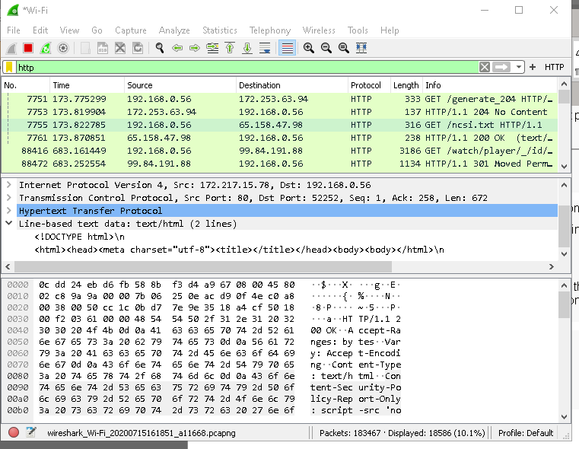

**2.**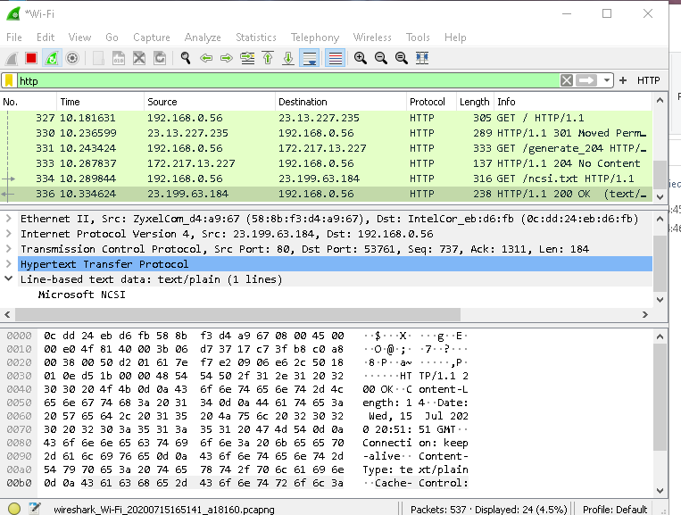

**3.**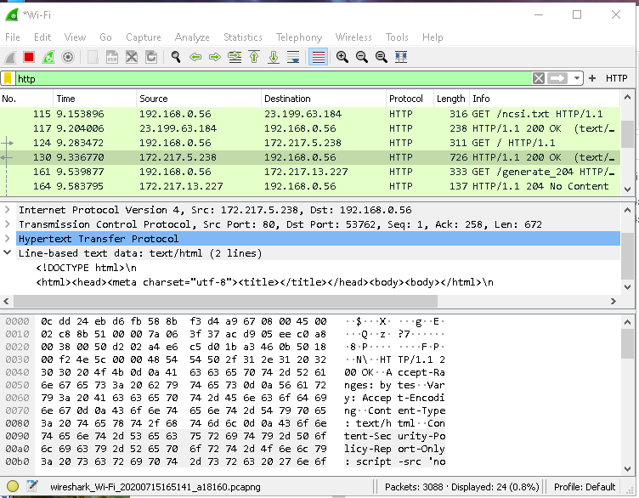

**4.**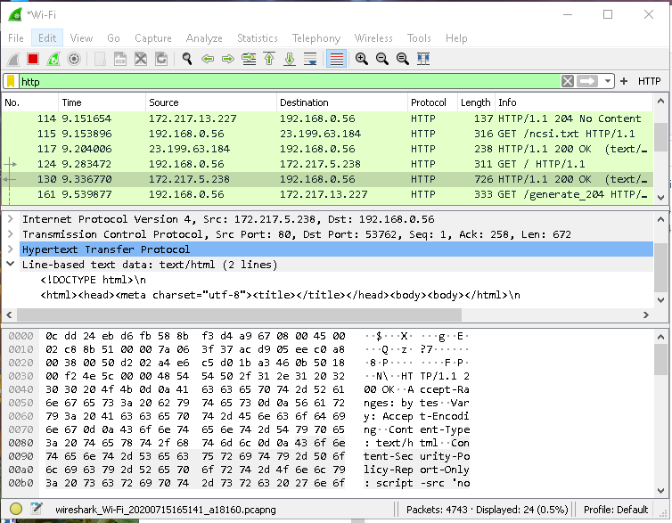

**5.**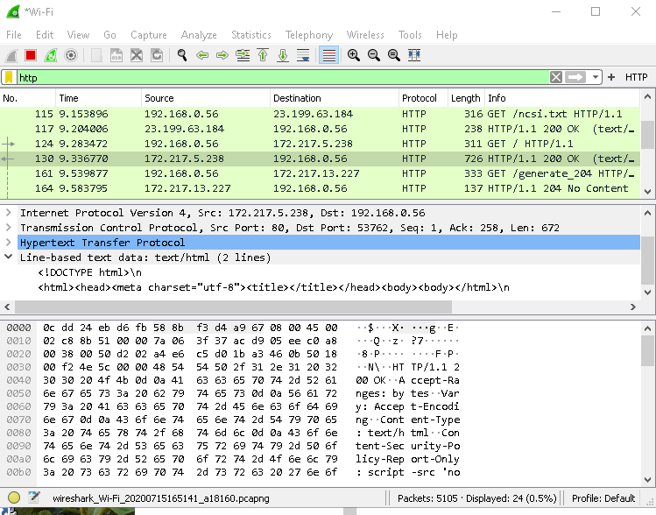

**Red.com**

**1.**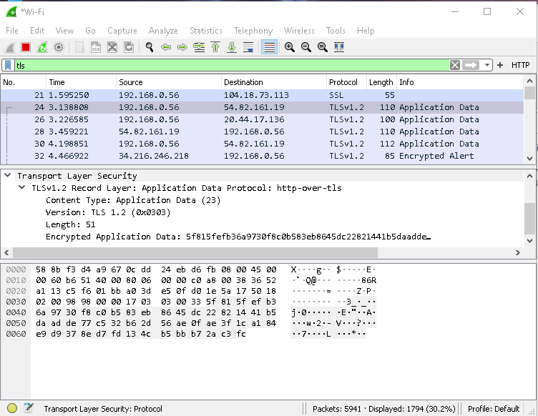

**2.**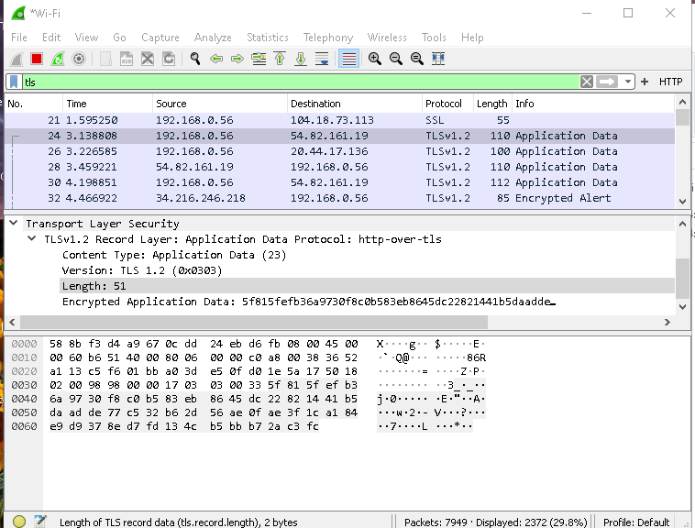

**3.**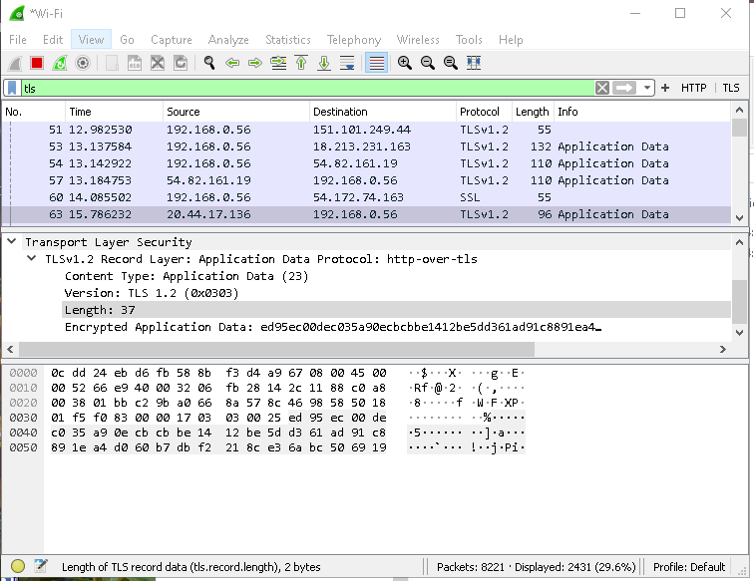

**4.**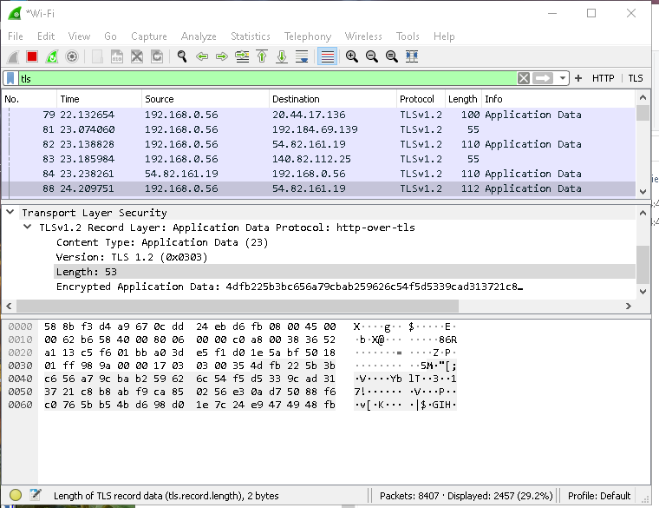

**5.**