NoSQL-HandsOn1

Part 1

Query 1, 2 and 3 Insert Three New Users Using insertOne() To Appusers Database.





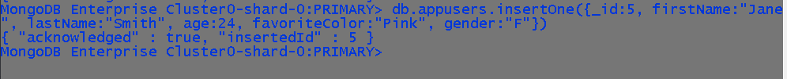

Query 4 Find Using find() Documents Through Mongo Shell.

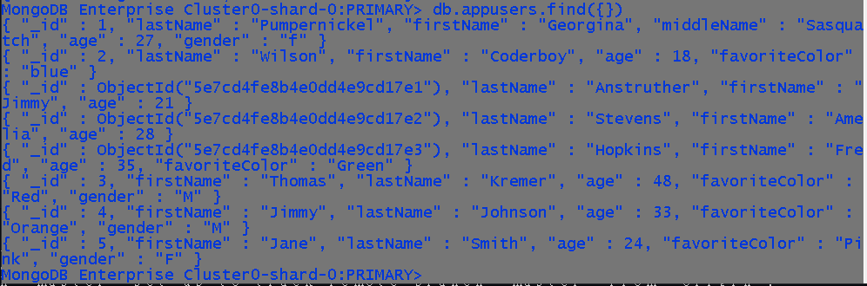

Query 5 Create A New Collection Called Cars Within The Database .

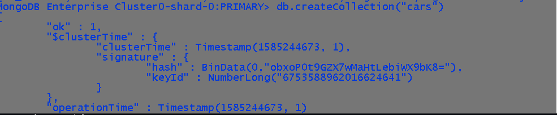

Query 6 Insert Five Cars With Make Model Color Year fourDoor fourWheelDrive, fourDoor And fourWheelDrive Should Be Boolean.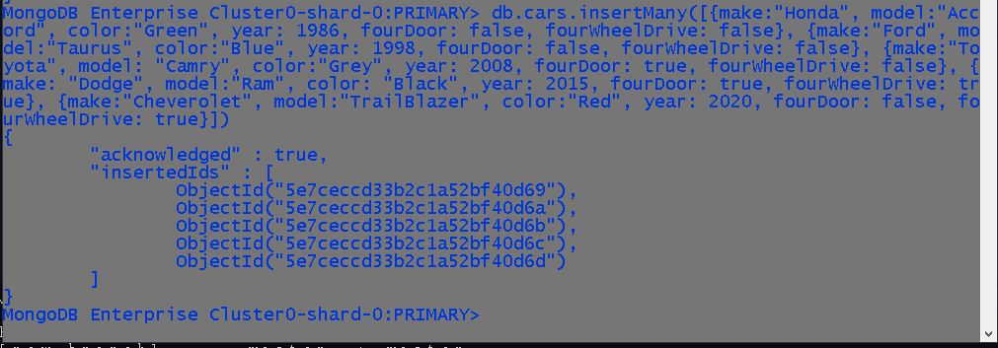

Query 7 Run A Find Query To View Newly Created Documents.

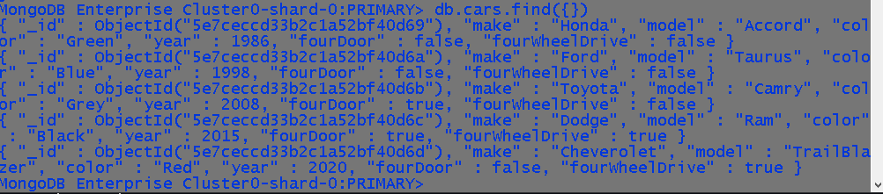

View Of Atlas With New Data In Database.

