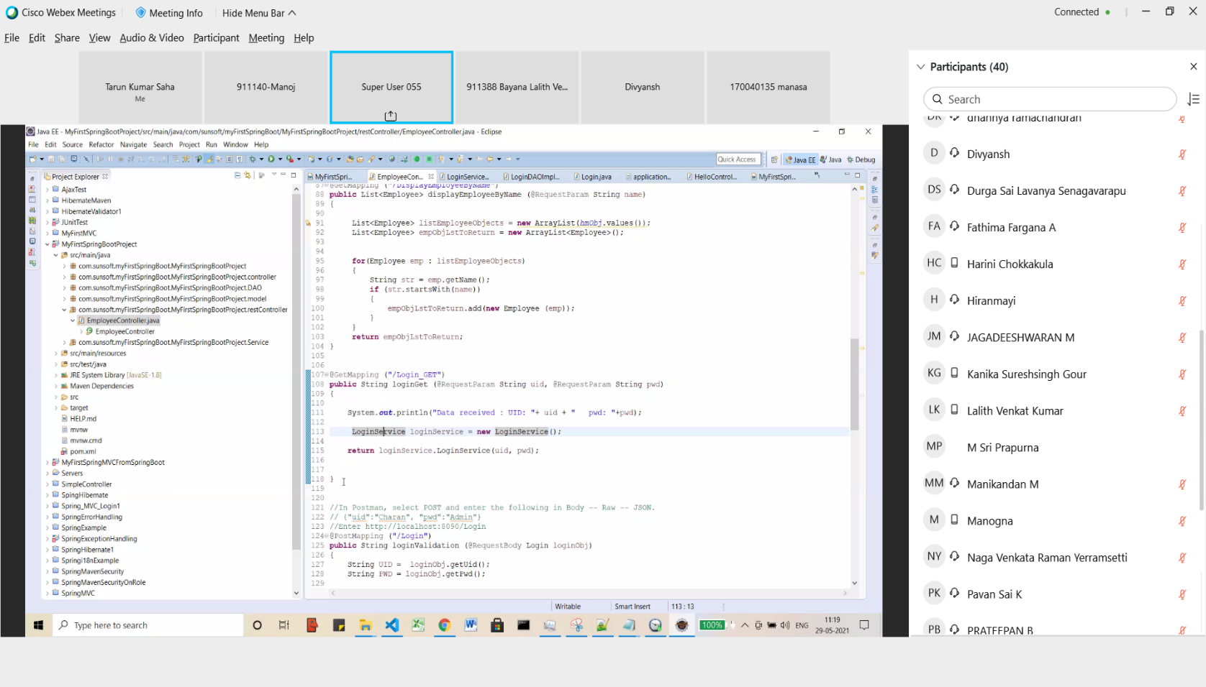Service

Login RowMappper

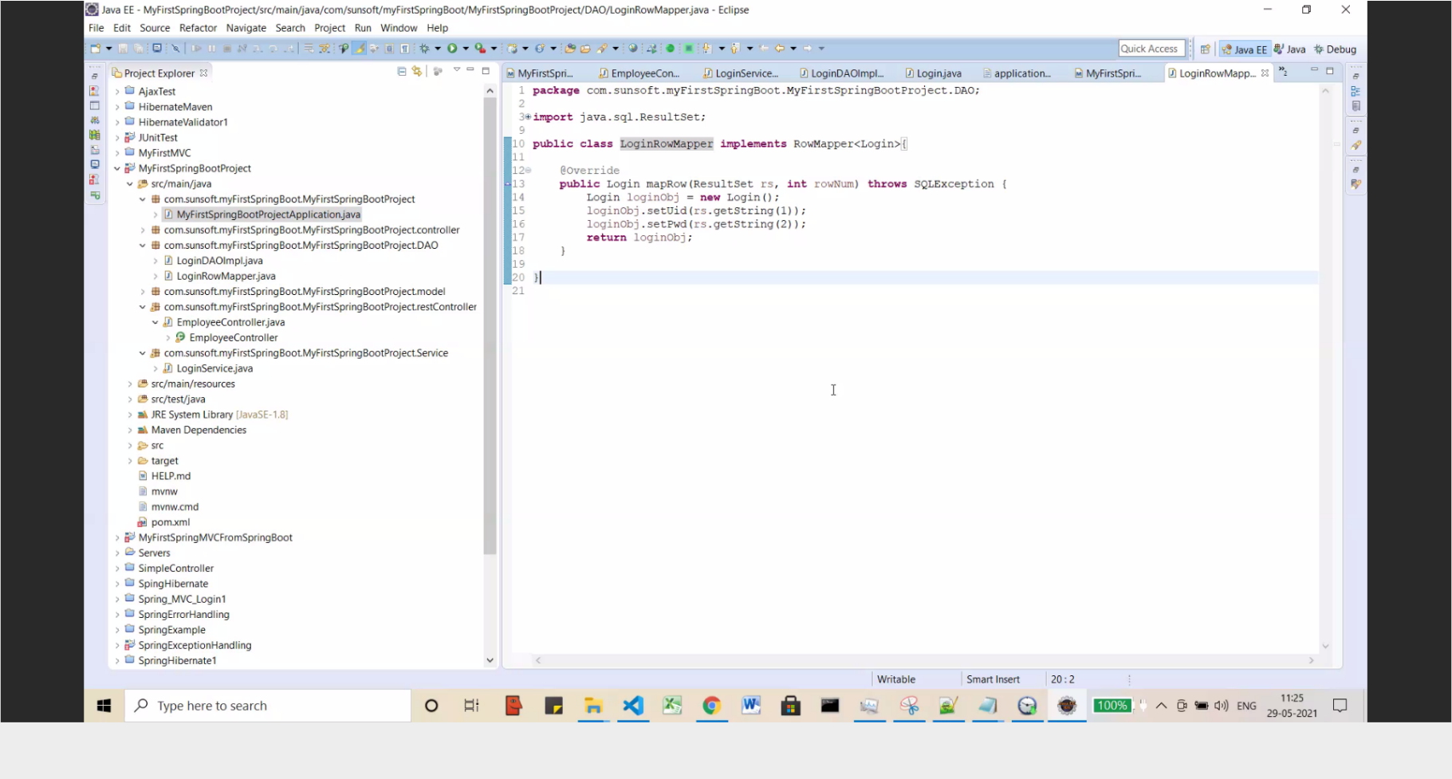

Login Dao

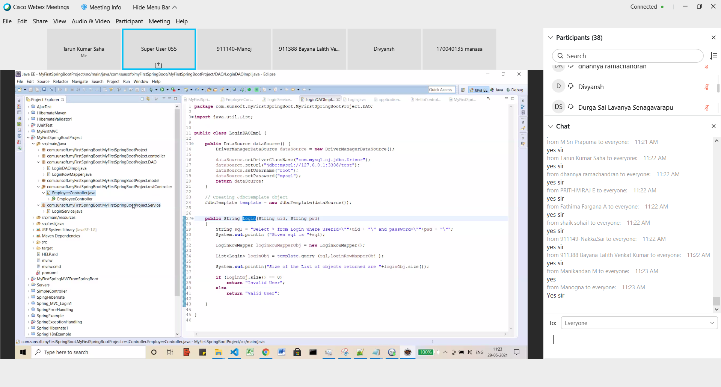

Controller

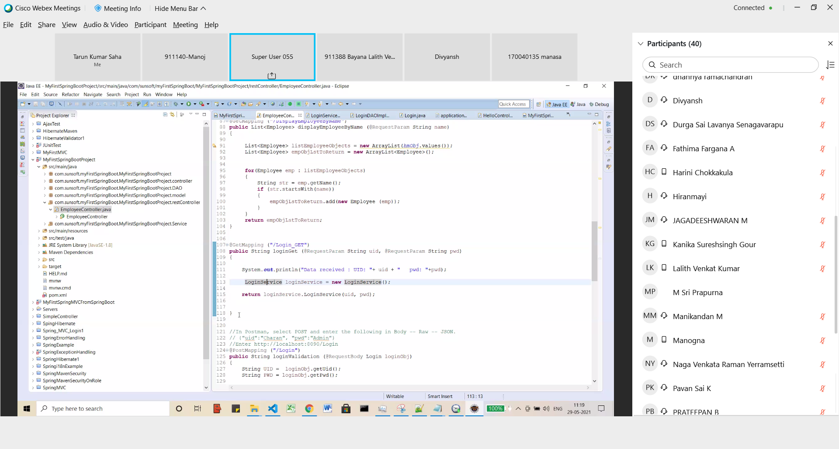

Properties

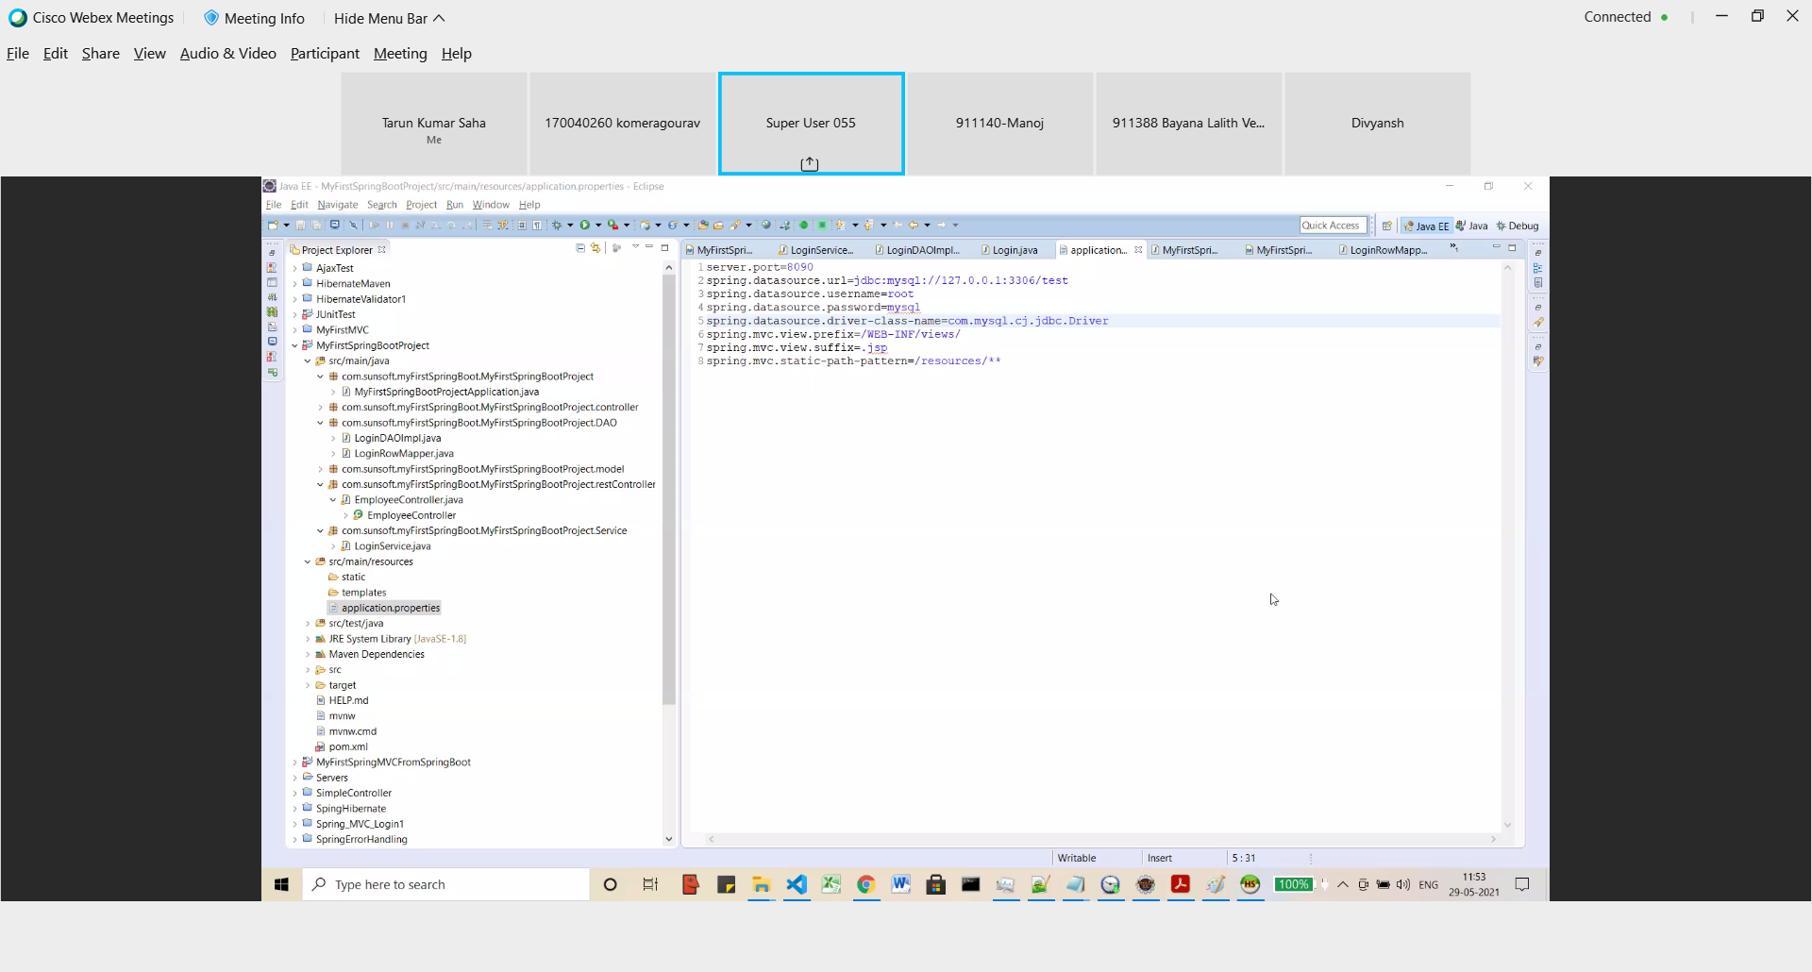

Post mapping

Imports

import org.springframework.beans.factory.annotation.Autowired;import org.springframework.http.HttpStatus;import org.springframework.http.ResponseEntity;import org.springframework.web.bind.annotation.DeleteMapping;import org.springframework.web.bind.annotation.GetMapping;import org.springframework.web.bind.annotation.PathVariable;import org.springframework.web.bind.annotation.PostMapping;import org.springframework.web.bind.annotation.PutMapping;import org.springframework.web.bind.annotation.RequestBody;import org.springframework.web.bind.annotation.RequestMapping;import org.springframework.web.bind.annotation.RequestParam;import org.springframework.web.bind.annotation.RestController;import com.sunsoft.myFirstSpringBoot.MyFirstSpringBootProject.Service.LoginService;import com.sunsoft.myFirstSpringBoot.MyFirstSpringBootProject.model.Employee;import com.sunsoft.myFirstSpringBoot.MyFirstSpringBootProject.model.Login;

