**Market Campaign Insights Analysis**

**Data Analysis Using SQL**

Created the dataset manually using the sql commands and loading it into the powerBI and making it an interactive Dashboards.

**SQL Commands to analysis the data**

1. Show all customer records

**Query:-**

SELECT * FROM customers;

**Output:-**

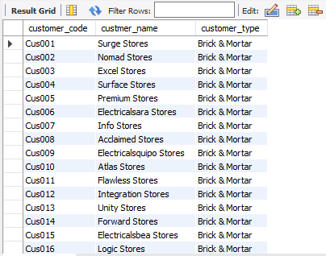

1. Show total number of customers

**Query:-**

SELECT count(*) FROM customers;

**Output:-**



1. Show transactions for Chennai market (market code for chennai is Mark001

**Query:-**

SELECT * FROM transactions where market_code='Mark001';

**Output:-**

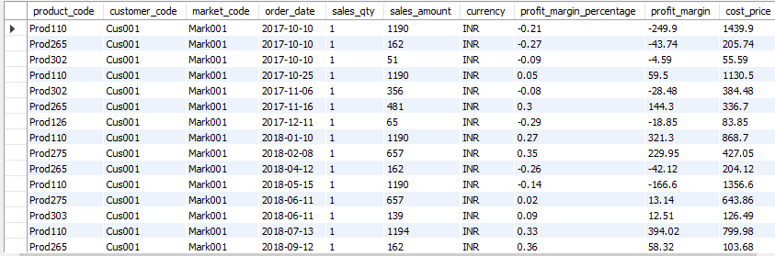

1. Show distrinct product codes that were sold in chennai

**Query:-**

SELECT distinct product_code FROM transactions where market_code='Mark001';

**Output:-**

1. Show transactions where currency is US dollars

**Query:-**

SELECT * from transactions where currency="USD"

**Output:-**

1. Show transactions in 2020 join by date table

**Query:-**

SELECT transactions.*, date.* FROM transactions INNER JOIN date ON transactions.order_date=date.date where date.year=2020;

**Output:-**

1. Show total revenue in year 2020

**Query:-**

SELECT SUM(transactions.sales_amount) FROM transactions INNER JOIN date ON transactions.order_date=date.date where date.year=2020 and transactions.currency="INR\r" or transactions.currency="USD\r";

**Output:-**

1. Show total revenue in year 2020, January Month

**Query:-**

SELECT SUM(transactions.sales_amount) FROM transactions INNER JOIN date ON transactions.order_date=date.date where date.year=2020 and and date.month_name="January" and (transactions.currency="INR\r" or transactions.currency="USD\r");

**Output:-**

1. Show total revenue in year 2020 in Chennai

**Query:-**

SELECT SUM(transactions.sales_amount) FROM transactions INNER JOIN date ON transactions.order_date=date.date where date.year=2020 and transactions.market_code="Mark001";

**Output:-**

