HOW TO RUN STREAMLIT!

Before you open VScode, make sure to download the **llama-2-7b-chat.Q4_K_M.gguf** file.

* Put the file inside api/models/ (DON’T COMMIT IT!!!!!)

Once that’s done, we can start to launch the API:

1. Make a new terminal (powershell)
2. Create a virtual environment by running: python -m venv venv
3. Activate the virtual environment by running: venv/Scripts/activate
4. To install the chatbot requirements; run: pip install -r requirements.txt

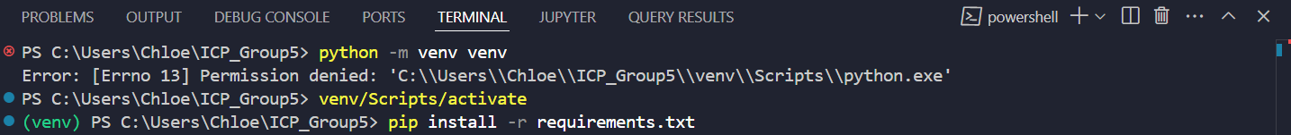

* 1. If the code has an error, you need to do the following
     1. Go visual studio installer (download if don’t have)
     2. Click on modify
     3. Select Desktop with C++ tools
     4. Install
     5. Restart your computer after that and then run everything again

1. Navigate to the API folder by running: cd api
2. Run the API using: uvicorn api:app –reload



Once you get this output, you’re good to go!

1. Access the API documentation through this link: <http://127.0.0.1:8000/docs#/>

To open StreamLit, make a new powershell terminal:

* Run the command: streamlit run streamlit_app.py
* Ctrl + Click on the Local URL to access the StreamLit platform

Create a Replicate API token:

* Click on ‘API Tokens’ and create new token

Paste the token into the StreamLit Credential Token input (Boxed in red in image below) and press enter

* You should be able to access the StreamLit interface 😊

To delete the virtual environment when closing VScode, run: rmdir /s /q venv