The input will be provided by an analog rotatry switch which has 5 positions which will be each be used to set the led to one of the following configurations

1. Off
2. Brightest
3. Intermediate Brightness
4. Least Bright
5. Flashing @ 2 Hz

The microcontroller will be run by a 9V battery. The other input to the battery will be the chosen switch input. The battery chosen must be small and light and should be able to drive the microcontroller for a significant time. Looking into Solar cells to do something different.

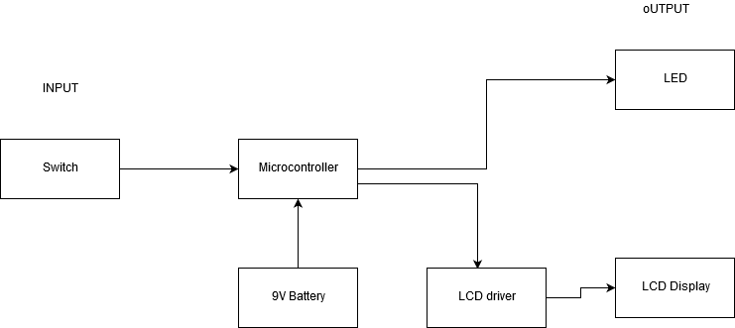At the output, the led will be lit in one of the configurations. The LCD display panel will indicate the chosen switch position as well as the battery level. The LCD will be driven by a lcd Driver.