Nhóm 6: Web cho thuê khách sạn
Weekly report: 30/06/2025 – 05/07/2025
Tên các thành viên:
STT | MSSV | Họ tên | Lớp
1 | 2280602562 | Trần Khương Trung Nhật Quang | 22DTHQB1
2 | 2280601930 | Lê Đức Minh | 22DTHQB1

SUMMARY which has completed:
- Basic database by using SQL Server.
- Completed core functionalities: hotel search, room selection, booking, and payment.
DESCRITION USECASE:
- Usecase:
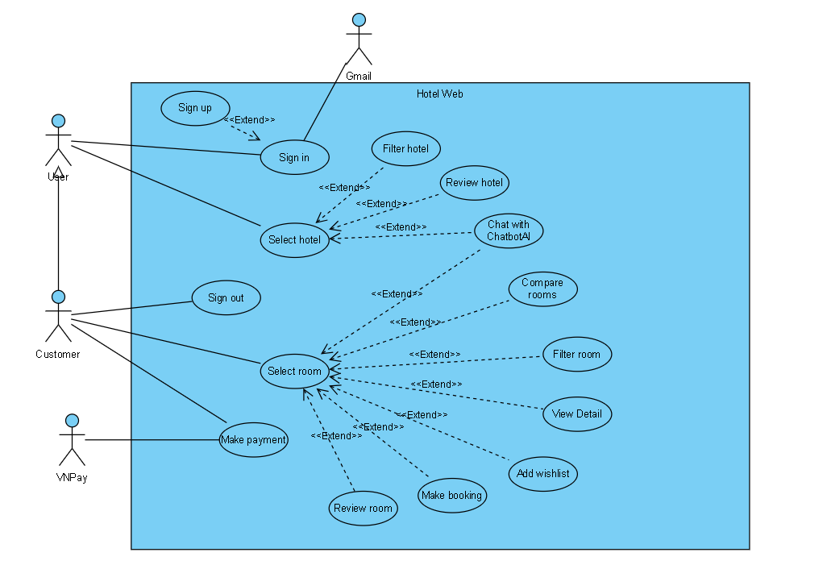

1. Use Case: Sign Up
- Description: The user creates a new account.
- Primary Actor: User
- Secondary Actor: None
- Pre-condition: The user does not have an account on the system.
- Post-condition: The user's account is created and redirected to the Sign In page.
- Main Flow:
  - The user selects the "Sign Up" option.
  - The system requests input of information (email, password).
  - The user enters the information and submits the request.
  - The system verifies the information and creates the account.
- Alternate Flow:
  - If the user already has an account, the system displays a notification and redirects to the Sign In page.
- Exception Flow:
  - If the information is invalid (e.g., email already exists), the system displays an error message and requests the user to re-enter.

2. Use Case: Sign In
- Description: The user logs into the web using an existing account.
- Primary Actor: User
- Secondary Actor: Gmail
- Pre-condition: The user has a valid account.
- Post-condition: The user is successfully logged in and can access the system's features.
- Main Flow:
  - The user selects the "Sign In" option.
  - The system requests input of email and password.
  - The user enters the information and submits the request.
  - The system verifies the information and allows login.
  - The system displays the main web page.
- Alternate Flow:
  - If the user selects Sign Up, the system redirects to the registration process.
  - The user logs in using a Gmail account.
- Exception Flow:
  - If the login information is incorrect, the system displays an error message and requests re-entry.

3. Use Case: Sign Out
- Description: The customer logs out of the Hotel Web system.
- Primary Actor: Customer
- Secondary Actor: None
- Pre-condition: The user is logged into the system.
- Post-condition: The user is logged out and redirected to the login page.
- Main Flow:
  - The user selects the "Sign Out" option.
  - The system confirms the request and performs the logout.
  - The system redirects the user to the Index page.
- Alternate Flow: None.
- Exception Flow:
  - If there is a system error during logout, the system displays an error message.

4. Use Case: Select Hotel
- Description: The user selects a hotel from the list to view details or book a room.
- Primary Actor: User, Customer
- Secondary Actor: None
- Pre-condition: The user is logged in and accesses the main page.
- Post-condition: The selected hotel and its detailed information are displayed.
- Main Flow:
  - The user selects the hotel search option.
  - The system displays a list of hotels.
  - The user selects a hotel.
  - The system displays detailed information about the hotel.
- Alternate Flow:
  - The user can apply filter criteria to narrow the list before selecting.
- Exception Flow: None.

5. Use Case: Filter Hotel
- Description: The user applies filters to narrow down the hotel list.
- Primary Actor: User, Customer
- Secondary Actor: None
- Pre-condition: The user has accessed the hotel search page.
- Post-condition: The hotel list is updated according to the filters.
- Main Flow:
  - The user selects filter criteria options.
  - The system updates the hotel list.
- Alternate Flow: None.
- Exception Flow: None.

6. Use Case: Review Hotel
- Description: The user views ratings and detailed information about a hotel.
- Primary Actor: Customer
- Secondary Actor: None
- Pre-condition: The user has selected a hotel.
- Post-condition: Hotel rating and detailed information are displayed.
- Main Flow:
  - The user selects the "Review Hotel" option.
  - The system displays information and ratings about the hotel.
- Alternate Flow: None.
- Exception Flow:
  - The review cannot be posted.

7. Use Case: Chat with ChatBotAI
- Description: The user chats with a chatbot to receive support or information.
- Primary Actor: User, Customer
- Secondary Actor: ChatBotAI
- Pre-condition: The user is logged in and accesses the system.
- Post-condition: The user receives a response from the chatbot.
- Main Flow:
  - The user selects the "Chat with ChatBotAI" option.
  - The system connects to ChatBotAI.
  - The user sends a question or request.
  - ChatBotAI responds to the question.
- Alternate Flow: None.
- Exception Flow:
  - The user or customer does not receive a response.

8. Use Case: Compare Rooms
- Description: The user compares hotel rooms.
- Primary Actor: Customer
- Secondary Actor: None
- Pre-condition: The user has selected a hotel.
- Post-condition: Room comparison information is displayed.
- Main Flow:
  - The user selects the "Compare Rooms" option.
  - The system displays comparison information for rooms (price, room type, amenities, etc.).
- Alternate Flow: None.
- Exception Flow:
  - If no room data is available for comparison, the system displays a "No data" message.

9. Use Case: Filter Room
- Description: The user applies filters to narrow down the room list.
- Primary Actor: User, Customer
- Secondary Actor: None
- Pre-condition: The user has selected a hotel.
- Post-condition: The room list is updated according to the filters.
- Main Flow:
  - The user selects filter criteria (price, room type, etc.) and applies the filter.
  - The system updates the room list.
- Alternate Flow: None.
- Exception Flow:
  - If no rooms match the filter, the system displays a "No rooms found" message.

10. Use Case: Select Room
- Description: The user selects a room to book or view details.
- Primary Actor: User, Customer
- Secondary Actor: None
- Pre-condition: The user has selected a hotel and the room list is displayed.
- Post-condition: The selected room and its detailed information are displayed.
- Main Flow:
  - The user selects a room.
  - The system displays detailed information about the room.
- Alternate Flow:
  - The user can apply filter criteria to narrow the list before selecting.
- Exception Flow:
  - If no rooms are available, the system displays a "Room not available" message.

11. Use Case: View Detail
- Description: The user or customer views detailed information about a hotel room.
- Primary Actor: User, Customer
- Secondary Actor: None
- Pre-condition: The user has selected a room or hotel.
- Post-condition: Detailed information is displayed.
- Main Flow:
  - The user selects the "View Detail" option.
  - The system displays detailed information.
- Alternate Flow: None.
- Exception Flow:
  - If no detailed data is available, the system displays a "No data" message.

12. Use Case: Add Wishlist
- Description: The customer adds a hotel or room to the wishlist.
- Primary Actor: Customer
- Secondary Actor: None
- Pre-condition: The user has selected a hotel or room.
- Post-condition: The hotel/room is added to the wishlist.
- Main Flow:
  - The user selects the "Add Wishlist" option.
  - The system adds the item to the wishlist.
- Alternate Flow: None.
- Exception Flow:
  - If already in the wishlist, the system displays a "Already in wishlist" message.

13. Use Case: Make Booking
- Description: The user makes a room booking.
- Primary Actor: Customer
- Secondary Actor: None
- Pre-condition: The user has selected a room.
- Post-condition: The booking is completed and confirmed.
- Main Flow:
  - The user selects the "Make Booking" option.
  - The system displays the booking form.
  - The user fills in the information and confirms.
  - The system proceeds to the payment step.
- Alternate Flow:
  - The user can cancel the booking and return to room selection.
- Exception Flow:
  - If the room is unavailable, the system displays a "Room already booked" message.

14. Use Case: Make Payment
- Description: The user makes a payment for the booking.
- Primary Actor: Customer
- Secondary Actor: VNPay
- Pre-condition: The user has completed the booking form.
- Post-condition: Payment is successful, and the booking is confirmed.
- Main Flow:
  - The user selects the "Make Payment" option.
  - The system redirects to VNPay.
  - The user completes the payment via VNPay.
  - VNPay confirms the payment and notifies Hotel Web.
  - The system confirms the booking.
- Alternate Flow:
  - The user can select an alternative payment method if VNPay is unavailable.
- Exception Flow:
  - If payment fails, the system displays an error message and allows retry.

15. Use Case: Review Room
- Description: The user rates or views ratings for a room after staying.
- Primary Actor: Customer
- Secondary Actor: None
- Pre-condition: The user has completed a booking and used the room.
- Post-condition: The rating is submitted or displayed.
- Main Flow:
  - The user selects the "Review Room" option.
  - The system displays the rating form or rating list.
  - The user submits a rating (if applicable).
- Alternate Flow: None.
- Exception Flow:
  - If the user lacks permission to rate, the system displays a "Not eligible" message.

