* **Data Source**

<https://github.com/AllThingsDataWithAngelina/DataSource/blob/main/sales_data_sample.csv>

* **Concepts Used:** 
  1. RFM ANALYSIS

1. Recency-Frequency-Monetary (RFM)
   1. It is an indexing technique that uses past purchase behaviour to segment customers.
2. An RFM report is a way of segmenting customers using three key metrics:
   1. **Recency** (how long ago their last purchase was),
   2. **Frequency** (how often they purchase), and
   3. **Monetary value** (how much they spent).
3. Data Points Use in RFM Analysis
   1. **Recency** – last order date
   2. **Frequency** – count of total orders
   3. **Monetary value** – total spend
   4. Common Table Expression CTE)
   5. Sub Query
   6. Built in functions DATEDIFF, NTILE, CAST, STUFF
   7. Temp Tables
   8. Case Statement

* **Steps Involved:**

1. Inspected Data by checking for unique values
2. Analysed product, year, deal size, best month for revenue from sales.
3. Identified best customer by RFM Analysis.
   * Used rfm as Common Table Expression (CTE) to get a table with CustomerName, Frequency, AvgMonetoryValue, MonetoryValue, LastOrderDate, Recency columns.
   * Introduced sub query for max_order_date.
   * Used DATEDIFF built-in function to calculate Recency
   * Did bucketing of 92 rows in 4 buckets through NTILE function for columns Frequency, Monetary Value and Recency.
   * Casted columns Frequency, Monetary Value and Recency as string and concatenated them to get rfm_cell_string.
   * Created **local temp table #rfm** by passing it as select into to prevent running all the scripts each time.
   * Customer Segmentation through case statement
4. **Combine values across rows** into one string.
   * Converted result into one line XML code.
   * Removed the first comma at the beginning of the XML code to get the string by using built-in STUFF function.

* **Questions:**

1. Maximum revenue generating product

Ans: Classic Cars ₹39,19,615.66

1. Maximum revenue generating year

Ans: 2004 ₹47,24,162.60

1. Maximum revenue deal size

Ans: Medium ₹60,87,432.24

1. What was the best month for sales? How much was earned in that month?

Ans: November (Max orders were received in this month) ₹21,18,885.67 (Including 2003, 2004)

1. What product do they sell maximum in November?

Ans: Classic Cars.

1. Who is the best customer?

Ans: Top 14 Loyal customers can be listed as below:

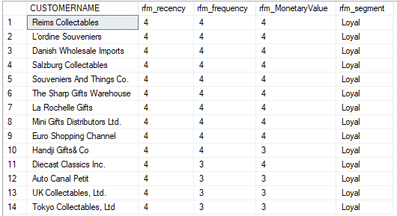

1. What products are most often sold together?

Ans: For Order Numbers 10243, 10409 and 10102, 10256 combinations of products purchased together are the same. So, we can say that these products are sold together. 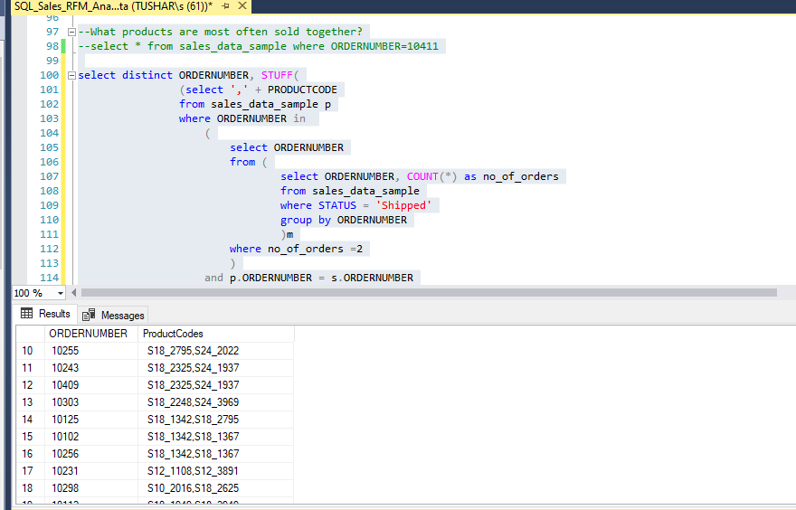

For Order Number 10236,10402 all three products are sold together.

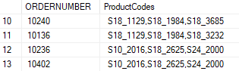

For Order number 10123, 10137 all four products are sold together

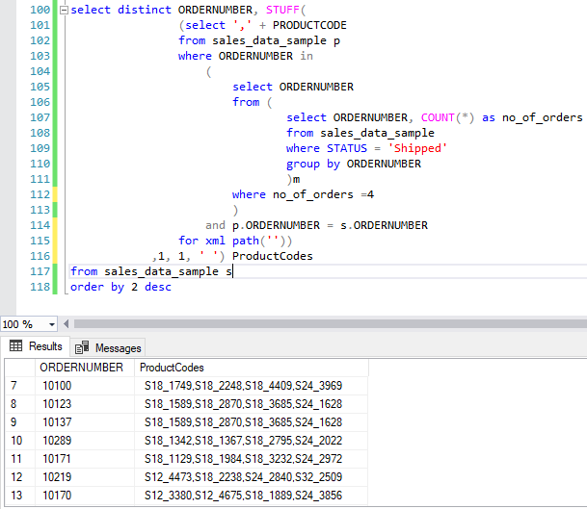

For Order number 10239, 10405 all five products are sold together

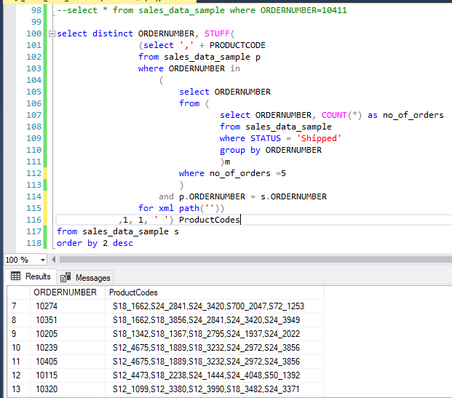

* **Visualisation through Tableau Software:**

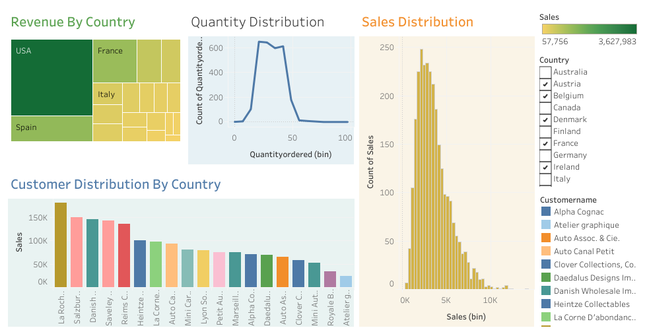

*Figure 1: Sales_Dashboard 1*

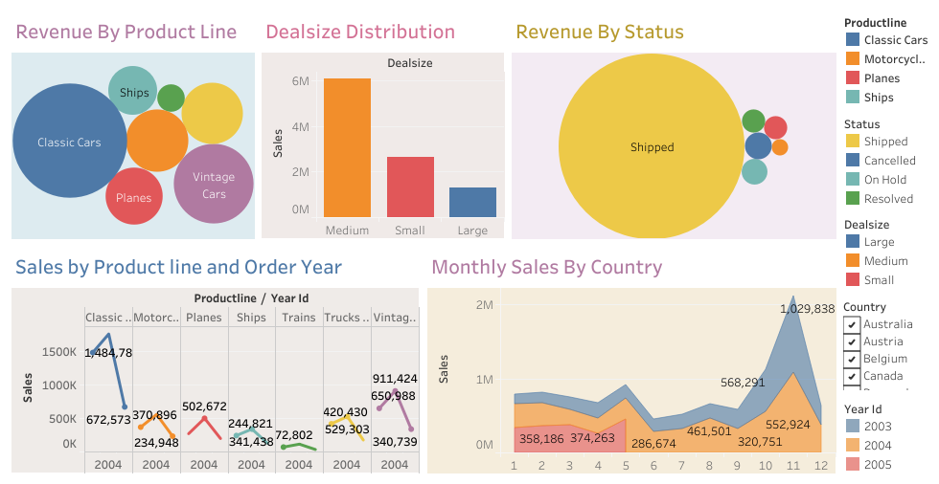

*Figure 2: Sales_Dashboard 2*