Hypothesis

1. More cancellations occur when prices are higher.
2. When there is longer waiting list, customer tends to cancel very frequently.
3. The majority of clients are coming from offline travel agents to make their reservations.

Analysis and Findings

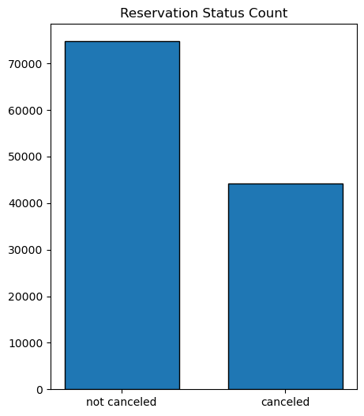

The accompanying bar graph shows the percentage of reservations that are cancelled and those that are not. It is obvious that there are still a significant number of reservations that have not being cancelled. There are still 37% of clients who cancelled their reservations, which has a significant impact on hotel earnings.

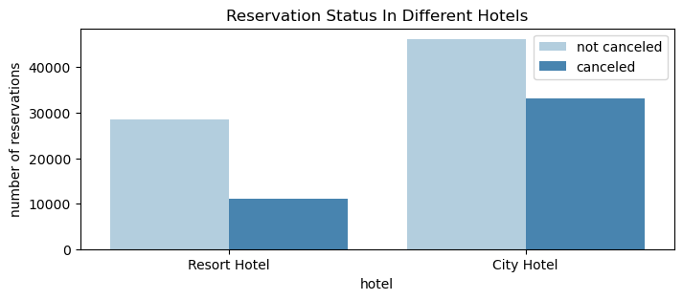

In comparison to Resort hotels, City hotels have more bookings. It’s possible that resort hotels are more expensive than those in cities.

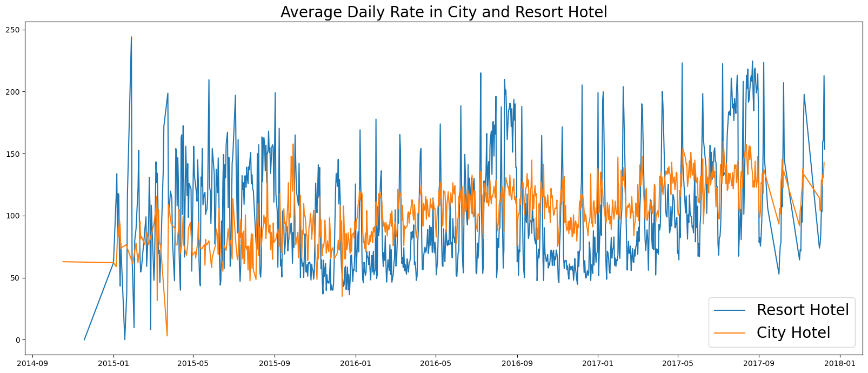

The line graph above shows that, on certain days, the average daily rate of a city hotel is less than a resort hotel and on other days it is even less. It goes without saying that weekends and holidays may see a rise in resort hotel rates.

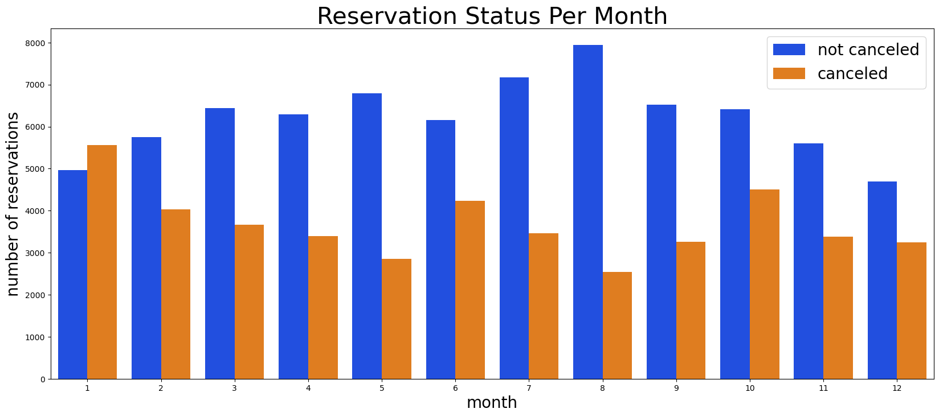

We have developed the grouped bar graph to analyze the months with the highest and lowest reservation levels according to reservation status. As can be seen, both the number of confirmed reservations and the number of cancelled reservations are largest in the month of August whereas January is the month with the most cancelled reservations.

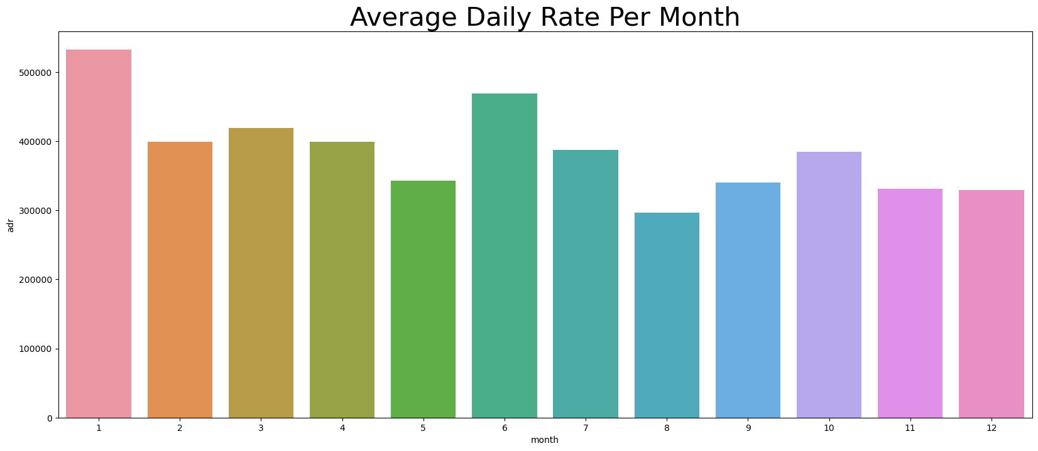

The bar graph demonstrates that cancellations are most common when prices are greatest and are least common when they are lowest. Therefore the cost of reservations is solely responsible for the cancellation.

Now, let’s see which country has the highest reservations cancelled. The top country Portugal is with the highest number of cancellations.

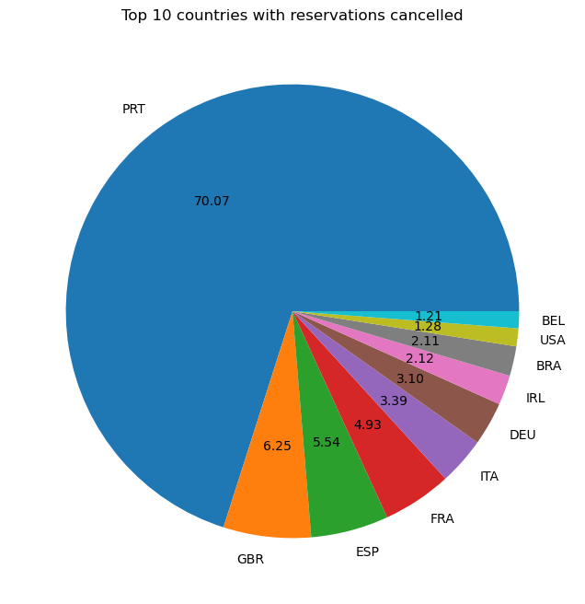

Let’s check the area from where guests are visiting the hotels and making reservations. Is it coming from direct or groups, Online or Offline Travel Agents? Around 46% of clients come from online travel agencies, whereas 27% come from groups. Only 4% clients book hotels by directly visiting them and making reservations.

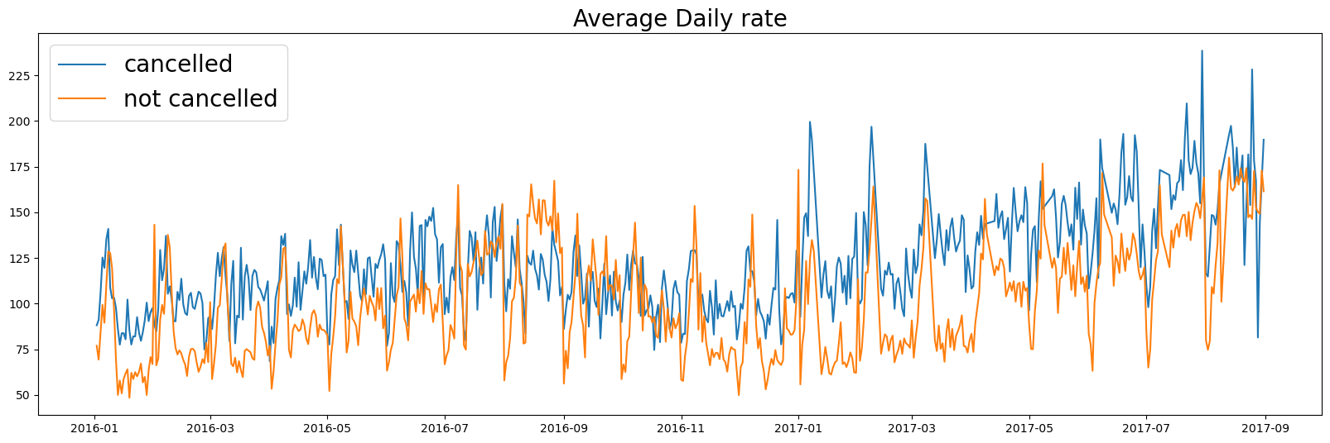

As seen in the graph, reservations are cancelled when the average daily rate is higher than when it is not cancelled. It clearly proves all the above analysis, that higher price leads to higher cancellations.

Suggestions

1. Cancellations rates rise as price does. In order to prevent cancellations on reservations, hotels could work on their pricing strategies and try to lower the rates for specific hotels based on locations. They can also provide some discount to the customers.
2. As the ratio of cancellations and non-cancellations of resort hotel is higher than city hotel, the hotels should provide a reasonable discount on the room prices on weekends or on holidays.
3. In the month of January the hotels can start campaigns or marketing with a reasonable amount to increase their revenue as cancellations are highest in this month.
4. They can also increase the quality of hotels and services mainly in Portugal to reduce the cancellation rate.