Statistical Modeling with R, Homework #2

Group Members

* Karish Raja Rai
* Tom Wiesing
* Julius Nzaramba

> ### Load the dataset again

> load("./OregonHomes.Rdata")

> summary(homes)

ID Price Floor Lot Bath Bed

Min. : 1 Min. :155.5 Min. :1.440 Min. : 1.000 Min. :1.000 Min. :2.000

1st Qu.:20 1st Qu.:242.8 1st Qu.:1.861 1st Qu.: 3.000 1st Qu.:2.000 1st Qu.:3.000

Median :39 Median :276.0 Median :1.965 Median : 4.000 Median :2.000 Median :3.000

Mean :39 Mean :285.8 Mean :1.969 Mean : 3.987 Mean :2.206 Mean :3.442

3rd Qu.:58 3rd Qu.:336.8 3rd Qu.:2.106 3rd Qu.: 5.000 3rd Qu.:3.000 3rd Qu.:4.000

Max. :77 Max. :450.0 Max. :2.896 Max. :11.000 Max. :3.100 Max. :6.000

NA's :1

Year Age Gar Status School

Min. :1905 Min. :-6.50000 Min. :0.000 Active :26 Adams : 3

1st Qu.:1958 1st Qu.:-1.20000 1st Qu.:1.000 Pending:13 Crest : 6

Median :1970 Median : 0.00000 Median :2.000 Sold :38 Edison :12

Mean :1969 Mean :-0.05195 Mean :1.571 Harris :14

3rd Qu.:1980 3rd Qu.: 1.00000 3rd Qu.:2.000 Parker :16

Max. :2005 Max. : 3.50000 Max. :3.000 Redwood:26

>

> ## and we need this down the road

> library(car)

# Question 1

> ## Create a new factor $GarGroup

> homes$GarGroup <- NA # init with NA

> homes$GarGroup[homes$Gar <= 1] <- "OneOrNoCar" # one group for OneOrNoCars

> homes$GarGroup[homes$Gar >= 2] <- "TwoOrThreeCars" # and another group for the other cases

> homes$GarGroup <- as.factor(homes$GarGroup) # make sure it is a factor

>

> ## make a boxplot

> boxplot(Price~GarGroup, data=homes)

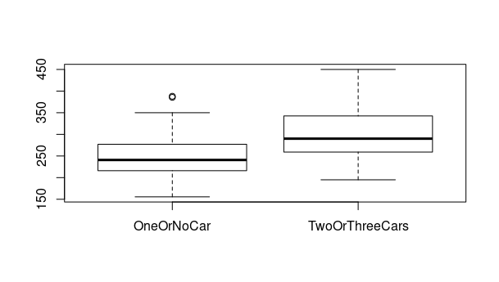

1. Yes we expect the mean of the prizes to differ significantly as the ranges for "TwoOrThreeCars" us significantly higher. Furthermore, the IQR is bigger for the second group.
2. The p-value is very small, so we can assume there is a significant difference in house prices

> t.test(Price~GarGroup, data=homes, var.equal=TRUE) # P = 0.001547

Two Sample t-test

data: Price by GarGroup

t = -3.2878, df = 74, p-value = 0.001547

alternative hypothesis: true difference in means is not equal to 0

95 percent confidence interval:

-73.93064 -18.13474

sample estimates:

mean in group OneOrNoCar mean in group TwoOrThreeCars

254.3000 300.3327

1. This is not actually given, we see OneOrNoCar has Variance 3809, TwoOrThreeCars has 2952.802

> sapply(levels(homes$GarGroup), function(g){var(homes[homes$GarGroup == g,]$Price, na.rm = TRUE)})

OneOrNoCar TwoOrThreeCars

3809.479 2952.802

# Question 2

> ex2a <- aov(Price~GarGroup, data=homes)

> summary(ex2a)

Df Sum Sq Mean Sq F value Pr(>F)

GarGroup 1 34796 34796 10.81 0.00155 **

Residuals 74 238211 3219

---

Signif. codes: 0 ‘***’ 0.001 ‘**’ 0.01 ‘*’ 0.05 ‘.’ 0.1 ‘ ’ 1

1 observation deleted due to missingness

1. There is a significant difference, as F > 1 and p = 0.00155 < 0.01
2. P =0.00155 < 0.01 => it is significant

> ex2b <- lm(Price~GarGroup, data=homes)

> summary(ex2b)

Call:

lm(formula = Price ~ GarGroup, data = homes)

Residuals:

Min 1Q Median 3Q Max

-105.33 -39.81 -13.55 39.59 149.67

Coefficients:

Estimate Std. Error t value Pr(>|t|)

(Intercept) 254.30 11.58 21.958 < 2e-16 ***

GarGroupTwoOrThreeCars 46.03 14.00 3.288 0.00155 **

---

Signif. codes: 0 ‘***’ 0.001 ‘**’ 0.01 ‘*’ 0.05 ‘.’ 0.1 ‘ ’ 1

Residual standard error: 56.74 on 74 degrees of freedom

(1 observation deleted due to missingness)

Multiple R-squared: 0.1275, Adjusted R-squared: 0.1157

F-statistic: 10.81 on 1 and 74 DF, p-value: 0.001547

1. The p-value for linear model and anova are the same. It differed slightly for the t test. All three compute a t statistic, so the value is obviously the same.

# Question 3

> ex3 <- aov(Price ~ as.factor(Gar), data=homes)

> summary(ex3)

Df Sum Sq Mean Sq F value Pr(>F)

as.factor(Gar) 3 36682 12227 3.725 0.015 *

Residuals 72 236325 3282

---

Signif. codes: 0 ‘***’ 0.001 ‘**’ 0.01 ‘*’ 0.05 ‘.’ 0.1 ‘ ’ 1

1 observation deleted due to missingness

1. Yes it does. P = 0.015
2. Only 2-0

> TukeyHSD(ex3)

Tukey multiple comparisons of means

95% family-wise confidence level

Fit: aov(formula = Price ~ as.factor(Gar), data = homes)

$`as.factor(Gar)`

diff lwr upr p adj

1-0 13.74545 -47.983945 75.47485 0.9361062

2-0 52.71345 2.532603 102.89431 0.0357791

3-0 72.59545 -43.232873 188.42378 0.3585166

2-1 38.96800 -7.942282 85.87828 0.1372769

3-1 58.85000 -55.599370 173.29937 0.5330866

3-2 19.88200 -88.774603 128.53860 0.9630134

1. There is an outlier for houses with no garage (see boxplot).

> boxplot(Price ~ as.factor(Gar), data=homes)

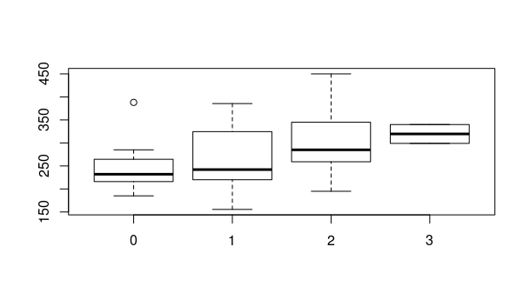

**Question 4**

> ex4 <- lm(Price ~ Floor + Lot + Bath + Bed + Year + Age + Gar + Status + School, data=homes)

1. Floor, Lot, Bed, Gar, School are significant.

> anova(ex4)

Analysis of Variance Table

Response: Price

Df Sum Sq Mean Sq F value Pr(>F)

Floor 1 11079 11078.6 5.4709 0.022574 *

Lot 1 15230 15229.8 7.5209 0.007962 **

Bath 1 5711 5711.5 2.8205 0.098103 .

Bed 1 23964 23963.5 11.8338 0.001046 **

Year 1 646 646.0 0.3190 0.574239

Gar 1 8429 8428.5 4.1622 0.045601 *

Status 2 9782 4890.9 2.4153 0.097707 .

School 5 72617 14523.4 7.1720 2.372e-05 ***

Residuals 62 125551 2025.0

---

Signif. Codes: 0 ‘***’ 0.001 ‘**’ 0.01 ‘*’ 0.05 ‘.’ 0.1 ‘ ’ 1

1. The AIC gives us the model quality, which is 808.8182

> AIC(ex4)

[1] 808.8182

1. As a numerical variable. We see this from the Df (degrees of freedom). For the explicit comparison, see the anova table in 4a) and the one below.

> aov(lm(Price ~ Floor + Lot + Bath + Bed + Year + Age + as.factor(Gar) + Status + School, data=homes))

Call:

aov(formula = lm(Price ~ Floor + Lot + Bath + Bed + Year + Age +

as.factor(Gar) + Status + School, data = homes))

Terms:

Floor Lot Bath Bed Year as.factor(Gar) Status

Sum of Squares 11078.57 15229.83 5711.46 23963.51 646.00 11728.25 9751.54

Deg. of Freedom 1 1 1 1 1 3 2

School Residuals

Sum of Squares 73174.98 121723.12

Deg. of Freedom 5 60

Residual standard error: 45.0413

1 out of 17 effects not estimable

Estimated effects may be unbalanced

1 observation deleted due to missingness

**Question 5**

The variable age is linearly dependent on year (we obviously have age + year == constant). Hence during the liner model analysis, the computation encounters a singularity and thus needs to pick one of the variables to ignore.

**Question 6**

> ex4

Call:

lm(formula = Price ~ Floor + Lot + Bath + Bed + Year + Age +

Gar + Status + School, data = homes)

Coefficients:

(Intercept) Floor Lot Bath Bed Year

-131.8769 72.5267 10.5655 5.4472 -12.0432 0.1271

Age Gar StatusPending StatusSold SchoolCrest SchoolEdison

NA 7.6951 -19.0634 -37.0352 1.2157 84.5645

SchoolHarris SchoolParker SchoolRedwood

50.3965 -14.3984 4.6459

We go over the significant variables.

* Floor: coefficient +72, i.e. better floor → higher costs (makes sense)
* Lot: coefficient +10, i.e. better lot → higher costs (makes sense)
* Bed: coefficient -12, i.e. more bedrooms → lower price (DOES NOT make sense)
* Gar: coefficient +7, i.e. more garage space → higher price (makes sense)
* School: different coefficients per district, only one negative. This makes sense if the Parker district is one of the worse districts.

**Question 7**

The final model uses Floor, Lot, Bed, Status, School.

> ex7f <- step(ex7, direction="both")

Start: AIC=591.14

Price ~ Floor + Lot + Bath + Bed + Age + Gar + Status + School

Df Sum of Sq RSS AIC

- Age 1 295 125846 589.32

- Bath 1 436 125986 589.40

- Gar 1 1338 126888 589.95

<none> 125551 591.14

- Bed 1 3542 129092 591.25

- Status 2 14279 139830 595.33

- Floor 1 11117 136667 595.59

- Lot 1 16862 142412 598.72

- School 5 72617 198168 615.83

Step: AIC=589.32

Price ~ Floor + Lot + Bath + Bed + Gar + Status + School

Df Sum of Sq RSS AIC

- Bath 1 658 126504 587.71

- Gar 1 2066 127912 588.56

<none> 125846 589.32

- Bed 1 4501 130347 589.99

+ Age 1 295 125551 591.14

- Status 2 14557 140403 593.64

- Floor 1 11371 137216 593.89

- Lot 1 16590 142435 596.73

- School 5 78087 203933 616.01

Step: AIC=587.71

Price ~ Floor + Lot + Bed + Gar + Status + School

Df Sum of Sq RSS AIC

- Gar 1 2432 128936 587.16

<none> 126504 587.71

- Bed 1 4148 130652 588.17

+ Bath 1 658 125846 589.32

+ Age 1 518 125986 589.40

- Status 2 15174 141678 592.32

- Lot 1 15995 142499 594.76

- Floor 1 16864 143368 595.23

- School 5 80042 206546 614.97

Step: AIC=587.16

Price ~ Floor + Lot + Bed + Status + School

Df Sum of Sq RSS AIC

<none> 128936 587.16

+ Gar 1 2432 126504 587.71

+ Age 1 1550 127386 588.24

+ Bath 1 1024 127912 588.56

- Bed 1 7690 136626 589.56

- Status 2 22760 151696 595.52

- Lot 1 18945 147881 595.58

- Floor 1 23307 152242 597.79

- School 5 80237 209172 613.93

**Question 8**

> crPlots(ex7f)

Warning message:

In smoother(.x, partial.res[, var], col = col.lines[2], log.x = FALSE, :

could not fit smooth

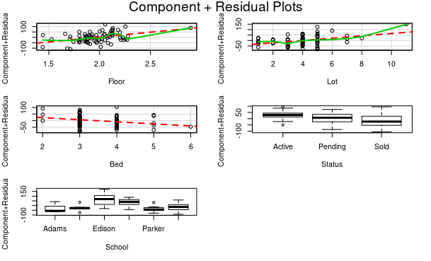

1. Some square terms should be included for the Lot and Floor components
2. Neither of shows a better smoothing.

> crPlots(ex7f, smoother.args=list(span=0.25))

Warning messages:

1: In smoother(.x, partial.res[, var], col = col.lines[2], log.x = FALSE, :

could not fit smooth

2: In smoother(.x, partial.res[, var], col = col.lines[2], log.x = FALSE, :

could not fit smooth

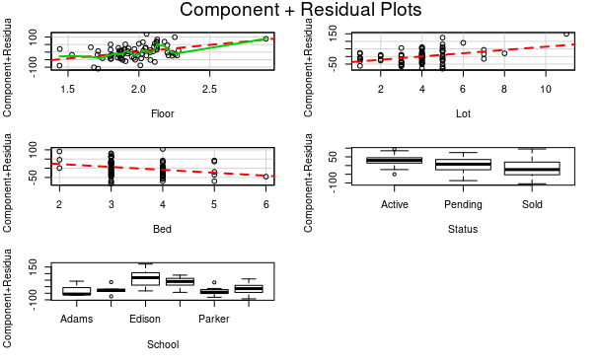> crPlots(ex7f, smoother.args=list(span=0.75))

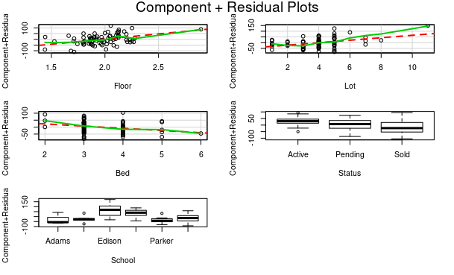

1. the AIC got lower to 802.0374, so it does not neccessarily make sense.

> ex8c <- lm(formula = Price ~ Floor + Lot + Bed + Status + School + I(Lot^2), data = homes)

> AIC(ex8c)

[1] 802.0374