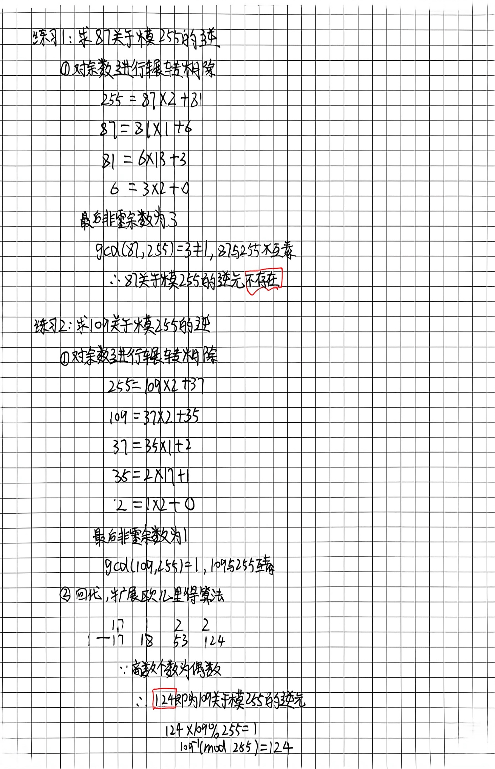
代码
def exgcd(a,b):
if b == 0:
return(a,1,0)

g,x1,y1 = exgcd(b,a%b)
x = y1
y = x1 - (a//b)*y1
return (g,x,y)

def mod_inverse(a,m):
g,x,y = exgcd(a%m,m)
if g!=1:
return None

return (x%m+m) %m

def printInv(a,m,inv):
if(inv == None):
print(f"{a}没有关于模{m}的逆元")
print()
else:
print(f"{a}关于模{m}的逆元:{inv}")
print()

if __name__ == "__main__":
# test1 61->105
a1,m1 = 61,105
inv1 = mod_inverse(a1,m1)
printInv(a1,m1,inv1)

# test2 31->105
a2,m2 = 31,105
inv2 = mod_inverse(a2,m2)
printInv(a2,m2,inv2)

#test3 87->255
a3,m3 = 87,255
inv3 = mod_inverse(a3,m3)
printInv(a3,m3,inv3)

#test4 109->255
a4,m4 = 109,255
inv4 = mod_inverse(a4,m4)
printInv(a4,m4,inv4)
运行结果
