Notes about CPU screenshots:

The program is run on a slow VM, so just running the CPU monitor puts all 4 cores at about 60-80% usage. This is up from about 20% from just the monitor running in the background, atom and terminal on the VM and word, VM, hyperV, LTSpice and file explorer on Windows.

The first time report is the one corresponding to the CPU screenshot

Two sets of data

The first two tests were performed with two versions of the code, one with and one without a feature (“computed” vector) that tracked which component currents had already been computed. This was intended to speed up computation but didn’t, for reasons I will explain in my part on the change in implementation of reactives.

Stuff in red is only relevant to me (David) for the part on how we changed the reactive implementation.

All tests are 10ms long.

bigtest

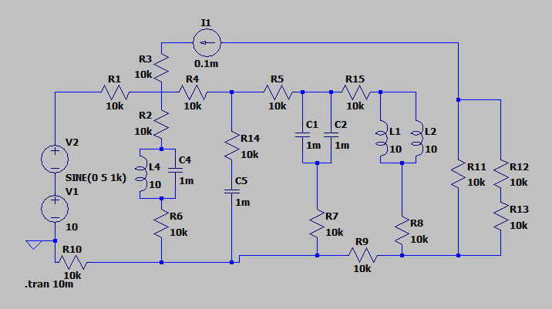

Without the computed vector

fakeRes3 basecase duration: 0

R6 basecase duration: 0

R7 basecase duration: 0

R8 basecase duration: 0

R9 basecase duration: 0

I1 basecase duration: 0

R10 basecase duration: 0

R11 basecase duration: 0

R12 basecase duration: 0

R13 basecase duration: 0

R14 basecase duration: 0

C5 basecase duration: 1

fakeRes4 basecase duration: 0

R15 basecase duration: 0

R1 basecase duration: 0

V2 basecase duration: 14

V1 basecase duration: 24

R1 basecase duration: 0

V2 basecase duration: 6

R1 basecase duration: 0

R2 basecase duration: 0

R3 basecase duration: 0

R4 basecase duration: 0

R5 basecase duration: 0

C1 basecase duration: 0

fakeRes1 basecase duration: 0

C2 basecase duration: 0

fakeRes2 basecase duration: 0

L1 basecase duration: 0

L2 basecase duration: 0

L4 basecase duration: 0

C4 basecase duration: 0

fakeRes3 basecase duration: 0

R6 basecase duration: 0

R7 basecase duration: 0

R8 basecase duration: 0

R9 basecase duration: 0

I1 basecase duration: 0

R10 basecase duration: 0

R11 basecase duration: 0

R12 basecase duration: 0

R13 basecase duration: 0

R14 basecase duration: 0

C5 basecase duration: 1

fakeRes4 basecase duration: 0

R15 basecase duration: 0

R1 basecase duration: 0

V2 basecase duration: 14

V1 basecase duration: 27

R1 basecase duration: 0

V2 basecase duration: 20

R1 basecase duration: 0

R2 basecase duration: 0

R3 basecase duration: 0

R4 basecase duration: 0

R5 basecase duration: 0

C1 basecase duration: 1

fakeRes1 basecase duration: 0

C2 basecase duration: 1

fakeRes2 basecase duration: 0

L1 basecase duration: 1

L2 basecase duration: 1

L4 basecase duration: 1

C4 basecase duration: 1

fakeRes3 basecase duration: 0

R6 basecase duration: 0

R7 basecase duration: 0

R8 basecase duration: 0

R9 basecase duration: 0

I1 basecase duration: 0

R10 basecase duration: 0

R11 basecase duration: 0

R12 basecase duration: 0

R13 basecase duration: 0

R14 basecase duration: 0

C5 basecase duration: 2

fakeRes4 basecase duration: 0

R15 basecase duration: 0

main duration: 9136546

L:L2:N011:N007:10

A is Number: 15 label: N011 supernode: 15 reactiveSuper: 0 superlabel: N011

B is Number: 14 label: N007 supernode: 14 reactiveSuper: 0 superlabel: N007

L:L4:N014:N009:10

A is Number: 16 label: N014 supernode: 16 reactiveSuper: 0 superlabel: N014

B is Number: 8 label: N009 supernode: 8 reactiveSuper: 0 superlabel: N009

C:C4:N009:fakeNode3:0.001

A is Number: 8 label: N009 supernode: 8 reactiveSuper: 0 superlabel: N009

B is Number: 2 label: fakeNode3 supernode: 8 reactiveSuper: 1 superlabel: N009

R:fakeRes3:fakeNode3:N014:0.1

A is Number: 2 label: fakeNode3 supernode: 8 reactiveSuper: 1 superlabel: N009

B is Number: 16 label: N014 supernode: 16 reactiveSuper: 0 superlabel: N014

R:R6:N014:N016:10000

A is Number: 16 label: N014 supernode: 16 reactiveSuper: 0 superlabel: N014

B is Number: 17 label: N016 supernode: 17 reactiveSuper: 0 superlabel: N016

R:R7:N010:N016:10000

A is Number: 13 label: N010 supernode: 13 reactiveSuper: 0 superlabel: N010

B is Number: 17 label: N016 supernode: 17 reactiveSuper: 0 superlabel: N016

R:R8:N011:N017:10000

A is Number: 15 label: N011 supernode: 15 reactiveSuper: 0 superlabel: N011

B is Number: 18 label: N017 supernode: 18 reactiveSuper: 0 superlabel: N017

R:R9:N017:N016:10000

A is Number: 18 label: N017 supernode: 18 reactiveSuper: 0 superlabel: N017

B is Number: 17 label: N016 supernode: 17 reactiveSuper: 0 superlabel: N016

I:I1:N002:N001:0.0001

A is Number: 19 label: N002 supernode: 19 reactiveSuper: 0 superlabel: N002

B is Number: 10 label: N001 supernode: 10 reactiveSuper: 0 superlabel: N001

R:R10:N016:0:10000

A is Number: 17 label: N016 supernode: 17 reactiveSuper: 0 superlabel: N016

B is Number: 0 label: 0 supernode: 6 reactiveSuper: 0 superlabel: N003

R:R11:N002:N017:10000

A is Number: 19 label: N002 supernode: 19 reactiveSuper: 0 superlabel: N002

B is Number: 18 label: N017 supernode: 18 reactiveSuper: 0 superlabel: N017

R:R12:N002:N015:10000

A is Number: 19 label: N002 supernode: 19 reactiveSuper: 0 superlabel: N002

B is Number: 20 label: N015 supernode: 20 reactiveSuper: 0 superlabel: N015

R:R13:N015:N017:10000

A is Number: 20 label: N015 supernode: 20 reactiveSuper: 0 superlabel: N015

B is Number: 18 label: N017 supernode: 18 reactiveSuper: 0 superlabel: N017

R:R14:N005:N012:10000

A is Number: 11 label: N005 supernode: 11 reactiveSuper: 0 superlabel: N005

B is Number: 21 label: N012 supernode: 21 reactiveSuper: 0 superlabel: N012

C:C5:N012:fakeNode4:0.001

A is Number: 21 label: N012 supernode: 21 reactiveSuper: 0 superlabel: N012

B is Number: 1 label: fakeNode4 supernode: 21 reactiveSuper: 1 superlabel: N012

R:fakeRes4:fakeNode4:N016:0.1

A is Number: 1 label: fakeNode4 supernode: 21 reactiveSuper: 1 superlabel: N012

B is Number: 17 label: N016 supernode: 17 reactiveSuper: 0 superlabel: N016

R:R15:N007:N006:10000

A is Number: 14 label: N007 supernode: 14 reactiveSuper: 0 superlabel: N007

B is Number: 12 label: N006 supernode: 12 reactiveSuper: 0 superlabel: N006

main duration: 5254854

above we see that printing out more stuff causes delays

common_node duration: 0

index duration: 0

index duration: 0

index duration: 0

index duration: 0

index duration: 0

index duration: 0

index duration: 0

currents duration: 157

common_node duration: 2

common_node duration: 1

common_node duration: 0

index duration: 0

index duration: 0

index duration: 0

index duration: 0

index duration: 0

index duration: 0

index duration: 0

currents duration: 132

common_node duration: 1

common_node duration: 1

common_node duration: 0

index duration: 0

index duration: 0

index duration: 0

index duration: 0

index duration: 0

index duration: 0

index duration: 0

currents duration: 63

common_node duration: 2

common_node duration: 1

common_node duration: 0

index duration: 0

index duration: 0

index duration: 0

index duration: 0

index duration: 0

index duration: 0

index duration: 0

currents duration: 66

common_node duration: 2

common_node duration: 1

common_node duration: 0

index duration: 0

index duration: 0

index duration: 0

index duration: 0

index duration: 0

index duration: 0

index duration: 0

currents duration: 74

main duration: 6459117

common_node duration: 1

common_node duration: 0

R1 basecase duration: 0

V2 basecase duration: 19

V1 basecase duration: 46

common_node duration: 1

R1 basecase duration: 0

V2 basecase duration: 21

R1 basecase duration: 0

R2 basecase duration: 0

R3 basecase duration: 0

R4 basecase duration: 0

R5 basecase duration: 0

index duration: 0

C1 basecase duration: 3

fakeRes1 basecase duration: 0

index duration: 0

C2 basecase duration: 3

fakeRes2 basecase duration: 0

index duration: 0

L1 basecase duration: 3

index duration: 0

L2 basecase duration: 5

index duration: 0

L4 basecase duration: 6

index duration: 0

C4 basecase duration: 6

fakeRes3 basecase duration: 0

R6 basecase duration: 0

R7 basecase duration: 0

R8 basecase duration: 0

R9 basecase duration: 0

I1 basecase duration: 0

R10 basecase duration: 0

R11 basecase duration: 0

R12 basecase duration: 0

R13 basecase duration: 0

R14 basecase duration: 0

index duration: 0

C5 basecase duration: 4

fakeRes4 basecase duration: 0

R15 basecase duration: 0

currents duration: 285

main duration: 9925503

here we see that component_index and common_node functions are extremely cheap compared to the whole of the current computation, and even compared to the basecases (keep in mind this is in the version without computed)

op duration: 549

transient duration: 5014194

main duration: 5016483

op duration: 606

transient duration: 5127834

main duration: 5130410

op duration: 705

transient duration: 5200117

main duration: 5203535

op duration: 497

transient duration: 5031532

main duration: 5033857

op duration: 443

transient duration: 5015776

main duration: 5018199

A few examples of bigtest resolution time

Regular (with computed vector)

op duration: 609

tran duration: 5290216

main duration: 5292786

op duration: 643

tran duration: 5444769

main duration: 5447404

op duration: 533

tran duration: 5324080

main duration: 5326489

op duration: 561

tran duration: 5411750

main duration: 5414247

op duration: 509

tran duration: 5210722

main duration: 5212990

we can see that the computed vector does not, in fact, save time.

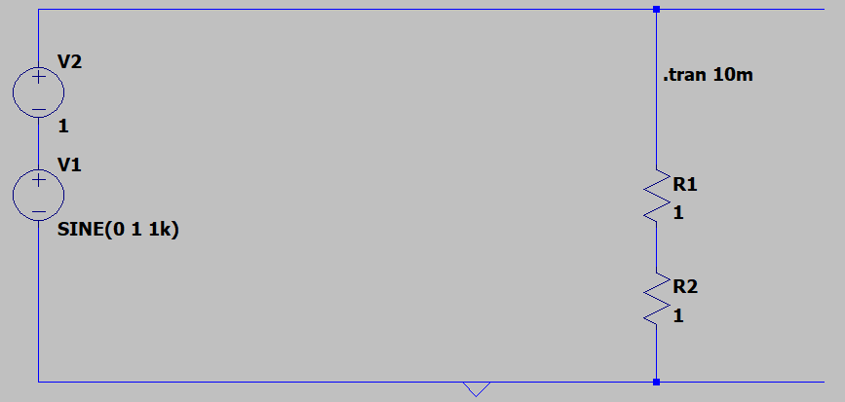

Sine_V-DC_R+R

Without computed

op duration: 76

transient duration: 591280

main duration: 592701

op duration: 65

transient duration: 572695

main duration: 573716

op duration: 112

transient duration: 591330

main duration: 592257

op duration: 78

transient duration: 578485

main duration: 579578

op duration: 77

transient duration: 560372

main duration: 561390

with computed :

op duration: 57

tran duration: 599390

main duration: 600241

op duration: 60

tran duration: 635981

main duration: 636851

op duration: 54

tran duration: 584470

main duration: 585489

op duration: 76

tran duration: 580324

main duration: 581505

op duration: 56

tran duration: 552906

main duration: 553784

Henceforth only the version of the program without the computed vector will be used

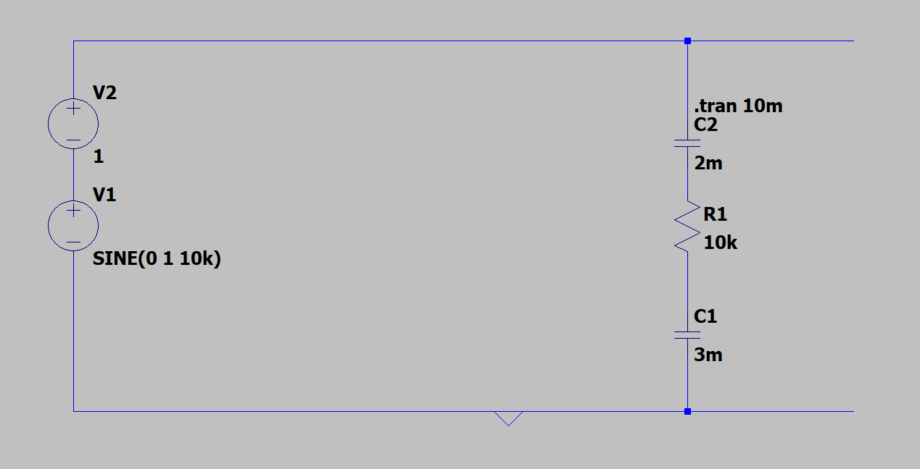

V-Sine_V-DC_C+C

op duration: 91

transient duration: 934834

main duration: 935689

op duration: 77

transient duration: 958011

main duration: 959045

op duration: 82

transient duration: 904126

main duration: 905162

op duration: 85

transient duration: 931266

main duration: 932285

op duration: 167

transient duration: 907640

main duration: 909025

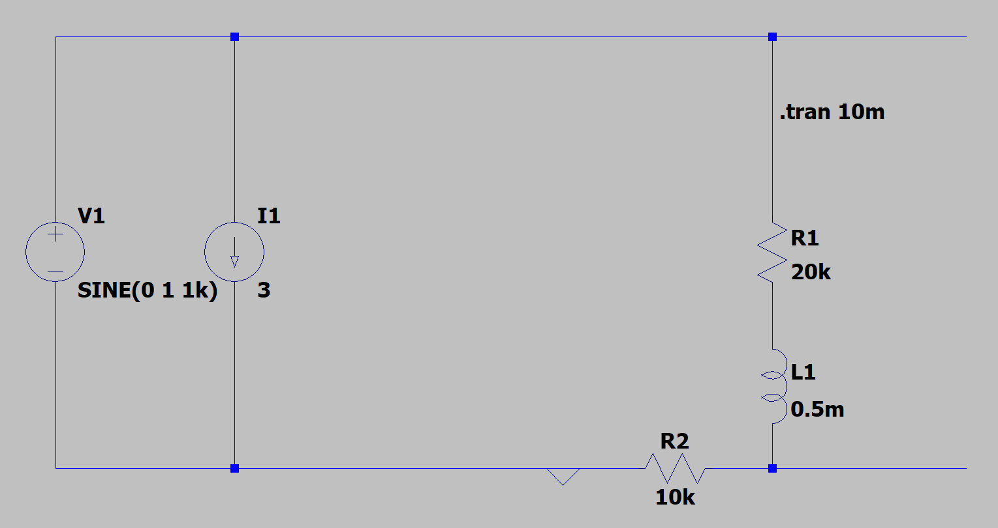

op duration: 50

transient duration: 622072

main duration: 622937

op duration: 78

transient duration: 611196

main duration: 612166

op duration: 68

transient duration: 619769

main duration: 620790

op duration: 55

transient duration: 587265

main duration: 588057

op duration: 80

transient duration: 610001

main duration: 610954

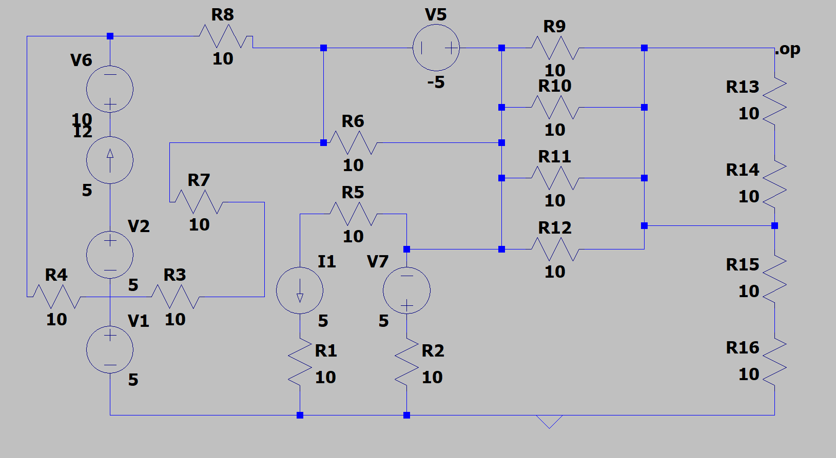

OP final test

op duration: 304

main duration: 877

op duration: 301

main duration: 822

op duration: 244

main duration: 937

op duration: 296

main duration: 947

op duration: 236

main duration: 789

Vsource para R

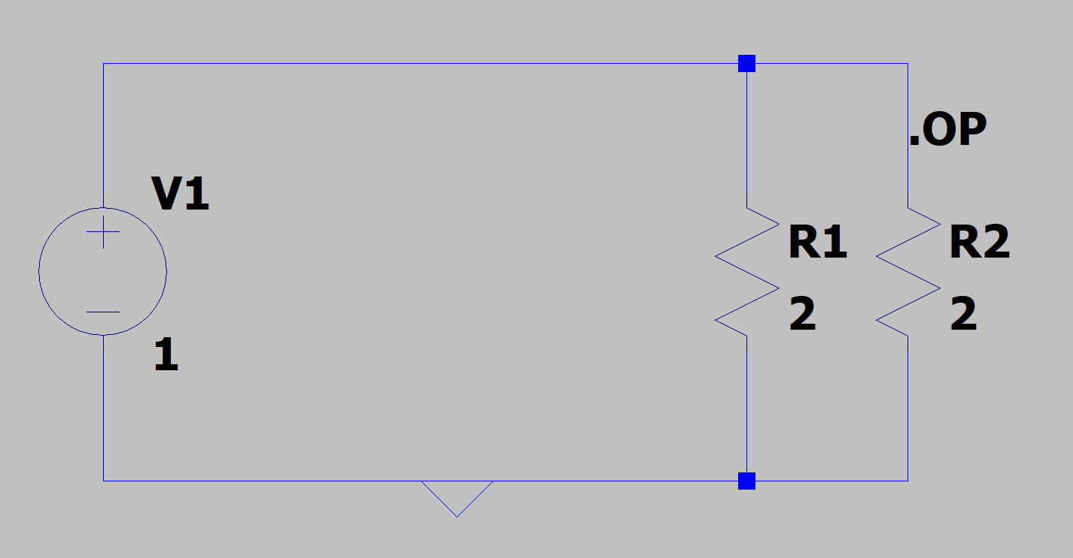

op duration: 100

main duration: 579

op duration: 55

main duration: 273

op duration: 63

main duration: 258

op duration: 36

main duration: 285

op duration: 54

main duration: 229

Mix Csource Vsource R

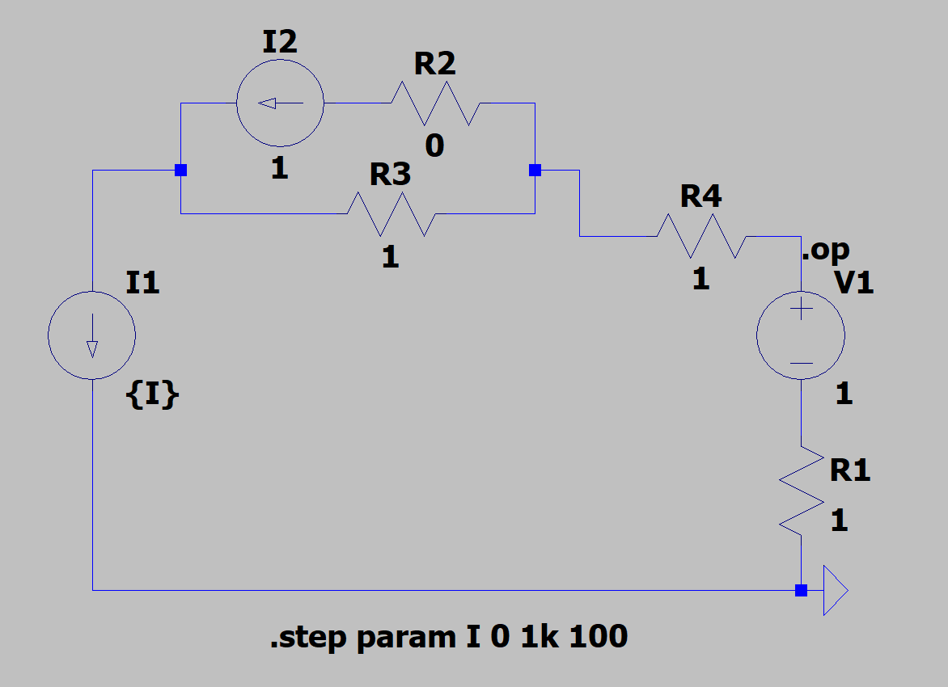

op duration: 60

op duration: 36

op duration: 85

op duration: 52

op duration: 51

op duration: 51

op duration: 49

op duration: 49

op duration: 79

op duration: 52

op duration: 61

main duration: 2132

op duration: 84

op duration: 38

op duration: 34

op duration: 34

op duration: 34

op duration: 33

op duration: 33

op duration: 34

op duration: 34

op duration: 34

op duration: 34

main duration: 1200

op duration: 106

op duration: 64

op duration: 53

op duration: 53

op duration: 53

op duration: 94

op duration: 75

op duration: 53

op duration: 41

op duration: 36

op duration: 67

main duration: 2305

op duration: 65

op duration: 38

op duration: 55

op duration: 57

op duration: 36

op duration: 52

op duration: 34

op duration: 34

op duration: 36

op duration: 71

op duration: 55

main duration: 1744

op duration: 55

op duration: 77

op duration: 35

op duration: 75

op duration: 55

op duration: 35

op duration: 90

op duration: 50

op duration: 90

op duration: 54

op duration: 54

main duration: 2309