Initial, L 3.6A, C, 12V

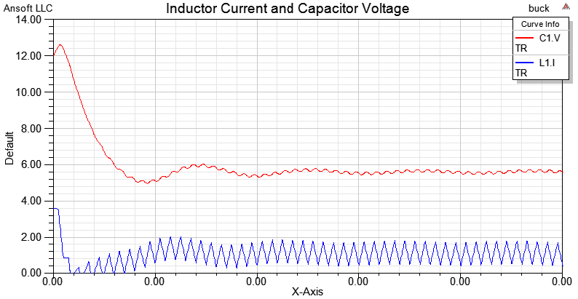

Initial, L 1.2A, C, 6V

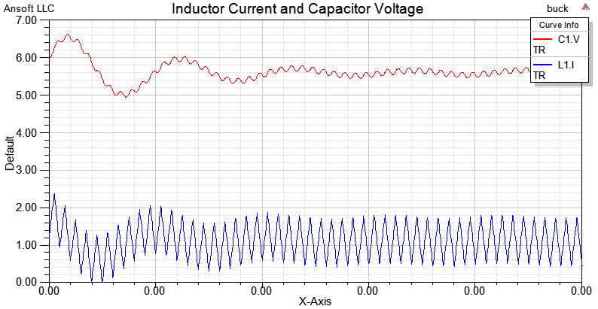

Initial, L 0, C, 0

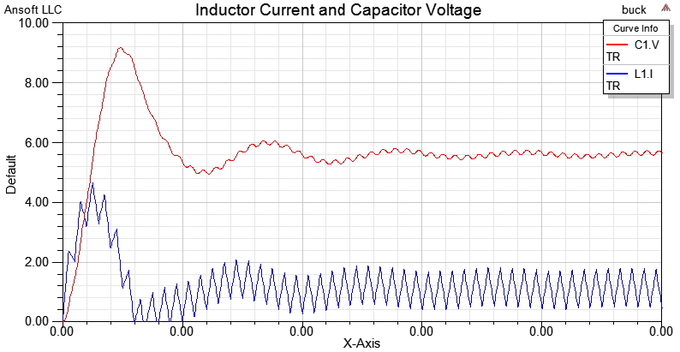

Initial, L 0H, C, 0H, R = 10 ohm

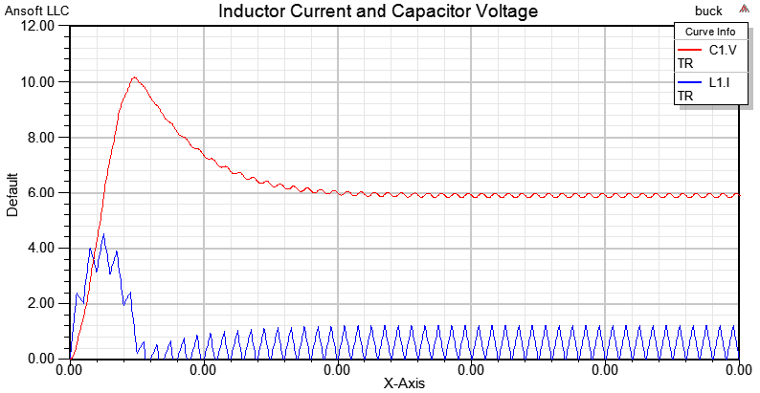

Initial, L 0H, C, 0H, L = 25uH, R = 5 ohm

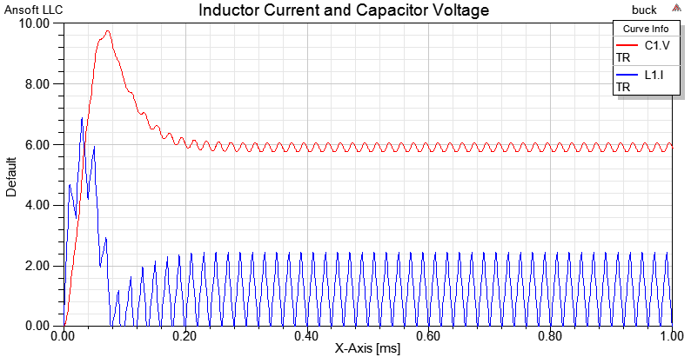

D = 0.2, L = 50, C = 22, R = 5

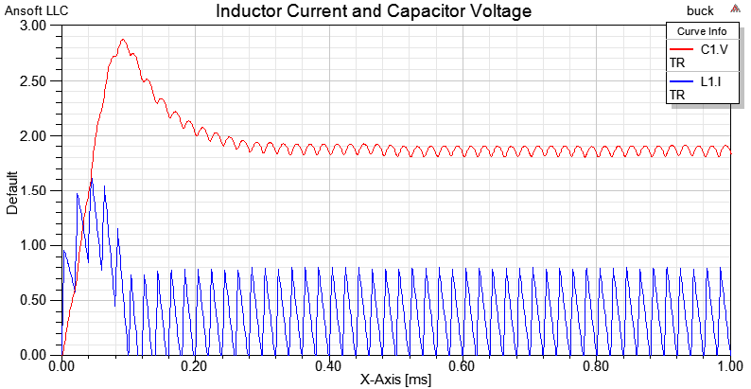

D = 0.8, L = 50, C = 22, R = 5

